Impact of Frontline Demonstrations on Productivity and Economics of Linseed (Linum usitatissimum L.) in Bihar

Abstract
Linseed (Linum usitatissimum L.) is an important oilseed crop grown in the eastern Indo-Gangetic plains of India, particularly in Bihar, where productivity remains low due to weak adoption of improved technologies. To address this gap, Krishi Vigyan Kendras (KVKs) across Bihar, under the supervision of ICAR–ATARI, Patna, implemented frontline demonstrations (FLDs) from 2019–20 to 2023–24. The present study assessed five-year performance data on yield, percent increase, economics, and benefit–cost ratio. Results revealed that demonstration plots recorded significantly higher yields (9.11–10.93 q/ha) than farmer’s practice (6.95–7.66 q/ha). Yield enhancement ranged from 22% to 43%. Demonstration plots also achieved higher net returns (₹25,952–₹44,764/ha) and benefit–cost ratios (2.45–2.99) compared to farmer’s practice (1.98–2.43). The findings confirm that adoption of improved varieties, seed treatment, line sowing, balanced fertilization, and integrated pest management can substantially enhance linseed productivity and profitability in Bihar. The study highlights the critical role of FLDs in bridging the yield gap in oilseed crops.

Keywords: Linseed; Frontline demonstration; Yield gap; Economics; Oilseed crops

1. Introduction
Linseed (Linum usitatissimum L.), also known as flaxseed, is one of the oldest cultivated oilseed crops in the world and occupies an important position among rabi oilseed crops in India (FAO, 2020; Directorate of Economics and Statistics, 2021). The crop is valued for its edible oil as well as for its industrial, nutritional, and medicinal uses. Linseed oil contains a high proportion of polyunsaturated fatty acids, particularly alpha-linolenic acid (ALA), which is associated with cardiovascular health benefits and anti-inflammatory properties (Singh et al., 2017). In addition to oil extraction, linseed is widely used in the manufacture of paints, varnishes, printing inks, linoleum, and soaps, while its oilcake serves as a protein-rich livestock feed and organic manure.
Globally, linseed is cultivated across temperate and subtropical regions, with major producing countries including Canada, China, Russia, India, and several European nations (FAO, 2020). In India, linseed is predominantly grown during the rabi season under rainfed conditions using residual soil moisture, especially in low-input and marginal production systems (Directorate of Economics and Statistics, 2021). Despite having a sizable area under linseed cultivation, India’s average productivity remains considerably lower than that of major linseed-producing countries, mainly due to cultivation on marginal lands and poor adoption of improved technologies (Kumar & Tripathi, 2019).
In Bihar, linseed is traditionally cultivated on marginal and sub-marginal lands, often as a relay (paira) crop after rice or under rainfed rabi conditions (Directorate of Economics and Statistics, 2021). Although the state possesses suitable agro-climatic conditions for linseed cultivation, including fertile alluvial soils and favorable winter temperatures, both the area and productivity of linseed have shown stagnation or decline over the years (Kumar & Tripathi, 2019). The average yield realized by farmers is significantly lower than the potential yield obtained under experimental and improved management conditions, indicating the presence of substantial yield gaps.
The low productivity of linseed in Bihar can be attributed to several constraints. Predominant rainfed cultivation and dependence on residual soil moisture often expose the crop to moisture stress at critical growth stages, adversely affecting yield (Singh et al., 2017). Limited availability and adoption of quality seeds of high-yielding varieties further constrain productivity, as many farmers continue to grow local or obsolete cultivars (Kumar & Tripathi, 2019). Inadequate adoption of recommended agronomic practices, such as optimum seed rate, line sowing, balanced nutrient application, timely weed management, and plant protection measures, also contributes to low yields. Moreover, biotic stresses such as aphids, powdery mildew, rust, and wilt are major yield-reducing factors in linseed-growing areas of eastern India (Singh et al., 2017).
The existence of wide yield gaps between potential yield, demonstration yield, and farmers’ yield highlights the urgent need for effective technology dissemination. Bridging these yield gaps requires not only improved varieties and production technologies but also efficient extension mechanisms that can transfer research findings to farmers’ fields (Kumar & Tripathi, 2019).
Frontline demonstrations (FLDs) are a key extension approach initiated by the Indian Council of Agricultural Research (ICAR) to demonstrate the production potential of newly released varieties and improved crop management practices under real farm conditions (ICAR, 2018). FLDs are conducted under the close supervision of scientists and aim to reduce the technological gap by showcasing visible benefits of improved practices over existing farmers’ practices.
Krishi Vigyan Kendras (KVKs), functioning as district-level farm science centers, play a pivotal role in planning, implementing, and monitoring FLDs across diverse agro-ecological regions (Meena & Singh, 2020). In Bihar, KVKs, under the technical guidance and monitoring of the Agricultural Technology Application Research Institute (ATARI), Patna, have been actively involved in conducting linseed FLDs to promote improved varieties, seed treatment, balanced fertilization, and integrated pest and disease management practices (Meena & Singh, 2020).
While yield improvement is a primary objective of FLDs, economic viability strongly influences farmers’ adoption decisions. Therefore, assessment of cost of cultivation, gross returns, net returns, and benefit–cost ratio is essential to evaluate the profitability and feasibility of improved linseed production technologies (ICAR, 2018; Singh et al., 2017). Economic analysis of FLDs provides clear evidence of the financial advantages of improved technologies, particularly for small and marginal farmers.

Considering the importance of linseed in the rabi oilseed economy of Bihar, the persistent yield gaps, and the need for effective technology dissemination, the present study evaluates the productivity and economic performance of linseed FLDs conducted by KVKs in Bihar with the support of ATARI, Patna, over a five-year period.

2. Materials and Methods

2.1 Study Area and Agro-climatic Conditions
The present investigation was undertaken based on frontline demonstrations (FLDs) on linseed (Linum usitatissimum L.) conducted by different Krishi Vigyan Kendras (KVKs) operating under the administrative control of the Agricultural Technology Application Research Institute (ATARI), Patna. The demonstrations were carried out during five consecutive rabi seasons from 2019–20 to 2023–24 across multiple districts of Bihar. The state of Bihar is situated in the eastern part of India between 24°20′10″ to 27°31′15″ N latitude and 83°19′50″ to 88°17′40″ E longitude and forms an important component of the Eastern Indo-Gangetic Plains (EIGP), a region characterized by fertile alluvial soils, high population pressure, and intensive agriculture.
Agro-climatically, the selected districts represent diverse production environments, ranging from flood-prone lowlands to relatively upland and rainfed situations. The soils of the region are predominantly alluvial in nature, varying from sandy loam to clay loam, with moderate to low organic carbon content and medium availability of major nutrients. The climate of Bihar is sub-tropical, with hot summers and mild winters. During the rabi season, average minimum and maximum temperatures range between 6–10°C and 20–28°C, respectively, which are generally favorable for linseed cultivation. Annual rainfall in the region varies from 1000 to 1500 mm, most of which is received during the south-west monsoon season, making linseed cultivation largely dependent on residual soil moisture during winter.
Linseed in Bihar is predominantly grown under rainfed and marginal conditions with limited input use, resulting in low productivity compared to national averages. Therefore, the selected locations provided a realistic platform for evaluating the performance of improved linseed production technologies under actual farmers’ field conditions. Conducting FLDs across diverse agro-ecological situations enabled a comprehensive assessment of technology performance and enhanced the external validity of the study findings, as suggested by earlier studies on oilseed crops under on-farm demonstrations.

2.2 Demonstration Design and Technological Interventions
The frontline demonstrations were laid out following the standard guidelines prescribed by the Indian Council of Agricultural Research (ICAR) for conducting FLDs through KVKs. Each demonstration involved a comparative assessment between improved technology (IT) and prevailing farmers’ practice (FP) on the same farmer’s field to minimize the influence of soil and environmental variability. The demonstrations were conducted in a cluster approach, ensuring better visibility, monitoring, and dissemination of results among the farming community.
Under the improved technology component, high-yielding and region-specific linseed varieties recommended by ICAR and State Agricultural Universities were used. These varieties were selected based on their higher yield potential, tolerance to biotic and abiotic stresses, and suitability to local agro-climatic conditions. Seeds were treated with recommended fungicides and bio-agents prior to sowing to protect seedlings from seed- and soil-borne diseases and to ensure better plant establishment. Seed treatment has been widely reported as a critical practice for enhancing crop stand and productivity in oilseed crops.
The recommended dose of fertilizers (RDF) was applied under IT plots based on soil test values or standard regional recommendations, ensuring balanced application of nitrogen, phosphorus, and potassium. Fertilizers were applied using appropriate methods and timings to improve nutrient use efficiency. Sowing was carried out in lines using a seed drill or manually at recommended row spacing to maintain optimum plant population, facilitate intercultural operations, and improve light interception. Timely weed management was ensured through manual or mechanical weeding, and integrated pest management (IPM) practices were adopted to manage insect pests and diseases using need-based chemical and non-chemical measures.
In contrast, farmers’ practice plots represented the existing traditional practices followed by the farmers in the area. These typically included the use of local or farm-saved seed without seed treatment, broadcasting method of sowing, imbalanced or inadequate fertilizer application, and minimal or no plant protection measures. Such practices often lead to poor crop stand, higher weed competition, and increased vulnerability to pests and diseases, ultimately resulting in lower yields.
A schematic comparison of technological components under improved technology and farmers’ practice is presented in Table 1.
Table 1. Comparative details of improved technology and farmers’ practice followed under linseed FLDs
Component | Improved Technology (IT) | Farmers’ Practice (FP)
Variety | High-yielding, recommended varieties | Local or farm-saved seed
Seed treatment | Treated with fungicide/bio-agents | No seed treatment
Sowing method | Line sowing at recommended spacing | Broadcasting
Fertilizer application | Recommended dose of fertilizers | Imbalanced or low dose
Weed management | Timely manual/mechanical weeding | Often neglected
Plant protection | Integrated pest management | Minimal or none

2.3 Data Collection and Economic Analysis
Primary data on crop performance and economics were systematically recorded by scientists of the respective KVKs throughout the crop growth period and at harvest. Grain yield was recorded from both demonstration and farmers’ practice plots by harvesting a representative area and converting the produce into quintals per hectare (q ha⁻¹). Proper care was taken to ensure accuracy and uniformity in yield estimation across locations and years.
Cost of cultivation was computed by considering all variable inputs used in crop production, including seed, fertilizers, plant protection chemicals, labor, machinery, and other operational costs. Gross returns were calculated based on the prevailing minimum support price or local market price of linseed during the respective season. Net returns were obtained by subtracting the total cost of cultivation from the gross returns. The benefit–cost (B:C) ratio was calculated as the ratio of gross returns to cost of cultivation, which serves as an important indicator of economic viability and profitability of the technology.
In addition, data on the number of farmers covered and total area under FLDs were recorded each year to assess the outreach and scale of the demonstrations. Yield advantage due to improved technology was expressed in terms of percentage increase over farmers’ practice using the following formula:
Yield increase (%) = | Demonstration yield−Farmers’ yield | ×100
Yield increase (%) = | Farmers’ yield | ×100
The systematic collection of both biological and economic data enabled a holistic evaluation of the impact of improved linseed production technologies under frontline demonstrations, as recommended in earlier extension and impact assessment studies.

2.4 Statistical Analysis
The data generated from frontline demonstrations conducted across different districts and years were compiled and analyzed using descriptive statistical tools. Year-wise and pooled means were calculated for grain yield, cost of cultivation, net returns, and B:C ratio to assess overall performance trends. The percent increase in yield and economic returns under improved technology over farmers’ practice was also computed to quantify the magnitude of advantage achieved through FLDs.
Since frontline demonstrations are primarily extension-oriented and are conducted under non-replicated farmers’ field conditions, advanced inferential statistical analyses such as analysis of variance were not applied. Instead, emphasis was placed on practical indicators such as yield enhancement, economic gain, and consistency of performance across locations and seasons, which are widely accepted criteria for evaluating FLD outcomes. The pooled analysis was based on secondary data compiled from annual progress reports and evaluation summaries of ATARI, Patna, ensuring consistency and reliability of the dataset.
The adopted analytical approach has been commonly used in earlier studies assessing the impact of frontline demonstrations on oilseed and pulse crops, thereby facilitating comparison and interpretation of results within a broader research and extension framework.

3. Results and Discussion

3.1 Yield Performance of Linseed under Frontline Demonstrations
The results of frontline demonstrations (FLDs) conducted on linseed across different districts of Bihar during five consecutive rabi seasons (2019–20 to 2023–24) clearly revealed the superiority of improved production technologies over the prevailing farmers’ practices. The grain yield recorded under demonstration plots consistently exceeded that of farmers’ practice in all the years of study (Table 1, fig 1 & 2). This indicates that the technological interventions promoted through FLDs were effective in enhancing linseed productivity under real farm conditions.
During 2019–20, the average yield obtained under improved technology (IT) was 9.46 q ha⁻¹, compared to 7.10 q ha⁻¹ under farmers’ practice (FP), resulting in a yield increase of 33.24%. Similar trends were observed in subsequent years, with yield advantages of 33.35%, 42.65%, 31.22%, and 33.41% during 2020–21, 2021–22, 2022–23, and 2023–24, respectively. The highest demonstration yield (10.93 q ha⁻¹) was recorded during 2021–22, which may be attributed to favorable weather conditions, better soil moisture availability, and effective adoption of the recommended package of practices. In contrast, relatively lower yields during 2022–23 could be linked to moisture stress and temperature fluctuations during critical crop growth stages.
The consistent yield enhancement across years highlights the robustness of the improved linseed production technologies demonstrated through KVKs. The observed yield gains can primarily be attributed to the use of high-yielding varieties, seed treatment, line sowing, balanced fertilization, timely weed management, and need-based plant protection measures. Earlier studies have also reported significant yield improvements in linseed due to the adoption of improved varieties and scientific crop management practices under FLDs (Singh et al., 2017; Kumar and Tripathi, 2019).
Table 2. Year-wise yield performance of linseed under frontline demonstrations and farmers’ practice in Bihar
Year | Farmer yield (q ha⁻¹) | Demonstration yield (q ha⁻¹) | Yield increase (%)
2019–20 | 7.10 | 9.46 | 33.24
2020–21 | 7.62 | 10.16 | 33.35
2021–22 | 7.66 | 10.93 | 42.65
2022–23 | 6.95 | 9.11 | 31.22
2023–24 | 7.55 | 10.07 | 33.41
Mean | 7.38 | 9.95 | 34.77

The pooled analysis over five years indicated an average yield of 9.95 q ha⁻¹ under FLDs compared to 7.38 q ha⁻¹ under farmers’ practice, reflecting an overall yield enhancement of 34.77%. These findings corroborate earlier reports emphasizing the role of FLDs in reducing yield gaps and improving crop productivity in oilseed crops (Meena and Singh, 2020; ICAR, 2018).
Fig 1 : Year-wise yield performance and yield advantage of FLDs over farmers’ practice

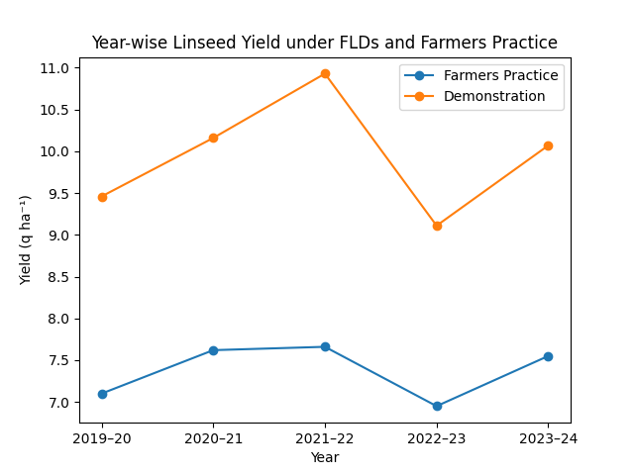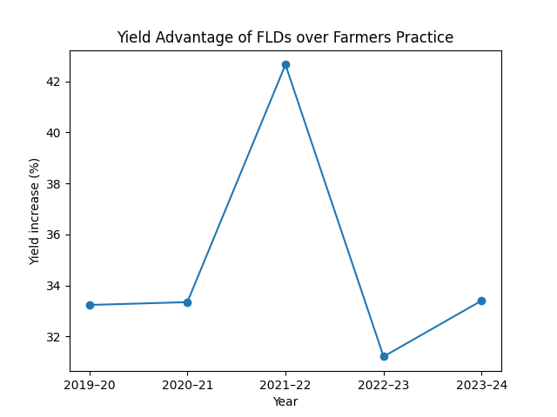

3.2 Yield Gap Analysis
The existence of yield gaps between potential yield, demonstration yield, and farmers’ yield provides valuable insights into the scope for further improvement in linseed productivity. In the present study, the yield gap between demonstration plots and farmers’ practice (extension gap) was substantial across all years, ranging from 2.16 to 3.27 q ha⁻¹. This clearly indicates the significant role of extension interventions in enhancing farmers’ yield levels.
The technology gap, defined as the difference between potential yield of the variety and the yield obtained under demonstration plots, reflects the influence of environmental factors and location-specific constraints. Although demonstration yields were considerably higher than farmers’ yields, they were still lower than the potential yields reported under research station conditions. This suggests the need for further refinement of technologies and improved site-specific recommendations to fully exploit the yield potential of linseed in Bihar.
The technology index, which indicates the feasibility and adoptability of the demonstrated technology, was found to be within an acceptable range, suggesting good compatibility of improved linseed technologies with farmers’ conditions. Similar observations have been reported by Singh et al. (2017) and Kumar and Tripathi (2019), who emphasized that lower technology index values indicate higher feasibility of demonstrated technologies.
Fig 2 : Benefit-cost ratio of Linseed under FLDs and Farmers Practice
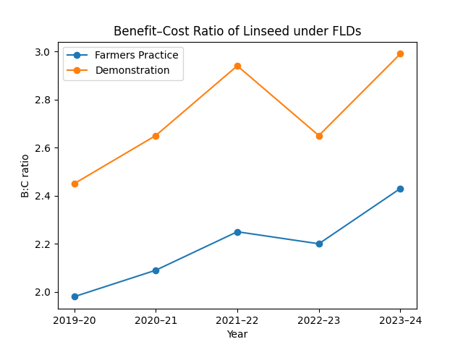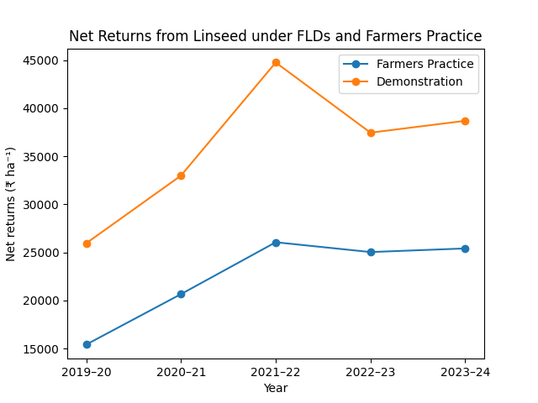

3.3 Economic Analysis of Linseed Production under FLDs
Economic viability is a critical determinant of technology adoption by farmers. The economic analysis of linseed cultivation under FLDs revealed a clear advantage of improved technology over farmers’ practice in terms of net returns and benefit–cost (B:C) ratio (Table 3). Across all years, demonstration plots recorded higher net returns and B:C ratios compared to farmers’ practice, indicating better profitability of improved linseed production technologies.
During 2019–20, the B:C ratio under improved technology was 2.45 compared to 1.98 under farmers’ practice, with net returns of ₹25,952 ha⁻¹ and ₹15,415 ha⁻¹, respectively. This trend continued in subsequent years, with the highest B:C ratio (2.99) and net returns (₹44,764 ha⁻¹) recorded during 2021–22 under demonstration plots. The comparatively lower economic returns during 2022–23 may be attributed to reduced yields and increased input costs.

Table 3. Economics of linseed cultivation under improved technology and farmers’ practice
Year | B:C ratio  (FP) | B:C ratio  (IT) | Net return FP (₹ ha⁻¹) | Net return IT (₹ ha⁻¹)
2019–20 | 1.98 | 2.45 | 15,415 | 25,952
2020–21 | 2.09 | 2.65 | 20,662 | 32,993
2021–22 | 2.25 | 2.94 | 26,061 | 44,764
2022–23 | 2.20 | 2.65 | 25,040 | 37,460
2023–24 | 2.43 | 2.99 | 25,416 | 38,695
Mean | 2.19 | 2.74 | 22,519 | 35,973

The pooled analysis showed that improved technology resulted in an average net return of ₹35,973 ha⁻¹ compared to ₹22,519 ha⁻¹ under farmers’ practice, reflecting an additional income of ₹13,454 ha⁻¹. The higher profitability under FLDs can be attributed to increased yields and more efficient use of inputs. These results are in agreement with earlier studies reporting higher economic returns from linseed cultivation under improved production technologies (Singh et al., 2017; FAO, 2020).

3.4 Impact of Individual Technological Interventions
The yield and economic gains observed under FLDs were the cumulative effect of multiple technological interventions. The use of high-yielding varieties played a pivotal role in enhancing productivity by ensuring better genetic potential and tolerance to biotic and abiotic stresses. Seed treatment improved germination and early seedling vigor, leading to better crop establishment. Line sowing facilitated uniform plant population and efficient intercultural operations, particularly weed management.
Balanced fertilization ensured adequate nutrient availability throughout the crop growth period, while timely weeding and integrated pest management minimized yield losses due to weeds and pests. Similar findings have been reported by Kumar and Tripathi (2019), who highlighted the synergistic effects of integrated crop management practices on linseed productivity.

3.5 Adoption and Extension Implications
The positive results of linseed FLDs had a significant influence on farmers’ perceptions and adoption behavior. Interaction with demonstration farmers and neighboring farmers revealed increased awareness and willingness to adopt improved linseed production technologies. The visible yield and economic benefits served as a powerful motivation for farmers to replace traditional practices with improved ones.
KVKs played a crucial role in facilitating technology transfer through training programs, field days, and regular monitoring. The participatory nature of FLDs helped build farmers’ confidence and enhanced the credibility of extension recommendations. Earlier studies have also emphasized the effectiveness of FLDs as an extension tool for accelerating technology adoption in oilseed crops (Meena and Singh, 2020; ICAR, 2018).

3.6 Discussion in the Context of Eastern Indo-Gangetic Plains
The findings of the present study are particularly relevant to the Eastern Indo-Gangetic Plains, where linseed is predominantly grown under marginal and rainfed conditions. The demonstrated yield gains and economic benefits indicate that improved linseed technologies can significantly enhance productivity and profitability even under resource-constrained environments. The results are consistent with regional studies conducted in eastern India, which reported substantial yield improvements through FLDs in oilseed crops (Singh et al., 2017; Kumar and Tripathi, 2019).
The variability in yield across years underscores the influence of climatic factors, particularly rainfall distribution and temperature, on linseed performance. This highlights the need for climate-resilient varieties and adaptive management practices to ensure stable yields under changing climatic conditions.

3.7 Overall Impact of FLDs on Linseed Production in Bihar
Overall, the linseed FLDs conducted by KVKs under the guidance of ATARI, Patna, had a significant positive impact on productivity, profitability, and technology dissemination. The consistent yield advantage, improved economic returns, and enhanced farmer awareness demonstrate the effectiveness of FLDs in bridging the yield gap and promoting sustainable linseed production in Bihar.

The study reinforces the importance of strengthening FLD programs, ensuring timely supply of quality inputs, and providing continuous technical backstopping to farmers. Scaling up successful FLD interventions can contribute substantially to enhancing linseed production, improving farmers’ income, and supporting oilseed self-sufficiency in the state.

4. Conclusion and Policy Implications

4.1 Conclusion
The present study comprehensively assessed the productivity and economic performance of linseed (Linum usitatissimum L.) under frontline demonstrations (FLDs) conducted by Krishi Vigyan Kendras (KVKs) across different districts of Bihar during five consecutive rabi seasons from 2019–20 to 2023–24, under the technical guidance and support of ATARI, Patna. The findings clearly demonstrate that the adoption of improved linseed production technologies significantly enhanced crop yield and profitability compared to the prevailing farmers’ practices.
Across all years of study, linseed cultivated under improved technology consistently outperformed farmers’ practice, registering an average yield advantage of about 35%. The higher productivity recorded in demonstration plots can be attributed to the integrated effect of high-yielding varieties, seed treatment, line sowing, balanced fertilization, timely weed management, and need-based plant protection measures. The year-wise consistency in yield improvement underlines the robustness and adaptability of the demonstrated technologies under diverse agro-ecological and socio-economic conditions prevailing in Bihar.
The economic analysis further confirmed the superiority of improved linseed technologies, as reflected by higher net returns and benefit–cost (B:C) ratios in FLD plots. On a pooled basis, demonstration plots generated substantially higher net income compared to farmers’ practice, indicating that the additional cost incurred on quality inputs and scientific management was economically justified. The favorable B:C ratios observed under FLDs signify that linseed cultivation using improved technologies is a financially viable and attractive option for small and marginal farmers of the state.
The existence of a considerable extension gap between demonstration yield and farmers’ yield highlights the critical role of extension interventions in bridging yield gaps. Although demonstration yields were lower than the potential yields reported under experimental conditions, the relatively low technology index suggests good feasibility and acceptability of the demonstrated technologies under farmers’ field situations. This underscores the effectiveness of FLDs as a practical tool for technology assessment, refinement, and dissemination.
Overall, the study validates the pivotal role of KVK-led FLDs in enhancing linseed productivity, improving farm profitability, and strengthening farmers’ confidence in improved agricultural technologies. The results clearly indicate that systematic promotion of scientific linseed production practices through FLDs can contribute significantly to oilseed production, income diversification, and livelihood security in Bihar, particularly in rainfed and resource-constrained environments.

4.2 Policy Implications
The findings of the present investigation have important policy implications for strengthening linseed production and extension strategies in Bihar and similar agro-ecological regions of eastern India. First, the consistent yield and economic advantages observed under FLDs emphasize the need to further scale up frontline demonstration programs on linseed through KVKs. Increased allocation of resources for FLDs, including quality seed distribution, critical inputs, and technical backstopping, would accelerate the adoption of improved linseed technologies at the grassroots level.
Second, availability and timely supply of quality seeds of improved linseed varieties emerged as a key factor influencing productivity gains. Policy initiatives should focus on strengthening the seed production and distribution system by involving public sector agencies, KVKs, and farmer producer organizations (FPOs). Encouraging community-based seed production and seed villages for linseed can help ensure local availability of quality seed at affordable prices, thereby reducing farmers’ dependence on local or obsolete varieties.
Third, capacity building and skill development of farmers through need-based training programs, field days, and exposure visits should be given high priority. The participatory approach adopted under FLDs, wherein farmers directly observe and evaluate improved technologies, has proven effective in enhancing awareness and adoption. Policymakers should support regular training and extension activities aimed at promoting integrated crop management practices, including balanced nutrient management, integrated pest management, and climate-resilient agronomic practices.
Fourth, considering the vulnerability of linseed cultivation to climatic variability, particularly under rainfed conditions, there is a need to promote climate-resilient varieties and adaptive management strategies. Research and extension programs should focus on developing and disseminating stress-tolerant linseed varieties and location-specific production recommendations to mitigate the adverse effects of moisture stress and temperature fluctuations.
Fifth, economic incentives and supportive policies can play a crucial role in encouraging farmers to adopt improved linseed technologies. Inclusion of linseed under government-supported schemes such as input subsidies, minimum support price mechanisms, crop insurance, and promotion of oilseed-based cropping systems would enhance farmers’ confidence and reduce production risks. Linking linseed growers with organized markets, value chains, and processing units can further improve price realization and farm income.
Finally, the study highlights the importance of strengthening the institutional synergy between research organizations, extension agencies, and policymakers. ATARI, KVKs, and state line departments should work in close coordination to ensure effective planning, implementation, monitoring, and impact assessment of FLDs. Feedback generated from FLDs should be systematically used for refining technologies and shaping future research and extension priorities.
In conclusion, scaling up scientifically validated linseed production technologies through a strong FLD-based extension framework, supported by appropriate policy interventions, can significantly enhance linseed productivity, profitability, and sustainability in Bihar. Such efforts would not only contribute to oilseed self-sufficiency but also support inclusive agricultural growth and livelihood improvement of small and marginal farmers in the region.

References:
ATARI Patna. (2019–2024). Annual FLD Reports. ICAR–Agricultural Technology Application Research Institute, Patna.
Brady, N.C. and Weil, R.R. (2017). The Nature and Properties of Soils. Pearson India.
Choudhary, A. K., Yadav, D. S., & Singh, A. (2014). Technological and extension yield gaps in oilseeds in India. Indian Journal of Agricultural Sciences, 84(6), 678–683.
Directorate of Economics and Statistics (2021). Agricultural Statistics at a Glance. Ministry of Agriculture and Farmers’ Welfare, Government of India.
FAO (2020). FAOSTAT Statistical Database. Food and Agriculture Organization of the United Nations, Rome.
ICAR (2018). Frontline Demonstrations: Guidelines and Impact. Indian Council of Agricultural Research, New Delhi.
ICAR (2019). Guidelines for Frontline Demonstrations. Indian Council of Agricultural Research, New Delhi.
Kumar, S., & Tripathi, R. S. (2019). Yield gaps and constraints in linseed cultivation in eastern India. Journal of Oilseeds Research, 36(2), 85–90.
Kumar, S., Singh, R., & Meena, M. L. (2019). Impact of frontline demonstrations on productivity and profitability of oilseed crops. Journal of Oilseeds Research, 36(2), 123–129.
Lal, R. (2015). Soil and crop management in India. Agriculture Systems, 132, 1–12.
Meena, B. S., & Singh, D. (2020). Role of KVKs in technology dissemination through frontline demonstrations. Agricultural Extension Review, 32(1), 12–18.
Samui, S. K., Maitra, S., Roy, D. K., Mondal, A. K., & Saha, D. (2000). Evaluation of frontline demonstration on groundnut. Journal of the Indian Society of Coastal Agricultural Research, 18(2), 180–183.
Singh, P., Sharma, R., & Verma, A. (2017). Productivity and profitability of linseed under improved production technologies. Indian Journal of Agronomy, 62(4), 456–461.
Singh, R.K., et al. (2020). Impact of frontline demonstrations on oilseed crop productivity. Journal of Oilseed Research, 37(2), 145–150.

