Original Research Article
System productivity, profitability and nutrient balance in maize – toria cropping sequence as influenced by integrated nutrient management practices

ABSTRACT

An experiment was conducted to find out suitable integrated nutrient management (INM) practices in maize with respect to system productivity, profitability and nutrient balance in maize- toria cropping sequence in Eastern Ghat High Land zone of Odisha during kharif and rabi season of 2016-17 and 2017-18. The experiment was conducted at Regional Research and Technology Transfer Station (OUAT), Semiliguda, Koraput, Odisha, India. It consisted of twelve treatments viz. T1- Soil test based fertilizer recommendation (STBFR); T2 - STBFR + Green manure (GM) with cowpea; T3 - STBFR + FYM @ 5 t ha⁻¹; T4 - STBFR + Lime @ 0.1 LR; T5 - STBFR + Sulphur @ 30 kg ha⁻¹; T6 - STBFR + Biofertilizer (Azotobacter + Azospirillum + PSB @ 4 kg ha⁻¹ each); T7 - STBFR + GM with cowpea + FYM @ 5 t ha⁻¹; T8 - STBFR + GM with cowpea + Lime @ 0.1 LR; T9 - STBFR + FYM @ 5 t ha⁻¹ + Lime @ 0.1 LR; T10 - STBFR + GM with cowpea + FYM @ 5 t ha⁻¹ + Lime @ 0.1 LR; T11 - STBFR + GM with cowpea + FYM @ 5 t ha⁻¹ + Sulphur @ 30 kg ha⁻¹ and T12 - STBFR + GM with cowpea + FYM @ 5 t ha⁻¹ + Biofertilizer (Azotobacter + Azospirillum + PSB @ 4 kg ha⁻¹ each) in randomized complete block design with three replications. Results showed that application of STBFR + GM with cowpea + FYM @ 5 t ha⁻¹ + Biofertilizer (Azotobacter + Azospirillum + PSB @ 4 kg ha⁻¹ each) in maize resulted in significantly higher system productivity (9.14 t ha⁻¹) of maize- toria cropping system expressed as maize equivalent yield along with highest net return (INR 57863 ha⁻¹) and B: C ratio (1.83). Post-harvest soil fertility showed improvement in available nitrogen, phosphorus, and potassium balance with the application of STBFR + GM with cowpea + FYM @ 5 t ha⁻¹ + Biofertilizer (Azotobacter + Azospirillum + PSB @ 4 kg ha⁻¹) as compared to others INM practices. Thus, integrating fertilizers as STBFR and green manure with cowpea + FYM @ 5 t ha⁻¹ + Biofertilizer (Azotobacter + Azospirillum + PSB @ 4 kg ha⁻¹) is not only efficient with respect to system productivity and profitability of maize- toria cropping sequence but also sustainable for soil health in experimental region.

Keywords: Maize, toria, INM, biofertilizers, productivity, nutrient balance

1. INTRODUCTION

Maize (Zea mays L.), frequently called as queen of cereals for its high genetic yield potential and has ability to adapt to a wide range of agro-climatic conditions. The total area under maize in India is about 120.91 lakh ha with production of 434.09 lakh tonnes and in Odisha, maize is cultivated in an area of 0.86 lakh ha with production and productivity of 2.65 lakh tonnes and 3071 kg ha⁻¹, respectively during 2024-25 (UPAg-DAFW, 2025). Toria (Brassica campestris var. toria) is a short duration crop cultivated mainly in Assam, Bihar, Odisha and West Bengal as a winter crop under residual moisture and nutrients (Gupta et al., 2014; Ray et al., 2022). Toria is an important oilseed crop of Odisha after harvest of kharif paddy. In Odisha, rapeseed-mustard is grown in an area of 0.17 lakh ha that produced 0.06 lakh tonnes with a productivity of 342 kg ha⁻¹ which is much below the national average of 1463 kg ha⁻¹ during 2024-25 (UPAg-DAFW, 2025). In Odisha, maize- toria cropping sequence could be a better option as maize has higher yield potential and greater drought tolerance than rice during the kharif season, and toria can be adopted as a succession crop due to its high value, short duration and ability to grow under residual soil fertility with minimal soil moisture (Biswasi et al., 2025). The exploitation of nutrients from the soil due to increasing food demand limits crop production. However, integrated nutrient management is the most important nutrient resources for increasing income and sustainability in crop production system. India has made tremendous progress in the production and consumption of fertilizers in the last four decades. But the use of chemical fertilizers will prove to be a major obstacle in increasing agricultural production in the future (Bavalgave et al., 2020). Highest productivity of crops in a sustainable manner without harming the soil and other natural resources can be achieved only by using appropriate combination of various organic manures and inorganic fertilizers (Chandrashekara et al., 2000; Sarathkumar et al., 2021). Use of organic manures like green manure, FYM and biofertilizers are necessary for improving the soil fertility and productivity besides reducing the expenditure on chemical fertilizers. Hence, present investigation was conducted to find out the effect of integrated nutrient management practices in maize on productivity, profitability and nutrient balance of maize- toria cropping sequence in Eastern Ghat High Land zone of Odisha.

2. MATERIALS AND METHODS

The experiment was conducted at the Regional Research and Technology Transfer Station (OUAT), Semiliguda, Koraput, Odisha during kharif and rabi seasons of 2016-17 and 2017-18. The experimental site is situated at 18°42' N latitude and 82°30'E longitude with an altitude of 884.0 m above the mean sea level. It comes under Eastern Ghat High Land zone of Odisha. The soil of experimental site was red, sandy loam in texture and strongly acidic in reaction (pH- 5.06) with medium soil organic carbon (7.13 g kg⁻¹), medium available nitrogen (472.0 kg ha⁻¹), high available phosphorus (33.2 kg ha⁻¹), high available potassium (313.0 kg ha⁻¹) and low available sulphur (11.45 kg ha⁻¹). Different weather data during experimentation are presented in Fig. 1 and 2. The experiment consists of twelve treatments viz. T1- Soil test based fertilizer recommendation (STBFR); T2 - STBFR + Green manure (GM) with cowpea; T3 - STBFR + FYM @ 5 t ha⁻¹; T4 - STBFR + Lime @ 0.1 LR; T5 - STBFR + Sulphur @ 30 kg ha⁻¹; T6 - STBFR + Biofertilizer (Azotobacter + Azospirillum + PSB @ 4 kg ha⁻¹ each); T7 - STBFR + GM with cowpea + FYM @ 5 t ha⁻¹; T8 - STBFR + GM with cowpea + Lime @ 0.1 LR; T9 - STBFR + FYM @ 5 t ha⁻¹ + Lime @ 0.1 LR; T10 - STBFR + GM with cowpea + FYM @ 5 t ha⁻¹ + Lime @ 0.1 LR; T11 - STBFR + GM with cowpea + FYM @ 5 t ha⁻¹ + Sulphur @ 30 kg ha⁻¹ and T12 - STBFR + GM with cowpea + FYM @ 5 t ha⁻¹ + Biofertilizer (Azotobacter + Azospirillum + PSB @ 4 kg ha⁻¹ each). The experiment was conducted in randomized complete block design with three replications. In maize crop FYM @ 5 t ha⁻¹ was applied at the time of last ploughing as per the treatment. Soil test based fertilizer, lime as CaCO₃ @ 580 kg ha⁻¹, sulphur @ 30 kg ha⁻¹, biofertilisers (Azotobacter + Azospirillum + PSB @ 4 kg ha⁻¹ each) were applied to the crop as per the treatments. Full dose of P, K and 25% N in form of DAP, MOP and urea were applied as basal and rest 50% and 25% N were applied to the maize crop at first and second earthing up, respectively. Maize hybrid variety Kaveri was sown with a spacing of 60 cm x 30 cm and seed rate of 15 kg ha⁻¹ in kharif season. In the plots with green manure, cowpea was sown between two rows of maize and incorporated cowpea as green leaf manure after harvesting of green pods. Toria (var. Anuradha) was sown in the same plot with a row spacing of 30 cm using a seed rate of 7.5 kg ha⁻¹ after harvest of maize in residual soil fertility and residual soil moisture in rabi season. Plant to plant spacing of 10 cm was maintained by thinning operation at 21 days after sowing. For system yield of maize- toria cropping sequence, the maize equivalent yield was calculated by addition of yield of maize and the maize equivalent yield with respect to toria. Economic parameters such as gross return, net return and benefit cost ratio were calculated by considering all inputs and outputs as per local situation. The nutrient balance sheet was worked out as follows:
Expected nutrient balance= (Initial nutrient status of soil + Nutrient added by treatment) – Nutrient uptake by crop
Apparent gain/ loss= Actual nutrient balance (i.e. available nutrient status of soil after harvest) - Expected nutrient balance
Actual gain/ loss= Actual nutrient balance – Initial nutrient status of soil
Data on maize equivalent yield was statistically analyzed following the standard procedure for randomized complete block design (Gomez and Gomez, 1984). Further significant differences between the treatments were compared with the critical difference at ±5% probability level.

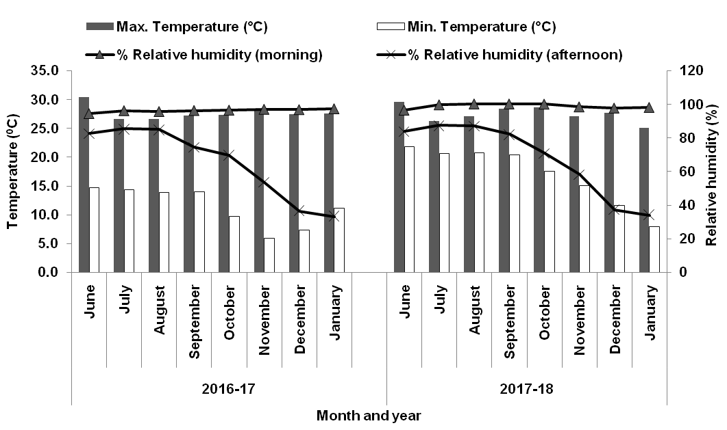
Fig. 1. Monthly mean temperature and mean relative humidity during cropping period
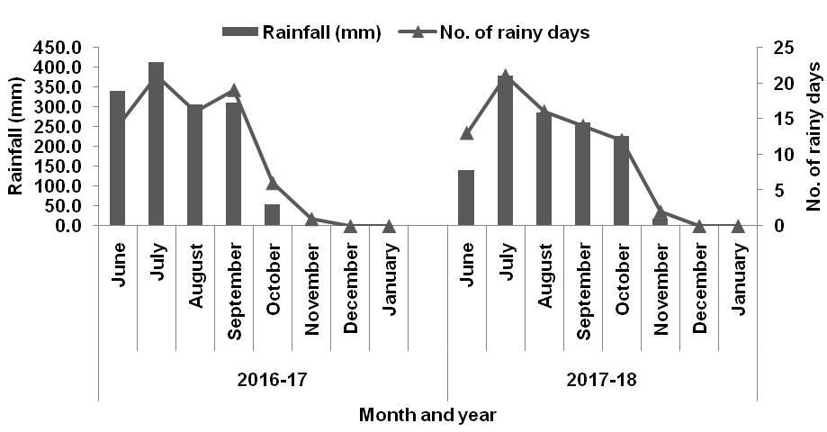
Fig. 2. Monthly total rainfall and number of rainy days during cropping period

3. RESULTS AND DISCUSSION

3.1 System productivity and profitability

Irrespective of years and pooled analysis, system productivity of maize-toria cropping system expressed as maize equivalent yield (MEY) was significantly influenced by integrated nutrient management in maize (Table 1). Highest MEY of 9.04 and 9.23 t ha⁻¹ obtained with the application of treatment T12 (STBFR + Green manure + FYM @ 5 t ha⁻¹ + Biofertilizers (Azotobacter + Azospirillum + PSB @ 4 kg ha⁻¹ each) followed by 8.55 and 8.70 t ha⁻¹ with treatment T11 (STBFR + Green manure + FYM @ 5 t ha⁻¹ + Sulphur @ 30 kg ha⁻¹) during 1st and 2nd year, respectively. Based on pooled analysis, significantly highest MEY obtained with T12 (9.14 t ha⁻¹) followed by T11 (8.63 t ha⁻¹) and T1 (STBFR) recorded lowest MEY (6.25 t ha⁻¹). This might be due the fact that efficiency of inorganic fertilizers increased when these were used in conjunction with organic manures. The organic sources enhanced the efficient utilization of the native as well as added fertilizer nutrients, which maintained balance between growth and yield attributes. Higher productivity was recorded with inorganic fertilizers in combination with FYM or green manure might be because of greater availability and uptake of all nutrients (Sumon et al., 2018; Sharma et al., 2018; Mangaraj et al., 2022). The economics of the cropping system (maize- toria) with respect to gross return, net return and B: C ratio were calculated for both the years of study and mean data of both years presented in Table 1. Among the different integrated nutrient management practices highest gross return (INR 127896 ha⁻¹), net return (Rs. 57863 ha⁻¹) and B: C ratio (1.83) of maize- toria cropping sequence were obtained when maize crop was cultivated with STBFR + Green manure with cowpea + FYM @ 5 t ha⁻¹ + Biofertilizers (Azotobacter + Azospirillum + PSB @ 4 kg ha⁻¹ each) i.e. T12. Higher gross return, net returns and B: C ratio might be due to higher system productivity. Some others study opined that the highest economic return registered with application of various organic sources of nutrient in combinations instead of their application alone (Jat et al., 2023; Biswasi et al., 2025).

Table 1. Effect of integrated nutrient management in maize on maize equivalent yield and system economics (mean data of two years) of maize-toria cropping system
Treatment | Maize Equivalent Yield  (t ha⁻¹) |  |  | Gross return  (INR ha⁻¹) | Net return (INR ha⁻¹) | B:C ratio
Treatment | 2016-17 | 2017-18 | Pooled | Gross return  (INR ha⁻¹) | Net return (INR ha⁻¹) | B:C ratio
T1- STBFR | 6.17 | 6.33 | 6.25 | 87494 | 26476 | 1.43
T2- STBFR + GM | 6.98 | 7.13 | 7.05 | 98761 | 35578 | 1.56
T3- STBFR + FYM | 7.27 | 7.44 | 7.36 | 102985 | 36967 | 1.56
T4- STBFR + Lime | 7.20 | 7.37 | 7.28 | 101948 | 38900 | 1.62
T5- STBFR + S | 6.83 | 6.98 | 6.91 | 96692 | 33524 | 1.53
T6- STBFR + BF | 7.11 | 7.21 | 7.16 | 100274 | 37406 | 1.59
T7- STBFR + GM + FYM | 7.81 | 7.93 | 7.87 | 110231 | 42048 | 1.62
T8- STBFR + GM + Lime | 8.07 | 8.15 | 8.11 | 113510 | 48297 | 1.74
T9- STBFR + FYM + Lime | 7.97 | 8.12 | 8.04 | 112628 | 44580 | 1.66
T10- STBFR + GM + FYM + Lime | 8.48 | 8.65 | 8.56 | 119861 | 49648 | 1.71
T11- STBFR + GM + FYM + S | 8.55 | 8.70 | 8.63 | 120779 | 50446 | 1.72
T12- STBFR + GM + FYM + BF | 9.04 | 9.23 | 9.14 | 127896 | 57863 | 1.83
SEm (±) | 0.46 | 0.45 | 0.46 | - | - | -
CD (0.05) | 1.37 | 1.32 | 1.28 | - | - | -
STBFR- Soil test based fertilizer recommendation, GM- Green manure with cowpea, FYM- Farm yard manure @ 5 tha⁻¹, Lime- Lime @ 0.1 LR, S- Sulphur @ 30 kg ha⁻¹, BF– Biofertilizer (Azotobacter + Azospirillum + PSB @ 4 kg ha⁻¹ each)

3.2 NPK balance
The addition of N through treatments was higher than its removal by crops in all cases except T8 (STBFR + Green manure wiith cowpea + Lime @ 0.1 LR). In T8, crop removal of N was higher than its application. Total highest N uptake (174.1 kg ha⁻¹) in the maize- toria cropping system was obtained from T12 i.e. STBFR + Green manure with cowpea + FYM @ 5 t ha⁻¹ + Biofertilizers (Azotobacter + Azospirillum + PSB @ 4 kg ha⁻¹ each) along with increased available N (546.0 kg ha⁻¹) in soil after two years (Table 2). Except T8, treatments having FYM gave positive apparent N balance and highest of 67.6 kg ha⁻¹ was observed with T12. Similarly application of FYM in maize resulted in gain in actual balance of N after two years of maize- toria cropping sequence and highest gain (74.0 kg ha¹) was observed with treatment T12 (Table 2). This could mean that, the earlier crop demand for nitrogen was met from the inorganic sources and later demand fulfilled with mineralized nitrogen from the organic sources and enhanced the soil N status (Senthivelu and Prabha, 2007). FYM treatment may increase nitrogen availability because of better biological activities, nitrogen mineralization and reduction in leaching loss (Senthivelu and Prabha, 2007; Choudhary et al., 2021). The phosphorus uptake in the maize- toria cropping system was found to be highest (37.5 kg ha⁻¹) in treatment T12 with highest available P in soil (44.5 kg ha⁻¹) after two years of study (Table 3). Among the different integrated nutrient management practices, application of STBFR + Green manure + FYM @ 5 t ha⁻¹ + Biofertilizer (Azotobacter + Azospirillum + PSB @ 4 kg ha⁻¹ each) i.e. T12 had more apparent gain of soil phosphorus (15.6 kg ha⁻¹) after two years of maize- toria cropping sequence. Similarly, net gain was also higher (11.3 kg ha⁻¹) with this treatment. This might be due the fact that application of fertilizer along with organic source of nutrients reduced actual phosphorus loss in soil (Ananthi and Shree, 2025) and application of PSB can enhance phosphorus availability to crop plants through mineralization of organic phosphorus (Morya et al., 2024).

Table 2. Effect of integrated nutrient management on balance sheet of available nitrogen (kg ha⁻¹) in soil after two years of experimentation
Treatments | Initial soil N status | Nutrient added through treatments | Nutrient uptake | Expected nutrient balance  (a+b)-c | Actual nutrient balance | Apparent gain/ loss  e-d | Actual gain/ loss e-a
Treatments | a | b | c | d | e | f | g
T1- STBFR | 472.0 | 150.0 | 125.1 | 496.9 | 448.0 | -48.9 | -24.0
T2- STBFR + GM | 472.0 | 150.0 | 135.7 | 486.3 | 461.0 | -25.3 | -11.0
T3- STBFR + FYM | 472.0 | 180.5 | 140.9 | 511.6 | 513.0 | 1.4 | 41.0
T4- STBFR + Lime | 472.0 | 150.0 | 142.0 | 480.0 | 455.0 | -25.0 | -17.0
T5- STBFR + S | 472.0 | 150.0 | 130.6 | 491.4 | 450.0 | -41.4 | -22.0
T6- STBFR + BF | 472.0 | 150.0 | 137.7 | 484.3 | 458.0 | -26.3 | -14.0
T7- STBFR + GM + FYM | 472.0 | 180.5 | 149.2 | 503.3 | 534.0 | 30.7 | 62.0
T8- STBFR + GM + Lime | 472.0 | 150.0 | 154.7 | 467.3 | 468.0 | 0.7 | -4.0
T9- STBFR + FYM + Lime | 472.0 | 180.5 | 153.1 | 499.4 | 517.0 | 17.6 | 45.0
T10- STBFR + GM + FYM + Lime | 472.0 | 180.5 | 161.7 | 490.8 | 528.0 | 37.2 | 56.0
T11- STBFR + GM + FYM + S | 472.0 | 180.5 | 165.9 | 486.6 | 521.0 | 34.4 | 49.0
T12- STBFR + GM + FYM + BF | 472.0 | 180.5 | 174.1 | 478.4 | 546.0 | 67.6 | 74.0
STBFR- Soil test based fertilizer recommendation, GM- Green manure with cowpea, FYM- Farm yard manure @ 5 tha⁻¹, Lime- Lime @ 0.1 LR, S- Sulphur @ 30 kg ha⁻¹, BF– Biofertilizer (Azotobacter + Azospirillum + PSB @ 4 kg ha⁻¹ each)

Table 3. Effect of integrated nutrient management on balance sheet of available phosphorus (kg ha⁻¹) in soil after two years of experimentation
Treatments | Initial soil phosphorus (P₂O₅) status | Nutrient added through treatments | Nutrient uptake | Expected nutrient balance  (a+b)-c | Actual nutrient balance | Apparent gain/ loss  e-d | Actual gain/ loss e-a
Treatments | a | b | c | d | e | f | g
T1- STBFR | 33.2 | 24.4 | 19.8 | 37.8 | 28.7 | -9.1 | -4.5
T2- STBFR + GM | 33.2 | 24.4 | 22.7 | 34.9 | 34.6 | -0.3 | 1.4
T3- STBFR + FYM | 33.2 | 33.2 | 24.8 | 41.6 | 40.0 | -1.6 | 6.8
T4- STBFR + Lime | 33.2 | 24.4 | 25.9 | 31.7 | 31.1 | -0.6 | -2.1
T5- STBFR + S | 33.2 | 24.4 | 21.5 | 36.1 | 30.8 | -5.3 | -2.4
T6- STBFR + BF | 33.2 | 24.4 | 23.4 | 34.2 | 37.5 | 3.3 | 4.3
T7- STBFR + GM + FYM | 33.2 | 33.2 | 28.6 | 37.8 | 41.8 | 4.0 | 8.6
T8- STBFR + GM + Lime | 33.2 | 24.4 | 30.9 | 26.7 | 31.6 | 4.9 | -1.6
T9- STBFR + FYM + Lime | 33.2 | 33.2 | 30.2 | 36.2 | 41.2 | 5.0 | 8.0
T10- STBFR + GM + FYM + Lime | 33.2 | 33.2 | 32.8 | 33.6 | 42.4 | 8.8 | 9.2
T11- STBFR + GM + FYM + S | 33.2 | 33.2 | 33.8 | 32.6 | 40.2 | 7.6 | 7.0
T12- STBFR + GM + FYM + BF | 33.2 | 33.2 | 37.5 | 28.9 | 44.5 | 15.6 | 11.3
STBFR- Soil test based fertilizer recommendation, GM- Green manure with cowpea, FYM- Farm yard manure @ 5 tha⁻¹, Lime- Lime @ 0.1 LR, S- Sulphur @ 30 kg ha⁻¹, BF– Biofertilizer (Azotobacter + Azospirillum + PSB @ 4 kg ha⁻¹ each)

Positive balance for apparent potassium was observed in soil under all the treatments (Table 4). The net balance was negative with all treatments with maximum loss in sole STBFR i.e. T1. In all the nutrient doses there was a positive apparent balance of potassium in soil ranged from 25.7 kg ha⁻¹ to 110.0 kg ha^{-1.} Among the integrated nutrient management in maize, STBFR + Green manure + FYM @ 5 t ha⁻¹ + Biofertilizer (Azotobacter + Azospirillum + PSB @ 4 kg ha⁻¹ each) i.e. T12 had more apparent gain of soil potassium (110.0 kg ha⁻¹) after two years of maize- toria cropping sequence. The initial available potassium value declined from 313.0 kg ha⁻¹ to 231.0 – 282.0 kg ha⁻¹ at the end of experiment after two years of study (Table 4). The heavy drop in available potassium might be due to higher uptake of potassium through the harvest of huge plant biomass of hybrid maize followed by toria. Declining trend in available potassium from its initial value was observed in some others study as a result of continuous cropping (Khamparia et al., 2018; Rawal et al., 2022).

Table 4. Effect of integrated nutrient management on balance sheet of available potassium (kg ha⁻¹) in soil after two years of experimentation
Treatments | Initial soil potassium (K₂O) status | Nutrient added through treatments | Nutrient uptake | Expected nutrient balance  (a+b)-c | Actual nutrient balance | Apparent gain/ loss  e-d | Actual gain/ loss e-a
Treatments | a | b | c | d | e | f | g
T1- STBFR | 313.0 | 46.7 | 154.4 | 205.3 | 231.0 | 25.7 | -82.0
T2- STBFR + GM | 313.0 | 46.7 | 169.6 | 190.1 | 258.0 | 67.9 | -55.0
T3- STBFR + FYM | 313.0 | 69.7 | 177.2 | 205.5 | 278.0 | 72.5 | -35.0
T4- STBFR + Lime | 313.0 | 46.7 | 178.4 | 181.3 | 241.0 | 59.7 | -72.0
T5- STBFR + S | 313.0 | 46.7 | 165.4 | 194.3 | 237.0 | 42.7 | -76.0
T6- STBFR + BF | 313.0 | 46.7 | 171.9 | 187.8 | 260.0 | 72.2 | -53.0
T7- STBFR + GM + FYM | 313.0 | 69.7 | 189.6 | 193.1 | 270.0 | 76.9 | -43.0
T8- STBFR + GM + Lime | 313.0 | 46.7 | 195.4 | 164.3 | 240.0 | 75.7 | -73.0
T9- STBFR + FYM + Lime | 313.0 | 69.7 | 194.0 | 188.7 | 265.0 | 76.3 | -48.0
T10- STBFR + GM + FYM + Lime | 313.0 | 69.7 | 201.6 | 181.1 | 273.0 | 91.9 | -40.0
T11- STBFR + GM + FYM + S | 313.0 | 69.7 | 204.2 | 178.5 | 267.0 | 88.5 | -46.0
T12- STBFR + GM + FYM + BF | 313.0 | 69.7 | 210.7 | 172.0 | 282.0 | 110.0 | -31.0
STBFR- Soil test based fertilizer recommendation, GM- Green manure with cowpea, FYM- Farm yard manure @ 5 tha⁻¹, Lime- Lime @ 0.1 LR, S- Sulphur @ 30 kg ha⁻¹, BF– Biofertilizer (Azotobacter + Azospirillum + PSB @ 4 kg ha⁻¹ each)

4. CONCLUSION
System productivity of maize- toria cropping system expressed as maize equivalent yield was recorded highest (9.14 tha⁻¹) with the application of soil test based fertilizer recommendation with green manure (cowpea), FYM @ 5 t ha⁻¹ and biofertilizers (Azotobacter + Azospirillum + PSB @ 4 kg ha⁻¹ each) in hybrid maize. Similarly, highest economic returns i.e. net return (INR 57863 ha⁻¹) and B: C ratio (1.83) was also observed with this treatment. Integrating soil test based fertilizer recommendation, green manure with cowpea, FYM @ 5 t ha⁻¹ and biofertilizer (Azotobacter + Azospirillum + PSB @ 4 kg ha⁻¹) was also sustainable with respect to soil fertility status after two years of experimentation.

REFERENCES

Ananthi, T., & Shree, J. S. (2025). Soil nutrient balance under influence of different organic manures and fertilizers in fodder maize. International Journal of Agriculture and Food Science, 7(7), 310-313. https://doi.org/10.33545/2664844X.2025.v7.i7d.522
Bavalgave, V. G., Rathod, M., Dudhat, M. S., & Tandel, B. (2021). Yield and uptake of sweet corn (Zea mays L. saccharata) as influenced by spacing and INM practices under south Gujarat condition. International Journal of Chemical Studies, 9(1), 706-708. https://doi.org/10.22271/chemi.2021.v9.i1j.11309
Biswasi, S. K., Tripathy, S., Sahoo, S. K., Sahoo, K. C., Dalei, B., Nayak, L., et al. (2025). Effect of integrated nutrient management on kharif hybrid maize, its residual effect on toria and system profitability of maize-toria cropping sequence in Odisha. International Journal of Research in Agronomy, 8(4), 26-29. https://www.doi.org/10.33545/2618060X.2025.v8.i4a.2735
Chandrashekara, C. P., Harlapur, S. I., Muralikrishna, S., & Girijesh, G. K. (2000). Response of maize to organic manure with inorganic fertilizers. Karnataka Journal of Agricultural Sciences, 13, 144-146.
Choudhary, M., Meena, V. S., Panday, S. C., Mondal, T., Yadav, R. P., Mishra, P. K., et al. (2021). Long-term effects of organic manure and inorganic fertilization on biological soil quality indicators of soybean-wheat rotation in the Indian mid-Himalaya. Applied Soil Ecology, 157. https://doi.org/10.1016/j.apsoil.2020.103754
Gomez, K. A., & Gomez, A. A. (1984). Statistical procedures for agricultural research. John Wiley & Sons. https://www.wiley.com/en-us/Statistical+Procedures+for+Agricultural+Research,+2nd+Edition-p-9780471879312
Gupta, V., Sharma, A., Kumar, J., Abrol, V., Singh, B., & Singh, M. (2014). Effects of integrated nutrient management on growth and yield of maize (Zea mays L.)- gobhi sarson (Brassica napus L.) cropping system in sub-tropical region under foothills of north-west Himalayas. Bangladesh Journal of Botany, 43(2), 147-155. https://doi.org/10.3329/bjb.v43i2.21666
Jat, R. A., Jain, N. K., Yadav, R. S., Reddy, K. K., Choudhary, R. R., Zala, P. V., et al. (2023). System-based integrated nutrient management improves productivity, profitability, energy use efficiency and soil quality in peanut-wheat cropping sequence in light black soils. Sustainability, 15(2), 1361. https://doi.org/10.3390/su15021361
Khamparia, N. K., Thakur, R., & Swarkar, S. D. (2018). Effect of continuous use of inorganic fertilizers and organic manure on crop productivity, soil fertility and sustainability of soybean-wheat cropping system in a vertisol. Journal of Soils and Crops, 28(1),19-25.
Mangaraj, S., Paikaray, R. K., Maitra, S., Pradhan, S. R., Garnayak, L. M., Satapathy, M., et al. (2022). Integrated nutrient management improves the growth and yield of rice and greengram in a rice-greengram cropping system under the coastal plain agro-climatic condition. Plants, 11(1), 142. https://doi.org/10.3390/plants11010142
Morya, R., Trivedi, S. K., Yadav, S. S., Gupta, N., & Bhargava, A. (2024). Balance sheet of N and P in hybrid pearl millet (Pennisetum glaucum L.) as influenced by sources and application methods. International Journal of Research in Agronomy, 7(6S), 246-249. https://doi.org/10.33545/2618060X.2024.v7.i6Sd.890
Rawal, N., Pande, K. R., Shrestha, R., & Vista, S. P. (2022). Soil nutrient balance and soil fertility status under the influence of fertilization in maize-wheat cropping system in Nepal. Applied and Environmental Soil Science, 2022, 2607468. https://doi.org/10.1155/2022/2607468
Ray, M., Roul, P. K., Behera, B., Sahoo, K. C., Mishra, N., & Das, S. (2022). Residual effect of integrated nutrient management on growth and yield toria in north central plateau zone of Odisha. International Journal of Plant & Soil Science, 34(21), 146-154. https://doi.org/10.9734/IJPSS/2022/v34i2131251
Sarathkumar, G., Sridhar, T. V., Rao, C. S., & Rekha, M. S. (2021). Effect of combined use of organic and inorganic fertilizers on yield and uptake of nutrients in maize. The Andhra Agricultural Journal, 68(3), 384-388. https://aau.edu.in/the-andhra-agricultural-journal/archives/
Senthivelu, M., & Prabha, A. C. S. (2007). Studies on nutrient uptake, post harvest nutrient availability and nutrient balance sheet under integrated nutrient management practices in wet seeded rice. The Asian Journal of Soil Science, 2(1), 33-39.
Sharma, A. K., Singh, T., Patel, A., & Yadav, R. A. (2018). Influence of integrated nutrient management practices on scented rice (Oryza sativa L.) pertaining to Eastern Uttar Pradesh. Journal of Pharmacognosy and Phytochemistry, 7(5), 1448-1453.
Sumon, M. J. I., Roy, T. S., Haque, M. N., Ahmed, S., & Mondal, K. (2018). Growth, Yield and Proximate Composition of Aromatic Rice as Influenced by Inorganic and Organic Fertilizer Management. Notulae Scientia Biologicae, 10(2), 211-219. https://doi.org/10.15835/nsb10210260
UPAg-DAFW. (2025). Unified Portal for Agricultural Statistics, Department of Agriculture & Farmers Welfare, Ministry of Agriculture, New Delhi. https://upag.gov.in/dash-reports/allindiaapy

