Case report
Hydatid cyst of the arm: a case report

Abstract
Echinococcosis or hydatidosis is an anthropozoonosis following the development in humans and certain animals of the larva of a cestode transmitted by dogs: Echinococcus granulosus. The soft parts of the limbs represent a rare location of this parasite. We present a case of isolated primary hydatid cyst of the arm in a 63-year-old rural woman. The diagnosis is based on imaging and immunological reactions and has been confirmed by histology. Surgical excision supplemented by chemotherapy based on antiparasitic drugs allowed recovery.

Keywords : Echinococcus granulosus, muscle hydatid cyst, arm, ultrasound.

Introduction
The muscular location of the hydatid cyst is rare, even in endemic countries [1, 2]. It is an anthropozoonosis caused mainly by the accidental ingestion of the larva of Echinococcus granulosus, multilocular echinococcosis, Echinococcus vogeli, Echinococcus oligarthrus [3]. This primitive and isolated parasitosis persists as a significant public health challenge. The diagnostic path must remain simple regardless of the the imaging means available to the medical team. The aim of this work is to analyze the epidemiological, diagnostic, and therapeutic aspects of muscular hydatidosis; and to highlight the role of ultrasound in its preoperative diagnosis[4], while gradually addressing the means of diagnosis, prognosis and recommendations for therapeutic solutions which will make it possible to resolve the consequences of possible failure and to avoid recurrences.

Case Presentation
63-year-old woman, of rural origin, farmer (sheep breeding), with no notable pathological history, consults for swelling on the posterior surface of the lower third of the left arm, which has been evolving over the last 5 years without any notion of trauma or septic inoculation, gradually increasing in volume and painless. The physical examination notes a good general condition, the examination of the left upper limb finds a circumscribed mass, soft, mobile, well limited, non-adherent on both superficial and deep planes and painless, measuring 15 cm x 10 cm, the examination neurovascular is normal (figure 1).
Laboratory examination was within normal limits and an indirect hemagglutination test was negative.
Plain radiographs demonstrated soft tissue thickening without calcifications or bony abnormalities.
An ultrasound of the left arm showed a posterior, cystic, oval subcutaneous formation with hypo-echoic content reinforcing the posterior echoes with non-vascularized serpiginous content on Doppler measuring 100 x 60 x 40 mm (figure 2). Magnetic resonance imaging showed a soft tissue cystic mass on the posterolateral aspect of the left arm with close contact with the muscle without loss of separating fatty border. It is in T1 iso signal relative to the muscles, T2 hyper signal, well limited, measuring, with regular contours, surrounded by a thin wall in hypo signal and seat of a serpiginous structure in hypo signal T1 and T2 in relation to the hydatid membrane detached. This mass is enhanced at the periphery after injection of paramagnetic contrast product (figure 3).
The chest x-ray and abdominal ultrasound did not note other locations.
The patient underwent medical treatment with albendazole 400 mg twice daily preoperatively for 4 weeks. Wide total resection surgery was performed under general anesthesia without harming the cyst walls (Figure 4, Figure 5). Histological examination confirmed the diagnosis of hydatid cysts of the soft tissues. Postoperative medical treatment with albendazole was continued for 3 months. At the first year of follow-up, there was no local or visceral recurrence with a good functional and aesthetic result (figure 6).

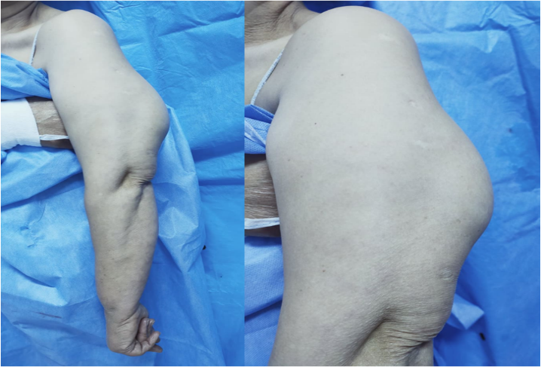
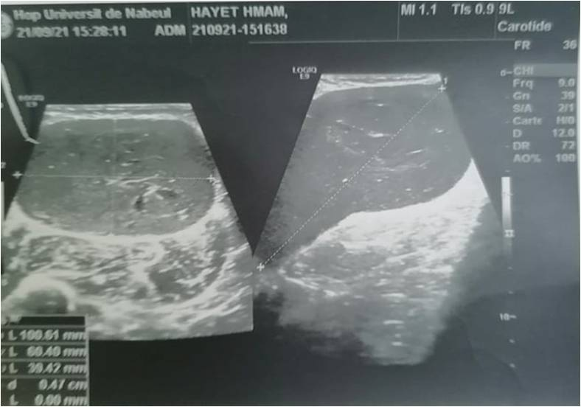Figure 2 : Ultrasound aspect

Figure 1 : clinical aspect
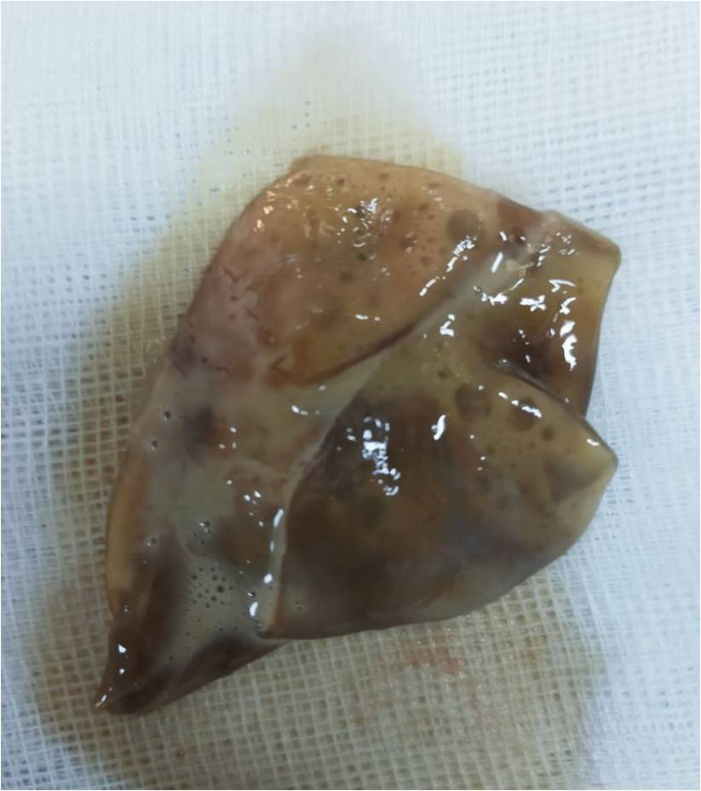
Figure 5 : Image of hydatid cyst after resection
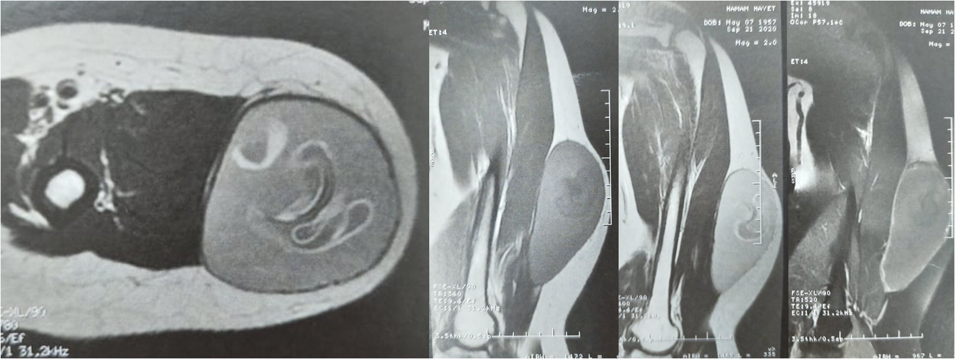
Figure 3 : MRI aspect

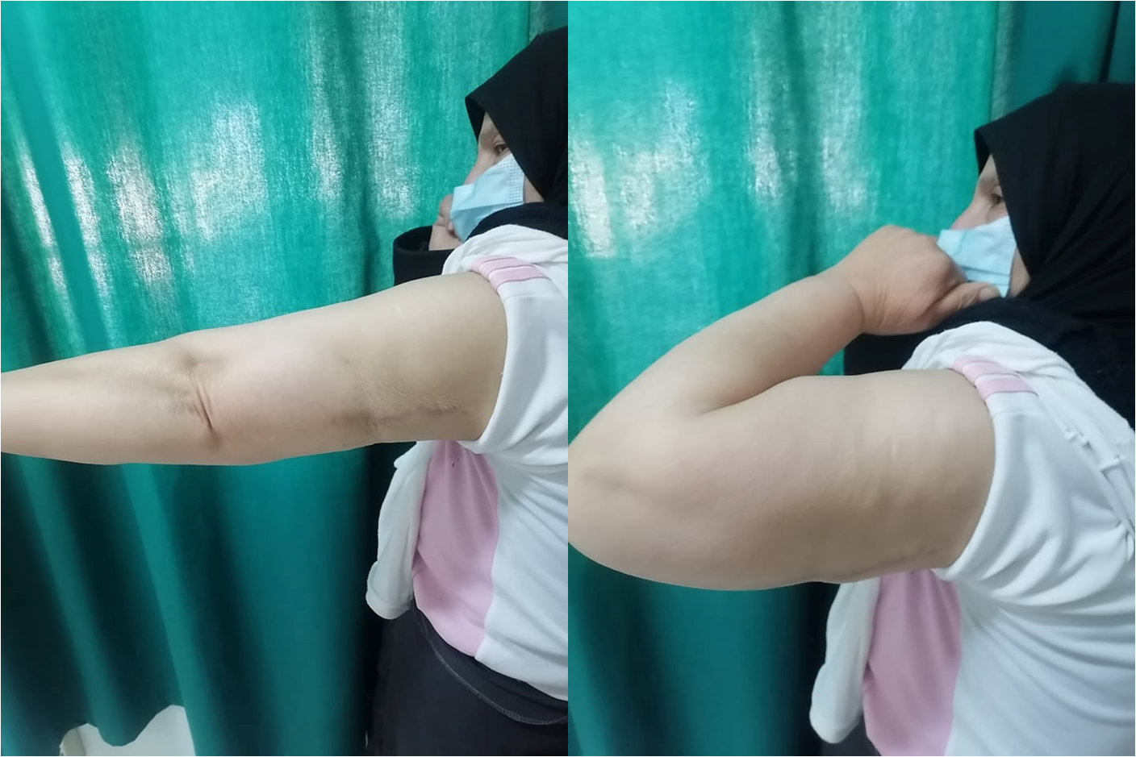 Figure 6 : functional result
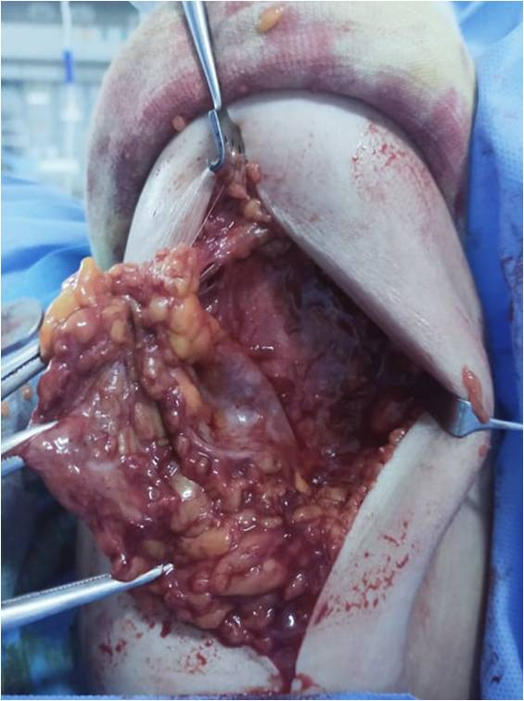
Figure 4 : Per-operative view

Discussion

The frequency of soft tissue hydatidosis is currently decreasing, despite the diffusion of efficient imaging techniques. It is currently estimated between 1 and 5.4% of all hydatid locations [5, 6, 7]. The difference in these estimates is due to the fact that old studies include muscular locations with cysts in subcutaneous cellular tissues ]8]. The muscle constitutes an environment that is not conducive to the development of the hydatid larva because of muscular contractility on the one hand and the production of lactate on the other hand [2]. Hexacanth embryos arriving in the digestive tract are most often stopped by the liver and lungs acting as real filters. A very small number of embryos enter the general circulation where they spread throughout the body. A certain number of muscle locations have been described, predominantly involving the neck, trunk and limbs, particularly the lower limb. The localization in the upper limb is very little reported in the literature, particularly at the arm level, which is exceptional and rarely reported in the literature [5,9, 10, 11, 12,13]. Furthermore, muscular hydatid disease is most often isolated primary [10], it is only associated with other hydatid locations in 8% of cases. Clinically, the symptoms of muscular hydatidosis are not specific. It is most often a soft tissue tumor, which grows very slowly, and may also suggest a cold abscess, myositis, or a calcified hematoma [14]. Sometimes, the presentation is misleading, simulating a hot abscess or a malignant soft tissue tumor, when the cyst is ruptured or superinfected. Rarely it is discovered when there are signs of nearby tissue compression. In endemic countries, rural origin and contact with dogs guide the diagnosis which must be made preoperatively. This allows both to avoid unnecessary procedures such as cyst puncture or biopsy, and enables the implementation of measures to protect the surgical field from potential hydatid dissemination, which carries the risk of anaphylactic shock, through the use of soaked fields of scolicide [10]. In this regard, the contribution of ultrasound is considerable, it must be a first-line examination [4, 15]. Generally, it is sufficient and reliable in 95% of cases [16]. CT, being a more expensive examination, should be reserved for doubtful cases following ultrasound. MRI, on the other hand, enables the diagnosis of hydatid cysts in their various evolutionary stages, particularly in the event of rupture. It also allows for a better locoregional anatomical study and a thorough analysis of the cyst wall. This wall presents a characteristic hyposignal on all sequences but more evident on T2 weighted imaging [17]. On the other hand, arteriography is of little interest, apart from the study of the relationship of the hydatid cyst with the vascular axes. However, it can be misleading by showing signs of malignancy in the event of inflammation of the pericyst [15]. Furthermore, the biological diagnosis of muscular hydatidosis is difficult [14]. Hypereosinophilia is neither constant nor specific, and immunological reactions are often negative when the cyst is not cracked or remodelled [14]. However, they constitute a complement to clinical and imaging in diagnosis and especially in monitoring treatment [16]. The persistence of a high antibody titer or a resurgence observed 6 months to 1 year after an intervention is in favor of secondary echinococcosis [18]. However, the treatment of muscular hydatidosis still remains surgical. Surgery is the most effective treatment, with significant morbidity of conservative surgical treatment that must be emphasized. Recent years have been marked by the development of percutaneous interventional radiology such as puncture aspiration-injection and re-aspiration (PAIR), and percutaneous drainage without re-aspiration, which have made it possible to improve the mortality and morbidity of hydatidosis. Additional drug treatment is necessary to achieve complete curative treatment and avoid reinfestations. Prophylaxis is a real treatment which must act at all levels of the epidemiological chain [19, 20].

Conclusion:
Muscular hydatidosis remains a rare and benign disease, provided that it is diagnosed pre-operatively using ultrasound, which allows certain pitfalls such as biopsy or intraoperative opening of the cyst to be avoided. Even with the development of interventional radiology; total pericystectomy remains the most effective treatment. However, as this parasitosis is not very stable in its domestic biological cycle, and sensitive to control measures [15], it remains accessible to individual and general prophylaxis, which constitutes the real treatment.

COMPETING INTERESTS DISCLAIMER:
Authors have declared that they have no known competing financial interests OR non-financial interests OR personal relationships that could have appeared to influence the work reported in this paper.

References
1. Raja Amri, Mohamed Othmen Chouchene, Romdhane Denguezli, Manel Loukil, Khaled Bouzaidi and Mohamed Ali Sbai. Hydatid Cyst of the Calf: A Rare Location of Hydatid Disease. Asian Journal of Orthopaedic Research 2020; 3(2): 238-241. https://journalajorr.com/index.php/AJORR/article/view/68
2-Saimot A.G. Other locations of hydatid disease. Rev. Prat. 1978, 28, 2887-2894.
3-Kammerer WS, Schantz PM. Echinococcal disease. Infect Dis Clin North Am 1993;7:605–18. https://pubmed.ncbi.nlm.nih.gov/8254162/
4-Gharbi H. A., Houssine W., Brauner M. W., Dupuch K. Ultrasound examination of the hydatid liver. Radiology, 1981, 139, 459-463. https://doi.org/10.1148/radiology.139.2.7220891
5-Akjouj S, El Kettani N, Raissouni Z, Semlali S, Aziz N, Amil T, et al. What is your diagnosis? Hydatid cyst of the arm. J Radiol 2006;87:989-991. https://doi.org/10.1016/s0221-0363(06)74121-x
6-Hammami T, Noomane F, Ketata M, Ganneme Y, Nasr M, Zouari K, et al. Muscular hydatid cyst of the thigh. Report of three cases. Rev Chir Orthop Reparatrice Appar Mot 2002;88:193-196. https://pubmed.ncbi.nlm.nih.gov/11973552/
7-Guthrie JA, Lawton JO, Chalmers AG. Case report: the MR appearances of primary intramuscular hydatid disease. Clin Radiol 1996;51:377-379. https://doi.org/10.1016/s0009-9260(96)80122-x
8- Desnuelle C., Kleisbauer J.P., Serratrice G. Muscular hydatid cyst of the thigh. Preoperative diagnosis. Sem. Hôp. Paris, 1986, 62, 1826-18283.
9. Aydin, Mehmet Ali Acar, Sua Sumer, Nazlım Aktug Demir, Omer Faruk Erkocak and Onur Ural. Primary hydatid disease of brachialis and biceps brachii muscles: a case report Bahattin Kerem Tropical Doctor 2014, Vol 44(1) 53–55. https://doi.org/10.1177/0049475513512636
10. Duncan GJ, Tooke SM. Echinococcus infestation of the biceps brachii. A case report. Clin Orthop 1990; 261: 247-250. https://pubmed.ncbi.nlm.nih.gov/2245554/
11. Primary hydatidosis of peripheral muscles. A series of 13 cases M. Mimeche, M.-M. Makhloufi, C. Derdous, H. Makhloufi Batna, Algeria. Works of societies / Review of orthopedic and traumatological surgery. 2016: 102; 788–803.
12. A. Ait lahcen, A. Messoudi, A. Rafaoui, A. Rahmi, B. Messoudi, H. Garnaoui, M. Rafai, M. Rahmi, A. Garch. Peripheral Muscular Hydatidosis: Diagnostic and Therapeutic Peculiarities. About 5 Cases and Review of the Literature. Moroccan Journal of Orthopedic and Traumatological Surgery. 2017; 68: 60-65.
13. Bülent Erol, Tolga Onay, Emrah Çalışkan, Erhan Okay. Oncological approach with antihelminthic chemotherapy and wide resection in the treatment of musculoskeletal hydatidosis. A review of 10 cases with mean follow-up of 64 months Acta Orthop. Belg., 2015, 81, 530-537. https://actaorthopaedica.be/acta/download/vol81/n3/530-537.pdf
14. Bourée P., Thulliez Ph., Millat B. Muscular hydatidosis of the calf. A case report. Bull. Soc. Path. Exo., 1982, 75, 201-204. https://gallica.bnf.fr/ark:/12148/bpt6k9774954b/f201.image
15-Chigot J.P., Benhamida M., Mercadier M. Regarding a case of muscular hydatid cyst. Gaz. Méd. France, 1974, 81, 5313-5315.
16-Bonitacino A., Carino R., Caratozzolo M. Ultrasound in hydatid disease. International Symposium on Hydatidology. Méd. Chir. Dig. 1989, 18, 301-312. https://hdl.handle.net/11573/111586
17- Amine Ammar, Hend Riahi, Mohamed Chaabouni, Nadia Venturelli, Valentin Renault, Benjamen Dray, Dominique Safa, Leila Abid, Mouna Chelli Bouaziz, Robert-Yves Carlier. The multifaceted musculoskeletal hydatid disease. Skeletal Radiol. 2024 Mar 14. doi: https://doi.org/10.1007/s00256-024-04644-0
18-Ben Ayaed M., Kamoun N., Makni K., Ben Romdhane K. Hydatid cyst, 281 cases with unusual localization, observed over a ten-year period (1972-1981). La Tunisie médicale, 1986, 64, 389-395.
19-Agoumi A. Concise medical parasitology. MEDIKA collection, Horizons internationales edition 2003:131-14.
20. Okan Akhan, Oguzhan Yildiz, Emre Unal, Turkmen Turan Ciftci, Devrim Akinci, Şimşek S, Hattapoğlu S. Intramuscular hydatid cyst in the lower extremity: report of three cases. Rev Soc Bras Med Trop. 2021 Aug 20;54:e02552021. https://doi.org/10.1590/0037-8682-0255-2021

