Case Report

A Case Report of Primary Complex Ventral Hernia with Loss of Domain in a Patient with Respiratory Compromise: Challenges and Insights

.
ABSTRACT

Primary ventral hernias (PVH) are congenital defects resulting from weaknesses in the abdominal wall. Complex ventral hernias, typically larger than 10 cm, involve a loss of domain (LOD), reducing abdominal cavity volume. This case report discusses a 62-year-old woman with a large right anterolateral complex ventral hernia that grew over 10 years, showing a 26% loss of domain on imaging. She had a BMI of 32. Due to her pre-existing respiratory conditions, including Interstitial Lung disease and Asthma, she was not a candidate for Botulinum toxin therapy. A multi-disciplinary team involving the Chest Physician, Anaesthetist, and Surgeon decided to carry out the Surgery under Epidural anaesthesia, which included Hernia reduction, Adhesiolysis, Posterior component separation, and Transversus abdominis release (TAR) with mesh reinforcement. Postoperative ICU monitoring was carried out for respiratory issues. This case demonstrates the successful management of large ventral hernias in high-risk respiratory disease patients with tailored anaesthesia and surgical methods.

Keywords: Primary Hernia, Loss of Domain, Complex Ventral Hernia, Hernia with Respiratory Disease

Abbreviations: LOD Loss of domain, ICU Intensive care unit, TAR Transversus Abdominis Release, BMI Body Mass Index, PPP Pre operative Progressive Pneumoperitoneum,
Introduction:
Primary ventral hernias (PVH) are congenital phenomena that can appear anytime from childhood to adulthood. They generally develop in specific anatomical locations, with a tendency for structural weaknesses and ultrastructural fragility of the aponeurosis¹. Lumbar hernias constitute a relatively uncommon type of hernia, representing less than 1.5% of all abdominal hernias². These hernias are predominantly observed in this area following surgical interventions or trauma. However, Primary Lumbar hernias may occur, but they are considered to be rare occurrences³.
Complex ventral hernias are classified as large abdominal wall hernias, characterised by a transverse defect with a diameter of at least 10cm⁴. In the context of size assessment, some researchers define complex ventral hernias as having a loss of domain (LOD) of at least 20%. The increasing relevance of loss of domain is evident, as it refers to the ratio between the volume of the hernia sac and the volume of the residual abdominopelvic cavity ⁵. This case highlights the effective management of a rare, large, complex primary ventral hernia with LOD in a respiratory-compromised patient.
Case presentation

A 62-year-old female presented with complaints of gradually increasing swelling in the right flank for the last 10 years. The patient had been experiencing discomfort for the past year due to the large swelling. She did not have a history of any previous abdominal surgery. The patient had a history of Interstitial Lung disease for 20 years and Asthma for the past 2 years.
A thorough physical examination revealed a swelling in the right flank region, approximately 15 x 10 cm (Figure 1A & 1B). The swelling was partially reducible and increased in size during the Valsalva manoeuvre or when standing from a supine position.
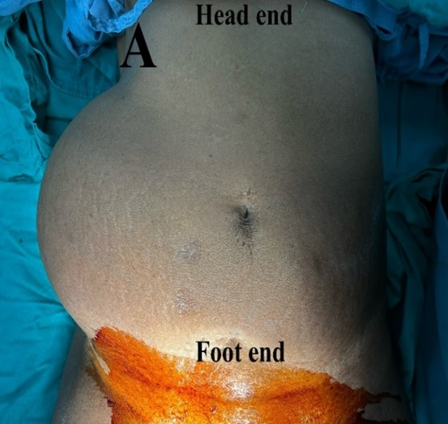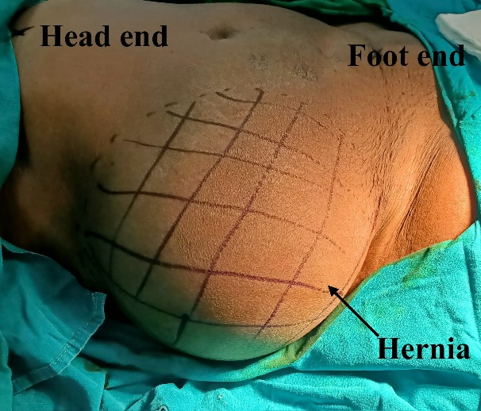
Figure 1A & 1B: Pre-Operative Hernia Picture
A plain and contrast-enhanced CT scan of the abdomen and pelvis revealed a large defect in the right anterolateral abdominal wall, measuring about 11.3 cm in maximum width and 13 cm in the supero-inferior extent (Figure 2A & 2B). The hernial sac volume was about 1340.08 cc, while the abdominal cavity volume was about 3668.73 cc. The loss of domain (LOD) was calculated to be about 26%.
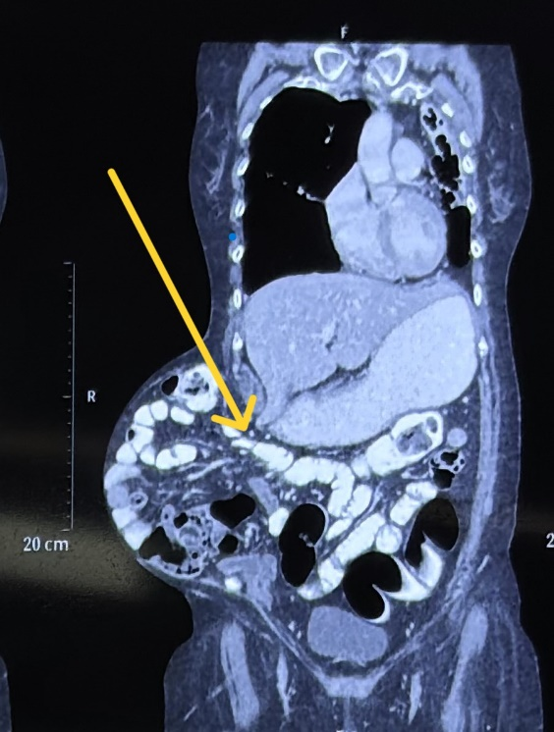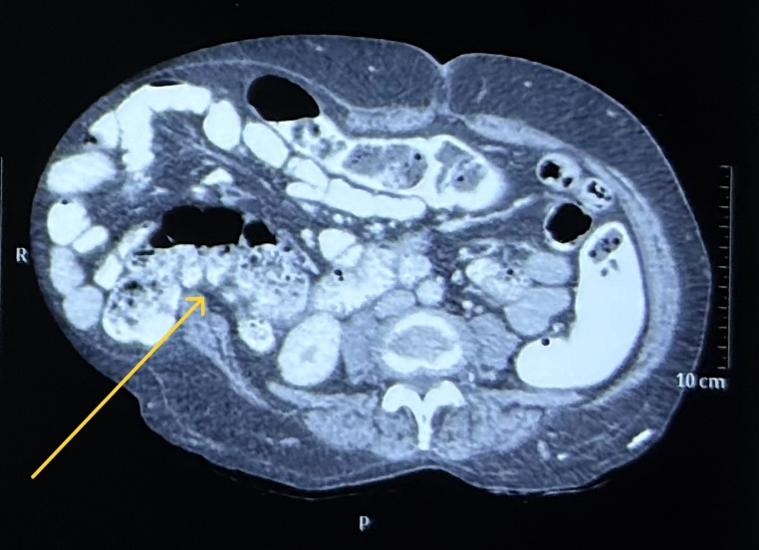
Figure 2a & 2B: CT scan Pre-Operative showing loss of domain
Due to the respiratory disease, the patient was deemed unfit for Botox therapy. Preoperative progressive pneumoperitoneum (PPP). She was found to be a high risk for general anaesthesia by the Chest Physician and Anaesthetist. After a Multidisciplinary discussion with the Physician, Anaesthetist, and Chest Physician, a collective decision was made to operate on the patient under Epidural anaesthesia. As part of the preoperative preparation, the patient was primarily advised to pursue weight reduction measures and was also administered chest physiotherapy, Spirometry to optimize respiratory function⁶. The patient underwent a midline laparotomy, during which the contents of the hernial sac were reduced via the intra-abdominal approach. Adhesiolysis was carried out with cold scissors in the standard fashion.
Abdominal wall reconstruction was performed through Posterior component separation, followed by Transversus abdominis release (TAR) using the 'bottom-up' approach. After performing TAR, lateral dissection was carried out on the right side of the abdomen to cross the defect and ensure adequate mesh coverage, followed by lateral dissection on the left side.
The posterior rectus sheath was closed, and a 30 cm x 30 cm medium-weight polypropylene mesh was placed in the TAR plane to provide adequate coverage (Figure 3).
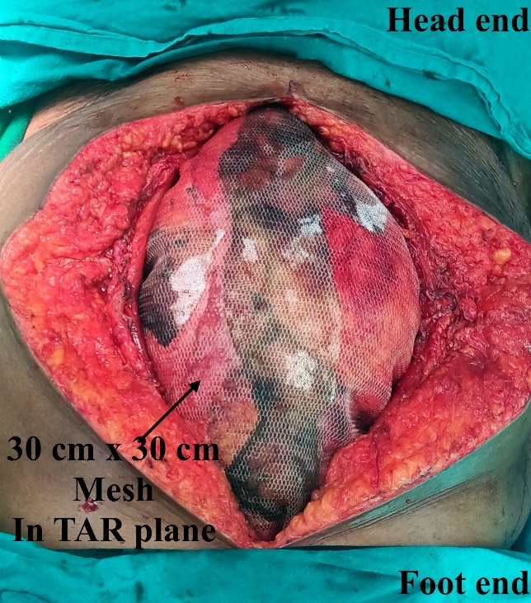
figure 3: mesh placement in tar plane
The hernia defect in the anterior rectus sheath (ARS) was closed separately as it was a lateral defect using non-absorbable suture material. The ARS approximation was begun with number 1 monofilament nylon suture material in an interrupted manner. Due to difficulty in approximating the ARS, a polypropylene mesh was used to bridge the midline and secured with non-absorbable sutures to prevent respiratory compromise and abdominal compartment syndrome(Figure 4).
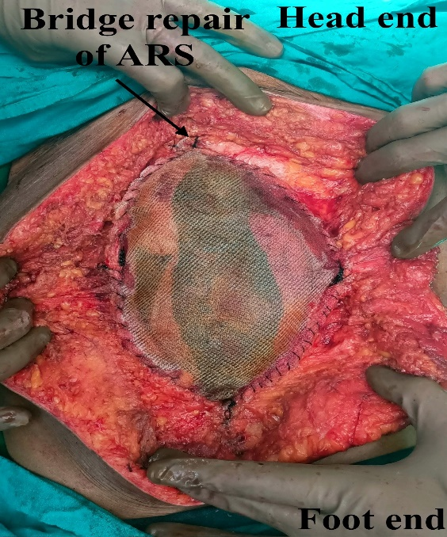
figure 4: Bridge repair of anterior rectus sheath
The subcutaneous drain was placed, and the incision was closed in layers. The total operative duration was 6 hrs. In the early postoperative period, she was monitored for signs of abdominal compartment syndrome by checking her urine output, arterial blood gas analysis, and respiratory pressures. The patient was kept in the ICU for a week because she required additional respiratory care and support due to a pre-existing lung condition. The patient was followed up at 2 weeks and 1 month post-surgery, with no evidence of recurrence or complications (Figure 5).
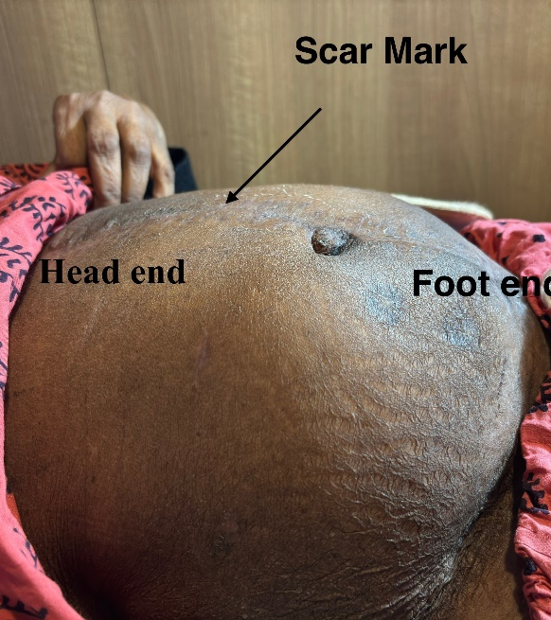
figure 5: 6 months Post-operative image of abdomen showing no recurrence
Discussion:
Complex giant incisional hernias present a significant challenge for Surgeons. Functionalizing the abdominal wall can only be achieved when the defect is closed without tension, which is especially challenging in larger defects.
In large hernias, repositioning the hernial contents into the abdominal cavity increases intra-abdominal pressure.⁷ This elevated pressure causes the diaphragm's cephalad displacement and impairs respiratory function. In such cases, the capacity of the abdominal cavity can be increased by Preoperative progressive pneumoperitoneum or by injecting Botulinum toxin. However, such modalities are contraindicated in patients with cardio-respiratory compromise⁸.
Generally, such large ventral hernias are to be repaired under General anaesthesia as they provide adequate muscle relaxation. However, the risks of general anaesthesia are higher in individuals with respiratory compromise or difficult airways⁷, making regional anesthesia an effective and feasible alternative with better outcomes in these high-risk cases⁹.
Posterior component separation is an effective technique in patients with lumbar hernia having loss of domain. The bridge repair method, which uses a polypropylene mesh to close the anterior rectus sheath, is an effective strategy for achieving a tension-free midline approximation¹⁰.
In this case, the patient underwent open hernia surgery under epidural anesthesia, with Transversus abdominis release performed to place a large mesh that provides adequate coverage of the defect and reduces the risk of recurrence. Thus, epidural anesthesia, combined with posterior component separation and bridge repair of the anterior rectus sheath, can be used to manage large primary ventral hernias in patients with respiratory diseases.

COMPETING INTERESTS DISCLAIMER:
Authors have declared that they have no known competing financial interests OR non-financial interests OR personal relationships that could have appeared to influence the work reported in this paper.

References:

- Kroese, L. F., Gillion, J. F., Jeekel, J., Kleinrensink, G. J., & Lange, J. F. (2018). Primary and incisional ventral hernias are different in terms of patient characteristics and postoperative complications - A prospective cohort study of 4,565 patients. International Journal of Surgery, 51, 114-119. https://doi.org/10.1016/j.ijsu.2018.01.010
- Kalyanasundar, S., Bhatnagar, A., Tiwari, M., Pandey, R., & Shalja. (2016). Giant Lumbar Hernia and Review of Literature. Indian Journal of Public Health Research & Development, 7(4), 249-252.
- Suarez, S., & Hernandez, J. D. (2013). Laparoscopic repair of a lumbar hernia: report of a case and extensive review of the literature. Surg Endosc, 27, 3421–9. https://doi.org/10.1007/s00464-013-2884-9 .
- Slater, N. J., Montgomery, A., Berrevoet, F., Carbonell, A. M., Chang, A., Franklin, M., Kercher, K. W., Lammers, B. J., Parra-Davilla, E., Roll, S., Towfigh, S., van Geffen, E., Conze, J., & van Goor, H. (2014). Criteria for definition of a complex abdominal wall hernia. Hernia, 18(1), 7–17. https://doi.org/10.1007/s10029-013-1168-6 .
- Tanaka, E. Y., Yoo, J. H., Rodrigues, A. J., Jr., Utiyama, E. M., Birolini, D., & Rasslan, S. (2010). A computerized tomography scan method for calculating the hernia sac and abdominal cavity volume in complex large incisional hernia with loss of domain. Hernia, 14(1), 63–69. https://doi.org/10.1007/s10029-009-0560-8 .
- Berkvens, Elske H. M.; Wegdam, Johannes A.1; Visser, Rhijn J. A.2; Bouvy, Nicole D.3; Nienhuijs, Simon W.4; de Vries Reilingh, Tammo S.1. Preoperative exercise therapy preventing postoperative complications following complex abdominal wall reconstruction: A feasibility study. International Journal of Abdominal Wall and Hernia Surgery 4(3):p 103-108, Jul–Sep 2021.
- Mamaniya, U. B., Dasgupta, P., Senthilnathan, P., & Chinnusamy, P. (2022). Giant lumbar incisional hernia with loss of domain. Journal of Minimal Access Surgery, 18(4), 606-608. https://doi.org/10.4103/jmas.jmas_274_21 .
- Subirana, H., Comas, J., Crusellas, O., Robres, J., Barri, J., Domenech, A., Borlado, C., & Castellví, J. (2023). Preoperative Progressive Pneumoperitoneum in the Treatment of Hernias With Loss of Domain. Our Experience in 50 Cases. Journal of Abdominal Wall Surgery, 2, 11230. https://doi.org/10.3389/jaws.2023.11230 .
- Thalji, M., Tarayrah, R., Ruzaygat, A., Motawe, D., & Ibedo, F. (2024). Classic incisional hernia repair under awake thoracic combined spinal -epidural anesthesia in a geriatric patient with multiple co-morbidities. *International Journal of Surgery Case Reports*, *119*(1), 109744. https://doi.org/10.1016/j.ijscr.2024.109744 .
- Novitsky, Y. W., Fayezizadeh, M., Majumder, A., Neupane, R., Elliott, H. L., & Orenstein, S. B. (2016). Outcomes of Posterior Component Separation With Transversus Abdominis Muscle Release and Synthetic Mesh Sublay Reinforcement. Annals of Surgery, 264(2), 226–232. https://doi.org/10.1097/SLA.0000000000001673 .

