Case report
Posterior polymorphous corneal dystrophy: A case report

Abstract:

Background: Posterior polymorphous corneal dystrophy (PPCD) is a rare hereditary corneal disease, the clinical forms can be varied, hence the term polymorphous.
Its polymorphous nature may lead to misdiagnosis, particularly when associated with anterior segment alterations.

Case Presentation: We report the case of a female patient who presented with an epithelial lesion of the cornea, initially suggestive of a primary epithelial pathology. Slit-lamp examination of the opposite eye revealed subtle endothelial abnormalities. Anterior segment optical coherence tomography (AS-OCT) demonstrated irregularities of Descemet’s membrane, while specular microscopy confirmed endothelial cell polymorphism and polymegathism consistent with PPCD. No family history of corneal dystrophy was noted. The patient was managed conservatively with ocular surface treatment, resulting in improvement of epithelial healing, and an endothelial keratoplasty has been proposed.

Discussion: This case highlights the importance of carefully examining the endothelium when faced with unexplained epithelial alterations. PPCD can manifest in a wide range of clinical forms, which explains its designation as polymorphous. Misdiagnosis is possible, particularly with conditions such as herpetic keratitis or early Fuchs endothelial dystrophy. Multimodal imaging, including AS-OCT and specular microscopy, plays a key role in detecting subclinical endothelial involvement.

Conclusion: PPCD may be revealed by an anterior corneal lesion, emphasizing the need for thorough endothelial evaluation in atypical epithelial presentations. Early recognition is crucial for appropriate follow-up and prevention of long-term endothelial decompensation.

Keywords : Cornea – Epithelium- Endothelium- Specular microscopy- AS-OCT - Posterior polymorphous corneal dystrophy .

Introduction:
Posterior polymorphous corneal dystrophy (PPCD) is a rare, typically bilateral, inherited corneal endothelial dystrophy characterized by abnormal proliferation and metaplasia of endothelial cells. These altered endothelial cells may assume epithelial-like features, leading to a wide spectrum of clinical appearances, which explains the term polymorphous. The condition is often asymptomatic and discovered incidentally during routine examination, although it may occasionally present with corneal edema, reduced visual acuity, or secondary glaucoma due to peripheral anterior synechiae and angle involvement.
PPCD may be underdiagnosed, particularly when the initial clinical presentation is subtle or overshadowed by concomitant anterior segment pathology. Misinterpretation as herpetic keratitis, early Fuchs endothelial dystrophy, or other corneal surface disorders is possible, especially in cases where epithelial lesions are present. Multimodal imaging, including anterior segment optical coherence tomography (AS-OCT) and specular microscopy, plays a key role in confirming endothelial abnormalities and distinguishing PPCD from other corneal disorders.
We report a case in which PPCD was revealed following a corneal epithelial lesion, emphasizing the importance of a comprehensive evaluation of the cornea—particularly the endothelium—even when the presenting signs appear to be limited to the superficial layers.

Case Presentation
A 32-year-old female presented with complaints of painful red right eye associated with photophobia and tearing for 1 week. She reported a previous episode of unilateral red eye in the same eye five years earlier, which had been treated as presumed herpetic keratitis without improvement. Her medical history was unremarkable, with no previous ocular trauma and no contact lens wear.

At presentation, visual acuity was severly reduced in the right eye, and intraocular pressure was within normal limits. Slit-lamp examination revealed a diffuse coneal oedema with multiple ruptured subepithelial bullae and loss of epithelial integrity with no signs of infection or stromal infiltrate (Figure 1) .

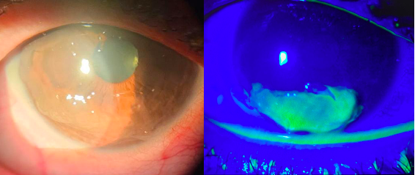

Figure 1 : Slit-lamp image of the right eye (RE) revealed a corneal oedema and loss of epithelial integrity.

The corrected visual acuity of the left eye was 8/10, and the biomicroscopic examination (Magnification x 40) revealed a subtle alterations in the form of axial vesicular and band-like lesions characteristic of endothelial involvement with clear epithelium and stroma (Figure 2).
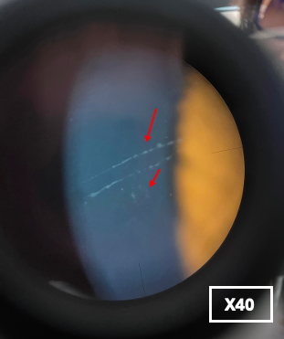

Figure 2: Biomicroscopic examination highlights vesicular and band-like lesions (red arrows).

Anterior segment optical coherence tomography (AS-OCT) showed in right eye increased corneal thickness and epithelial bullae in the inferior cornea (red arrow). In the left eye we found areas of hyper-reflective material on the backside of the endothelium (yellow arrow) (Figure 3).

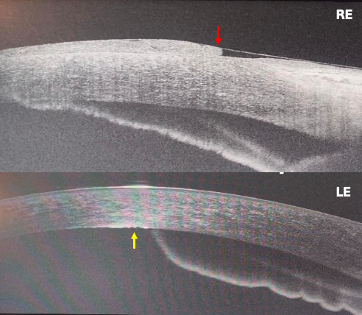

Figure 3: AS-OCT of the RE showing increased corneal thickness and epithelial bullae (red arrow), and in the LE an hyper-reflective material on the backside of the endothelium (yellow arrow).

Specular microscopy (SM) of the left eye revealed endothelial cell polymorphism and polymegathism, with decreased cell density compared to normative values. Parallel linear dark areas obscuring the normal dotted white endothelial mosaic were also observed. Assessment of the right eye was inconclusive due to corneal edema) (Figure 4).

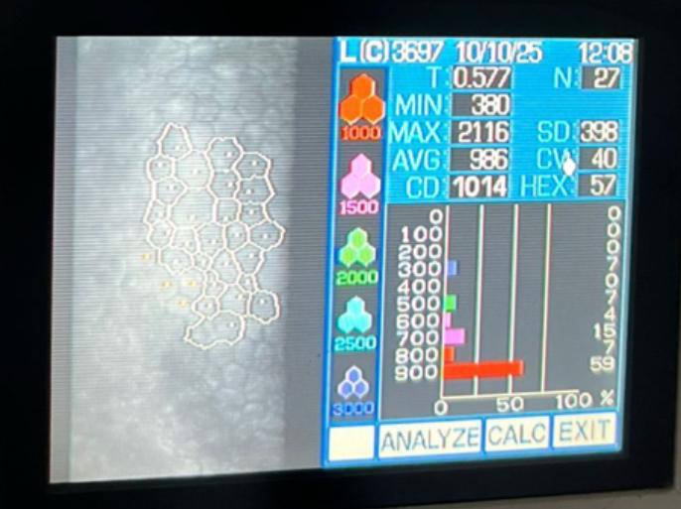

Figure 4: Specular microscopy of the LE revealing endothelial cell polymorphism and polymegathism, decreased cell density with a linear black area masking the dotted white endothelial mosaic.

The initial treatment consisted of debridement of the epithelial lesions, combined with hypertonic eye drops and healing agents. After seven days, the patient showed significant improvement: visual acuity improved to 2/10, epithelial signs such as photophobia and conjunctival hyperemia regressed, and re-epithelialization was observed. Endothelial opacities with vesicles became visible, and AS-OCT revealed endothelial thickening similar to that observed in the left eye (Figure 5).

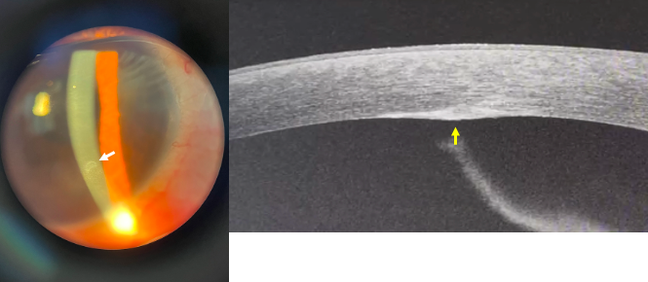
RE

Figure 5 : Slit lamp photographs of the RE seven days after treatment demonstrate the presence of endothelial opacities (white arrow) , and corresponding to endothelial thickening in AS-OCT ( yellow arrow).

The patient remains under regular follow-up while awaiting endothelial keratoplasty.

Discussion:

Posterior polymorphous corneal dystrophy (PPCD) is a rare endothelial dystrophy with heterogeneous clinical manifestations, which contributes to the variability in diagnosis and management reported across the literature. The present case illustrates an atypical and initially misleading presentation of PPCD, emphasizing the importance of careful clinical evaluation, multimodal imaging, and recognition of early endothelial changes, even when symptoms are unilateral.

This dystrophy follows an autosomal dominant pattern of inheritance. It results from an abnormal synthesis of type IV collagen by the corneal endothelial cells, which undergo an epithelial-like metaplastic transformation. These cells become multilayered, develop apical microvilli, form intercellular desmosomes, and may re-enter the mitotic cycle [1].

The incidence of PPCD remains very rare and is largely unknown worldwide, because the disease is often asymptomatic, many cases likely go undiagnosed, making accurate epidemiological estimation difficult. To our knowledge there are no reported cases of PPCD in north Africa patients in the literature. Nevertheless, some studies have reported very low prevalence of approximately 1 in 100,000 inhabitants [1] .

This disease is usually asymptomatic for many years and most patients are unaware of their condition and the diagnosis is often made incidentally during routine eye examinations [2]. Slit-lamp biomicroscopy examinations frequently reveals endothelial abnormalities, including clusters of vesicular lesions, band-like opacities, or more diffuse polymorphous opacities on Descemet’s membrane [3] .These features may appear in only one eye or may be asymmetric, even in the context of a bilateral disease. While many patients with these endothelial lesions maintain normal corneal clarity, some adult cases progress to epithelial decompensation. In a retrospective Indian study, about 23% of PPCD patients the presenting features leading to diagnosis was a painful red eye associated with epithelial decompensation and epithelial breakdown who unmasked the disease [4] .These observations highlight that PPCD should be considered in adults presenting with a unilateral red eye and epithelial compromise, even when the contralateral eye appears clinically quiet.

Paraclinical investigations play a critical role in the diagnosis and characterization of PPCD. Specular microscopy is particularly useful and has been widely reported to detect endothelial abnormalities, including polymorphism and polymegathism, reduced cell density, and the presence of vesicular, band-like, or “fingerprint” patterns that disrupt the normal hexagonal endothelial mosaic [3] [5] [6] . Meanwhile, anterior segment optical coherence tomography (AS-OCT) provides complementary information by demonstrating hyper-reflective endothelial lesions, localized posterior thickening, and, in cases with epithelial decompensation, secondary epithelial bullae and stromal edema [7][8].

Management of posterior polymorphous corneal dystrophy (PPCD) is largely guided by the severity of endothelial dysfunction and the presence of corneal edema. In most asymptomatic patients, conservative management is appropriate, including regular monitoring, lubricating eye drops, and hypertonic saline for mild epithelial edema. Episodes of epithelial decompensation may be managed temporarily with epithelial debridement, bandage contact lenses, or topical medications to reduce edema [2].

When corneal decompensation leads to significant visual impairment or persistent epithelial edema unresponsive to medical therapy, surgical intervention, specifically endothelial keratoplasty (DMEK or DSAEK) are preferred over penetrating keratoplasty for better long-term outcomes [4][9].

Conclusion

In summary, even though PPCD remains an underdiagnosed endothelial disorder and is most often asymptomatic, our case is particularly noteworthy in that the initial epithelial symptoms did not mask the underlying diagnosis, allowing the identification of the characteristic endothelial abnormalities.
The use of multimodal paraclinical imaging particularly AS-OCT and specular microscopy was essential in demonstrating characteristic endothelial alterations and in confirming bilateral involvement despite asymmetric clinical expression.
Through our case, we want to highlight the importance of carefully examining all corneal layers to avoid missing subtle endothelial abnormalities.

Conflicts of Interest
The authors declare that there are no conflicts of interest.

References

1. Bourges JL. Corneal dystrophies. J Fr Ophtalmol. 2017;40(6):e177–e192. https://doi.org/10.1016/j.jfo.2017.05.003

2. Guier CP, Patel BC, Stokkermans TJ, Gulani AC. Posterior polymorphous corneal dystrophy. StatPearls [Internet]. Treasure Island (FL): StatPearls Publishing; 2017–. PMID: 430880. https://www.ncbi.nlm.nih.gov/books/NBK430880/

3. Mendoza-Adam G, Hernandez-Camarena JC, Valdez-García JE. Posterior polymorphous dystrophy: case report and literature review. Arch Soc Esp Oftalmol. 2015;90(9):439–441. https://doi.org/10.1016/j.oftal.2015.01.003

4. Chaurasia S, Mittal R, Bichappa G, Ramappa M, Murthy SI. Clinical characterization of posterior polymorphous corneal dystrophy in patients of Indian ethnicity. Int Ophthalmol. 2017;37(4):945–952. d https://doi.org/10.1007/s10792-016-0360-y

5. Fung SS, Sami H, El Hamouly A, Jiandani D, Williams S, Mireskandari K, et al. Endothelial cell density in children with posterior polymorphous corneal dystrophy: a longitudinal case-control study. Eye (Lond). 2021;35(12):3397–3403. https://doi.org/10.1038/s41433-021-01451-y

6. Ahn YJ, Choi SI, Yum HR, Shin SY, Park SH. Clinical features in children with posterior polymorphous corneal dystrophy. Optom Vis Sci. 2017;94(4):476–481. https://doi.org/10.1097/OPX.0000000000001039

7. Siebelmann S, Scholz P, Sonnenschein S, Bachmann B, Matthaei M, Cursiefen C, et al. Anterior segment optical coherence tomography for the diagnosis of corneal dystrophies according to the IC3D classification. Surv Ophthalmol. 2018;63(3):365–380. https://doi.org/10.1016/j.survophthal.2017.08.001

8. Srinivasan S, Skarmoutsos P, O'Donnell C, Kaye SB. Localized bullous keratopathy secondary to posterior polymorphous dystrophy. Clin Exp Ophthalmol. 2008;36(8):800–801. https://doi.org/10.1111/j.1442-9071.2008.01875.x

9. Sorkin N, Einan-Lifshitz A, Boutin T, Showail M, Borovik A, Chan CC, Rootman DS. Descemet membrane endothelial keratoplasty in iridocorneal endothelial syndrome and posterior polymorphous corneal dystrophy. Can J Ophthalmol. 2019;54(2):190–195. https://doi.org/10.1016/j.jcjo.2018.05.012

