Case report

Bilateral Pheochromocytoma in an Adolescent Girl with Von Hippel–Lindau Syndrome: A Case Report

Abstract
Pheochromocytoma is a rare cause of secondary hypertension in children and adolescents. We report a case of a 15-year-old girl who presented with recurrent adrenergic spells and severe hypertension, subsequently diagnosed with bilateral pheochromocytoma associated with Von Hippel–Lindau (VHL) syndrome. This case underscores the critical importance of early clinical recognition, comprehensive biochemical and imaging assessment, genetic confirmation, and meticulous perioperative management.

Introduction
Pheochromocytomas are catecholamine-secreting tumors arising from chromaffin cells, accounting for a rare but potentially fatal cause of hypertension in children. A significant proportion are associated with hereditary syndromes, including Von Hippel–Lindau syndrome. Early diagnosis and appropriate management are essential to prevent complications.

Case Presentation
A 15-year-old girl presented with a one-month history of episodic palpitations, breathlessness, chest tightness, headache, diaphoresis, and a sense of impending doom. Each episode lasted 10–15 minutes and occurred 8–10 times daily. She also reported giddiness on standing. There was no prior history of similar episodes and no family history of hypertension or premature cardiovascular disease.
On examination, pulse rate was 110/min and regular. Blood pressure was 150/100 mmHg in the supine position with a postural fall to 120/80 mmHg on standing. There were no features suggestive of endocrinopathies or neurocutaneous syndromes. Systemic examination was otherwise unremarkable.

Investigations
ECG and chest radiography were normal. In view of classical spells, pheochromocytoma was suspected ,Plasma Metanephrine and Normetanephrine were measured after the patient had rested in the supine position for 30 minutes . Plasma Metanephrine was 8.2 ng/L (7-88) , but Plasma Normetanephrine was significantly elevated 3720 ng/L(20-135). Contrast-enhanced CT of the abdomen showed a heterogeneously enhancing right adrenal mass measuring approximately 4 cm, a left adrenal lesion measuring about 2.5 cm, and a left para-aortic lesion measuring 2.2cm
Ga-68 DOTATATE PET scan demonstrated intensely enhancing lesions involving both adrenal glands and a left para-aortic region, suggestive of multifocal pheochromocytoma. Clinical exome sequencing was performed to evaluate the patient for pathogenic variations associated with her early-onset bilateral pheochromocytoma. The analysis identified a heterozygous pathogenic variant in the VHL gene located in Exon 2. Specifically, the variant is a c.414A>G (p.Pro138). Retinal examination done which did not show retinal hemangioblastoma . MRI Brain did not show any cerebellar lesion.

Diagnosis
Based on clinical presentation, imaging findings, and genetic analysis, a diagnosis of bilateral pheochromocytoma associated with Von Hippel–Lindau syndrome was established.

Management
Preoperative preparation included initiation of alpha-adrenergic blockade with prazosin, followed by beta-blockade with metoprolol after adequate alpha blockade. Liberal salt intake was advised. Surgical management was planned as bilateral adrenalectomy.
Laparoscopic adrenalectomy was attempted; however, intraoperative bleeding and hypotension necessitated conversion to open right adrenalectomy. Intraoperative hypertension was managed with nitroglycerin infusion. Postoperatively, the patient developed transient hypotension, which was managed with intravenous fluids.Unilateral adrenalectomy was done at first stage and completion surgery was done later. Histopathological examination of the resected adrenal specimen confirmed the diagnosis of pheochromocytoma. Postoperatively, plasma normetanephrine levels normalized, blood pressure stabilized without antihypertensive medications, and the patient was initiated on physiologic glucocorticoid and mineralocorticoid replacement, with structured adrenal crisis education. The left para-aortic lesion was managed with active surveillance, given its small size, absence of compressive symptoms, and biochemical control following adrenal surgery. Following confirmation of Von Hippel–Lindau syndrome, the patient and family underwent formal genetic counseling, with detailed discussion regarding the hereditary nature of the disease, implications for family members, and the need for lifelong surveillance. Parental testing and segregation analysis were discussed as part of cascade screening. A comprehensive VHL surveillance protocol was instituted, including periodic abdominal MRI to screen for renal cell carcinoma and pancreatic neuroendocrine tumors, regular ophthalmologic examinations for retinal hemangioblastomas, audiological assessment for endolymphatic sac tumors, and consideration of Brainstem and spinal MRI in accordance with contemporary surveillance guidelines
.

Discussion and Review of Literature
Pheochromocytomas and paragangliomas (PPGLs) are rare catecholamine-secreting neuroendocrine tumors arising from chromaffin cells of the adrenal medulla and extra-adrenal paraganglia, respectively. Although uncommon in childhood, PPGLs represent a critical and potentially fatal cause of secondary hypertension in the pediatric and adolescent population. Importantly, pediatric PPGLs differ fundamentally from adult disease in terms of genetic predisposition, tumor multiplicity, malignant potential, and long-term outcomes, mandating a distinct diagnostic and management paradigm (1).
A defining feature of pediatric PPGL is the exceptionally high prevalence of underlying germline mutations. Contemporary series demonstrate that up to 70–80% of children and adolescents with PPGL harbor pathogenic variants in susceptibility genes, even in the absence of a positive family history (1,2). This rate far exceeds that observed in adult cohorts and supports the current recommendation for universal genetic testing in all pediatric cases. Advances in next-generation sequencing have further expanded the recognized genetic landscape, with mutations in VHL, RET, SDHB, SDHD, SDHC, SDHA, MAX, and TMEM127 accounting for the majority of hereditary cases (2,3).
Among these, von Hippel–Lindau (VHL) syndrome is one of the most frequently implicated conditions in pediatric pheochromocytoma. VHL-associated PPGLs characteristically present at a younger age and often exhibit bilateral adrenal involvement or multifocal disease (3). From a biochemical standpoint, these tumors typically display a noradrenergic phenotype, with predominant elevation of normetanephrine and minimal or absent metanephrine secretion. This pattern reflects reduced expression of phenylethanolamine-N-methyltransferase within VHL-related tumors and provides a valuable diagnostic clue in clinical practice (4). Large genotype–phenotype correlation studies have consistently reinforced this biochemical signature, enabling more targeted genetic evaluation and counseling (4,5).
Bilateral adrenal pheochromocytomas and multifocal disease are particularly suggestive of hereditary syndromes such as VHL, multiple endocrine neoplasia type 2 (MEN2), and SDHx-related disorders. In the landmark multicenter study by Neumann et al., nearly 80% of pediatric pheochromocytoma patients were found to carry germline mutations, with VHL mutations contributing substantially to bilateral adrenal disease (1). More recent analyses confirm these findings and further emphasize that early age at onset, bilaterality, extra-adrenal tumors, or recurrence should prompt comprehensive genetic testing regardless of family history (2,3).
Accurate tumor localization and staging are central to optimal management. Cross-sectional imaging with contrast-enhanced computed tomography (CT) or magnetic resonance imaging (MRI) remains the first-line modality for anatomical assessment. MRI is often preferred in pediatric patients to minimize radiation exposure and provides excellent soft-tissue contrast, particularly for adrenal and paraspinal lesions (6). Functional imaging has assumed an increasingly important role, especially in hereditary and multifocal disease. Among available modalities, 68Ga-DOTATATE PET/CT has emerged as a highly sensitive and specific tool for detecting PPGLs expressing somatostatin receptor subtype 2 (7). Several comparative studies and meta-analyses published over the past decade have demonstrated superior lesion detection with 68Ga-DOTATATE PET/CT compared with conventional scintigraphy and even other PET tracers, particularly in SDHx- and VHL-related tumors (7,8). Improved detection of occult or multifocal lesions has significant implications for surgical planning and long-term surveillance.
Preoperative medical preparation remains a cornerstone of PPGL management and is particularly critical in pediatric patients, who may present with labile blood pressure and increased catecholamine sensitivity. Adequate alpha-adrenergic blockade, typically with phenoxybenzamine or selective alpha-1 blockers, followed by cautious beta-blockade where indicated, is essential to prevent perioperative hypertensive crises, arrhythmias, and cardiovascular complications (9). The Endocrine Society Clinical Practice Guideline continues to endorse this stepwise approach, supported by robust observational data demonstrating reduced perioperative morbidity and mortality with appropriate preoperative optimization (9). Despite meticulous preparation, patients with large, bilateral, or multifocal tumors remain at risk for hemodynamic instability, underscoring the need for experienced multidisciplinary perioperative care involving endocrinology, anesthesia, and surgery.
Surgical management in hereditary bilateral pheochromocytoma presents significant challenges, particularly in children and adolescents. Total bilateral adrenalectomy effectively eliminates tumor burden but results in lifelong adrenal insufficiency and dependence on glucocorticoid and mineralocorticoid replacement. To mitigate this, cortical-sparing adrenalectomy has gained increasing acceptance in selected patients with hereditary disease, especially those with VHL (10). Contemporary series suggest that adrenal-sparing approaches can preserve endogenous steroid production in a substantial proportion of patients while maintaining acceptable rates of local control (10,11). However, the risk of local recurrence necessitates careful patient selection, expert surgical technique, and lifelong follow-up.
Long-term surveillance is of paramount importance in patients with hereditary PPGL syndromes. Individuals with VHL remain at ongoing risk for recurrent pheochromocytoma, contralateral adrenal disease, and other syndrome-associated neoplasms, including renal cell carcinoma, pancreatic neuroendocrine tumors, and central nervous system hemangioblastomas (3,11). Current consensus recommendations advocate lifelong biochemical screening and periodic imaging tailored to the underlying genetic mutation, age, and disease burden (2,3). Early detection through structured surveillance has been shown to reduce morbidity and improve long-term outcomes in hereditary PPGL syndromes.
Conclusion
In summary, the contemporary literature supports a comprehensive and structured approach to pediatric PPGL encompassing early clinical suspicion, biochemical confirmation, advanced anatomical and functional imaging, universal genetic testing, meticulous perioperative preparation, and individualized surgical planning. The present case aligns closely with these principles and reinforces current recommendations for the evaluation and management of pheochromocytoma in adolescents, particularly within the context of hereditary syndromes such as VHL. Ongoing advances in molecular genetics and functional imaging continue to refine risk stratification and personalized care in this complex and high-risk patient population.

Key Clinical Message
Recurrent adrenergic spells with hypertension in adolescents should prompt evaluation for pheochromocytoma, and identification of hereditary syndromes such as VHL is crucial for long-term surveillance.

References
- Neumann, H. P. H., Bausch, B., McWhinney, S. R., Bender, B. U., Gimm, O., Franke, G., Schipper, J., Klisch, J., Altehoefer, C., Zerres, K., Januszewicz, A., Eng, C., Smith, W. M., Munk, R. D., Manz, T., Glaesker, S., Apel, T. W., Treier, M., Reineke, M., ... Szmigielski, C. (2002). Germ-line mutations in nonsyndromic pheochromocytoma. N Engl J Med, 346(19), 1459–1466. https://doi.org/10.1056/NEJMoa020152.
- Buffet A, Burnichon N, Favier J, Gimenez-Roqueplo AP. Pheochromocytoma and paraganglioma: genetics, diagnosis, and treatment. Endocr Relat Cancer. 2020;27(11):R559–R575. doi:10.1530/ERC-20-0166.
- Taïeb D, Pacak K, Langton K, et al. Pheochromocytoma and paraganglioma: from genetics to personalized medicine. Lancet Diabetes Endocrinol. 2019;7(9):699–711. doi:10.1016/S2213-8587(19)30140-1.
- Eisenhofer G, Lenders JWM, Siegert G, et al. Plasma methoxytyramine: a novel biomarker of metastatic pheochromocytoma and paraganglioma. J Clin Endocrinol Metab. 2012;97(7):2311–2320. doi:10.1210/jc.2011-3338.
- Crona, J., Lamarca, A., Ghosal, S., Welin, S., Skogseid, B., & Pacak, K. (2019). Genotype–phenotype correlations in pheochromocytoma and paraganglioma: a systematic review and individual patient meta-analysis. Endocrine-Related Cancer, 26(5), 539–550. https://doi.org/10.1530/ERC-19-0024.
- Martucci, V. L., & Pacak, K. (2014). Imaging of pheochromocytoma and paraganglioma. Radiologic Clinics of North America, 52(4), 729–742. https://doi.org/10.1016/j.rcl.2014.04.001.
- Janssen I, Chen CC, Millo CM, et al. PET/CT comparing ^68Ga-DOTATATE and other radiopharmaceuticals in paraganglioma and pheochromocytoma. J Nucl Med. 2016;57(2):186–191. doi:10.2967/jnumed.115.161018.
- Han S, Suh CH, Woo S, Kim YJ, Lee JJ. Performance of ^68Ga-DOTATATE PET/CT for detection of pheochromocytoma and paraganglioma: a systematic review and meta-analysis. Eur J Nucl Med Mol Imaging. 2019;46(10):2112–2124. doi:10.1007/s00259-019-04306-8.
- Lenders, J. W. M., Duh, Q. Y., Eisenhofer, G., Gimenez-Roqueplo, A.-P., Grebe, S. K. G., Murad, M. H., Naruse, M., Pacak, K., & Young, W. F., Jr. (2014). Pheochromocytoma and paraganglioma: An Endocrine Society clinical practice guideline. The Journal of Clinical Endocrinology & Metabolism, 99(6), 1915–1942. https://doi.org/10.1210/jc.2014-1498.
- Castinetti, F., Taieb, D., Henry, J. F., Walz, M., Guerin, C., Brue, T., Conte-Devolx, B., Neumann, H. P. H., & Sebag, F. (2016). MANAGEMENT OF ENDOCRINE DISEASE: Outcome of adrenal sparing surgery in heritable pheochromocytoma. European Journal of Endocrinology, 174(1), R9–R18. https://doi.org/10.1530/EJE-15-0549.
- Lloyd, R. V., Osamura, R. Y., Klöppel, G., & Rosai, J. (Eds.). (2022). *WHO Classification of Tumours: Endocrine and Neuroendocrine Tumours* (5th ed.). International Agency for Research on Cancer. https://publications.iarc.who.int/645.

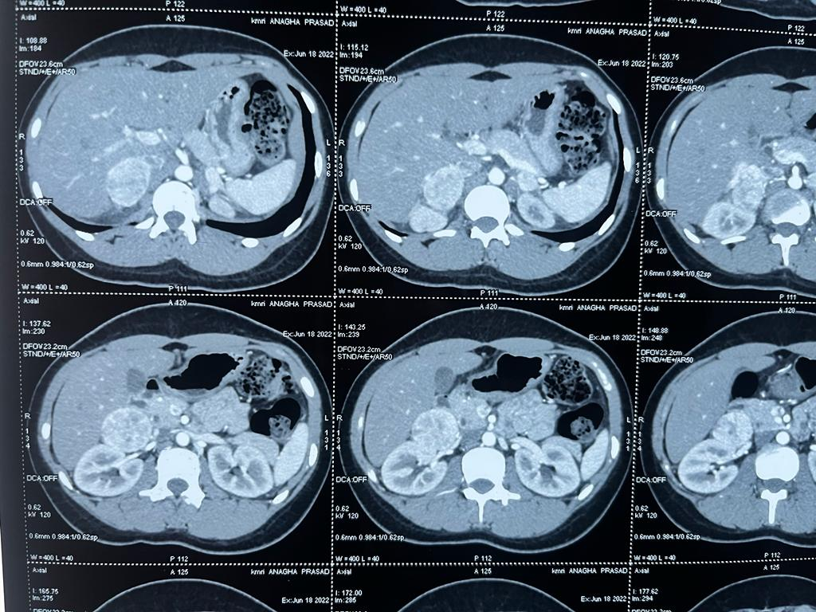
FIGURE 1 - CONTRAST CT ABDOMEN SHOWING BILATERAL ADRENAL MASS-PHEOCHROMOCYTOMA

FIGURE 2 - GA DOTATATE PET IMAGING SHOWING INTENSLY ENHANCING LESION BILATERAL ADRENAL LESION
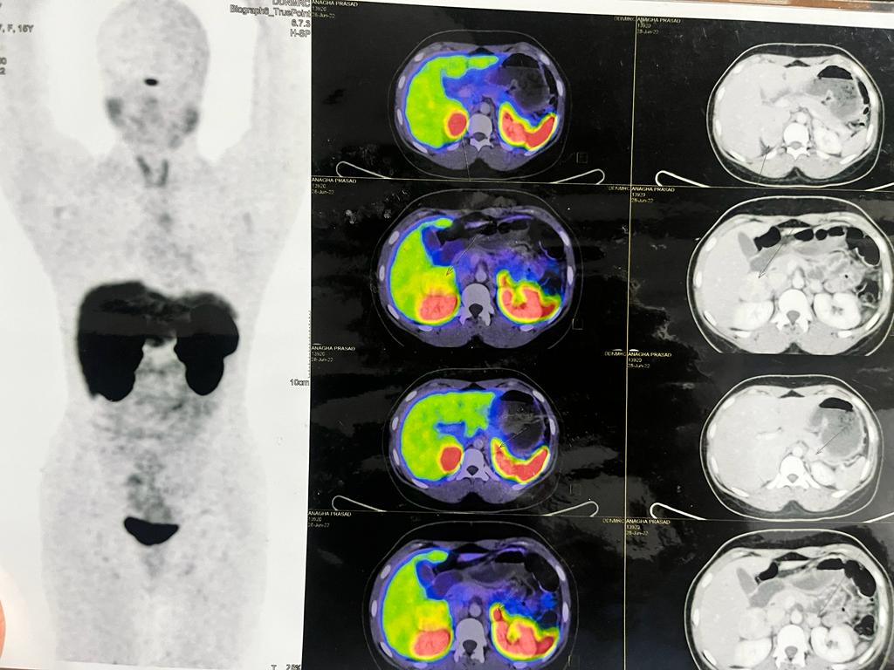

FIGURE 3 ADRENALECTOMY GROSS SPECIMEN
