Histopathology of Papillomavirus lesion in carp (Cyprinus carpio)

ABSTRACT
Papillomavirus (PV) is a small circular double-stranded DNA virus of the Papillomaviridae family, widely distributed among vertebrates and characterized by high tropism for keratinized and mucosal epithelia. This study performed a histopathological evaluation of a cutaneous lesion found in a carp (Cyprinus carpio) from a fish farm in Rio Grande do Sul, Brazil, suspected of Papillomavirus infection. The specimen was euthanized and necropsied, and samples of skin and internal organs were collected for histological examination. Samples were fixed in 20% buffered formalin, processed in paraffin, and stained with hematoxylin and eosin. Microscopic evaluation revealed hyperkeratosis, acanthosis, papillomatosis, and eosinophilic intranuclear inclusions suggestive of viral replication. Koilocytes with perinuclear halos and nuclear displacement were identified, serving as pathognomonic markers of Papillomavirus infection. The stroma exhibited basement membrane disruption and diffuse lymphoplasmacytic infiltration. These histological findings are consistent with a diagnosis of cutaneous papillomatosis, confirming viral etiology. This study highlights the relevance of histopathology as a primary diagnostic tool for differentiating epithelial proliferative lesions in fish, emphasizing the need for subsequent molecular confirmation.
Keywords: Papillomatosis, koilocytosis, histopathological diagnosis, epithelial lesions.

INTRODUCTION
Papillomaviruses (PV) are small, non-enveloped viruses belonging to the Papillomaviridae family, which comprises two subfamilies, more than 50 genera, and approximately 130 recognized species to date (Van Doorslaer et al., 2018). These viruses have a genome consisting of circular double-stranded DNA and exhibit marked host specificity, infecting a wide variety of vertebrates, including mammals, birds, reptiles, and fish. This diversity reflects a long virus-host coevolution, resulting in great adaptation and genomic variation among viral species (Mizutani, 2016; Saleh et al., 2021).
Although some papillomaviruses can be considered part of the normal skin microbiota, certain species have pathogenic potential, being able to induce infections in the epithelium of the skin and mucous membranes. These viruses demonstrate marked tropism for keratinized epithelium and mucosal epithelium, where they establish latent, subclinical, or clinically evident infections (Antonsson e Hansson, 2002). Clinical forms typically manifest as papillomas, characterized by the proliferation and thickening of the epithelium, with the formation of exophytic structures resulting from hyperplasia and hyperkeratosis induced by viral replication in the basal and suprabasal layers of the epithelium (Van Doorslaer et al., 2018; Surján et al., 2021).
Papillomatosis is an infectious disease transmitted through horizontal contact (López-Bueno et al., 2016). The clinical presentation consists of proliferative lesions that can be benign or neoplastic. Typically, benign lesions are self-limiting, while neoplastic lesions can have varying degrees of malignancy (Van Doorslaer et al., 2018; Van Doorslaer, 2013).
Papillomavirus lesions are characterized by the appearance of lesions that may resemble warts and can be confused with other pathologies. Microscopically, however, inflammatory cells and viral inclusions in epithelial cells are visible (Beutner & Tyring, 1997; Feng et al., 2025)
Under histopathological analysis, cellular changes typical of viral infection are observed, including the presence of inflammatory cells in the stroma and intranuclear viral inclusions in infected epithelial cells. Among the most characteristic morphological changes are epithelial hyperplasia, acanthosis, parakeratosis, and the presence of koilocytosis — epithelial cells with clear cytoplasm and irregular nuclei — which represent a classic histological marker of Papillomavirus infection (Doorbar et al., 2012).
In view of the need for a differential diagnosis with the different pathologies that can manifest in a similar clinical way, we opted for the analysis of the macroscopic aspects of the lesions and the histopathological examination for the confirmation of papillomatosis. Thus, in the present study, the histopathology of the lesions found in a fish suspected of Papillomavirus infection was evaluated, which presented the growth of a moderately firm papilloma.

MATERIALS AND METHODS
The investigation took place at the Laboratory of Immunology and Pathology of Aquatic Organisms (LIPOA), located at the Marine Aquaculture Station (EMA-FURG), at the Federal University of Rio Grande. The fish were sent to the laboratory by a carp (Cyprinus carpio) producer from a production farm located in Canguçu, Rio Grande do Sul, Brazil. Samples were sent to our laboratory in search of confirmation of the diagnosis. The fish arrived alive and were euthanized with Benzocaine (500mg/L) and necropsy was performed according to the protocol established in our laboratory.
For histopathological analysis, fragments of papillomas were removed through an elliptical incision with a scalpel. Tissue samples were also collected from internal organs, skin and muscles (1.0 cm x 1.0 cm each fragment). All samples were fixed in 20% buffered formalin for 48 h and then transferred to 70% alcohol, where they remained until processing (Prophet, 1992).
For histological analyses, the tissues were processed in an automated histological processor (LEICA TP 1020) and embedded in Paraplast®. For histological sectioning, a semi-automatic rotary microtome (LEICA RM 2245) was used.
The 5 μm thick sections were placed on simple frosted-tip slides, deparaffinized, and stained with hematoxylin and eosin for analysis under an optical microscope (Luna, 1968). The tissues were observed under a Zeiss Primo Star optical microscope equipped with an Axiocam ERC5s - AxionVision (LE) camera.

RESULTS
Histopathology revealed findings such as hyperkeratosis, papillary proliferations in the squamous epithelium, and eosinophilic materials, which may be attributed to intranuclear inclusions. In the stroma, rupture of the basement membrane and diffuse infiltration of lymphoplasmacytic cells were observed (Figure 1 e 2).

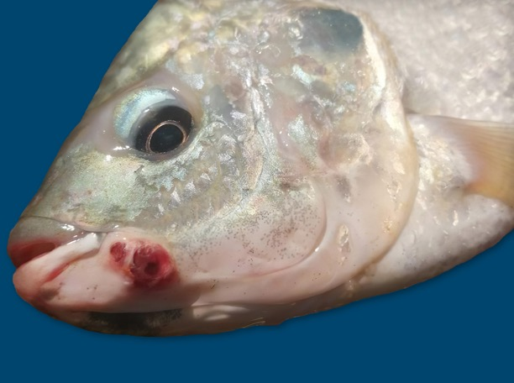
Figure 1. Specimen of Cyprinus carpio carp with verrucous and hemorrhagic lesion.
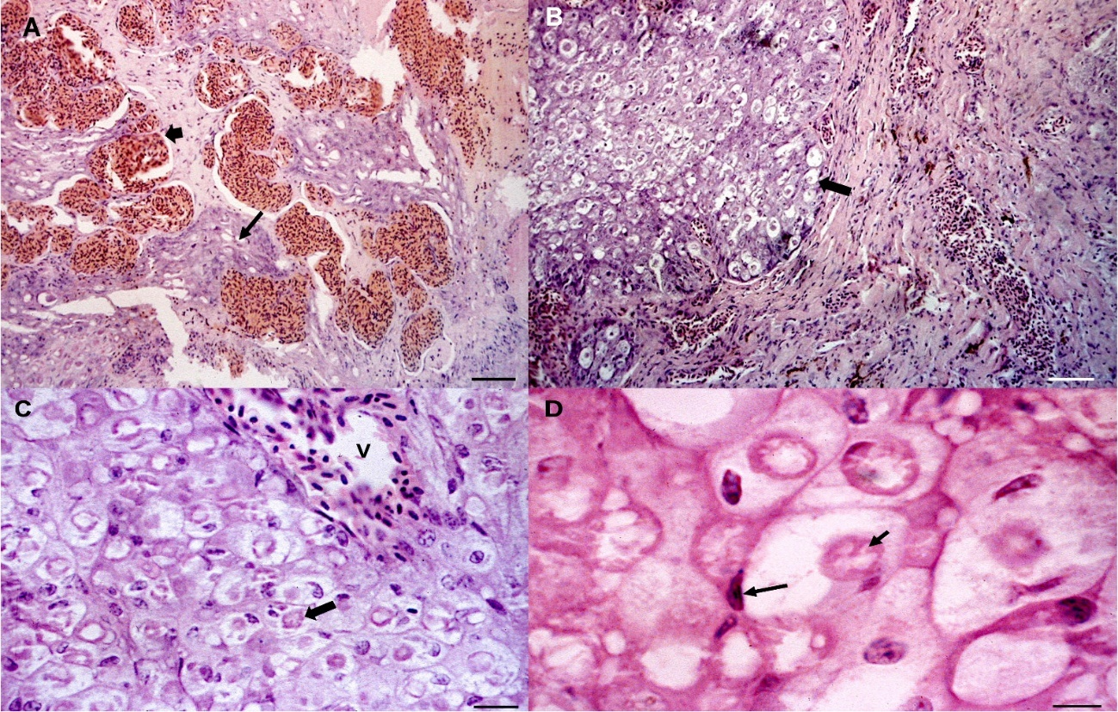
Figure 2. A. Photomicrograph of carp (C. carpio) skin histology showing dermis with abundant dilated capillaries (short arrow). Between the capillaries, a cell with koilocytosis is observed (broad arrow). H.E. 10x B. Photomicrograph of carp (C. carpio) skin histology showing a section with abundant cells exhibiting koilocytosis and viral inclusions arranged in nodules on dermal connective tissue (arrow). H. E. 20x. C. Photomicrograph of carp (C. carpio) skin histology showing inflammatory characteristics showing cells with koilocytosis and nuclear inclusions (arrow) surrounding a vascular structure. H. E. 20x. D. Photomicrograph of carp (C. carpio) skin histology showing a detail of papilloma cells showing koilocytosis and nuclear inclusion, with the cell nucleus displaced to the periphery (arrow). H.E. 40x

DISCUSSION
It is possible to identify Papillomavirus lesions by evaluating characteristics such as koilocytosis, dyskeratosis, papillomatosis, hyperkeratosis, acanthosis, and keratohyalin granules. Histological evaluation of the lesion is of great importance, as it allows the identification of intraepithelial tumors associated with viruses with oncogenic potential (Oliveira et al., 2003)
In the histopathological analysis, vegetative growth of the epithelium was observed with extensive and deep epidermal ridges and dermal papillae, which projected in the opposite direction to the ridges, with a highly vascularized connective tissue axis, tubular keratin with connective tissue, mononuclear lymphocytic infiltrate with active fibroblasts, and mitotic figures with lymphoplasmacytic infiltrate in the dermal papillae. These results characterize a developmental phase with viral replication and synthesis as described by Campo (2006).
In the present study, it was possible to identify the presence of koilocytes and intranuclear inclusions, as in the analysis performed by Casanova et al., (2017) when detecting cutaneous and gastric papillomatosis in a hamster. Koilocytes are squamous epithelial cells with a hyperchromatic, irregular, and displaced nucleus, surrounded by a clear perinuclear halo and karyorrhexis according to Glenn et al. (2009) and Anaya-Saavedra, & Vázquez-Garduño (2024). They are considered pathognomonic morphological markers of HPV infection (Krawczyk et al., 2008)
The histopathology of the excised warts allowed the study of the tissue through the surface cells, since these are cells derived from basal or germinal cell layers.
Histologically, papillomaviruses are characterized by large, eosinophilic viral inclusions with nuclear displacement to the cell periphery. These findings were consistent with the diagnosis of papilloma, which is based on symptomatology and histopathological examination. Characteristics such as epithelial hyperplasia, with proliferation of keratinocytes and increased thickness, as described by Cotran et al. (2000), were observed. These alterations are observed in different species, such as dogs, cattle, sheep, and goats (Al-Salihi et al., 2020; Al-Dabhawi et al., 2019; Gharban et al., 2023; Gasparotto et al., 2024; Ghorani et al., 2024).
However, confirmation of Papillomavirus must be done using molecular or biomolecular diagnostic tools (Feng et al., 2025). Papillomavirus skin and mucocutaneous infections have been associated with squamous cell carcinomas. Although some papillomaviruses (PV) are considered part of the normal human skin microbiota, certain species have pathogenic potential and can trigger infections in the skin epithelium and mucous membranes. These viruses have a high tropism for keratinized epithelial cells and mucous membranes, where they can establish latent, subclinical, or clinically evident infections (Antonsson e Hansson, 2002).

REFERENCES
Al-Dabhawi, A., Al-Salihi, K., Erzuki, I., & Ali, T., 2019. Clinico-Histopathological and Immunohistochemistry Study of Ruminant’s Cutaneous Papillomavirus in Al-Muthanna Veterinary Hospital/ Iraq. https://doi.org/10.20944/preprints201902.0177.v1.
Al-Salihi, K., Al-Dabhawi, A., Ajeel, A., Erzuki, I., & Ali, T., 2020. Clinico-Histopathological and Immunohistochemical Study of Ruminant's Cutaneous Papillomavirus in Iraq. Veterinary Medicine International, 2020. https://doi.org/10.1155/2020/5691974.
Anaya-Saavedra, G., & Vázquez-Garduño, M., 2024. Oral HPV-associated dysplasia: is koilocytic dysplasia a separate entity. Frontiers in Oral Health, 5. https://doi.org/10.3389/froh.2024.1363556.
Antonsson, A.; Hansson, B.G. healthy skin of many animal species harbors papillomaviruses which are closely related to their human counterparts. J. Virol. 2002, 76, 12537–12542.
Beutner, K. R., & Tyring, S. (1997). Human papillomavirus and human disease. The American journal of medicine, 102(5), 9-15.
Campo, M.S. Bovine papillomavirus: old system, new lessons? In Campo, M.S. (Eds.). Papillomavirus research: from natural history to vaccine and beyond. Wymondham, England: Caister Academic Press, 2006. p.1-34.
Casanova, M. I., Lange, C. E., Martorell, J., Burballa, A., Ferrer, L., & Ramis, A. (2017). Cutaneous and gastric papillomatosis in a pet Siberian Hamster (Phodopus sungorus). Journal of Exotic Pet Medicine, 26(3), 213-218.
Cotran, R. S.; Kumar, V.; Collins, T. Neoplasia. In: Patologia estrutural e funcional. 6. ed. Rio de Janeiro: Guanabara Koogan, 2000. p. 233-295.
Doorbar, J.; Quint, W.; Banks, L.; Bravo, I.G.; Stoler, M.; Broker, T.R.; Stanley, M.A. (2012). The biology and lifecycle of human papillomaviruses. Vaccine 2012, 30, F55–F70.
Feng, Y., Wang, K., Zhou, D., Yuan, Y., Chen, Y., Wang, J., ... & Wang, A. (2025). Canine papillomavirus: status of diagnostic methods and vaccine innovations. Virology Journal, 22(1), 128.
Gasparotto, P., Santos, I., Filho, J., Da Silva, M., Souza, F., De Macedo Sousa, J., Driemeier, D., Canal, C., Da Silva, F., & Daudt, C., 2024. Characterization of Bovine Papillomavirus Types Detected in Cattle Rumen Tissues from Amazon Region, Brazil. Animals, 14. https://doi.org/10.3390/ani14152262.
Gharban, H., Al-Shaeli, S., & Hussen, T., 2023. Molecular genotyping, histopathological and immunohistochemical studies of bovine papillomatosis. Open Veterinary Journal, 13, 26-41. https://doi.org/10.5455/ovj.2023.v13.i1.4.
Ghorani, M., Esmaeili, H., & Khordadmehr, M., 2024. Clinico‐histopathological and molecular detection of small ruminants’ papillomaviruses in Iran. Veterinary Medicine and Science, 10. https://doi.org/10.1002/vms3.1516.
Glenn, W., Heng, B., Whitaker, N., Lawson, J., M. C., Casadio, G., Kahn, C., B. H., Wk, G., Y. Y., D. T., Lutze-Mann, D., Nj, W., Js, L., & Lutze-Mann, T. (2009). Koilocytes indicate a role for human papilloma virus in breast cancer. British Journal of Cancer, 101, 1351–1356. https://doi.org/10.1038/sj.bjc.6605328
Krawczyk, E., Suprynowicz, F. A., Liu, X., Dai, Y., Hartmann, D. P., Hanover, J., & Schlegel, R. (2008). Koilocytosis: a cooperative interaction between the human papillomavirus E5 and E6 oncoproteins. The American journal of pathology, 173(3), 682-688.
López-Bueno A, Mavian C, Labella AM, Castro D, Borrego JJ, Alcami A, Alejo A (2016) Concurrence of iridovirus, polyoma virus, and a unique member of a new group of fish papillomaviruses in lymphocystis disease-affected gilthead sea bream. J Virol 90:8768–8779.
Luna LG. 1968. Manual of Histologic staining Methods of the Armed Forces Institute of Pathology. 3rd edn. Mc Graw Hill Book Co, New York.
Mizutani, T. 2016. Papillomaviruses and Polyomaviruses in fish. In Aquaculture Virology (pp. 177-181). Academic Press.
Oliveira, M. C., Soares, R. C., Pinto, L. P., & Costa, A. D. L. (2003). HPV e carcinogênese oral: revisão bibliográfica. Revista Brasileira de Otorrinolaringologia, 69, 553-559.
Prophet, E. B. (Ed.). (1992). Laboratory methods in histotechnology. American Registry of Pathology.
Saleh, M., Sellyei, B., Kovács, G., & Székely, C. 2021. Viruses Infecting the European Catfish (Silurus glanis). Viruses 2021, 13, 1865.
Surján, A., Fónagy, E., Eszterbauer, E., Harrach, B., & Doszpoly, A. (2021). Complete genome sequence of a novel fish papillomavirus detected in farmed wels catfish (Silurus glanis). Archives of Virology, 166(9), 2603-2606.
Van Doorslaer K, Chen Z, Bernard HU, Chan PKS, DeSalle R, Dillner J, Forslund O, Haga T, McBride AA, Villa LL, Burk RD (2018), ICTV Report Consortium ICTV virus taxonomy profile: papillomaviridae. J Gen Virol 99:989–990.
Van Doorslaer, K. Evolution of the Papillomaviridae. Virology 2013, 445, 11–20.

