Patterns and Drivers of Livestock Depredation in Human-Wildlife Conflict Zones: A Case Study from Valmiki Tiger Reserve, India

Abstract
This study investigates the extent, patterns, and socio-economic impacts of human-wildlife conflict (HWC) in and around the Valmiki Tiger Reserve (VTR), India, through household surveys conducted across 88 villages (n = 428). Results reveal that 94.85% of respondents reported experiencing wildlife-induced challenges, with agriculture (95.32%) being the primary livelihood, often supplemented by livestock rearing. Livestock depredation was reported by 74.14% of households, with leopards (Panthera pardus) and tigers (Panthera tigris) responsible for most cattle and buffalo losses, while wolves (Canis lupus) and wild dogs (Cuon alpinus) primarily targeted goats and poultry. Depredation incidents peaked in winter, followed by the monsoon. Proximity to the reserve significantly influenced perceptions of conflict severity (Mann-Whitney U = 515.34, p = 0.016), with 69.46% viewing HWC as a severe threat. While mitigation strategies such as livestock enclosures, guard dogs, and active guarding are common, they remain insufficient to prevent losses. Incidents of direct human injury were rare (2.46%), indicating that HWC in VTR is predominantly economic in nature. The findings emphasize the urgent need for adaptive conflict mitigation strategies that address both predator conservation and community livelihoods.
Keywords: Human–wildlife conflict, Livestock depredation, Valmiki Tiger Reserve, Large carnivores, Rural livelihoods
Introduction
Human-wildlife conflict (HWC) has emerged as a significant threat to the survival of many large, endangered, and rare mammals worldwide (Distefano, 2005). The IUCN World Parks Congress (2005) defines HWC as a result of conflicting behaviors and needs between humans and wildlife, primarily driven by competition over space and natural resources. As human populations continue to expand, encroachment into wildlife habitats intensifies, leading to increased negative interactions between humans and wild animals (Watson, 2010).
The growing human population and expansion of settlements adjacent to protected areas exacerbate this conflict. Rising demand for space, agricultural land, and resources forces wildlife into closer contact with humans, resulting in increased incidents of habitat destruction, retaliatory killings, and local species extinctions (Goodale et al., 2015). Many species struggle to adapt to altered habitats, and those unable to cope face severe population declines or extinction.
To ensure the long-term survival of both humans and wildlife, it is imperative to develop effective policies and conservation strategies that promote peaceful coexistence. This requires a multi-faceted approach, including habitat conservation, community engagement, sustainable land-use planning, and conflict mitigation strategies. Raising awareness among local communities, implementing compensation schemes for wildlife-induced damages, and promoting eco-friendly livelihood alternatives can significantly reduce HWC and foster positive human-wildlife relationships. Only through integrated conservation efforts and proactive management strategies can we strike a balance between human development needs and wildlife conservation, ensuring harmonious coexistence for future generations.
MATERIAL AND METHODS
Study Area

The Valmiki Tiger Reserve (VTR) is the only tiger reserve in Bihar and a significant part of the Terai Arc Landscape (TAL), a crucial transboundary ecosystem supporting diverse flora and fauna. The TAL is recognized as one of the 200 globally important eco-regions for wildlife conservation and biodiversity preservation (Johnsingh et al., 2004). VTR extends between 27°16′ to 27°50′ North latitude and 83°50′ to 84°16′ East longitude, covering an area of 901 sq. km (Chanchani et al., 2014). It is situated in the northwestern part of the West Champaran district of Bihar, a region named after the abundant Champa trees found in the area (Chaudhury, 1960). The mighty Gandak River forms its western boundary, while the reserve shares its northern border with Chitwan National Park in Nepal and has a minor connectivity with Sohagibarwa Wildlife Sanctuary in Uttar Pradesh (Chanchani et al., 2021).
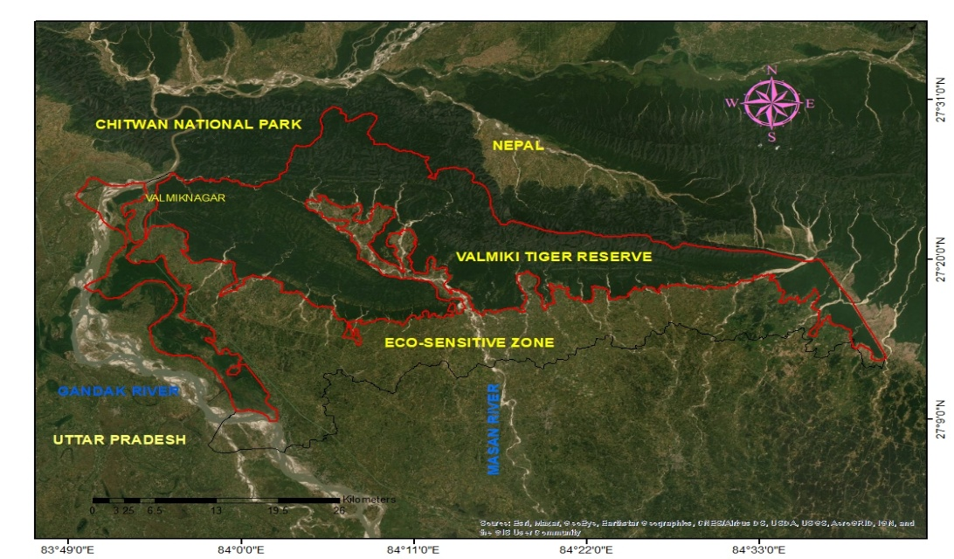
Fig.1. Location map of Eco-sensitive zone and Valmiki Tiger Reserve

Primary Data Collection

The primary data collection process involved a household questionnaire survey, conducted to analyze the perceptions, experiences, and mitigation strategies of local communities affected by human-wildlife conflict (Goodale et al., 2015). The survey covered 92 villages categorized into three distinct spatial classes based on their proximity to the protected area:
- Village Class 1 – Villages located inside the protected boundary or partially falling within it.
- Village Class 2 – Villages sharing a boundary with the protected area.
- Village Class 3 – Villages more than 5 km away from the protected boundary but within the eco-sensitive zone.

A simple random sampling method was employed to select the survey villages, resulting in 28 villages from Class 1, 25 villages from Class 2, and 39 villages from Class 3. In total, 428 households were surveyed across 92 villages, ensuring adequate representation of local populations living at varying distances from VTR. The questionnaire survey included both open-ended and closed-format questions, allowing for a detailed understanding of the nature, frequency, and impact of human-wildlife conflicts, along with local mitigation efforts (White et al., 2005). To facilitate effective data collection, a trained field assistant from the local community was employed. The assistant first contacted village headmen, explained the purpose and nature of the survey, and obtained oral consent from all participants before conducting interviews (McGuinness & Taylor, 2014). The average age of respondents ranged from 18 to 60 years, with 80.84% of the participants being male (346 individuals) and 19.15% female (82 individuals). The questionnaire survey was conducted from December 2021 to February 2022, with each interview lasting 20 to 35 minutes (average 30 minutes).

Additionally, field observations and photography were conducted to document visual evidence of wildlife damages, including crop destruction, livestock predation, property damage, and human injuries. These observations served as supplementary data to validate the information obtained through surveys. To analyze the long-term trends of human-wildlife conflict, secondary data sources were incorporated into the study. Newspaper reports were used to identify incidents of human-wildlife conflict over the past two years (2020–2021). Reports from Prabhat Khabar and Dainik Jagaran were examined to understand the spatial distribution, frequency, and nature of wildlife-related incidents in VTR and its eco-sensitive zone. This helped corroborate survey responses and assess seasonal variations in human-wildlife interactions.
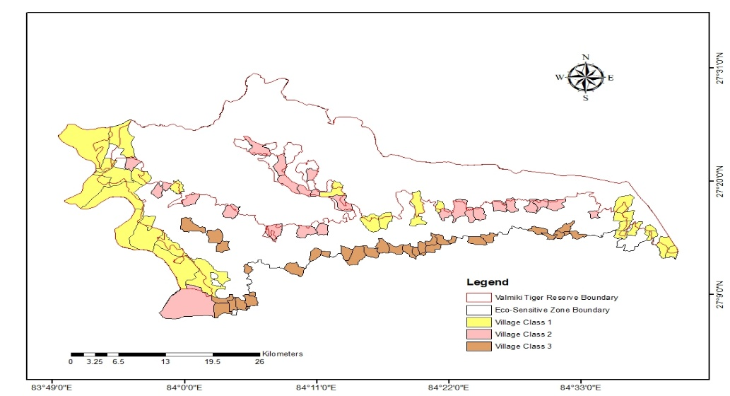
Fig.2. Survey villages situated in VTR boundary and Eco-sensitive zone.

Data Analysis
To ensure the validity and reliability of the collected survey data, statistical tests were conducted to analyze differences in human-wildlife conflict patterns across the three village classes (Class 1, Class 2, and Class 3).
a) Testing for Normality: Shapiro-Wilk Test
Before performing comparative statistical analysis, a Shapiro-Wilk test was applied to check whether the survey data followed a normal distribution. The results indicated that the data was not normally distributed, meaning that parametric statistical tests (such as t-tests or ANOVA) were not suitable for analysis.
b) Mann-Whitney U Test for Comparing Village Classes
Since the data was non-normally distributed, the Mann-Whitney U test was employed to determine whether there were significant differences in responses across the three village classes. The Mann-Whitney U test is a non-parametric alternative to the t-test, commonly used to compare differences between two independent groups when the assumption of normality is violated (Logan, 2010). This test was applied to assess differences in: Wildlife species responsible for livestock depredation, Frequency and intensity of wildlife attacks on different villages. The Statistical Package for Social Sciences (SPSS) version 20 for Windows (IBM SPSS Inc., Chicago, USA) was used to process and analyze the collected data.
Result and Discussion
The study highlights the widespread issue of human-wildlife conflict in the surveyed area, with 94.85% of respondents (n = 406) reporting encounters or observations of wildlife-induced challenges, while only 5.14% (n = 22) stated they had not experienced any conflicts. The majority of respondents (95.32%) relied on agriculture as their primary livelihood, supplementing their income with animal rearing. In terms of livestock rearing, 88% of respondents owned an average of two livestock per household, with most practicing local grazing or stall-feeding, while 14% grazed their livestock inside protected areas, potentially increasing exposure to predation.
Characteristics | Village class 1 n(%) | Village class 2 n(%) | Village class 3 n(%) | Total n(%)
No. of Villages | 28 | 26 | 34 | 88
No. of Respondents | 128 | 108 | 170 | 406
Occupation(Agriculture) | 122(95.31) | 104(96.29) | 161(94.70) | 387(95.32)
Average livestock/HH | 2 | 2 | 3
Types of Conflict
Livestock Depredation | 87(67.97) | 93(86.11) | 121(71.18) | 301(74.14)
Human Injury | 3(2.34) | 2(1.85) | 5(2.94) | 10(2.46)

Table 1. Household and human-wildlife characteristics of 406 surveyed households in and around VTR.

In addition to crop loss, livestock depredation by large carnivores was identified as another major source of economic loss for communities living near VTR. Tigers (Panthera tigris), leopards (Panthera pardus), wolves (Canis lupus), and wild dogs (Cuon alpinus) were the primary predators responsible for attacking livestock. The frequency of livestock attacks was highest in villages closest to VTR, highlighting the direct impact of predator presence on rural livelihoods.
Common Name | Scientific Name | Village class 1 (%) | Village class 2 (%) | Village class 3 (%) | Total (%)
Tiger | Panthera tigris | 24.64 | 26.17 | 24.22 | 24.97
Leopard | Panthera pardus | 37.44 | 34.77 | 33.23 | 34.85
Wolf | Canis lupus | 26.54 | 28.13 | 30.43 | 28.64
Wild dog | Cuon alpinus | 11.37 | 10.94 | 12.11 | 11.53
Table.2. Percent of Livestock depredation events by predators that were recorded as being involved in HWC in various village classes.

Table 2 presents the percentage of livestock depredation events attributed to major predators across different village classes in the study area. Leopards (Panthera pardus) emerged as the predominant predator, accounting for the highest proportion of depredation events (34.85%), followed by wolves (Canis lupus, 28.64%) and tigers (Panthera tigris, 24.97%). Wild dogs (Cuon alpinus) contributed comparatively less (11.53%). The relative contribution of each predator showed minor variation across village classes, but the overall pattern highlights leopards as the most frequent livestock predator in the Valmiki Tiger Reserve landscape. Previous research in Chitwan National Park, Nepal, found that tigers and leopards were responsible for more than 90% of total livestock depredation (Lamichhane et al., 2018). In the current study, leopards were identified as the most frequent predator. In contrast, tigers caused greater economic losses due to their tendency to target larger livestock, such as cattle and buffalo (Malviya & Ramesh, 2015).
The majority of incidents occurred during winter (53.82%), with the highest number recorded in Village Class 3 (64 events, 52.89%). This was followed by the monsoon season (21.93%), particularly in Village Class 3 (28.93%). Summer and spring accounted for comparatively fewer depredation events, representing 13.95% and 10.30% of the total, respectively. The seasonal trend suggests that livestock depredation risk peaks in winter months, with monsoon also emerging as a critical period in certain villages (Table 3).
Season |  | Village class 1 n(%) | Village class 2 n(%) |  | Village class 3 n(%) |  |  | Total n(%)
Summer | 17(19.54) |  |  | 15(16.13) |  | 10(8.26) | 42(13.95)
Monsoon | 20(22.99) |  |  | 11(11.83) |  | 35(28.93) | 66(21.93)
Winter | 42(48.28) |  |  | 56(60.22) |  | 64(52.89) | 162(53.82)
Spring | 8(9.20) |  |  | 11(11.83) |  | 12(9.92) | 31(10.30)
Total | 87(100) |  |  | 93(100) |  | 121(100) | 301(100)

Table 3. Livestock depredation in different seasons.

Overall, the majority of households (69.46%) perceived HWC as a severe problem, with the highest proportion reported in Village Class 2 (89.81%), followed by Class 1 (85.16%). In contrast, Village Class 3 showed more variation, where less than half (44.71%) considered HWC a severe problem, while nearly half (48.82%) regarded it as a moderate problem. Only a small proportion of respondents across all classes (4.19%) reported no problem with HWC. These results suggest that perceptions of conflict severity are strongest in Classes 1 and 2 villages, while Class 3 communities exhibit a relatively balanced view between severe and moderate levels of conflict (Table 4). The findings reveal a statistically significant difference in attitudes towards HWC between village classes 1 and 3 (Mann-Whitney U = 515.34, p = 0.016), suggesting that the proximity of human settlements to VTR plays a crucial role in shaping local perceptions of wildlife conflict.

Attitude towards HWC | Village class 1 n(%) | Village class 2 n(%) | Village class 3 n(%) | Total n(%)
Severe Problem | 109(85.16) | 97(89.81) | 76(44.71) | 282(69.46)
Moderate Problem | 16(12.50) | 8(7.41) | 83(48.82) | 107(26.35)
No Problem | 3(2.34) | 3(2.78) | 11(6.47) | 17(4.19)

Table 4. Attitude towards human-wildlife conflict (HWC) in various village class
The most widely reported strategy was the use of physical structures such as sheds, fences, or enclosures (75.86%), consistently practiced across all village classes, with the highest use in Class 2 (85.19%). Guarding of livestock was also common (63.05%), particularly in Class 2 villages (89.81%). The use of guard dogs was less prevalent overall (24.88%), though it was relatively more frequent in Class 2 (43.52%) compared to Classes 1 and 3 (Table 5). These findings suggest that while physical barriers are the primary preventive measure, guarding—either by humans or with dogs—remains an important supplementary strategy, especially in villages closer to high-conflict zones. To protect their livestock, respondents used strategies such as guarding animals during grazing and at night, constructing enclosures, and employing guard dogs, yet there was no significant difference in depredation patterns between different village classes (Mann-Whitney U = 873.34, p = 0.49).

Mitigation Method | Village class 1 n(%) | Village class 2 n(%) | Village class 3 n(%) | Total n(%)
Guarding | 83(64.84) | 97(89.81) | 76(44.71) | 256(63.05)
Guarding by dogs | 23(17.97) | 47(43.52) | 31(18.24) | 101(24.88)
Physical structures | 95(74.22) | 92(85.19) | 121(71.18) | 308(75.86)

Table 5. Mitigation methods used by respondents to prevent livestock depredation

Among the species, wild dogs (Cuon alpinus) accounted for the highest number of human injury cases (52), while leopards (Panthera pardus) were most frequently associated with livestock depredation (26) and panic events (34). Tigers (Panthera tigris) were involved in 7 human injury cases, 16 depredation events, and 19 instances of panic.
Common Name | Scientific Name | Human Injury | Livestock Depredation | Panic due to presence
Tiger | Panthera tigris | 7 | 16 | 19
Leopard | Panthera pardus | 16 | 26 |  | 34
Bear | Melursus ursinus | 9 | 00 |  | 18
Wolf | Canis lupus | 12 | 04 |  | 18
Wild Dog | Cuon alpinus | 52 | 08 |  | 02
Monkey | Rhesus Macaque | 14 | 00 |  | 12
Crocodile | Gangeticus | 2 | 06 |  | 18
Python | Pythonidae spp | 4 | 00 |  | 23

Table 6. Human injury, livestock depredation, and the panic situation were reported in the local newspaper from 2020 to 2021
Bears (Melursus ursinus), wolves (Canis lupus), and crocodiles (Gavialis gangeticus) also contributed notably to human injuries and panic situations, though livestock losses were relatively lower (Table 6). Interestingly, pythons (Pythonidae spp.) and monkeys (Macaca mulatta) were not associated with livestock depredation but were frequently reported for generating panic. Previous studies in Chitwan National Park, Nepal, documented that rhinoceroses, tigers, and sloth bears were responsible for the majority of human attacks (Silwal et al., 2017). However, in the present study, only 2.46% of respondents reported cases of human injuries. This suggests that VTR’s human-wildlife conflict is predominantly economic in nature, rather than a direct threat to human safety.
Conclusion
Human-wildlife conflict in and around the Valmiki Tiger Reserve represents a persistent and economically significant challenge for local communities. The high dependence on agriculture and livestock rearing increases vulnerability to wildlife-induced losses, with leopards and tigers causing substantial damage to larger livestock and wolves and wild dogs impacting smaller animals. Seasonal peaks in depredation, particularly during winter, highlight the need for targeted preventive measures during high-risk periods. Although traditional mitigation strategies such as enclosures, guard dogs, and vigilant herding are employed, their limited effectiveness calls for improved, community-driven, and scientifically informed approaches. Given the statistically significant link between proximity to VTR and perceived conflict severity, conservation planning must incorporate buffer-zone management, alternative livelihood options, and compensation mechanisms to reduce economic strain. Addressing these challenges is essential to balancing predator conservation with the socio-economic well-being of human communities in the VTR landscape.

References
Chaudhury, P.C.R. 1960. Bihar District Gazetteers Champaran. Patna.
Chanchani, P., Noon, B. R., Bista, A., & Warrier, R. (2024). Influence of resource gradients and habitat edges on density variation in tiger populations in a multi-use landscape. Frontiers in Ecology and Evolution. https://doi.org/10.3389/fevo.2024.1209309
Chanchani, P., Lamichhane, B.R., Maurya, K., et al. 2014. Tigers of the transboundary Terai Arc Landscape – Status, distribution and movement in the Terai of India and Nepal. National Tiger Conservation Authority, Govt. of India, and Dept. of National Park and Wildlife Conservation, Govt. of Nepal.
Distefano, E. (2005). Human-wildlife conflict worldwide: A collection of case studies, analysis of management strategies and good practices. FAO, Sustainable Agriculture and Rural Development (SARD) Initiative. http://www.fao.org/3/a-au241e.pdf
Goodale, K., Parsons, G. J., & Sherren, K. (2015). The nature of the nuisance—damage or threat—determines how perceived monetary costs and cultural benefits influence farmer tolerance of wildlife. Diversity, 7(3), 318–341. https://doi.org/10.3390/d7030318
Johnsingh, A. J. T., Ramesh, K., Qureshi, Q., David, A., Goyal, S. P., Rawat, G. S., Rajapandian, K., & Prasad, S. (2004). Conservation status of tiger and associated species in the Terai Arc Landscape, India. Wildlife Institute of India. https://dspace.wii.gov.in/bitstream/handle/123456789/1009/2004_Johnsingh%20A.J.T.,%20Ramesh%20K.,%20Qureshi%20Q.,%20David%20A.,%20Goyal%20S.P.,%20Rawat%20G.S.,%20Rajapandian%20K.%20and%20Prasad%20S_Conservation%20status%20of%20tiger%20and%20associated%20species%20in%20the%20Terai%20Arc%20Landscape,%20India..pdf .
Lamichhane, B. R., Persoon, G. A., Leirs, H., Poudel, S., Subedi, N., Pokheral, C. P., Bhattarai, S., Thapaliya, B. P., & de Iongh, H. H. (2018). Spatio-temporal patterns of attacks on human and economic losses from wildlife in Chitwan National Park, Nepal. PLoS ONE, 13(4), e0195373. https://doi.org/10.1371/journal.pone.0195373
Logan, M. (2010). Biostatistical design and analysis using R: A practical guide. John Wiley & Sons. https://www.wiley.com/en-us/Biostatistical+Design+and+Analysis+Using+R%3A+A+Practical+Guide-p-9781405190084
Malviya, M., & Ramesh, K. (2015). Human–felid conflict in corridor habitats: implications for tiger and leopard conservation in Terai Arc Landscape, India. Human–Wildlife Interactions, 9(1), 48–57. https://doi.org/10.26077/x9tx-gb97
McGuinness, S., & Taylor, D. (2014). Farmers' perceptions and actions to decrease crop raiding by forest-dwelling primates around a Rwandan forest fragment. Human Dimensions of Wildlife, 19(2), 179-190. https://doi.org/10.1080/10871209.2014.853330
Silwal, T., Kolejka, J., Bhatta, B. P., Rayamajhi, S., Sharma, R. P., & Poudel, B. S. (2017). When, where and whom: assessing wildlife attacks on people in Chitwan National Park, Nepal. Oryx, 51(2), 370–377. https://doi.org/10.1017/S0030605315001489
Walston, J., Robinson, J. G., Bennett, E. L., Breitenmoser, U., da Fonseca, G. A. B., Goodrich, J., Gumal, M., Hunter, L., Johnson, A., Karanth, K. U., Leader-Williams, N., Mackinnon, K., Miquelle, D., Pattanavibool, A., Poole, C., Rabinowitz, A., Smith, J. L. D., Stokes, E. J., Stuart, S. N., Vongkhamheng, C., & Wibisono, H. (2010). Bringing the Tiger Back from the Brink—The Six Percent Solution. PLoS Biology, 8(9): e1000485 https://doi.org/10.1371/journal.pbio.1000485
White, P. C. L., Jennings, N. V., Renwick, A. R., & Barker, N. H. L. (2005). Questionnaires in ecology: A review of past use and recommendations for best practice. Journal of Applied Ecology, 42(3), 421–430. https://doi.org/10.1111/j.1365-2664.2005.01032.x .

