Evaluating The Therapeutic Effects of Aqueous Leaf Extract of Nephrolepis Biserrata on Biochemical, Haematological, Physical, Atherogenic, And Histopathological Parameters in Testosterone Propionate-Induced Benign Prostatic Hyperplasia in Male Wistar Rats

ABSTRACT

Background: Benign Prostatic Hyperplasia (BPH) is a common non-cancerous enlargement of the prostate gland, predominantly affecting men over the age of 50(1). It results from the overgrowth of stromal and smooth muscle cells within the prostate (2). The condition leads to lower urinary tract symptoms (LUTS), such as frequent urination, nocturia, and difficulty in voiding, which can severely reduce quality of life
Aim: This study aims to evaluate the therapeutic effects of the aqueous leaf extract of Nephrolepis biserrata on biochemical, haematological, physical, atherogenic, and histopathological parameters in testosterone propionate-induced benign prostatic hyperplasia (BPH) in male Wistar rats.
Objectives: To Evaluate Phytochemical Screening of Nephrolepis biserrata, assessment of its proximate and mineral Composition, its biochemical parameters, haematological assessment and histological assessment of prostate architecture
Methods: following 7 days of acclimatization, rats were exposed to 8mg/kg of testosterone propionate subcutaneous for 11,22 and 33 days thereafter treated with 100mg/kg ,200mg/kg and 300mg/kg of nephrolepis biserrrata aqueous leaf extract orally for 11,22 and 33 days .at the end of the 11,22- and 33-days experimentation, animals were euthanized, blood and tissue samples was collected for haematological, biochemical and histological analysis.
Results: the results showed that nephrolepis biserrata enhances (SOD, CAT, GPX) activities and Reduced MDA concentration. also, nephrolepis biserrata reduces inflammatory biomarkers, total cholesterol, LDL, Triglyceride and elevation of HDL as well as restoration of distorted architectural structure of the prostate tissue.
Conclusion: in conclusion, this study suggests that nephrolepis biserrata protect against testosterol propionate induced benign prostatic hyperplasia by enhancing oxidative stress enzymes, inhibiting dihydrotestosterone as well attenuation of prostate tissue membrane disruption.

Keywords: Nephrolepis biserrata, oxidative stress, inflammation, testosterone propionate,Benign Prostatic Hyperplasia

INTRODUCTION

Benign Prostatic Hyperplasia (BPH) is a common non-cancerous enlargement of the prostate gland, predominantly affecting men over the age of 50 (1). It results from the overgrowth of stromal and smooth muscle cells within the prostate (2). The condition is characterized by lower urinary tract symptoms (LUTS), including frequent urination, nocturia, and difficulty in voiding, which can significantly reduce quality of life. The pathophysiology of BPH is multifactorial and involves hormonal imbalances, particularly elevated dihydrotestosterone levels, as well as chronic inflammation and oxidative stress (3).
Conventional treatment options for BPH include alpha-adrenergic blockers such as doxazosin and 5-alpha-reductase inhibitors like finasteride. Although these therapies are effective, they are often associated with adverse side effects, including sexual dysfunction, gynecomastia, and hypotension. Consequently, there has been growing interest in plant-based alternatives that may offer comparable therapeutic efficacy with reduced toxicity and fewer side effects (4).
Nephrolepis biserrata, commonly known as buckler fern or Paku in certain parts of Malaysia, is a perennial fern that grows abundantly in wet and shaded environments such as riverbanks and marshes (5). Traditionally, the plant has been used in the management of various ailments, including miscarriage prevention, support of foetal development, wound healing, and gastrointestinal disorders (6). Scientific interest in Nephrolepis biserrata is largely attributed to its rich phytochemical composition, which includes alkaloids, flavonoids, tannins, saponins, terpenoids, steroids, phenols, and cardiac glycosides (7).
These bioactive compounds are widely recognized for their anti-inflammatory, antioxidant, and anti-androgenic properties, making Nephrolepis biserrata a promising candidate for the management of BPH. In addition, lipid metabolism plays a crucial role in BPH progression, as dyslipidemia has been shown to exacerbate prostatic enlargement and inflammatory processes (8).
This study evaluated the therapeutic potential of the aqueous leaf extract of Nephrolepis biserrata in the management of testosterone propionate-induced BPH in male Wistar rats. The investigation covered biochemical, haematological, inflammatory, oxidative, and physical biomarkers, thereby providing a comprehensive assessment of the plant’s therapeutic effects.

Aim of the Study
This study aimed to evaluate the therapeutic effects of the aqueous leaf extract of Nephrolepis biserrata on biochemical, haematological, physical, atherogenic, and histopathological parameters in testosterone propionate-induced benign prostatic hyperplasia (BPH) in male Wistar rats.

Objectives
- To evaluate the phytochemical composition of Nephrolepis biserrata.
- To assess the proximate and mineral composition of Nephrolepis biserrata.
- To determine selected biochemical parameters following extract administration.
- To assess haematological parameters in treated and control animals.
- To evaluate histological changes in prostate architecture following treatment.

MATERIALS AND METHODS

Plant Collection and extraction
Fresh leaves of Nephrolepis biserrata were collected from the Choba River bank in Rivers State, Nigeria, and were authenticated at the Herbarium of the University of Port Harcourt. The collected leaves were thoroughly washed to remove debris, air-dried at room temperature, and ground into a fine powder using a mechanical grinder. The powdered plant material was extracted with deionized water by maceration. The resulting filtrate was concentrated using a water bath and subsequently stored in a refrigerator until further analysis.
Phytochemical screening
Qualitative phytochemical screening of the aqueous leaf extract of Nephrolepis biserrata was carried out to identify the presence of major bioactive constituents. Standard qualitative methods, as described by Harborne and Trease & Evans, were employed for the detection of alkaloids, flavonoids, saponins, tannins, terpenoids, steroids, and phenolic compounds.
Table 1. Phytochemical constituents of Nephrolepis biserrata
Phytochemical | Status
Alkaloids | +
Flavonoids | +
Saponins | +
Phenols | +
Steroids | +
Tannins | +
Terpenoids | +
(+) = present
( - ) = absent

Animal Handling
Eighty healthy male Wistar rats weighing 200–250 g were used for this study. The animals were housed under standard laboratory conditions, with a controlled temperature of 25–28 °C and a 12-hour light/dark cycle. They were allowed to acclimatize for one week prior to the commencement of the experiment. All procedures involving animal handling and experimental protocols were conducted in accordance with the ARRIVE guidelines for the care and use of laboratory animals (NIH publication, 1996, No. 85-23).

Ethical Approval
The experimental protocol for this study was thoroughly reviewed and approved by the Ethics Committee of the University of Port Harcourt, Choba, Rivers State, Nigeria, with approval reference number UPH/CEREMAD/REC/MM98/048.

Experimental Design
The rats were divided into sixteen (16) groups of five animals per group according to their body weight, and each group was subjected to the following treatments: Group 1 (normal control) received distilled water for 33 days; Group 2 (negative control, 11 days) received 8 mg/kg body weight of testosterone propionate (TP) for 11 days; Group 3 (negative control, 22 days) received 8 mg/kg body weight of TP for 22 days; Group 4 (negative control, 33 days) received 8 mg/kg body weight of TP for 33 days; Group 5 (positive control, 11 days) received 8 mg/kg body weight of TP plus 5 mg/kg body weight of finasteride and 1 mg/kg body weight of doxazosin for 11 days; Group 6 (positive control, 22 days) received 8 mg/kg body weight of TP plus 5 mg/kg body weight of finasteride and 1 mg/kg body weight of doxazosin for 22 days; Group 7 (positive control, 33 days) received 8 mg/kg body weight of TP plus 5 mg/kg body weight of finasteride and 1 mg/kg body weight of doxazosin for 33 days; Group 8 consisted of TP-induced rats treated with 100 mg/kg body weight of the extract for 11 days; Group 9 consisted of TP-induced rats treated with 100 mg/kg body weight of the extract for 22 days; Group 10 consisted of TP-induced rats treated with 100 mg/kg body weight of the extract for 33 days; Group 11 consisted of TP-induced rats treated with 200 mg/kg body weight of the extract for 11 days; Group 12 consisted of TP-induced rats treated with 200 mg/kg body weight of the extract for 22 days; Group 13 consisted of TP-induced rats treated with 200 mg/kg body weight of the extract for 33 days; Group 14 consisted of TP-induced rats treated with 300 mg/kg body weight of the extract for 11 days; Group 15 consisted of TP-induced rats treated with 300 mg/kg body weight of the extract for 22 days; and Group 16 consisted of TP-induced rats treated with 300 mg/kg body weight of the extract for 33 days.

Acute Toxicity Test (LD₅₀)
The safety of the aqueous leaf extract of Nephrolepis biserrata was assessed using the Organisation for Economic Co-operation and Development (OECD) Guideline 425 (Up-and-Down Procedure). Oral administration of the extract at doses up to 5000 mg/kg body weight produced no observable signs of toxicity or mortality during the observation period, indicating that the extract was non-toxic at the therapeutic doses used in this study.

Induction of Benign Prostatic Hyperplasia (BPH)

Benign prostatic hyperplasia was induced in the rats by daily subcutaneous injections of testosterone propionate at a dose of 8 mg/kg body weight for periods of 11, 22, and 33 days. The normal control group received distilled water throughout the experimental period. Rats in the positive control groups received finasteride (5 mg/kg body weight) and doxazosin (1 mg/kg body weight) concurrently with testosterone propionate administration.

Treatment Design

Following the induction of benign prostatic hyperplasia, rats were treated according to their respective group allocations. Treatment consisted of finasteride in combination with doxazosin for the positive control groups, while the experimental treatment groups received aqueous leaf extract of Nephrolepis biserrata at doses of 100, 200, and 300 mg/kg body weight for durations of 11, 22, and 33 days, respectively.

Sample Collection
At the end of each treatment period, the rats were sacrificed. Blood samples were collected for biochemical and haematological analyses, while the prostate and testis tissues were carefully excised for histopathological examination and biochemical assays.

Biochemical Assays

The following biochemical parameters were measured in this study. The lipid profile, including total cholesterol, high-density lipoprotein (HDL), low-density lipoprotein (LDL), and triglycerides, was estimated using standard enzymatic methods as previously described [24][25][26]. Inflammatory markers, namely tumor necrosis factor-alpha (TNF-α), interleukin-6 (IL-6), and C-reactive protein (CRP), were determined using established methods reported in the literature [27][28]. Oxidative stress parameters, including malondialdehyde (MDA), catalase, glutathione peroxidase, and superoxide dismutase, were also assessed using standard assay procedures. Prostate-specific antigen (PSA) levels were determined by adopting previously described methods [17][29].

RESULTS

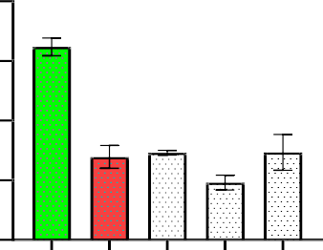
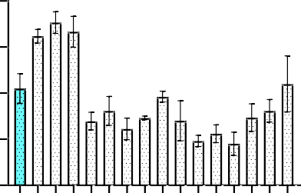
8 8
#
*
*
*
*
* *
CRP(mg/L) (day 11)
6 6
CRP(mg/L)
4 4
2 2
0 0
group 1 (cntrl)
group 2
group 3
group 4
group 5
group 6
group 7
group 8
group 9
group 10
group 11
group 12
group 13
group 14
group8
group5(+ctr)
group2(-ctr)
group 15
group 16
group14
group11

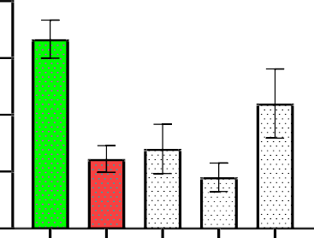
#
*
*
*
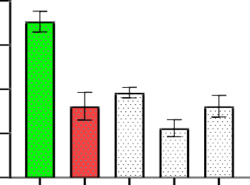
8
#
*
*
*
*
CRP (mg/L)(day 33)
8
CRP(mg/L) (day 22)
6
6
4
4

2 2

0 0
group4(-ctr)
group7(ctr)
group10
group13
group16
group3(-ctr)
group6(+ctr)
group9
group12
group15

Figure 1: Nephrolepis biserrata aqueous leaf extract attenuates C-reactive protein (CRP) concentration on day (11), (22), and (33).
Testosterone propionate–induced groups showed elevated CRP levels, indicating increased systemic inflammation, while treatment with the extract resulted in a dose- and time-dependent reduction in CRP concentration across the experimental periods. All values are expressed as mean ± SEM (=5), *p<0.05 when compared with positive control groups, while #p<0.05 was significant when compared with the negative control groups. Extract = Nephrolepis biserrata .
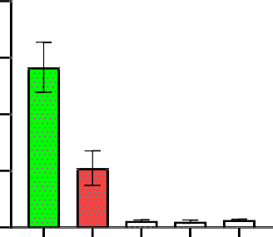
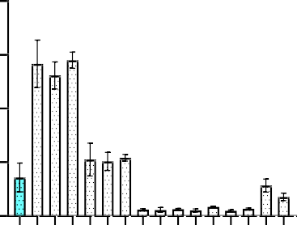
80 80
#
*
* *
*
*
* *
IL-6(pg/mL) (day 11)

60 60
IL-6(pg/mL)

40 40

20 20

0 0
group 1 (cntrl)
group 2
group 3
group 4
group 5
group 6
group 7
group 8
group 9
group 10
group 11
group 12
group 13
group 14
group 15
group 16
group 8
group 11
group 14
group 5 (+ctr)
group 2 (-ctr)

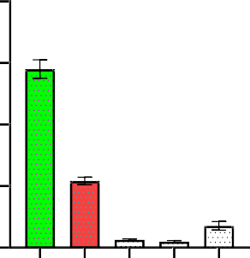
80
IL-6(pg/mL) (day 33)
#
*
#* #*
*#
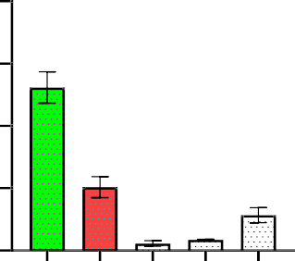
80
#
*
*
*# *#
IL-6 (pg/mL)(day 22)
60
60

40
40

20 20

0 0
group 4 (-ctr)
group 7 (ctr)
group 10
group 13
group 16
group 3 (-ctr)
group 6 (+ctr)
group 9
group 12
group 15

Figure 2: Nephrolepis biserrata aqueous leaf extract attenuates interleukin-6 (IL-6) levels on day (11), (22), and (33).
Testosterone propionate–induced groups showed elevated IL-6 levels, reflecting enhanced inflammatory response, while treatment with the extract resulted in a progressive reduction in IL-6 levels across the treatment durations, indicating anti-inflammatory activity of the extract. All values are expressed as mean ± SEM (=5), *p<0.05 when compared with positive control groups, while #p<0.05 was significant when compared with the negative control groups. Extract = Nephrolepis biserrata.

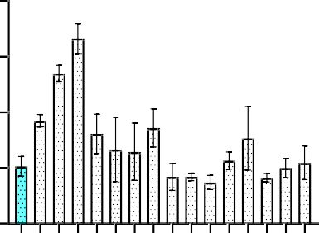
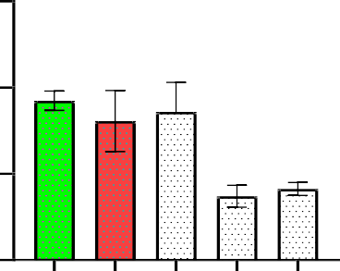
20 15
*
*
TNF(pg/mL) (day 11)
*
*

15 10
TNF(pg/mL)

10
5
5

0 0
group 1 (cntrl)
group 2
group 3
group 4
group 5
group 6
group 7
group 8
group 9
group 10
group 11
group 12
group 13
group 14
group 15
group 16
group8
group11
group14
group2(-ctr)
group5(+ctr)

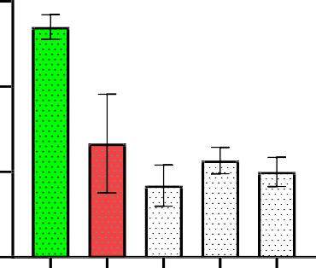
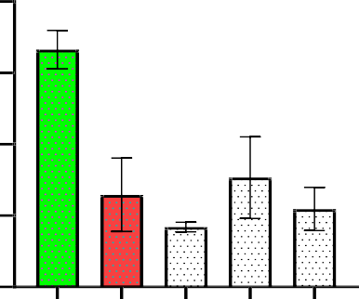
15 20
#
*
*
*
*
TNF(pg/mL) (day 33)
#
*
*
*
*
TNF (pg/mL)(day 22)

15
10
10

5
5

0 0
group 3 (-ctr)
group 6 (+ctr)
group 9
group 12
group 15
group4(-ctr)
group7(ctr)
group10
group13
group16

Figure 3: Nephrolepis biserrata aqueous leaf extract attenuates tumor necrosis factor alpha (TNF-α) levels on day (11), (22), and (33).
Testosterone propionate–induced groups exhibited elevated TNF-α levels, indicating enhanced inflammatory activity associated with benign prostatic hyperplasia, while treatment with the extract resulted in a marked reduction in TNF-α levels across the experimental periods, suggesting effective anti-inflammatory action. All values are expressed as mean ± SEM (=5), *p<0.05 when compared with positive control groups, while #p<0.05 was significant when compared with the negative control groups. Extract = Nephrolepis biserrata. These findings support earlier reports that chronic inflammation plays a central role in BPH progression and that suppression of pro-inflammatory cytokines contributes to prostate tissue remodeling and symptom regression [15, 16].

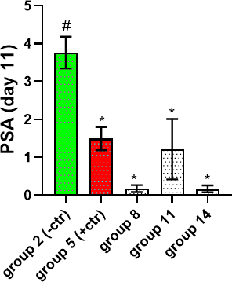
8
*
* *

6
PSA(ng/mL)

4

2

0
group 1 (cntrl)
group 2
group 3
group 4
group 5
group 6
group 7
group 8
group 9
group 10
group 11
group 12
group 13
group 14
group 15
group 16

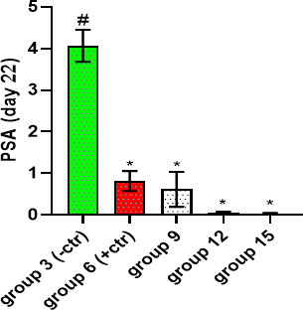
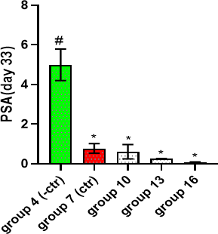

Figure 4: Effect of aqueous extract of Nephrolepis biserrata on prostate-specific antigen (PSA) concentration on day (11), (22), and (33). Testosterone propionate–induced groups showed elevated PSA levels, indicative of androgen-driven prostatic hyperplasia, while treatment with the extract resulted in a progressive reduction in PSA concentration across the experimental periods. All values are expressed as mean ± SEM (=5), *p<0.05 when compared with positive control groups, while #p<0.05 was significant when compared with the negative control groups. Extract = Nephrolepis biserrata. Elevated PSA levels are a recognized surrogate marker of androgen-driven prostatic hyperplasia, and their reduction following treatment suggests effective modulation of prostatic epithelial activity [17].
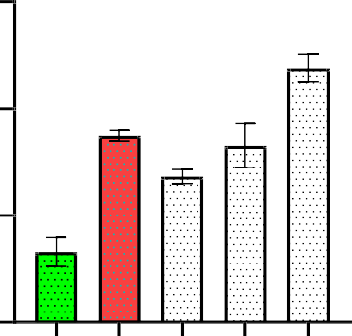
30
#*
*
*
*
#
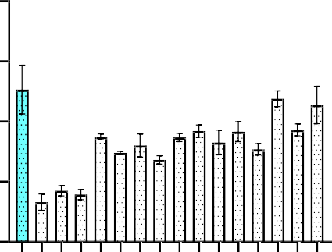
40
* *
*
*
*
*
*
* * *
P/CAT (day 11)

30 20
P/CAT

20
10
10

0 0
group 1 (cntrl)
group 2
group 3
group 4
group 5
group 6
group 7
group 8
group 9
group 10
group 11
group 12
group 13
group 14
group 15
group 16
group 2 (-ctr)
group 5 (+ctr)
group 8
group 11
group 14

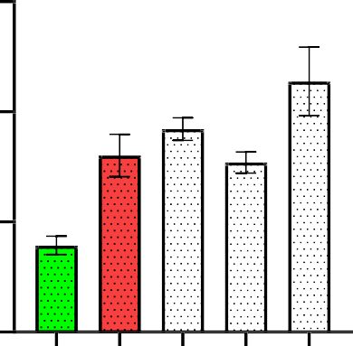
30
*
*
*
*
#
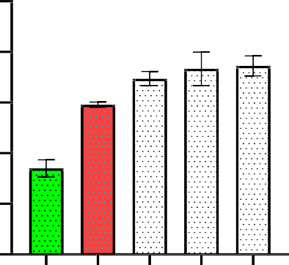
25
*
*
*
*
#
P/CAT (day 33)

20
P/CAT (day 22)
20
15

10 10

5
0 0
group 4 (-ctr)
group 7 (ctr)
group 10
group 13
group 16
group 3 (-ctr)
group 6 (+ctr)
group 9
group 12
group 15

Figure 5: Effect of aqueous extract of Nephrolepis biserrata on catalase (CAT) activities on day (11), (22), and (33). Testosterone propionate–induced groups showed reduced catalase activity, indicating impaired antioxidant defense, while treatment with the extract resulted in a progressive increase in CAT activities across the experimental periods, suggesting enhancement of endogenous antioxidant capacity. All values are expressed as mean ± SEM (=5), *p<0.05 when compared with positive control groups, while #p<0.05 was significant when compared with the negative control groups. Extract = Nephrolepis biserrata..
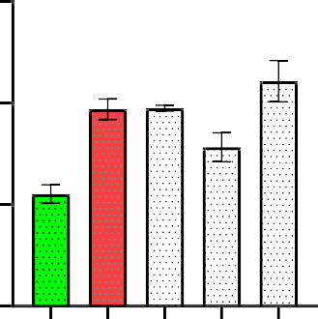
60
*
*
*
#
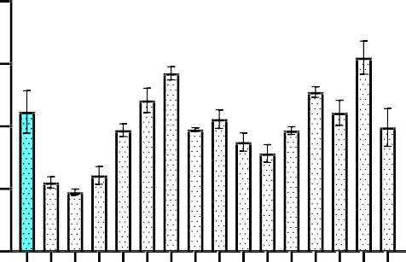
80
*
* * *
P/GPX (day 11)

60 40

40
P/GPX
20
20

0 0
group 2 (-ctr)
group 5 (+ctr)
group 8
group 11
group 14
group 1 (cntrl)
group 2
group 3
group 4
group 5
group 6
group 7
group 8
group 9
group 10
group 11
group 12
group 13
group 14
group 15
group 16

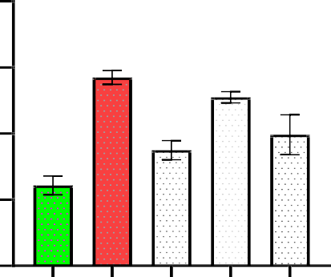
80
*
*
#*
#
#
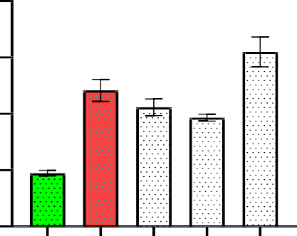
80
#*
*
*
*
#
P/GPX (day 33)

60 60
P/GPX (day 22)

40 40

20 20

0 0
group4(-ctr)
group7(ctr)
group10
group13
group16
group3(-ctr)
group6(+ctr)
group9
group12
group15

Figure 6: Nephrolepis biserrata aqueous extract attenuates glutathione peroxidase (GPX) activity on day (11), (22), and (33). Testosterone propionate–induced groups exhibited reduced GPX activity, indicating increased oxidative stress, while treatment with the extract resulted in a progressive increase in GPX activity across the experimental periods, suggesting improved antioxidant defense. All values are expressed as mean ± SEM (=5), *p<0.05 when compared with positive control groups, while #p<0.05 was significant when compared with negative control groups. Extract = Nephrolepis biserrata.
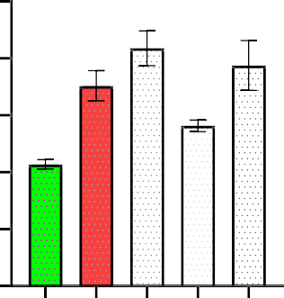
50
*
*
*
#
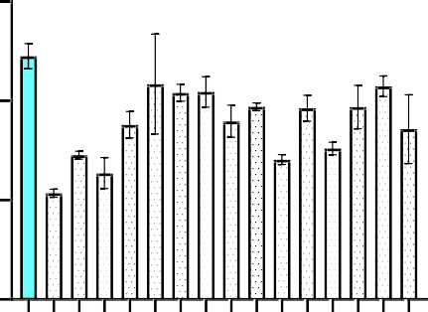
60
* *
*
*
*
40
P/SOD (day 11)

40 30
P/SOD

20
20
10

0 0
group 1 (cntrl)
group 2 (-ctr)
group 2
group 3
group 4
group 5
group 6
group 7
group 8
group 9
group 10
group 11
group 12
group 13
group 14
group 15
group 16
group 5 (+ctr)
group 8
group 11
group 14

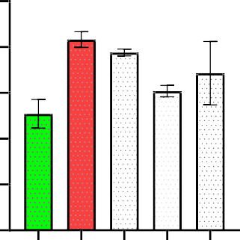
50
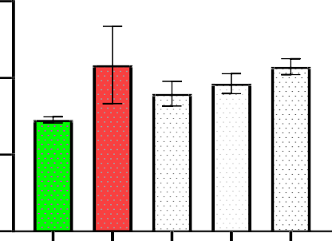
60
P/SOD (day 33)
40
P/SOD (day 22)

40 30

20
20
10

0 0
group 4 (-ctr)
group 7 (ctr)
group 10
group 13
group 16
group9
group12
group15
group3(-ctr)
group6(+ctr)

Figure 7: Nephrolepis biserrata aqueous extract attenuates tissue peroxidation by elevating glutathione peroxidase (GPX) activities on day (11), (22), and (33). Testosterone propionate–induced groups showed increased tissue peroxidation, reflecting heightened oxidative stress, while administration of the extract resulted in a significant elevation of GPX activity across the experimental periods, indicating enhanced antioxidant defense. All values are expressed as mean ± SEM (=5), p<0.05. Restoration of endogenous antioxidant enzymes following extract administration indicates attenuation of oxidative stress, a key contributor to testosterone-induced prostatic enlargement [18, 19]..

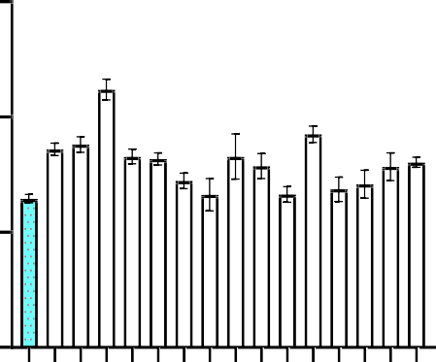
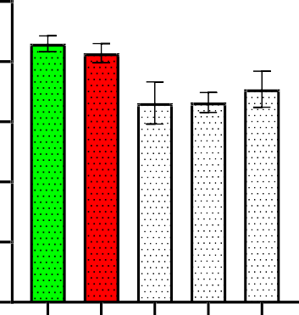
15 10
*
* *
*
*
*
total chol (mmol/L) day 11
Total Chol.(mmol/L)

8
10
6

4
5
2

0 0
group 1 (cntrl)
group 2 (-ctrl)
group 2
group 3
group 4
group 5
group 6
group 7
group 8
group 9
group 10
group 11
group 12
group 13
group 14
group 15
group 16
group 5 (+ctrl)
group 8
group 11
group 14

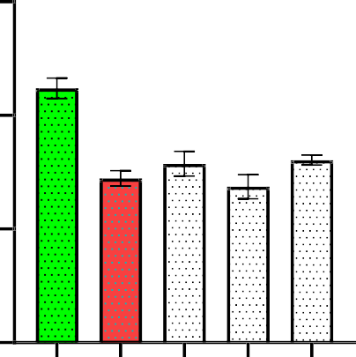
15
Total chol (mmol/L) 33
#
*
*
*
*
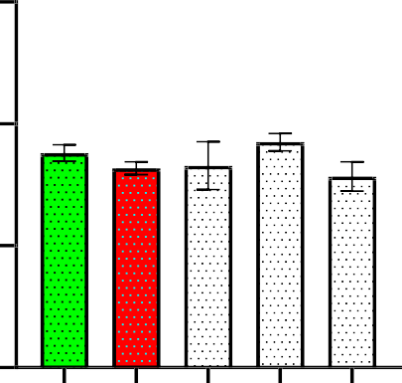
15
Total chol (mmol/L) 22

10
10

5 5

0 0
group 4 (-ctrl)
group 7 (+ctrl)
group 10
group 13
group 16
group 3 (-ctrl)
group 6 (+ctrl)
group 9
group 12
group 15

Figure 8: Nephrolepis biserrata aqueous leaves extract attenuates reduced total cholesterol in experimental groups concentration on day (11), (22) and (33).
ALL Values are expressed mean±SEM (=5), *p<0.05 when compared with positive control groups. while #p<0.05 was significant when com pared with the with negative control groups. Extract= of nephrolepis biserrata
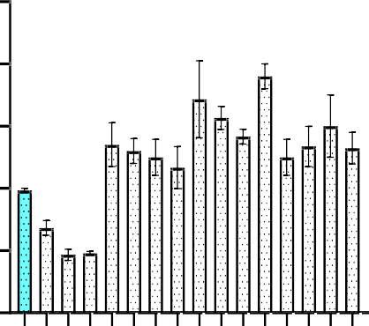
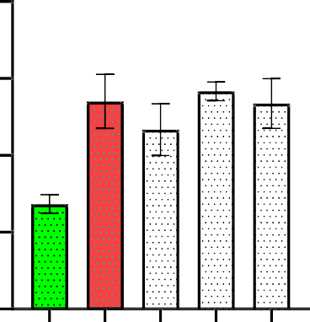
5 4
*
*
*
*
*
#
HDL-C (mmol/L) 11

4 3
HDL-C (mmol/L)

3
2
2
1
1

0 0
group1(cntrl)
group2
group3
group4
group5
group6
group7
group8
group9
group10
group11
group12
group13
group14
group15
group16
group 2 (-ctrl)
group 5 (+ctrl)
group 8
group 11
group 14

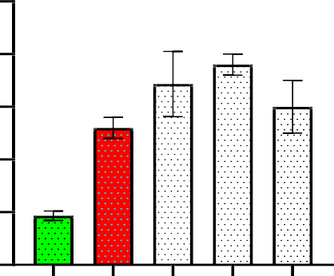
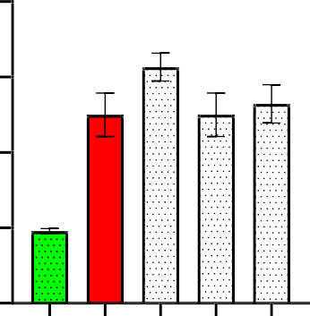
5 4
*
*
*
*
#
HDL-C (mmol/L) 33
*
*
*
*
#
HDL-C (mmol/L) 22

4 3

3
2
2
1
1

0 0
group 4 (-ctrl)
group 7 (+ctrl)
group 10
group 13
group 16
group3(-ctrl)
group6(+ctrl)
group 9
group12
group15

Figure 9: The aqueous extract of Nephrolepis biserrata ameliorates high-density lipoprotein (HDL) concentration on day (11), (22), and (33). Testosterone propionate, induced groups showed reduced HDL levels, indicating dyslipidemia associated with benign prostatic hyperplasia, while treatment with the extract resulted in a dose- and time-dependent increase in HDL concentration across the experimental periods, suggesting improvement in lipid metabolism. All values are expressed as mean ± SEM (=5), *p<0.05 when compared with positive control groups, while #p<0.05 was significant when compared with the negative control groups. Extract = Nephrolepis biserrata.

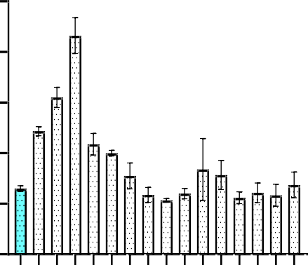
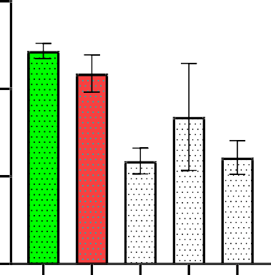
5 3
*
*
*
LDL-C (mmol/L) 11

4
LDL-C (mmol/L)
2
3

2 1
1

0 0
group1(cntrl)
group2
group3
group4
group5
group6
group7
group8
group9
group10
group11
group12
group13
group14
group15
group16
group 2 (-ctrl)
group 5 (+ctrl)
group 8
group 11
group 14

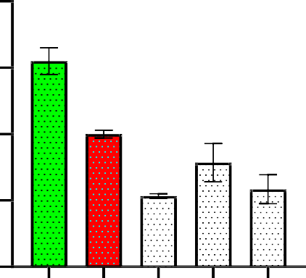
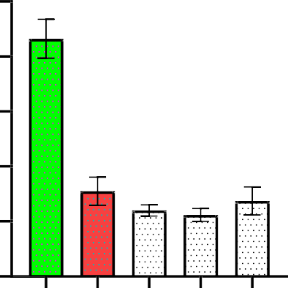
4 5
#
*
*
#*
#*
LDL-C (mmol/L) 33
#
*
*
*
*
LDL-C (mmol/L) 22
4
3
3
2
2

1 1

0 0
group 4 (-ctrl)
group 7 (+ctrl)
group 10
group 13
group 16
group 3 (-ctrl)
group 4 (-ctrl)
group 9
group 12
group 15

Figure 10: Effect of aqueous leaf extract of Nephrolepis biserrata on low-density lipoprotein cholesterol (LDL-C) concentration in testosterone propionate–induced benign prostatic hyperplasia in male Wistar rats. Testosterone propionate administration resulted in elevated LDL-C levels, indicating dyslipidemia associated with benign prostatic hyperplasia, while treatment with the extract produced a reduction in LDL-C concentration, suggesting an improvement in lipid metabolism..
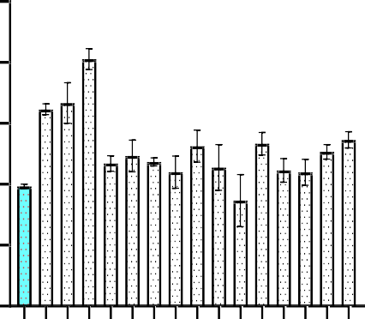
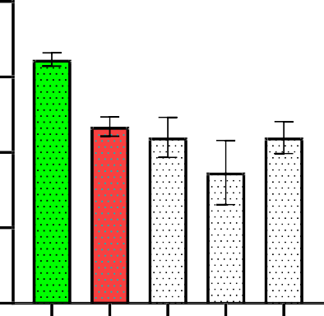
5 4
*
*
*
Triglyceride (mmol/L) 11
*
*

4 3
Triglycerides (mmol/L)

3
2
2
1
1

0 0
group1(cntrl)
group2
group3
group4
group5
group6
group7
group8
group9
group10
group11
group12
group13
group14
group15
group16
group 2 (-ctrl)
group 5 (+ctrl)
group 8
group 11
group 14

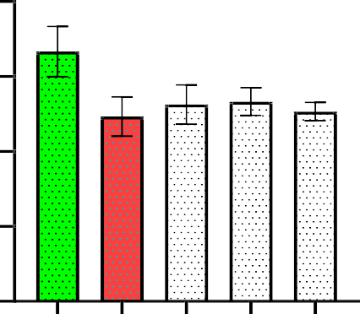
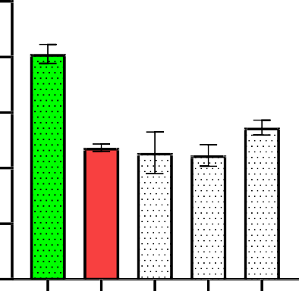
4 5
Triglyceride (mmol/L) 33
#
*
*
*
*
Triglyceride (mmol/L) 22
4
3
3
2
2

1 1

0 0
group 4 (-ctrl)
group 7 (+ctrl)
group 10
group 13
group 16
group 3 (-ctrl)
group 6 (+ctrl)
group 9
group 12
group 15

Figure 11: Effect of aqueous leaf extract of Nephrolepis biserrata on triglyceride concentration in testosterone propionate, induced benign prostatic hyperplasia in male Wistar rats. Testosterone propionate administration resulted in elevated triglyceride levels, indicating altered lipid metabolism associated with benign prostatic hyperplasia, while treatment with the extract led to a reduction in triglyceride concentration, suggesting an ameliorative effect on dyslipidemia.

2.5
VLDL-C (mmol/L)

2.0

1.5

1.0

0.5
2.0

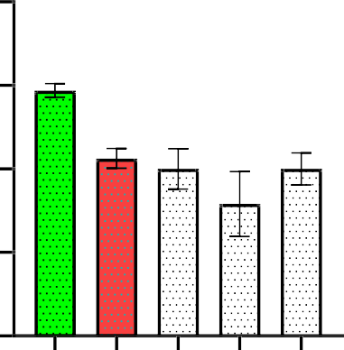
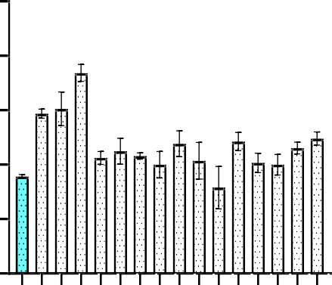
1.5
*
VLDL-C (mmol/L) 11
*
* *

1.0

0.5

0.0
group1(cntrl)
group2
group3
group4
group5
group6
group7
group8
group9
group10
group11
group12
group13
group14
group15
group16
group 2 (-ctrl)
group 5 (+ctrl)
group 8
group 11
group 14
0.0

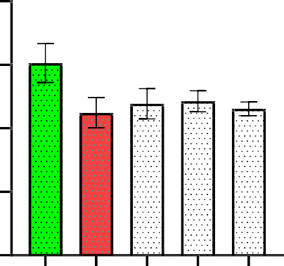
2.0
VLDL-C (mmol/L) 22

1.5

1.0

0.5

0.0
group 4 (-ctrl)
group 7 (+ctrl)
group 10
group 13
group 16
group 3 (-ctrl)
group 6 (+ctrl)
group 9
group 12
group 15
2.5

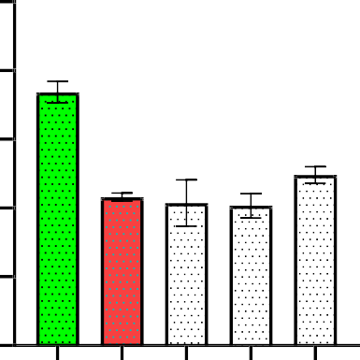
2.0
#
*
*
*
*
VLDL-C (mmol/L) 33

1.5

1.0

0.5

0.0

Figure 12: The aqueous extract of Nephrolepis biserrata ameliorates very low-density lipoprotein (VLDL) concentration in testosterone propionate–induced benign prostatic hyperplasia on day (11), (22), and (33). Testosterone propionate–induced groups exhibited elevated VLDL levels, reflecting dyslipidemia associated with benign prostatic hyperplasia, while treatment with the extract resulted in a progressive reduction in VLDL concentration across the experimental periods, indicating improvement in lipid metabolism. All values are expressed as mean ± SEM (=5), *p<0.05 when compared with positive control groups, while #p<0.05 was significant when compared with the negative control groups. Extract = Nephrolepis biserrata.

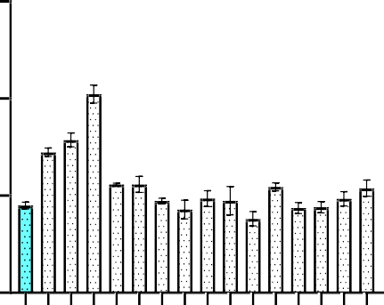
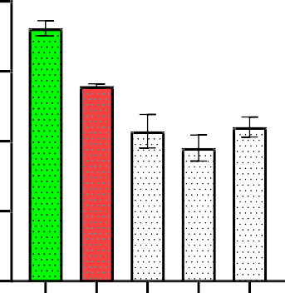
15 8
*
* *
#
*
*
#* *
Non HDL-C(mmol/L) 11
Non HDL-C(mmol/L)

6
10
4

5
2

0 0
group 1 (cntrl)
group 2
group 3
group 4
group 5
group 6
group 7
group 8
group 9
group 10
group 11
group 12
group 13
group 14
group 15
group 16
group 2 (-ctrl)
group 5 (+ctrl)
group 8
group 11
group 14

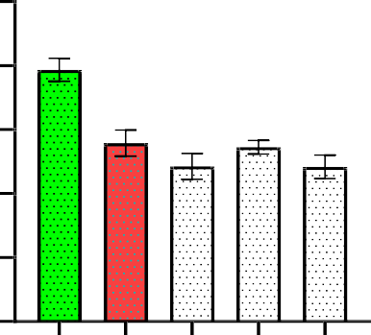
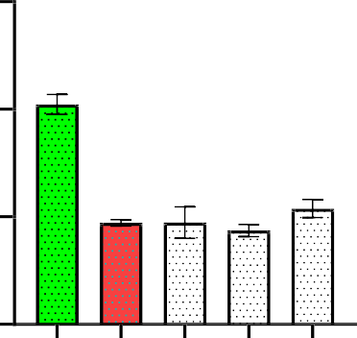
10 15
#
*
*
*
*
Non HDL-C (mmol/L) 33days
#
*
*
*
*
Non HDL-C(mmol/L) 22days

8
10
6

4
5
2

0 0
group 4 (-ctrl)
group 7 (+ctrl)
group 10
group 13
group 16
group 3 (-ctrl)
group 6 (+ctrl)
group 9
group 12
group 15

Figure 13: The aqueous extract of Nephrolepis biserrata ameliorates HDL concentration on day (11), (22), and (33). Testosterone propionate–induced groups showed reduced HDL levels, reflecting dyslipidemia associated with benign prostatic hyperplasia, while treatment with the extract resulted in a progressive increase in HDL concentration across the experimental periods, indicating improvement in lipid profile. All values are expressed as mean ± SEM (=5), *p<0.05 when compared with positive control groups, while #p<0.05 was significant when compared with the negative control groups. Extract = Nephrolepis biserrata. Dyslipidemia has been implicated in the pathogenesis of BPH through vascular dysfunction and inflammatory signaling, and improvement in lipid indices may confer both prostatic and cardiovascular protection [20].

Histopathological Examination
Prostate and testis tissues were fixed in 10% neutral buffered formalin, routinely processed, embedded in paraffin wax, sectioned at appropriate thickness, and stained with hematoxylin and eosin (H&E). Microscopic examination was carried out to evaluate tissue architecture, cellular morphology, and the presence of inflammatory changes.

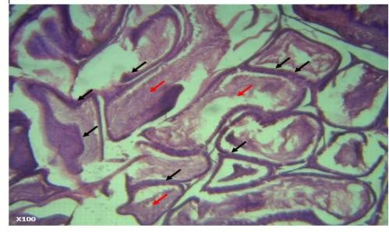
Plate 1: Photomicrograph of prostate of normal control

Photomicrograph of the prostate of the normal control group. The photomicrograph shows a normal prostate with acini lined by secretory columnar epithelial cells. The glandular lumen contains corpora amylacea (red arrow).

Plate 2: Photomicrograph of prostate of negative control 11 days

There is adenosis or atypical adenomatous hyperplasia of the prostate gland as indicated by the presence of uniform round glands arranged in a circumscribed nodule in the fibromuscular stroma and reduced secretory epithelium
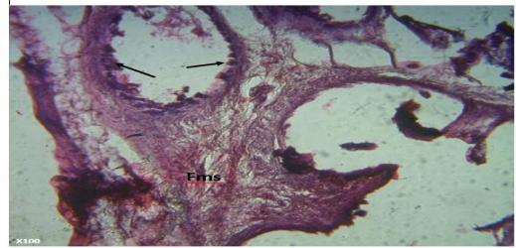

Plate 3: Photomicrograph of prostate of negative control 22 days

Photomicrograph of the prostate of the negative control group (22 days). The photomicrograph shows hyperplasia of the secretory epithelium with mild disruption of the glandular lining [black arrow]. The fibromuscular stroma (Fms) is evident surrounding the glandular structures.

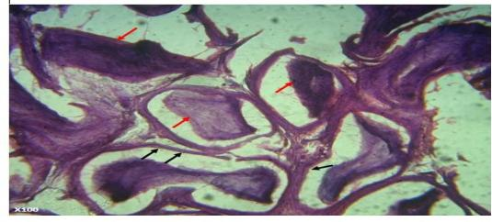

Plate 4: Photomicrograph of prostate of negative control 33days
Photomicrograph of the prostate of the negative control group (33 days). The photomicrograph shows prostate acini with a cystic atrophy appearance characterized by reduced height of the secretory epithelium [black arrow]. The presence of corpora amylacea is also observed within the glandular lumen [red arrow].

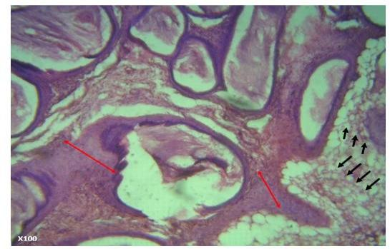
Plate 5: Photomicrograph of prostate of positive control 11 days
Photomicrograph of the prostate of the positive control group (11 days). The photomicrograph shows an increased thickness of the fibromuscular stroma (red line) and the presence of uniform round glands arranged in circumscribed nodules within the fibromuscular stroma (green arrow), indicating adenosis or atypical adenomatous hyperplasia of the prostate gland.

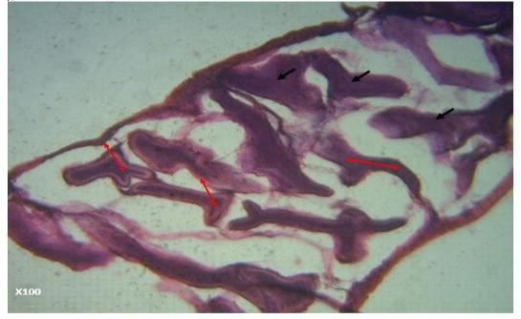
Plate 6. Photomicrograph of prostate of positive control 22 days

Photomicrograph of the prostate of the positive control group (22 days). The photomicrograph shows papillated acini (red line) with a slightly decreased thickness of the fibromuscular stroma. The glandular lumen contains secretions that appear collagenous.

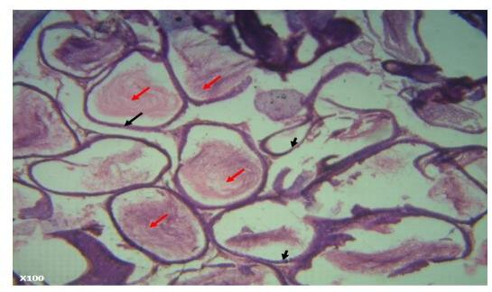
Plate 7: Photomicrograph of prostate of positive control 33 days
Photomicrograph of the prostate of the positive control group (33 days). The photomicrograph shows a normal prostate with acini lined by secretory columnar epithelial cells. The glandular lumen contains corpora amylacea.

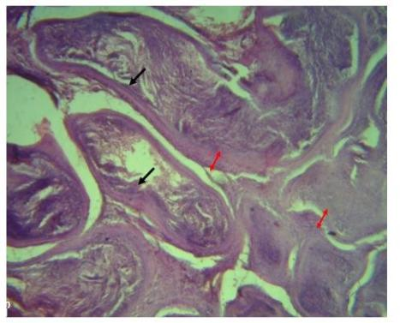

Plate 8: Photomicrograph of extract treated group which received 100mg/kg b. wt of the extract for 11 days
Photomicrograph of the prostate of the extract-treated group that received 100 mg/kg body weight of the extract for 11 days. The photomicrograph shows an increased thickness of the fibromuscular stroma (red line) surrounding the acini, indicating prostatic hyperplasia. The glandular lumen contains collagenous secretions.
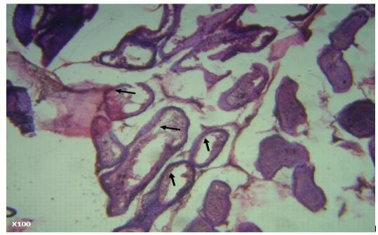
Plate 9: Photomicrograph of extract treated group which received 100mg/kg b. wt of the extract for 22 days
Photomicrograph of the prostate of the extract-treated group that received 100 mg/kg body weight of the extract for 22 days. The photomicrograph shows a reduction in the fibromuscular stroma, with the secretory epithelium clearly observed (black arrow).

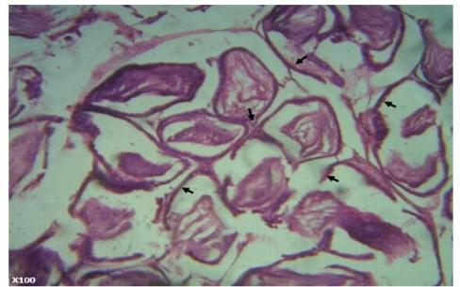
Plate 10: Photomicrograph of extract treated group which received 100mg/kg b.wt of the extract for 33 days

Photomicrograph of the prostate of the extract-treated group that received 100 mg/kg body weight of the extract for 33 days. The photomicrograph shows a normal prostate with acini lined by secretory cuboidal to columnar epithelium (black arrow). The glandular lumen contains corpora amylacea.

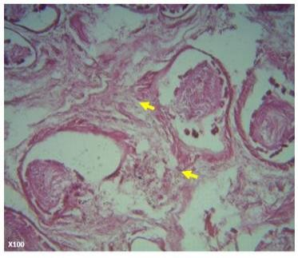

Plate 11: Photomicrograph of extract treated group which received 200mg/kg b. wt of the extract for 11 days
Photomicrograph of the prostate of the extract-treated group that received 200 mg/kg body weight of the extract for 11 days. The photomicrograph shows a moderate increase in the fibromuscular stroma, which appears less dense.

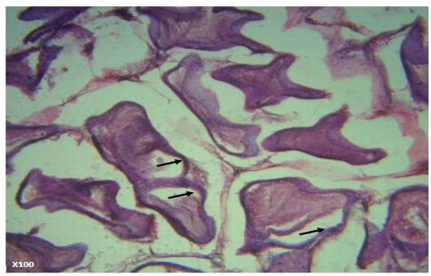
Plate 12: Photomicrograph of extract treated group which received 200mg/kg b. wt of the extract for 22 days
Photomicrograph of the prostate of the extract-treated group that received 200 mg/kg body weight of the extract for 22 days. The photomicrograph shows a normal prostate with more papillated acini lined by secretory cuboidal to columnar epithelium (black arrow). The glandular lumen contains corpora amylacea.

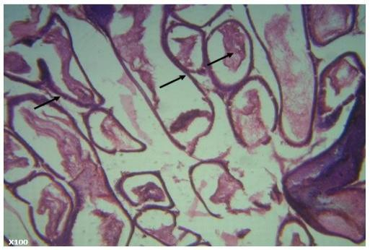
Plate 13: Photomicrograph of extract treated group which received 200mg/kg b. wt of the extract for 33 days

Photomicrograph of the prostate of the extract-treated group that received 200 mg/kg body weight of the extract for 33 days. The photomicrograph shows a normal prostate with acini lined by secretory cuboidal to columnar epithelium (black arrow).

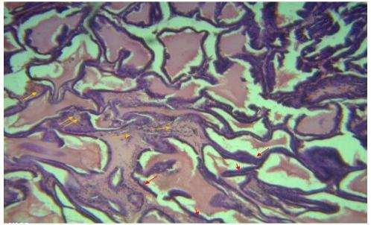
Plate 14: Photomicrograph of extract treated group which received 300mg/kg b.wt of the extract for 11 days

Photomicrograph of the prostate of the extract-treated group that received 300 mg/kg body weight of the extract for 11 days. The photomicrograph shows the presence of cellular infiltration within the stroma (yellow arrow), indicating mild inflammation of the prostate. The acini are lined by dense epithelium composed predominantly of tall columnar cells (black arrow). The glandular lumen contains corpora amylacea.

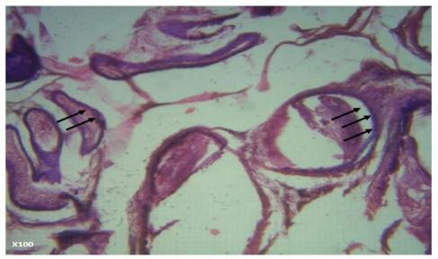

Plate 15: Photomicrograph of extract treated group which received 300mg/kg b. wt of the extract for 22 days

Photomicrograph of the prostate of the extract-treated group that received 300 mg/kg body weight of the extract for 22 days. The photomicrograph shows a normal prostate with acini lined by secretory cuboidal to columnar epithelium (black arrow).

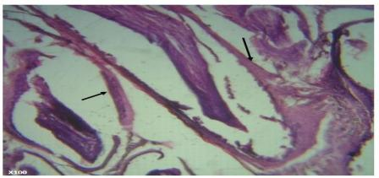

Plate 16: Photomicrograph of extract treated group which received 300mg/kg b. wt of the extract for 33 days
Photomicrograph of the prostate of the extract-treated group that received 300 mg/kg body weight of the extract for 33 days. The photomicrograph shows a normal prostate with acini lined by secretory cuboidal to columnar epithelium (black arrow).

DISCUSSION
The present study showed that administration of testosterone propionate effectively induced benign prostatic hyperplasia (BPH) in male Wistar rats, as evidenced by biochemical, haematological, and histological alterations characteristic of BPH [15]. These findings are consistent with earlier reports [9], confirming the reliability of testosterone propionate as an experimental model for BPH induction. The aqueous leaf extract of Nephrolepis biserrata demonstrated notable therapeutic effects across multiple physiological domains, indicating its potential role in the management of BPH.

Lipid Profile
Testosterone propionate–induced rats showed significantly elevated levels of total cholesterol (TCHOL), low-density lipoprotein cholesterol (LDL-C), and triglycerides, accompanied by a reduction in high-density lipoprotein cholesterol (HDL-C). These findings are in agreement with previous reports [10] and are consistent with BPH-associated metabolic dysfunctions and increased atherogenic risk. Dyslipidemia has been associated with prostatic enlargement and inflammatory processes, further exacerbating disease progression.
Treatment with N. biserrata extract at doses of 100, 200, and 300 mg/kg resulted in dose- and time-dependent normalization of lipid parameters. HDL-C levels increased, while LDL-C, total cholesterol, and triglyceride levels were significantly reduced in extract-treated groups, indicating lipid-lowering and cardioprotective effects. The observed efficacy was comparable to that of the positive control group treated with finasteride and doxazosin.

Inflammatory Biomarkers
Chronic elevation of inflammatory mediators such as tumor necrosis factor-alpha (TNF-α), interleukin-6 (IL-6), and C-reactive protein (CRP) has been shown to promote stromal proliferation and epithelial hyperplasia in BPH [16, 21]. In the present study, these inflammatory markers were significantly elevated in testosterone-induced groups, consistent with previous findings [11].
Following treatment with N. biserrata extract, a substantial and consistent reduction in TNF-α, IL-6, and CRP levels was observed. This effect suggests a strong anti-inflammatory potential of the extract, which may be attributed to its phytochemical constituents such as phenols, flavonoids, saponins, and tannins [12]. The present findings support earlier reports that phenolic and flavonoid compounds possess potent anti-inflammatory activities and play a role in suppressing prostatic inflammation [12].

.

Oxidative Stress Markers
Oxidative stress status was assessed using malondialdehyde (MDA) as an index of lipid peroxidation, alongside antioxidant enzymes including catalase and glutathione peroxidase. Elevated MDA levels and reduced antioxidant enzyme activities observed in untreated BPH rats confirmed increased oxidative damage. Treatment with N. biserrata extract significantly restored antioxidant enzyme activities and reduced MDA levels, demonstrating strong antioxidant properties.
These effects are attributed to the high phenolic and flavonoid content of the plant [13], which enhances endogenous antioxidant defense mechanisms and reduces lipid peroxidation. The present findings are consistent with earlier studies [13], as well as reports indicating that plant-derived polyphenols and flavonoids exert protective effects against oxidative stress in prostate tissue [18, 19].
Prostate Specific Antigen (PSA) and 5-Alpha Reductase
Prostate-specific antigen (PSA) levels and 5-alpha reductase activity were significantly increased in the negative control group, indicating prostatic hypertrophy and androgen-driven hyperplasia. Treatment with N. biserrata extract effectively downregulated PSA and 5-alpha reductase levels, mimicking the pharmacological actions of finasteride.
Natural inhibitors of 5-α-reductase have gained attention as safer alternatives to conventional BPH therapy [17, 22]. The findings of this study validate the extract’s potential as a natural 5-alpha reductase inhibitor and are consistent with previous reports [12].

Histopathological Findings
Histopathological examination revealed epithelial hyperplasia, glandular proliferation, and stromal thickening in the prostates of BPH-induced rats [14]. In contrast, extract-treated groups exhibited reduced epithelial thickness, decreased glandular crowding, and restoration of normal prostate architecture, indicating tissue regeneration and healing. Testicular histology also demonstrated recovery from testosterone-induced degeneration, in agreement with earlier findings [15].
Histological normalization following antioxidant and anti-inflammatory treatment has been consistently reported in experimental models of testosterone-induced BPH [15, 23], further supporting the therapeutic efficacy of Nephrolepis biserrata.

CONCLUSION

This study demonstrates that the aqueous leaf extract of Nephrolepis biserrata possesses significant therapeutic potential in the management of testosterone propionate–induced benign prostatic hyperplasia (BPH) in male Wistar rats. The extract exerted multifaceted beneficial effects across a range of physiological and pathological parameters associated with BPH.
The plant extract exhibited strong antihyperlipidemic effects, as evidenced by significant reductions in total cholesterol, LDL-C, and triglyceride levels, alongside a marked increase in HDL-C. Improvement in lipid profile is particularly important given the role of dyslipidemia in exacerbating BPH pathology and associated cardiovascular risks.
The anti-inflammatory potential of the extract was confirmed by significant reductions in key inflammatory markers, including TNF-α, IL-6, and CRP. These findings support its effectiveness in alleviating chronic prostatic inflammation, which is a major contributor to the progression of benign prostatic hyperplasia.
In addition, oxidative stress commonly associated with prostatic enlargement was markedly ameliorated, as demonstrated by the restoration of catalase and glutathione peroxidase activities and a reduction in malondialdehyde (MDA) levels. These antioxidant effects are likely mediated by the rich flavonoid and phenolic content of Nephrolepis biserrata.
Furthermore, the downregulation of prostate-specific antigen (PSA) levels and inhibition of 5-alpha reductase enzyme activity further validate the extract’s efficacy in counteracting prostatic hyperplasia at the molecular level, mimicking the action of standard pharmacological agents such as finasteride.
Histological assessment revealed restoration of normal prostate architecture in extract-treated groups, confirming tissue recovery and structural normalization. In conclusion, the aqueous leaf extract of Nephrolepis biserrata demonstrates strong antioxidant and anti-inflammatory properties, with proven efficacy in reversing testosterone-induced BPH without observable toxicity. These findings position the plant as a promising natural alternative or complementary therapy in the management of benign prostatic hyperplasia. Further clinical studies are recommended to validate these findings in human subjects and to isolate the specific phytochemicals responsible for its pharmacological effects. These results align with growing evidence supporting plant-based therapies as viable complementary approaches in the management of benign prostatic hyperplasia [20, 22].
.

COMPETING INTERESTS DISCLAIMER:
Authors have declared that they have no known competing financial interests OR non-financial interests OR personal relationships that could have appeared to influence the work reported in this paper.

REFERENCES

Kishorebabu, A., Sree, S. N., & Chandralekha, S. P. (2019). A Review on Benign Prostatic Hyperplasia. World Journal of Current Medical and Pharmaceutical Research, 192-197.
Mugisha, E. K. (2025). Pathophysiology of Benign Prostatic Hyperplasia: Cellular and Molecular Mechanisms. IDOSR JOURNAL OF APPLIED SCIENCES, 10(1), 26-35. https://doi.org/10.59298/IDOSRJAS/2025/101.263500
Egan, K. B. (2016). The epidemiology of benign prostatic hyperplasia associated with lower urinary tract symptoms: prevalence and incident rates. Urologic Clinics of North America, 43(3), 289-297. https://doi.org/10.1016/j.ucl.2016.04.001
Sitar, N. A. (2024). Pharmacological Management of Benign Prostatic Hyperplasia: Reviewing Current and Emerging Drugs. EURASIAN EXPERIMENT JOURNAL OF PUBLIC HEALTH, 7(2), 95-99. https://www.eejournals.org
Rosli, N. H. M. (2014). Hotosynthetic Studies on Eight Filmy Ferns (Hymenophyllaceae) from Shaded Habitats in Malaysia. University of Malaya (Malaysia).
Oyawaluja, B. O., Oyawaluja, A. A., Akinyimika, D. E., Odukoya, O. A., & Coker, H. A. (2024). Antioxidant Profiling, Phytochemical Investigation and Pharmacognostic Evaluation of Nephrolepis biserrata (SW.) Schott (Nephrolepidaceae). Tropical Journal of Phytochemistry and Pharmaceutical Sciences, 3(2), 208-215. https://doi.org/10.26538/tjpps/v3i2.8

Alamgir, A. N. M. (2018). Secondary metabolites: Secondary metabolic products consisting of C and H; C, H, and O; N, S, and P elements; and O/N heterocycles. In Therapeutic use of medicinal plants and their extracts: volume 2: phytochemistry and bioactive compounds (pp. 165-309). Springer International Publishing. https://doi.org/10.1007/978-3-319-92387-1_3

Thomas-Charles, C., & Fennell, H. (2019). Anti-prostate cancer activity of plant-derived bioactive compounds: A review. Current Molecular Biology Reports, 5(3), 140-151. https://doi.org/10.1007/s40610-019-00123-x
Kayode, O. T., Owolabi, A. V., & Kayode, A. A. A. (2020). Biochemical and histomorphological changes in testosterone propionate-induced benign prostatic hyperplasia in male Wistar rats treated with ketogenic diet. Biomedicine & Pharmacotherapy. https://doi.org/10.1016/j.biopha.2020.110863
Tyagi, A., Rajalakshmi, M., Jeyaraj, D. A., Sharma, R. S., & Bajaj, J. S. (1999). Effects of long-term use of testosterone enanthate. II. Effects on lipids, high and low density lipoprotein cholesterol and liver function parameters. International Journal of Andrology, 22(6), 347-355. https://doi.org/10.1046/j.1365-2605.1999.00190.x
Zhang, Q., Jiang, K., Huo, R. C., Zhang, J. Q., & Yang, Z. G. (2023). Association between interleukin-6 and lower urinary tract symptoms of benign prostatic hyperplasia. Revista Internacional de Andrología, 21(2), 100334. https://doi.org/10.1016/j.androl.2021.10.002
Rubió, L., Motilva, M. J., & Romero, M. P. (2013). Recent advances in biologically active compounds in herbs and spices: a review of the most effective antioxidant and anti-inflammatory active principles. Critical Reviews in Food Science and Nutrition. https://doi.org/10.1080/10408398.2011.574802
Pérez-Torres, I., Castrejón-Téllez, V., Soto, M. E., Rubio-Ruiz, M. E., Manzano-Pech, L., & Guarner-Lans, V. (2021). Oxidative Stress, Plant Natural Antioxidants, and Obesity. International Journal of Molecular Sciences. https://doi.org/10.3390/ijms22041786
Raafat, M., Kamel, A. A., Shehata, A. H., Ahmed, A. S. F., Bayoumi, A. M., Moussa, R. A., Abourehab, M. A. S., & El-Daly, M. (2022). Aescin protects against experimental benign prostatic hyperplasia and preserves prostate histomorphology in rats via suppression of inflammatory cytokines and COX-2. Pharmaceuticals, 15(2), 130. https://doi.org/10.3390/ph15020130

Konkol, Y., Vuorikoski, H., Streng, T., Tuomela, J., & Bernoulli, J. (2019). Characterization a model of prostatic diseases and obstructive voiding induced by sex hormone imbalance in the Wistar and Noble rats. Translational Andrology and Urology, 8(Suppl. 1). https://doi.org/10.21037/tau.2019.02.03
Wu, D., Shi, Z.-E., Xu, D., Wu, Y., Qian, S.-B., & Qi, J. (2021). Serum interleukin 6 and acute urinary retention in elderly men with benign prostatic hyperplasia in China: A cross-sectional study. Translational Andrology and Urology, 10(1), 455–465. https://doi.org/10.21037/tau-20-914
Adhyam, M., & Gupta, A. K. (2012). A review on the clinical utility of PSA in cancer prostate. Indian Journal of Surgical Oncology, 3(2), 120–129. https://doi.org/10.1007/s13193-012-0142-6
Randenia, N., Noer, E. R., & Anjani, G. (2024). The Role of Phenolic Compounds as Anti-Inflammatory in Obese Individuals. Indonesian Journal of Global Health Research, 6(2), 703-714. https://doi.org/10.37287/ijghr.v6i2.2682 .
Tang, X. H., Liu, Z. Y., Ren, J. W., Zhang, H., Tian, Y., Hu, J. X., Sun, Z. L., & Luo, G. H. (2025). Comprehensive RNA-seq analysis of benign prostatic hyperplasia (BPH) in rats exposed to testosterone and estradiol. Scientific Reports, 15(1), 2750. https://doi.org/10.1038/s41598-025-87205-2
Adeyemi, O. S., & Faniyan, T. O. (2021). Plant-derived therapeutics in benign prostatic hyperplasia: Mechanistic insights. Journal of Ethnopharmacology, 269, 113688.
https://doi.org/10.1016/j.jep.2020.113688
De Nunzio, C., Presicce, F., & Tubaro, A. (2020). Inflammatory mediators in benign prostatic hyperplasia. Nature Reviews Urology, 17, 299–313.
https://doi.org/10.1038/s41585-020-0309-5
Fontana, F., Raimondi, M., Marzagalli, M., Di Domizio, A., & Limonta, P. (2020). Natural Compounds in Prostate Cancer Prevention and Treatment: Mechanisms of Action and Molecular Targets. Cells. https://doi.org/10.3390/cells9020460
Gacci, M., Sebastianelli, A., Salvi, M., et al. (2021). The role of oxidative stress in male lower urinary tract symptoms. European Urology Focus, 7(1), 85–93.
https://doi.org/10.1016/j.euf.2019.11.008
Allain, C. C., Poon, L. S., Chan, C. S. G., Richmond, W., & Fu, P. C. (1974). Enzymatic determination of total serum cholesterol. Clinical Chemistry, 20(4), 470–475. https://doi.org/10.1093/clinchem/20.4.470
Kannan, S., Mahadevan, S., Ramji, B., Jayapaul, M., & Kumaravel, V. (2014). LDL-cholesterol: Friedewald calculated versus direct measurement-study from a large Indian laboratory database. Indian Journal of Endocrinology and Metabolism, 18(4), 502-504. https://doi.org/10.4103/2230-8210.137496
Telles, S., Pal, S., Sharma, S. K., Singh, A., Kala, N., & Balkrishna, A. (2018). The association between the lipid profile and fasting blood glucose with weight related outcomes in healthy obese adults. BMC Research Notes https://doi.org/10.1186/s13104-018-3485-4
Zhao, X., Niu, Y., Zhao, X. L., Ruan, H. J., Xiang, Y., Wang, L. Y., Feng, Y., & Tang, Q. Y. (2023). Associations Between Serum TNF-α, IL-6, hs-CRP and GLMD in Obese Children and Adolescents: A Cross-Sectional Study. Diabetes, Metabolic Syndrome and Obesity, 16, 3915–3923. https://doi.org/10.2147/DMSO.S434482
Wunderle, C., Martin, E., Wittig, A., Tribolet, P., Lutz, T. A., Köster-Hegmann, C., Stanga, Z., Mueller, B., & Schuetz, P. (2025). Comparison of the inflammatory biomarkers IL- 6, TNF-α, and CRP to predict the effect of nutritional therapy on mortality in medical patients at risk of malnutrition : A secondary analysis of the randomized clinical trial EFFORT. *Journal of Inflammation (London), 22*(1), 16. https://doi.org/10.1186/s12950-025-00442-0
Ajala, A. O., Adedeji, T. A., & Busuyi, J. S. (2023). A comparative study of prostate specific antigen (PSA) point-of-care-testing (POCT) techniques. Annals of Health Research, 9(1). https://doi.org/10.30442/ahr.0901-05-189

