Original Research Article

An Intelligent Image-Based Approach for Classification of Bangladeshi Pineapple Varieties

Abstract
In Bangladesh, pineapple variety identification is still largely dependent on experience and eye-tracking. As a result, there is a possibility of misclassification in marketing, grading, pricing, and agricultural supply chain management. This study proposes a feature-based machine learning approach to automatically identify varieties from pineapple images. In the proposed approach, noise reduction, contrast adjustment, and fruit region (ROI) separation will be performed through image preprocessing. Then, three classes of features—color, texture, and shape—will be extracted to create a composite feature vector, where RGB/HSV-based statistical features will be used for color features, LBP/GLCM-based descriptors for texture features, and contour-based metrics (such as area, perimeter, circularity, and aspect ratio) will be used for shape features. The collected dataset will be divided into training and testing parts, and the varieties will be classified using Decision Tree and k-Nearest Neighbors (KNN) algorithms. Accuracy, precision, recall, and F1-score will be used to measure the effectiveness of the models. The research presents a solution that can be implemented at low computational cost, which can provide effective support for rapid variety identification, quality control, and agricultural decision-making at the field level.

Keywords: Decision Tree (DT), k-Nearest Neighbors (KNN), Machine Learning (ML).
- Introduction
Pineapple is an important cash crop in Bangladesh, and accurate identification of pineapple varieties (such as Original Pineapple, Dhakaia Fruit, and Rangamatia Fruit) at the field and market levels plays a major role in production, grading, pricing, and supply management. The major varieties cultivated in Bangladesh are Original Pineapple, Dhakaia Fruit, and Rangamatia Fruit. A crop survey report by the Bangladesh Bureau of Statistics (BBS) also mentions the same three varieties, which makes this issue more realistic in the domestic context. However, in reality, accurate identification by eye alone is difficult due to the close proximity of the varieties in terms of peel color, “eye pattern” texture, shape, light and shade, and ripeness. As a result, traditional manual identification methods are time-consuming and laborious and can cause problems in grading/quality control and inventory management due to human error. Therefore, the need for image-based computer vision and machine learning has arisen to identify varieties automatically, quickly, and accurately. In relation to this problem, recent studies have proposed various vision-based methods for pineapple identification, maturity determination, grading, and variety differentiation.
For example, Chang et al.[1] proposed a system for detecting pineapple maturity and distance (3D distance) using deep learning in the field. Similarly, Arboleda et al. [2] proposed a fuzzy logic-based pineapple maturity classifier using color-based features from image processing. In addition, Lai et al.[3] demonstrated a method for pineapple detection and maturity classification using improved YOLOv7 in complex field environments, where real challenges such as light-background variation were considered. Syazwani et al.[4] demonstrated an ML-based framework using various classifiers (including DT, KNN) for automatic identification and fruit counting from top-view pineapple crown, which supports the practicality of computer vision in agriculture. On the other hand, the use of non-destructive sensing and feature-based ML to detect cultivar/variety differences has also gained importance. Mohd Ali et al.[5] demonstrated the use of infrared thermal imaging for quality prediction during storage of different varieties of pineapple in Food Control. In a similar cultivar-level distinction, Mohd Ali et al. [6]reported on the use of thermal imaging and ML to differentiate pineapple cultivars. MDPI presented a method for non-destructive internal quality assessment using Visible or Near-Infrared (VIS/NIR) transmittance spectroscopy and ML. In addition, Dittakan et al. [7]proposed the use of texture analysis (including LBP) in Pattavia pineapple grading, which showed that pineapple peel texture was an important distinguishing feature. From the above studies, it is understood that color, texture, and shape features are important for automatic identification in pineapple, but a local variety-centric, low-cost, interpretable classical ML setup in Bangladesh is still of practical value. Therefore, in this study, we propose a hybrid feature-based approach in the common variety context in Bangladesh, where color + shape + LBP texture features will be combined to perform variety classification using Decision Tree and k-Nearest Neighbors (KNN) algorithms [8], [9]. The performance of the models will be evaluated using accuracy, precision, recall, and F1-score, and confusion matrix analysis will be used to identify which variety is causing more confusion. Main Contributions of the Research
- To present an image-based visual recognition problem for identifying common pineapple varieties in Bangladesh.
- To propose an effective hybrid feature set combining color, shape and LBP texture.
- To create a benchmark Pineapple Image Dataset for research.
- To provide a low-cost classification framework and comparative analysis using Decision Tree and KNN.

The rest of the paper is organized as follows: Section 2 presents the proposed methodology. Section 3 describes the experimental setup and discusses the results and performance analysis. Finally, Section 4 concludes the study.

2. Methodology

The proposed method in this study has been completed in five consecutive steps. The steps are image acquisition, image preprocessing, feature extraction, pineapple variety classification, and proposed method evaluation. In the first step, pineapple images are collected from various sources. In the second step, the necessary preprocessing techniques are applied to make the collected images suitable for analysis so that noise reduction, standardization, and clear highlighting of important parts are possible.
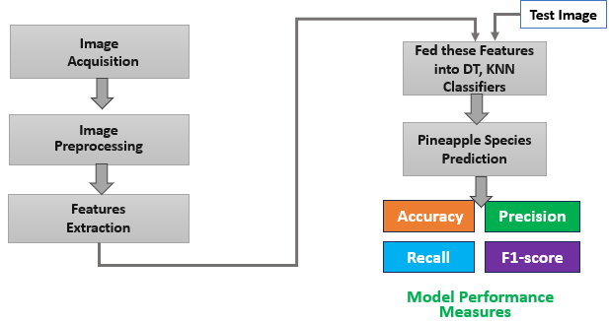

Fig 1. Represent the Proposed Methodology.

In the third step, feature extraction is completed by determining color, shape, and texture-based features from the images. Then, the extracted features are provided as input to the Decision Tree and K-Nearest Neighbors (KNN) classifier to classify pineapple varieties. The complete model proposed in this study is presented in Figure 1. In the last step, the effectiveness of the proposed method is verified using recognized performance metrics such as accuracy, precision, recall, and F1-score. Each step of this method is explained in more detail in the following sections.
2.1 Image Acquisition

For this study, pineapple images were collected from various pineapple gardens in Madhupur Upazila of Tangail District, Bangladesh. Direct field images were taken to accurately represent the common pineapple varieties in real-world conditions. In this study, images of three types of pineapple, locally known as Original Pineapple, Dhakaia Fruit, and Rangamatia Fruit, were collected.

2.2 Image Preprocessing

In this study, the original RGB image of the pineapple collected in the image preprocessing step is first taken so that the original color and detail of the image are preserved. Then, all the images are resized to 250×250 pixels to bring a specific value so that all the images in the dataset come to the same size and the feature extraction and classification steps can be done quickly and stably. In the next step, the image is converted to grayscale so that the effect of color is reduced and it is possible to analyze the texture, shape, and intensity patterns more clearly. Finally, contrast and brightness are increased to make the important parts of the image clearer, as a result of which the pattern, stain details, and borders of the outer skin of the pineapple are more visible, and good results are obtained in the subsequent feature extraction.
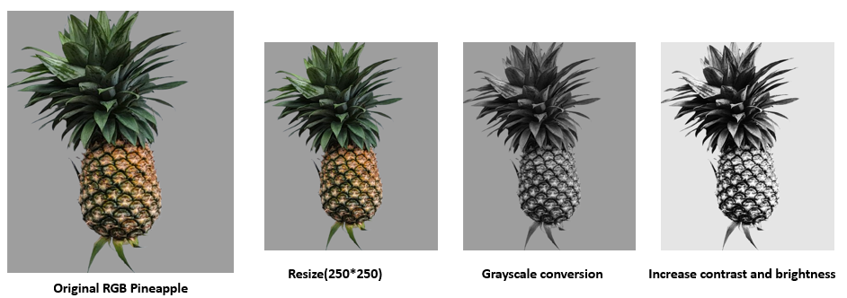
Fig. 2 Depicts the different Image Preprocessing Steps.

2.3 Feature Extraction

Feature extraction is a process where useful and meaningful information (features) is extracted from an image and expressed in numerical form, so that a machine learning model can “identify” the class of the image based on that information. Because the classifier (Decision Tree, KNN) cannot make good decisions by directly looking at the raw pixels; it needs to be given some “measurable signal” that clarifies the differences within the image[8], [9], [10], [11]. In the case of pineapple, there are subtle differences in color tone, peel pattern, texture, fruit size-structure, eye scale arrangement, etc. between different varieties. Feature extraction converts these differences into numbers, resulting in images of the same variety having similar feature values ​​and images of different varieties having different feature patterns. In this study, four types of features were mainly used for pineapple variety identification: Color, Texture, LBP (Local Binary Pattern), and Shape.

- Color features help to capture the external color differences of pineapples (e.g. ripeness level, yellow-green tone of the peel, brightness). Color is usually expressed numerically by extracting the mean, standard deviation, or histogram-based values ​​from the RGB, HSV color space.
- Texture features refer to the roughness, scale density, pattern depth, and mottling characteristics of the pineapple peel. They usually use intensity variation or GLCM-like measures (e.g. contrast, homogeneity, energy) to quantify the peel pattern.
- LBP (Local Binary Pattern) is a very effective technique for texture, where a local pattern is created by comparing each pixel with its surrounding pixels. It captures small details of the peel, graininess, and repeated patterns that can vary between varieties.
- Shape features help capture the overall structure of a pineapple (tall/short, wide/narrow), the outline of the fruit, and geometric characteristics. Shape is typically represented numerically using measurements such as area, perimeter, aspect ratio, circularity, solidity.
Once feature extraction is complete, a feature vector (a list of numbers) is created for each image. These feature vectors are then fed into the classifier. For example, in the KNN case, the feature vector of a new pineapple image is compared to the feature vectors of the training data, and the variety is determined based on the closest (similar) samples. On the other hand, the decision tree creates thresholds/rules on different features (such as “color mean is high on one side” and “texture contrast is low on the other side”) and reaches the final verity class by making step-by-step decisions. In this way, feature extraction converts the pineapple image into “machine-understandable data,” which makes variety classification more accurate, faster, and interpretable.

2.3 Machine Learning Classifiers

This study uses two widely used machine learning classifiers—Decision Tree (DT) and K-Nearest Neighbors (KNN)—to identify the variety of pineapples[12], [13]. The color, texture, LBP, and shape feature vectors obtained from the feature extraction step are given as inputs to these two classifiers so that each image can be classified into a specific variety class. In the KNN classifier, k = 5 is set. That is, the feature vector of a new pineapple image is compared with the training data, and the 5 nearest neighbors are selected, and the variety class among them that has the greatest number of varieties is considered as the variety of the new image (majority voting). This method is effective in variety identification because it keeps images with similar feature patterns together. On the other hand, the Decision Tree (DT) classifier is configured to use 25 trees (trees = 25) to control the complexity of the tree and obtain stable results. Here, the data is divided step by step according to the different rules of the features, and the final decision is made, so it is also relatively easy to explain which feature is having the most impact on which variety.

2.4 Proposed Model Evaluation

Four standard performance metrics were used to evaluate the performance of the proposed pineapple variety classification model in this study—accuracy, precision, recall, and F1-score. accuracy indicates the percentage of samples that the model correctly classified. Precision indicates how accurate the predictions are (i.e., how low the rate of misclassification is). Recall indicates how many samples of a particular variety the model correctly identified out of the total number of samples. F1-score is the balanced composite value of precision and recall, which is especially important when the number of samples of a variety is relatively small or the classes are unequal. Using these four metrics together, it is clear how reliably the proposed model is working in identifying each variety, not just the overall result [14], [15], [16]. These four standard metrics are described step by step respectively.

Accuracy: Overall correctness of predictions. Mathematically,
$Accuracy=\frac{TP+TN}{TP+TN+FP+FN}$ Equation (1).
where TP, TN, FP and FN represent the true positive, true negative, false positive, and false negative respectively.
Precision: Correct positive predictions. Mathematically,
$Precision=\frac{TP}{TP+FP}$ Equation (2).
Recall: Ability to detect all positives. Mathematically,
$Recall=\frac{TP}{TP+FN}$ Equation (3).
F1-score: Balance of precision & recall. Mathematically,
$F-Score=\frac{2*\left(recall*precision\right)}{recall+precision}$ Equation (4).
- Result Analysis

This section will present the results and analysis of the research conducted for the identification of different varieties of pineapple in Bangladesh step by step. Here, there will be a brief but clear description of the experimental setup, dataset used, and data documentation. Then, the presentation method, feature contribution, testing process, and comparison of results between different models will be highlighted. The next section will show the impact analysis of different features so that it can be understood which features have the most impact on the performance of the model. In addition, the data training process and how the 80% training and 20% testing split (train-test split) was done will also be explained in detail. Finally, the performance of two widely used machine learning algorithms, Decision Tree and K-Nearest Neighbor (KNN) models, will be discussed in comparison, where the results will be analyzed using relevant metrics, including accuracy, precision, recall, and F1-score.

  - Dataset Prepared and Augmentation

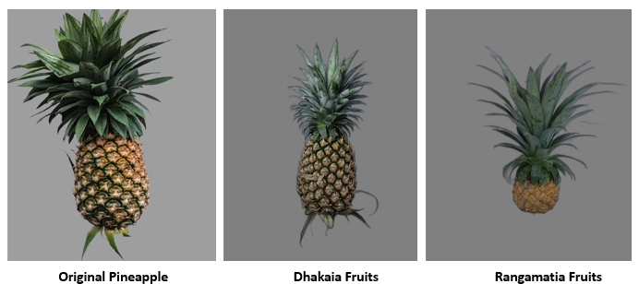
The method of collecting pineapple images in this study has been mentioned earlier in Section 2.1. In this section, we present the image capture technique and data preparation steps in detail. Our dataset is divided into three categories, and each category contains 94 images.
Fig 3. Depicts the Pineapple Sample.
The categories are Original Pineapple, Dhakaia Fruits, and Rangamati Fruits sample. For each category, the camera was rotated to 180° and 360° angles to cover the data from different directions, and multiple views were taken. Fig. 3 illustrates the three types of pineapple varieties. This included variations in different angles, textures, and shapes of the same variety in the dataset, which helps improve the generalization of the model. After image collection, data augmentation techniques were applied to further enrich the dataset. Here, each image is scaled to 0.8 (zoom-out) and 1.2 (zoom-in) scales so that the effects of different sizes and perspectives are added to the dataset and the model can work well in real conditions. The total number of images in the dataset with this augmentation stands at about 2050.
Table 1. presents the Pineapple Image Augmentation Technique
SN | Pineapple Categories | Original Image | Rotation (angles  180 to 360 | Zoom-out and Zoom-in) | (Total Original + Augmentation Image)
1 | Original Pineapple | 94 | 2×94 | 2×94 | 470
2 | Dhakaia Fruits, | 94 | 2×94 | 2×94 | 470
5 | Rangamatia Fruits | 94 | 2×94 | 2×94 | 470
Total images |  |  |  |  | 1410

A summary of the augmentation techniques used in this study is presented in Table 1, where how each technique was applied and its role in augmenting the dataset is clearly shown.

  - Features Contribution Test
Tab. 2 compares the performance of Decision Tree (DT) and KNN models according to the feature set used in each experimental setup and analyzes the contribution of features. First, using only the Color feature (Setup–1) gives high performance in both models (DT: 0.955, KNN: 0.961), indicating that color is an important visual indicator for distinguishing pineapple varieties in Bangladesh. However, relying only on color may be somewhat unstable in real applications due to lighting, camera exposure, or environmental changes.
Table 2. demonstrates the features contribution of each experimental setup.
Ex. Setting | Feature Set | Model | Accuracy | Precision | Recall | F1-Score
1 | Color | DT | 0.955 | 0.955 | 0.955 | 0.955
1 | Color | KNN | 0.961 | 0.963 | 0.961 | 0.961
2 | Haralick_GLCM | DT | 0.923 | 0.929 | 0.923 | 0.922
2 | Haralick_GLCM | KNN | 0.950 | 0.951 | 0.950 | 0.950
3 | Shape | DT | 0.320 | 0.323 | 0.319 | 0.315
3 | Shape | KNN | 0.323 | 0.275 | 0.319 | 0.182
4 | LBP | DT | 0.904 | 0.903 | 0.904 | 0.903
4 | LBP | KNN | 0.955 | 0.956 | 0.955 | 0.956
5 | Color+Haralick | DT | 0.934 | 0.935 | 0.934 | 0.934
5 | Color+Haralick | KNN | 0.944 | 0.944 | 0.944 | 0.944
6 | Color+Shape | DT | 0.948 | 0.948 | 0.948 | 0.948
6 | Color+Shape | KNN | 0.930 | 0.933 | 0.930 | 0.931
7 | Color+LBP | DT | 0.925 | 0.925 | 0.925 | 0.925
7 | Color+LBP | KNN | 0.959 | 0.959 | 0.959 | 0.959
8 | Haralick+LBP | DT | 0.955 | 0.955 | 0.955 | 0.955
8 | Haralick+LBP | KNN | 0.968 | 0.968 | 0.968 | 0.968
9 | Shape+LBP | DT | 0.905 | 0.907 | 0.905 | 0.905
9 | Shape+LBP | KNN | 0.946 | 0.948 | 0.946 | 0.947
10 | All_Features | DT | 0.955 | 0.955 | 0.955 | 0.955
10 | All_Features | KNN | 0.970 | 0.973 | 0.970 | 0.950

Using Haralick_GLCM (Setup–2) as the texture feature reduces the performance of DT slightly (Accuracy≈0.923), but KNN gives relatively good performance (Accuracy=0.950), indicating that texture information is effective in distinguishing varieties. In contrast, using the Shape feature alone (Setup–3) results in very low performance in both models (≈0.32), meaning that pineapple shape is not reliable enough for class separation in this dataset, as there may be shape/size variation within the same variety and there may be morphological similarity between different varieties. Using LBP (Setup–4) results in moderate DT (Accuracy ≈ 0.904) but significantly improved KNN (Accuracy ≈ 0.955), proving that local texture patterns are very effective features in pineapple variety identification.

In the case of combination features, Color+Haralick (Setup–5) gives moderate to good results in both DT and KNN models (DT: 0.934, KNN: 0.944), but while DT is good in the Color+Shape (Setup–6) setup (0.948), the performance of KNN decreases compared to Color alone (≈0.930), which indicates that the Shape feature is added as additional “noise” here and can weaken the decision in some cases. In the Color+LBP (Setup–7) case, KNN shows strong results again (≈0.959); that is, the classification is more accurate when local texture is added to the color information. The most remarkable results are found in the Haralick+LBP (Setup–8) setup, where DT (0.955) and especially KNN provide the highest and most consistent performance (Accuracy/Precision/Recall/F1 = 0.968). This explains that the GLCM-based global texture and LBP-based local texture together are able to capture the pattern and texture features of pineapple peel best. KNN also gives good results in Shape+LBP (Setup–9) (≈0.946–0.947), but slightly lower than Haralick+LBP, because global texture information is missing here.

Finally, using All Features (Setup–10), the Accuracy (0.970) and Precision (0.973) of KNN are the highest, but the F1-Score is relatively low (0.950), which indicates that adding all the features together may increase the error in some classes by adding some redundant or less effective features and reduce the overall balanced performance (especially F1). According to the above analysis, it is reasonable to select Haralick+LBP (Setup–8) as the most suitable (best) feature set for pineapple variety classification in Bangladesh. Because in this setup, the KNN model in particular gave the highest and most stable results (0.968) in all metrics (Accuracy, Precision, Recall, F1) simultaneously, indicating that this texture-based feature combination is the most effective in class separation and relatively more robust in real applications.

  - Proposed Model Comparison with Best Features Set

The overall performance comparison of DT and KNN models using the All_Features feature set is shown in Fig. 4. Here it can be seen that the Accuracy, Precision, Recall and F1-Score of the DT model are at almost the same level (around 0.955), meaning that DT provides relatively stable predictions but the improvement margin is somewhat lower.
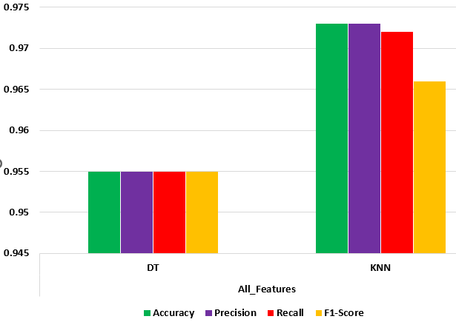

Fig 4. Display the comparative performance among these models.
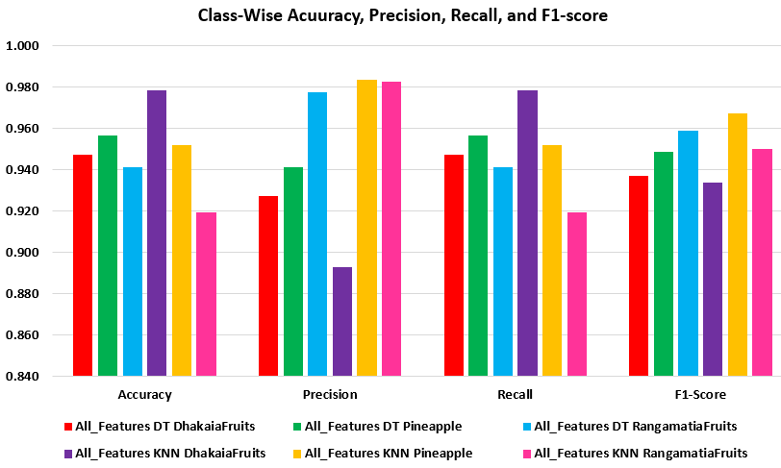
On the other hand, the KNN model performed better on the same feature set, with Accuracy and Precision improving to around 0.973 and Recall improving to around 0.972. However, the F1-Score of KNN is relatively low (around 0.966), indicating that the Precision–Recall balance is not completely equal in some classes. Overall, KNN performed better than DT overall on the All_Features set, especially in terms of Accuracy/Precision/Recall.

Fig. 5 Represents the Class-Wise Performance

Fig. 5 presents the class-wise performance of DT and KNN for three classes (DhakaiaFruits, Pineapple, and RangamatiaFruits). In the DT model, the Pineapple class has the strongest fruit (accuracy around 0.956, precision around 0.941, and F1 around 0.948), the DhakaiaFruits class is moderate (accuracy around 0.947, precision around 0.927, and F1 around 0.937), and the RangamatiaFruits class has relatively low accuracy (0.941), but the precision is the highest (0.977) and the F1 is good (0.959)—which means that DT is reducing false positives in this class. In the KNN model, the DhakaiaFruits class has the highest accuracy/recall (about 0.978), but the precision is relatively low (about 0.893), so the F1 is about 0.933—this is usually the case when the class is more “confusable” and there are more false positives. In the Pineapple class, the KNN gave the most balanced and robust performance (precision is about 0.983, accuracy is about 0.952, and F1 is about 0.967), which indicates that the features are very effective in distinguishing this class. In the RangamtiaFruits class, the KNN has a very high precision (about 0.982), but the accuracy/recall is relatively low (about 0.919), so the F1 is about 0.950—meaning that KNN is a little “conservative” in making predictions in this class, but what it predicts is correct in most cases. In summary, Fig. According to Figure 2, KNN is the hardest in the Pineapple class, there is some imbalance in the DhakaiaFruits class due to low precision, and the RangamatiaFruits class is considered challenging because although precision is high, recall is relatively low.

  - Discussion

In this study, a real-world image dataset has been prepared for the identification of three varieties of pineapples in Bangladesh (Original Pineapple, Dhakaia Fruits, and Rangamati Fruits), where 94 images in each category were captured by the camera in multi-angle 180° and 360° views. Later, the dataset was enriched by applying 0.8 (zoom-out) and 1.2 (zoom-in) as scaling augmentation, and the total number of images was mentioned as “approximately 2050.” At the same time, the total is shown in Table 1 as 1410, so it is important to make the data counting part consistent in one place in the final manuscript. According to the feature contribution test (Tab. 2), although the Color feature alone gives good results, it is mentioned that it may be somewhat unstable in real-world applications due to light/exposure variations. The Shape feature alone gave the weakest performance, which means that the shape features in this dataset are not strong enough to separate the classes. Texture-based features, especially LBP and Haralick+LBP combinations, have proven to be the most effective; KNN in the Haralick+LBP setup gives the highest and most stable results (0.968) in all metrics. On the other hand, in the All_Features set, KNN has the highest accuracy and precision (0.970, 0.973), but F1 is relatively low (0.950), indicating that combining all the features may result in some less effective features, which may reduce the balanced performance in some classes. Therefore, it is reasonable to select Haralick+LBP as the best feature set for pineapple variety classification.

- Conclusion

This study has compared the DT and KNN models in a feature-based machine learning approach for pineapple variety identification in Bangladesh. The experimental results show that pineapple peel texture-related features (especially Haralick and LBP) contribute the most to the variety differentiation, and KNN achieved the highest and most consistent performance (0.968) in the Haralick+LBP feature set. Although some metrics are highest in the All_Features set, the Haralick+LBP set is more suitable in terms of balanced performance in real applications due to the reduced F1. In future work, making the dataset larger and multi-region based, testing the robustness by increasing the light/background variation, and making the augmentation reporting part consistent will strengthen the practical applicability of this model.

Dataset availability: Data will be made available on request.

Reference

[1] C.-Y. Chang, C.-S. Kuan, H.-Y. Tseng, P.-H. Lee, S.-H. Tsai, and S.-J. Chen, “Using deep learning to identify maturity and 3D distance in pineapple fields,” Sci Rep, vol. 12, no. 1, p. 8749, 2022. https://doi.org/10.1038/s41598-022-12096-6
[2] E. R. Arboleda, C. L. T. Dejesus, and L. M. S. Tia, “Pineapple maturity classifier using image processing and fuzzy logic,” IAES International Journal of Artificial Intelligence, vol. 10, no. 4, p. 830, 2021. https://doi.org/10.11591/ijai.v10.i4.pp830-838
[3] Y. Lai, R. Ma, Y. Chen, T. Wan, R. Jiao, and H. He, “A pineapple target detection method in a field environment based on improved yolov7,” Applied Sciences, vol. 13, no. 4, p. 2691, 2023. https://doi.org/10.3390/app13042691
[4] R. W. N. Syazwani, H. M. Asraf, M. A. M. S. Amin, and K. A. N. Dalila, “Automated image identification, detection and fruit counting of top-view pineapple crown using machine learning,” Alexandria Engineering Journal, vol. 61, no. 2, pp. 1265–1276, 2022. https://doi.org/10.1016/J.AEJ.2021.06.053
[5] M. M. Ali, N. Hashim, S. Abd Aziz, and O. Lasekan, “Quality prediction of different pineapple (Ananas comosus) varieties during storage using infrared thermal imaging technique,” Food Control, vol. 138, p. 108988, 2022. https://doi.org/10.1016/j.foodcont.2022.108988
[6] M. Mohd Ali, N. Hashim, S. Abd Aziz, and O. Lasekan, “Characterisation of pineapple cultivars under different storage conditions using infrared thermal imaging coupled with machine learning algorithms,” Agriculture, vol. 12, no. 7, p. 1013, 2022. https://doi.org/10.3390/agriculture12071013
[7] K. Dittakan, N. Theera-Ampornpunt, and P. Boodliam, “Non-destructive grading of pattavia pineapple using texture analysis,” in 2018 21st International Symposium on Wireless Personal Multimedia Communications (WPMC), 2018, pp. 144–149. https://ieeexplore.ieee.org/xpl/conhome/8703706/proceedings
[8] E. Miyamoto and T. Merryman, “Fast calculation of Haralick texture features,” Human computer interaction institute, Carnegie Mellon University, Pittsburgh, USA. Japanese restaurant office, 2005. https://api.semanticscholar.org/CorpusID:1956826
[9] T. Löfstedt, P. Brynolfsson, T. Asklund, T. Nyholm, and A. Garpebring, “Gray-level invariant Haralick texture features,” PLoS One, vol. 14, no. 2, p. e0212110, 2019. https://doi.org/10.1371/journal.pone.0212110
[10] A. Lopez-Alanis, H. De-la-Torre-Gutierrez, and A. Hernández-Aguirre, “A thresholdless wildfire pixel detection employing color contrast features,” Applied Intelligence, vol. 55, no. 17, Nov. 2025, doi: 10.1007/s10489-025-07004-0. https://doi.org/10.1007/s10489-025-07004-0
[11] D. M. Woebbecke, G. E. Meyer, K. Von Bargen, and D. A. Mortensen, “Shape features for identifying young weeds using image analysis,” Transactions of the ASAE, vol. 38, no. 1, pp. 271–281, 1995. https://doi.org/10.13031/2013.27839
[12] H. Manzoor, F. Khursheed, and A. M. Hafiz, “Finger vein recognition using an ensemble of KNN classifiers based on robust image features,” Signal Image Video Process, vol. 19, no. 10, Oct. 2025, doi: 10.1007/s11760-025-04369-0. https://doi.org/10.1007/s11760-025-04369-0
[13] M. A. Suciu and R. I. Lung, “A Nash equilibria decision tree for binary classification,” Applied Intelligence, vol. 55, no. 2, Jan. 2025, doi: 10.1007/s10489-024-06132-3. https://doi.org/10.1007/s10489-024-06132-3
[14] S. M. A. Al Shuaeb, Md. R. Hassan, and M. Uddin, “Soil Wetness Classification in Agriculture Using Machine Learning Models,” Asian Journal of Soil Science and Plant Nutrition, vol. 10, no. 4, pp. 803–815, Dec. 2024, doi: 10.9734/ajsspn/2024/v10i4451.
[15] S. M. A. Al Shuaeb, A. Hossen, M. A. H. Dinar, and U. K. Roy, “Analyzing Different Architectures of Convolutional Neural Networks for Tomato Grading System,” Asian Journal of Research in Computer Science, vol. 17, no. 12, pp. 137–147, Dec. 2024, doi: 10.9734/ajrcos/2024/v17i12534. https://doi.org/10.9734/ajrcos/2024/v17i12534
[16] A. L. Fahad, N. H. Nayem, M. N. Hossain, M. L. Rabbani, R. K. Opu, and S. M. A. Al Shuaeb, “Sand fineness modulus prediction in construction sector using convolutional neural network,” Asian Journal of Civil Engineering, vol. 25, no. 1, pp. 443–450, 2024. https://doi.org/10.1007/s42107-023-00786-z

