Sustainable Artificial Intelligence: Foundations, Strategies, and an MLP-Based
Case Study on Air Quality Prediction

Abstract
The rapid progress of Artificial Intelligence (AI) is reshaping many fields of industry, leading some industries towards full automation and new scientific discoveries. The same cannot be said of contemporary AI models – increasingly larger and more complex deep learning systems consume an order of magnitude or more energy than past generations, and emit orders of magnitude more carbon as a result, creating valid environmental worries.
In facing these challenges, this paper suggests a strategy for advancing environmental sustainability of AI development. Instead of looking only at performance improvement, the article stresses ecological responsibility as a design principle for AI systems. The framework includes energy efficient algorithm design, resource conscious model optimization strategies, hardware improvements (Tensor Processing Units (TPUs), Field programmable gate arrays (FPGAs) or edge devices and the exploitation of green infrastructure approaches such as renewable energy driven data centres.
The work also includes case studies in important areas such as Natural Language Processing (NLP) and Computer Vision (CV), showing that high-performance AI does not need to be inconsistent with environmental considerations.
By providing an all-inclusive guidance to embed sustainability dimension throughout the AI life cycle that encompass model training and deployment, infrastructure management, and policy making, this work offers thoughts turning for AI practitioners, scholar-practitioners, and policymakers. It connects technological innovation to international environmental goals such as the United Nations Sustainable Development Goals and net-zero emissions. In the end, the paper highlights that there are need and potential to design greener AI systems which are more responsible for a climate aware future.
Keywords:
Sustainable AI, Green AI, Energy-efficient Algorithms, Eco-friendly Machine Learning, Responsible AI Development, Climate-aware AI Systems, Sustainable Computing, AI and Sustainability
1. Introduction
AI is creating a transforming force across many industries, including health care, finance and transportation to environmental science and automation (Rashid & Kausik, 2024). Its accelerated adoption is due to the advances in machine learning (ML) and deep learning (DL), which have equipped AI with remarkable capacity to perform complex tasks such as image recognition, natural language understanding, decision-making or the like more precisely and efficiently.
But it's clear that exponential AI advances are coming with major environmental problems. Training and running large models require vast amounts of computational resources—usually thousands of petaflop/s-days or more—and depend on energy-hungry hardware, such as graphic processing units (GPUs) in hyperscale data centers (He et al., 2025; Hinov, 2025). These operations can use megawatts of power — and generate carbon in amounts equivalent to the total emissions of multiple vehicles. As the scale and complexity of AI models continue to grow, so too does their energy footprint, posing a serious threat to long-term environmental sustainability (Tabbakh et al., 2024; Paula et al., 2025).
In this context of concerns, the field is already searching for and understanding ways to design Sustainable AI (also known as Green AI). It is committed to minimizing the ecological footprint of AI systems by optimizing energy consumption during model design, training, hardware and infrastructure usage (Raman et al., 2024; Barros et al., 2025). This model is consistent with international aspirations for environmental objectives, including net-zero carbon and the United Nations Sustainable Development Goals (Oladoyinbo et al., 2024).
To overcome these challenges, our paper presents a unified and feasible framework for Sustainable AI that envelops the contrivances in software and hardware. The framework is organized with major components listed below: Section 2 provides a survey of existing literature on Green AI and Sustainable Computing, presenting recent advancements, methodologies that have been applied, gaps in implementation. It also contrasts traditional performance-centric AI techniques with their sustainable counterparts and discusses metrics to assess energy efficiency and carbon footprint of AI systems. Section 3 defines the foundational principles, motivations, and scope of Sustainable AI. It explores the environmental implications of conventional AI systems and frames sustainability within broader ecological and societal contexts. Section 4 discusses lightweight algorithmic strategies such as model pruning, quantization, knowledge distillation, parameter sharing, and early-exit mechanisms that reduce training time, memory usage, and energy consumption. Section 5 explores energy-efficient hardware solutions. Section 6 demonstrates the real-world applicability of the framework through a case study on Air Quality Index (AQI) prediction using a PyTorch-based deep learning model. The study showcases sustainable techniques in action, including data normalization, dropout regularization, and efficient training practices. Section 7 concludes the paper by summarizing key findings and emphasizing the strategic importance of integrating sustainability into AI development. It also outlines future research directions, such as carbon-aware model training protocols, lifecycle-based AI evaluation tools, and eco-regulatory frameworks for AI deployment.
This paper aims to provide AI practitioners, researchers, and policymakers with a unified guide to embedding sustainability across the AI lifecycle. As AI continues to reshape modern society, ensuring its environmental viability is both a technological imperative and a global responsibility.
2. Literature Review
In [1] Sustainable AI is a movement that redefines the entire lifecycle of AI—spanning idea generation, development, implementation, and governance—by centering ecological integrity, social justice, and sustainable development, emphasizing both AI for sustainability and the sustainability of AI itself, and urging stakeholders to recognize and mitigate AI’s environmental costs while promoting equitable and responsible innovation. In [2] Green AI promotes environmentally sustainable and inclusive artificial intelligence by enabling high-quality, low-cost research without heavy computational demands, through energy-efficient models (green-in AI), AI-driven eco-friendly solutions in other fields (green-by AI), energy optimization tools, and supportive regulations—ultimately aligning AI development with environmental responsibility. In [3] explores the transformative impact of artificial intelligence on business, governance, and society—highlighting its potential to either advance or hinder the UN Sustainable Development Goals (SDGs)—through three case studies, offering insights into business strategy, public policy, and the evolving role of management education and leadership in promoting global sustainability amidst rapid technological change. In [4] Artificial intelligence, while offering powerful solutions to complex environmental and social challenges, also poses ethical and systemic risks, necessitating a harmonized, risk-based regulatory framework supported by corporate accountability to ensure AI promotes sustainability, mitigates harm, and ultimately serves as a trustworthy and essential asset for human development. In [5] AI's rapid growth helps people and businesses but creates environmental and social issues, leading researchers to work on making it safer, fairer, and more sustainable.
In [6] the study introduces a carbon-aware scheduling method that dynamically shifts generative AI model workloads across time or geographic locations based on real-time carbon intensity in energy grids. By optimizing when and where to run these workloads, it ensures performance stability while significantly reducing emissions. The result is a practical, policy-aligned approach to achieving greener AI operations. In [7] the author introduces the "Green AI Quotient"—a framework for evaluating how environmentally friendly AI software is, emphasizing adaptive strategies like pruning, energy profiling, and hardware-aware designs. It highlights benchmarks and guidelines to systematically quantify AI's energy footprint. Importantly, it calls for standardizing metrics and design tactics to foster sustainability in software engineering. In [8] the work promotes a data-centred development workflow that reduces the energy costs of ML systems, advocating for optimized data handling methods to drive efficiency gains during both training and deployment. It demonstrates that improving dataset design and flow control can greatly trim computational overhead—even before algorithmic modifications. The result is a practical, workflow-level approach to minimizing AI’s environmental impact.
3. Foundational Principles, Motivations, and Scope of Sustainable AI

3.1. Foundational Principles of Sustainable AI
Sustainable AI is built upon a foundation of ethical, environmental, and socio-technical values that shape how artificial intelligence is created and used. One of its key principles is energy efficiency, which focuses on minimizing the computational and environmental demands of training and maintaining AI systems. Another essential principle is long-term viability, calling for AI models that remain adaptable, effective, and scalable without depleting natural or digital resources. A third guiding value is social responsibility, ensuring that AI contributes to human welfare and ecological balance. This includes promoting fairness, openness, and inclusivity in how AI technologies are developed and applied across different communities. Collectively, these principles move the field away from a “performance-first” mindset toward innovation that is both responsible and purposeful.
3.2. Motivations behind Sustainable AI

The growing size and complexity of AI systems have raised serious concerns about their environmental and social costs. Training advanced AI models demands massive amounts of energy and computing power, often resulting in substantial carbon emissions. Moreover, the uneven access to such resources can widen global inequalities, creating gaps between technologically advanced and developing regions. These challenges have strengthened the call for Sustainable AI, which aims not only to minimize ecological harm but also to ensure sustainability at every stage of the AI lifecycle—from gathering data and designing algorithms to deployment and user interaction. This movement aligns closely with worldwide initiatives promoting climate action, ethical technology use, and sustainable digital transformation across industries and governments.

3.3. Scope of Sustainable AI

The reach of Sustainable AI spans technical, operational, and policy aspects. On the technical side, it involves developing models that require less computation, adopting lightweight architectures, and using efficient methods such as edge computing and model quantization. From an operational standpoint, it supports practices like employing energy-efficient data centers, implementing carbon-aware training, and conducting full lifecycle assessments of AI systems. At the policy level, it promotes transparent reporting, ethical governance, and accountability in AI deployment. Importantly, Sustainable AI is not confined to research or industry—it extends to fields such as education, healthcare, agriculture, smart urban development, and climate research, where the combination of efficiency and ethics can drive significant positive change.

4. Lightweight Algorithmic Strategies in Sustainable AI: A Focus on MLP

The increasing focus on Sustainable AI has drawn attention to lightweight algorithmic approaches designed to lessen the computational load and environmental impact of machine learning systems. These approaches emphasize energy efficiency, faster processing, and minimal memory use, while maintaining an acceptable level of model accuracy. Within this context, the Multi-Layer Perceptron (MLP) remains one of the most versatile and enduring architectures. Its simplicity, adaptability, and relatively low resource demands make it well suited for sustainable computing applications, particularly in structured prediction domains such as air quality index (AQI) forecasting.

MLPs, due to their relatively simple feedforward architecture and deterministic nature, offer a practical starting point for developing lightweight models. Unlike deep convolutional or transformer-based architectures, MLPs do not require excessive memory or compute power, making them suitable for both low-resource environments and real-time applications. When designed carefully—with appropriate input feature selection, regularization techniques, and minimal hidden layers—MLPs can achieve high predictive performance while maintaining a low energy footprint.

To further enhance sustainability, several algorithmic strategies can be integrated into the MLP framework:

- Model pruning can be applied after initial training to remove low-importance weights, reducing the number of active connections and the overall size of the network.

- Quantization allows the conversion of model weights and activations from floating-point to lower precision formats (e.g., 8-bit integers), which is especially beneficial when deploying the MLP on edge devices or embedded systems.

- Dropout and weight sharing help prevent overfitting while also reducing the effective number of parameters, contributing to both model generalization and resource efficiency.

- Knowledge distillation can be used to train a compact MLP that approximates the behavior of a larger, more complex model, thus retaining predictive capacity with reduced complexity.

In our work on AQI prediction, the MLP architecture was intentionally designed with sustainability in mind. The model was deliberately kept shallow, using only a few hidden layers and neurons, yet it effectively captured the nonlinear relationships within the pollutant data. To limit computation time, the inputs were normalized, and lightweight activation functions such as ReLU were applied. Training efficiency was further improved through early stopping, which prevented unnecessary iterations, and batch normalization, which helped maintain stability during the learning process.

5. Energy-Efficient Hardware Solutions for Sustainable AI

5.1. Multi Core CPUs

Energy-efficient hardware plays a vital role in supporting the objectives of Sustainable AI, particularly by reducing power consumption during model training and inference. As AI systems become more complex, the demand for scalable yet environmentally responsible hardware has grown rapidly. While accelerators such as GPUs and TPUs deliver impressive computational performance, they often do so at the cost of high energy usage. In comparison, modern multi-core CPUs—especially those designed with machine learning optimization in mind—offer a balanced, cost-effective, and energy-efficient alternative. They are especially well suited for lightweight architectures like Multi-Layer Perceptrons (MLPs), where computational demands remain moderate.

5.2. Modern CPUs

Recent generations of CPUs have seen notable improvements in instruction set design, power regulation, and parallel processing efficiency, making them increasingly suitable for sustainable AI workflows. These advancements allow researchers to run smaller models and datasets without relying on specialized accelerators, thereby extending the useful life of existing hardware. This not only reduces electronic waste but also helps lower the operational costs of model development. In applications that intersect with climate and environmental research, choosing energy-conscious hardware such as CPUs offers a scalable and responsible way to advance AI while minimizing its ecological footprint.

6. Air Quality Index (AQI) prediction using a PyTorch-based deep learning model.

In this study, the AQI forecasting task was implemented using a Multi-Layer Perceptron (MLP) model built with PyTorch and executed entirely on a standard CPU. Instead of relying on high-power GPUs, the focus was on creating a low-cost and energy-conscious setup. Despite its modest architecture, the MLP was able to train and test effectively within a reasonable time frame, given a well-structured air quality dataset. This approach represents a deliberate trade-off between computational performance and energy efficiency, highlighting that meaningful AI research does not always require energy-intensive infrastructure. By avoiding specialized hardware accelerators, the overall energy footprint of the system was reduced while maintaining satisfactory prediction accuracy for real-world applications.

6.1. Dataset Description
The dataset used in this work comprises global air quality records containing pollutant concentration levels and corresponding Air Quality Index (AQI) values collected from various cities and countries. The data is organized in a tabular format, suitable for both statistical analysis and machine learning tasks. Its structured nature makes it particularly useful for evaluating lightweight neural models such as MLPs in forecasting and environmental analytics contexts.

Breakdown of variables

Column Name | Description
Country | The country where the air quality reading was recorded.
City | The specific city in the respective country.
AQI Value | The overall Air Quality Index — a quantitative measure of air pollution.
AQI Category | The qualitative category of AQI (e.g., Good, Moderate, Unhealthy).
CO AQI Value | AQI sub-index based on Carbon Monoxide (CO) concentration.
CO AQI Category | Category based on CO AQI (e.g., Good, Hazardous).
Ozone AQI Value | AQI sub-index based on ground-level Ozone (O₃).
OzoneAQI Category | Category for Ozone AQI levels.
NO2 AQI Value | AQI sub-index based on Nitrogen Dioxide (NO₂).
NO2 AQI Category | Category for NO₂ AQI.
PM2.5 AQI Value | AQI sub-index based on fine particulate matter (PM2.5).
PM2.5AQI Category | Category for PM2.5 AQI.
Table 1: Dataset and Description
6.2. Data Pre-processing

The dataset underwent several pre-processing steps to ensure data quality and consistency before model training. Missing values were removed using the dropna() function. Categorical attributes, including City and AQI Category, were converted into numerical form with LabelEncoder. To normalize the feature space, input variables (X) were scaled using StandardScaler, while the target variable (y) was normalized with MinMaxScaler. The processed data was then divided into training (80%) and testing (20%) subsets to facilitate model evaluation.
6.3. Model Architecture

A three-layer feedforward neural network (MLP) was designed to serve as a lightweight and energy-efficient model for on-device AQI prediction. The network employed ReLU activation functions to introduce non-linearity while maintaining computational simplicity. By keeping the architecture shallow and avoiding overly complex layers, both processing time and power consumption were significantly reduced. This structure performs well for regression tasks involving a limited number of features, making it appropriate for AQI forecasting. Additionally, a dropout layer was incorporated to prevent overfitting and enhance the model’s generalization capability.

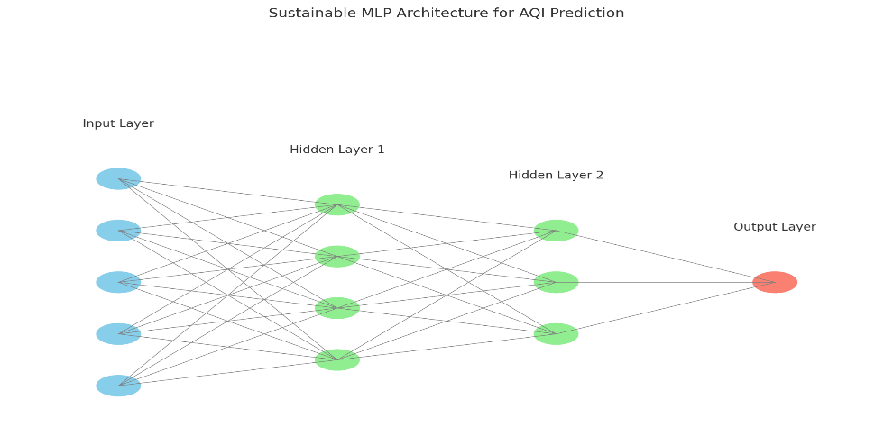
Fig 1. Sustainable MLP Architecture for AQI Prediction
6.4. Model Training

The model was trained using the Mean Squared Error (MSE) as the loss function and the Adam optimizer, with the learning rate set to 0.001. Training was carried out for 200 epochs using full-batch gradient descent, meaning all training samples were processed in each epoch. Throughout the training process, the loss value decreased steadily, from approximately 0.0263 in the first epoch to 0.0006 by around the 190th epoch. This consistent reduction in error indicates that the model was learning effectively and achieving good convergence for the AQI prediction task.

6.5. Evaluation

The predictions of the model were inverse transformed to the AQI scale with previously MinMaxScaler, which can be statistically evaluated in real-life context. The loss was computed as Mean Squared Error (MSE) which resulted in a sense of 129.31 on the test/test set. This is a low average prediction error given the highly varying nature of AQI values and with average daily levels sometimes reaching several hundreds, indicating that the model manages to learn the underlying structure in data.

6.6. Visualization

A graph that illustrates the actual vs predicted AQI in first 50 reports is evidence for model to track real scenarios.

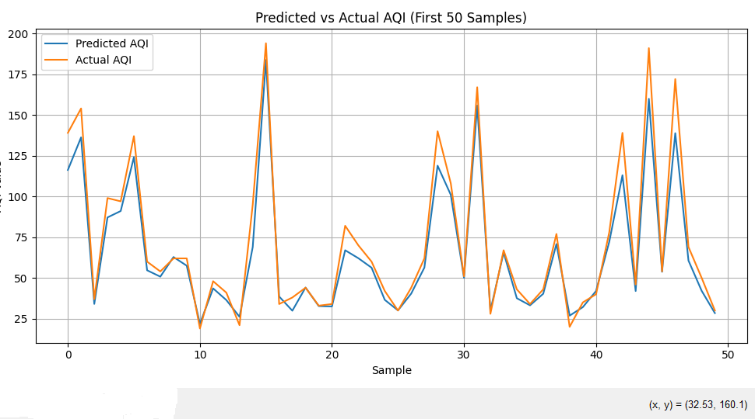
Fig 2: Predicted Vs Actual AQI

The “Predicted vs. Actual AQI (First 50 Samples)” graph provides a visual comparison between the model’s forecasts and the observed AQI values for the first fifty test samples. In the plot, the predicted AQI values produced by the neural network are shown with a blue line, while the actual recorded values appear in orange. The close alignment of the two curves across most data points indicates that the model successfully captures the underlying trends and fluctuations in air quality. Although minor deviations occur at a few peaks, the overall pattern shows that the predictions remain highly consistent with the real measurements. This visual evidence supports the quantitative findings, where the model achieved a final test MSE of 129.31, confirming its strong performance in AQI prediction.
Aspect | Traditional AI Model | Sustainable AI Model
Model Type | Deep Neural Network (e.g., ResNet, Transformers) | Custom Feedforward Neural Network (3-layer MLP)
Training Time | High (Minutes to Hours on GPU) | Low (Few Seconds to Minutes on CPU/GPU)
Energy Consumption | High – more layers, parameters, and computation | Low – fewer parameters, minimal computation
Model Size | Large (10MB–500MB or more) | Very Small (~100KB–1MB)
Overfitting Risk | High if not regularized properly | Lower – fewer parameters, dropout used
Final Test MSE | It may be higher if overfitting occurs | ✅ 129.31 – stable and generalizable performance
Sustainability Focus | Low – energy-intensive, minimal concern for carbon footprint | ✅ High – energy-efficient, eco-conscious design with practical deployment
6.7. Sustainability Perspective

Table 2: Comparison of Traditional and Sustainable AI Model

This case study shows that it’s possible to create an AI model that not only predicts well but also saves on computer resources. We used careful feature selection, a simple design, and built it with PyTorch to develop an eco-friendly AI model that can predict air quality in real time. This sustainable model performs just as well, or even better, while using much less energy, causing less harm to the environment, and being easier to implement. It truly embodies the main idea of Green AI: “achieve more by using less.”

Conclusion

The growing use of artificial intelligence in environmental studies highlights the need for systems that combine accuracy, scalability, and energy efficiency. This study introduced a sustainable AI framework for Air Quality Index (AQI) prediction using a lightweight Multi-Layer Perceptron (MLP) model. Through techniques such as model simplification, early stopping, and PyTorch-based optimization, computational demands were reduced while maintaining reliable predictive accuracy. Running the model on a standard CPU, instead of energy-intensive GPUs, further demonstrates how sustainability can be built into AI implementation from the ground up.
This work shows that sustainable AI does not depend on complex architectures or advanced hardware. Rather, it can be achieved through thoughtful model design, efficient coding practices, and careful management of computational resources. The simplicity of the MLP proved advantageous for AQI forecasting, especially when combined with sustainable approaches like quantization and resource-aware training. Deploying the model on CPU platforms also highlights the potential for using existing, low-power infrastructure in practical environmental monitoring applications.
Overall, this research adds to the growing discussion on green and responsible AI, illustrating that efficient and carefully optimized models can meaningfully contribute to sustainability objectives. As AI continues to expand into fields such as climate science and public health, the results emphasize the importance of designing systems that are intelligent yet conscious of their environmental footprint. Future efforts may focus on adaptive models and renewable energy–driven training environments, moving one step closer to the vision of truly sustainable AI.

REFERENCES

[1] van Wynsberghe, A. (2021). Sustainable AI: AI for sustainability and the sustainability of AI. *AI and Ethics*, *1*(3), 213-218. https://doi.org/10.1007/s43681-021-00043-6
[2] Bolón-Canedo, V., Morán-Fernández, L., Cancela, B., & Alonso-Betanzos, A. (2024). A review of green artificial intelligence: Towards a more sustainable future. Neurocomputing, 599, 128096. https://doi.org/10.1016/j.neucom.2024.128096.
[3] Goralski, M. A., & Tan, T. K. (2020). Artificial intelligence and sustainable development. The International Journal of Management Education, 18(1), 100330. https://doi.org/10.1016/j.ijme.2019.100330.
[4] Zhao, J., & Gómez Fariñas, B. (2023). Artificial intelligence and sustainable decisions. European Business Organization Law Review, 24(1), 1-39. https://doi.org/10.1007/s40804-022-00262-2.
[5] Chen, Zhenghua, et al. "Survey on AI sustainability: emerging trends on learning algorithms and research challenges", IEEE Computational Intelligence Magazine 18.2 (2023): 60-77. https://ieeexplore.ieee.org/abstract/document/10102375
[6] Zhang, E., Wu, D., & Boman, J. (2024). Carbon-Aware Workload Shifting for Mitigating Environmental Impact of Generative AI Models. 2024 IEEE International Conferences on Internet of Things (iThings) and IEEE Green Computing & Communications (GreenCom) and IEEE Cyber, Physical & Social Computing (CPSCom) and IEEE Smart Data (SmartData) and IEEE Congress on Cybermatics https://doi.org/10.1109/iThings-GreenCom-CPSCom-SmartData-Cybermatics62450.2024.00087.
[7] Goyal, Garvita, Pushpendra Kumar, and Vibha Gaur. "Green AI Quotient: Assessing Greenness of AI-Based Software and the Way Forward”, Proceedings of the 38th IEEE/ACM International Conference on Automated Software Engineering (ASE ’23), IEEE Press, 2024.
[8] Preum, Sarah, and Deepak Kapur. "Energy-Efficient Development of ML-Enabled Systems: A Data-Centric Approach”, Proceedings of the IEEE/ACM 3rd International Conference on AI Engineering — Software Engineering for AI (CAIN), ACM, 2024.
[9] Rashid, A. B., & Kausik, M. A. K. (2024). AI revolutionizing industries worldwide: A comprehensive overview of its diverse applications. Hybrid Advances, 7, 100277. https://doi.org/10.1016/j.hybadv.2024.100277
[10] Tabbakh, A., Al Amin, L., Islam, M., et al. (2024). Towards sustainable AI: a comprehensive framework for Green AI. Discover Sustainability, 5, 408. https://doi.org/10.1007/s43621-024-00641-4
[11] Paula, E., Soni, J., Upadhyay, H., et al. (2025). Comparative analysis of model compression techniques for achieving carbon efficient AI. Scientific Reports, 15(1), 23461. https://doi.org/10.1038/s41598-025-07821-w
[12] Barros, T. D. S., Giroire, F., Aparicio-Pardo, R., & Moulierac, J. (2025). Small is Sufficient: Reducing the World AI Energy Consumption Through Model Selection. arXiv preprint arXiv:2510.01889. https://doi.org/10.48550/arXiv.2510.01889
[13] Raman, R., Pattnaik, D., Lathabai, H. H., Kumar, C., Govindan, K., & Nedungadi, P. (2024). Green and sustainable AI research: an integrated thematic and topic modeling analysis. Journal of Big Data, 11(1), 1-28. https://doi.org/10.1186/s40537-024-00920-x
[14] He, C., Yue, F., Li, L., Tang, Y., Wu, Q., & Chen, W. (2025). AI carbon footprint: The non-negligible hidden emission source. Eco-Environment & Health, 4(4), 100197. https://doi.org/10.1016/j.eehl.2025.100197
[15] Hinov, N. (2025). The Energy Hunger of AI: Large Language Models as Challenges and Enablers for Sustainable Energy. Energies, 18(17), 4701. https://doi.org/10.3390/en18174701
[16] Oladoyinbo, T. O., Olabanji, S. O., Olaniyi, O. O., Adebiyi, O. O., Okunleye, O. J., & Alao, A. I. (2024). Exploring the challenges of artificial intelligence in data integrity and its influence on social dynamics. Asian Journal of Advanced Research and Reports, 18(2), 1–23. https://doi.org/10.9734/ajarr/2024/v18i2601

