A LIGHTWEIGHT HYBRID MODEL FOR THE SECURE TRANSMISSION OF MEDICAL IMAGES USING LSB WATERMARKING, ECIES AND AES-CTR

.
ABSTRACT

The use of telemedicine suffers the issue of the necessity to encrypt transmission of medical images across unreliable networks. Hybrid cryptography methods such as ECC-LSB watermarking have offered confidentiality but are usually not fast and real time. In this research paper, a lightweight model that combines Least Significant Bit (LSB) watermarking with Elliptic Curve Integrated Encryption Scheme (ECIES) and Advanced Encryption Standard in Counter Mode (AES-CTR) to encrypt medical images in a fast and parallel way is proposed. The model inserts patient Electronic Health Records (EHR) data as LSB watermarking in the red channel of the image and encrypts each RGB channel with an AES-CTR key, and the ECIES guarantees safe exchange of keys. As theoretical results show, experimental results revealed a better image quality than the traditional ECC-LSB frameworks, with MSE = 0.0022, PSNR = 74.64 dB, and UIQI = 1.0000. The system offered has confidentiality and efficiency that are appropriate in real-time telemedicine and PACS setup.

Keywords: [Image Encryption, Medical Images, LSB watermarking, Elliptic Curve integrated Encryption Scheme, AES-CTR, Peak Signal to Noise Ratio, Mean Square Error, Universal Image Quality Index}

1. INTRODUCTION
The significance of medical data is extremely high because of the significance of its application in clinical diagnostics, monitoring of patient conditions, and treatment planning, research, and education among a wide range of commercial and other applications. [1]
With the increased number of healthcare systems that are digitalized, the management and protection of such data have become a priority. The medical records have very sensitive patient information like the identity of the patient, the laboratory test findings and allergies, medical history, and surgical history. Such personal and diagnostic parameters can lead to identity theft, insurance fraud, and even manipulation or corruption of diagnostic images that can adversely impact clinical decision-making due to unauthorized access of medical data [2]. Healthcare information is consequently a very important resource and a legal requirement of hospitals, pharmaceuticals, insurers, and research institutions.
The rising level of data breaches of healthcare institutions is another reason as to why more security measures are required along the entire lifecycle of medical data. Protection should be ensured whether in storage process or in transit by ensuring security is achieved by watermarking of the data, advanced encryption and tight access control.
Laws and regulations, like HIPAA, GDPR, and ISO/IEC 27799, establish necessary confidentiality, integrity, and availability of health information [3] which represent a more general social necessity to ensure the security of information outside of a clinical setting [4].
The contributions of this paper are summarized by:
Illustrated the advantage of red-channel LSB watermark, to bind the metadata in the image pixels and enhance confidentiality.
Per-channel lightweight encryption in the efficient transmission of colored images.
Good opposition to contemporary adversarial attacks.
Performance of real-time telemedicine-friendly.
Analysis of the results proves that our algorithm gains a high performance in encrypting medical images than other methods.
The paper aims to:
Achieve high security.
To design a light weight secured hybrid algorithm for transmission of medical images and embedded Electronic Health Record using Least Significant Bit watermarking, Elliptic Curve Integrated Encryption Scheme with AES-CTR.
To evaluate the security strength, computational overhead, and preservation of picture quality of the proposed scheme in comparison to other watermarking schemes currently in use, such as (Eshraq, 2020).
Many studies based on medical image security were made, to enhance the security and efficiency of healthcare data at rest and in transit. Several approaches in one way or the other, proposed a hybrid method in protecting health care information.
Among which we have:
[6] developed a new, user-friendly, and visible watermarking scheme of medical images- Visual and User-Friendly Medical Image Watermarking Scheme (VUF-MIWS)-that was developed to ensure the safety of medical image ownership without compromising the usefulness of medical images in the diagnosis of illness. VUF-MIWS uses a special collection of inpainting and data hiding methods to insert hospital logos as visible watermarks, which can be extracted without leaving any trace when authenticity of the image is confirmed, and the image can be returned to its original condition. The experimental findings indicate that the scheme has a strong performance, where the watermarking scheme is able to store critical diagnostic data with high fidelity. The algorithm gained a Peak Signal-to-Noise Ratios (PSNR) greater than 70 dB and Structure similarity Index Measures (SSIM) of 0.99 at painted images, meaning there was slight loss of the quality of the image.
In [7], the authors in the current paper have discussed the various kinds of medical images and the attacks that could compromise the transmission of medical images in detail. This survey paper outlines known medical data security solutions and various challenges that are related to them. The detailed description of security measures, including cryptography, steganography and watermarking are presented and the current studies regarding the topic are reviewed entirely. The paper aim will be to summarize and evaluate the various algorithms of each method with respect to various parameters like PSNR, MSE, BER, and NC.
[8] presented a reversible data hiding method of security of medical images in the form of multi-layer. The method entails embedding sensitive information by employing multi-layer difference expansion but remains reversible thereby restoring the original image perfectly. It guarantees diagnostic fidelity and confidentiality of data. The algorithm is very efficient in embedding without visual deterioration but adds complexity to computation because of multilayer encoding and decoding. It also has several clinical advantages due to reversibility, but processing time is potentially impacted in a large-scale setting.
This method, [9] suggested adds a fingerprint of a patient in the form of a watermark to improve the verification of identity and privacy in the medical images. It has a hybrid lifting wavelet transform (LWT) and discrete wavelet transform (DWT) which enhances the strength of watermark and imperceptibility. The factors to be used in adaptive scaling and embedding are calculated based on Local Binary Patterns of the host image. This is done by a two-level wavelet decomposition and then non-blind watermark extraction that is the same as the watermark embedding procedure. The resistance to common image attacks is demonstrated in experimental validation of the multiple medical modalities (e.g., X-ray, CT). The PSNR and NCC based performance evaluation show high robustness and authentication performance compared to the current watermarking methods.
[10] have introduced a reversible scheme of watermarking which is capable of supporting high payload capacity as well as low computational cost. The medical image is partitioned into a Border Region (BR) and Non-Border Region (NBR) with the latter being upscaled via Neighbor Mean Interpolation (NMI), allowing to maintain reversibility. Electronic Patient Report (EPR) is ciphered with the help of adaptively generated pseudorandom key based on the host image and the Enigma machine and implanted through NMI. An encrypted payload in the NBR and a Global Integrity Code in the BR are used to do dual-level tamper detection based on LSB. Experiment results on 100 images have high visual integrity and high visual strength (PSNR=41.03 dB, SSIM=0.99, NC = 0.99, BER = 0.0019), rapid average embedding and extraction speed (0.88 s and 0.83 s). The method also shows a lot of strength against the multiple image processing attacks and it has a better performance than various other similar methods. The remaining of this paper contains Section 2, which discusses the proposed method in detail. Section 3 demonstrates simulation results and analysis. Finally, the paper is concluded in Section 4.]

2. material and methods

MATLAB R2023a was utilized in simulating and calculating the MSE, PSNR, and UIQI. Also Testing whether the images are of good quality or not.

2.1 THE PROPOSED scheme

In this scheme, the EHR of the patient is embedded into the red channel of the medical image by watermarking technique. The attached picture is further partitioned into three color channel (RGB) images and ciphers by Elliptic Curve Integrated Encryption Scheme (ECIES) with AES-CTR mode and then transmitted. A brief explanation of the various components of the proposed system is given below

2.1.1 LSB WATERMARKING
The LSB watermarking scheme is aimed at inserting the text as the EHR into the pixel values of mini red channel of an image in a medical field [14] The technology enables the safe association between picture information and patient data without producing noticeable distortion [11].
The computational overhead of LSB watermarking is low, which is among the most convincing benefits of LSB watermarking and qualifies such a system to be used in real-time health systems. [15] LSB only works in the three-dimensional domain and performs mere binary operations like bits masking and replacement to write secret data into pixels of an image. An illustration of image embedding is shown in Figure 1.

Figure 1. Embedding a medical record into a cover image

2.1. 2 ECIES KEY EXCHANGE
Watermarking, in isolation, is not sufficient for protecting images against opportunistic loss and thus requires the additional strength of encryption. One of the most significant public-key cryptographic protocols for image security is the Elliptic Curve Integrated Encryption Scheme (ECIES), or a variant [12]. ECIES protects confidentiality by encrypting the medical image with symmetric key cryptography, the symmetric key is protected using elliptic curve (ECC). Given that ECC can be paired with light-weight faster encryption such as AES in counter mode (AES-CTR), it is advantageous for limits in telemedicine solutions and cloud applications with tight low latency connections (Arasada Subashini, 2023). ECIES can provide the same security level as RSA or other traditional public-key systems using short keys, which lessens computation overhead, and this is ideal for portable diagnostic devices and real-time health care systems.

2.1. 3 AES-CTR ENCRYPTIONS
AES-CTR (also known as Advanced Encryption Standard in Counter Mode) is a symmetric encryption algorithm that takes a block cipher and turns it into a stream cipher by encrypting the consecutive values on a counter and XORs those with plaintext. It is both very popular due to its high speed, simplicity and capability to parallelize the encryption and the decryption processes [12].
Padding is not required when using AES-CTR mode because any amount of data to be encrypted is an integral numerous of the block size, so plaintext will be converted into an equally sized block of ciphertext no matter whether the data is a multiple of the block size or not.
Counter (CTR) mode is a common form of block cipher mode of operation based on block cipher algorithm. A high-level encryption or processing capability (Advanced Encryption Standard) [13].

2.2 SYSTEM ARCHITECTURE AND WORKFLOW
Two processes in which the system works namely, sender side processing and receiver side processing.
Sender side processing:
Input phase: A diagnostic medical image (e.g., PNG format) and a patient EHR in a form of textual records.
- Watermarks stream: Integrate the EHR in the last insignificant bits (LSBs) of the Red (R) channel with 2 bits or 3 bits LSB.
- Channel Separation step: Divide the image into red, green and blue channels respectively.
- Encryption stage: Each channel is to be encrypted by ECIES protocol uses elliptic curve key exchange to establish a shared symmetric key (AES-256-CTR) on which to encrypt each of the RGB channels.
- Packing procedure: Store encrypted channels as secure data file (e.g. encrypted_R.dat, for red channel).
Receiver Side processing:
- Receive phase: initialize a reception of (encrypted_R.dat, encrypted_G.dat, encrypted_B.dat,) files.
- Decryption step: Decryption of R, G, B channels with the ECIES-derived-key.
- Image Reconstruction step: It combines the decrypted RGB elements to form medical image.
- Step one in the extraction of EHR: continue the action of extraction on red channel: decode embedded EHR inverse of embedded LSB decoding logic.

2.3 METHODOLOGICAL FRAMEWORK (VISUAL)
Overview of secure medical image transmission (Sender processing) in Figure 2.

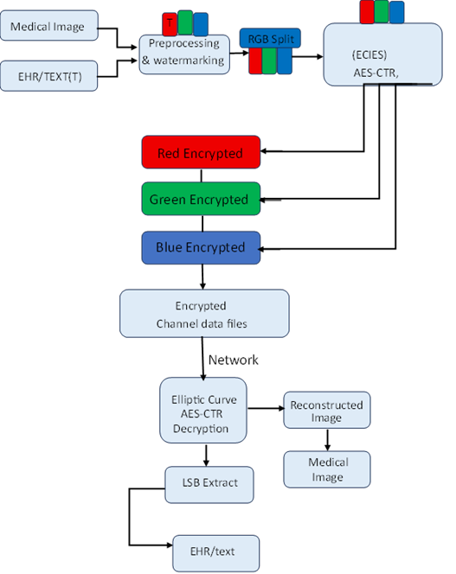
Fig 2. Illustration of the hybrid system framework

Algorithm 1 Proposed Encryption Algorithm

Inputs for the process are; Medical image (RGB image) and EHR) plaintext.
Output for the process are; Encrypted R, G, B channel files and a watermarked image.
Steps:
i. Start
ii. Original RGB medical image
iii. Enter the EHR clear message
iv. Encode the EHR message in binary string
v. Import the RGB image and take out the red, green and blue channels.
vi. Embed binary EHR data into LSBs of red channel LSB watermarking.
vii. merge RGB and save as watermarked image.
viii. Separate the watermarked image into three different R, G, and B data streams.
For each RGB channel:
- Make ECC key pair (public and private).
- Share secret on ECIES (ECDH)
- Derive AES-256 KEY FROM SHARED SECRET
- conversation data for Channels on AES-256 CTR mode encrypted.
- Save:
- Encrypted channel
- IV (nonce)
- Public key
Package:
- Encrypted R, G, B files
Public key(s)
- Send data over the network
- End

Fig 3, illustrates the flowchart of proposed Encryption algorithm

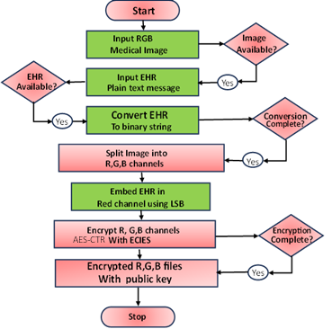

Figure 3. Flowchart of the proposed encryption algorithm

Algorithm 2 Proposed decryption algorithm

Input for the process are; Encrypted R, G, B channel files, ECC public key(s), and Private key for decryption.
Output process will involve; Reconstructed watermarked image, Extracted EHR.
Steps:
- Start
- Receive R, G, B files, hashes, and public key(s) that are encrypted
For each RGB channel:
- Get shared secret key by the use of public key received from and locally held key ECIES.
- Decrypt channel is AES 256 CTR
- reconstruct encrypted rgb image
- To replenish Single-virtues decoding R, G, and B channels
- Colorize by the elimination of the repetitive EHR on the LSBs on the Red channel
- Decoded EHR message was produced
- Results: Decryption
- End

Fig 4, below illustrates the flowchart of proposed decryption algorithm

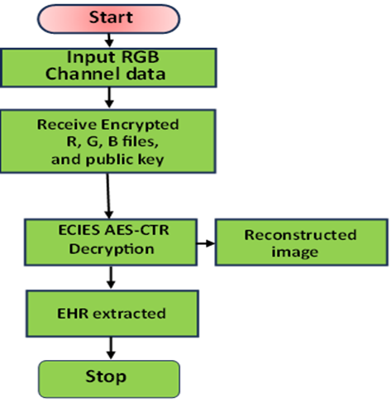

Figure 4 Proposed decryption flowchart

2.4 MATHEMATICAL MODEL OF THE PROPOSED

2.5. METRICs USED

The following are the Metrics used in [16], [17]

3. RESULTS and discussion

In Fig 5, the original image before encryption and a reconstructed image after decryption. This shows a high level of quality since the original and reconstructed are closely same.
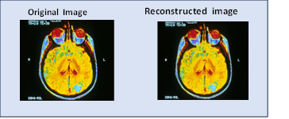
Figure 5. Original image and reconstructed image.
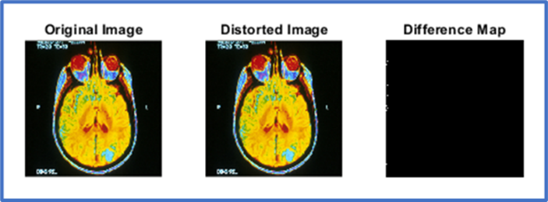
In fig 6, difference map indicates less or not perceivable distortion as areas showing a closely relatable reconstructed image after decryption.

Figure 6. Distortion difference in original image for the proposed.
In fig 7, the distortion difference on Eshraq seems to have less noise which is not easily perceivable by the human eye. Looking at the difference map; with a simulation of MSE at 0.0024, PSNR at 74.35 dB, and UIQI at 1.0000.
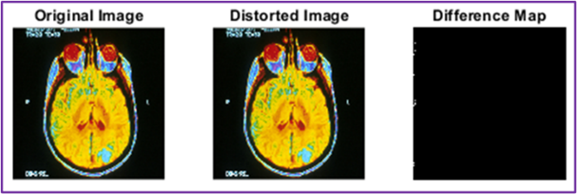

Figure 7. Distortion difference in Eshraq’s LSB-ECC study.

From table 1, the image Quality metrics shows that, MSE/PSNR/UIQI closely match the LSB baseline from Eshraq framework, demonstrating that confidentiality and integrity can be added without degrading diagnostic quality, with the proposed still performing slightly better than the framework of Eshraq.
Lower value of MSE at 0.0022 incorporated in the proposed method implies that extremely little error was added in the process of watermarking, encryption and decryption.
The dimensionality of 74.64 dB is far more superior than normal levels (value greater than 40 dB is excellent) that signifies almost no distortion.

Table 1. Metric results attained for image quality check.

Method | MSE | PSNR | UIQI
Proposed study (Hybrid) | 0.0022 | 74.64 dB | 1.0000
Eshraq (2020) ECC, LSB | 0.0024 | 74.35 dB | 1.0000

In Fig 8, a UIQI of 1.0000 values indicates an absolutely perfect correlation between the reconstructed image and the original image which confirms excellent structural faithfulness and preservation of brightness and contrast. When the metrics used are compared, the proposed method has MSE of 0.0022, slightly higher than Eshraq’s with a difference of 0.002. Meanwhile, where a PSNR, and UIQI is proposed at (74.64 dB against 74.35 for Eshraq’s, and 1.0000 is same).

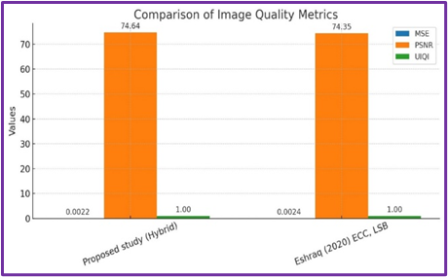

Figure 8. Image Quality of the Proposed vs. Eshraq Framework

Image metrics on both studies simulated in MATLAB R2023a, on five (5) MRI image data sets of different sizes. Images source: https://visualsonline.cancer.gov/details.cfm?imageid=2416
Table 2. Image Quality Metrics from both Methods
From table 2, the image Quality metrics shows that, MSE/PSNR/UIQI closely match the LSB baseline from Eshraq framework, demonstrating that confidentiality and integrity can be added without degrading diagnostic quality. However, the proposed still performing slightly better than the framework of Eshraq using different image sizes. For the purpose of this study, 256×256 image size is used as the benchmark for both studies.

From Table 3 below we look at the simulation results of both study on Time complexity and power consumption.
Table 3. Time and Power metrics
Process | Proposed study |  | Eshraq’s LSB-ECC
CPU = 25;  corei7,8gb RAM, SATA disk. | Time (S) | Power(J) | Time(S) | Power (J)
Encryption | 0.128397 | 3.21J | 0.84 | 0.14(J)
Embedding | 0.002173 | 0.57J | 0.01 | 7.56(J)
Decryption | 0.101042 | 2.53J | 0.70 | 0.16(J)
Totals | 0.231612 | 6.31J | 1.55 | 7.86(J)

In Table 3, it is observed that, for all processes involved in both methods, the proposed used less time and power in total. With time in seconds used for all processes lesser, and power consumed indicating a reasonable margin in comparison with the existing scheme. This demonstrate that the proposed can be used in a telemedicine setting without degrading efficiency.

Rationalization of technique

- LSB Watermarking will be used because of its simplicity and insignificant visual impact on diagnostic images.
- ECIES: ECIES is a protocol that offers high encryption using lightweight key exchange and can be used in an environment with real-time and constrained application.
- AES-CTR is known for its fast parallelable encryption (per-channel encryption) thereby reducing latency even after processing bulk healthcare data. An efficiency is processing healthcare data over other methods.
The methodology is based on the available studies and continues them in the form of a new combination of methods. The work is also the first to combine LSB and ECC together to provide better security without compromising clinical images quality (Eshraq, 2020). Altogether, it can be concluded that the proposed system offers an organized an efficient framework of medical image transmission: The fast LSB steganography is used to embed EHR data into images, ECIES asymmetric key exchange with AES-CTR encryption is used to encrypt data across different color channels. Collectively, these elements can be used to create an effective, efficient, scalable, and hack-resistant solution that can be implemented in various healthcare settings.

Table 4 makes a transmission feature comparison Between the Proposed Hybrid Framework and Eshraq 2020 ECC-LSB Model.

Table 4. Comparative Summary of Key Transmission Features

Parameter | Proposed Hybrid Framework WATERMARKING, ECIES, and AES-CTR. | Eshraq 2020 Framework (ECC-LSB)
Core Design | Multi-layer approach with asymmetric key exchange, symmetric mutual encryption and watermarking which is used to obtain complete-session protection. | Medical images contain dual-layer security where ECC ciphers are used, and steganography is used with LSB.
Encryption Process | ECC (ECIES) is only used once during the session when negotiating key, AES-CTR is an efficient encryption algorithm with a linear complexity of O(N). | LSB embedding is done to a complete payload followed by ECC, no symmetric cipher is employed which causes longer computations in small datasets even in large datasets.
Integrity Check | None. Check of data at cost of latency. | No integrity check layer
Steganographic Layer | LSB watermarking does not affect the quality of the diagnostic image by embedding metadata (patient ID, diagnostics). | Medical images carry encrypted texts that are concealed using ECC to ensure that the ciphertext is not visible under the LSB steganography.
Computational Overhead | Low parallelizable AES operations and single polling latency of an ECC exchange step, therefore the best fit when telemedicine applications or large image sets are required. | Increased per block cost of ECC encryption, appropriate in medium size payloads and secure archives, but not in secure high-speed transfer.
Security Model | Layered defense - the attacker must locate the concealed information, decrypt AES encryption using ECC key. | Two step defense - attacker must locate the obscured data and crack ECC encryption in order to discover the plaintext.
Experimental Findings | High throughput PSNR should be high because of the lightweight watermarking and encryption. | High PSNR values (>70 dB in the vast majority of cases) that evidence image quality preservation and improved ECC results in comparison with RSA.
Application Objective | Best optimized with integrated EHR systems, distributed hospitals, instantly sharing information, and also ensuring security throughout the sessions of the sessions of diagnostic images shared on a point-to-point basis. | Ideally suited to secure file transfer, secure image storage and confidential communication of diagnostic images in a point-to-point manner.

Observations:
- Security Focus: Both systems use LSB and ECC as a foundation to confidentiality. The hybrid framework, however ensures there is endorsement of fast and bulk encryption using AES-CTR.
- Performance Trade-off: Eshraq 2020 provides per-block ECC encryption which is more secure at the cost of a slower processor compared to AES-CTR which is optimized to handle high-speed medical data flows.
- Domain of Use: Eshraq has an architecture that is particularly well-suited to secure archival or single-image transfer, whereas the hybrid design is particularly applicable to telemedicine (real-time), geographically dispersed EHR, and high-volume diagnostic imaging networks.
- Quality of the Image: Both techniques will retain diagnostic image quality. According to Eshraq (2020), PSNR will always be greater than 70 dB and, therefore, depending on the implementation of the lightweight watermarking, the hybrid system can ensure similar or higher PSNR.

4. Conclusion

In this research paper, a lightweight model consists of Least Significant Bit (LSB) watermarking with Elliptic Curve Integrated Encryption Scheme (ECIES) and Advanced Encryption Standard in Counter Mode (AES-CTR) to encrypt medical images in a fast and parallel way is proposed. The research paper confirmed the hypothesis of the hybrid encryption model as a safe and effective and scalable method of transmitting medical images in untrusted networks.
The system was able to provide confidentiality, authenticity, and integrity of data with the addition of LSB watermarking and ECIES-AES-CTR encryption, without compromising on diagnostic image quality (PSNR > 70 dB) and minimizing the calculation cost. The findings verify that the framework gives a multi-layered security and is more practical and secure compared to the current encryption methods.

COMPETING INTERESTS DISCLAIMER:
Authors have declared that they have no known competing financial interests OR non-financial interests OR personal relationships that could have appeared to influence the work reported in this paper.

References

[1] Ewoh, P., & Vartiainen, T. (2024). Vulnerability to Cyberattacks and Sociotechnical Solutions for Health Care Systems: Systematic Review. Journal of Medical Internet Research. https://doi.org/10.2196/46904

[2] Gajanayake, R., Iannella, R., & Sahama, T. (2014). Privacy oriented access control for electronic health records. Electronic Journal of Health Informatics, 8(2), e15..
[3] International Organization for Standardization. (2016). Health informatics - Information security management in health using ISO/IEC 27002 (ISO 27799:2016). ISO. https://doi.org/10.31030/2561354.

[4] Alsehli, A., Abdul, W., & Ghouzali, S. (2021). Secure Image Authentication Using Watermarking and Blockchain. Intelligent Automation & Soft Computing, 28(2), 577–591. https://doi.org/10.32604/iasc.2021.016382.

[5] Bin Hureib, E. S., & Gutub, A. A. (2020). Enhancing medical data security via combining elliptic curve cryptography and image steganography. International Journal of Computer Science and Network Security, 20(8), 1-8. https://doi.org/10.22937/IJCSNS.2020.20.08.1.

[6] Lin, C.-C., Lin, Y.-H., Lin, T.-L., & Lai, J.-L. (2025). VUF-MIWS: A Visible and User-Friendly Watermarking Scheme for Medical Images. Electronics, 14(1), 122. https://doi.org/10.3390/electronics14010122.
[7] Magdy, M., Hosny, K. M., Ghali, N. I., & Ghoniemy, S. (2022). Security of medical images for telemedicine: a systematic review. Multimedia Tools and Applications. https://doi.org/10.1007/s11042-022-11956-7.

[8] Maniriho, P., Mahoro, L. J., Bizimana, Z., Niyigaba, E., & Ahmad, T. (2021). Reversible difference expansion multi-layer data hiding technique for medical images. International Journal of Advances in Intelligent Informatics, 7(1), 1-11. https://doi.org/10.26555/ijain.v7i1.483.
[9] Vaidya, S. P. (2023). Fingerprint-based robust medical image watermarking in hybrid transform. The Visual Computer, 39(6), 2245–2260. https://doi.org/10.1007/s00371-022-02406-4.
[10] Singh, P., Devi, K. J., Thakkar, H. K., Bilal, M., Nayyar, A., & Kwak, D. (2023). Robust and secure medical image watermarking for edge-enabled e-healthcare. IEEE Access, 11, 135831–135845. https://doi.org/10.1109/ACCESS.2023.3340001.
[11] Kumar A, R. M. (2022). Survey of medical image security using watermarking and encryption. Health Informatics Journal, 28(1), 45-59.
[12] Velmurugadass, P., Dhanasekaran, S., Anand, S. S., & Vasudevan, V. (2020). Enhancing Blockchain security in cloud computing with IoT environment using ECIES and cryptography hash algorithm. Materials Today: Proceedings. https://doi.org/10.1016/j.matpr.2020.08.519
[13] Xilinx. (2019). CTR Mode. Vitis Security Library. https://xilinx.github.io/Vitis_Libraries/security/2019.2/guide_L1/internals/ctr.html
[14] Taleby Ahvanooey, M. L. (2018). An overview of data hiding techniques: Classical and quantum approaches. Journal of Information Security and Applications, 42, . 10-22.
[15] Faheem, Z. B., Ali, M., Raza, M. A., Arslan, F., Ali, J., Masud, M., & Shorfuzzaman, M. (2022). Image Watermarking Scheme Using LSB and Image Gradient. Applied Sciences, 12(9), 4202. https://doi.org/10.3390/app12094202.
[16] Benssalah, M., Rhaskali, Y., & Drouiche, K. (2021). An efficient image encryption scheme for TMIS based on elliptic curve integrated encryption and linear cryptography. Multimedia Tools and Applications, 80(2), 2081–2107. https://doi.org/10.1007/s11042-020-10300-x.
[17] Kumar, S., & Sharma, D. (2024). A chaotic based image encryption scheme using elliptic curve cryptography and genetic algorithm. Artificial Intelligence Review, 57(4), 87. https://doi.org/10.1007/s10462-024-10719-0.

