Effects of Aqueous Leaves Extracts of Individual and Polyherbal Formulated Ointments on Wound Healing and Demonstration of Elastic Fibres of Wounded Skin of Wistar Rats

ABSTRACT
Wound defined as a loss or breaking of epithelial cellular. Wound healing is a complex process that is dependent on several factors that may hasten or affect the process of wound healing activity. The aim of the study was to assess the effects of aqueous leaves extract of individual and polyherbal formulated ointments in wounded skin of wistar rats. Total of 45 healthy wistar rats were divided into 9 groups, with 5 rats in each. Group A negative control, wounded no treatment, group B positive control, wounded and treated with standard drug, group C test wounded treated with aqueous extract of A nilotica only, group D test wounded treated with aqueous leaves extract of A. vera only, group six E test group wounded and treated with aqueous leaves extract of C. procera only, group F test wounded treated with combinations of aqueous leaves extract of A. nilotica and A. vera, group G wounded treated with combinations of aqueous leaf extract of A. nilotica and C. procera, the group H wounded treated with aqueous leaves extract of aloe vera and C. procera and group I test wounded treated with aqueous leaves extract of polyherbal formulation of A. nilotica, A. vera and C. procera. The result of the study showed that extracts of A. nilotica has better physical properties than other extracts, The aqueous leaves extract the Acacia nilotica, Aloe vera and Calotropis procera shows very good physical characteristics and presence of secondary metabolites that possessed wound healing effect. Conclusion the research showed elastic fibres deposition in groups treated with aqueous leaves extract of Acacia nilotica formulated ointments and in combination of the three extracts of the studied sections.
Keywords: Polyherbal Formulated Ointments, Elastic fibres, Wound Healing and Wistar Rats

1.0 Introduction
Wounds are physical injuries that occur due to internal and external breakage of skin that results in an opening or rupture of the skin [1, 2]. An instant and proper wound healing is necessary for the re-establishment of functional tissues and disordered structural maintenance following an injury [3]. This complex phenomenon involves constant cell-cell and cell-matrix interactions that promote healing of wounds in three different overlapping phases that are inflammatory phase, proliferative phase and remodelling phase [4]. Wounds are usually classiﬁed based on the area of affected skin nature; the injured skin layers or the nature of the skin repair process [5]. Injuries that affect only the epidermal skin layer are called superﬁcial wound, while injuries that damaged both the epidermis and dermal layers are referred to as partial-thickness wound. Full-thickness wounds are injuries of the epidermis, dermis including the sweat glands and hair follicles, and the underlying subcutaneous fat or deeper tissues as well [6]. Cutaneous wound healing consists of a sequence of molecular and cellular events which occur after the onset of a tissue lesion in order to restore the damaged tissue. This process can be subdivided into four phases namely haemostasis, inﬂammation, proliferation, and remodelling [7, 8]. Temporal evolution of cell mediated wound healing and relative ECM components synthesis, Undamaged skin, Haemostatic phase and immune cells invasion in the wound bed, Proliferation phase characterized by keratinocytes, fibroblasts and endothelial cells migration and proliferation for angiogenesis, collagen deposition, granulation tissue formation, re-epithelialization, and wound contraction to occur, Maturation phase consisting in collagen remodelling (from type III to type I) and wound closure [9].
Acacia first described in 1773 by the Swedish botanist Carl Linnaeus. Acacia is a genus of shrubs and trees belonging to the subfamily Mimosoideae of the family Fabaceae or Leguminosae. It is a complex species with nine subspecies, six are native to the African tropics in Nigeria it is refers to a Bagaruwa with Hausa language and the others are native to the Indian subcontinent [12]. Acacia nilotica is a tree widely distributed all over India, Sri Lanka, Sudan, Saudi Arabia and Egypt [10, 11]. Arabia. Acacia nilotica has different English names: like Indian gum arabic, Tomentose Babool, Black piquant, Black babul, Gum arabic, Egyptian mimosa, Egyptian thorn, Prickly Acacia, Nile acacia, Scented thorn and Scented-pod acacia; and different Arabic names: as Ummughilan, Usarequrz [13].
Aloe vera is a perennial, drought-resisting, succulent plant belonging to the Asphodelaceae family. The name, aloe, is derived from the Arabic "alloeh" or Hebrew "halal" meaning bitter shiny substance in Hausa language it is refers to as Karan-massallaci. It has a vast traditional role in indigenous system of medicine like ayurveda, siddha, Unani and homoeopathy [14]. Aloe barbadensis miller or Aloe vera, a semi tropical plant is one of the 250 species of Aloe. Most commonly used for its medicinal properties, Aloe Vera or the Sanskrit name "Ghee kunwar" is a member of Lilly family. The plant has lance-shaped, sharp pointed, and jagged & edged leaves [15]. Aloe vera is found as the wild herb along the coast of south India. It is under cultivation in fairly large areas in many parts of India viz; Tamil Nadu, Gujarat, Maharashtra etc. [15]. Aloes are often thought to only grow in hot and dry climates but they actually grow in a variety of climates including desert, grassland, and coastal or even alpine locations [16]. There are more than 200 compounds found in Aloe barbadensis, about 75 of which have biological activity, Aloe vera leaves contain a diverse array of compounds, including anthraquinones (e.g. aloe-emodin), anthrones and their glycosides (e.g. 10-(1, 5’ anhydroglucosyl)-aloeemodin- 9-anthrone, also known as aloin A and B), chromones, carbohydrates, proteins, glycoproteins, amino acids, organic acids, lipids, sugars, vitamins and minerals [17, 18, 19].
Calotropis procera is perennial shrub belongs to the family Apocynaceae. It is widely distributed in Asia, America and Africa in Nigeria it is refers to as Tunfafiya with Hausa language. It grows in almost all parts of Punjab Pakistan as wild shrub especially in plains, pasture and roads way. It is a multipurpose plant. The fiber of plant useful for making baskets, rope, bags and nets. The wood used as timber and fuel purpose [20]. Also used as fodder for animal. The latex of plant is an important source for the preparation of folk medicines. C. procera is a perennial shrub has ability to achieve height of 2.5 m-6 m, grey green leaves, with succulent and waxy appearance derived the name Procera. They are 15 cm-30 cm long and 2.5 cm-10 cm broad. The flower petals are arranged in pentamerous form, small, cream or greenish white at the base and purple violet at the extremity of the lobes. It has deep root system and contains fleshy fruits. C. procera is mostly pollinated by two carpenters’ bees (Xylocopa) ([21].

1.1 MATERIAL AND METHODS

1.2 STUDY LOCATION
The study was carried out in collaboration with Laboratory of Histopathology Department, School of Medical Laboratory Sciences, where tissue processing and staining procedures were carried out, Animal House and Department of Pharmacognosy of Faculty of Pharmaceutical Sciences, Usmanu Danfodiyo University, Sokoto where Animals were procured, surgical wound intervention.
1.3 ETHICAL APPROVAL
All the procedures of this research were performed according to the Guideline for the Care and Use of Laboratory Animals. Protocols approval of the research was formally obtained from the Ethics and Research Committee on the use of Laboratory Animals for research of the Usmanu Danfodiyo University, Sokoto. The ethical approval registration Number was given as NHREC/UDU-HREC/25/06/2023.
1.4 PLANTS COLLECTION AND DRYING OF THE LEAVES
The fresh leaves materials of A. nilotica, A. vera and C. procera were collected at the Herbarium Garden of Botany Department, Faculty of Biological Sciences, Usmanu Danfodiyo University Sokoto. All fresh individual leaves of plants were allowed to dried under the shade in Histopathology Laboratory to avoid destruction of suspected active ingredients by the sunlight.
1.5 PLANTS IDENTIFICATION AND AUTHENTIFICATION
The leaves of each individual plant of A. nilotica, A. vera and C. procera were identified and authenticated by the Department of Pharmacognosy, Faculty of Pharmaceutical Sciences, where specimen voucher number was assigned to each individual plant leaves as follows; A. nilotica: PCG/UDUS/faba/0006 C. procera: PCG/UDUS/apoc/0003 and A. vera: PCG/UDUS/asph/0001 and deposited in the same Department.
1.6 PLANTS PREPARATION AND EXTRACTION PROCEDURES
The fresh leaves of each individual plant of A. nilotica, A. vera and C. procera were washed with clean water and dried under shade. The dried leaf of each individual plant was grinded into fine powder by using a grinder. The crude powdered of each individual leaf was measured about 1000 g and soaked into 3000 mL of distilled water and allowed to stay for 3 days accompanied by continuous shaking of each individual mixture every day. The suspension each individual leaf was extracted by using the cold extraction method according to Rahee & Malik [22]. The suspension each individual leaf was filtered after 3 days by using fine clothes and then filtrates were refiltered using paper through filter funnel, the filtrates of each individual leaf was place on water bath for water to evaporate in order to obtain the pure extract of each individual plants to be use in the treatment of surgically wounded skin of wistar rats as done by Wei et al. [23]. The aqueous extract products of each individual leave were subjected to isolation, purification and sterilization procedures in order to get germ free and isolate that contain pure active components of each individual leaves responsible for wound healing.
1.7 PREPARATION OF EXTRACTS OINTMENTS AND APPLICATION ON THE WOUNDED SITE
White soft paraffin wax of 95 grams was weighed and melted in a water bath and 5 gram of each individual aqueous leaves extract was weighed and added to the melted white soft paraffin wax to serve as 5 % aqueous extract ointments to be used for the treatment of each individual test groups. Similar measurements were made of 0.25 gram of each 2 individual aqueous extract and combined to make it 5 grams then added to 95 grams of white soft paraffin wax to serve as 5 % aqueous extract ointments. Also 1.7 g of each 3 individual aqueous extract was weighed and combined to make it 5 grams then added to 95 g of white soft paraffin wax to serve as 5 % aqueous extract ointments to be used for treatment of polyherbal formulated ointments group. Each individual aqueous leaves extract ointments and polyherbal formulated ointments of A. nilotica, A. vera and C. procera were applied topically every day on the surgical wounded surface and the wound was covered using sterile gauze. The 5 % Betadine ointment was used for the treatment of the standard group alongside with test groups, to serve as positive control.
1.8 PURCHASE AND CARE OF EXPERIMENTAL ANIMALS
The healthy wistar rats (animals) were purchased from Animal House of Ahmadu Bello University, Zaria. The animals were transported to Sokoto and allowed to acclimatize for the period of 14 days at room conditions and fed with standard pellet diet (sterile food) and water ad libitum. World Health Organisation (WHO), guidelines for animal handling and care were strictly followed in this study. The animals were housed in a cage containing sterile saw dust (procured locally) as bedding throughout the experimental period. The animals were examined and investigated by physical examination and tests backing were done to declare the rat free of any skin parasites or infections before the experiment began. The sterile saw dust in the cages was changed every day to maintain aseptic conditions.

Table 1: Experimental Design
Experimental Groups (5 rats) | Treatment Given | Route/Duration /day
A. Negative control | Clean with normal saline | Topically/21
B. Positive control | Betadine ointment (5 %) | Topically/21
C. A. nilotica | Extract of A. nilotica (5 %) | Topically/21
D. A. vera | Extract of A. vera (5 %) | Topically/21
E. C. procera | Extract of C. procera (5 %) | Topically/21
F A. nilotica and A. vera | Extract of A. nilotica and A. vera (2.5 % each) | Topically/21
G. A. nilotica and C. procera | Extract of A. nilotica and C. procera (2. 5 % each) | Topically/21
H. A. vera and C. procera | Extract of A. vera C. procera and (2.5 % each) | Topically/21
I. A. nilotica, A. vera and C. procera | Extract of A. nilotica, A. vera and C. procera (1.7 % each) | Topically/21

1.9 SHAVING OF FUR AND ACUTE DERMAL TOXICITY STUDY

The fur (hairs) on the dorsal part (back) where the surgical wound was created of each animal was disinfected then shaved using a sterile surgical blade and the surface was decontaminated by wiping with sterile disinfectant (spirit). The animals were anaesthetized using chloroform vapour as done by Morton and Malone [24]. The prepared herbal ointments of 5 % formulations of each individual aqueous leaves extract were immediately applied on the shaved skin of wistar rats and left for an hour to be observed for any signs of irritation and abnormal change in colour of the skins, before the application of the extract to the surgically wounded sites. This is to ascertain the safety of the extract on the skin of the experimental animals, as done by Ravishankar and Satya-Sireesh [25].

1.10 CREATION OF EXCISIONAL SURGICAL WOUNDS ON BACK OF ANIMALS
The Injection ketamine 0.5 ml/kgbwt was administered intra-muscularly to each rat, to calm the animals and the surgical wound was inflicted by excising the skin flap in an aseptic fashion using sterile surgical knife, scissors and forceps where 2 cm x 2 cm diameter in length of full thickness wound was made on the shaved dorsal area of each rat. All the animals’ tail were labeled with different colors using permanent marker according to group and kept in separate groups of five rats per cage. The intervention was commenced with formulated ointments were topically applied daily; the wounded areas were left open. The treatments continued for twenty-one days, then followed by animals sacrificed on the 21 days as done by Ravishankar & Satya-Sireesh [25].

1.11 MEASUREMENT OF PERCENTAGE WOUND CONTRACTION
The animal was hold in proper position, the wound contractions were measured using a ruler by measuring the diameter on the wounded margin, the value obtained was used to calculate the percentage of wound contraction by using below formular.

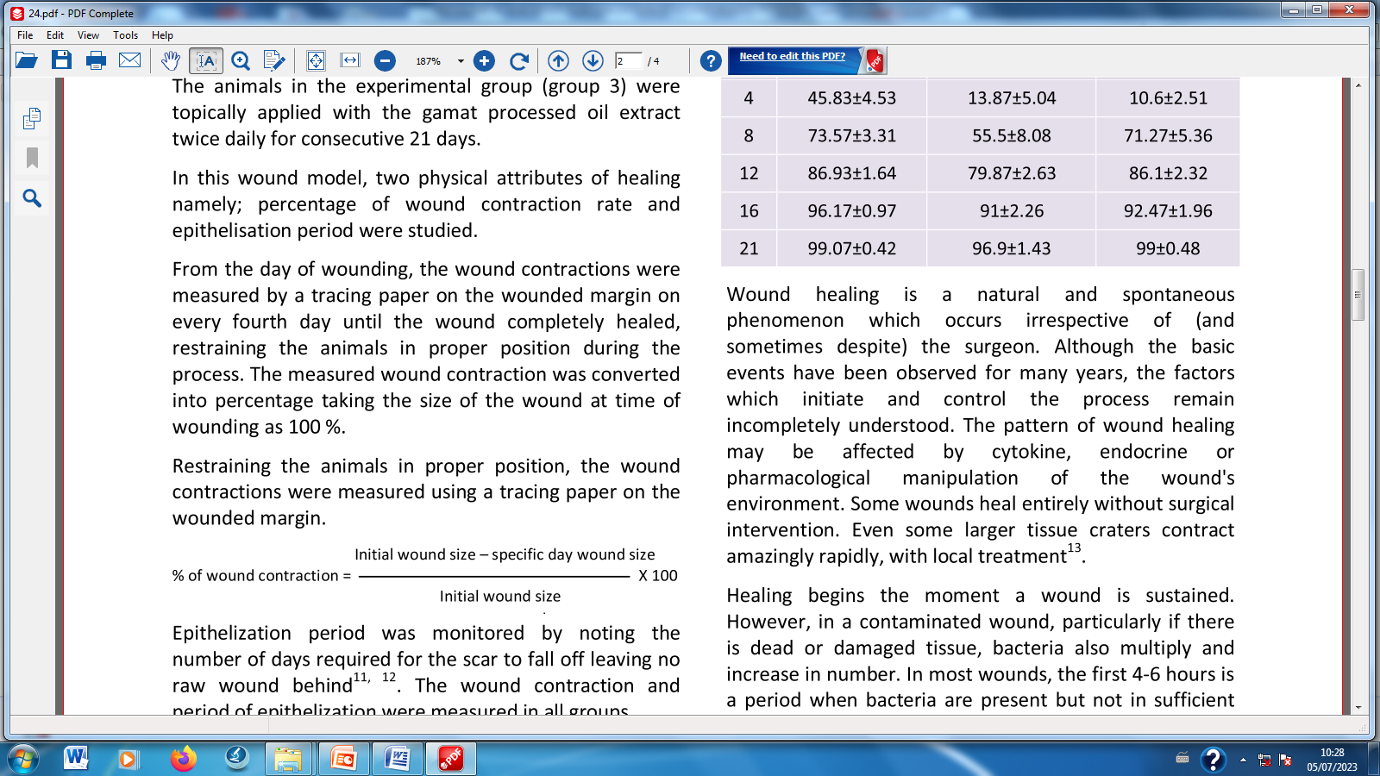
Manjunatha et al. [26]; Srikanth et al., [27]

1.12 ANIMAL SACRIFICE AND SAMPLES COLLECTION
At the end of twenty-one (21) days of the treatment period, the animals were sacrificed by intra-muscular injection of Ketamine 0.5 ml/kgbwt, the skin at the wounded site was carefully excised with the aid of surgical blade and dissecting forcep. The skin at the surgically wounded site was carefully excised with the aid of surgical blade, scissor and dissecting forcep. It washes with normal saline and fix immediately in 10% formol saline and were subjected to Weigert Van Geison (WVG) staining techniques.
1.13 LABORATORY ANALYSIS
1. Histopathological Analysis
Histopathological examination of skin sections of the surgically wounded sites was subjected to Weigert Van Geison staining for demonstration of elastic fibres as described by Avwioro [29].
a. Tissue Processing by Automatic Tissue Processor Machine
The skin from margin of surgically wounded rat was brought out of fixative and examine macroscopically on cutting bench representative part of it was cut and place in a pre-labeled cassette. The tissues were dehydrated, cleared and impregnated using automatic tissue processor (Leica TPO1020 model), after which they were embedded using embedding center (Leica EG1160 model). The sections of the skin were embedded in tissue blocks and then cut at 3µm using rotary microtome (Leica RM2125RT), then floated out on labeled glass slides. The cut sections were allowed to dry on hot plate for 15 minutes and stained in Haematoxylin and Eosin stains. Stained sections were examined microscopically using X10 and X40 objectives lenses. Photomicrograph of the skin tissue sections were taken with AmScope Camera and presented alongside with control sections [28].

b. Van Gieson Staining Technique
The sections on the slides were first dewaxed in 2 changes for xylene 10 minutes in each xylene, then followed by hydration in descending grades of alcohol from absolute down to 90 % and then to 70 % for 2 minutes each, then they were washed with water briefly. The skin sections on the slides were stained with Weigert’s Haematoxylin and allowed to stay for 20 minutes, then they were washed in distilled water briefly. The sections on the slides were stained with Van Gieson stain and allowed to stay for13 minutes, then they were then rinsed well in distilled water. The sections on the slides were dehydrated in absolute alcohol in 2 changes then clear with xylene in 2 changes. The sections on the slides were finally mounted in DPX Mountant [28].

c. Microscopy and Photomicrograph
All the sections of the skin-stained slide tissue photomicrographs were snapped by using a light Microscope (AmScope, USA) and a Digital Camera was employed for photomicrography (AmScope, USA). Sections assessed and scored as shown in the table below. The results were presented semi-quantitative scores alongside with sections of control.
Table 2: Summary of semi-quantitative scoring pattern of histological stained sections
S/No | Parameters and description | Scores
1 | The degree of elastic fibres formation
 | a. Elastic fibres appears very dense | ++++
 | b. Elastic fibres appears dense | +++
 | c. Elastic fibres appears to be less dense | ++
 | d. Elastic fibres appears to be very low dense | +
(Ignatius et al. [30].

1.14 DATA ANALYSIS
Data obtained were analyzed using SPSS software version 27.0 and presented as means ± standard error of mean (SE±M). wound contractions were compared using a one-way analysis of variance (ANOVA) with Bonferroni’s post-hoc test for multiple comparisons, p-values of less than 0.05 (P < 0.05) was considered to be statistical significance. The photomicrographs of stained sections of skin were taken with AmScope microscopic camera and presented alongside with test and control groups after scoring of the sections.

1.15 RESULTS
Table 3: Physical characteristics of aqueous leaves extracts of Acacia nilotica, Aloe vera and Calotropis procera
Plants | Colour | Smell | Texture | Percentage (%) Yield
Acacia nilotica | Dark-brown | Sweet | Gummy | 10
Aloe vera | Brown | Sweet | Powder | 15
Calotropis procera | Brown | Sweet | Powder | 20

Table 4: The effect individual and polyherbal aqueous leaves extract of formulated ointments on initial and final wound diameter
 | Experimental Groups | Number / Group | Initial Wound Diameter (cm) | Final Wound Diameter (cm)
A |  | 5 | 2.00 ± 0.00 | 1.61 ± 0.11
B |  | 5 | 2.00 ± 0.00 | 1.22 ± 0.13ª
C |  | 5 | 2.00 ± 0.00 | 0.95 ± 0.08^{ab}
D |  | 5 | 2.00 ± 0.00 | 0.74 ± 0.04^{abc}
E |  | 5 | 2.00 ± 0.00 | 1.36 ± 0.07^{acd}
F |  | 5 | 2.00 ± 0.00 | 0.48 ± 0.03^{abcde}
G |  | 5 | 2.00 ± 0.00 | 1.14 ± 0.08^{acdef}
H |  | 5 | 2.00 ± 0.00 | 0.69 ± 0.03^{abcefg}
I |  | 5 | 2.00 ± 0.00 | 0.25 ± 0.01^{abcdefgh}

Values are expressed as Mean ± SD.
Key: Groups description A: Negative Control, B: Positive Control, C: Acacia, D: Aloe vera, E: Calitropis, F: Acacia + Aloe vera, G: Acacia + Calotropis, H: Aloe vera + Calotropis, I: Acacia + Aloe vera + Calotropis. ªP<0.05 when compared with group A, ^{b}P<0.05 when compared with group B, ^{c}P<0.05 when compared with group C, ^{d} P<0.05 when compared with group D, ^{e}P<0.05 when compared with group E, ^{f}P<0.05 when compared with group F, ^{g}P<0.05 when compared with group G, ^{h}P<0.05 when compared with group H
Plate 1a: Gross appearance of surgical wounds of various groups on day one
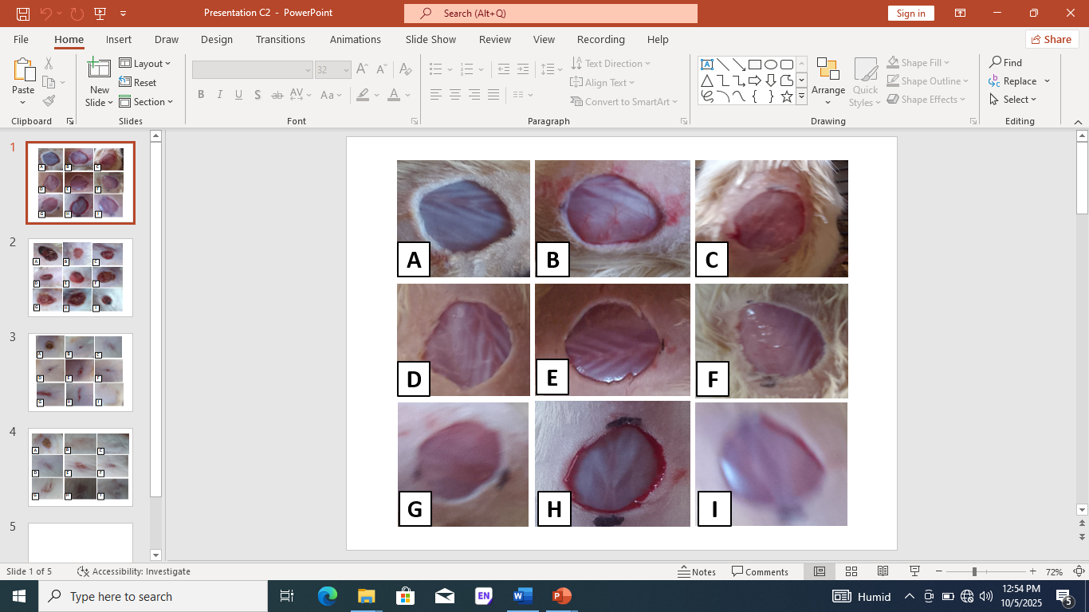
Key: Groups description A = Negative control, B = 5 % Betadine ointment, C = A. nilotica, D = Aloe vera, E = C. procera, F = A. nilotica and Aloe vera, G = A. nilotica and C. procera, H = Aloe vera and C. procera and I = A. nilotica, Aloe vera and C. procera

Plate 1b: Effect of individual and polyherbal formulated aqueous leaves extract ointments on gross appearance of surgical wounds of various groups on day twenty-one
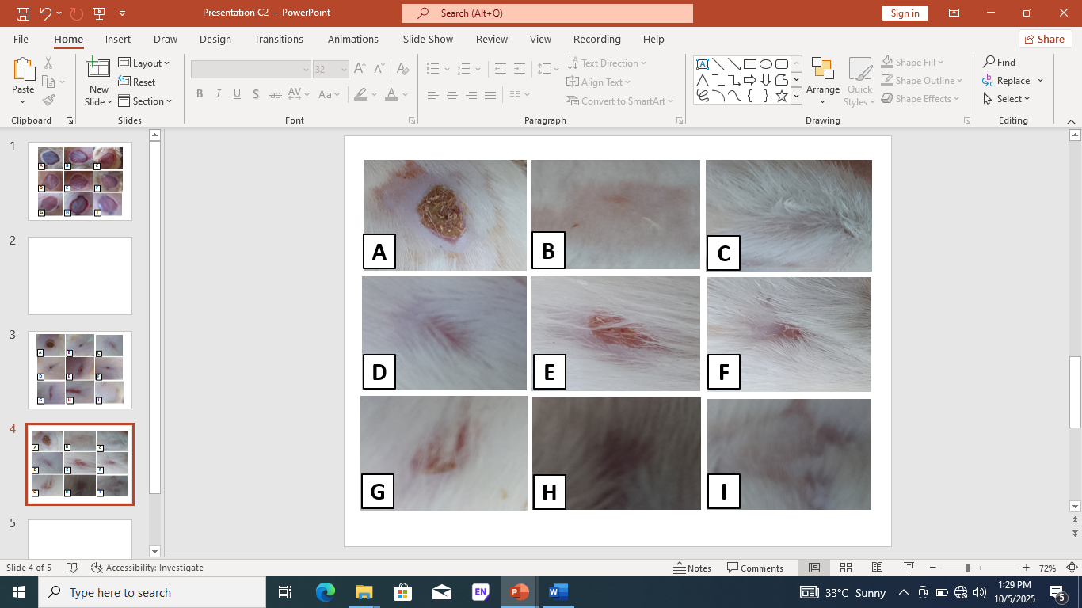

Key: Groups description A = Negative control, B = 5 % Betadine ointment, C = A. nilotica, D = Aloe vera, E = C. procera, F = A. nilotica and Aloe vera, G = A. nilotica and C. procera, H = Aloe vera and C. procera and I = A. nilotica, Aloe vera and C. procera

Plate 2: Effect of individual and polyherbal formulated aqueous leaves extract ointments on section of skin showing distribution elastic fibres stained with WVG X100
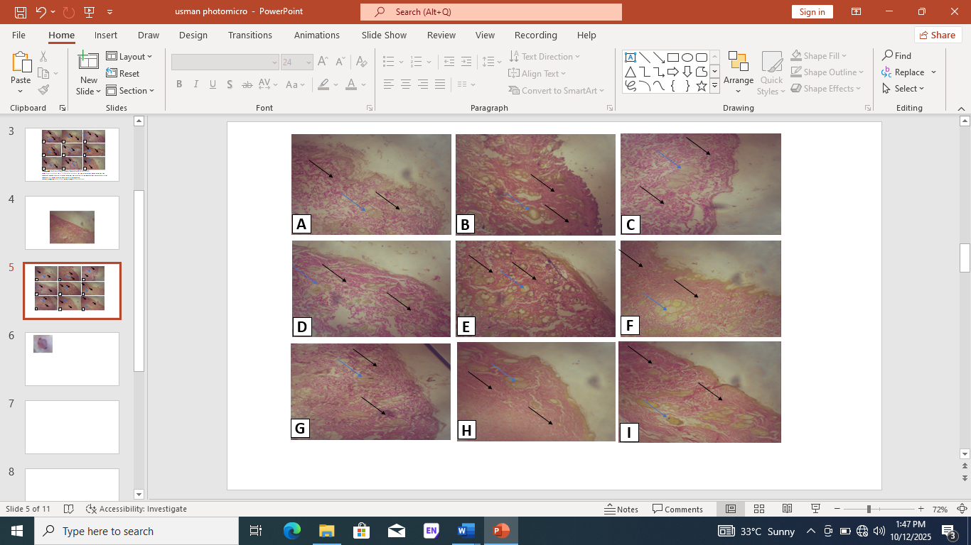
Key: Groups description A = Negative control (low dense elastic fibre), B = 5 % Betadine ointment (normal dense elastic fibre), C = A. nilotica (normal dense elastic fibre), D = Aloe vera (normal dense elastic fibre), E = C. procera (low dense elastic fibre), F = A. nilotica and Aloe vera (normal dense elastic fibre), G = A. nilotica and C. procera (normal dense elastic fibre), H = Aloe vera and C. procera (low dense elastic fibre), and I = A. nilotica, Aloe vera and C. procera (normal dense elastic fibre), Black arrow = Elastic fib

Table 5: The effect individual and polyherbal formulated ointments on semi-quantitative scoring of histological skin sections
S/No | Parameter and description | Scores | A | B | C | D | E | F | G | H | I
1 | Degree of elastic formation  elastic fibres very dense  elastic fibres normal dense  elastic fibres less dense  elastic fibres very low dense | +++  ++  +  - | -  -  +  - | +++  -  -  - | +++  -  -  - | -  ++  -  - | -  -  +  - | -  ++  -  - | -  -  +  - | -  ++  -  - | +++  -  -  -

Key: Groups description A = Negative control, B = 5 % Betadine ointment, C = A. nilotica, D = Aloe vera, E = C. procera, F = A. nilotica and Aloe vera, G = A. nilotica and C. procera, H = Aloe vera and C. procera and I = A. nilotica, Aloe vera and C. procera

1.16 DICUSSION
The aqueous extraction leaves procedure of Acacia nilotica, Aloe vera and Calotropis procera were carried out and have very good physical characteristics with significant percentage yield of the extract of 10 %, 15 % and 20 % respectively, the findings of this study were contrary with the findings of the research conducted and reported by Saini [31] and Albert et al. [32], where they reported that, the weight of each pod samples before extraction was 100 g. After extraction, the aqueous extract yielded 14 g while the ethanol extract was 28.6 g, the extracts were dark, the reason could be due to different medium of extraction was used in each research. Similar contrast findings were also reported by the research conducted and reported by Shaﬁul et al. [33], where they reported high percentage yield value above the percentage yield value reported in this study. The reason for this contrary result could be attributed to the fact that, the plant and medium for extraction used in their research was Costus speciosus leaf and 95 % ethanol which were quite different from the one used in this research which was aqueous on Acacia nilotica leaves and distilled water.
The measurements of the wound length diameter at the wounded site were carried out on first day and the last day of the intervention. The initial measurements were 2 cm in all the experimental groups while the last measurements on the last of the experiment were observed to have statistically significant mean difference in decrease percentage of wound length diameter across the groups that have been treated with individual and in combination of the aqueous leaves extract of 5 % aqueous extract of Acacia nilotica, Aloe vera and Calotropis procera formulated ointments, when compared with both positive and negative control groups. P ≤ 0.05 was taken as statistically significant. These findings were in line with the findings of the research conducted and reported by Saini [31], where he reported that different parts Acacia nilotica tree are widely utilized in folk medicine. Most of the Acacias are of medicinal benefits to the human being. Acacia nilotica plant has been used as antiscorbutic, nerve stimulant, cold, natriuretic, diarrhea, congestion, dysentery, leucorrhea, sclerosis, anti-oxidant, ophthalmia. The reason could be suspected to be due to the same plant were used in both researches.
The gross appearance of the surgically wounded sites there was no significant wound closure in negative control group (allowed to heal naturally), but in group C treated with 5 % Acacia nilotica aqueous leaves extract formulated ointment, D that was treated with 5 % Aloe vera aqueous leaves extract formulated ointment and group I which was treated with combination of the three extracts of 5 % aqueous leaves extract of Acacia nilotica, Aloe vera and Calotropis procera have shown remarkable increase in wound healing and consequence of wound closure on the last day of the experimental intervention. Other groups treated with combination of aqueous leaves extract of 5 % Acacia nilotica, and Aloe vera, Acacia nilotica and Calotropis procera also shows significant wound healing and wound closure, meaning that extracts possess synergy effect to contribute to wound reduction in diameter and consequently wounds closure. The findings are in agreement with similar findings of the research carried out and reported by Shaﬁul et al. ([33], where they mentioned that a better wound healing pattern with complete wound closure was observed in treated mice within 21 days, while it took about 30 days in negative control mice group, also there was a signiﬁcant reduction in wound area from day three onwards in treated mice, and also, on later days, the closure rate was much faster than when compared with negative control mice. The reason may be due to the same method of preparation and application of different extract on the wounded site.
The section of skin stained with Weigher’s van Gieson technique Show poor collagen deposition on group A which was not treated with any extract rather allowed to heal naturally, Collagen deposition and distribution was observed to normally deposited and distributed in group C treated with 5 % aqueous extract of Acacia nilotica, in group D treated with 5 % aqueous extract of Aloe vera, group I treated with combination of the three extracts of 5 % aqueous extract of Acacia nilotica, Aloe vera and Calotropis procera, in groups F treated with combination of treated with 5 % Acacia nilotica, and Aloe vera formulated ointments. The findings were in line with the findings of the study conducted and reported by Yung-Ze et al. [34], who reported that, results indicated that vehicle group and negative control group not treated diabetic wounds had poor collagen deposition, the treated type 1 diabetic groups exhibited significantly increased collagen deposition on day 15 and groups treated with other dilutions of the extracts treated group showed the highest level of collagen deposition. The reason for this similar finding could be attributed to the same mode of preparation and solvents of the extract ointment was used in both researches.
The sections stained with Weighers van Geison stain shows normal dense scoring of elastic fibre deposition in group C treated with 5 % aqueous extract of Acacia nilotica, D treated with aqueous extract of Aloe vera, F treated with 5 % aqueous extract of combination of two extract of Acacia nilotica and Aloe vera, G treated with 5 % aqueous extract of combination of two extract of Acacia nilotica and Calotropis procera, and I treated with combination of the three different combination of 5 % aqueous extract of Acacia nilotica, Aloe vera and Calotropis procera. While group E and H shows less dense scoring of elastic fibres deposition. These findings were dissimilar with the findings of the study conducted and reported by Eman et al. [35], where they that images of H & E-stained wound sections of skin on day 15 shows Inflammatory cell infiltration, epidermal cell regeneration, granulomas and the number of blood vessels were all observed. The reason could be suspected to be due to different model and design were not the same in both studies.

1.7 CONCLUSION
The aqueous leaves extract the Acacia nilotica, Aloe vera and Calotropis procera possess very good physical characteristics and presence of secondary metabolites that possessed wound healing effect.
There was significant reduction in percentage wound diameters length in group treated with of extract of 5 % aqueous leaves extract of Acacia nilotica individual and in combination of all the three extracts. This shows that three extracts have synergy relation to one another.
There was normal elastic fibres deposition in groups treated with individual 5 % aqueous leaves extract of Acacia nilotica formulated ointments and in combination of the three extracts of the studied sections

REFERENCES
- Agarwal, P. K., Singh, A., Gaurav, K., Goel, S., Khanna, H. D., & Goel, R. K. (2009). Evaluation of wound healing activity of extracts of plantain banana (Musa sapientum var. paradisiaca) in rats. Indian Journal of Experimental Biology, 47(1), 32-40. http://nopr.niscpr.res.in/handle/123456789/4600
- Kim, D. J., Mustoe, T., & Clark, R. A. (2015). Cutaneous wound healing in aging small mammals: a systematic review. Wound Repair Regeneration. https://doi.org/10.1111/wrr.12290
- Murthy, S., Gautam, M. K., Goel, S., Purohit, V., Sharma, H., & Goel, R. K. (2013). Evaluation of In Vivo Wound Healing Activity of Bacopa monniera on Different Wound Model in Rats. BioMed Research International. https://doi.org/10.1155/2013/972028
- Diegelmann, R. F., & Evans, M. C. (2004). Wound healing: an overview of acute, fibrotic and delayed healing. Frontiers in Bioscience, 9, 283-289. https://doi.org/10.2741/1184
- Moor, E. D., & McAnalley, B. H. (1995). Drink containing mucilaginous polysaccharides and its preparation (U.S. Patent 5,443,830). https://patents.google.com/patent/US5443830A/en
- Boateng, J. S., Matthews, K. H., Stevens, H. N. E., & Eccleston, G. M. (2008). Wound healing dressings and drug delivery systems: A review. Journal of Pharmaceutical Sciences, 97(8), 2892–2923. https://doi.org/10.1002/jps.21210
- Shakespeare, P. (2001). Burn wound healing and skin substitutes. Burns, 27(5), 517–522. https://doi.org/10.1016/S0305-4179(01)00017-1
- Tavakoli, S., & Klar, A. S. (2020). Advanced Hydrogels as Wound Dressings. Biomolecules, 10(8), 1169. https://doi.org/10.3390/biom10081169
- Gurtner, G. C., Werner, S., Barrandon, Y., & Longaker, M. T. (2008). Wound repair and regeneration. Nature, 453, 314–321. https://doi.org/10.1038/nature07039
- Farzana, M. U. Z. N., Tharique, I. A., & Sultana, A. (2014). A review of ethnomedicine, phytochemical and pharmacological activities of Acacia nilotica (Linn) willd. Journal of Pharmacognosy and Phytochemistry, 3(1), 84-90. https://www.phytojournal.com/archives/2014/vol3issue1/PartB/2.1.pdf
- Verma, R. K. (2017). Taxonomical study of Acacia nilotica (linn) wild (a dye yielding plant) in Churu district. *World Journal of Pharmaceutical Research*, *6*(10), 1347-1354. https://doi.org/10.20959/wjpr201710-9408
- Raj, A., Haokip, V., & Chandrawanshi, S. (2015). Acacia nilotica: A multipurpose tree and source of Indian Gum Arabic. South Indian Journal of Biological Sciences, 1(2), 66-69. https://doi.org/10.22205/sijbs/2015/v1/i2/100421
- Kaushal, K. (2017). A review of pharmacological activities of Acacia nilotica (Linn) willd W.S.R to osteoporosis. Journal of Advanced Research in Ayurveda, Yoga, Unani, Siddha and Homeopathy, 4(1&2), 3-7. https://doi.org/10.24321/2394.6547.201702
- Joseph, B., & Raj, S. J. (2010). Pharmacognostic and phytochemical properties of Aloe vera linn –an overview. International Journal of Pharmaceutical Sciences Review and Research, 4(2), 106-110. https://www.globalresearchonline.net/journal/volume4_issue2/017.pdf
- Das, N., & Chattopadhay, R. N. (2004). Commercial cultivation of Aloe. Natural Product Radiance, 3(2), 85-87. http://nopr.niscpr.res.in/handle/123456789/9406
- UC Davis. (2009). The genus Aloe. http://greenhouse.ucdavis.edu/conservatory
- Roy Upton, Pavel Axentiev MS, Diana Swisher MA. Aloe vera Leaf. American Herbal Pharmacopoeia; 2012. 1-52.
- Saeed MA, Ahmad I, Yaqub U, Akbar S, Waheed A, Saleem M, NasirudDin. Aloe Vera: A Plant of Vital Significance. Science vission; 2004. 9: 1-13.
- Patidar A, Bhayadiya RK, Nimita M, Pathan JK, Dubey PK. Isolation of Aloin from Aloe vera, its characterization and evaluation for antioxidant activity. International journal of pharmaceutical research and development; 2012. (2)4: 24-28
- Azhar M. "Study of ethnobotany and indigenous use of Calotropis procera (Ait.) in Cholistan desert, Punjab, Pakistan." Journal of Agric Research; 2014. 1.52:117-126.
- Aliyu R. "Efficacy and phytochemical analysis of latex of Calotropis procera against selected dermatophytes. " Journal of Intercultivation Ethnopharmacology; 2015. 4.4:314-317.
- Rahee, S. A., & Mallik, J. (2012). Phytochemical screenings of the methanol extract of whole plant Borreria articulari. International Journal of Pharmaceutical & Biological Archives, 3(5), 1062-1066. https://www.ijpba.info/ijpba/index.php/ijpba/article/download/106/106
- Wei, L., Chen, Y., Lin, J., Zhao, J., Chen, X., Xu, W., Liu, X., Sferra, T. J., & Peng, J. (2011). Scutellaria barbata D. Don Induces Apoptosis of Human Colon Carcinoma Cell through Activation of the Mitochondrion-dependent Pathway. *Journal of Medicinal Plants Research*, *5*(10), 1962–1970. https://doi.org/10.5897/JMPR.EA5714319600
- Morton, J. J., & Malone, M. H. (1972). Evaluation of vulneray activity by an open wound procedure in rats. Archives Internationales de Pharmacodynamie et de Thérapie, 196(1), 117–126. https://pubmed.ncbi.nlm.nih.gov/5059357/
- Ravishankar, K., & Satya Sireesha, A. (2021). Exploration of antimicrobial and wound healing activities using ethanolic leaf extract gel of Nyctanthes arbor-tristis on rabbits. *Advancement in Medicinal Plant Research*, *9*(4), 68-74. https://netjournals.org/AMPR2021/AMPR21.010.pdf
- Manjunatha, B. K., Vidya, S. M., Rashmi, K. V., Mankani, K. L., Shilpa, H. J., & Jagadeesh Singh, S. D. (2005). Evaluation of wound-healing potency of Vernonia arborea Hk. *Indian Journal of Pharmacology*, *37*(4), 223–226. https://doi.org/10.4103/0253-7613.16567
- Srikanth, D., Shenoy, R. R., & Rao, C. M. (2008). The effects of topical (gel) astemizole and terfenadine on wound healing. Indian Journal of Pharmacology, 40(4), 170-174. https://doi.org/10.4103/0253-7613.43164
- Khalaf, A. A., Hassanen, E. I., Zaki, A. R., Tohamy, A. F., & Ibrahim, M. A. (2019). Histopathological, immunohistochemical, and molecular studies for determination of wound age and vitality in rats. International Wound Journal, 16(6), 1416–1425. https://doi.org/10.1111/iwj.13206
- Avwioro O. G. Histochemistry and Tissue Pathology. PrinciplesandTechnique3rd Edition. Clavenrianum Press. Ibadan Nigeria; 2014. pp 147-190
- Ignatius, A. K., Rini, D., & Sri, H. Y. (2020). The Effect of Tempeh Extract Gel on Wound Healing in Diabetes Rats: Overview of Tissue Collagen, Wound Closure, Epithelialization and Capillarization. Jurnal Farmasi Sains dan Komunitas, 17(1), 51-58. https://doi.org/10.24071/Jpsc.002357
- Saini, M. L., Saini, R., Roy, S., & Kumar, A. (2008). Comparative pharmacognostical and antimicrobial studies of Acacia species (Mimosaceae). Journal of Medicinal Plants Research, 2(12), 378–386. https://doi.org/10.5897/JMPR.9000378
- Fasogbon, A. O., Odewade, J. O., & Omojoyegbe, R. T. (2021). Antibacterial Potential of Pod Extracts of Gum Arabic Tree (Acacia nilotica). Equity Journal of Science and Technology, 8(1), 100–104. https://doi.org/10.4314/equijost.v8i1.17
- Zishan, S. A., Uddin, M. M., Mohammad, M., Azad, S. M. A. K., Naima, J., Ibban, S. S., & Arman, M. S. I. (2024). Costus speciosus leaf and seed extracts for wound healing: a comparative evaluation using mice excision wound models. Clinical Phytoscience. https://doi.org/10.1186/s40816-024-00368-9
- Cheng, Y. Z., Liu, I. M., Cheng, J. T., Lin, B. S., & Liu, F. (2020). Wound healing is promoted by Musa paradisiaca (banana) extract in diabetic rats. Archives of Medical Science, 20(2), 632–640. https://doi.org/10.5114/aoms.2020.92344
- Abdullah, E., Taha, S., Sulaiman, N., & Ahmed, M. (2022). Impact of acacia arabica topical gel on skin wound healing: An experimental study. Pharmacia, 69(1), 77–83. https://doi.org/10.3897/pharmacia.69.e72595

