Assessment of the relationship between heavy metal content and soil chemical properties in soils of contrasting parent materials in South East Nigeria

Abstract
This study investigated the influence of parent materials and soil characteristics on the distribution and concentration of heavy metals in soils developed from shale, alluvium, sandstone and coastal plain sand. Soil samples were randomly collected and analyzed for key physical and chemical properties including pH, organic matter, exchangeable cations, available phosphorus alongside zinc, copper and lead concentrations following standard procedures. Results showed clear relationships between soil properties and heavy metals in the different soil parent materials. Shale derived soils exhibited the highest metal concentrations due to their fine texture and mineral rich composition while soils developed from sandstone and coastal plain sands contained significantly lower levels reflecting their lower chemical activity. The soils were generally dominated by zinc followed by lead and the least metal therein was copper. The study recommends regular monitoring of heavy metals especially those formed from metal rich parent materials, soil fertility improvement using organic amendments, adoption of soil specific management strategies and sustainable land use practices.
Keywords: Parent materials, Pearson correlation matrix, Soil chemical properties
Introduction
Heavy metals are metals with high atomic weight and a density greater than 5g/cm³ (Zhang et al., 2018). They are considered as a part of the soil and are needed for several organs of both plants and animals. However, they cause severe damage to the soil and plants when their concentration exceeds the prescribed level. Heavy metals arise from many sources such as industry, mining and agriculture. In terms of the sources in agriculture, these can be categorized into fertilizers, pesticides, livestock manure and waste water (Li et al., 2014). There has been recent rapid increase in the risk of heavy metal pollution in the environment especially in the agricultural sector by accumulating in the soil and in plant uptake (Toth et al., 2016). A study by Xiao et al., (2017) reported that agriculture and industry significantly influenced heavy metal pollution in agricultural soils and plants.
Total metal concentrations in soils may be affected by soil parent material as well as anthropogenic sources (Kabata-Pendias and Pendias, 2001). The natural heavy metal concentrations of arable lands usually depend on the heavy mental composition of the parent material (De Temmerman et al., 2003). The concentration and behavior of heavy metals do not only depend on contamination, they are also strongly controlled by soil chemical properties and parent material. Soil parent materials are considered as geological or organic precursors to the soil whose composition has direct impact on the physical, chemical, morphological, biological and mineralogical characteristics of soils (Brady and Weil, 2012). Parent material has profound influence on the characteristics of soils, and variations in soil could be attributed to nature of parent material as it influences soil characteristics (Ibanga, 2006). Different parent materials contain different natural levels of these metals as well as influence soil texture, pH, organic matter, clay content and mineralogy-all of which affect metal mobility and availability.
Cd, Pb, Cu, and Zn cause an alarming combination of environmental and health problems (Zhang et al., 2018). Zn is one of the most mobile heavy metals and it is present in its free as well as complex forms in soils. Its availability is mainly governed by the soil pH, calcareous soil, clay fractions and soil organic matter. Different land use patterns and agricultural practices are known to result in elevated zn concentrations in surface soils (Kabata-Pendias, 2010). Copper is naturally occurring as a pure metal. Soil texture plays a significant role in determining the copper content of the soil. It is often lowest in light sandy soil and highest in loamy soils. Copper tends to be absorbed by soil organic matter, carbonates, clay minerals and oxyhydroxides of manganese and iron (Kabata-Pendias, 2010). Several studies on different soil parent materials in Southeastern Nigeria have been conducted (Azu et al., 2018, Osodeke and Ubah, 2005). However, this study was conducted to assess the relationship between zinc, copper and lead and selected soil chemical properties selected parent materials in south East Nigeria.

Materials and Methods
Study area
The study was carried out in South East Nigeria. South East Nigeria lies between latitudes 4º20’ and 7º25’N and longitudes 5º25’ and 9º51’E (Njoku et al., 2006). It consists of Abia, Anambra, Ebonyi, Enugu and Imo States and occupies a land mass of about 12% of the total land area of Nigeria (Odurukwe et al., 1995). In these areas, temperatures are high and change slightly during the year (mean daily temperature about 27ºC). The rainy season begins in April and lasts until October with annual rainfall ranging from 1500 to 2200mm with mean annual relative humidity of about 75%, and humidity reaching 90% in the rainy season. According to Okorie and Okpala, (2000), the vegetation is essentially secondary forests tending towards derived savannah because of population pressure and repeated annual bush burning.
The soils of these areas are known to have developed from four parent materials including sandstone, Alluvium, Coastal Plain Sand and Shale as Akamigbo and Asadu (1985) stated that over 80% of Eastern Nigeria is of sedimentary geologic deposits made up of shales, coastal plain sands, false bedded sandstones and alluvium. Agriculture and trading are major socio-economic activities in the study area in addition to stone mining/quarry. The cash crops include oil palm, raffia palm, rice, groundnut, melon, cocoa, rubber, maize etc. Food crops such as yam, cassava, cocoyam, plantain and maize are also produced in large quantities.
Soil Sampling
A reconnaissance visit was made prior to soil sampling at each of the study locations to identify and interact with farmers, farm households and possible sampling fields. Four parent materials were selected for this study and their locations are as follows: sandstone (Ohafia, Abia State), coastal plain sand (Umuahia, Abia State), shale (Afikpo, Ebonyi State) and alluvium (Oguta, Imo state). Three (3) farms were randomly selected in each parent material and composite samples collected using soil Auger from each farm at three different depths (0-20 cm, 20-40 cm and 40-60cm). The soil samples collected were air dried, crushed and sieved through a 2 mm sieve, then bagged and labeled accordingly and analyzed in the laboratory for particle size distribution, chemical properties and zinc, copper and lead extracted according to standard methods.
Experimental design
The experiment was laid out as a 4×3 factorial in randomized complete block design (RCBD). Four levels of factor A (parent material) - shale, alluvium, sandstone and coastal plain sand, three levels of factor B (Soil Depth)- 0-20 cm, 20-40 cm and 40-60cm replicated thrice giving a total of thirty six (36) soil samples.
Statistical analyses
Data collected from the experiment were subjected to two way analysis of variance and significant means separated using F-LSD following the procedure outlined by Obi (2018) while the relationship between heavy metal content and soil chemical properties in the parent materials under investigation was analyzed using Pearson correlation matrix plot
Results and discussion
Soil depth, parent material and their interaction had significant effects on particle size distribution, soil chemical properties and zinc, copper and lead concentrations (Tables 1 and 2). Soil pH (H₂O) at 0-20 cm for soils developed on alluvium, coastal plain sand, and sandstone were moderately acidic (pH>5.5), while those observed for shale was strongly acidic (pH<5.5) according to Jones (2003). The acidic nature of the soils shows the inherent characteristics of soils of the tropics irrespective of their parent material. Organic matter was observed to be moderate (OM mostly between 1.5-2.0%) at 0-20 cm depth across all the parent materials and low (< 1.5%) at 20-40 cm. Higher level of OM at the depth of 0-20 cm may attributed to accumulation of organic materials or litter materials at the surface soils as has been reported by Byers et al. (2023). Relatively lower values of OM recorded in coastal plain sand soils than other parent materials could be attributed to OM losses through leaching and runoff due to porous nature of coastal plain. Available phosphorus was slightly higher in surface soils than subsoil and the values recorded falls under the moderate (8-20 mg/kg) fertility ratings following the rating of Landon (2014). Slightly higher value of available P in surface soils than subsoil buttress the influence of organic matter on soil available P. Exchangeable Ca was low (< 5 cmol/kg) across all the parent materials at each depth except in alluvium at 0-20 cm depth where it was found to be moderate (5-10 cmol/kg) according to Landon (2014). Magnesium was low (<1.5 cmol/kg) at the depth of 0-20 cm, low in coastal plain sand and sandstone and moderate in alluvium and shale (1.5-3.0 cmol/kg) at the depths of 20-40 cm and 40-60 cm based on the rating of Landon (2014). Potassium was rated moderate (0.2-0.4 cmol/kg) across all parent materials and depths while Na was rated low (<0.3 cmol kg) except in shale at 0-20 cm soil depth where it was moderate (0.3-0.7 cmol/kg) (Landon, 2014). Low levels of bases in the soils could be due to leaching caused by higher rainfall and acid nature of most parent materials according to Enwezor et al. (1981).

Table 1: Effect of parent materials and soil depth on particle size distribution and soil chemical properties
Parent materials | Sand | Silt | Clay | Tex  Class | pH (H2O) | OC (%) | OM (%) | TN (%) | AP (mg/kg) | Ca (cmol/kg) | Mg (cmol/kg) | K (cmol/kg) | Na (cmol/kg) | EA  (cmol/kg) | BS  (%)
 |  |  |  |  |  |  | 0-20 cm
Alluvium | 66.85 | 17.15 | 16 | S | 5.55 | 1.82 | 3.13 | 0.16 | 15.50 | 5.18 | 2.35 | 0.29 | 0.29 | 1.56 | 83.28
Coastal plain sand | 77.6 | 11.16 | 11.25 | SL | 5.78 | 1.33 | 2.30 | 0.12 | 14.45 | 3.98 | 1.80 | 0.26 | 0.27 | 1.66 | 79.14
Sandstone | 80.1 | 9.4 | 10.5 | SL | 5.65 | 1.40 | 2.42 | 0.12 | 14.45 | 3.7 | 1.60 | 0.25 | 0.26 | 1.69 | 77.62
Shale | 36.27 | 26 | 37.73 | CL | 5.18 | 1.55 | 2.71 | 0.14 | 14.95 | 4.8 | 2.35 | 0.28 | 0.34 | 1.71 | 81.51
 |  |  |  |  |  |  | 20-40 cm
Alluvium | 50.6 | 26.15 | 23.25 | SCL | 5.18 | 0.97 | 1.67 | 0.09 | 13.40 | 4.0 | 1.55 | 0.25 | 0.26 | 1.67 | 77.94
Coastal plain sand | 72.6 | 13.9 | 13.5 | SL | 5.60 | 1.14 | 1.96 | 0.10 | 13.08 | 3.5 | 1.35 | 0.22 | 0.24 | 1.73 | 75.31
Sandstone | 72.85 | 14.4 | 12.75 | SL | 5.60 | 1.32 | 2.29 | 0.11 | 13.58 | 3.48 | 1.23 | 0.20 | 0.22 | 1.70 | 74.82
Shale | 41.1 | 23.9 | 35 | CL | 4.70 | 1.28 | 2.25 | 0.11 | 12.90 | 4.33 | 1.68 | 0.23 | 0.24 | 1.77 | 78.14
 |  |  |  |  |  |  | 40-60 cm
Alluvium | 50.6 | 23.65 | 25.75 | SCL | 5.30 | 0.91 | 1.58 | 0.08 | 12.60 | 3.68 | 1.25 | 0.20 | 0.21 | 1.67 | 75.74
Coastal plain sand | 68.35 | 16.4 | 15.25 | SL | 5.45 | 0.96 | 1.65 | 0.08 | 12.43 | 3.05 | 1.00 | 0.18 | 0.20 | 1.79 | 71.04
Sandstone | 71.6 | 14.4 | 14 | SL | 5.60 | 1.02 | 1.82 | 0.09 | 12.70 | 3.20 | 0.95 | 0.18 | 0.20 | 1.73 | 72.21
Shale | 40.1 | 22.9 | 37 | CL | 4.93 | 1.02 | 1.65 | 0.08 | 11.95 | 3.83 | 1.50 | 0.19 | 0.21 | 1.78 | 76.05
LSD0.05
Parent material | 2.08 | 0.26 | 1.97 |  | 0.23 | 0.12 | 0.17 | 0.007 | 0.37 | 0.35 | 0.17 | 0.010 | 0.017 | 0.050 | 1.910
Soil Depth | 1.80 | 0.23 | 1.71 |  | 0.20 | 0.11 | 0.14 | 0.06 | 0.32 | 0.29 | 0.15 | 0.009 | 0.015 | 0.040 | 1.650
Parent material x depth | 3.61 | 0.93 | 3.42 |  | 0.40 | 0.22 | 0.29 | 0.012 | 0.63 | 0.59 | 0.29 | 0.019 | 0.030 | 0.085 | 3.302

Table 2: Effect of depth on heavy metal contents of soils of contrasting parent materials
Parent material Zn Cu Pb
0-20cm
Alluvium 18.80 5.10 11.50
Coastal plain sand 16.20 1.62 5.90
Sandstone 18.80 3.60 7.20
Shale 22.80 7.20 13.30
20-40cm
Alluvium 15.60 3.80 6.50
Coastal plain sand 17.50 1.78 6.0
Sandstone 19.20 3.50 6.80
Shale 19.40 5.20 11.33
40-60cm
Alluvium 15.20 3.80 6.60
Coastal plain sand 14.60 1.88 5.20
Sandstone 18.50 3.10 5.60
Shale 18.80 5.00 11.10
LSD0.005
Parent material 0.433 0.257 0.492
Depth 0.375 0.223 0.426
Parent material ×depth 0.750 0.446 0.852

Relationship between heavy metal content and soil chemical properties
Presented in Figures 1 to 4 are the Pearson correlation matrix plot depicting relationship between heavy metal contents and soil chemical properties in soil developed from sandstone (Fig. 1), shale (Fig. 2), coastal plain sand (Fig. 3), and alluvium (Fig. 4). For soil developed from sandstone, Zn showed a positive and significant correlation with available phosphorus (AP) (r =0.73, p<0.01), TN (r = 0.62, p<0.01), OC (r = 0.56, p<0.05), and negatively correlated with clay (r = -0.48, p<0.05). This result implies that an increase in concentration of Zn in soil developed on sandstone will subsequently increase the level of available phosphorus, TN, and OC whereas soils with more clay content will have lower concentration of Zn. Cu showed a positive and significant correlation with sand (r =0.51, p<0.05), AP (r =0.62, p<0.01), TN (r = 0.51, p<0.05), OC (r = 0.48, p<0.05), and negatively correlated with silt (r =-0.51, p<0.05) and clay (r = -0.50, p<0.05). This result implies that an increase in concentration of Cu in soil developed on sandstone will subsequently increase the level of AP, TN, and OC. While soils with more clay and silt contents will have lower concentration of Cu compared with soil having less clay. Meanwhile soils high in sand contents will have higher concentration of Cu. This result is contrary to previous studies (Yan et al., 2018; Andrea et al., 2019), where Cu showed positive correlation with silt contents. However, positive relationship between Cu and organic carbon corroborates the results of other studies. Therefore, Cu is adsorbed by soil organic carbon (Mengel et al., 2001). Similarly, Pb showed a positive and significant correlation with sand (r =0.50, p<0.05), AP (r =0.65, p<0.01), TN (r = 0.65, p<0.01), OC (r = 0.60, p<0.01), Mg (r = 0.49, p<0.05), and ECEC (r = 0.48, p<0.05), and negatively correlated with clay (r = -0.50, p<0.05). This result implies that an increase in concentration of Pb in soil developed from sandstone will subsequently increase the level of AP, TN, OC and Mg. These results agree with the correlations verified in the studies by Mello et al. (2020) in the Southwestern Amazon region where sandy soils are poor in heavy metals when compared to clayey and organic soils.

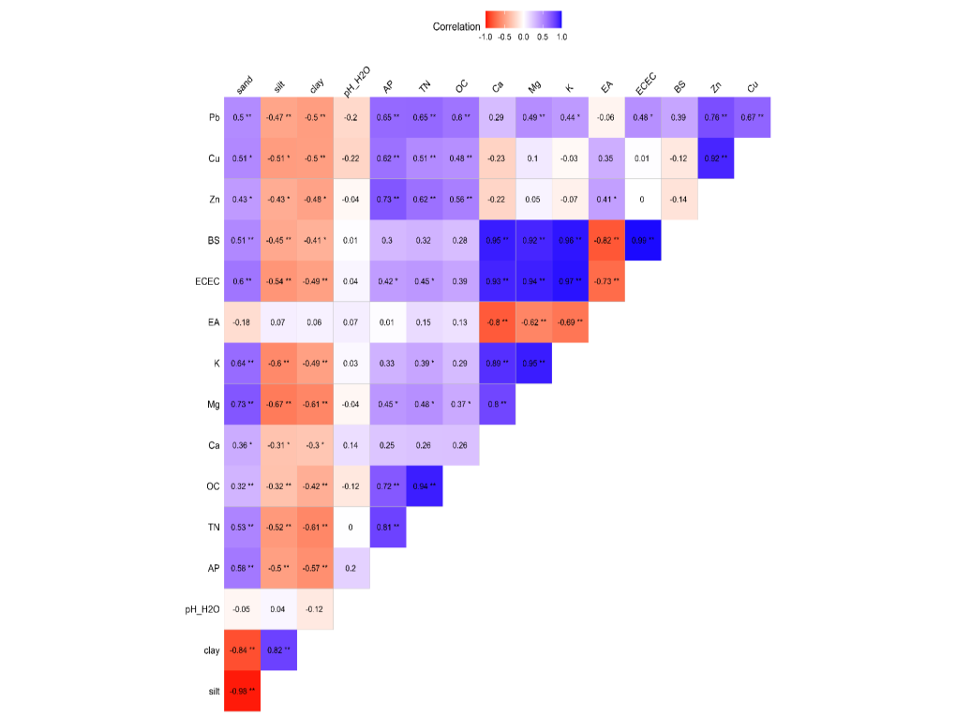
Fig. 1: Correlation matrix plot showing relationship between heavy metals and studied soil properties in soil developed from Sandstone
Note: * Significant at P ≤ 0.05; ** significant at P≤ 0.01

Subsequently, for soil developed from shale, Zn did not show any significant correlation with soil properties. The result is consistent with previous studies on basaltic soil (Temel et al., 2024), where Zn showed no correlation with soil properties. However, Cu showed a positive and significant correlation with silt (r =0.61, p<0.05) and a negative correlation with sand (r = -0.65, p<0.01). Similarly, Pb showed a positive and significant correlation with silt (r =0.79, p<0.01) and had no significant correlation with other soil properties. This result implies that soils with more silt content will have lower concentration of Pb, and vice versa.

For soil developed from coastal plain sand, Zn showed a negative and significant correlation with clay (r = -0.49, p<0.05) and EA (r = -0.65, p<0.05). Coastal plain sand soils are known to be rich in quartz contents. Research indicates that the quantity of quartz in soil reduces soil's zinc concentration (Temel et al., 2024). As it is widely accepted, soil pH decreases with increased quartz content (Gray et al., 2016). Exchangeable acidity however increases with increased quartz content. Further result indicated that Cu showed a positive and significant correlation with sand (r =0.71, p<0.01), and negatively correlated with silt (r =-0.75, p<0.05), clay (r = -0.62, p<0.05), TN (r = -0.59, p<0.05) and OC (r = -0.62, p<0.05). This means that an increase in concentration of Cu in soil developed from coastal plain sand will subsequently reduce the level of TN and OC. Similarly, Pb showed a positive and significant correlation with sand (r =0.63, p<0.01), Ca (r =0.48, p<0.05), Mg (r = 0.55, p<0.01) and BS (r = 0.51, p<0.05) and negatively correlated with silt (r = -0.66, p<0.05) and clay (r = -0.58, p<0.05). This result implies that an increase in concentration of Pb in soil developed from coastal plain sand will subsequently increase the level of Ca, Mg and base saturation while soils with high sand contents will have a higher concentration of Pb.
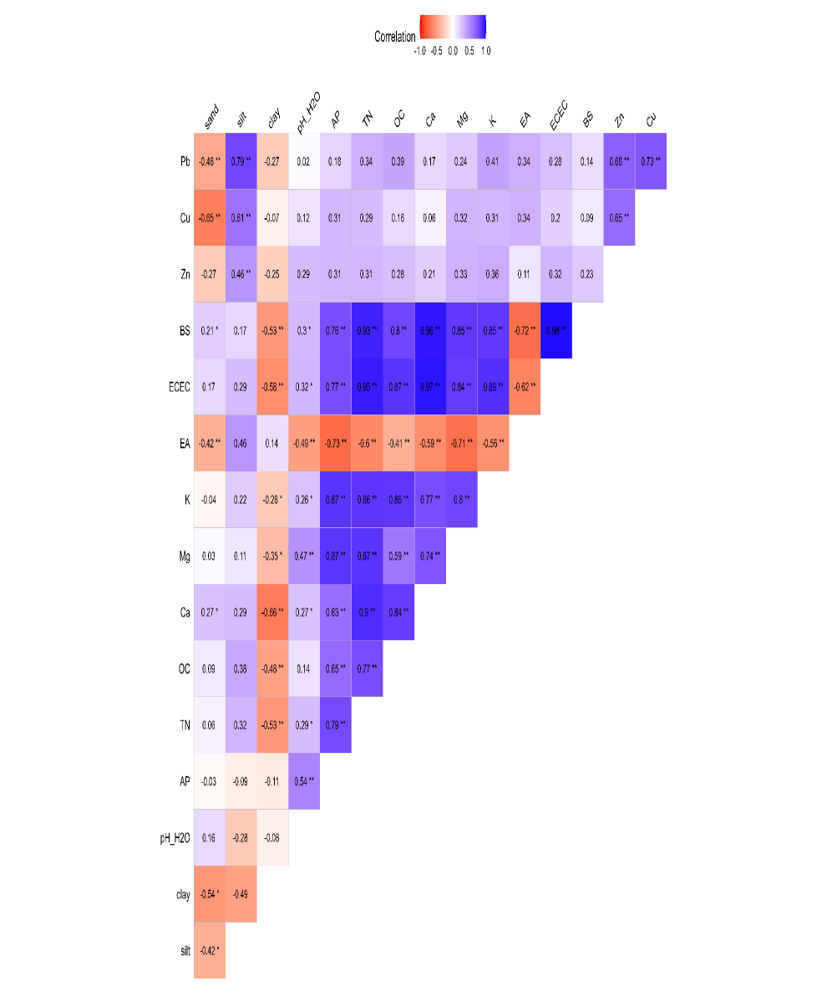
Fig. 2: Correlation matrix plot showing relationship between heavy metals and studied soil properties in soil developed from shale
Note: * Significant at P ≤ 0.05; ** significant at P≤ 0.01

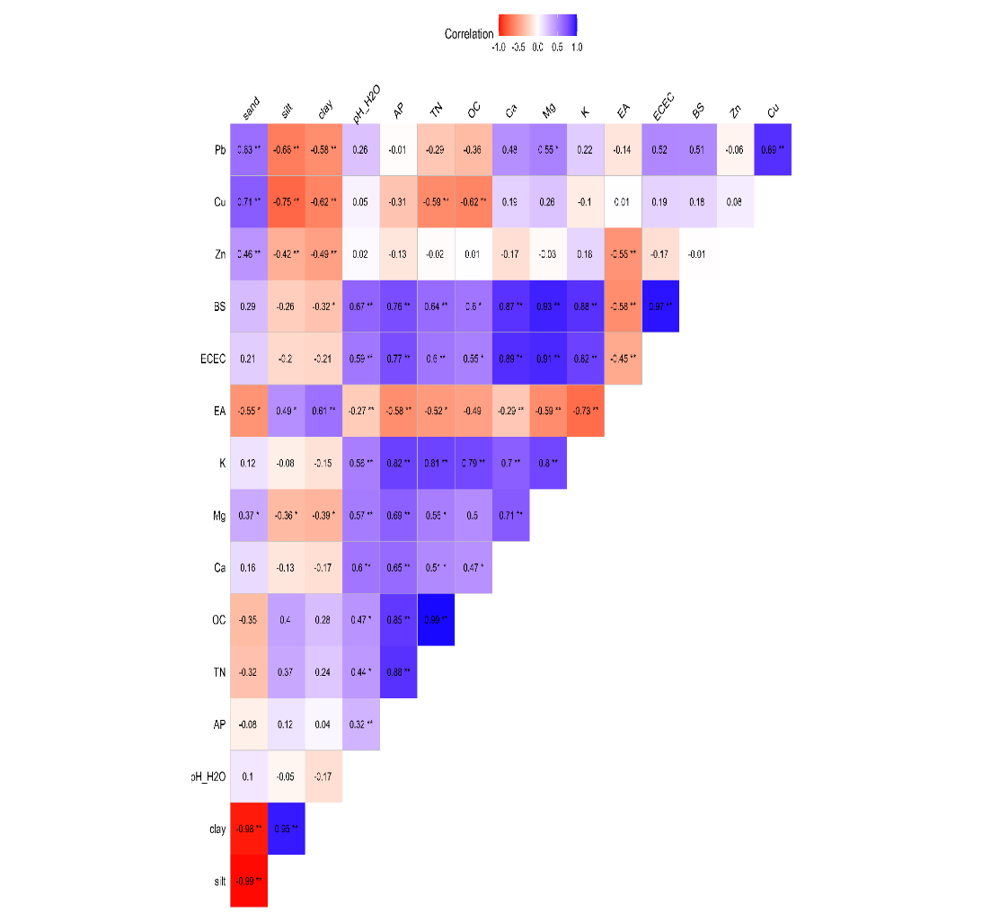
Fig. 3: Correlation matrix plot showing relationship between heavy metals and studied soil properties in soil developed from coastal plain sand
Note: * Significant at P ≤ 0.05; ** significant at P≤ 0.01

For soil developed from alluvium, Zn showed a negative and significant correlation with pH (r = -0.58, p<0.05) and positive and significant correlation with EA (r = 0.56, p<0.05). This result implies that an increase in pH in soil developed from alluvium will subsequently decrease the concentration of Zn. While an increase in exchangeable acidity (EA) will increase the concentration of Zn. However, Pb did not show any significant correlation with soil properties on soil developed on alluvium. Further result indicated that Cu showed a negative and significant correlation with pH (r =0.66, p<0.01), and positively correlated with TN (r =0.60, p<0.05), OC (r = 0.59, p<0.05) and EA (r = 0.65, p<0.05). Das et al. (2019) reported that lead and Zn can compete with and inhibit the uptake of essential nutrients like magnesium, calcium, iron, and manganese by plants. This interference can lead to nutrient deficiencies in plants and affect their growth and productivity.
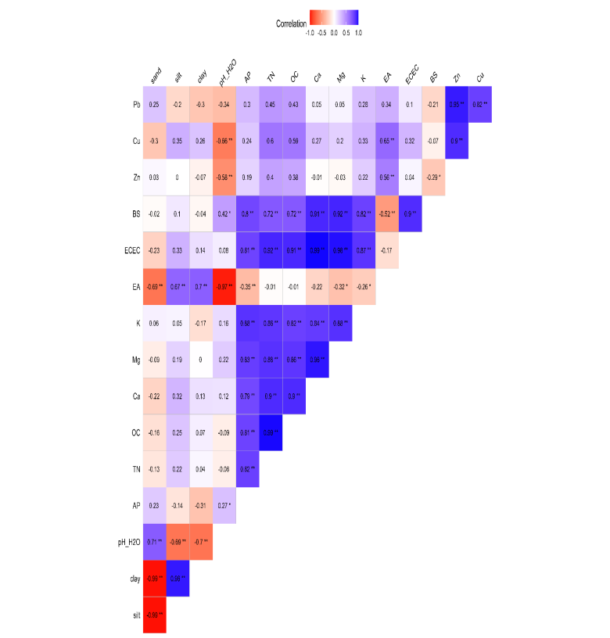
Fig. 4: Correlation matrix plot showing relationship between heavy metals and studied soil properties in soil developed from alluvium. Note: * Significant at P ≤ 0.05; ** significant at P≤ 0.0

Conclusion
This study demonstrates that the distribution and behavior of heavy metals in soils are strongly influenced by parent material and soil properties. Heavy metals levels in soils are influenced by parent materials and their mobility, retention and availability by soil physical and chemical properties. Parent material is the primary source of naturally occurring heavy metals in the soil and different geological materials contain different metal concentrations. Parent materials high in clays and metal-bearing minerals produce soils richer in heavy metals whereas sandy parent materials produce metal-poor soils. Soils derived from fine textured and geochemically active parent materials particularly shale showed higher concentrations of heavy metal due to their inherent clay minerals and metal bearing compounds. In contrast, soils formed from sandstone and coastal plain sands contained lower concentrations because of their quartz rich, coarse-textured and highly leached nature. Texture also plays a role in metal mobility and retention.
Soil properties further modified the mobility, retention and availability of these metals. Factors such as pH, organic matter content, cation exchange capacity and texture played significant roles in determining whether metals are tightly bound within the soil matrix or present in soluble and bioavailable forms. Acidic sandy soils exhibited lower metal retention and higher potential mobility whereas clay-rich high CEC soils showed greater capacity to adsorb and immobilize metals. Soil pH was seen to affect the heavy metals studied. Low pH increases metal solubility, higher mobility and bioavailability. Organic matter forms stable complexes with copper, zinc and lead hence higher organic matter would lead to heavy metal binging and lower mobility.
The study recommends regular monitoring of heavy metals especially those formed from metal rich parent materials, soil fertility improvement using organic amendments. Adoption of soil specific management strategies is strongly advised, liming of soils of the study area which are inherently acidic and promoting sustainable land use.

References
Andrea, M. M. E., Carolina, T. E. A., José, C. B. T., Luis, M. N. J., Carlos, G. M. L. (2019). Evaluation of contaminants in agricultural soils in an Irrigation District in Colombia, Heliyon, 5(8).
Akamigbo, F. O. R., & Asadu, C. L. A. (1982). Influence of parent materials on the soils of southeastern Nigeria. East African Agricultural and Forestry Journal, 48(1-4), 81-91. https://doi.org/10.1080/00128325.1982.11663106
Azu, D. E. O., Osodeke, V. E., Ukpong, I. M., & Osisi, A. F. (2018). Chemistry and mineralogy of soils derived from different parent materials in Southeastern Nigeria. International Journal of Plant & Soil Science, 25(3), 1-16. https://doi.org/10.9734/IJPSS/2018/44764
Brady, N. C. and Weil R.R. (2012). .The nature andproperties of soils.14 Edition. India: Pearson Education. ISBN: 978-93-325-1910-7. P. 61-67.
Byers, A. K., Garrett, L. G., Armstrong, C., Dean, F., & Wakelin, S. A. (2023). Soil depth as a driver of microbial and carbon dynamics in a planted forest (Pinus radiata) pumice soil. SOIL, 9(1), 55-70. https://doi.org/10.5194/soil-9-55-2023
De Temmerman, L., Vanongeval, L., Boon, W., Hoenig, M., & Geypens, M. (2003). Heavy metal content of arable soils in Northern Belgium. Water, Air, Soil Pollut., 148(1-4), 61-76. https://doi.org/10.1023/A:1025498629671
Enwezor, W. O., Udo, E. J. and Sobulo, R. A. (1981). Fertility Status and Productivity of Acid sands. In Acid Sands of Southern Nigeria. Soil Sci. Soc. Nig. Spec. Publ. Monog. 1:56-73.
Gray, J. M., Bishop, T. F. A., & Wilford, J. R. (2016). Lithology and soil relationships for soil modelling and mapping. Catena, 147, 429-440. https://doi.org/10.1016/j.catena.2016.07.045
Ibanga, I. J. (2006). Soil studies: the pedologicalapproach, Calabar: MAESOT Printing and Computers. Pp 66-94.
Kabata-Pendias, A., & Pendias, H. (2001). Trace elements in soils and plants. CRC Press. https://doi.org/10.1201/9781420039900
Kabata-Pendias, A. (2010). Trace Elements in soils and plants. CRC Press. https://doi.org/10.1201/b10158

Landon, J. R. (2014). Booker Tropical Soil Manual: A handbook for soil survey and agricultural land evaluation in the tropics and subtropics. Routledge. https://doi.org/10.4324/9781315846842

Li, Z., Ma, Z., Van der Kuijp, T. J., Yuan, Z., & Huang, L. (2014). A review of soil heavy metal pollution from mines in China: Pollution and health risk assessment. Science of the Total Environment, 468–469, 843–853. https://doi.org/10.1016/j.scitotenv.2013.08.090
Mello, F. M. de., Teodoro, M. E. L. dos R., Mesquita, G. N. C. de., Pinheiro, H. S. K., & Bilal, E. (2020). Heavy Metals Backgrounds and Guiding Values in Southwestern Amazonian Soils – A Comparative Study. Carpathian Journal of Earth and Environmental Sciences, 15(1), 71–86. https://doi.org/10.26471/cjees/2020/015/110
Mengel, K., Kirkby, E. A., Kosegarten, H., & Appel, T. (2001). Copper. In K. Mengel, E. A. Kirkby, H. Kosegarten, & T. Appel (Eds.), *Principles of plant nutrition* (5th ed., pp. 599-611). Springer. https://doi.org/10.1007/978-94-010-1009-2
Njoku, J. C., Okpara, D. A., & Asiegbu, J. E. (2001). Growth and yield responses of sweet potato inorganic nitrogen and potassium in a tropical ultisol. Nigerian Agricultural Journal, 32, 30-41.
Odurukwe, S. O. Aruebunwa, F. A., Iloka, A. W., Udeabor, A. and Ibedu, M. A. (1995).Physical Environment of Southeast Nigeria. In: Indigenous Fallow and Multipurpose Tree and Shrub Species in the farming system southeastern zone of Nigeria. A Report of Diagnostic Survey.NRCRI. Umudike Publs.
Okorie, P. E. and Okpala, I. E. (2000).Effect of animal manure and inorganic fertilization on ground flora development at two degraded sites in Umudike.Nigerian Journal of Sustainable Agriculture and the Environment, 2(1):84-88.
Osodeke, V. E. and Uba, A. F. (2005). Determination of Phosphorus Fraction in Selected Soils of Southeastern Nigeria. International Journal of Natural and Applied Sciences, 1(1):10-14.
Temel, E., Everest, T., Sungur, A., & Özcan, H. (2024). Determination of Cu, Pb, and Zn Contents of Soils Formed on Different Parent Materials (Çanakkale, Türkiye). Turkish Journal of Agricultural and Natural Sciences, 11(1), 216–225. https://doi.org/10.30910/turkjans.1326951

Tóth, G., Hermann, T., Da Silva, M.R., & Montanarella, L. (2016). Heavy metals in agricultural soils of the European Union with implications for food safety. Environment International, 88, 299–309. https://doi.org/10.1016/j.envint.2015.12.017
Xiao, R., Wang, S., Li, R., Wang, J. J., & Zhang, Z. (2017). Soil heavy metal contamination and health risks associated with artisanal gold mining in Tongguan, Shaanxi, China. Ecotoxicology and Environmental Safety, 141, 17–24. https://doi.org/10.1016/j.ecoenv.2017.03.002
Yan, X., Liu, M., Zhong, J., Guo, J., & Wu, W. (2018). How human activities affect heavy metal contamination of soil and sediment in a long-term reclaimed area of the Liaohe River Delta, North China. Sustainability, 10(2), 338. https://doi.org/10.3390/su10020338

Zhang, W. (2018). Global pesticide use: Profile, trend, cost / benefit and more. Proceedings of the International Academy of Ecology and Environmental Sciences, 8, 1–27. http://www.iaees.org/publications/journals/piaees/online-version.asp

