Morphological Survey of Endangered Tree species Adansonia digitata Linn. In Ten Districts of Uttar Pradesh, India

ABSTRACT
Adansonia digitata, is a exquisite unique endangered tree species in India. This tree has been declared as heritage site in many districts such as Sichora village Mahoba, Hamirpur, kintoor Barabanki, Jhusi Pryagraj, district Industrial center Sultanpur and Nawab Wajid Ali Shah zoological Garden Lucknow. According to the prevalent legend in Kintoor Barabanki Sichora, Mahoba, Hamirpur, Sultanpur, Chandrashekhar Azad Park, Prayagraj the Adansonia digitata trees are recognized as the sacred Parijat and kalpavriksha or wishing tree of Indian mythology. The eye catching profile of Adnsonia digitata, marvelous and heritage tree has attracted environmentalist tourists, botanists and research scholar in some last year’s. The districts were selected based on the prevalence of Adansonia digitata species. This paper presents data on the number, age, included locating Adansonia digitata trees, girth size and taking photographs; observing flowering and fruiting; and recorded parameters such as fruit shape, fruit size, fresh fruit weight, dry fruit weight, number of seeds per fruit, pulp weight, and seed weight, seed coloured and seed length from the 13 study sites.The fieldwork, conducted over the past 15 years. I recorded a total of 27 Adansonia digitata trees from 13 study sites across 10 districts of Uttar Pradesh. The 07 fruiting trees were recorded at 5 locations( study sites). The percentage of fruiting trees was very less 25.92%. I traveled over 5000 kilometres during this fieldwork. Approximately 50,000 photographs of Adansonia digitata were taken from the 13 study sites during the Survey period. The center of my research work was I.P (.P.G.) College first campus Bulandshahr and Panchvati, Numaish Ground Bulandshahr. The morphological characteristics of valuable Adansonia digitatatree species provide great information that can be used in its conservation in Uttar Pradesh.

Key Words: - Adansonia digitata, Endangered, Heritage, Survey, Uttar Pradesh.

INTRODUCTION
Adansonia digitata 'Kalpavriksha' is an endangered tree in India. It is not native to India, it is native to Africa. It is the national tree of Madagascar. Its populations are limited in Uttar Pradesh state. There are many reasons for this, like as global warming, habitat loss, lack of awareness, deforestation, industrialization, urbanization, climate change, due to anthropogenic activities, low percentage of fruit ( pod ) production, low germination etc. Adansonia digitata are revered tree in many Indian states such as Rajasthan, Gujarat, Madhya Pradesh, and Uttar Pradesh etc. It is a heritage tree declared in some locations of Uttar Pradesh, hence its conservation need and awareness are very important. It is a deciduous, massive and majestic tree up to 25 m high, which may live for hundreds of years (Gebauer et al., 2002). Its role as a landmark and social hub further cements its position as a cultural and practical centrepiece (Theophilus Deenadayal and Tarun Jain 2024). The remarkable, long-lived baobab tree has a short, swollen trunk with a girth of up to about 28 m, ending in thick, wide-spreading branches that carry a large, round canopy reaching a height of up to 25 m (Sidibe and Williams 2002). The fruits are capsules with a woody, hard shell and many seeds embedded in a whitish powdery fruit pulp.

Almost all parts of baobab are useful for human beings (Wickens and Lowe 2008), The naturally dry, whitish fruit pulp is high in sugars, vitamin C and minerals such as calcium, magnesium and iron (Stadlmayr et al. 2013). Adansonia digitata L. belongs to the Malvaceae family and is generally known as the Baobab, Dead rat tree, Elephant Tree, Upside-Down Tree, Khurasani Imli, Tamarind Baobab, Hathion ka jhad, Gorakh Chinch, Gorakh Imli, Kalpavriksh, Parijat tree, Bottle tree, The tree of life, Monkey bread tree, Sour gourd, Cream of tartar tree, Gorakshi tree etc. Adansonia digitata species are hermaphrodite with both male and female reproductive structures in the same flower. The bud of the flower is the size (length about 6.2 cm, width 19.2 cm, weight 73 g) and shape of a golf ball and is covered by a green velvet type protective layer (five caylx). Adansonia digitata flower is unique very large (length about 15 cm, width about 6.2 cm and fresh flower weight about 69 g ) number of stamens( about 380 to 425 ) attached to a central column ( length 4,2 cm), that are visited at night by honey bees and other insects to take nectar. Adansonia digitata flower have a long style (4.5-8.2 cm) extends from the top of the ovary, growing through and projecting beyond the staminal tube. The ovary is ovoid (egg-shaped) and typically has 8 to 10 locules. The ovary is also covered in fine hairs. The length of the peduncle recorded 32 cm. in I. P. (P. G.) College Bulandshahr and baobabs flower have a greater peduncle recorded 87 cm in Gulistan e Syed Aligarh Muslim University, Aligarh (the peduncle (stalk) that attaches the flower, and later the fruit, to the branch). Baobab fruit pulp is traditionally used against diarrhoea, scurvy, cough, dysentery, small pox and measles. Several scientific studies have been performed such as on its anti-diarrheic properties (Tal- Dia et al., 1997); demonstrating its anti-inflammatory, analgesic (pain killing) and antipyretic (temperature reducing) properties (Ramadan et al., 1993); Hence, the baobabs play an important biological role in the conservation of ecosystems of which lemurs, fruit bats, sunbirds, and hawk moths are important constituents ( Baum, 1996). It was purposely conducted to identify farmers’ varieties of the fruit and characterize them based on Baobab is one of the most importance trees of the world (Pakenham 2002, Bynum and Bynum 2014). The fruit has a hard stony shell and is covered with small green velvety hair. Their shape can vary from globose, ellipsoid and fusiform. Large fruit can weigh over 778.0 g and contain more than 180 seeds; smaller fruit can be only a about 18 to 25 seeds. The kidney-shaped seeds of Adansonia digitata fruit have a hard seed coat, which is not readily separated from the kernel. The endosperm has a roasted gram-like taste. In my own observations, 10 districts of Uttar Pradesh were found to be important for the unique and iconic tree species Adansonia digitata Linn.

Material and Methods
Mahoba and Hamirpur districts are located in the Bundelkhand region of Uttar Pradesh, have a red soil, dry deciduous forests, semi-arid tropical monsoon climate, characterized by scorching summers (42-46°C), monsoon season (June-Sept) rainfall (70-100 cm average for Bundelkhand), winters (10-15°C). Mahoba (approx. 25.28°N, 79.87°E) sits around 214 meters (702 ft) in elevation, part of the lower Bundelkhand plateau, while Hamirpur (around 25.95°N, 80.15°E) is generally lower, with an average elevation of about 80 meters (260 ft), both lying in the southern plains of Uttar Pradesh near the Yamuna and Betwa rivers The districts of Prayagraj, Raebareli, Lucknow, Sultanpur, and Barabanki are all located in the vast, fertile Gangetic Plain of Uttar Pradesh, generally falling within the central or eastern plain zones hot summers (41-47°C+) and cool winters (7- 10°C). Prayagraj latitude 25°26′09″N longitude 81°50′47″E altitude 322 ft , Lucknow latitude 26°51′ N longitude 80°57′E altitude 404 ft , Sultanpur latitude 26°15′30″N longitude 82°04′20″E altitude 312 ft Rae Bareli latitude 26°23′22″N longitude 81°23′56″E altitude 393 ft, Barabanki latitude26°56′N longitude 81°13′E altitude 410 ft. Aligarh, Bulandshahr, and Ghaziabad are districts in Western Uttar Pradesh, located in the fertile Ganga-Yamuna Doab (plain), characterized by alluvial soil. Information about Adansonia digitata in Uttar Pradesh has been gathered over the past 15 years through various field research activities, which helped in locating Adansonia digitata trees. For our analysis, freshly ripened fruits were collected from the study sites. The length and circumference at the widest point of each fruit were measured using a measuring tape and any damaged trees were also recorded. The methodology encompasses detailed field observations, measurements, and morphometric data collection, ensuring a comprehensive understanding of the tree’s role in its 13 sites, 10 districts of Uttar Pradesh. Materials and Tolos -Tape measure, Scale, pencil, Nicon camera D-5600, Weighing electronic scale, Knife, bag, Note book.

RESULTS and discusssion

In my own survey, I had recorded total twenty seven Adansonia digitata Linn. trees from 13 study sites of ten districts of Uttar Pradesh. Eleven trees were recorded as producing flowers and twelve trees were recorded as not producing flowers at 13 study sites. (Table No.1 Fig. No 2 - 25). The 7 fruiting trees were recorded at five study sites (Table No. 2, Fig. No.10,13,14,15 and 21). The percentage of fruiting trees was very low 25.92%. Interesting was the observation of morphometric that during the flowering and fruiting period in 13 sites of 10 districts Uttar Pradesh state. (Fig. 3-27).The Adansonia digitata tree was found to be very low distributed in Uttar pradesh. Our exploratory results indicated fruit and seed morphological variation (Table No 1-3 Fig.10,13,14,15 and 21 ). Globose, ellipsoid and fusiform fruit types were identified. Fruit and seed characteristics for the seven trees five study sites are summarized in Table 1-3 and Fig. 27. Our results show significant differences in all morphological characteristics (Table No. 1-3 and Fig. 3-27). Largest no of fruits (298) per tree recorded From site I.P. College first campus Bulandshahr, Greatest no of seeds (177±3.0) per fruit recorded from site Sichora village Mahoba, largest fresh/dry fruit weight (778.0 g/200. 3 g) fruit weight recorded from site Gulistan e Syed Aligarh, Greatest length and fruit width were measured with 35.16 ± 7.5 cm and 9.46 ± 0.35 cm in the fusiform and globose fruits from sites Nawab Wajid ali Shah Zoological Garden, Hazratganj, Lucknow and Sichora village Mahoba respectively. Results summarized in fruit produced sites 1. Sichora village Kabrai, Mahoba ( fruit shape; globose, length; mean 15.56±0.30 cm, width; 9.46±0.35cm, fresh fruit weight; 685.7g, fruit dry weight; 174.3g, number of seeds per fruit177±3.0, Seed weight with pulp 0.599 g, single seed weight 0.315 g, seed coloured black, singal seed length 0.8 cm.) 2. Nawab Wajid Ali Shah Zoological Garden Hazratganj Lucknow, (fruit shape, Fusiform; length; 35.16 ±7.5 cm, width; 6.93 ± 0.66 cm ± fresh fruit weight; 570.3 g, fruit dry weight; 144.9 g, number of seeds per fruit mean114± 19, Seed weight with pulp 0.690, single seed weight 0.489 g, seed coloured dark brown, seed length; 1.1cm. ). 3. Gulistan e Syed Aligarh Muslim University, Aligarh (fruit shape Ellipsoid; length; mean 17.23 ± 0.92 cm, width; mean7.56± 0.20 cm, fresh fruit weight; 778.0 g, fruit dry weight; 200.3 g, number of seeds per fruit mean 135±13, Seed weight with pulp 0.450, seed weight 0.278 ). 4. I.P. P.G. College Bulandshahr (fruit shape Ellipsoid; length; 15.4± 0.26 cm, width; 6.63 ± 0.47 cm, fresh fruit weight; 557.0g, fruit dry weight; 135.9g Number of seeds per fruit mean 86± 25, Seed weight with pulp 0.658 g, seed weight 0.490 g). 5. Manav Aushadhiya Park Raj Nagar sector- 4 Ghaziabad. (fruit shape Ellipsoid; length; 13.73±1.61 cm, width; mean 6.3± 0.36 cm, fresh fruit weight; 405.0 g, fruit dry weight; 102.0 g number of seeds per fruit mean 76± 13, Seed weight with pulp 0.436 g , seed weight 0.253 g Table 1, 2 and 3 Fig. No 27). For morphological characteristics, of trees showing in (Table 1-3 and fig 3-27) the highest values were several times higher than means of trees exhibiting low values for the respective characteristic. Damaged trees were also recorded from 13 sites of Uttar Pradesh (Table No. 4) Supported work of this research,Von Breitennbach (1985) distinguished four principal growth phases in the development of Adansonia digitata: sapling phase (up to 10–15 years), cone phase (up to 60–70 years), bottle phase (up to 200–300 years) and an old age phase (up to 500–800 years). Initially the trees grow extremely fast, especially in the cone phase, but very slowly during the greater part of their life. In Sudan, flowering was found to occur between May and July and fruiting extends from August to October (Al Amin 1990). It doesn’t occur in areas where sand is deep and sensitive to water logging and frost. It has been reported mostly from semi-arid localities (Salim et al., 2012). The trees that bore flowers and fruits were recorded, and three fruits were plucked. Researchers measured parameters such as the number of trees, trunk thickness, age, fruit length, fruit weight, and fruit size, number of seeds, seed weight with pulp, and seed weight without pulp. The results revealed that the fruit of the Little information is available on fruit yield of baobab trees in Sudan and Kenya. In Kordofan, Sudan, Gebauer (unpublished data) counted fruits of six mature trees which resulted in an average of 381 fruits per tree with a range between 145 and 595 fruits per tree. These results established with the support of the previous research done in various countries such as in Kenya, Muchiri and Chikamai (2003) assessed baobab trees in Kibwezi. Fruit counts of the 25 randomly selected trees yielded between 12 and 2675 fruits per tree with an average of 360 fruits per tree. Kehlenbeck et al. (unpublished data) assessed yields of 96 trees along a transect from Kibwezi to the Kenyan coast. According to the interviewed 64 tree owners, average number of fruits per tree was 707 with a range of 140–1800 fruits per tree. However, alternate bearing, removal of immature fruits, e.g. by baboons, and early harvests of mature fruits are challenges toaccurate yield assessments. Substantial variability in fruit size and shape has been observed in A. digitata for Sudan and Kenya, with fruit shapes ranging from globose to fusiform (Fig. 11). In Sudan, Gurashi and Kordofani (2014) categorized 486 fruit samples into 12 fruit shape classes. Gebauer and Luedeling (2013) described four distinctive fruit types, with significant differences in percentage of pulp per total fruit, ranging from 14 to 21 %. Recent surveys in Kordofan recorded fruit lengths of up to 44 cm, widths of up to 15 cm and weights of up to 647 g (Fig. 11). Considerable variation in the flavour of the creamy pulp is widely known and people commonly taste crushed fruits on local markets prior to purchasing them. Maundu et al. (1999) reported for Kenya that farmers can distinguish the taste of the fruits by the fruit shapes. Elongated fruits are supposedly sweeter than short fruits (Simitu and Oginasako 2005). Kehlenbeck et al. (unpublished) documented 64 baobab trees in eastern Kenya and collected fruit samples. Average fruit length and weight ranged from 9 to 30 cm and from 62 to 627 g, respectively, while the average proportion of pulp ranged from 7 to 34 % of total fruit weight. In a recent survey in Kilifi, Kenya, fruit lengths, widths and weights of up to 37 cm, 13 cm and 683 g, respectively were measured (Fig. 11). Maximum fruit size and weight records from Sudan and Kenya exceed reports from Benin (Assogbadjo et al. 2005b) However, fruit lengths of up to 54 cm reported by Wickens (1982) also reported a low within-tree morphological variability in capsule shape of baobabs in Benin and suggested a high heritability of this trait. The present findings showed that the DBH of baobab trees at the study sites agree with the earlier studies showed by Baum, (1995) and Gebauer et al. (2002) in Sudan. The current study reported that fruit size was found to be within the range (13.24-18.29 cm length, 7.27-9.4 cm wide). The result is inconsistent Munthali et al. (2012) fruits from Malawi who reported (11.9 - 16.5 cm length and 6.8 -7.6 cm width) and Assogbadjo et al. (2006) in Benin (16.8-20.7 cm length, 6.2 -8.3 width). The dendrometic results were also significantly different (P≤ 0.05) between studied population/locations. Trees from ElbGerri site were smallest and shortest in DBH and height, respectively. Fruits from Elroseies site were have the largest values (long; 18.29 cm±5.72, width; 9.40 cm ±2.13 and heavy; 264.17g ±99.23). There was a trend that the heavier the fruit, the greater the number of seeds. The pulp weight percentage was found to be significantly higher both at El Mansora site and KourTaggat than others study sites. Nasreldin Abdelrahaman Gurashi1, Kamal F. Elkhalifa (2022). Variances in fruit morphology influence be connected to differences in ecological sites between baobabs from Blue Nile and Kordofan As a consequence, many tree species are threatened and disappear more and more from their natural ecosystems. The present study focuses on the endangered tree species Adansonia digitata Linn. conserve in 13 study sites of Uttar Pradesh.

Table-1
Morphological characteristics (Approximate Age, no of tree, girth size, flowering, flowering period and fruiting) of Adansonia digitata in thirteen study sites
S.No. | Study sites | Districts of Uttar Pradesh | Approximate Age | No of A. digitata reported | Girth size in Meters | Flowering | Flowering Period | Fruiting
1. | Jhunsi | Prayagraj | 800 | 01 | 18.2 | Yes | July to September | Not
2. | Chandrahekhar Azad Park | Prayagraj | 400 | 01 | 8.25 | Yes | July to October | Not
3. | Kintoor | Barabanki | 1000 | 01 | 13.3 | Yes | July to September | Not
4. | Nawab Wajid ali Shah Zoological Garden, Hazratganj | Lucknow | 150 | 01 | 10.1 | Yes | July to September | Yes
5. | Indira Gandhi Memorial Botanical Garden | Raebareli | 17 | 07 | 1.0,1.1,1.5,1.15, 1.30, 1.45,1.50 | Not | ---------- | Not
6. | District Industry Center | Sultanpur | 800 | 01 | 13.5 | Yes | July to October | Not
7. | Sichora village Kabrai | Mahoba | 2000 | 01 | 13.2 | Yes | June to August | Yes
8 | Jai Bhadrakali mata Temple | Hamirpur | 1000 | 01 | 11.3 | Yes | June to August | Not
9. | Gulistan e Syed A.M.U. | Aligarh | 25 | 02 | 2.51, 2.05 | Yes  Third time | July to December | Yes  Ist. Time,2 trees
10. | I.P.(P.G.)Colllege,First Campus | Bulandshahr | 35 | 01 | 3.17 | Yes  Ist Time | July to October | Yes  Ist Time
11. | Panchvati Numaish ground | Bulandshahr | 17 | 01 | 1.58 | Yes  Ist Time | July to October | Not
12. | Manav Aushadhiya Park Raj nagar sector- 4 | Ghaziabad | 20 | 05 | 2.25,2.30,1.20,1.15,1.0 | Yes,  Third time,  Only 2 trees | July to December | Yes  Second time  Only-2 trees
13. | City Forest | Ghaziabad | 16 | 04 | 2.20,1.53,1.30,1.38 | Yes,  Second time,  Only 2 trees | July to October | Not
 | Total |  |  | 27

Table- 2.
Fruit characteristics (Fruits no, fruit shape, fruit width, length, fruit fresh/dry weight, pulp weight, seed weight and taste of pulp) of Adansonia digitata in five fruiting sites
S.No. | Study sites | Districts of Uttar Pradesh | Number of fruits reported/ tree | Fruit shape | Fruits width  (cm) | Fruit Length  (cm) | Fresh Fruit weight  (g) | Dry Fruit weight  (g) | Number of seeds per fruit  (g) | Seed weight with pulp  (g) | Seed weight  (g) | Taste of pulp
1. | Sichora village near kabrai | Mahoba | 87 | Globose | 9.46 ± 0.35 | 15.56 ±030 | 685.7 | 174.3 | 177±3.0 | 0.599 | 0.315 | sour and Sweet
2. | Nawab Wajid ali Shah Zoological Garden, Hazratganj | Lucknow | 270 | Fusiform | 6.93 ± 0.66 | 35.16 ± 7.5 | 570.3 | 144.9 | 114± 19 | 0.690 | 0.489 | sour and Sweet
3. | Gulistan e Syed A.M.U. Campus | Aligarh | 220 | Ellipsoid | 7.56± 0.20 | 17.23 ± 0.92 | 778.0 | 200.3 | 135±13 | 0.450 | 0.278 | Very slightly sour
4. | I.P. (P. G.) College, First Campus | Bulandshahr | 298 | Ellipsoid | 6.63 ± 0.47 | 15.4± 0.26 | 557.0 | 135.9 | 86± 25 | 0.658 | 0.490 | Very slightly sour
5. | Manav Aushadhiya Park Raj nagar sector- 4 | Ghaziabad | 130 | Ellipsoid | 6.3± 0.36 | 13.73±1.61 | 405.0 | 102.0 | 76± 13 | 0.436 | 0.253 | Very slightly sour

Table- 3.
Seed characteristics (Seed coloured and seed length ) of Adansonia digitata in five fruiting sites

S.No. | Study sites | Districts of Uttar Pradesh | Seed coloured | Seed length cm
1. | Sichora village near kabrai | Mahoba | Black | 0.8
2. | Nawab Wajid ali Shah Zoological Garden, Hazratganj | Lucknow | Dark Brown | 1.1
3. | Gulistan e Syed A.M.U. Campus | Aligarh | Light brown | 1.1
4. | I.P. ( P. G.) College, First Campus | Bulandshahr | Light brown | 1.1
5. | Manav Aushadhiya Park Raj nagar sector- 4 | Ghaziabad | Light brown | 0.9

Table- 4.
Adansonia digitata Cultural Significance Site of Uttar Pradesh State

S.No. | Heritage sites | Districts of Uttar Pradesh | Damaged part of Adansonia digitata tree | Adansonia digitata tree known as
1. | Jhunsi | Prayagraj | trunk | Kalpvriksh
2. | Chandrahekhar Azad Park | Prayagraj |  | Kalpvriksh
3. | Kintoor | Barabanki | trunk | Parijaat ( Revered Tree)
4. | District Industry Center | Sultanpur |  | Kalpvriksh
5. | Sichora village Kabrai | Mahoba | trunk | Kalpvriksh
6. | Jai Bhadrakali mata Temple | Hamirpur |  | Kalpvriksh (wish fulfilling tree)
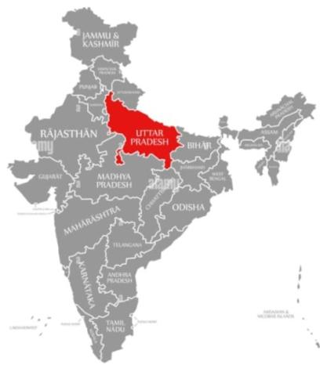
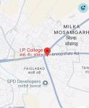
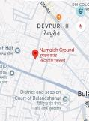
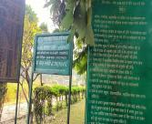
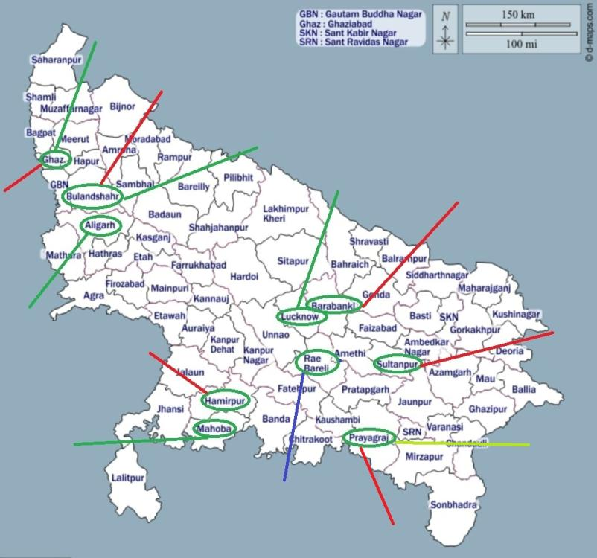

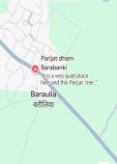
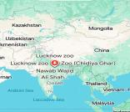
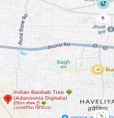
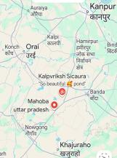
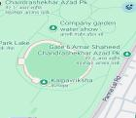
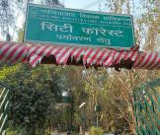
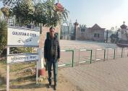
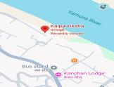
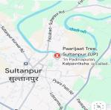
m
Fig. 1. Map of India
Fig. 2. Uttar Pradesh Map presenting location of 13 study sites of Adansonia digitata Linn.

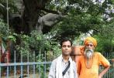
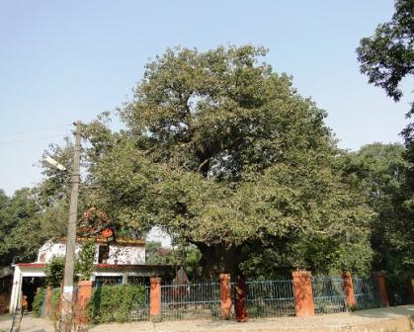
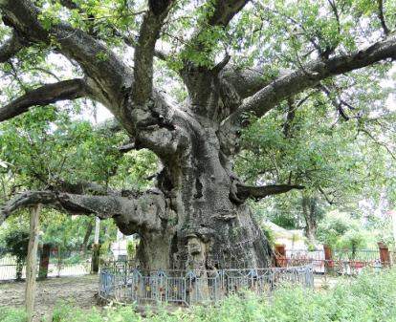
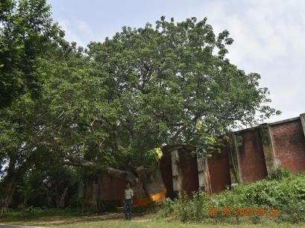
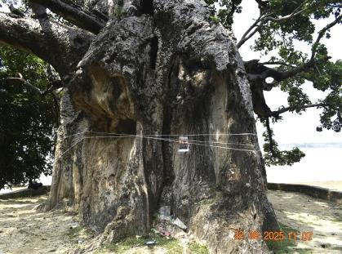
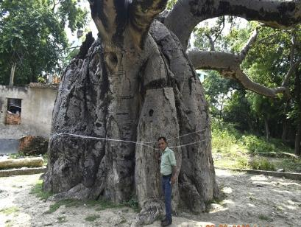
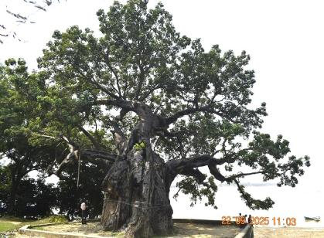
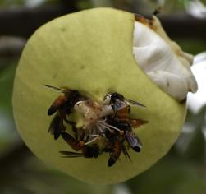
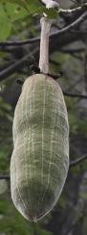
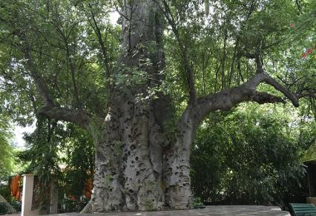
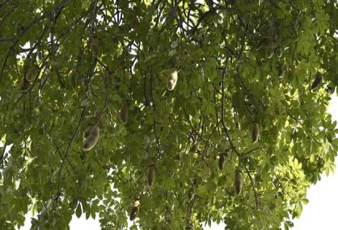
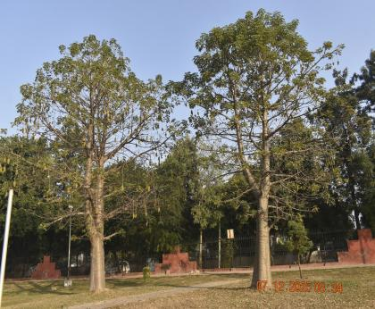
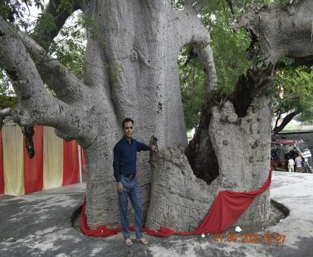
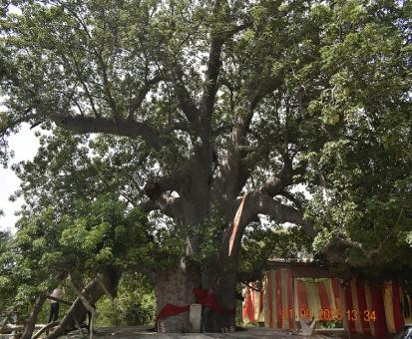
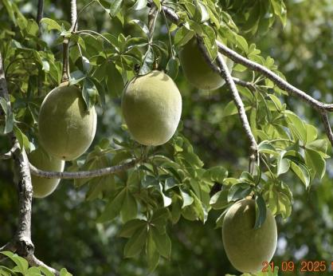
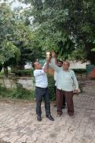
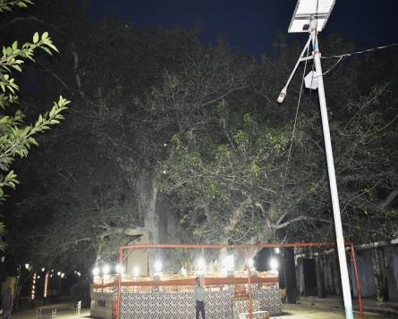
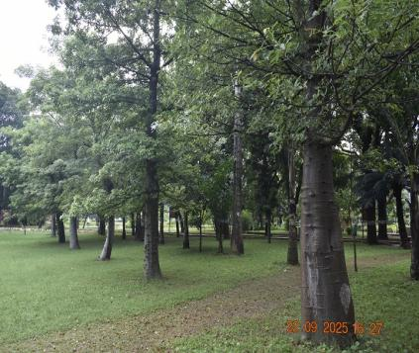
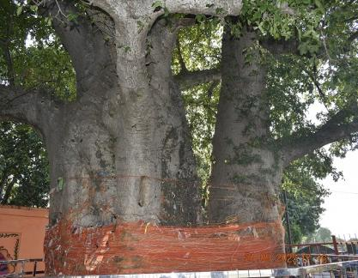
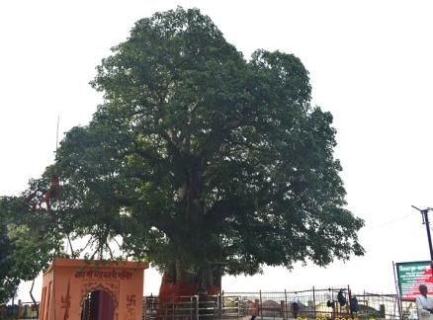
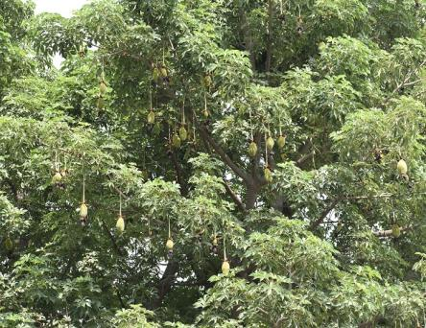
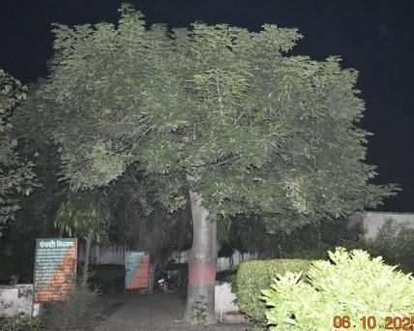
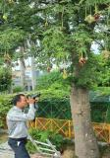
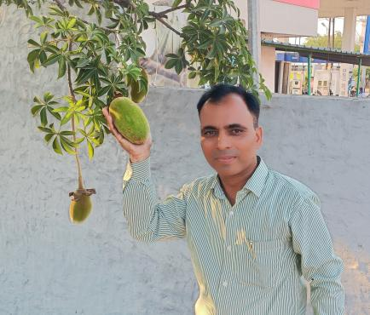
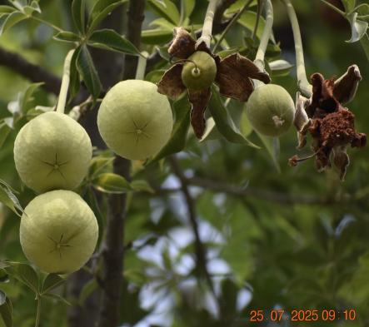
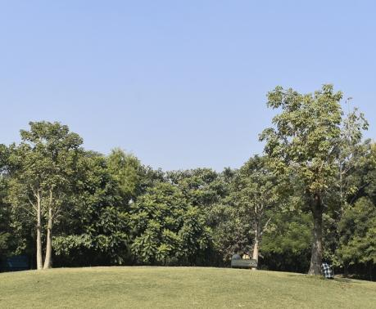
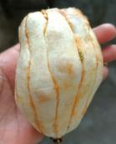
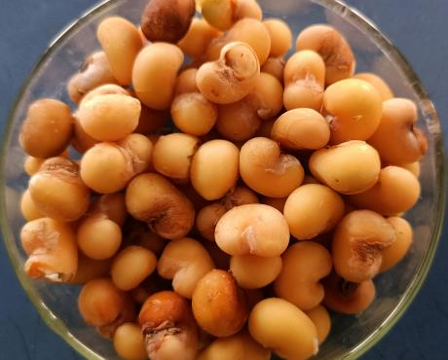
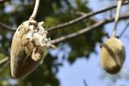
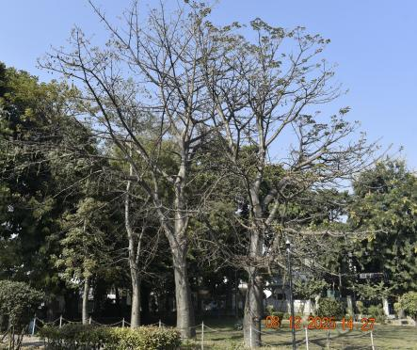
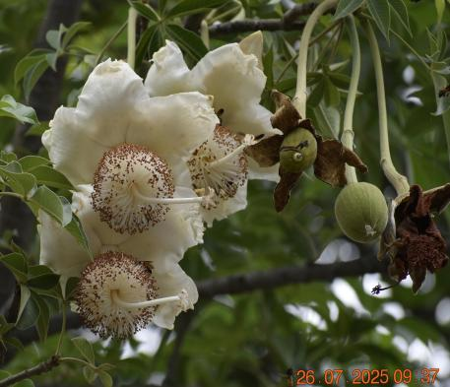

Fig. 5. View of Termite damaged trunk of adansonia digitata in Jhusi Pryagraj.
Fig .6. 400 years old Adansonia digitata tree located in Chandrashekhar azad Park, Prayagraj.
Fig. 8. Close up old Adansonia digitata tree located in Kintoor Barabanki.

Fig. 7. 1000 years old Adansonia digitata tree located in Kintoor Barabanki.

Fig. 4. 18.2 meters Measuring the circumference of the Adnsonia digitata tree trunk with measuring tap.
Jhusi Pryagraj.
Fig. 3. 700 years old Adansonia digitata tree located in Jhusi Prayagraj.

Fig. 9. 150 years old Adansonia digitata tree located in Nawab Wajid Ali Shah Zoological Garden, Lucknow.
Fig. 10. Fruits hanging from the branches of the Adansonia digitata tree in Nawab Wajid Ali Shah Zoological Garden, Lucknow.

Fig. 14. 25 years Adansonia digitata tree located in Gulistan e Syed, Aligarh.

Fig. 13. Fruits hanging from the branches of the Adansonia digitata tree in Sichora village, Mahoba.
Fig. 11. 2000 years old Adansonia digitata tree located in Sichora village, Mahoba.
Fig. 12. Half Part dameged of Adansonia digitata tree located in Sichora village, Mahoba.
Fig.18. 11 Meters Trunk of Adansonia digitata tree located in Hamirpur.

Fig. 19. 800 years old Adansonia digitata tree located in Sultanpur.

Fig. 20. 17 years old Adansonia digitata tree located in Indira Gandhi Memorial Botanical Garden Raebareli.

Fig. 17. 1000 years old Adansonia digitata tree located in Hamirpur.
Fig. 16. 17 years old Adansonia digitata tree located in Numaish Ground, Bulandshahr.

Fig. 15. Fruits hanging from the branches of the Adansonia digitata tree at IP College.
Fig. 26. View of without shell immature fruit and without pulp Immature seeds .

Fig. 25. Immature fruits bearing on branches of Adansonia digitata in I. P.( P.G.) College, First Campus, Bulandshahr.

Fig. 23. Mature buds hanging from the branches of the Adansonia digitata tree in I. P. College, Bulandshahr.

Fig. 21. Adansonia digitata tree located in Manave park Rajnagar sector -4 Ghaziabad.

Fig. 22. Adansonia digitata trees located in City Forest Park Ghaziabad.

Fig. 24. Flowers hanging on branches of Adansonia digitata in in I. P.( P.G.) College, First Campus , BSR.

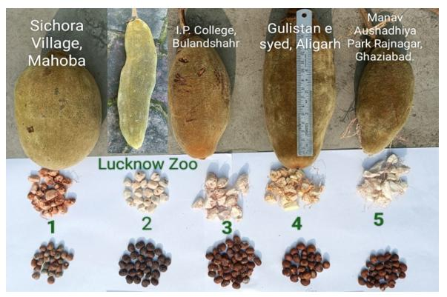

Fig. 27. Fruit characteristics assessed on Adansonia digitata trees in
1. Sichora village Mahoba, 2. Nawab Wajid Ali Shah Zoological Garden Lucknow 3. I. P. (P.G.) College First campus Bulandshahr. 4. Gulistan e Syed Aligarh, 5. Manav Park Rajnagar sector – 4 Ghaziabad, State Uttar Pradesh.

Conclusion

It is concluded that the aim of the present study is to spread awareness towards conservation of endangered tree Adansonia digitata in those areas where the plant is now rarely found. This research work will also prove to be of immense usefulness for the conservation of iconic monuments tree species in the Uttar Pradesh state. Since this plant is beneficial for humans in many ways, therefore it is required that wide propagation and conservation of this plant should be carried out, in order to ensure that future generations can benefit from it.

COMPETING INTERESTS DISCLAIMER:
Authors have declared that they have no known competing financial interests OR non-financial interests OR personal relationships that could have appeared to influence the work reported in this paper.

References

- Assogbadjo, A. E., Sinsin, B., & Van Damme, P. (2005). Caractères morphologiques et production des capsules de baobab (Adansonia digitata L.) au Bénin. Fruits, 60(5), 327–340. https://doi.org/10.1051/fruits:2005039
- Assogbadjo, A. E., Kyndt, T., Sinsin, B., Gheysen, G., & Van Damme, P. (2006). Patterns of genetic and morphometric diversity in baobab (Adansonia digitata) populations across different climatic zones of Benin (West Africa). Annals of Botany, 97(5), 819–830. https://doi.org/10.1093/aob/mcl043
- Baum, D. A. 1996. The ecology and conservation of the baobab of Madagascar, Primate Report, Vol 46, No 1, 311–327.
- Baum, D. A. (1995). A systematic revision of Adansonia (Bombacaceae). Annals of the Missouri Botanical Garden, 82(3), 440-470. https://doi.org/10.2307/2399893V
- Buchmann, C., Prehsler, S., Hartl, A., & Vogl, C. R. (2010). The importance of baobab (Adansonia digitata L.) in rural West African subsistence–suggestion of a cautionary approach to international market export of baobab fruits. Ecology of Food and Nutrition, 49(3), 145–172. https://doi.org/10.1080/03670241003766014
- Bynum H, Bynum W (2014). Remarkable plants that shape our world. Thames and Hudson Ltd in association with Royal Botanic Gardens Kew, UK.
- De Caluwé, E., Halamová, K., & Van Damme, P. (2010). Adansonia digitata L. – A review of traditional uses, phytochemistry and pharmacology. Afrika Focus, 23(1), 11–51. https://doi.org/10.21825/af.v23i1.5037
- De Smedt, S., Alaerts, K., Kouyate, A. M., Van Damme, P., Potters, G., & Samson, R. (2011). Phenotypic variation of baobab (Adansonia digitata L.) fruit traits in Mali. Agroforestry Systems, 82, 87-97. https://doi.org/10.1007/s10457-010-9357-0
- El-Amin, H. M. (1990). Trees & shrubs of the Sudan. Ithaca Press. https://www.cabidigitallibrary.org/doi/10.1079/CABICOMM_19910653795
- Gebauer, J., El-Siddig, K., & Ebert, G. (2002). Baobab (Adansonia digitata L.): A review on a multipurpose tree with promising future in the Sudan. European Journal of Horticultural Science, 67(4), 155-160. https://doi.org/10.1079/ejhs.2002/7085
- Gebauer, J., & Luedeling, E. (2013). A note on baobab (Adansonia digitata L.) in Kordofan, Sudan. *Genetic Resources and Crop Evolution*, *60*, 1587–1596. https://doi.org/10.1007/s10722-013-9964-5
- Gurashi, N. A., & Kordofani, M. A. Y. (2014). Morphological variation in fruit shapes of Adansonia digitata L. from Blue Nile and North Kordofan States, Sudan. Journal of Forest Products & Industries, 3(2), 106–111. http://researchpub.org/journal/jfpi/archives.html
- Maundu PM, Ngugi GW, Kabuye CHS (1999) Traditional food plants of Kenya. National MuseumsofKenya.http://www.fastonline.org/CD3WD_40/CD3WD/AGRIC/H1093E/EN/ B567_7.HTM#B567_7_9. Accessed 23 Nov 2014.
- Muchiri, M. N., & Chikamai, B. N. (2003). Testing techniques to assess fruit yield: the case of baobab (Adansonia digitata) from the drylands of Kenya. In J. Wong, F. Ndeckere-Ziangba, & D. Pouakouyou (Eds.), Summary of six case study reports as a contribution to development of practical techniques to assess non-wood forest product resources. Non-wood forest products program, working paper, FOPW/03/6. Food and Agriculture Organization of the United Nations. https://www.fao.org/tempref/docrep/fao/010/y9375b/y9375b00.pdf
- Munthali, C. R. Y., Chirwa, P. W., & Akinnifesi, F. K. (2012). Phenotypic variation in fruit and seed morphology of Adansonia digitata L. (baobab) in five selected wild populations in Malawi. Agroforestry Systems, 85(2), 279–290. https://doi.org/10.1007/s10457-012-9500-1
- Gurashi, N. A., & Elkhalifa, K. F. (2022). Variations in Morphometrics of Fruits, Seed and Dendrometric Measurements of Adansonia digitata L. in Sudan. Journal of Forestry and Natural Resources, 1(2), 13-20. https://doi.org/10.20372/vpvwjj48
- Pakenham, T. (2002). Remarkable trees of the world. W. W. Norton & Company.
- Lewington, A., & Parker, E. (1999). Ancient trees: Trees that live for a thousand years.
- Ramadan, A., Harraz, F. M., & El-Mougy, S. A. (1994). Anti-inflammatory, analgesic and antipyretic effects of the fruit pulp of Adansonia digitata. *Fitoterapia*, *65*(5), 418-422. http://indianmedicine.eldoc.ub.rug.nl/id/eprint/14637
- Salim, A. S., Simons, A. J., Orwa, C., Chege, J., Owuor, B., & Mutua, A. (2012). *Adansonia digitata*. Agroforestree database a tree species reference and selection guide. International Centre for Research in Agroforestry. https://www.worldagroforestry.org/treedb/AFTPDFS/Adansonia_digitata.PDF
- Sidibe, M., & Williams, J. T. (2002). *Baobab, Adansonia digitata L.* International Centre for Underutilised Crops. https://books.google.com/books/about/Baobab_Adansonia_Digitata_L.html?id=2002
- Tal-Dia A. et al. (1997): A Baobab solution for the prevention and treatment of acute dehydration in infantile diarrhea.
- Deenadayal, T., & Jain, T. (2024). Ecological, cultural, and morphological analysis of a singular Adansonia digitata L. tree in Devadurga Taluk, Raichur District Karnataka India. *International Journal of Home Science*, *10*(3), 464-470. https://doi.org/10.22271/23957476.2024.v10.i3g.1738
- Von Breitenbach, F. (1985) Aantekeninge oor die groeitempo van aangeplante kremetartbome (Adansonia digitata) en opmerkinge ten opsigte van lewenstyd, groeifases en genetiese variasie van die spesie. J. Dendrol.5, 1–21.
- Wickens, G. E. (1982). The baobab—Africa’s upside-down tree. Kew Bulletin, 37, 173–209. https://doi.org/10.2307/4109961
- Wickens, G. E., & Lowe, P. (2008). The baobabs: Pachycauls of Africa, Madagascar and Australia. Springer Science + Business Media, B.V. https://doi.org/10.1007/978-1-4020-6431-9

