Identification of the Potential for Increasing the Economic Value of Arabica Coffee as a Non-Timber Forest Product (NTFP) on Lombok Island

.
ABSTRACT

Arabica coffee on Lombok Island has strategic potential as a Non-Timber Forest Product (NTFP) capable of integrating ecological, social, and economic functions through agroforestry systems. This study aims to identify the existing potential and to formulate strategies for enhancing the economic value of Arabica coffee as an NTFP in Lombok Island by adopting an agroforestry-based and value chain strengthening approach. The research employed a qualitative descriptive design using a case study method conducted in major Arabica coffee production centers within forest and agroforestry landscapes, particularly in Sajang and Sembalun. Data were collected through semi-structured interviews, in-depth interviews with key informants, field observations, document analysis, and Focus Group Discussions, and were analyzed thematically through data reduction, data display, and conclusion drawing supported by source and method triangulation. The findings indicate that Lombok Arabica coffee possesses strong biophysical and ecological potential as an NTFP, supported by elevations above 1,000 m above sea level, a cool climate, fertile volcanic soils, and sustainable agroforestry practices, which collectively generate high-quality beans with distinctive sensory characteristics suitable for specialty coffee markets. However, its economic value has not yet been fully optimized due to uneven productivity, limited adoption of improved cultivation and post-harvest technologies, underdeveloped product diversification, weak farmer institutions, the absence of organic certification, and constrained market access and branding. This study identifies seven strategic pillars for strengthening the economic value of Arabica coffee as an NTFP, including the enhancement of cultivation practices based on local knowledge, post-harvest innovation and quality assurance, circular economy based product diversification, collective certification schemes, cooperative strengthening and digitalization, promotion through Geographic Indication–based branding, and supportive local government policies.

Keywords: agroforestry; coffee; NTFPs; sustainability; value-added

1. INTRODUCTION

Indonesia is widely recognized as one of the world’s largest coffee-producing countries (Ibnu & Rosanti, 2022), characterized by a high diversity of coffee varieties originating from different regions. Among these, Arabica coffee stands out as a premium commodity with significant economic and ecological potential (Permatasari et al., 2025). Arabica coffee requires relatively low temperatures and shaded growing conditions to achieve optimal production (Kusumaningtyas & Chofyan, 2013). Consequently, it is predominantly cultivated in mountainous areas with cool climates and fertile volcanic soils.
In West Nusa Tenggara, the largest Arabica coffee-producing area is located in Sajang Village, Sembalun District, East Lombok Regency. This region is well known for producing Arabica coffee in substantial quantities with quality and flavor profiles comparable to those of other major Arabica-producing regions in Indonesia (Chandra et al., 2023). Sembalun is a highland area surrounded by mountain ranges and characterized by a cool climate, with temperatures ranging from 7°C to 20°C (Haryantini et al., 2023). These unique agroclimatic conditions make Sembalun highly suitable for the cultivation of high-quality Arabica coffee.
Arabica coffee cultivated by local communities was initially planted within state forest or protected forest areas and subsequently managed sustainably by local farmers. At present, these lands have become part of community-managed forest areas, offering substantial potential as sources of environmentally friendly and high-value Non-Timber Forest Products (NTFPs). As an NTFP, Arabica coffee holds strategic importance because its cultivation does not degrade forest structure; instead, it can function as an environmentally sound agroforestry system. Coffee-based agroforestry systems help maintain forest structure and ecological processes while supporting sustainable land use (Hayyun et al., 2018).
Moreover, coffee-based agroforestry contributes to soil and water conservation, biodiversity protection, nutrient cycling, microclimate regulation, carbon sequestration, disease suppression, and increased farmer income (Supriadi & Pranowo, 2015). Coffee is widely recognized as one of the NTFPs with high economic value (Ilmi, 2023), and Arabica coffee has made a meaningful contribution to the livelihoods of communities surrounding forest areas. However, its economic potential has not yet been fully optimized. Field observations indicate persistent constraints, including limited market access, weak value addition at the farmer level, low diversification of processed coffee products, and the absence of integrated, area-based management supported by strong economic institutions.
Therefore, identifying the potential for increasing the economic value of Arabica coffee as an NTFP on Lombok Island is essential to promote more productive, sustainable, and inclusive management practices that generate broader socio-economic benefits for forest-dependent communities. This study aims to identify and analyze opportunities for enhancing the economic value of Arabica coffee as an NTFP on Lombok Island by considering the multiple factors influencing its development. The analysis includes a comprehensive assessment of physical, technical, institutional, and economic potentials, as well as existing social and policy support. The findings are expected to provide a robust foundation for designing locally appropriate, sustainable, and community-oriented strategies to enhance the economic value of Arabica coffee while maintaining forest conservation objectives.

2. methodology

2.1 Study Area

This study was conducted in several Arabica coffee production centers on Lombok Island, with a particular focus on forest areas and locations with significant agroforestry potential. These sites represent community-managed landscapes where Arabica coffee is cultivated in proximity to forest ecosystems and plays an important role as a Non-Timber Forest Product (NTFP).

2.2 Data and Information Collection Techniques
To obtain objective and comprehensive data relevant to the objectives of this study, multiple data collection approaches were employed as follows:
- Interviews
Semi-structured interviews were conducted to collect both quantitative and qualitative data from predetermined target groups involved in Arabica coffee production and management.
- In-depth Interviews
In-depth interviews were carried out to explore qualitative aspects in a more detailed and comprehensive manner. The interviewees included key informants with specific expertise and experience relevant to the issues examined in this study, such as community leaders, extension officers, and institutional stakeholders.
- Document Review
Document analysis was undertaken to complement and enrich the findings of the field study. This process involved reviewing research reports, policy documents, and other relevant secondary data sources related to Arabica coffee, agroforestry, and NTFP development.
- Direct Field Observation
Direct observations were conducted to examine on-site conditions, including the physical characteristics of the development areas and the biophysical conditions of Arabica coffee plantations.
- Focus Group Discussions (FGDs)
FGDs were organized to elicit collective perspectives and generate ideas for formulating strategies to enhance the economic value of Arabica coffee. Participants included farmers, local stakeholders, and relevant institutional representatives.

2.3 Research Variables
The variables examined in this study include:
- Opportunities for Enhancing the Economic Value of NTFPs
This variable refers to various opportunities that can be leveraged to increase the value added of Arabica coffee through innovation, policy support, and improved market access.
- Economic Value Potential of NTFPs
This variable represents the capacity of Arabica coffee to generate optimal economic value based on product quality, production volume, and the effectiveness of available resource management.
- Strategies for Enhancing the Economic Value of NTFPs
This variable encompasses planned and systematic actions aimed at optimizing the economic value of Arabica coffee through community empowerment, institutional strengthening, and technological development.
- Challenges in Enhancing the Economic Value of NTFPs
This variable refers to constraints encountered in the management and development of Arabica coffee, including limitations in technology, infrastructure, and farmer capacity.

2.3 Data Analysis
Data obtained from in-depth interviews and FGDs were analyzed qualitatively through three main stages: data reduction, data display, and conclusion drawing. Data reduction involved filtering and selecting relevant information from interview and FGD transcripts, followed by categorization according to themes and issues related to the potential enhancement of the economic value of Arabica coffee as an NTFP.
Data were presented in the form of descriptive narratives, thematic matrices, and direct quotations from informants to capture perspectives, experiences, and challenges faced by communities and stakeholders in Arabica coffee management. This presentation facilitated the identification of relationships among variables and the interpretation of local contextual dynamics.
The final stage involved drawing conclusions by interpreting the synthesized data to formulate key findings related to physical, technical, institutional, economic, social, and policy dimensions. Data validity was strengthened through source and method triangulation by comparing information obtained from different informants and data collection techniques.

3. results and discussion

3.1 Biophysical and Ecological Potential of Arabica Coffee as a Non-Timber Forest Product (NTFP)
The Sajang and Sembalun areas on Lombok Island exhibit agroecological characteristics that strongly support the development of Arabica coffee as a Non-Timber Forest Product (NTFP). Mountainous topography, cool climate, and fertile volcanic soils create optimal growing conditions for Arabica coffee with distinctive sensory attributes. Elevations exceeding 1,000 m above sea level provide favorable microclimatic conditions that contribute to the complexity of flavor profiles highly valued in specialty coffee markets. Previous studies indicate a positive correlation between altitude and sensory complexity as well as overall Arabica coffee quality (Muiz et al., 2024).
In addition, local coffee farming practices predominantly adopt agroforestry systems, characterized by mixed planting with multipurpose shade trees such as avocado and durian. Coffee-based agroforestry systems contribute to soil and water conservation, reduce land degradation and erosion, and enhance ecosystem resilience (Ismono et al., 2022). Therefore, Arabica coffee cultivated under agroforestry systems meets the criteria of NTFPs, as it does not degrade forest ecosystems but instead strengthens their ecological and social functions.
However, productivity levels remain highly variable among farmers. Average yields range from 500 g to 1 kg of green beans per tree per harvest season, influenced by differences in cultivation techniques, plant age, and maintenance intensity. With more systematic agronomic interventions, increasing productivity to approximately 1.5 kg per tree is considered achievable.

3.2 Arabica Coffee Cultivation Systems

Arabica coffee cultivation in the study area is generally conducted using traditional practices with a predominantly organic approach. Farmers rely on livestock manure, leaf compost, and coffee pulp waste as primary fertilizer inputs. However, these materials are often applied in raw form without prior processing, limiting their effectiveness as plant nutrients. This condition highlights significant opportunities to improve fertilization efficiency through simple technologies such as aerobic composting or fermentation using local microorganism solutions (MOL). MOL contains macro- and micronutrients as well as beneficial bacteria that function as organic matter decomposers, plant growth stimulators, and bio-activators (Lubis, 2020). The integration of MOL in fermenting organic inputs such as manure and coffee pulp can enhance nutrient availability, accelerate decomposition, and substantially improve fertilization efficiency in Arabica coffee plantations.
According to Hulupi and Martini (2013), coffee pruning aims to shape healthy plant structures and regulate plant height to facilitate maintenance and harvesting. Pruning also optimizes the formation of productive branches, improves light penetration and air circulation within the canopy, and enhances pest and disease management. Two primary pruning systems were observed in the field: the lancuran and paying systems. The lancuran system allows plants to grow tall with minimal pruning, resulting in lower labor inputs but often reduced productivity and less efficient selective harvesting. This system is commonly practiced due to its low cost, yet it limits light penetration and air circulation, negatively affecting plant health and yield.
In contrast, the paying system involves intensive pruning to form an umbrella-shaped canopy with horizontal branching. This structure enhances productive branching, improves light distribution, and facilitates pest control and harvesting. Previous studies emphasize that canopy management plays a critical role in optimizing photosynthetic efficiency and fruit yield in coffee production systems (Yunusa et al., 2018). Accordingly, broader adoption of the payung pruning system is expected to increase both quantitative yields and qualitative bean attributes.
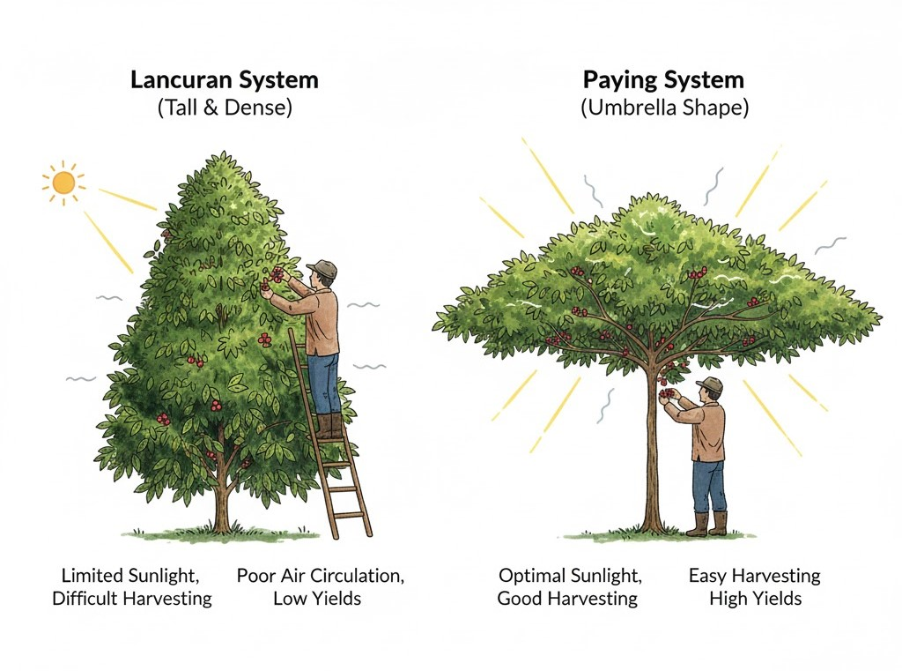
Figure 1. Comparison Lancuran and Paying Systems

Figure 1 compares the lancuran and paying pruning systems in Arabica coffee cultivation, highlighting their structural and productivity differences. The lancuran system produces tall and dense canopies that limit sunlight penetration, reduce air circulation, and make harvesting more difficult, ultimately resulting in lower yields. In contrast, the paying system forms an umbrella-shaped canopy that optimizes light interception, improves airflow, and facilitates harvesting, thereby enhancing photosynthetic efficiency and increasing coffee yield.
Pruning influences not only yield quantity but also bean quality. Well-maintained plants tend to produce uniform fruits with optimal sugar content, which is essential for achieving high cupping scores. Mawardah and Ariska (2022) report that pruning techniques significantly enhance coffee productivity, underscoring their importance in cultivation systems. Nevertheless, successful pruning implementation depends heavily on labor skills and technical competence (Atikah et al., 2024). Limited technical capacity and insufficient continuous training remain key constraints to adoption, highlighting the need for extension services and demonstration plots to support more productive and sustainable cultivation practices.

3.3 Post-Harvest Management and Quality Differentiation

Post-harvest handling plays a critical role in determining final coffee quality and market competitiveness. Proper post-harvest management enables the preservation of coffee quality potential and supports classification into specialty grades (Nadaleti et al., 2022). Findings from FGDs indicate that farmers in Sajang are familiar with and have experimented with various processing methods, including fully washed, wet-hulled, honey processes, and experimental fermentation techniques such as winey fermentation and carbonic maceration. Each method exerts distinct effects on sensory attributes, including acidity, body, and aroma.
Fermentation is a key stage in post-harvest processing due to its substantial influence on final bean characteristics (Lidya et al., 2024). Flavor profiles are often enhanced through modified fermentation processes, such as the addition of lactic acid bacteria to reduce caffeine content and pH, resulting in more distinctive sensory attributes. However, limited infrastructure including greenhouse drying facilities, controlled fermentation rooms, and low-temperature dryers poses a major constraint. Consequently, green bean quality often fluctuates and remains highly dependent on weather conditions, directly affecting market prices.
Standardization of post-harvest processes and the integration of appropriate technologies are therefore prerequisites for increasing value added. Technical training, research collaboration, and collective facilities should be prioritized in institutional intervention strategies. Simple, appropriate technologies such as solar dryers, multi-tier drying racks, and humidity control systems are essential to stabilize quality and consistently achieve cupping scores above 80, the threshold for entry into premium markets.

3.4 Product Diversification and Circular Economy Approaches
Beyond green beans, coffee offers substantial economic potential through underutilized by-products. Coffee husks (cascara), mucilage, and spent coffee grounds can be processed into value-added products such as herbal teas, coffee-based soaps, liquid organic fertilizers, and cosmetic ingredients. This approach not only enhances economic returns but also strengthens circular economy principles by minimizing waste. Renovan et al. (2024) demonstrate that utilizing coffee waste within production systems promotes sustainability by eliminating residual waste streams.
Field observations indicate that training programs on coffee by-product processing have been implemented at the village level, including the production of coffee-scented soaps. While these initiatives provided initial knowledge, implementation remains limited due to perceptions of complexity, time requirements, and delayed economic returns. As a result, enthusiasm for product diversification has declined, preventing its development into a sustainable economic activity. Nonetheless, coffee-based diversification holds significant potential for empowering women, youth, and vulnerable groups within local economies. Sustained mentoring, simplified production processes, and institutional support through cooperatives, local SMEs, and village governments are required. The establishment of community-based joint processing units could address technical barriers while facilitating product standardization, certification, packaging, and access to digital marketing and broader markets.
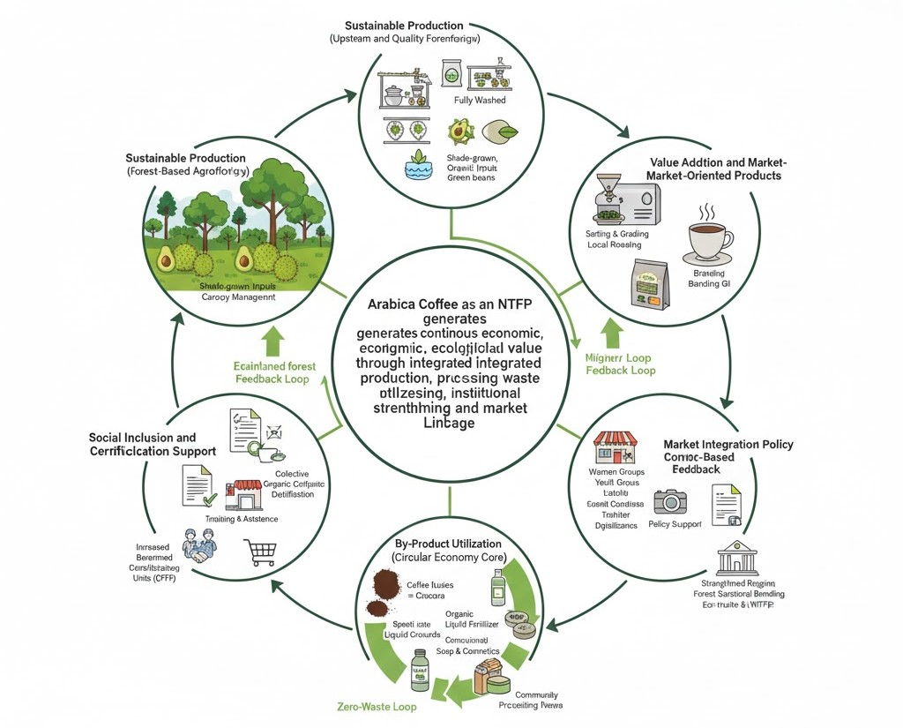
Figure 2. Circular Economy Model for Enhancing the Economic Value of Arabica as a Non Timber Forest Product (NTFP) in Lombok Island

Figure 2, illustrates an integrated circular economy model for enhancing the economic value of Arabica coffee as a non-timber forest product (NTFP) in Lombok Island. It shows how forest-based agroforestry production, improved post-harvest processing, value addition, and by-product utilization are interconnected with social inclusion, institutional support, and market integration. Through ecological, quality, economic, social, institutional, and policy feedback loops, the model demonstrates that Arabica coffee functions not only as a commodity but as an ecosystem-based system that simultaneously strengthens forest conservation, farmer income, and rural resilience.

3.5 Farmer Institutions and Organic Certification Implementation
Although most farmers apply traditional organic practices, none currently possess formal organic certification. Certification serves not only as quality assurance but also as a gateway to premium domestic and export markets, where certified organic coffee prices may reach two to three times those of conventional products. Certification encourages quality improvement and sustainability, supported by consumers’ willingness to pay higher prices for compliant products (Herminingsih et al., 2023). However, major barriers include high certification costs, limited information, and insufficient institutional facilitation.
In this context, cooperatives play a strategic role in promoting collective organic certification. Cooperatives can act as intermediaries between farmers and certification bodies while serving as central nodes in production, marketing, and capacity-building activities. The Bumi Lestari Cooperative has begun adopting this role, although challenges remain in management capacity, access to finance, and digitalization needs. Strengthening cooperative institutions is therefore essential for expanding inclusive and sustainable organic certification at the farmer level.

3.6 Market Access, Branding, and the Role of Local Policies

Market access for Sajang Arabica coffee remains largely local and reliant on cooperative distribution channels, while the potential of social media, e-commerce platforms, and partnerships with national roasteries has yet to be fully realized. As market demand for transparency and quality increases, digitalization of coffee value chains has become increasingly urgent. Digital technologies enable price transparency, product traceability, and locally grounded storytelling strategies that appeal to younger consumers and premium markets.
Geographical Indication (GI) status for “Sembalun Arabica Coffee” represents a strategic asset for branding and value enhancement. GI certification provides legal protection for products with distinctive characteristics linked to specific geographical origins (Fuad & Latjeme, 2021). GI utilization can be expanded through coffee festivals, tourism sector collaboration, and promotion at national and international events. Local governments play a crucial role in generating demand through affirmative policies, such as prioritizing local coffee consumption in government activities, tourism destinations, and public facilities. These measures simultaneously protect local NTFPs and strengthen community-based economies rooted in local knowledge.

3.7 Strategies for Strengthening the Arabica Coffee Value Chain as an NTFP
Based on the comprehensive analysis, strategies for strengthening the economic value of Arabica coffee as an NTFP on Lombok Island can be structured around seven key pillars:
- Strengthening Cultivation Based on Local Knowledge
- Systematic adoption of the paying pruning system
- Processing of fermented organic fertilizers
- Post-Harvest Innovation and Quality Assurance
- Provision of greenhouse drying and low-temperature drying equipment
- Training in innovative fermentation techniques
- Product Diversification and Circular Economy
- Development of cascara, soaps, liquid fertilizers, and herbal instant coffee
- Engagement of women- and youth-led SMEs
- Certification and Production Standardization
- Collective certification schemes through cooperatives
- Technical assistance and quality documentation
- Institutional Strengthening and Cooperative Digitalization
- Integration of cooperatives with digital platforms
- Inclusive access to financing for production facilities
- Promotion and Storytelling-Based Marketing
- Optimization of GI as a flagship brand
- Campaigns promoting local coffee consumption
- Affirmative Local Government Policies
- Development of coffee-based ecotourism and educational tourism
- Incentives for the consumption of local NTFP products within regional programs

4. Conclusion

This study concludes that Arabica coffee in Lombok Island, particularly in the Sajang Sembalun area, possesses strong potential to be developed as a high-value and sustainable Non-Timber Forest Product (NTFP). From a biophysical and ecological perspective, favorable highland agroecological conditions, forest-based agroforestry systems, and environmentally friendly cultivation practices position Arabica coffee as both an economically viable commodity and a contributor to forest conservation, soil and water protection, and ecosystem stability. Nevertheless, productivity and quality levels remain highly variable due to limitations in cultivation techniques, pruning systems, fertilization practices, and post-harvest management.
The findings demonstrate that enhancing the economic value of Arabica coffee as an NTFP requires integrated interventions along the entire value chain. These include the systematic adoption of the paying pruning system, the use of fermented organic fertilizers, post-harvest innovations for quality differentiation, and the utilization of coffee by-products within a circular economy framework. Furthermore, strengthening farmer institutions through cooperatives, implementing collective organic certification, and optimizing Geographical Indication branding and digital marketing are critical factors for improving market access and farmers’ bargaining power.
Overall, this study highlights that the development of Arabica coffee as an NTFP cannot be pursued through isolated measures but must adopt a comprehensive and multi-pillar approach integrating ecological, technical, institutional, economic, and policy dimensions. Such an integrated strategy has the potential to simultaneously increase farmer income, enhance rural economic resilience, promote social inclusion, and ensure the sustainable management of forest landscapes in Lombok Island.

References

Atikah, N., Suhartanto, M. R., & Wachjar, A. (2024). Pemangkasan Meningkatkan Produktivitas Tanaman Kopi Robusta (Coffea canephora Pierre ex. A. Froehner) di Malang, Jawa Timur. Buletin Agrohorti, 12(2), 294–303. https://doi.org/10.29244/agrob.v12i2.51583
Chandra, L. Y. K., Linggarweni, B. I., & Novida, S. (2023). Analisis Pendapatan Usaha Kopi Bubuk Arabika di Desa Sajang Kecamatan Sembalun Kabupaten Lombok Timur. Jurnal Ekonomi Dan Bisnis, 3(2), 148–155. https://doi.org/10.56145/jurnalekonomidanbisnis.v3i2.71
Fuad, F., & Latjeme, A. A. (2017). Perlindungan Indikasi Geografis Aset Nasional Pada Kasus Kopi Toraja. Jurnal Magister Ilmu Hukum: Hukum dan Kesejahteraan, 2(2), 10–16. https://doi.org/10.36722/jmih.v2i2.742
Haryantini, B. A., Haryanto, H., Sunantra, I. M., Wardhana, A. W., Arifin, Z., Baharuddin, B., Zainab, S., & Apzani, W. (2023). PERTANIAN MAJU DAN BERKUALITAS DI DESA SEMBALUN KECAMATAN SEMBALUN LOMBOK TIMUR: Advanced And Quality Agriculture In Sembalun Village, Sembalun District, East Lombok. Al-Amal: Jurnal Pengabdian Masyarakat, 1(2), 44–51. https://doi.org/10.59896/amal.v1i2.41
Hayyun, D. A., Megantara, E. N., & Parikesit, P. (2018). Kajian layanan ekosistem pada sistem agroforestri berbasis kopi di Desa Cisero, Garut. Jurnal Pengelolaan Lingkungan Berkelanjutan (Journal of Environmental Sustainability Management), 2(3), 200–219. https://journal.bkpsl.org/index.php/jplb
Herminingsih, H., Rokhani, R., Iswati, I., & Sudarko, S. (2023). Manfaat Ekonomi Sertifikasi Indikasi Geografis (IG) Terhadap Petani Kopi Rakyat: Studi Kasus di Kabupaten Bondowoso, Jawa Timur. Jurnal Ilmiah Respati, 14(1), 56–63. https://doi.org/10.52643/jir.v14i1.3082
Hulupi, R., & Martini, E. (2013). Pedoman budi daya dan pemeliharaan tanaman kopi di kebun campur. World Agroforestry Centre (ICRAF) Southeast Asia Regional Program. https://www.worldagroforestry.org/publication/pedoman-budi-daya-dan-pemeliharaan-tanaman-kopi-di-kebun-campur
Ibnu, M., & Rosanti, N. (2022). Tren produksi dan perdagangan negara-negara produsen kopi terbesar di dunia dan implikasinya bagi Indonesia. Buletin Ilmiah Litbang Perdagangan, 16(2). https://doi.org/10.55981/bilp.2022.5
Ilmi, N. (2023). Kontribusi Kopi Terhadap Pendapatan Usahatani Masyarakat Pada Areal Hutan Kemasyarakatan di Desa Kalobba, Kecamatan Tellulimpoe, Kabupaten Sinjai = Contribution of Coffee to Community Farming Income in Community Forest Areas in Kalobba Village, Tellulimpoe District, Sinjai Regency. Universitas Hasanuddin. https://repository.unhas.ac.id/id/eprint/27000/
Ismono, H., Arifin, B., Tanaka, K., & Kada, R. (2022). Impacts of Coffee Agroforestry and Sustainability Certification on Farmers' Livelihood in Sumatra-Indonesia. Sustainability Science and Resources, 2(5), 77–95. https://doi.org/10.55168/ssr2809-6029.2022.2005
Kusumaningtyas, R., & Chofyan, I. (2013). Pengelolaan hutan dalam mengatasi alih fungsi lahan hutan di Wilayah Kabupaten Subang. Jurnal Perencanaan wilayah dan kota, 13(2). https://journals.unisba.ac.id/index.php/planologi/article/view/267
Lidya, B., Wildiani, I. R., Ramadhan, M. Z., & Hariyadi, T. (2024). The Effect of Fermentation Time in Full Wash and Honey Processing on Arabica Coffee Characteristics. Fluida, 17(2), 78–84. https://doi.org/10.35313/fluida.v17i2.6124
Lubis, Z. (2020). Pemanfaatan mikroorganisme lokal (MOL) dalam pembuatan kompos. Prosiding Seminar Nasional Hasil Pengabdian, 3(1), 361–374. https://jurnal.umnaw.ac.id/index.php/PSNHP/article/view/107/100
Mawardah, N., & Ariska, N. (2022). Teknik Pemeliharaan dan Produksi Tanaman Kopi Arabika (Coffea Arabica) Di Kabupaten Aceh Tengah. Jurnal Pertanian Agros, 24(3), 1243–1246. https://ejournal.janabadra.ac.id/index.php/JA/article/view/2400/1900
Muiz, K., Nilahayati, N., Nasruddin, N., Jamidi, J., & Hafifah, H. (2024). Analisis Kualitas Fisik Dan Cita Rasa Kopi Arabika (Coffea arabica L.) Pada Dua Rentang Ketinggian. Jurnal Agrium, 21(3), 258–265. https://doi.org/10.29103/agrium.v21i3.18994
Nadaleti, D. H. S., de Rezende Abrahão, J. C., Malta, M. R., Dos Santos, C. S., Pereira, A. A., & Carvalho, G. R. (2022). Influence of postharvest processing on the quality and sensory profile of groups of arabica coffee genotypes. Journal of the Science of Food and Agriculture, 102(15), 6899–6906. https://doi.org/10.1002/jsfa.12051
Permatasari, P., Anjani, A. R., Wulandari, A. T., Ferdiansyah, A. P., Ardan, A., Putra, A. D. A., Buwana, B. S., Anandyra, D. A., Wibowo, F. R., Ferdiansyah, F. A., Pratama, G. W., Sekarraya, I. C., Iqbal, M. A., Utami, N. D., Melani, W., Anggraini, N. T., Ratnasari, R. R. H., Ramadhan, R. S., Azzahra, R. Z., Pratiwi, R. C., & Fadhilah, S. (2025). Peningkatan Minat Kelompok Tani dalam Budidaya Kopi Arabika Berbasis Konservasi untuk Mendukung Agroedutourism di Desa Bansari, Kecamatan Bansari, Temanggung. Jurnal Pengabdian Masyarakat Inovasi Indonesia, 3(2), 105–114. https://doi.org/10.54082/jpmii.732
Renovan, A. P., Prawiranegara, B. M. P., Situmorang, Y. L. A., & Sugandi, W. K. (2024). Analisis Rantai Pasok Berkelanjutan Pada Produk Limbah Kopi dengan Pendekatan Sirkular Ekonomi di Perusahaan Lestari Kopi, Kabupaten Garut. Prosiding Semnastek - Jurnal UMJ. https://jurnal.umj.ac.id/index.php/semnastek/article/view/18000
Supriadi, H., & Pranowo, D. (2015). Prospects for the development of coffee-based agroforestry in Indonesia. Perspektif: Review Penelitian Tanaman Industri, 14(2), 135–150.
Yunusa, I. A. M., Kukhang, T. I. D., Powell, K. S., & Holzapfel, B. P. (2020). Canopy management for optimizing productivity of polyculture coffee production system. Acta Horticulturae, 1281, 257–264. https://doi.org/10.17660/ActaHortic.2020.1281.35

