Original Research Article
Runoff and Sediment Yield Analysis of Ariqua Watershed, Tekeze Basin, Ethiopia

Abstract
Ethiopia's main issues are the degradation of land and water resources. In this study, a physically based watershed model SWAT2012 was applied to the Ariqua watershed for runoff and sediment yield analysis. The objectives were to estimate runoff and sediment yield analysis and order to prioritize the most erodible sub-watershed. To set up the model for simulation, a 30 x 30 m DEM (Digital Elevation Model), land use map and soil map were used. Daily stream flow and sediment data from 2001 to 2015 were applied for SWAT simulation. The model was calibrated using both automated and manual calibration. The first six years (2006 to 2011) were used for calibration and the rest (2012 to 2015) were used for validation. Sensitivity analysis, model calibration and validation were also performed to evaluate the model performance. The coefficient of determination (R²) and Nash Sutcliffe (ENS) were used to evaluate model calibration and validation. Both showed a good model performance agreement (model of fitness) between measured and simulated monthly flow and sediment yield. The model prediction result indicated that the 15 years annual average measured and simulated stream flow generated was 137 m³/s and 124 m³/s, whereas for suspended sediment yield was 12.54 ton/ha/yr and 13.92 ton/ha/yr respectively. Out of 23 sub watersheds, sub watershed (SWT-23) and (SWT-20) generated high stream flow with 383.5 m³/s and 287.3 m³/s. Similarly, (SWT- 23) and (SWT-16) contributed very high sediment yield, 33.1 ton/ha/yr and 31.1 ton/ha/yr respectively.

Key words: SWAT model, Runoff, Sediment yield, and Ariqua watershed

- Introduction

Water resources are very vital renewable resources that are the basis for the survival and development of any society. Human health and welfare, food security and industrial developments are dependent on adequate supplies of suitable quality of water. Conversely, too much water results in socio-economic damages and loss of life due to flooding. The liveliness of natural ecological systems depends on mankind’s stewardship of water resources. Proper utilization of these resources necessitates assessment and management of the quality and quantity of water resources both spatially and temporally (Dilnesaw, 2006).
Soil erosion is the detachment and transportation of soil particles from their original place to further downstream by erosion agents such as water and wind. It is one of the normal aspects of landscape development. The severity of erosion increases with the decrease in cover material most likely vegetation. It is a serious problem affecting the quality of soil, land, water resources upon which man depends for his sustenance. Today, soil erosion is universally recognized as a major environmental and agricultural problem. Because the top soil is eroded by erosion agents such as water and wind, its fertility and nutrient content decreases. This eventually results in the loss of productivity. Since more than 85% of the country‘s population depends on agriculture for living; physical soil and nutrient losses lead to food insecurity (Luelseged, 2005). Rapidly increasing population, deforestation, over cultivation, expansion of cultivation at the expense of lands under communal use rights (grazing and woody biomass resources), cultivation of marginal and steep lands, overgrazing, and other social, economic and political factors have been the driving force to a series of soil erosion in the basin in general.
The problem of land degradation is a threat and devastating challenge to the proposed Ariqua watershed, the upstream of the Tekeze dam reservoir areas, due to generating high runoff discharges and imposing huge sediment yield, which may result in reducing water storage capacity of the dam reservoir, unless the upper watershed is treated with appropriate watershed management interventions and strategies (MoWIE, 2015). Therefore, there is an urgent need for developing an integrated watershed management plan based on hydrological simulation studies using suitable modeling approaches. Considering hydrological behavior of the watershed and applicability of the existing models for the solutions of aforementioned problems, this study is intended to be undertaken with the application of the Soil and Water Assessment Tool (SWAT) model combined with remote sensing and ArcGIS to estimate the soil loss and runoff yield of Ariqua watershed. Estimation of monthly, seasonal and long-term runoff yield helps to identify the best and sustainable land use and management options in the area. Therefore, the output of this study can be used as an input to plan and implement effective land and water resources development and management.

The review of Soil and Water Assessment Tool (SWAT) model applicability to local situation indicated that the model is capable of simulating hydrological processes with reasonable accuracy and can be applied to large un-gauged watershed. Setegn (2008) evaluated the applicability of SWAT model to examine the influence of topography, land use, soil and climatic condition on stream flow, soil erosion and sediment yield and concluded as SWAT model performs to be adequately accurate. It was also proved by Easton et al. (2010) as SWAT was applied to the entire Blue Nile. Thus, among all hydrological models, the SWAT model was selected for this study because it was promising model for simulation predominantly in Agricultural watershed. The time series data on rainfall, runoff and sediment yield are available at the stream gauging station of the catchment, and these are used to calibrate and validate the SWAT model and to assess its applicability in simulating runoff and sediment yield from the Ariqua watershed.

Therefore, to address the above situation, watershed management is one of the most important approaches, which helps to reduce land degradation, increase vegetation cover, and increases the productivity of the watershed area. In line with this, the present study was designed with runoff and siltation from the watershed of Ariqua was initiated with the estimate potential runoff and sediment yield and prioritize sub-watershed with respect to sedimentation of the specified area.

2.Material and methods

  - Description of the study area

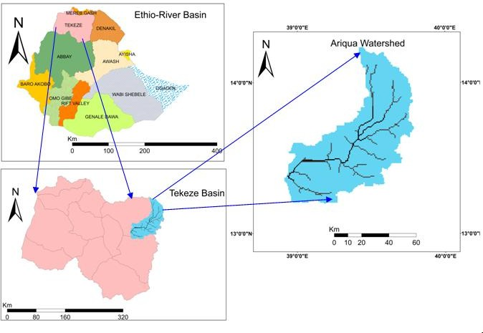This study was conducted in the Ariqua watershed (Figure 1), Tekeze basin, which is found in the central zone, Tigray Region. Ariqua watershed is also one of the three sub-catchments of Giba sub-basin of Tekeze basin. The watershed having an area of 519,618.38 ha, and it is situated between 13⁰ 00' N to 14⁰ 00' N latitude and 38⁰ 00' E to 39⁰ 00' E longitude with an average elevation of 1764 meter above sea level. It is found at a distance of 180 km from Mekelle.

Figure 1. Location map of the study area

The mean annual rainfall is 555.33 mm and the mean monthly temperature also varies between 14 ⁰C and 27 ⁰C throughout the year. The slope of the watershed is between the flat to the rolling terrain slope of the watershed area. Generally this area is being used for agriculture.

  - Method of data collection

The shape file of the major soil type and land use data of the study area was collected from Ministry of Water, Irrigation and Electricity (MoWIE, 2015) and the soil map of the study area was generated by using ArcGIS10.1 software. Daily climatic data, rainfall, maximum and minimum temperature, relative humidity, wind speed and sunshine hours (January 1991- December 2015) covering a period of 25 years were collected from National Meteorological Service Agency (NMSA). The mean annual rainfall data were used in five adjacent metrological stations of the study area for analysis of runoff and sediment yield (H/selam, Mekelle , Samre, Yechila and Wukro).

Hydrological data, available stream flow and sediment yield data of the watershed gauging station have been required for calibrating and validating SWAT model. Hence the gauging station (Ariqua gauging station) in the sub-basin which have continuous record for a relatively long period and therefore average monthly stream flow discharge and sediment yield data (2001-2015) for this station were collected from the (MoWIE).

The spatial data includes Digital Elevation Model (DEM), digital stream network, land use and land cover map, and soil map. The high resolution DEM (30 X 30 m) was obtained from online elevation databases of the SRTM(http://earthexplorer.usgs.gov/). The DEM used as input for SWAT model. Land use/land cover affects the runoff and sediment transport in the watershed. For this study, the 2015 land use/land cover data as a shape file was obtained from MoWIE, department of GIS.

  - Hydrological Model SWAT

The Soil and Water Assessment Tool (SWAT), a river basin, or watershed, scale model. SWAT was used to forecast how land management techniques will affect the yields of the water, sediment, and agricultural chemicals in huge, intricate watersheds with different soil types, land uses, and management techniques over long periods of time. SWAT requires specific information about weather, soil properties, topography, vegetation, and land management practices occurring in the watershed. The physical processes associated with water movement, sediment movement, crop growth, nutrient cycling, etc. directly modeled by SWAT using input data. It is computationally efficient and simulation of a very large basin. SWAT model developed by Arnold et al., (1998), has gained international acceptance as a robust interdisciplinary watershed modeling. SWAT estimate and simulate the sediment yield using the Modified Universal Soil loss Equation (MUSL) 14, (Williams, 1995).
Sed = 11.8 x (Q_{surf} x q_{peak} x area_{hru})^{0.56} x K_{USLE} x C_{USLE} x LS_{USLE} x C_{FRG} (1)

Where, sed is the sediment yield on a given day (metric tons), Q_{surf} is the surface runoff volume (mm /ha), q_{peak} is the peak runoff rate (m³/s), area_{hru} is the area of the HRU (ha). The K_{USLE} is the soil erodibility factor, C_{USLE} is the cover and management factor, and LS_{USLE} is the support practice factor are obtained from the Universal soil loss Equations and C_{FRG} is the coarse fragment factor.

2.4 Hydrological Model Inputs

The spatial databases needed for the ArcSWAT2012 model include the digital elevation model (DEM), land use and land cover, and soils. Daily observed climate data, river discharge and sediment concentration data are also required for the model to predict stream flow and calibration purposes. Initially, the model simulated the watershed into sub-basins. The user had the option of allowing SWAT to automatically delineate the watershed and sub-basins using the DEM or the user provided predefined sub-basins. The land area in a sub-basin was divided into hydrologic response units (HRUs). HRUs are portions of a sub-basin and possess unique land use, slope range, and soil attributes (Neitsch et al., 2005).

- Result and discussion

3.1 Digital Elevation Model (DEM) and Slope

The DEM is one of the main inputs of the SWAT model. The topography is defined by DEM, which describes the elevation of any point in a given area at a specific spatial resolution. The DEM data was processed from the STRM dataset shown in (Figure 2). Before the DEM data was loaded into the ArcSWAT interface, it was projected into the projected coordinate system. The projection of the DEM data was done using the Arc tool box operation in ArcGIS. The projected coordinate system parameters of study area are: UTM _ other GCS _Adindan UTM zone 37 N.

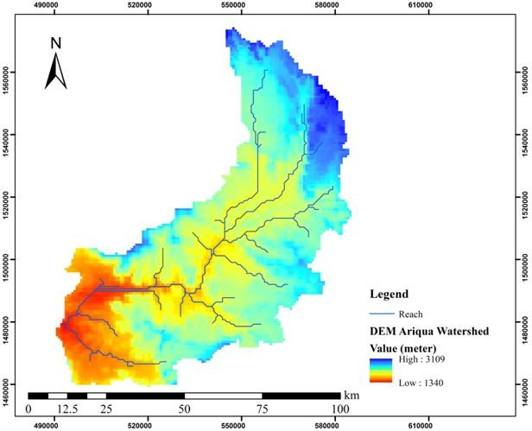  Fig 2. DEM of the watershed | 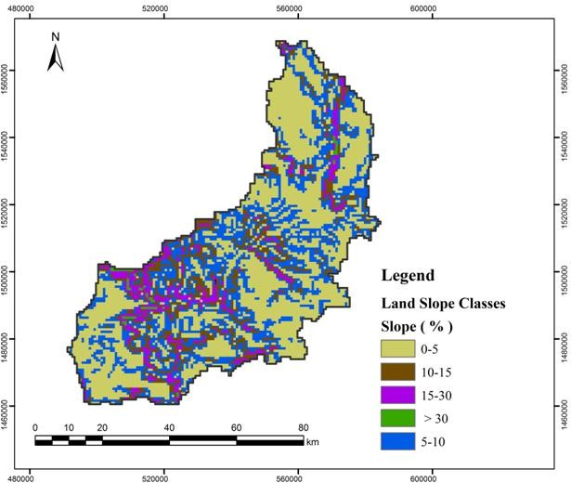  Fig 3. Slope classification of the watershed
During the creation of HRU, the slope was classified to the reasonable range. Accordingly, for this work to minimize complexity and to use manageable data and also considering the steepness of the area, the slope was classified into five classes. The classes were: 0 -5%, 5 -10%, 10 - 15%, 15- 30%, and above 30% (Figure 3). Based on these classes, the map of the slopes of the area was developed. Based on FAO (2006) slope classes, 10.82 % of the area has more than 30 % slope and between 15 – 30 % slope covers 13.5 % of the watershed. The area in between the slope range of 0 % to 15 % covers about 75.68 % of the watershed. Generally this area is being used for agricultural use.

3.2 Soil types and land use, land cover

According to the FAO/UNSCO-ISRIC soil classification, the soils in the study area could be grouped in to five major categories. Table 1 and Figure 4 indicate the major soils in the area. Based on the threshold percentage values, 237 HRUs were created. So, the land use, soil and slope maps should be 100% overlaid to create HRUs that had similar hydrological condition. The area coverage in the watershed by each land use type is presented in Table 2 and Figure 5.
Table 1. Major soil types of Ariqua watershed
Soil Type | SWAT Code | Area (Ha) | Coverage (%)
Lithic Leptosols | LP_li | 188,101.85 | 36.20
Chromic Cambisols | CM_cr | 144,817.64 | 27.87
Eutric Leptosols | LP_eu | 136,555.71 | 26.28
Vertic Cambisols | CM_vr | 7,794.28 | 1.50
Rendezic Leptosols | LP_rz | 42,348.90 | 8.15
Total |  | 519,618.38 | 100.00

Table 2. land use/land cover of Ariqua watershed
Land Use Type | SWAT Code | Area (Ha) | Coverage (%)
Shrubs land | RNGB | 112,445.42 | 21.64
Grazing Land | RNGE | 175,890.82 | 33.85
Cultivated Land | AGRC | 209,925.83 | 40.40
Bare Land | SWRN | 16,056.21 | 3.09
Plantation | ALFA | 155.89 | 0.03
Natural Forest | FRSE | 1,714.74 | 0.33
Water | WATR | 467.66 | 0.09
Wood Land | FRST | 2,961.82 | 0.57
Total |  | 519,618.38 | 100.00

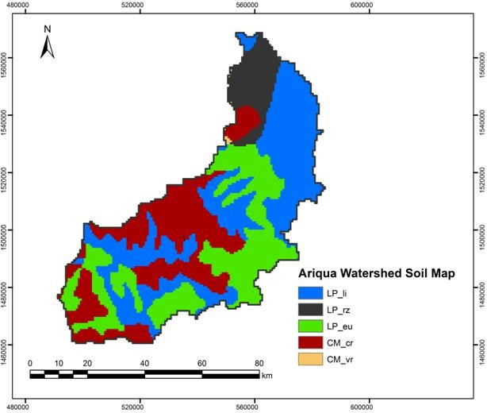  Fig. 4: Major soil group map | 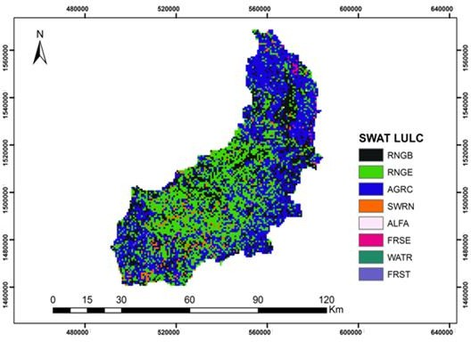  Fig 5: Land use map

3.3 Simulation of stream flow

    - Sensitivity analysis

Though there were 28 sensitivity parameters in SWAT model; around 13 parameters are effective for monthly flow simulation analysis with the category of sensitivity ranging from very high to small. In this study, parameter sensitive to the model was SCS runoff curve number: moisture condition II (CN2), soil evaporation compensation factor (ESCO), available water capacity (mm water/mm soil), (Sol_AWC), shallow aquifer for " revap" (mm) (Revapmin) and soil depth for each layer (SOL_Z) were found to be the most sensitive parameters in runoff simulation (Table 3). On the other hand, parameters such as average slope steepness (HRU/SLP), plant uptake compensation factor (EPCO) and average slope length (SLSUBBSN) were found to be least sensitive in runoff yield simulation.

Table 3. Results of sensitivity analysis for flow.
SWAT parameter Bounds/Ranges t-stat¹ P- value² Rank Sensitivity class
Code
CN2 SCS runoff curve number 35 – 98 -29.6 0.00 1 High
Moisture condition II
ESCO Soil evaporation 0-1 -8.51 0.00 2 High
compensation factor
SOL-AWC Available water capacity 0-1 -6.08 0.00 3 High
(mm water/mm soil)
Revapmin Shallow aquifer for 1.0 -24 4.15 0.00 4 High
" revap" (mm)
SOL_Z Soil depth for each layer +25 -2.85 0.00 5 High
CANMX Maximum canopy storage 0-100 1.6 0.13 6 Medium
Blai Leaf area index for crops 0- 2000 1.44 0.16 7 Medium
GW-Revap Ground water "revap" 0-1 -1.35 0.21 8 Medium
Coefficient
GWQMN Shallow aquifer for return 0-5000 -1.18 0.23 9 Medium
Flow (mm)
CH_K2 Conductivity in the main 0.01-50 -1.15 0.26 10 Medium
Channel (mm/hr)
HRU/SLP Average slope steepness 0- 90 0.75 0.82 11 Small
EPCO Plant uptake compensation 0-1 0.37 0.87 12 Small
Factor
SLSSUBBN Average slope length 10-150 0.01 0.92 13 Small
¹ t-stat provides a measure of the sensitivity. Larger absolute values indicate a sensitive parameter. ² p-values determine the significance of the sensitivity. A value close to zero denotes more significance.

3.3.2 Calibration of Stream Flow

The model was run for fifteen years January 1, 2001, to December 31, 2015, stream flow data of Ariqua watershed. The calibration was therefore performed for a period of six years (January 1, 2006 to December 31, 2011) of stream flow data. The calibration result of stream flow between measured and simulated monthly flow (R² and ENS) is put in (Fig. 6). The statistical criteria should be used during the calibration process to acceptable ranges. According to SWAT developers in (Santhi et al., 2001), he assumed an acceptable calibration for hydrology at a D <± 25%, R² > 0.6 and E_{NS} > 0.5.


Flow (m3/s)
800
700
600
500
400
300
200
100
0
Observed
Simulated
Time (Month)
Jan-06 May-06 Sep-06 Jan-07 May-07 Sep-07 Jan-08 May-08 Sep-08 Jan-09 May-09 Sep-09 Jan-10 May-10 Sep-10 Jan-11 May-11
Sep-11
R² = 0.89 ENS = 0.61

Figure 6. Calibration results of average monthly observed and simulated flow
(2006-2011)
    - Validation of stream flow

The SWAT model was validated for runoff from the observed data of 2012-2015.The validation involves a model run with unchanged parameter set against an independent set of data series as a further analysis of model performance. The three statistical goodness of fit were used for model validation (Fig. 7).


Flow (m3/s)
Observed

Simulated
800
700
600
500
400
300
200
100
0
Time ( Month)
Jan-12 Mar-12 May-12 Jul-12 Sep-12 Nov-12 Jan-13 Mar-13 May-13 Jul-13 Sep-13 Nov-13 Jan-14 Mar-14 May-14 Jul-14 Sep-14 Nov-14 Jan-15 Mar-15 May-15 Jul-15 Sep-15 Nov-15
R² = 0.79 ENS = 0.67

Figure 7. Validation results of average monthly observed and simulated flow (2012-2015)

3.4. Simulation of Sediment Yield

Sediment yield is the amount of sediment transported out of a watershed or sub-watershed. This value is used for model calibration and validation because it can be compared against available measured data sets.

3.4.1. Sensitivity analysis of sediment yield

Sensitivity analysis was carried out for sediment to identify parameters that affect sediment yield. The most sensitive parameters for erosion simulations were: USLE soil erodibility factor (USLE_K), USLE land cover and management factor (USLE_C), USLE support practice factor (USLE_P), and channel re-entrainment linear parameter (SPCON). Based on the analysis result channel re-entrainment exponent parameter (SPEXP), channel erodibility factor (CH_COV1) and sediment concentration in the lateral flow and ground water flow (LD_SED) were relatively sensitive parameter for sediment yield. On the other hand, average slope length (SLSHBBSN), average slope steepness (HRU/SLP) and average depth of main channel (CH_D) were less sensitive parameter. These sediment parameters were used to compute the amount of sediment from a catchment (from upland) and from the channel (in stream sediment). Seven parameters were identified as the most sensitive parameters that significantly affect sediment yield (Table 4).
Table 4. Results of sensitivity analysis for sediment
SWAT parameter Variation t-stat¹ P- value² Rank Sensitivity
Code range class
USLE_K USLE soil erodibility factor 0-0.35 6.01 0.00 1 High
USLE_C USLE cover or management 0-0.35 4.09 0.00 2 High
Practice factor
USLE_P USLE conservation practice 0-1 3.26 0.00 3 High
factor
SPCON Linear factor for channel 0.0001-0.01 -2.84 0.00 4 High
Sediment routing
SPEXP Exponential factor for 1-1.50 1.71 0.21 5 Medium
Channel sediment routing
CH_COV1 Channel erodibilty factor 0-0.20 1.53 0.142 6 Medium
(cm/h/pa)
LAT_SED Sediment concentration in 0-2 1.35 0.136 7 Medium
lateral flow and ground
water flow
SLSSUBBN Average slope length 10-150 -1.32 0.92 8 Small
HRU/SLP Average slope steepness 0-1 -1.30 1 9 Small
CH_D Average depth of main 0-30 1.0 0.85 10 Small
channel
¹ t-stat provides a measure of the sensitivity. Larger absolute values indicate a sensitive parameter.
² p-values determine the significance of the sensitivity. A value close to zero denotes more significance.

Calibration of sediment yield

The SWAT model was calibrated for sediment by comparing monthly model simulated sediment yield against monthly measured sediment yield from the Ariqua watershed for the period 2006 to 2011. Observed sediment yields were adjusted on the monthly basis, and simulation runs were conducted on a monthly basis to compare the modeling output with the measured monthly discharge at the outlet of Ariqua watershed (Fig. 8). The goodness of fitness is put into R² and ENS (Fig. 8).

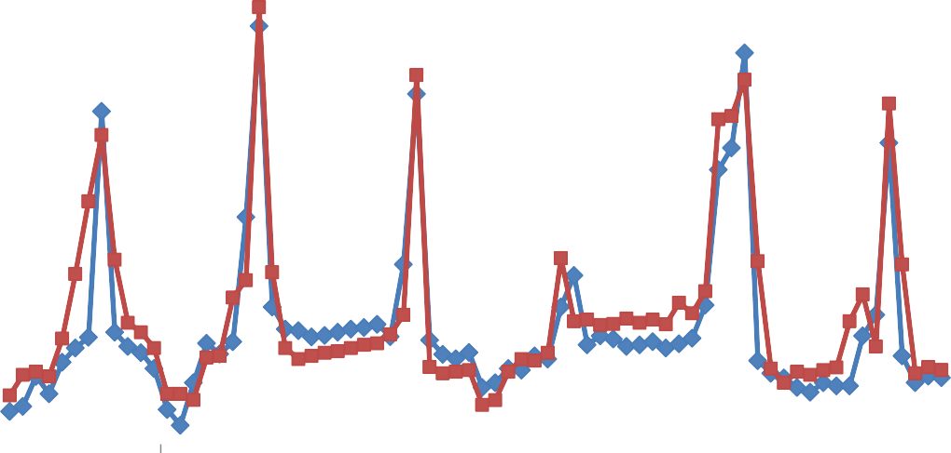
Sediment Yield (ton/ha)
Observed
Simulated
30
25
20
15
10
5
0
Time ( Month)
Jan-06 May-06 Sep-06 Jan-07 May-07 Sep-07 Jan-08 May-08 Sep-08 Jan-09 May-09 Sep-09 Jan-10 May-10 Sep-10 Jan-11 May-11
Sep-11
R² = 0.87 ENS = 0.72

Figure 8. Calibration result of monthly observed and simulated sediment yield (2006- 2011)

Validation of sediment yield

The SWAT model was validated for runoff and sediment yield from the observed data of January 2012 to December 2015. An independent observed data that was not used in sediment calibration was used to validate sediment yield without making further adjustments of sensitive parameters. In the validation period, good agreement between simulated and observed sediment was demonstrated (Fig. 9).

Sediment yield (ton/ha)
30
25
20
15
10
5
0
Observed
Simulated
Time ( Month)
Jan-12 Mar-12 May-12 Jul-12 Sep-12 Nov-12 Jan-13 Mar-13 May-13 Jul-13 Sep-13 Nov-13 Jan-14 Mar-14 May-14 Jul-14 Sep-14 Nov-14 Jan-15 Mar-15 May-15 Jul-15 Sep-15 Nov-15
R² = 0.81 ENS = 0.59

Figure 9. Validation result of monthly observed and simulated sediment yield (2012 – 2015)

  - Spatial pattern of stream flow and sediment yield sources areas

After calibration and validation, the model was run for 15 years from 2001 to 2015. From this model, simulation output stream flow and sediment yield of each sub-watershed area were identified in the Ariqua watershed. Spatial analysis of runoff and sediment yield potential areas is one of the many tasks SWAT can do while modeling runoff. The spatial distribution of sub-basin wise stream flow in m³/s is given in (Fig. 10). According to the figure 10 below, the annual average measured and simulated stream flow generated was 137 m³/s and 124 m³/s respectively. From the spatial distribution (Figure 10), it can be observed that sub-watersheds (SWT-23) and (SWT- 20) produced the highest rate of discharge, 383.2 m³/s and 287.3 m³/s, while the lowest discharge rate was occurred in the catchment (SWT-2) and (SWT-11),13.54 m³/s and 14.61 m³/s respectively. So, the nature of the soil, combined with the steep slopes and agricultural lands that lacked conservation measures, contributed to both high discharge.

Similarly, the 15 years annual average measured and simulated suspended sediment yield generated was 12.54 ton/ha/yr and 13.92 ton/ha/yr respectively. The spatial distribution of sediment generation for the Ariqua watershed as simulated by the model is presented in (Fig. 11). From the Figure 11, it can be observed that out of 23 sub-watersheds, (SWT-23) and (SWT-16) produced very high annual average sediment yield that need immediate intervention to minimize sediment loss from the watershed, which is above the tolerable limit (2-18 ton/ha/yr) (Hurni, 1985; Gebreyesus and Kuribel, 2009) in the Tigray case, medego watershed. This indicated that soil erosion is a serious problem of the study area. From this for sub-watershed (SWT-23) the first conservation priority is needed.

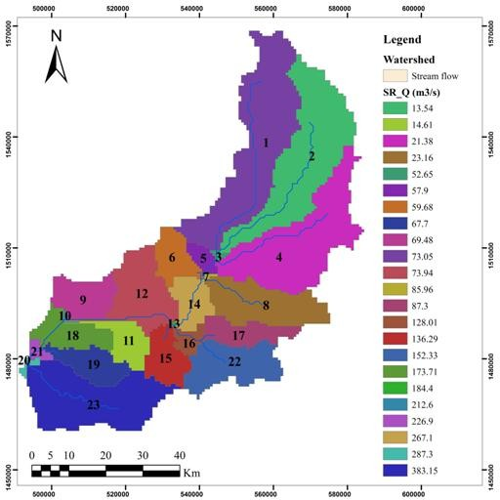  Fig 10. Simulated average annual stream flow by sub-watershed (m³/s) | 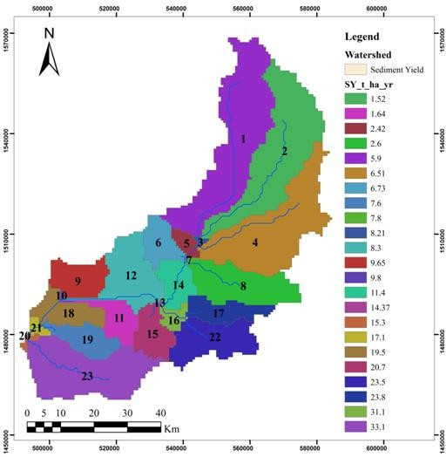  Fig 11. Simulated average annual sediment yield by sub-watershed (ton/ha/yr)

4. Conclusion

As the main focus of this study is depend on runoff and sediment yield analysis of the Ariqua watershed characteristics, understanding the biophysical, hydrological and hydraulic problems and proposing pertinent intervention measures to control degradation, improving land and water productivity, enhancing ecological and environmental functions in developing countries are serious challenges due to the absence of relevant information and data.

To examine the runoff and sediment yield of the watershed over its hydrological response, the physically based hydrological model was used for simulation. According to the stream flow sensitivity analysis, SCS runoff curve number: moisture condition II (CN2), Soil evaporation compensation factor (ESCO) and Available water capacity (mm water/mm soil) (SOL_AWC) and Soil depth for each layer (SOL_Z) were found to be the most sensitive parameters in runoff simulation. The soil erodibility factor (USLE_K), land cover and management factor (USLE_C) and support practice factor (USLE_P) and Linear factor for channel sediment routing (SPCON) were the most sensitive parameters for sediment yield. Contrarily, average slope length (SLSHBBSN) and average slope steepness (HRU/SLP) were less sensitive parameters for both runoff and sediment yield.

The suitability and performance of the SWAT model using calibration and validation statistics. Calibration and validation were for six years (2006-2011) and four years (2012- 2015) respectively. Accordingly, a good agreement between measured and simulated monthly stream flow and sediment yield was demonstrated (R²= 0.89 and E_{NS} = 0.61) for calibration, (R²= 0.79 and E_{NS} = 0.67) for validation and (R² = 0.87 and E_{NS} = 0.72) for calibration, (R² = 0.81 and E_{NS} = 0.59) for validation respectively. Based on the statistical model evaluation criteria, the model result indicates it was in an acceptable limit in simulating stream flow and sediment yield in calibrating and validating.

Following the calibration, the Ariqua watershed currently has annual stream flow of 124 m³/sec and annual average sediment yield of 13.92 ton/ha/yr. The seasonal variability of stream flow and sediment yield from the individual sub-basins shows maximum stream flow and sediment yield was observed during heavy rainfall seasons (July to September). There is a direct relationship between runoff and sediment yield, which means sediment yield, is a function of runoff and other processes happening in the watershed.

6. References

- Arnold, J. G., Srinivasan, R., Muttiah, R. S., & Williams, J. R. (1998). Large Area Hydrologic Modeling and Assessment Part I: Model Development. Journal of the American Water Resources Association, 34(1), 73-89. https://doi.org/10.1111/j.1752-1688.1998.tb05961.x
- Chekol, D. A. (2006). *Modeling of Hydrology and Soil Erosion of Upper Awash River Basin* (PhD Dissertation, University of Bonn). http://www.stiftung-fiat-panis.de/images/PF/PF2004_01.pdf
- Easton, Z. M., Fuka, D. R., White, E. D., Collick, A. S., Ashagre, B. B., McCartney, M., Awulachew, S. B., & Ahmed, A. A. (2010). A multi basin SWAT model analysis of runoff and sedimentation in the Blue Nile, Ethiopia. Hydrology and Earth System Sciences, 14, 1827–1841. https://doi.org/10.5194/hess-14-1827-2010
- FAO. (2006). Guidelines for soil description, 4th edition. Rome: FAO. https://www.fao.org/4/a0541e/a0541e.pdf
- Brhane, G., & Mekonen, K. (2009). Estimating Soil Loss Using Universal Soil Loss Equation (USLE) for soil conservation planning at medego watershed, Northern Ethiopia. *Journal of American Science*, *5*(1), 58-69. https://www.jofamericanscience.org/journals/am-sci/0501/10_0556_brhane.pdf
- Hurni, H. (1985). Erosion-productivity-conservation systems in Ethiopia. In Proceedings 4th International Conference on Soil Conservation (pp. 654-674). Maracay, Venezuela. https://doi.org/10.7892/boris.77547
- Tamene Desta, L. (2005). Reservoir Siltation in Ethiopia: Causes, Source Areas, and Management Options. [Doctoral dissertation, University of Bonn].
- Federal Democratic Republic of Ethiopia. Ministry of Water, Irrigation and Electricity. (2019). Environmental and Social Impact Assessment Summary Report for Tekeze-Humera Irrigation Project. https://www.afdb.org/sites/default/files/documents/environmental-and-social-impact-assessment-summary-report-tekeze-humera-irrigation-project.pdf
- Neitsch, S. L., Arnold, J. G., Kiniry, J. R., & Williams, J. R. (2005). Soil and Water Assessment Tool theoretical documentation: Version 2005. U.S. Department of Agriculture, Agricultural Research Service, Grassland, Soil and Water Research Laboratory; and Texas A&M University, Blackland Research Center. https://swat.tamu.edu/media/1292/swat2005theory.pdf
- Santhi, C., Arnold, J. G., Williams, J. R., Dugas, W. A., Srinivasan, R., & Hauck, L. M. (2001). Validation of the SWAT model on a large river basin with point and nonpoint sources. Journal of the American Water Resources Association, 37(5), 1169-1188. https://doi.org/10.1111/j.1752-1688.2001.tb03630.x
- Setegn, S. G. (2008). Hydrological and sediment yield modelling in Lake Tana Basin, Blue Nile Ethiopia. (PhD Dissertation). Royal Institute of Technology (KTH), Sweden. https://kth.diva-portal.org/smash/get/diva2:14005/FULLTEXT01.pdf
- Williams, J. R., & Berndt, H. D. (1977). Sediment Yield Prediction Based on Watershed Hydrology. Transactions of the ASAE. https://doi.org/10.13031/2013.35710

