Analyzing the Land Use Land Cover Type of Kechemo Watershed, Keyih_Tekli District, Central zone of Tigray, Ethiopia.

Abstract
Analyzing Land Use and Land Cover (LULC) types is crucial for environmental management, urban planning, agriculture, disaster mitigation and sustainable development. In Ethiopia, Climate Action through Landscape Management (CALM) Program for Results has been participating in land degradation reduction activities. And currently, it has expanded its program in to Tigray region, Kechemo watershed. However, the current LULC type and vegetation status of the watershed have not been studied, making it impossible to observe and evaluate changes resulting from the program's intervention. Therefore, this study was aimed to assess and map the current land use type and vegetation status of Kechemo watershed. Sentinel 2 image was used to determine the land use and the vegetation status of the watershed. The land use type was classified with the help of supervised classification method using support vector machine (SVM) algorithm. Besides, the vegetation status of the watershed was determined using NDVI and OSAVI vegetation index. The results show that the watershed consists of cultivated land (66.94%), shrub land (28.96%), bare land (3.46%), and settlements (0.64%). The overall accuracy and kappa coefficient was 90.04% and 0.87 respectively. In addition, the NDVI and OSAVI value is highest in autumn
(0.436) and lowest in winter (-0.111) season. Averagely, about 56.3% and 42.2% coverage of the watershed is classified under low vegetation class and bare land respectively. Therefore, it is recommended to give more emphasis to restore the vegetation resource of the watershed to improve the ecosystem service of the watershed.
Keywords: Land use class, Vegetation index, NDVI, OSAVI

1. Introduction

1.1 Background
Land use land cover (LULC) type of a given area indicates the current and /or history of the land’s utilization type (such as agriculture, settlement, grazing, mining, etc.) of the physical and biological cover over the surface of land, including water, vegetation, bare soil (Nedd et al., 2021; Roy and Roy, 2010). Land use land cover change (LULCC) is one of the human induced alterations of land resource either positively or negatively. Land use land cover change strongly affects the Earth’s eco-environments by altering surface properties. For instance, productivity, water quality and availability, the spread of invasive species, habitats and biodiversity, carbon fluctuations, and climate variability could be influenced by the changing of land cover (Feng et al., 2023; Das, 2014).
Different studies revealed that Ethiopia has been experiencing a LULC changes caused by various factors. For example, a study by Gebeyehu et al. (2023) in Nyangatom district of Southern Nations, Nationalities and Peoples Regional (SNNPR) state shows that in the period of 1992-2020, water body, open woodland, riverine forest, and dense woodland was reduced by 23%, 18%, 18%, and 7%, respectively. The researcher described that the main drivers of this land use land cover change were agricultural expansion, overgrazing, and drought, conflicts, invasion of alien plant species and change in policy institutions. Besides, Bufebo and Elias (2021) reported that in the year of 1973 in 2017, forest land was reduced from 29.51% to 20.52% whereas agricultural land was increased from 70.49% to 79.48%.
Soil erosion is a critical problem in the country which is caused by both natural and anthropogenic factors such as LULC changes through inappropriate agricultural practices and high human & livestock population pressure, deforestation, overgrazing, and climatic variability (Alemu,2015;Teku and Derbib, 2025). A study conducted by Reta et al. (2025) in Dumuga watershed of Abay basin indicates an increment of cultivated land by 14.7% and reduction of forest cover declining by 9.5% caused a soil loss to be raise the maximum soil loss rate from 726.7 tons/ha/year to 937.8 tons/ha/year in in the year between 1993 and 2023. The very severe erosion rate of class has also increased from 41.0% to 54.1%.
To halt land resources deterioration, different local & international projects and programs such as SLMP, MERET and PSNP have been doing land management and conservation activities. Besides, Climate Action through Landscape Management (CALM) Program for Results has been participating in the land management and conservation activities in Ethiopia. This program encourages to establish watershed users’ associations, and provides results-based support to incentivize field-based interventions to scale up participatory watershed management activities to reduce land degradation (World Bank, 2019a and 2019b).
After pausing the 2020s war in Tigray through the Pretoria agreement, CALMP4R has expanded its program in to Tigray region. Kechemo watershed is one of the sites of the program that is located in Tigray, Keyih Tekli woreda. However, the current LULC type and vegetation status of the watershed should be assessed before the intervention that will help to observe and evaluate the change after intervention of the program. Therefore, this study aimed to assess and map the current land use type and vegetation status of Kechemo watershed.

2. Methodology

2.1. Description of Study Area
The study area is found in Keyih Tekli woreda, central zone of Tigray which is 106 km away west of Mekelle, the capital of Tigray. Its geographical location is between 1516335.75 – 1519535.39 m north and 497118.56 – 500174.18 m east. The elevation of the site ranges between 1862 and 2340 m above sea level (Fig.1).
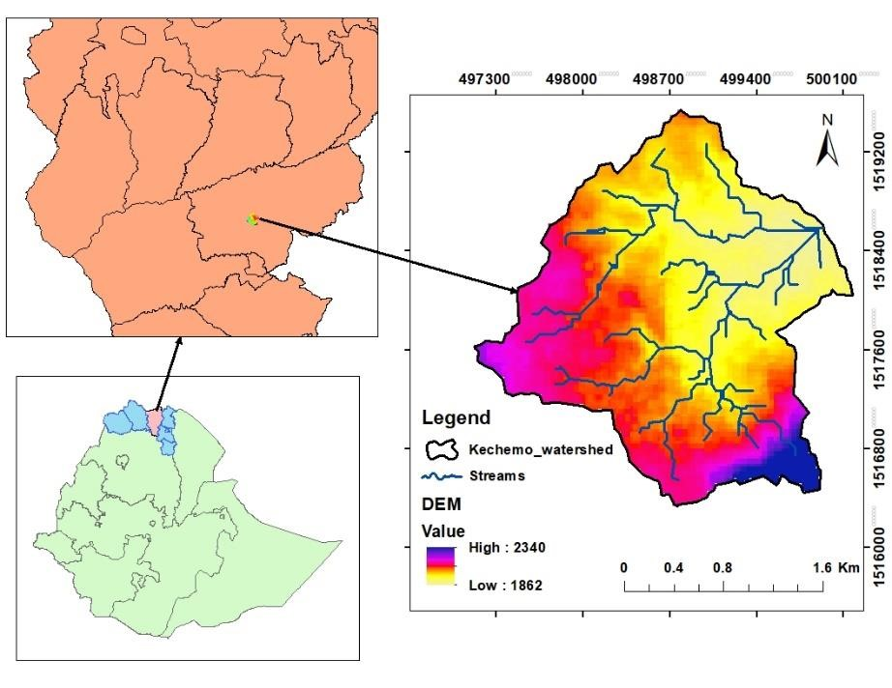

Figure 1: Location map of the study area
The rainfall and temperature data of the study area was obtained from IRI – International Research Institute for Climate and Society | ENACTS (columbia.edu). Accordingly, the total annual rainfall is 713.53 mm that ranges from 2.07- 252.60 mm monthly whereas the average monthly minimum and maximum temperatures range from 13.4°C to 27.4°C (Fig. 2).

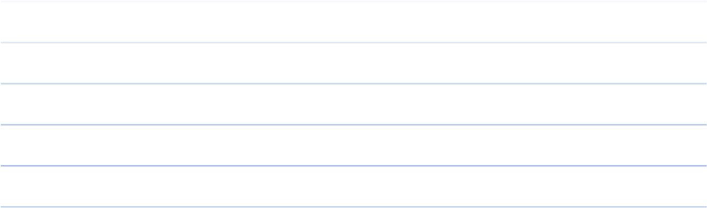

0.0
5.0
10.0
15.0
20.0
25.0
30.0
35.0
0
50
100
150
200
250
300
Jan
Feb
Mar
Apr
May
Jun
Jul
Aug
Sep
Oct
Nov
Dec
Temperature[
°
C]
Rainfall[mm]
Month
Rainfall[mm]
Temp_max[°C]
Temp_min[°C]
Figure 2: Monthly rainfall and temperature of the study area

2.2. Data Collection and Analysis

2.2.1. Land use preparation of the watershed
To prepare the LULC type of the study area for the year 2025, a Sentinel2 image was downloaded from Copernicus Open Access Hub (Table1). Then, a 10 m spatial resolution bands (B2, B3, B4 and B8) were used for the land use classification process. The selected bands were stacked in ENVI 5.3 software and classified with the help of supervised classification method using support vector machine (SVM) algorithm. 70% of ground truth points, which were collected using Global Positioning System GPS in field and google earth were applied for the training purpose, and the rest 30% points were used for accuracy assessment.
Accuracy assessment has been made through the confusion matrix or error matrix following the procedures outlined in (Lillesand et al.1994; Story et al., 1986; Congalton, 1991). The following mathematical equations were used to analyze producer, user and overall accuracy as well as Kappa coefficient (K);
total number of correct pixels in a category
Producers accuracy = *100…. Eq.1
Total no of pixels derived from the reference data (i.e.,Column total)
total number of correct pixels in a category
Users’ accuracy = ∗ 100……… Eq.2
total no of pixels derived from the reference data (i.e.,Row total) total number of correct pixels in a category
Overall accuracy = ∗ 100…………………….. Eq.3 total number of accuracy sites (Column Total)
Kappa coefficient (K) is a measure of the agreement between two maps considering all elements of the error matrix. It is defined in terms of an error matrix as given below:
𝐾 = (total sample∗sum of corrected samples) −(row total∗colomon total)………………………….. Eq.4
(𝑠𝑢𝑚 𝑡𝑜𝑡𝑎𝑙 𝑠𝑎𝑚𝑝𝑙𝑒)^2− (row total∗colomon total)

2.2.2. Determining Vegetation Status of the Watershed
Vegetation indices like Normalized Difference Vegetation Index (NDVI) and Optimized Soil Adjusted Vegetation Index (OSAVI) are important for assessment of vegetation health status (De La Iglesia Martinez and Labib, 2023; Fern et al., 2018). Even though, both NDVI and OSAVI uses the Red and NIR wavebands, OSAVI considers the standard value of 0.16 for the canopy background adjustment factor (Hishe et al., 2024).
NDVI= (NIR – RED) / (NIR + RED) …………………………………………………….... Eq.5
OSAVI= (NIR – RED) / (NIR + RED + 0.16) ……………………………………….…… Eq.6
So, sentinel2 images for each the 4 seasons of Ethiopia, Summer (Jun-August), Autumn (September-November), Winter (December-February) and Spring (March-May) in the time range of June 2024 up to March 2025 were downloaded from Copernicus Open Access Hub (Table1). Because rainfall distribution between the seasons is different in Ethiopia (Adane & Asmerom, 2025). And this variation of rainfall can affect the vegetation status of the study area. Hence, taking the satellite image from different seasons can control the variation of vegetation index due to climate. The image data were selected based on their availability and cloud coverage per each season. Then, the vegetation status of Kechemo watershed has been assessed using eq.5 and 6 in ArcMap software. The NIR and RED bands were represented by band 8 and 4, which has 10 m resolution.
Table 1: Satelite image data acquired for the watershed across the seasons
Season | Satellite data | Acquisition date
Summer | Sentinel2A | 04 June-2024
Autumn | Sentinel2B | 26 November-2024
Winter | Sentinel2A | 10 January-2025
Spring | Sentinel2C | 11 March-2025

3. Results

3.1. Land Use Land Cover Type of the Watershed
As shown in Figure 3, the study area was categorized into four LULC classes; namely: cultivation land, vegetation (shrub land), settlement, and bare lands. Cultivation land has the highest coverage area (66.92%) in the watershed followed by vegetation (shrub land) (Table2). Settlement land has the lowest coverage (0.64%) of the watershed. This indicates that agriculture is the most important source of income in the watershed.
The overall accuracy of the land use classification was 90.04% (Table3). The Kappa coefficient (K) value was also 0.87. Based on the rating criteria of kappa statistics (Rwanga and Ndambuki, 2017), the kappa value in this study is classified as perfect. Therefore, as the international standard for digital mapping requires an overall accuracy exceeding 85% and Kappa value above 0.85, the land use class of this study is valid and acceptable.
Table 2: Land use land cover type and its coverage area of Kechemo watershed
SN | Land use type | Area in ha | Percent
1 | Cultivation land | 365.26 | 66.942
2 | Settlement | 3.49 | 0.640
3 | Bare land | 18.86 | 3.456
4 | Vegetation (shrubland) | 158.03 | 28.962
 | Total | 545.64 | 100

Table 3: Accuracy assessment of the land use classification
 | Settlement | Vegetation | Cultivation land | Bare land | Total | User accuracy  (%)
Settlement | 34 | 0 | 2 | 3 | 39 | 87.179
Vegetation | 0 | 33 | 1 | 0 | 34 | 97.059
Cultivation land | 0 | 2 | 29 | 1 | 32 | 90.625
Bare land | 0 | 1 | 3 | 26 | 30 | 86.667
Total | 34 | 36 | 35 | 30 | 135
Producer accuracy  (%) | 100 | 91.67 | 82.86 | 86.67
Over all accuracy  (%) |  |  | 90.04
Kappa  coefficient  (K) |  |  | 0.8715

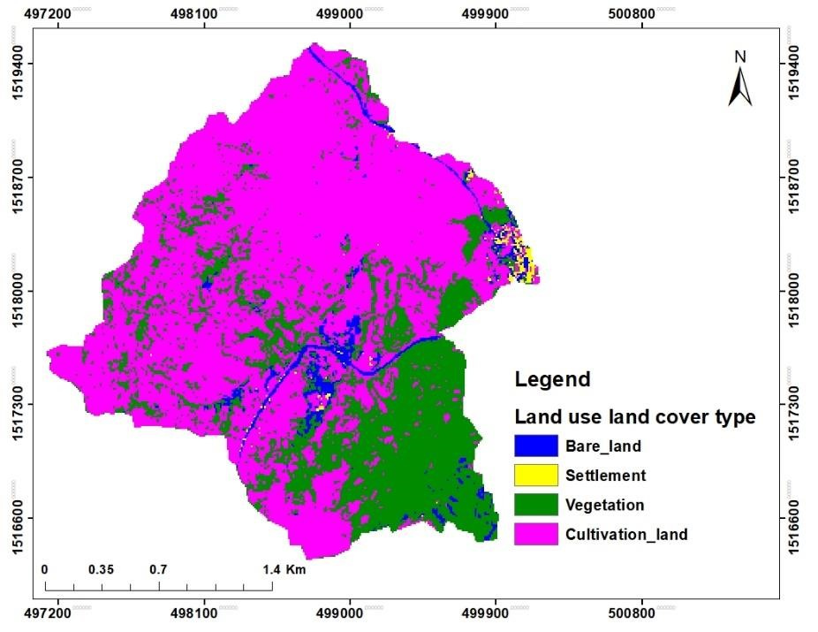
Figure 3: Land use land cover type of Kechemo watershed

3.2. Vegetation Status of Kechemo Watershed
An NDVI value ranging from 0-0.1 is classified as bare land (USGS, 2018). So NDVI and OSAVI value classified above 0.2 was considered as land covered with different vegetation density classes (Hishe et al., 2024) as shown in table 4.
Table 4: Vegetation status of Kechemo watershed
Vegetation index | Vegetation index range and its coverage in percent
Vegetation index | Bare land  (0-0.1) | Low  (0.1-0.2) | Medium  (0.2-0.3) | High  (0.3-0.4)
Mean of NDVI | 42.236 | 56.302 | 1.429 | 0.033
Mean of OSAVI | 42.243 | 56.294 | 1.429 | 0.033
As can be seen in Table 5, the value of NDVI and OSAVI was not varied. So, the average NDVI and OSAVI of the watershed ranges from -0.055 to 0.372 with overall mean of 0.112(±0.034). The lowest NDVI and OSAVI value was recorded in winter season; whereas autumn season has the highest value. Similarly, autumn season has the highest mean of NDVI and OSAVI followed by winter, spring and summer respectively (Fig.4 &5). June month is the beginning of rainfall for summer season whereas November is the ending month of autumn season in which the rainfall season is stopped. So, the higher value of NDVI and OSAVI in autumn season can be due to the better vegetation cover and health resulted by the better rainfall distribution started in June. This result shows that the watershed becomes green following the rainfall start from June (in summer) and dries in autumn season when the rainfall stops. Based on the result in Table 4, the highest area (~56.3%) of the watershed is under low vegetation cover and about 42.2% of the watershed is under bare land. Hence, the watershed has very low coverage of vegetation (Fig.6).
Table 5: descriptive statistics of NDVI & OSAVI
Season | Minimum |  | Maximum |  | Average |  | Standard deviation
Season | NDVI | OSAVI | NDVI | OSAVI | NDVI | OSAVI | NDVI | OSAVI
Summer | -0.015 | -0.015 | 0.336 | 0.336 | 0.085 | 0.085 | 0.024 | 0.024
Autumn | -0.068 | -0.068 | 0.436 | 0.436 | 0.137 | 0.137 | 0.045 | 0.045
Winter | -0.111 | -0.111 | 0.415 | 0.415 | 0.136 | 0.136 | 0.046 | 0.046
Spring | -0.0244 | -0.024 | 0.299 | 0.299 | 0.088 | 0.088 | 0.028 | 0.028
Average | -0.055 | -0.055 | 0.372 | 0.372 | 0.112 | 0.112 | 0.034 | 0.034

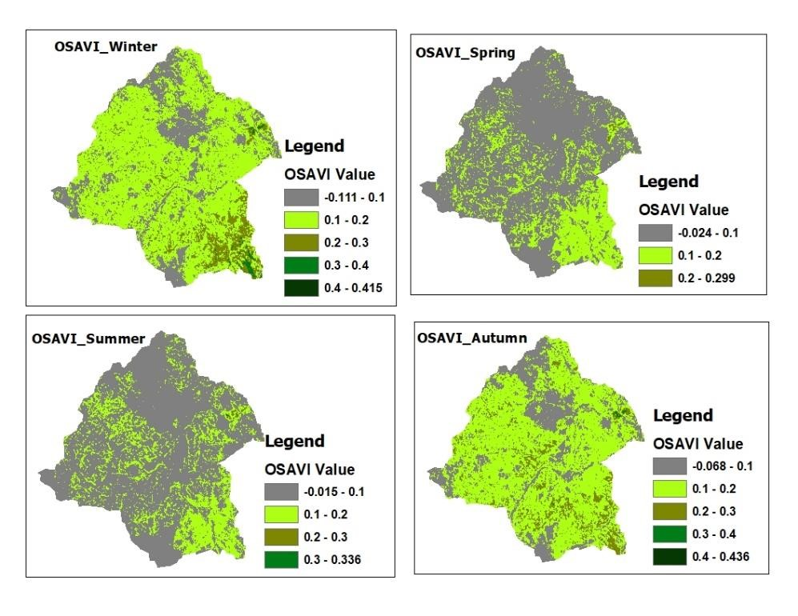

Figure 4: OSAVI of Kechemo watershed across seasons
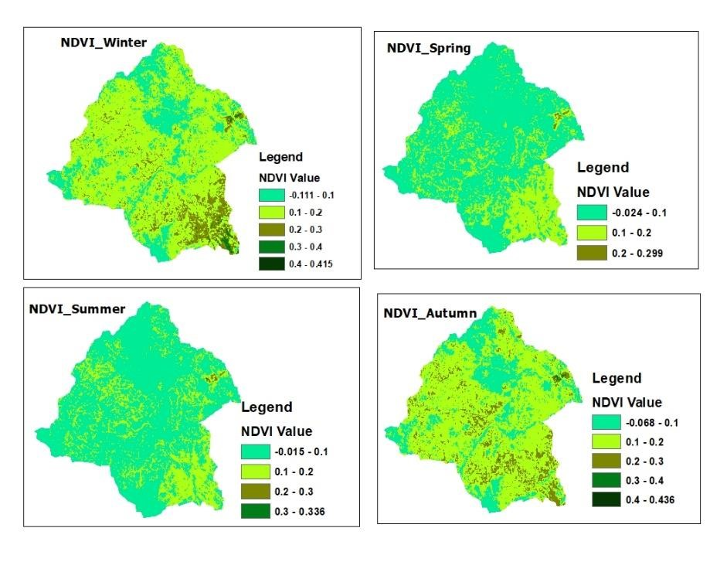

Figure 5: NDVI of Kechemo watershed across seasons

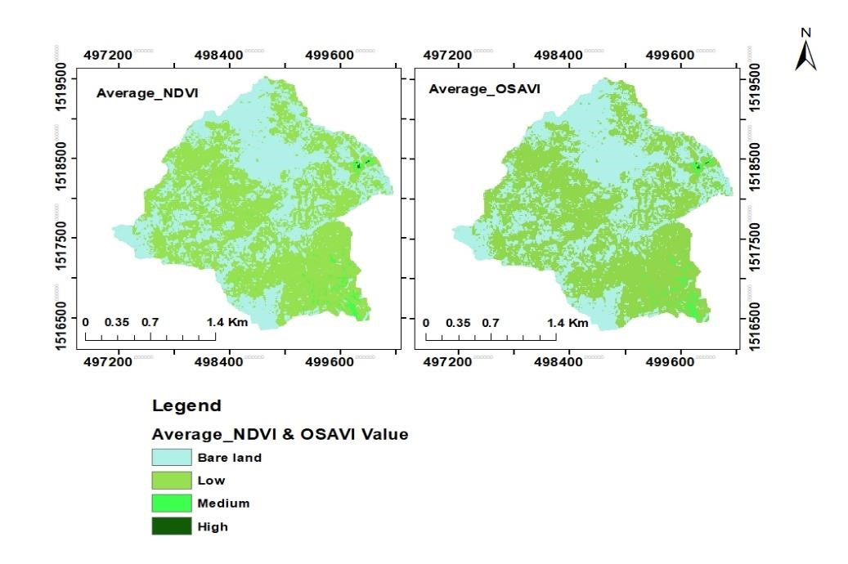

Figure 6: Vegetation status of Kechemo watershed based on NDVI and OSAVI vegetation indexes 4. Discussion
Analyzing land use land cover type, and vegetation cover status of a given watershed is an interesting to understand & monitor the environment and its resources. Hence, the result of this study shows that the most part of the watershed is covered by agricultural land. This might be due to primary source of income of the community is agricultural activities. However, agricultural land is the main source of human induced greenhouse gas emission (Omotoso et al., 2024). Because expansion of agriculture causes deforestation that help to reduce CO₂ concentration. Likewise, only 28% of Kechemo watershed is occupied by vegetation. As a result, the average value of vegetation index (NDVI &OSAVI) of the watershed is low. This clearly indicate that the watershed is affected by scarcity of soil organic matter inputs, like litters, that amends the soil health and its productivity potential. Soil organic matter content plays a vital role on the binding of soil particles and their ability to resist detachment by rainfall and runoff. It also recovers the soil's water holding capacity that reduces the risk of generating potentially erosive overland water flow. Similarly, it supports soil biology (such as earthworms, fungi, bacteria and plant root exudates) which helps to improve soil aggregation and soil structure, stabilizing soil pore networks and connectivity. This facilitates infiltration of rainfall and reduces the risk of overland flow generation (Rickson, 2023; Louise et al., 2020).
When the vegetation cover is reduced, not only the inputs for SOM are diminished, but also the soil and land surface temperature is expected to be increased (Yu et al., 2022). Consequently, the microorganisms of the soil are damaged due to the shortage of organic matter and increasing of soil temperature. Because soil microbes are sensitive to temperature (Fang et al., 2021). Finally, this can lead to the releasing of carbon, which could be stored in the soil with the help of microorganisms, to atmosphere. The microclimate of the watershed could be altered, which affects the livelihood of the community. So, a priority should be given to the climate smart agriculture as well as vegetation restoration activities in Kechemo watershed.

5. Conclusion
In conclusion, this study was conducted to assess and document the LULC type and vegetation status of Kechemo watershed, central zone of Tigray, which is among the sites under CALM program for result. So, the result this study shows that the watershed has 4 land use types (namely: cultivation land, settlement, bare land, and vegetation/shrub land). The cultivation land has the highest coverage area in the watershed. The watershed is covered by vegetation/shrub land followed to cultivation land. The overall accuracy was 90.04% while the kappa coefficient value was 0.87.
In addition, the NDVI and OSAVI value of the watershed reaches up to 0.436 in autumn season. But it is lowest in winter season (-0.111). But in average, about 56.3% coverage of the watershed is classified under low vegetation class while the 42.2% of the watershed’s area is under bare land.
Therefore, it is recommended to give more emphasis to restore the vegetation resource of the watershed to enhance the soil nutrients, mitigate carbon emission and climate change, and thereby improve the ecosystem service of the watershed. In general, this study will be used as baseline for observation or evaluating of the changes in vegetation status as well as land use types due to the intervention of CALM program for result.

6. References
- Adane, A., & Asmerom, B. (2025). Analysis of spatiotemporal distribution, variability, and trends of rainfall in Wollo area, Northeastern Ethiopia. PloS one, 20(1), 1-29. https://doi.org/10.1371/journal.pone.0312889
- Alemu, B. (2015). The effect of land use land cover change on land degradation in the highlands of Ethiopia. Journal of Environment and Earth Science, 5(1), 1-13. https://www.iiste.org/Journals/index.php/JEES/article/view/18912/19505
- Bufebo, B., & Elias, E. (2021). Land Use/Land Cover Change and Its Driving Forces in Shenkolla Watershed, South Central Ethiopia. The Scientific World Journal. https://doi.org/10.1155/2021/9470918
- Congalton, R. G. (1991). A review of assessing the accuracy of classifications of remotely sensed data. Remote Sensing of Environment, 37(1), 35-46. https://doi.org/10.1016/0034-4257(91)90048-B
- Das, G. G. (2014). Land Use, Land Cover, and Food-Energy-Environment Trade-Off: Key Issues and Insights for Millennium Development Goals. In N. K. Alfen (Ed.), Encyclopedia of Agriculture and Food Systems (pp. 114-133). Elsevier. https://doi.org/10.1016/B978-0-444-52512-3.00081-4
- Martinez, A. D. L. I., & Labib, S. M. (2023). Demystifying normalized difference vegetation index (NDVI) for greenness exposure assessments and policy interventions in urban greening. Environmental Research https://doi.org/10.1016/j.envres.2022.115155
- Fang, J., Wei, S., Shi, G., Cheng, Y., Zhang, X., Zhang, F., Lu, Z., & Zhao, X. (2021). Potential effects of temperature levels on soil bacterial community structure. E3S Web of Conferences, 292, 01008. https://doi.org/10.1051/e3sconf/202129201008
- Feng, H., Wang, S., Zou, B., Nie, Y., Ye, S., Ding, Y., & Zhu, S. (2023). Land use and cover change (LUCC) impacts on Earth's eco-environments: Research progress and prospects. Advances in Space Research, 71(3), 1418-1435. https://doi.org/10.1016/j.asr.2022.09.054
- Fern, R. R., Foxley, E. A., Bruno, A., & Morrison, M. L. (2018). Suitability of NDVI and OSAVI as estimators of green biomass and coverage in a semi-arid rangeland. Ecological Indicators https://doi.org/10.1016/j.ecolind.2018.06.029
- Gebeyehu, A. K., Snelder, D., & Sonneveld, B. (2023). Land use-land cover dynamics, and local perceptions of change drivers among Nyangatom agro-pastoralists, Southwest Ethiopia. Land Use Policy. https://doi.org/10.1016/j.landusepol.2023.106745
- Hishe, S., Gidey, E., Zenebe, A., Bewket, W., Lyimo, J., Knight, J., & Gebretekle, T. (2023). The impacts of armed conflict on vegetation cover degradation in Tigray, northern Ethiopia. International Soil and Water Conservation Research. https://doi.org/10.1016/j.iswcr.2023.11.003
- Lillesand, T. M., and Kiefer, R. W. (1994). Remote sensing and image interpretation. Wiley. https://www.wiley.com/en-us/Remote+Sensing+and+Image+Interpretation%2C+7th+ Edition-p-9781118343289.
- Page, K. L., Dang, Y. P., & Dalal, R. C. (2020). The Ability of Conservation Agriculture to Conserve Soil Organic Carbon and the Subsequent Impact on Soil Physical, Chemical, and Biological Properties and Yield. Frontiers in Sustainable Food Systems. https://doi.org/10.3389/fsufs.2020.00031
- Nedd, R., Light, K., Owens, M., James, N., Johnson, E., & Anandhi, A. (2021). A Synthesis of Land Use/Land Cover Studies: Definitions, Classification Systems, Meta-Studies, Challenges and Knowledge Gaps on a Global Landscape. Land. https://doi.org/10.3390/land10090994
- Omotoso, A. B., & Omotayo, A. O. (2024). The interplay between agriculture, greenhouse gases, and climate change in Sub-Saharan Africa. Regional Environmental Change. https://doi.org/10.1007/s10113-023-02159-3
- Reta Roba, Z., Moisa, M. B., Purohit, S., Tsegay Deribew, K., & Obsi Gemeda, D. (2025). Assessment of soil erosion and sediment yield in response to land use and land cover changes using geospatial techniques in Dumuga Watershed, Ethiopia. ALL EARTH, 1-18. https://doi.org/10.1080/27669645.2025.2460917
- Rickson, R. J. (2023). Water induced soil erosion. In Encyclopedia of Soils in the Environment (pp. 193-207). Academic Press. https://doi.org/10.1016/B978-0-12-822974-3.00231-7
- Roy, P. S., & Roy, A. (2010). Land use and land cover changein India: A remote sensing & GISprespective. Journal of the Indian Institute of Science, 489-502. https://www.researchgate.net/publication/289770159_Land_use_and_land_cover_change_in_India_A_remote_sensing_GIS_prespective.
- Rwanga, S. S., & Ndambuki, J. M. (2017). Accuracy assessment of land use/land cover classification using remote sensing and GIS. International Journal of Geosciences, 8(4), 611-622. https://doi.org/10.4236/ijg.2017.84033
- Story, M., & Congalton, R. G. (1986). Accuracy Assessment: A User's Perspective. Photogrammetric Engineering and Remote Sensing. https://www.asprs.org/wp-content/uploads/pers/1986journal/mar/1986_mar_397-399.pdf
- Teku, D., & Derbib, T. (2025). Uncovering the drivers, impacts, and urgent solutions to soil erosion in the Ethiopian Highlands: a global perspective on local challenges. Front. Environ. Sci. https://doi.org/10.3389/fenvs.2024.1521611
- USGS. (2018, November 27). NDVI, the Foundation for Remote Sensing Phenology. https://www.usgs.gov/special-topics/remote-sensingphenology/science/ndvi-foundation-remote-sensing-phenology
- Martin, P. J. (2019). *Final Environmental and Social Systems Assessment (ESSA) - ETHIOPIA CLIMATE ACTION THROUGH LANDSCAPE MANAGEMENT PROGRAM FOR RESULTS - P170384*. World Bank Group. https://documents1.worldbank.org/curated/en/944441558461376718/pdf/Final-Environmental-and-Social-Systems-Assessment-ESSA-ETHIOPIA-CLIMATE-ACTION-THROUGH-LANDSCAPE-MANAGEMENT-PROGRAM-FOR-RESULTS-P170384.pdf
- World Bank Group. (2019). Ethiopia - Climate Action Through Landscape Management Program for Results. http://documents.worldbank.org/curated/en/505981556223192603
- Yu, L., Liu, Y., Bu, K., Wang, W. J., & Zhang, S. (2022). Soil temperature mitigation due to vegetation biophysical feedbacks. Global and Planetary Change. https://doi.org/10.1016/j.gloplacha.2022.103971

