Case report
Parachute Mitral Valve: An Uncommon Congenital Heart Disease in a Syndromic Nigerian Child

Abstract
Introduction: Parachute mitral valve (PMV) is a rare congenital malformation characterized by all mitral chordae tendineae inserting into a single papillary muscle. The resultant unifocal attachment often leads to mitral inflow obstruction of varying severity. While PMV is sometimes isolated, it has also been reported in association with extracardiac anomalies and genetic syndromes, though this remains uncommon.
Case Presentation: We report a case of a 2-year-old male toddler who presented with exertional dyspnea, easy fatigability, and recurrent chest infections since infancy. Clinical examination revealed dysmorphic facial features, short stature, and webbed neck, raising strong suspicion for Noonan syndrome. Cardiac auscultation demonstrated an apical mid-diastolic murmur. Echocardiography confirmed a parachute mitral valve with thickened mitral leaflets and restricted mobility, producing significant mitral inflow obstruction. No other structural cardiac malformations were detected. Work-up for extracardiac involvement further supported a syndromic diagnosis, although genetic testing was not available at the time of evaluation. The patient was managed conservatively with diuretics and regular cardiology follow-up. Symptom improvement was noted on medical therapy, though surgical intervention may be required if progression of obstruction occurs. This case highlights the importance of thorough evaluation in children presenting with dysmorphic features and cardiac murmurs.
Conclusion: PMV is a rare congenital anomaly that may occur as part of a broader syndromic presentation. Early recognition, echocardiographic diagnosis, and multidisciplinary care are essential to optimize outcomes in affected children.
Key words: Parachute Mitral Valve, Congenital Heart Disease, Syndrome, Infant.

Introduction
Parachute mitral valve (PMV) is a congenital heart disease that describes a rare abnormality of the mitral valve in which all the chordate tendinae of the mitral valve originates from only one of its papillary muscle¹. The word Parachute is used to describe the appearance of the mitral valve due to the connection of the chordae to a single papillary muscle, given a funnel-shaped valve². Parachute mitral valve (PMV) has a clinical significant from its associated mitral stenosis resulting from the anatomic defect³. PMV is commonly found to occur with other congenital heart diseases such as coartation of the aorta, supravalvular ring of the left atrium, aortic stenosis or a complex CHD called shone’s syndrome⁴. Shi-Min et al⁵ in Putian, China in 2020 documented 330 parachute mitral valve cases reported in a systematic review within the year 2000 and 2018. This study also reported that 13% of parachute mitral valve had other CHD, while 87% were isolated defect. Diagnosis is made with an echocardiography^{6,7}.
There are few studies that reported the occurrence of PMV in children with a syndrome known with extra cardiac anomalies. Schaverien et al⁸ in 2004 in Canada reported that 26% of all 84 patients diagnosed with a PMV between 1977 and 2001 had extra cardiac anomalies in which Down syndrome and DiGeorge syndrome had the highest prevalence, others were turners syndrome, Edward syndrome and Williams syndrome . This case report is on a male toddler with compendium of physical features that are highly suggestive of Noonan syndrome.

Case Report
This is 13 month old boy who presented with a two month old history of recurrent difficulty with breathing. Difficulty with breathing was insidious in onset associated with fast breathing and precipitated by marked exertion. It is not associated with cough or paedal edema. There is no history of frequent pauses while feeding, no history of recurrent chest infections, no excessive sweating or cyanosis following exertion. He initially presented to the referring hospital where a murmur was heard following which he was referred to our facility for an echocardiography. Pregnancy, birth and neonatal periods were uneventful. Delays noted in his developmental milestones such as sitting without support attained at 11 months, babbling at 10months, yet to say a word at 13month. He had received all vaccines according to the National program on immunization schedule up to date. He is the last of two children in a monogamous family.
On examination at presentation, he was conscious and active, not in respiratory distress not pale, acyanosed in room air, with no pedal oedema. Dysmorphic features noted included a broad neck, a low posterior hairline, widely set eyes, micrognathia, a depressed nasal root; a short nose with broad base, widely spaced nipples (Figure 1 -3). Respiratory rate of 34 cpm, and breath sounds were vesicular, oxygen saturation in room air 96%. Pulse rate of 110 bpm which was regular, normal volume and synchronous with other peripheral pulses. Cardiac apex beat located at the 4th left intercostal space mid-axillary line and a first, second heart sounds and no murmur heard. There was no organomegaly on abdominal examination.

Figure (1-3)- A 13-month-old boy with several dysmorphic features
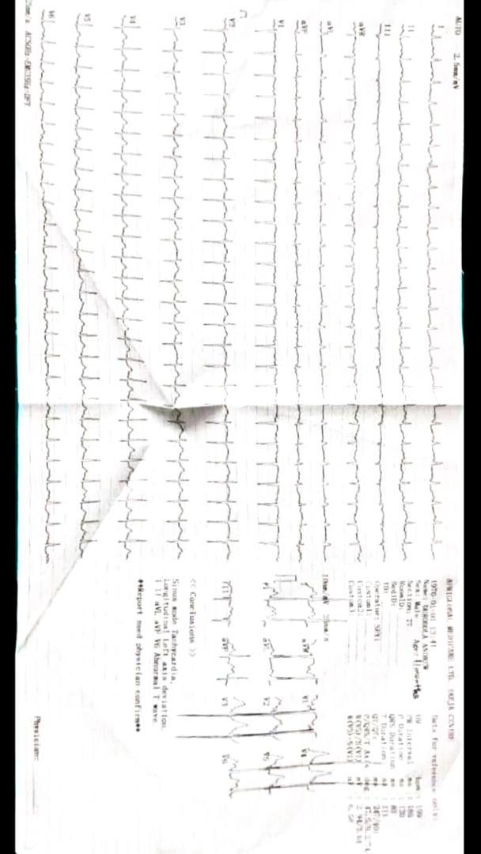

Figure 4 – Electrocardiography Finding
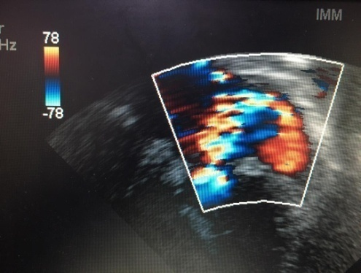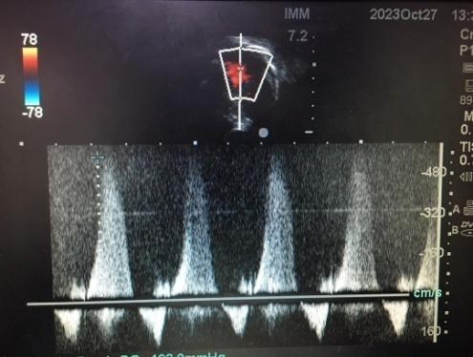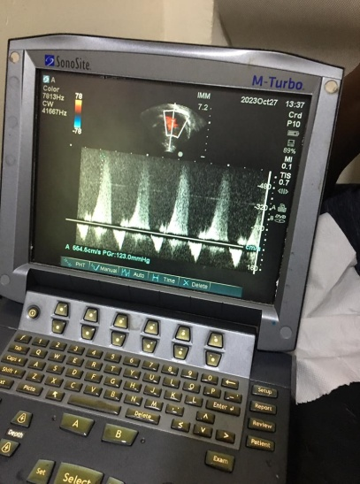

Figure (5-7)- Echocardiography Finding
Electrocardiography showed sinus tachycardia and p mitrale (Figure 4)
Echocardiography (Figure 5-7) showed dilated left atrium and ventricle, Parachute-like Mitral valve, mildly stenosed, annulus of 23mm MVA of 3.5, Bicuspid aortic valve with Mild valvar aortic stenosis with sub aortic membrane.
A diagnosis of Parachute mitral valve in a syndromic infant suggestive of Noonan syndrome was made. Patient was to be followed up on the cardiology clinic and repeat ECHO in 6months. Patient was lost to follow up.

Discussion
Parachute mitral valve is known to be associated with a severe mitral valve stenosis³, however, in this case report, the patient has a mild mitral stenosis. In this PMV, all chordae tendineae are
thickened and shortened, and they attach to a single posterior located papillary muscles, giving rise to the mitral stenosis. The anterior papillary muscle is usually absent^{5,9}. The first documented report of PMV was by Shone et al⁹ in 1963, were he described the mitral valve pathology of "an insertion of the chordae into a single papillary muscle, producing a funnel-shaped valve", and the commonly associated Shones syndrome. Oosthoek et al² in 1998 in Netherlands, reported the likely embryology of PMV that it results from a disruption during the normal delamination of the trabecular ridge condensing into a single muscle at the fifth and nineteenth week of gestation.
The occurrence of PMV in patients with syndromes dues to chromosomal disorders has been reported in few, such as in down syndrome and DiGeorge syndrome, however, for the patient in this case report, his features are highly suggestive of Noonan syndrome. Noonan syndrome is a genetic disorder that is characterized by a number of features that differs in the combinations and severity¹⁰. Its cardinal features are the typical physical appearance (hypertelorism, down-slanting eyes, broad or webbed neck, low posterior hairline), congenital heart disease, typical chest deformity and short stature¹¹. The diagnosis is usually based on the presence of characteristic signs, however, molecular testing can help to confirm¹². Cardiac defect occurs in 80% of patients with Noonan syndrome with the commonest known to be stenotic pulmonary valve followed by hypertrophic cardiomyopathy¹³. Although virtually all types of CHD has been described in Noonan syndrome, the other frequently seen CHD are atrial septal defect, ventricular septal defect, Tetralogy of Fallot and coartation of the aorta.¹⁴ Few studies have reported congenital mitral valve stenosis in patients with Noonan syndrome^{15,16}, however none with PMV as far as this researcher is concerned.
The diagnosis of PMV is usually likely when a two-dimensional echocardiography on the parasternal short-axis view shows only one papillary muscle⁶. This uncommon cardiac defect is often associated with supramitral ring, subvalvular or valvular aortic stenosis and COA, or the complete “Shone complex,” which is the combination of all or some of these abnormalities¹⁷. The patient in this case report above had valvular aortic stenosis in addition.
The clinical manifestation varies as it dependent on the severity of the mitral stenosis and also on the other associated cardiac defect present^{4,18}. Patient with isolated PMV with mild mitral stenosis are usually asymptomatic, however, with worsening stenosis, It may present with clinical features of low cardiac output and right ventricular failure such as chest infections, failure to thrive, dyspnea on exertion, cough, cyanosis and congestive cardiac failure.¹⁹ The patient case that was summarized above had occasional episodes of exertional dyspnea.
Parachute mitral valves are frequently managed by mitral valve repair, and mitral valve replacement is indicated only for patients with severe mitral valve lesions.⁵ The infant presented in this report will probably require surgical repair of the valves however valvular replacement is not indicated since the valvular stenosis are not severe. Sungkyu et al²⁰ in 2017 in South Korea reported that stenotic mitral valve repair in paediatric patients has been majorly successful, however, a close follow-up is important to look out for possible post-operative complications such as a mitral regurgitation and stenosis.
Ethics approval and consent to participate
Ethics approval was waived because the content of the report was within the care of the patient. The content was also anonymized. Written informed consent was obtained from mother of the infant.
Consent for publication
A written informed consent was obtained from the mother of the infant.
Competing interests
The authors declare that they have no conflicts of interest

References
1. Davachi, F., Moller, J. H., & Edwards, J. E. (1971). Diseases of the Mitral Valve in Infancy: An Anatomic Analysis of 55 Cases. Circulation, 43(4), 565–579. https://doi.org/10.1161/01.cir.43.4.565
2. Oosthoek, P. W., Wenink, A. C. G., Wisse, L. J., & Gittenberger-de Groot, A. C. (1998). Development of the papillary muscles of the mitral valve: Morphogenetic background of parachute-like asymmetric mitral valves and other mitral valve anomalies. Journal of Thoracic and Cardiovascular Surgery, 116(1), 36–46. https://doi.org/10.1016/S0022-5223(98)70240-5.
3. Park, M. K., & Salamat, M. (2020). Park's Pediatric Cardiology for Practitioners (7th ed.). Elsevier. https://www.elsevier.com/books/parks-pediatric-cardiology-for-practitioners/park/978-0-323-68107-0.
4. Glancy, D. L., Chang, M. Y., Dorney, E. R., & Roberts, W. C. (1971). Parachute mitral valve. Further observations and associated lesions. American Journal of Cardiology, 27(3), 309–313. https://doi.org/10.1016/0002-9149(71)90309-2.
5. Yuan, S. M. (2020). Parachute mitral valve: Morphology and surgical management. Turkish Journal of Thoracic and Cardiovascular Surgery, 28(1), 219–226. https://doi.org/10.5606/tgkdc.dergisi.2020.18041
6. Baumgartner, H., Hung, J., Bermejo, J., Chambers, J. B., Evangelista, A., Griffin, B. P., Iung, B., Otto, C. M., Pellikka, P. A., & Quiñones, M. (2009). Echocardiographic Assessment of Valve Stenosis: EAE/ASE Recommendations for Clinical Practice. Journal of the American Society of Echocardiography, 22(1), 1-23. https://doi.org/10.1016/j.echo.2008.11.029.
7. Fitzsimons, B., & Koch, C. G. (2005). Parachute mitral valve. Anesthesia & Analgesia, 101(6), 1613–1614. https://doi.org/10.1213/01.ANE.0000181831.71239.7B
8. Schaverien, M. V., Freedom, R. M., & McCrindle, B. W. (2004). Independent factors associated with outcomes of parachute mitral valve in 84 patients. Circulation. https://doi.org/10.1161/01.CIR.0000129269.98460.C8.
9. Shone, J. D., Sellers, R. D., Anderson, R. C., Adams, P., Jr., Lillehei, C. W., & Edwards, J. E. (1963). The developmental complex of “parachute mitral valve,” supravalvular ring of left atrium, subaortic stenosis, and coarctation of aorta. American Journal of Cardiology, 11, 714–725. https://doi.org/10.1016/0002-9149(63)90098-5
10. Roberts, A. E., Allanson, J. E., Tartaglia, M., & Gelb, B. D. (2013). Noonan syndrome. Lancet, 381(9863), 333-342. https://doi.org/10.1016/S0140-6736(12)61023-X.
11. Zenker, M., Edouard, T., Blair, J. C., & Cappa, M. (2022). Noonan syndrome: improving recognition and diagnosis. Archives of Disease in Childhood. https://doi.org/10.1136/archdischild-2021-322858.
12. Carcavilla, A., Suárez-Ortega, L., Rodríguez Sánchez, A., Gonzalez-Casado, I., Ramón-Krauel, M., Labarta, J. I., Quinteiro Gonzalez, S., Riaño Galán, I., Ezquieta Zubicaray, B., & López-Siguero, J. P. (2020). Noonan syndrome: genetic and clinical update and treatment options. Anales de Pediatría (English Edition), 93(1), 61.e1-61.e14. https://doi.org/10.1016/j.anpedi.2020.04.008.
13. Burch, M., Sharland, M., Shinebourne, E., Smith, G., Patton, M., & McKenna, W. (1993). Cardiologic abnormalities in Noonan syndrome: phenotypic diagnosis and echocardiographic assessment of 118 patients. Journal of the American College of Cardiology, 22(4), 1189–1192. https://doi.org/10.1016/0735-1097(93)90436-5.
14. Roberts, A. E. (2001). Noonan Syndrome. GeneReviews. https://www.ncbi.nlm.nih.gov/books/NBK1124/.
15. Linglart, L., & Gelb, B. D. (2020). Congenital heart defects in Noonan syndrome: Diagnosis, management, and treatment. American Journal of Medical Genetics - Seminars in Medical Genetics, Part C, 184(1), 73–80. https://doi.org/10.1002/ajmg.c.31765.
16. Lam, J., Corno, A., Oorthuys, J. W., & Marcelletti, C. (1982). Unusual combination of congenital heart lesions in a child with Noonan's syndrome. Pediatric Cardiology, 3(1), 23–26. https://doi.org/10.1007/BF02082326
17. Séguéla, P. E., Houyel, L., & Acar, P. (2011). Congenital malformations of the mitral valve. Archives of Cardiovascular Diseases. https://doi.org/10.1016/j.acvd.2011.06.004.
18. Hakim, F. A., Kendall, C. B., Alharthi, M., Mancina, J. C., Tajik, J. A., & Mookadam, F. (2010). Parachute mitral valve in adults—A systematic overview. Echocardiography, 27(5), 581–586. https://doi.org/10.1111/j.1540-8175.2009.01143.x.
19. Shah, S. N., & Sharma, S. (2018). Mitral Stenosis. In *StatPearls*. StatPearls Publishing. https://www.ncbi.nlm.nih.gov/books/NBK430742/.
20. Cho, S., Kim, W. H., Kwak, J. G., Lee, J. R., & Kim, Y. J. (2017). Surgical results of mitral valve repair for congenital mitral valve stenosis in paediatric patients. Interactive Cardiovascular and Thoracic Surgery, 25(6), 877–882. https://doi.org/10.1093/icvts/ivx203.

