Machine Learning-based Automatic Grading of Mangoes

Abstract

Automation in agriculture plays a vital role in improving product quality and increasing economic value. Mango grading is an important process in which both time and accuracy are critical; consumers, producers, exporters and intermediaries can be affected when either factor is compromised. Traditionally, mango grading has been performed manually, which is time-consuming, labor-intensive and prone to human error. Therefore, an automated mango grading system is highly desirable. In this study, we propose an image-based mango grading approach using five machine learning models. Mangoes are classified into four grades—ripe, semi-ripe, green and rotten—using Artificial Neural Network (ANN), Convolutional Neural Network (CNN), Decision Tree (DT), K-Nearest Neighbor (KNN) and Support Vector Machine (SVM). We evaluate and compare the models based on accuracy. Experimental results show that, with a large image dataset, CNN achieves the highest accuracy and outperforms the other models. The findings suggest that the proposed approach can be extended to automated grading of other agricultural products.

Keywords: Artificial Neural Network (ANN), Convolutional Neural Network (CNN), Decision Tree (DT), K-Nearest Neighbor (KNN) and Support Vector Machine (SVM).

- Introduction
Bangladesh is an agricultural country. Almost 60% of the population depends directly on agricultural products, which contribute significantly to our GDP. A variety of agricultural products are produced, many of which are essential. One important agricultural product is the mango. Mangoes are primarily produced in Southeast Asia and India. Buddhist monks cultivated the mango, and Buddha is said to have meditated under a mango tree. In many parts of the world, mango is known as the “King of Fruits.” It is a rich source of vitamins C and A.Nowadays, mango production is increasing due to the high demand in the local market. Different varieties of mangoes, such as Himsagar and Khirshapati, are very popular in both the domestic and international markets. Therefore, proper grading of mangoes is essential to enhance their export value. Mango grading depends on several factors, including shape, size, color, maturity, and weight. These factors are carefully considered during grading to maintain mango quality. Currently, the sorting and grading of mangoes are performed manually. The manual grading process is time-consuming, labor-intensive, and inconsistent, with accuracy varying from person to person. To overcome the limitations of the traditional grading system, there is a growing need for an automatic grading system using computer vision. Digital image processing and computer vision systems have advanced significantly in recent years and are widely applied in various fields, including telecommunications, medical imaging, intelligent sensing systems, remote sensing, and printing. These technologies also have extensive applications in agriculture, automating tasks such as precision agriculture, robotics, automatic guidance, non-destructive inspection, quality control, and automated sorting and grading of agricultural products. Various researchers have applied different methods for grading fruits and vegetables, including tomatoes, dates, apples, strawberries, peaches, and tamarind. In this context, we aim to develop an automated grading system specifically for mangoes. Grading and sorting mangoes properly is not an easy task. The traditional manual grading system faces several challenges. First, manual grading is complex and depends heavily on the availability and expertise of laborers. Second, it is often expensive. Third, the conventional process requires multiple supervisors. Fourth, extensive documentation must be maintained. In contrast, an automatic grading system generates necessary documents automatically, is faster, more cost-effective, and provides higher accuracy. Therefore, in this thesis, we aim to develop a machine learning-based automatic mango grading system. The specific objectives of our work are listed below:
- To collect and label images of mangoes to build a dataset.
- To preprocess the images to reduce noise and standardize resolution.
- To train five machine learning models for mango grading.
- To compare the performance of these models using standard evaluation metrics.

- Literature Review

In this section, we review related work on computer-vision-based sorting, grading and quality assessment. For example, the authors in [1] classified mangoes into three size categories (big, semi-large and small) and used a geometry-based approach to estimate mass from the projected area, reporting 97% accuracy. Seema and colleagues [2] presented an automatic mango grading system using machine learning, where SVM and fuzzy logic were applied and the fuzzy approach achieved lower accuracy. Physical properties such as size, shape, surface area and color were analyzed in [3], including image acquisition, segmentation and property computation. Yossy et al. [4] developed a mango grading system based on color detection (ripe vs. unripe) using ANN. Support Vector Machines and fuzzy logic were combined in [5] to determine grade based on shape and color, and a fuzzy expert system was used in [6] to classify mango diseases with 98.88% overall accuracy. Fuzzy-logic-based mango grading using color and size was also reported in [7], and a hybrid system combining ANN with Fourier descriptors and spatial-domain analysis was evaluated in [8].
Beyond mangoes, several studies have explored automated sorting using sensors, vision and learning models. A microcontroller-based fruit sorting system considering dimension and color was presented in [9]. Internal defect detection in mangoes using soft X-rays was studied in [10], while volume estimation from 2D images was developed in [11]. Color and size feature extraction for mango grading was proposed in [12], and volume estimation for apples and oranges using image processing was investigated in [13]. Mango size and defect analysis using image analysis and nearest-neighbor methods was reported in [14]. Similar maturity/defect classification approaches were explored for oranges and other fruits in [15]–[19]. A comparative discussion of ANN, SVM, DT and KNN was provided in [20], and a machine-vision-based automatic mango sorting and grading system was developed in [21]. These studies motivate our image-based mango grading approach and our comparison of multiple learning models.

- Methodology

This study presents an image-based mango grading methodology using five classification algorithms: Artificial Neural Network (ANN), Decision Tree (DT), K-Nearest Neighbor (KNN), Support Vector Machine (SVM), and Convolutional Neural Network (CNN). The collected mango images are grouped into four grades—green, semi-ripe, ripe and rotten—and are used to train and evaluate the models.

3.1 Proposed System

A block diagram and an algorithm are used to describe the proposed system (Fig. 1). First, the collected mango images are resized and filtered, and additional preprocessing steps are applied to reduce noise and standardize the input. Next, relevant features are extracted. Finally, the machine learning models are trained to grade the mango images. After training, the models are evaluated using the test images and the overall performance is computed.

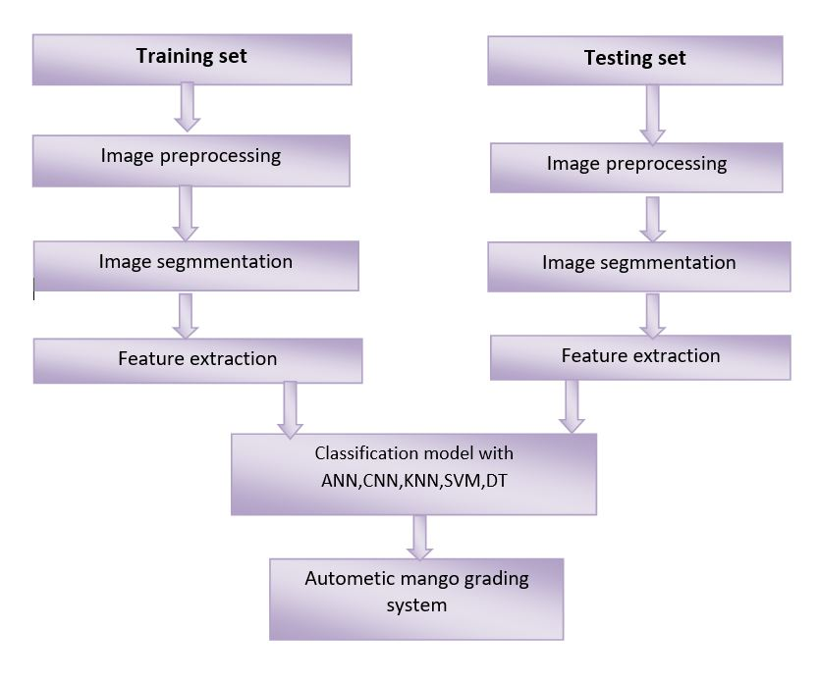

Figure 1: Block diagram of the proposed system

The steps of the proposed approach are summarized in Algorithm 1.
Algorithm 1: Mango Grading
1 | Read training mango images from the dataset
3 | Feed the train the models (ANN, DT, KNN, SVM, and CNN) for grading
4 | Read test image
5 | Apply the trained machine learning model for grading images
6 | Calculate grading_error
7 | If (log_error > threshold)  Go to step 1.  Else  Log accuracy.

3.2 Dataset Description

In this work, we collected mango images from multiple markets and locations. The images were categorized into four classes—green, ripe, semi-ripe and rotten—as illustrated in Fig. 2. Each class contains more than one thousand images (Table 1). The dataset was randomly split into training (70%) and testing (30%) sets.

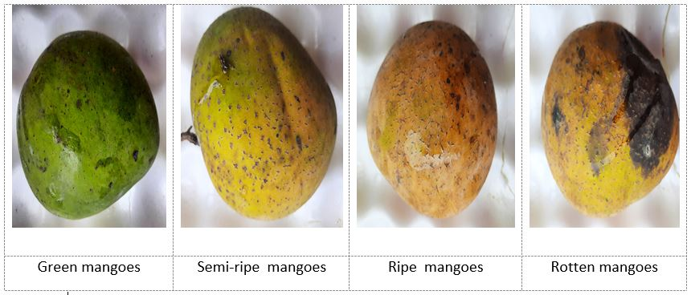
Figure 2: Four types of mango grading
Different mango varieties such as Surma, Fozli, Arsina, Amrapali, Mollika and Zinuk were collected. Images were captured using a camera and categorized into green, ripe, semi-ripe and rotten classes as shown in Table 1.
Table 1: Summary of the mango image dataset
Class | Grade | Number of images
Class a | Green | 1012
Class b | Ripe | 1035
Class c | Semi-ripe | 1151
Class d | Rotten | 1009

3.3 Image Pre-processing

Image preprocessing aims to enhance image quality and extract useful information for classification. Images captured from different sources may have varying resolutions and noise; therefore, preprocessing is required to standardize the input. In this work, we resized images using MATLAB’s imresize() function and applied imfilter() for smoothing, sharpening and edge enhancement. We also used rgb2gray() to convert RGB images to grayscale where necessary, and graycomatrix() to compute texture features.

3.4 Feature Extraction
Feature extraction (or feature learning) refers to deriving measurable characteristics from an image that help differentiate one class from another. The goal is to obtain a compact set of discriminative features that supports accurate classification. In our experiments, CNN learns image features automatically. Fig. 3 illustrates the feature learning process used in the model.

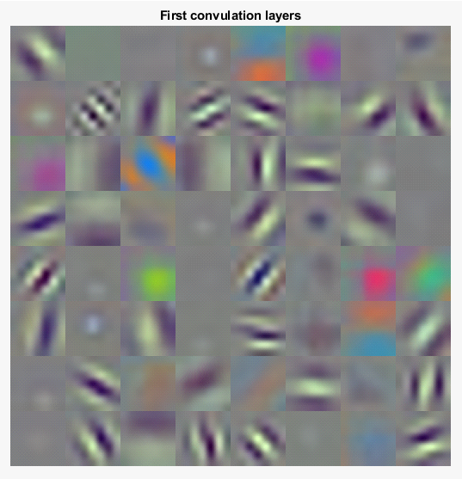
Figure 3: Automatic feature extraction using CNN
3.5 Machine Learning Models

Machine learning is an important branch of artificial intelligence. In this study, five different algorithms are trained and applied for mango grading: Artificial Neural Network (ANN), Decision Tree (DT), K-Nearest Neighbor (KNN), Support Vector Machine (SVM) and Convolutional Neural Network (CNN). ANN can learn complex non-linear relationships by imitating the behavior of neurons. Decision trees classify data step-by-step using feature-based rules that are easy to interpret. KNN is a distance-based approach in which a new sample is assigned the class of its nearest neighbors and often works well on smaller datasets. SVM finds an optimal hyperplane that maximizes separation between classes, enabling high-accuracy classification. CNN is a deep learning model particularly suited for image data; it can automatically learn hierarchical features and usually performs best when sufficient training images are available [22], [23], [24].

  - Model Performance Evaluation

The performance of the proposed approach is evaluated using four standard metrics: Accuracy, Precision, Recall and F1-score. These metrics help assess how reliably the models classify mangoes into different grading categories [25], [26].

Accuracy: Overall correctness of predictions, defined as (TP + TN) / (TP + TN + FP + FN).
where TP, TN, FP and FN denote true positive, true negative, false positive and false negative, respectively.
Precision: Proportion of correct positive predictions, defined as TP / (TP + FP).
Recall: Ability to detect all positive samples, defined as TP / (TP + FN).
F1-score: Harmonic mean of Precision and Recall, defined as 2 × (Precision × Recall) / (Precision + Recall).

- Results and Discussion
This section presents the experimental results of five machine learning models for mango grading: ANN, DT, KNN, SVM and CNN. For each experiment, 70% of the images were used for training and 30% for testing. The performance of each model was evaluated and compared quantitatively.
Classification Result of ANN: We evaluated ANN using the test set and summarized performance using its confusion matrix. Across repeated tests, the model achieved an accuracy above 80% for the four-class mango grading task (Fig. 4).

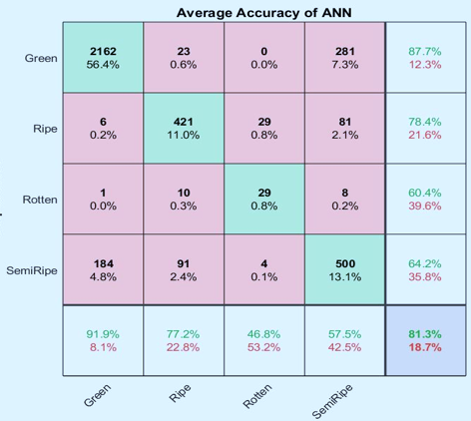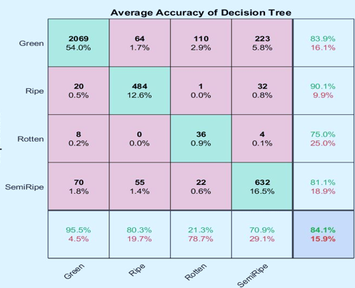

Figure 4: Confusion matrix for ANN Figure 5: Confusion matrix for DT
Classification Result of DT: The Decision Tree (DT) model was evaluated using a confusion matrix on the test set. Mango grading accuracy was computed as the number of correct predictions divided by the total number of test samples. DT achieved an accuracy above 80% in our experiments (Fig. 5).

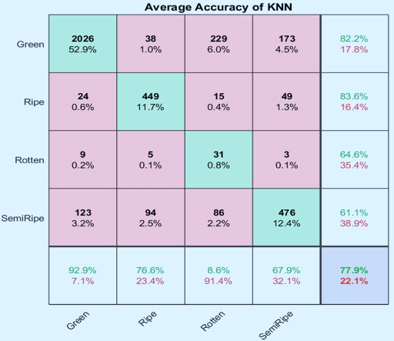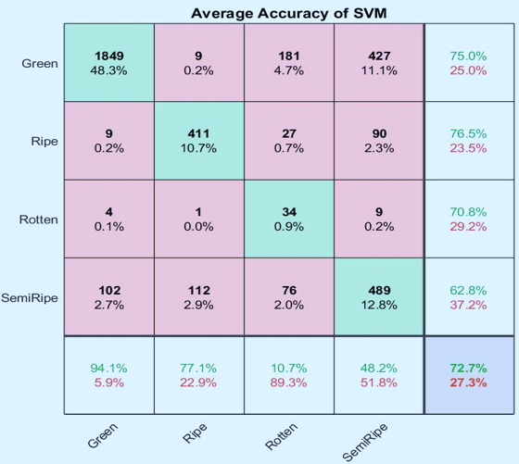

Figure 6: Confusion matrix for KNN Figure 7: Confusion matrix for SVM
KNN Classification Result: The KNN model produced slightly different outputs across test samples; therefore, we report average performance across multiple evaluations. KNN achieved an accuracy above 70% for mango grading in our experiments (Fig. 6).

SVM Classification Result: SVM achieved an accuracy of 72.7% in classifying the test images (Fig. 7). The ripe class was identified with higher accuracy than the semi-ripe class, which showed relatively lower classification performance.
CNN Classification Result: For CNN, we trained the model using a large set of images divided into four grading categories. CNN achieved an accuracy above 90% (Fig. 8), indicating superior performance for image-based mango grading when sufficient data are available.
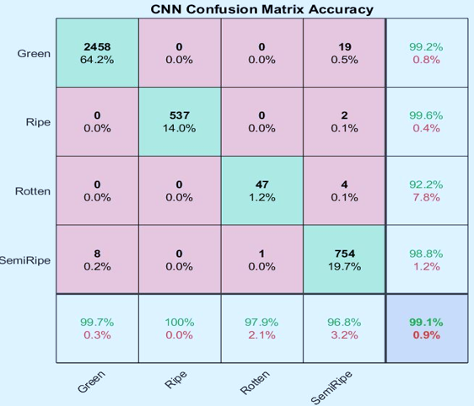

Figure 8: Confusion matrix for CNN
To assess the reliability of the five models, each model was executed ten times. In each run, four standard metrics—Accuracy, Precision, Recall and F1-score—were computed. We then calculated the average values to reduce the effect of random variation and to make the comparison more reliable. The performance results are presented in Table 2, and the comparative bar chart is shown in Fig. 9.
Table 2: Performance comparison of different models
Run | Models | Accuracy | Precision | Recall | F1-score
1 | ANN | 0.813 | 0.796 | 0.796 | 0.796
1 | KNN | 0.779 | 0.7634 | 0.763 | 0.7634
1 | SVM | 0.727 | 0.7116 | 0.712 | 0.7116
1 | DT | 0.841 | 0.8242 | 0.824 | 0.8242
1 | CNN | 0.991 | 0.9812 | 0.981 | 0.9812
2 | ANN | 0.782 | 0.7664 | 0.766 | 0.7664
2 | KNN | 0.753 | 0.7379 | 0.738 | 0.7379
2 | SVM | 0.726 | 0.7115 | 0.712 | 0.7115
2 | DT | 0.811 | 0.7938 | 0.794 | 0.7938
2 | CNN | 0.991 | 0.9812 | 0.981 | 0.9812
3 | ANN | 0.791 | 0.7752 | 0.775 | 0.7752
3 | KNN | 0.771 | 0.7566 | 0.757 | 0.7566
3 | SVM | 0.728 | 0.7134 | 0.713 | 0.7134
3 | DT | 0.82 | 0.8036 | 0.804 | 0.8036
3 | CNN | 0.987 | 0.9673 | 0.967 | 0.9673
4 | ANN | 0.744 | 0.7291 | 0.729 | 0.7291
4 | KNN | 0.787 | 0.7713 | 0.771 | 0.7713
4 | SVM | 0.757 | 0.7419 | 0.742 | 0.7419
4 | DT | 0.846 | 0.8291 | 0.829 | 0.8291
4 | CNN | 0.992 | 0.9822 | 0.982 | 0.9822
5 | ANN | 0.773 | 0.7576 | 0.758 | 0.7576
5 | KNN | 0.777 | 0.7615 | 0.762 | 0.7615
5 | SVM | 0.724 | 0.7095 | 0.71 | 0.7095
5 | DT | 0.812 | 0.7957 | 0.796 | 0.7957
5 | CNN | 0.992 | 0.9822 | 0.982 | 0.9822
Table 2 summarizes the performance of ANN, DT, KNN, SVM and CNN using Accuracy, Precision, Recall and F1-score. To reduce the effect of randomness in data splitting and training, each model was evaluated over multiple runs, and the results show consistent trends. CNN delivers the highest and most stable performance across all metrics, indicating strong robustness when a large training dataset is available. Among the classical machine learning models, DT performs best overall, suggesting that rule-based feature splits remain effective for this grading task. ANN and KNN provide moderate performance, whereas SVM performs comparatively lower in this dataset. Overall, the results indicate that CNN is the most suitable model for automated mango grading, with DT serving as the strongest traditional baseline.
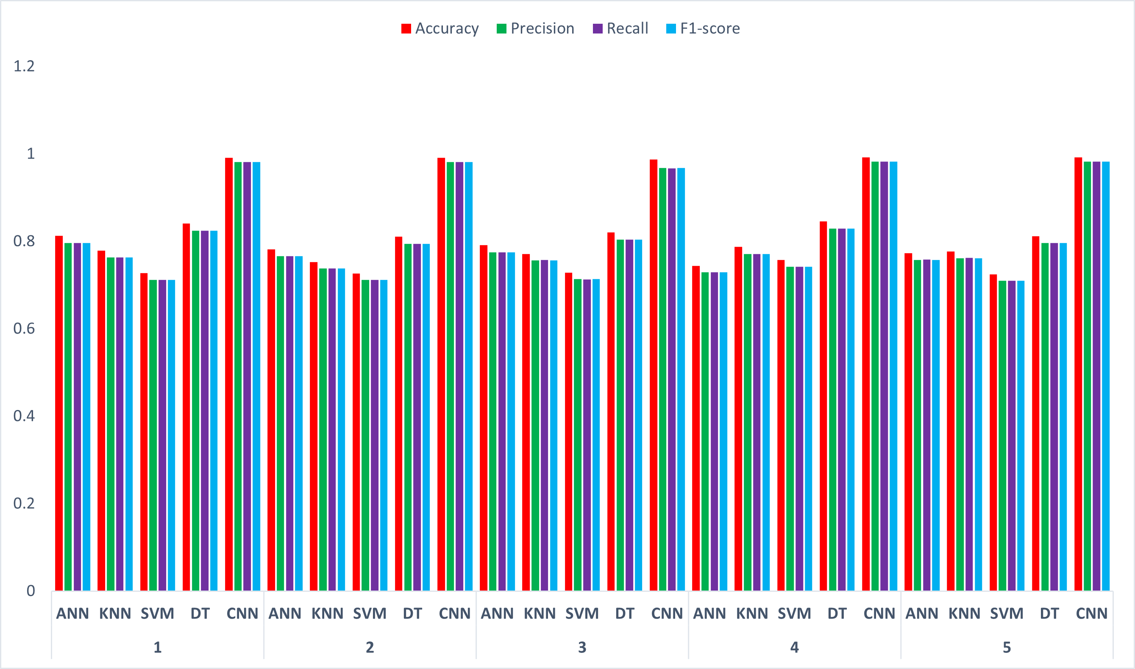
Figure 9: Performance comparison among the models

As shown in Fig. 9–10, Precision and Recall for each model in Run 5 are almost equal, indicating balanced behavior in terms of false positives and false negatives. CNN achieved the highest Precision/Recall (≈ 0.982), followed by DT (≈ 0.796). ANN and KNN achieved moderate scores (≈ 0.76), while SVM achieved the lowest performance (≈ 0.71).

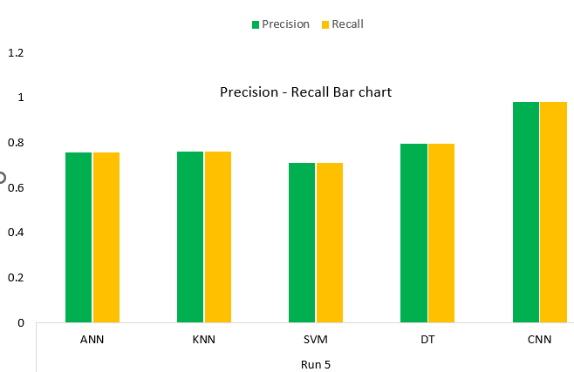

Figure 10: Precision–Recall bar chart
As shown in Table 1 and Fig. 9–10, model performance is reported using four widely used metrics: Accuracy, Precision, Recall and F1-score. Accuracy measures the overall proportion of correct predictions. Precision measures how often predicted samples of a grade are correct, while Recall measures how many true samples of a grade are successfully retrieved. F1-score provides a balanced summary of Precision and Recall. To ensure that the comparison is not dominated by a single random split, results are computed across multiple runs and then compared. Fig. 9–10 show that CNN achieves the best performance across all runs, with consistently high Accuracy and Precision/Recall values, and only minor variation between runs. This indicates that CNN effectively learns discriminative visual patterns for mango grading when sufficient training data are available. Among the traditional methods, DT is the best-performing baseline, but it remains noticeably below CNN in overall performance. In addition, Precision and Recall are close to each other for most models, suggesting a balanced trade-off between false positives and false negatives. Overall, the results confirm that CNN is the most effective model for this task, while DT provides the strongest classical alternative.

4.1 Discussion

In this study, five machine learning models—ANN, DT, KNN, SVM, and CNN—were tested and compared to develop an image-based automated mango grading system. The dataset was divided into four classes (Green, Semi-ripe, Ripe, Rotten) for training and testing, allowing for realistic comparison of the models’ performance. The analysis of the results shows that the CNN model consistently performed the highest. The main reason for this is that CNN can automatically learn the subtle patterns of color, texture, and shape within an image, and with sufficient data, these learned features are able to generalize well across different environments/variations. As a result, CNN performs very well in classes with relatively clear visual differences such as “Green vs. Ripe” or “Ripe vs. Rotten”. On the other hand, Decision Tree (DT) performed relatively well among the classical models. The advantage of Decision Tree is that it is interpretable; that is, the decision made based on which feature/characteristic can be explained in the form of a rule. In a real-world application (e.g. market/packing house), if a decision maker wants to know the answer to the question “Why is this mango marked as Semi-ripe?”, DT can provide a relatively easy explanation. ANN and KNN gave mediocre results. ANN can generally perform well, but its performance is often highly dependent on the amount of data, network architecture, and tuning. In the case of KNN, performance and computational cost can be limited when the data is large and the class boundaries are complex. SVM performed relatively poorly—this is an important observation. In practice, the “Semi-ripe” class can be the most challenging, because the color/texture changes slowly in the Semi-ripe stage and in many cases there is visual overlap with “Green” or “Ripe”. As a result, class separation becomes complicated and it can be relatively difficult for SVM to create a stable decision boundary, especially if the feature set is not optimally designed. Overall, the results of this study indicate that CNN-based methods are the most effective and realistic for mango grading when large and diverse image datasets are available, and Decision Tree can be considered a strong baseline in terms of interpretability and ease of implementation.

4.2 Potential Impact
Time and labor saving: Manual mango grading is labor-intensive, time-consuming and prone to human error. The proposed image-based automated grading system can significantly reduce time and labor costs in packing houses, warehouses and processing centers if it can determine grades quickly. This will enable grading of more mangoes at the same time.
Increased quality control and consistency: In human-based grading, there is subjective variation in the decisions of one person to another. Automated systems give similar results under the same rules, thus increasing the uniformity of grading. This can play a major role in ensuring standardized grading, especially in export or large markets.
Increased market value and export capacity: Farmers, traders and exporters all benefit from transparency in pricing, packaging and supply management according to grade. Ensuring accurate grading can increase consumer satisfaction, reduce returns/rejections, and increase product value—which can increase the competitiveness of the country's agricultural products in the long run.
Opportunity to create mobile/real-time : smartphone/tab and showing instant grading. This will allow farmers or collectors at the field level to make quick decisions—such as which batch will be marketed first, which will be kept in storage, or which needs quick processing.

- Conclusion

Automated fruit classification introduces artificial intelligence into the agriculture sector by enabling fast, consistent and non-destructive quality assessment. In this paper, we developed an image-based mango grading system and compared five machine learning models (ANN, DT, KNN, SVM and CNN). Experimental results demonstrate that CNN performs best when a large number of training images are available, achieving the highest accuracy and the most stable performance across runs. Therefore, CNN is a suitable model for automating mango grading and can help overcome the limitations of conventional manual grading by providing faster, more accurate and potentially lower-cost operation.

Dataset availability: Data will be made available upon request.

DISCLAIMER (ARTIFICIAL INTELLIGENCE): The authors hereby declare that no generative AI technologies—such as large language models (e.g., ChatGPT, Copilot) or text-to-image generators—were used in the writing or editing of this manuscript.

References

[1] M. A. Momin, M. T. Rahman, M. S. Sultana, C. Igathinathane, A. T. M. Ziauddin, and T. E. Grift, “Geometry-based mass grading of mango fruits using image processing,” Information Processing in Agriculture, vol. 4, no. 2, pp. 150–160, 2017, doi: 10.1016/j.inpa.2017.03.003.
[2] C. Engineering, A. Kumar, and G. S. Gill, “Automatic Fruit Grading and Classification System Using Computer Vision : A Review,” no. I, pp. 598–603, 2015, doi: 10.1109/ICACCE.2015.15.
[3] Panitnat. Yimyam, Chalidabhongse. Thanarat, and Suwanee. Sirisomboon, Panmanas. Boonmung, “Physical Properties Analysis of Mango using Computer Vision,” Iccas2005, p. 5, 2005.
[4] E. H. Yossy, J. Pranata, T. Wijaya, H. Hermawan, and W. Budiharto, “Mango Fruit Sortation System using Neural Network and Computer Vision,” Procedia Computer Science, vol. 116, pp. 596–603, 2017, doi: 10.1016/j.procs.2017.10.013.
[5] N. B. A. Mustafa, S. K. Ahmed, Z. Ali, W. B. Yit, A. A. Z. Abidin, and Z. A. Md Sharrif, “Agricultural produce sorting and grading using support vector machines and fuzzy logic,” in ICSIPA09 - 2009 IEEE International Conference on Signal and Image Processing Applications, Conference Proceedings, 2009, pp. 391–396. doi: 10.1109/ICSIPA.2009.5478684.
[6] R. Pandey, N. Gamit, and S. Naik, “A novel non-destructive grading method for Mango (Mangifera Indica L.) using fuzzy expert system,” Proceedings of the 2014 International Conference on Advances in Computing, Communications and Informatics, ICACCI 2014, pp. 1087–1094, 2014, doi: 10.1109/ICACCI.2014.6968366.
[7] H. G. Naganur, S. S. Sannakki, V. S. Rajpurohit, and R. Arunkumar, “Fruits Sorting and Grading using Fuzzy Logic,” vol. 1, no. 6, pp. 117–122, 2012.
[8] A. M. Aibinu, M. J. E. Salami, A. A. Shafie, N. Hazali, and N. Termidzi, “Automatic Fruits Identification System Using Hybrid Technique,” 2011, doi: 10.1109/DELTA.2011.47.
[9] D. Jhala, A. Bagade, S. Naik, S. Lad, and B. Shah, “Microcontroller Based Fruit Sorting Using Image Processing In Matlab,” IOSR Journal of Engineering (IOSRJEN), vol. 4, pp. 43–46, 2018.
[10] K. A. & K. Veena. T, D. V. Chidanand, “Quality Analysis of Mango Fruit with Fruit Fly Insect by Non-Destructive Soft X-Ray Method,” International Journal of Agricultural Science and Research (IJASR), vol. 5, no. 3, pp. 37–46, 2015.
[11] K. A. Forbes and G. M. Tattersfield, “Estimating fruit volume from digital images,” IEEE AFRICON Conference, vol. 1, pp. 107–112, 1999, doi: 10.1109/afrcon.1999.820775.
[12] A. MVyas, B. Talati, and S. Naik, “Quality Inspection and Classification of Mangoes using Color and Size Features,” International Journal of Computer Applications, vol. 98, no. 1, pp. 1–5, 2014, doi: 10.5120/17144-7161.
[13] D. Kalantari, “Size determination of apple and orange fruits using the image processing technique.,” Advances in Agriculture, Sciences and Engineering Research, vol. 4, no. 2, pp. 1537–1543, 2014.
[14] T. U. Ganiron Jr, “Size properties of mangoes using image analysis,” International Journal of Bio-Science and Bio-Technology, vol. 6, no. 2, pp. 31–42, 2014.
[15] C. P. Diana Carolina and N. T. Deivis David, “Classification of oranges by maturity, using image processing techniques,” 2014 3rd International Congress of Engineering Mechatronics and Automation, CIIMA 2014 - Conference Proceedings, 2014, doi: 10.1109/CIIMA.2014.6983466.
[16] C. K. Shetty, S. B. Kulkarni, U. P. Kulkarni, K. Ramesh, and R. Hegadi, “Defect Recognition of Fruit using Statistical Approach,” vol. 22, no. 7, pp. 331–334, 2015.
[17] C. Science and M. Studies, “Weight Based Fruits Sorting System,” pp. 308–313, 2015.
[18] M. F. Ibrahim, F. S. Ahmad Sa’ad, A. Zakaria, and A. Y. Md Shakaff, “In-Line Sorting of Harumanis Mango Based on External Quality Using Visible Imaging,” Sensors, vol. 16, no. 11, p. 1753, 2016.
[19] . S. J., “Grading of Tomatoes Using Digital Image Processing on the Basis of Size,” International Journal of Research in Engineering and Technology, vol. 05, no. 10, pp. 109–111, 2016, doi: 10.15623/ijret.2016.0510020.
[20] R. Gaur and V. S. Chouhan, “Classifiers in Image processing,” International Journal on Future Revolution in Computer Science & Communication Engineering IJFRCSCE, pp. 22–24, 2017.
[21] C. S. Nandi, B. Tudu, and C. Koley, “Machine vision based techniques for automatic mango fruit sorting and grading based on maturity level and size,” in Sensing Technology: Current Status and Future Trends II, vol. 8, 2014, pp. 27–46. doi: 10.1007/978-3-319-02315-1_2.
[22] S. S. T. Gontumukkala, Y. S. V. Godavarthi, B. R. R. T. Gonugunta, R. Subramani, and K. Murali, “Analysis of image classification using SVM,” in 2021 12th International Conference on Computing Communication and Networking Technologies (ICCCNT), 2021, pp. 1–6.
[23] S. Y. Chaganti, I. Nanda, K. R. Pandi, T. G. Prudhvith, and N. Kumar, “Image Classification using SVM and CNN,” in 2020 International conference on computer science, engineering and applications (ICCSEA), 2020, pp. 1–5.
[24] H. Manzoor, F. Khursheed, and A. M. Hafiz, “Finger vein recognition using an ensemble of KNN classifiers based on robust image features,” Signal Image Video Process, vol. 19, no. 10, Oct. 2025, doi: 10.1007/s11760-025-04369-0.
[25] S. M. A. Al Shuaeb, A. Hossen, M. A. H. Dinar, and U. K. Roy, “Analyzing Different Architectures of Convolutional Neural Networks for Tomato Grading System,” Asian Journal of Research in Computer Science, vol. 17, no. 12, pp. 137–147, Dec. 2024, doi: 10.9734/ajrcos/2024/v17i12534.
[26] B. Hossain, U. K. Roy, Shamsunnaher, Md. S. A. A. Kawser, and S. M. A. Al Shuaeb, “Image-based Pest Identification Using Support Vector Machine for Agricultural Crop Protection,” Asian J Res Crop Sci, vol. 10, no. 3, pp. 13–22, Jun. 2025, doi: 10.9734/ajrcs/2025/v10i3368.

