Original Research Article

Forecasting Revenue Differentials in Malaysia: A Comparative Analysis of GST and SST Regimes Using Time
Series and Regression Models

ABSTRACT

Malaysia’s indirect tax landscape has undergone significant structural transformations, transitioning from the Sales and Service Tax (SST 1.0) to the Goods and Services Tax (GST) in 2015, and reverting to a revised SST (SST 2.0) in 2018. This study quantifies the long-term revenue implications and fiscal opportunity costs of these regime shifts. Utilizing a methodological triangulation approach, the study employs Holt-Winters and ARIMA models for long-run historical data (SST 1.0 and GDP) and regression- based forecasting for the shorter GST and SST 2.0 series. The findings reveal a substantial and widening revenue gap: by the fourth quarter of 2028, a continued GST regime is projected to generate approximately RM21.8 billion quarterly compared to RM10.9 billion under SST 2.0, representing a quarterly fiscal opportunity cost of RM10.9 billion, implying that the GST regime would generate effectively double the yield of SST 2.0. The analysis identifies a “Predictability-Potency Paradox”, where SST 2.0 exhibits greater budgetary predictability (R² = .601), while GST demonstrates significantly higher revenue buoyancy (β = 0.048). These results highlight a critical “Policy Trilemma” facing Malaysian policymakers, involving the challenge of balancing revenue maximization, political acceptability, and administrative simplicity.
Keywords: Indirect tax, GST vs SST, Revenue forecasting, Time series analysis, Regression analysis

INTRODUCTION
Malaysia's indirect tax framework has undergone several major transitions over the past decade, reflecting a dynamic interplay between fiscal necessity and socio-political demands. From the long-standing Sales and Services Tax (SST 1.0) established in 1972, the nation shifted to a Goods and Services Tax (GST) in April 2015, only to repeal it in June 2018 and subsequently reinstate a revised SST (SST 2.0) later that year. Each of these policy changes reflected shifting government priorities, economic pressures, and public sentiment, creating distinct revenue patterns that complicate long-term fiscal analysis. Political narratives played a central role in these reforms, where the GST launch faced widespread protests over rising living

costs, while the reversion to SST 2.0 was framed as a move to regain public support, albeit with implications for revenue yield. Consequently, budgetary shortfalls, party manifestos, and electoral cycles have all significantly influenced the timing and nature of these tax implementations and reversals.

Background of the Study

The Malaysian fiscal landscape has undergone a series of profound and impactful transformations in its indirect tax structure over the past few decades, culminating in a particularly turbulent phase between 2015 and 2018. Historically, the nation operated under the single-stage Sales and Service Tax (SST 1.0) regime introduced in 1972. In an effort to modernize the tax system, broaden the tax base, and enhance revenue efficiency, the government implemented the multi-stage Goods and Services Tax (GST) in April 2015. Proponents argued that the GST’s comprehensive nature and input tax credit mechanism would reduce tax evasion and create a more robust revenue stream.

However, the GST implementation faced significant challenges. It encountered considerable public pushback fuelled by perceptions of increased living costs and the administrative complexities imposed on businesses. These socio-political pressures led to the abolition of the GST following the 2018 general election and the subsequent reinstatement of a revised Sales and Service Tax (SST 2.0). This policy reversal was primarily driven by a political commitment to alleviate the financial burden on consumers and simplify tax compliance. Despite the documentation of the political rationale behind these shifts, there remains a critical scarcity of empirical research that precisely quantifies the long-term revenue implications or the fiscal opportunity cost of abandoning the GST regime.

Objective of the Research

The primary objective of this study is to fill the existing research gap by developing a robust forecasting framework to quantify and compare the revenue-generating capabilities of SST 1.0, GST, and SST 2.0. Specifically, this research aims to analyse historical revenue trends and the macroeconomic influence of Gross Domestic Product (GDP), examining patterns such as seasonality and volatility to understand the intrinsic dynamics of each regime. Furthermore, the study seeks to forecast hypothetical revenue by constructing a counterfactual scenario that projects the revenue Malaysia might have generated had the GST regime remained in effect beyond 2018. By rigorously comparing these hypothetical GST projections against the actual and forecasted collections of the SST 2.0 regime, the research identifies efficiency gaps and quantifies the fiscal opportunity cost. To ensure robust prediction accuracy, the study employs a methodological triangulation approach, utilizing both univariate time-series models (e.g., Holt-Winters, ARIMA) and regression-based econometric models to address data disparities.

Significance of this Research

This study holds significant theoretical and practical value for fiscal policy formulation in Malaysia. It contributes to the literature on revenue forecasting by demonstrating how tailored time-series and hybrid modelling techniques can be applied to economies characterized by frequent structural breaks and limited data series, providing a reference for understanding tax revenue volatility and the dynamic interplay between economic conditions and tax performance.

Practically, the findings provide evidence-based guidance for policymakers navigating the complex trade- offs between revenue maximization, political acceptability, and administrative simplicity, a challenge framed in this study as the "Policy Trilemma". By quantifying the long-term revenue differential between GST and SST 2.0, the study offers a tangible assessment of the fiscal cost of recent policy decisions. These insights are vital for informing future tax reform strategies, enhancing fiscal sustainability, and aiding stakeholders, including tax authorities and financial analysts, in improving the predictability of national revenue flows.

- Literature Review
Malaysia’s indirect tax framework has evolved through three major regimes: SST 1.0, GST, and SST 2.0. SST 1.0, introduced in 1972, was a single-stage tax with limitations on revenue yield (Nasir et al., 2015).

GST (April 2015 to August 2018) was a multi-stage value-added tax designed to broaden the tax base and enhance revenue collection through its input tax credit mechanism, but public resistance over consumer prices and complexity led to its repeal. The reinstatement of SST 2.0 aimed to restore public confidence, albeit at the cost of reduced revenue yield compared to GST (Rahman et al., 2018).


The abrupt shift between these regimes, including the three-month "tax holiday" in mid-2018, created pronounced volatility in indirect-tax revenue. Such fluctuations complicate budget forecasts, disrupt expenditure commitments, and highlight the challenge faced by policymakers in designing a tax framework that is both fiscally effective and socially acceptable (Ministry of Finance Malaysia, 2018; Zainal, 2019). The SST 1.0 era was characterized by steady, low-volatility growth; the GST era showed a sharp surge with pronounced fluctuations; and SST 2.0 demonstrates a smoother, upward trend, though more muted than GST (see Figure 1).
Consumption Tax Revenue (RM million)
16000
14000
12000
10000
8000
6000
4000
2000
0

Fig. 1. Quarterly Consumption Tax Revenue in Malaysia, Q1 1996–Q1 2024.
Q1 1996
Q4 1996
Q3 1997
Q2 1998
Q1 1999
Q4 1999
Q3 2000
Q2 2001
Q1 2002
Q4 2002
Q3 2003
Q2 2004
Q1 2005
Q4 2005
Q3 2006
Q2 2007
Q1 2008
Q4 2008
Q3 2009
Q2 2010
Q1 2011
Q4 2011
Q3 2012
Q2 2013
Q1 2014
Q4 2014
Q3 2015
Q2 2016
Q1 2017
Q4 2017
Q3 2018
Q2 2019
Q1 2020
Q4 2020
Q3 2021
Q2 2022
Q1 2023
Q4 2023

Traditional revenue forecasting methods include judgmental methods, which rely on expert opinion, and incremental methods, which fit statistical trends like exponential smoothing (International Monetary Fund, 2019). Causal or elasticity models estimate revenue-to-GDP elasticities via regression to generate forecasts (Jenkins, Kuo, & Shukla, 2000). More rigorous econometric frameworks include the ARIMA model for capturing internal dynamics, and ARIMAX, which extends ARIMA by incorporating exogenous variables like GDP to jointly estimate internal dynamics and external influences (Hyndman & Athanasopoulos, 2018). A critical methodological challenge in this study is addressing the data scarcity for GST (14 observations) and SST 2.0 (22 observations). Applying complex time-series models like ARIMA to such short series risks overfitting, where the model captures random noise rather than underlying structural patterns. To mitigate this, a hybrid modelling framework is employed, combining time-series techniques for long, stable series (SST 1.0 and GDP) with regression-based models for short series, leveraging the strong theoretical association between consumption tax revenue and GDP (Chandren, Mohammad, & Ahmad, 2022).

METHODOLOGY

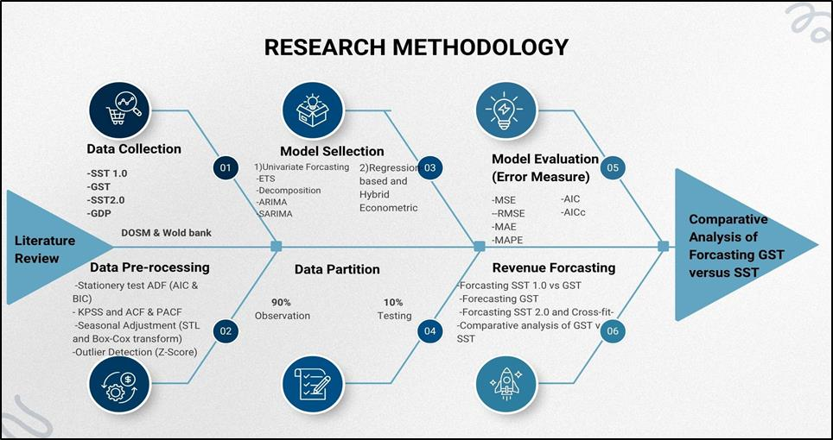
Fig. 2. Research Framework of the Study

The research employed a rigorous, six-stage quantitative methodology, as illustrated in the study's framework (Figure 2), to forecast revenue and conduct a comprehensive comparative analysis between the Goods and Services Tax (GST) and the Sales and Services Tax (SST) regimes. The initial Data Collection phase involved sourcing secondary time series data for the target variables which is SST 1.0, GST, SST 2.0, and Gross Domestic Product (GDP) primarily from the Department of Statistics Malaysia (DOSM) and Ministry of Finance Malaysia. Following data acquisition, the Data Pre-processing stage was executed to ensure data quality and stationarity, involving critical time-series diagnostics such as the Augmented Dickey-Fuller (ADF) and Kwiatkowski–Phillips–Schmidt–Shin (KPSS) tests, guided by the Akaike Information Criterion (AIC) and Bayesian Information Criterion (BIC). This phase also included Seasonal- Trend Decomposition using Loess (STL), Box-Cox transformations, and Z-Score method for outlier detection.
Subsequent to pre-processing, the dataset was subjected to Data Partition, where 90% of the observations were allocated for model training, and the remaining 10% were reserved for out-of-sample testing. The Model Selection phase explored both univariate forecasting models, including Exponential Smoothing (ETS), Decomposition, ARIMA, and SARIMA, alongside Regression-based and advanced Hybrid Econometric models to capture complex linear and non-linear dynamics. Model adequacy and forecasting precision were then rigorously evaluated during the Model Evaluation phase using a suite of error measures: Mean Squared Error (MSE), Root Mean Squared Error (RMSE), Mean Absolute Error (MAE), Mean Absolute Percentage Error (MAPE), and the information criteria (AIC and AICc). The final Revenue Forecasting phase utilized the optimal models to generate forecasts for SST 1.0, GST, and SST 2.0, culminating in the Comparative Analysis of Forecasting GST versus SST to draw policy-relevant conclusions regarding the relative performance and suitability of the two tax systems.

RESULTS AND COMPARATIVE ANALYSIS
The empirical analysis aimed to rigorously evaluate the performance of Malaysia’s indirect tax regimes and quantify their revenue potential using both descriptive and econometric approaches. The descriptive statistics confirm clear distinctions across regimes: the Goods and Services Tax (GST) produced the highest average quarterly revenue (RM 9.67 billion), but was also the most volatile (Coefficient of Variation, CV = 26.1%). The Sales and Service Tax (SST 2.0) yielded a lower average (RM 7.35 billion) but demonstrated greater stability (CV = 17.8%), while SST 1.0 remained modest in yield (RM 2.66 billion).

Stationarity Testing and Model Selection

Visual inspection of the raw data identified clear non-stationary patterns. Figure 3 (SST 1.0, 1996–2015) reveals a distinct upward trend with recurring seasonal spikes, while Figure 4 (GDP, 2015–2025) illustrates persistent growth disturbed only by pandemic volatility. These trajectories strongly suggested non- stationarity in the level data.

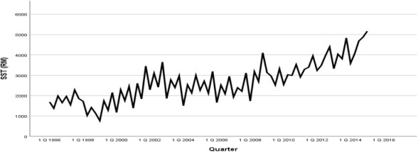  Fig. 3. Quarterly SST 1.0 Revenue, 1996–2015 | 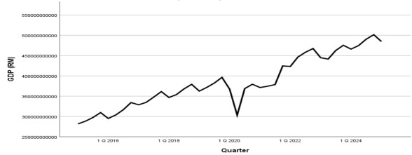  Fig. 4. Quarterly GDP Nominal, 2015–2025
Formal diagnostics, including the Augmented Dickey-Fuller (ADF) and Kwiatkowski-Phillips-Schmidt-Shin (KPSS) tests, corroborated the visual evidence, confirming that both series were non-stationary in levels. To address this, a first-differencing transformation was applied. This process effectively removed the deterministic trends, resulting in series that fluctuate around a constant mean with stabilized variance. The efficacy of this transformation is demonstrated in Figure 5 (SST 1.0) and Figure 6 (GDP), which display the stationary, differenced data.
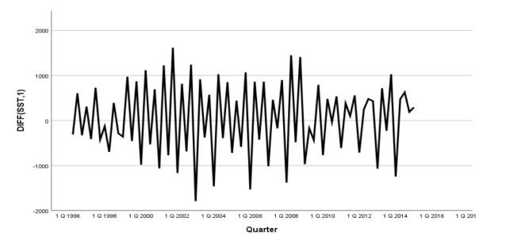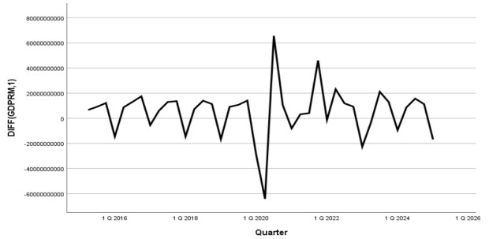

Fig. 5. First Difference of Quarterly SST 1.0 Revenue, 1996–2015
Fig. 6. First Difference of GDP Nominal,2015–2025

Formal diagnostics, including the Augmented Dickey-Fuller (ADF) and Kwiatkowski-Phillips-Schmidt-Shin (KPSS) tests, corroborated the visual evidence. As summarized in Table 1, both series achieved stationarity only after first differencing, confirming they are integrated of order one, I(1).

Table 1. Results of ADF and KPSS unit root tests (5% level)

Variable | ADF | ADF (1st Diff.) | KPSS | KPSS (1st Diff.)
GDP | -1.045 | -6.7455 | 0.7530 | 0.38712
 | Prob = 0.7276 | Prob = 0.0000
 | 5% CV = -2.9369 | 5% CV = -2.9411 | 5% CV = 0.4630 | 5% CV = 0.4630
SST 1.0 | 0.9050 | -10.1098 | 1.04978 | 0.24017
 | Prob = 0.9951 | Prob = 0.0001
 | 5% CV = -2.9018 | 5% CV = 2.9018 | 5% CV = 0.4630 | 5% CV = 0.4630

Following stationarity confirmation, a rigorous selection process was undertaken to identify the optimal forecasting models by evaluating multiple candidates against standard accuracy metrics.

Model Selection for GDP For the GDP series, five distinct models were evaluated: ARIMA(1,1,0), ARIMA(2,1,0), ARIMA(2,1,1), SARIMA(2,1,0)(1,0,0)[4], and the Holt-Winters Multiplicative model. The performance metrics for these candidates are detailed in Table 2.

Table 2. Forecast Accuracy Metrics for GDP Models (RMSE, MAE, MAPE, MPE)

Model | RMSE | MAE | MAPE (%) | MPE (%)
ARIMA(1,1,0) | 11,059,273,316 | 10,313,340,000 | 2.31 | –1.84
ARIMA(2,1,0) | 9,743,180,725 | 9,003,346,000 | 2.02 | –1.45
ARIMA(2,1,1) | 7,936,152,726 | 7,646,206,000 | 1.72 | –1.01
SARIMA(2,1,0)(1,0,0) | 17,264,838,948 | 16,153,143,000 | 3.63 | –3.18
Holt–Winters Multiplicative | 14,083,382,042 | 13,038,397,000 | 2.91 | +0.57
Note. RMSE = Root Mean Squared Error; MAE = Mean Absolute Error; MAPE = Mean Absolute Percentage Error; MPE = Mean Percentage Error.

As shown in Table 2, the ARIMA(2,1,1) model proved superior, achieving the lowest out-of-sample RMSE (RM 7.94 billion) and MAPE (1.72%). The accurate forecast trajectory of this selected model is illustrated in Figure 7.

Model Selection for SST 1.0 Concurrently, for the seasonally volatile SST 1.0 series, candidates including ARIMA(1,1,0), ARIMA(1,1,1), ARIMA(3,1,0), SARIMA(1,1,1)(1,0,0)[4], and Holt-Winters Multiplicative were assessed. The comparative results are presented in Table 3.

Table 3. Forecast Accuracy Metrics for SST 1.0 Models (RMSE, MAE, MAPE, MPE)

Model | RMSE | MAE | MAPE (%) | MPE (%)
ARIMA(1,1,0) | 474,942,232 | 434,860,000 | 11.79 | +6.42
ARIMA(1,1,1) | 280,798,964 | 253,983,000 | 6.96 | –1.83
ARIMA(3,1,0) | 229,157,708 | 205,377,000 | 5.63 | –3.91
SARIMA(1,1,1)(1,0,0) | 173,264,264 | 157,478,000 | 4.35 | –1.02
Holt–Winters Multiplicative | 158,007,928 | 144,076,000 | 4.01 | –0.76

The Holt-Winters Multiplicative model emerged as the optimal choice, achieving the lowest RMSE (RM 158 million) and MAPE (4.01%). This confirms the model's capability to effectively capture the recurring seasonal fluctuations visible in Figure 8.

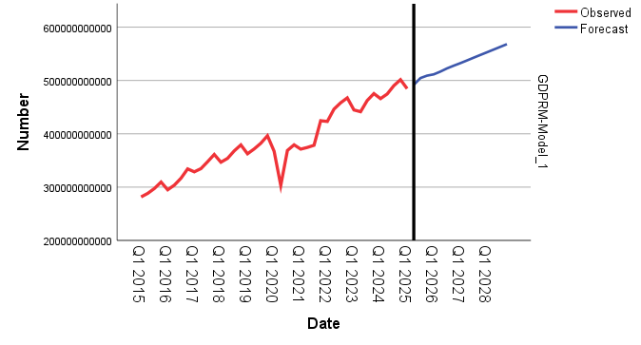  Fig. 7. Forecast of GDP from 2015 to 2028 using ARIMA(2,1,1) Model | 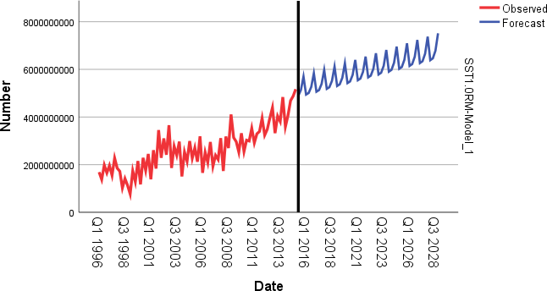  Fig. 8. Forecast of SST 1.0 from 1996 to 2028 using Holt–Winters Multiplicative  Model

Evaluating the Revenue-GDP Relationship and Hypothesis Testing

To quantify the responsiveness of tax revenue to economic activity, regression analysis was performed with GDP as the predictor. To formally validate this relationship, the following hypotheses were established and tested for both the GST and SST 2.0 regimes:
H₀: GDP has no significant effect on tax revenue (𝛽 = 0)
H₁: GDP has a significant positive effect on tax revenue (𝛽 > 0)

Table 4. Summary of Regression Results for GST and SST 2.0 on GDP

Dependent | Coefficient (β) | Constant | R2 | Sig. (p)
GST | 0.048 | –5,443,578,472 | 0.323 | .043
SST 2.0 | 0.022 | –1,564,986,494 | 0.601 | <.001

The regression results in table 4 led to the rejection of the null hypothesis (H₀) for both tax regimes, confirming that GDP is a statistically significant driver of revenue. The specific models derived from this analysis are detailed below.

𝐺𝑆𝑇𝑡 = 𝛼 + 𝛽 𝐺𝐷𝑃𝑡 + 𝜀𝑡 [1]
𝑆𝑆𝑇2.0𝑡 = 𝛼 + 𝛽 𝐺𝐷𝑃𝑡 + 𝜀𝑡 [2]

Model 1: GST and GDP The regression equation for GST is specified as:

𝐺𝑆̂𝑇𝑡 = −5,443,578,472 + 0.048 ⋅ 𝐺𝐷𝑃𝑡 [3]

The slope coefficient (β = 0.048, p = 0.043) is statistically significant at the 5% level, supporting the alternative hypothesis (H₁) that increases in GDP lead to higher GST revenue. The model explains 32.3% of the variation in revenue (R² = 0.323), suggesting moderate predictability but high potency.

Model 2: SST 2.0 and GDP The regression equation for SST 2.0 is specified as:
𝑆𝑆̂𝑇2.0𝑡 = −1,564,986,494 + 0.022 ⋅ 𝐺𝐷𝑃𝑡 [4]
The slope coefficient (β = 0.022, p < 0.001) is highly significant, leading to a decisive rejection of H₀. While the coefficient is lower than that of GST (indicating lower revenue yield per unit of GDP), the model demonstrates significantly greater explanatory power (R² = 0.601), reflecting a more stable and predictable revenue stream.

The comparison of these models reveals a "Predictability-Potency Paradox". While SST 2.0 is more predictable (higher R²) GST is far more potent (higher 𝛽). This trade-off is visually supported by the Revenue-to-GDP ratio trends shown in Figure 9. During the GST period (2015–2018), the ratio peaked at approximately 4.0%, reflecting high fiscal potency.

Fig. 9. Revenue-to-GDP Ratio, 2015–2024
%
4.5
4
3.5
3
2.5
2
1.5
1
0.5
0
1/1/2015
5/1/2015
9/1/2015
1/1/2016
5/1/2016
9/1/2016
1/1/2017
5/1/2017
9/1/2017
1/1/2018
5/1/2018
9/1/2018
1/1/2019
5/1/2019
9/1/2019
1/1/2020
5/1/2020
9/1/2020
1/1/2021
5/1/2021
9/1/2021
1/1/2022
5/1/2022
9/1/2022
1/1/2023
5/1/2023
9/1/2023
1/1/2024

Comparative Revenue Forecasts

The final models were used to generate a comprehensive comparative forecast up to Q4 2028 (see Figure 10). This juxtaposition synthesized the SST 1.0 time-series forecast with the GDP-driven regression forecasts for GST (counterfactual) and SST 2.0 (actual/projected).
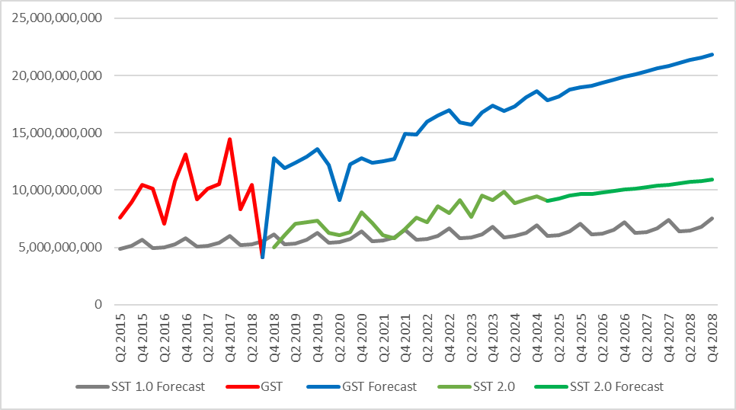

Fig. 10. Consumption Taxes Revenue (2015-2028)

The quantitative findings are summarized in Table 5, underscoring long-term fiscal trade-offs.

Table 5. Summary of Comparative Forecasts (Q4 2018 – Q4 2028)

Quarter | GDP | SST 1.0 | GST | SST 2.0
Q4 2018 | 379,200,000,000 | 6,118,061,168 | 12,758,021,528 | 5,005,000,000
Q4 2019 | 396,345,000,000 | 6,257,624,555 | 13,580,981,528 | 7,316,000,000
Q4 2020 | 379,358,000,000 | 6,397,187,942 | 12,765,605,528 | 8,050,000,000
Q4 2021 | 424,516,510,000 | 6,536,751,330 | 14,933,214,008 | 6,595,000,000
Q4 2022 | 467,365,699,000 | 6,676,314,717 | 16,989,975,080 | 7,982,000,000
Q4 2023 | 475,410,264,000 | 6,815,878,104 | 17,376,114,200 | 9,164,000,000
Q4 2024 | 501,471,983,000 | 6,955,441,491 | 18,627,076,712 | 9,467,397,132
Q4 2025 | 509,073,405,312 | 7,095,004,878 | 18,991,944,983 | 9,634,628,423
Q4 2026 | 527,727,661,907 | 7,234,568,265 | 19,887,349,300 | 10,045,022,068
Q4 2027 | 547,816,481,856 | 7,374,131,652 | 20,851,612,657 | 10,486,976,107
Q4 2028 | 568,089,259,866 | 7,513,695,039 | 21,824,706,002 | 10,932,977,223

The forecasts reveal two key findings. First, the revenue gap between GST and SST 2.0 is both substantial and widening over time. By Q4 2028, the counterfactual GST revenue is projected at RM 21.8 billion, double the SST 2.0 forecast of RM 10.9 billion. This divergence translates into a quarterly fiscal opportunity cost of approximately RM 10.9 billion, underscoring the significant revenue potential foregone under the current regime. Second, the analysis affirms the relative efficacy of SST 2.0 compared to its predecessor. By Q4 2028, SST 2.0 is expected to yield RM 10.9 billion, markedly higher than the RM 7.5 billion projected for SST 1.0. This improvement demonstrates that SST 2.0 represents a more effective and buoyant revenue‑collection framework than the pre‑2015 system, even if it falls short of GST’s revenue‑generating capacity.

DISCUSSION AND IMPLICATIONS
The persistent revenue differential is not a statistical anomaly but a predictable and direct consequence of the fundamental structural differences between the tax systems. GST is a broad-based, multi-stage tax levied on the value added at each stage, capturing a wide spectrum of economic activity (Rahman et al., 2018). Furthermore, its Input Tax Credit mechanism creates a self-policing paper trail, incentivizing businesses to register and accurately declare transactions to claim credits, thereby minimizing tax leakage and the scope for the shadow economy (Nawi et al., 2020). In contrast, SST 2.0 is a single-stage tax levied primarily at the manufacturing/import level or on a prescribed list of services, inherently restricting its revenue capacity and lacking the comprehensive compliance mechanisms of the GST. The quantified shortfall represents a significant constraint on the government's fiscal space, limiting its capacity to fund critical public expenditures in infrastructure, healthcare, and education.

The findings present Malaysian policymakers with a difficult "Policy Trilemma," challenging them to simultaneously balance three competing objectives: fiscal maximization, political acceptability, and administrative simplicity (Wong & Eng, 2018). The GST path offers the highest revenue yield, which is crucial for funding public services and reducing national debt, but it carries high political costs and administrative complexity. Conversely, the SST 2.0 path is less burdensome on consumers and simpler for businesses, making it more socially acceptable, yet this comes at the cost of a substantial, quantifiable revenue shortfall. While the single-stage nature of SST is simpler than the resource-intensive GST, this simplicity is intrinsically linked to its narrower tax base and lower revenue yield. The long-term revenue trajectories clearly delineate the fiscal path Malaysia is on under SST 2.0, a path characterized by a significant and ongoing opportunity cost which directly impacts the government's ability to meet pressing national objectives.

The research provides empirical quantification for the Policy Trilemma, moving the debate beyond rhetoric to evidence-based decision-making. Furthermore, the finding that SST 2.0 is superior to SST 1.0 validates

the concept of a modernized single-stage system, implying that policy learning occurred. This provided a crucial baseline for subsequent policy action, such as the expansion of the SST 2.0 scope in July 2025 (Ministry of Finance Malaysia, 2025). However, the conclusions must be understood within the study’s limitations. The severe lack of data for GST (14 observations) and SST 2.0 (22 observations) necessitated the use of simple regression models, which are less robust than time-series analyses possible with longer datasets. The low R² of the GST model (.323) is direct evidence that other unmodeled factors, such as compliance trends, administrative enforcement, and the shadow economy, significantly impact revenue. Additionally, the forecasts for SST 2.0 are based on data prior to the expansion of its scope that took effect on July 1, 2025. Consequently, the study’s SST 2.0 forecast of RM 10.9 billion by Q4 2028 should be regarded as a conservative baseline or underestimate of its true potential, given that the projection does not fully account for the expansion of scope introduced under the SST 2.0 regime starting July 2025 (Ministry of Finance Malaysia, 2025).

CONCLUSION
This research set out to provide an objective, evidence-based quantification of the revenue trade-offs in Malaysia’s indirect tax system. The findings confirm that the 2018 repeal of GST resulted in a substantial and widening fiscal opportunity cost for the nation, with GST being a significantly more powerful engine for revenue generation. However, the study also complicates the narrative by confirming SST 2.0 is a more modernized, predictable, and fiscally effective regime than its predecessor, SST 1.0. This study has fulfilled its objective by illuminating the quantifiable consequences of the chosen path, empowering policymakers to navigate the Policy Trilemma and design an optimal indirect tax system for Malaysia's future.

Future policy considerations should acknowledge that while SST 2.0 is an improvement over the pre-2015 system, it remains fiscally inferior to a broad-based consumption tax. Recommendations for future research include modelling the 2025 SST 2.0 expansion to create a new, more accurate forecast for Malaysia's fiscal trajectory. Additionally, future studies should attempt to develop multi-factor econometric models incorporating variables like inflation, trade volumes, or household debt to better explain the noise in tax collection data.

References
Aggarwal, C. C. (2017). Outlier analysis (2nd ed.). Springer.

Akaike, H. (1974). A new look at the statistical model identification. IEEE Transactions on Automatic Control, 19(6), 716–723.

Barnett, V., & Lewis, T. (1994). Outliers in statistical data (3rd ed.). John Wiley & Sons.

Chandren, S., Mohammad, N. A., & Ahmad, N. (2022). Value relevance of operating performance during the GST and SST periods in Malaysia. International Journal of Academic Research in Business and Social Sciences, 12(8), 1355–1368.

Cleveland, R. B., Cleveland, W. S., McRae, J. E., & Terpenning, I. (1990). STL: A seasonal trend decomposition procedure based on Loess. Journal of Official Statistics, 6(1), 3–73.

Department of Statistics Malaysia. (2025). Quarterly nominal GDP [Data set]. OpenDOSM. https://open.dosm.gov.my/data-catalogue/gdp_qtr_nominal

Dickey, D. A., & Fuller, W. A. (1979). Distribution of the estimators for autoregressive time series with a unit root. Journal of the American Statistical Association, 74(366a), 427–431.
Hyndman, R. J., & Athanasopoulos, G. (2018). Forecasting: Principles and practice (2nd ed.). OTexts. International Monetary Fund. (2019). World economic outlook: Growth slowdown, precarious recovery.
Washington, DC: International Monetary Fund.

Jenkins, G. P., Kuo, C. Y., & Shukla, G. P. (2000). Tax analysis and revenue forecasting: Issues and techniques. Harvard Institute for International Development.

Kwiatkowski, D., Phillips, P. C. B., Schmidt, P., & Shin, Y. (1992). Testing the null hypothesis of stationarity against the alternative of a unit root: How sure are we that economic time series have a unit root? Journal of Econometrics, 54(1-3), 159–178.

Ministry of Finance Malaysia. (2018). Managing the transition: Tax holiday between GST and SST 2.0.
Putrajaya: Government of Malaysia.

Ministry of Finance Malaysia. (2025). Federal government revenue [Data set]. Malaysia Open Data Portal. https://data.gov.my/data-catalogue/federal_finance_qtr_revenue

Nasir, A. M., Halim, A. A., & Ahmad, M. (2015). GST and the influencing factors of prices hikes in daily and consumable goods after the implementation of GST. Journal of Technology and Social Science, 1(1), 1–10.

Nawi, I. I., Jamel, S. M., Hamid, A. A., & Zawawi, M. M. H. (2020). The Impact of Goods and Services Tax on Malaysian Economic Growth. Journal of Applied Economics and Business, 8(3), 45–58.

Rahman, M. A., Ismail, S., & Mohamad, N. (2018). A comparative analysis of Goods and Services Tax (GST) and Sales and Service Tax (SST) in Malaysia. Journal of Advanced Research in Business and Management Studies.

Rahman, R. A., Mahmud, M. A., Zaini, M. S., & Meor Zawawi, M. M. H. (2018). Public Perception on the Repeal of GST and Implementation of SST in Malaysia. International Journal of Management and Accounting, 1(2), 11–25.

Wong, S. Y., & Eng, Y. K. (2018). The reintroduction of Sales and Service Tax (SST) in Malaysia: An analysis of its implications. International Journal of Business and Social Science.

Zainal, A. B. (2019). Fiscal Challenges During the Tax Holiday: Revenue Management in Transitional Periods. Journal of Government Finance and Policy, 10(1), 30–45.

