Case report
The Unexpected Occurrence of Bilateral Femoral Nerve Palsy After Severe Scoliosis Surgery- A Case Report

Abstract
Severe scoliosis, a debilitating spinal condition, is marked by an exaggerated coronal curve of the spine, surpassing 90 degrees. Addressing this complex deformity often requires extensive osteotomy and fusion procedures, which come with a significant risk of complications. Neuromonitoring is commonly employed to mitigate the risks associated with complex spinal procedures, particularly during critical steps like pedicle screw placement and scoliosis correction maneuvers.
A 30-year-old man, morbid obesity, with no pre-existing neurological deficits underwent corrective osteotomy and fusion for severe thoracic kyphoscoliosis, cobb angle 95 degree. Deteriorating pulmonary function necessitates surgical intervention for him, despite initially deferring surgery at a younger age. The patient was positioned prone utilizing dome-shaped gel pads onto the chest wall and iliac crest. Baseline Motor Evoked Potential (MEP) demonstrated a decrease in the left lower extremity preoperatively. A further decline in signal strength was observed during the final stages of spinal correction. Postoperatively, the patient exhibited weakness in hip flexion and knee extension, accompanied by numbness consistent with femoral nerve distribution. Acute spinal cord injury was ruled out via immediate MRI. While nerve conduction study (NCS) proved inconclusive, the patient achieved full recovery within 6 weeks following a dedicated rehabilitation program.
Bilateral femoral nerve palsy is an exceptionally rare complication following spinal surgery. This case highlights the critical role of optimal patient positioning, particularly in obese patients undergoing lengthy procedures, to minimize the risk of such complications. Despite adherence to consensus-based guidelines for managing intraoperative neuromonitoring changes and the exclusion of acute spinal cord injury, this case underscores the importance of meticulous attention to positioning.

Keywords:
femoral nerve palsy, prone position, neuromonitoring, scoliosis surgery
Introduction
Adolescent idiopathic scoliosis (AIS) is the most common form of pediatric scoliosis. It occurs in individuals between the ages of 10 to 18, without identifiable cause [1]. When AIS remains untreated into adulthood, the progression rate typically ranges from 0.5 to 1 degree yearly once the coronal angle reaches 50 degrees, subsequently lead to back pain, lumbar radiculopathy, cosmetic problems, nerve damage, and even cardiac and pulmonary restriction like in this case [1]. Moreover, adult curves tend to be less flexible and more rigid compared to those in adolescents, often necessitating more complex and invasive surgical interventions [1]. This report details a challenging case of a morbidly obese individual with untreated AIS who developed bilateral femoral nerve palsy following spinal corrective surgery. We outline the complexities encountered in diagnosing the condition and discuss the patient's outcome

Case Report
A 30-year-old male with morbid obesity and severe thoracic kyphoscoliosis (Cobb angle of 85 degrees) (Figure 1) presented for corrective osteotomy and fusion. Although he initially deferred surgery at a younger age, deteriorating pulmonary function necessitated the intervention. The procedure was performed with the patient in a prone position, utilizing dome-shaped gel pads for support over anterior chest and iliac crest (Figure 2). Baseline motor evoked potential showed a slight decrease (less than 60 percent) in the left lower extremity after positioning, before surgical incision. Senior spine surgeons initially placed bilateral pedicle screws from T4 to L1 using a freehand technique, verifying placement with a sound probe and neuromonitoring after each screw insertion. A six-level Ponte osteotomy from T6 to T11 was then performed with intraoperative neuromonitoring guidance, utilizing a bone scalpel to minimize spinal cord injury. Subsequent single-rod insertion on concave side to correct the 3D deformity, followed by segmental derotation and distraction, did not alter IONM signals. These signals remained stable until the final stage of surgery, contralateral rod placement. However, a decline in IONM signals was observed during this final stage. This intraoperative neuromonitoring changes were addressed immediately according to established consensus-based guidelines [2], though baseline signals could not be reestablished.
Postoperatively, the patient exhibited weakness in hip flexion and knee extension, along with numbness consistent with femoral nerve distribution. Acute spinal cord injury was ruled out via immediate MRI. Despite inconclusive nerve conduction studies, the patient regained full function within six weeks through a rehabilitation program emphasizing core strengthening, gluteal and quadriceps exercises, and walking frame ambulation. At six months post-op, the patient remained asymptomatic and ambulated well.

Discussion
The femoral nerve, originating from the anterior rami of the L2, L3, and L4 nerve roots, is the largest branch of the lumbar plexus. It courses inferiorly through the psoas major muscle in the posterior abdominal wall, providing branches to the iliacus and pectineus muscles before entering the thigh. The femoral nerve divides into anterior and posterior divisions approximately 4cm below the inguinal ligament. The anterior division gives rise to the anterior cutaneous branches, the branch to the sartorius, the branch to the pectineus; while posterior division supply the saphenous nerve, and the branches to the quadriceps femoris. Our patient suffered bilateral weak hip flexors and knee extensors and numbness over anterior femoral cutaneous branch and saphenous nerve distribution immediately after spine surgery. While the femoral nerve does innervate the iliacus and psoas muscles (hip flexors) prior to the compression site at the inguinal region, the observed postoperative weakness in hip flexion suggests involvement of the sartorius and pectineus muscles, which also contribute to hip flexion. This involvement of secondary hip flexors likely explains the faster recovery of hip flexor strength compared to knee extension in this patient.
While brachial plexus injury, ulnar nerve compression, and lateral femoral cutaneous nerve injury are well-documented postoperative complications following prone positioning during spine surgery, bilateral femoral nerve compressive neuropathy in this context has yet to be reported in the literature.[3] We hypothesize that in this unique case, the combination of using dome-shaped gel pads positioned over the anterior chest wall and inguinal region, the patient's morbid obesity, and the extended surgical time all contributed to the bilateral femoral nerve injury. While alternative positioning devices like the Wilson frame (which offers a larger supporting contact surface area) or the Andrew frame (with the patient in a knee-chest position to avoid hip compression) are options, each carries its own set of risks. We propose that utilizing softer supports with a larger contact surface area, such as a hand-rolled pillow (Figure 3), may be a viable strategy for minimizing the risk of femoral nerve injury in similar cases.
Prior to surgical intervention, a slight decrease in the baseline left lower extremity MEP signal (80%) was observed after positioning the patient prone. The slight reduction in the MEP signal was not considered significant due to the patient's normal neurological examination preoperatively and because the signal amplitude loss remained below 60 percent.[2] Similarly, we learned to recognize position-induced femoral nerve palsy from a case report where intraoperative neuromonitoring detected transient femoral nerve palsy immediately after positioning. The patient was repositioned. An initial decrease in motor evoked potentials to the quadriceps alone, sparing the tibialis anterior, suggests isolated femoral nerve palsy after positioning. [4]
Intraoperative neuromonitoring was utilized throughout the procedure to continuously assess for spinal cord or nerve root irritation after the placement of each pedicle screw. No IONM signal changes were observed following deformity correction with a single rod on the concave (left) side. However, deterioration of the MEP signal occurred only after rod insertion on the convex (right) side. Immediate action was taken in response to these intraoperative IONM signal changes, adhering to a consensus-based checklist. The MEP signal ultimately returned to baseline upon reversal of the deformity correction. A Stagnara wake-up test would not have been effective in detecting the femoral nerve involvement in this particular case. This is because the patient would be unable to perform the required movements of hip flexion and knee extension while positioned prone intraoperatively.
Nerve conduction studies performed immediately postoperatively were inconclusive in diagnosing the femoral nerve injury, likely due to the patient's obesity. Studies have shown that nerve conduction parameters can be significantly impacted by obesity, as measured by body mass index(BMI) and body fat percentage (BF%).[5] Additionally, early NCS (performed less than 14 days after injury) are often unable to differentiate between neuropraxia, axonotmesis, and neurotmesis because Wallerian degeneration has not yet set in. A whole-spine MRI utilizing a metal artifact reduction sequence was conducted immediately postoperatively, revealing normal spinal cord and pedicle screw positioning. A whole spine MRI, rather than a CT scan, was chosen for this case due to two primary factors. First, the decline in neuromonitoring signals during the final surgical stage suggested spinal cord or nerve root irritation/stretching from the deformity correction, rather than malpositioned pedicle screws. Second, advancements in MRI techniques, such as metal artifact reduction sequences, allow for clear visualization of clinically significant pedicle screw malposition.

Conclusion
Meticulous attention to patient positioning and the use of supportive padding to alleviate pressure on vulnerable structures are crucial during prone positioning. When possible, shorter surgical durations or staged procedures to minimize time spent in the prone position are also recommended. This case report highlights the importance of utilizing a consensus-based checklist in response to intraoperative IONM signal changes. It also emphasizes the value of immediate postoperative MRI of the whole spine with a MARS sequence to rule out spinal cord or nerve root injury that could be caused by malpositioned pedicle screws or deformity correction. While bilateral femoral nerve neuropraxia is an uncommon complication after spine surgery, this case demonstrates that it can occur. Fortunately, with appropriate rehabilitation, recovery is possible.

References
- Menger, R. P., & Sin, A. H. (2023, April 3). Adolescent Idiopathic Scoliosis. In *StatPearls [Internet]*. StatPearls Publishing. https://www.ncbi.nlm.nih.gov/books/NBK499908/
- Laratta, J. L., Ha, A., Shillingford, J. N., Makhni, M. C., Lombardi, J. M., Thuet, E., Lehman, R. A., & Lenke, L. G. (2018). Neuromonitoring in Spinal Deformity Surgery: A Multimodality Approach. Global Spine Journal, 8(1), 68-77. https://doi.org/10.1177/2192568217706970
- Cunha, P. D., Barbosa, T. P., Correia, G., Silva, R., Cruz Oliveira, N., Varanda, P., et al. (2023). The ideal patient positioning in spine surgery: a preventive strategy. EFORT Open Reviews, 8(2), 63-72. https://doi.org/10.1530/EOR-22-0135
- Naroji, S., Belin, L. J., Maltenfort, M. G., Vaccaro, A. R., Schwartz, D., Harrop, J. S., & Weinstein, M. (2009). Vulnerability of the femoral nerve during complex anterior and posterior spinal surgery. J Spinal Cord Med, 32(4), 432-435. https://doi.org/10.1080/10790268.2009.11753252
- Salamh, F., Habib, S. S., AlRouq, F., Albarrak, A., Al-Khlaiwi, T., & Khan, A. (2024). Relationship of obesity indices with clinical severity and nerve conduction studies in females presenting with median nerve compression neuropathy at the wrist. Journal of Family Medicine and Primary Care, 13(4), 1291-1295. https://doi.org/10.4103/jfmpc.jfmpc_1253_23

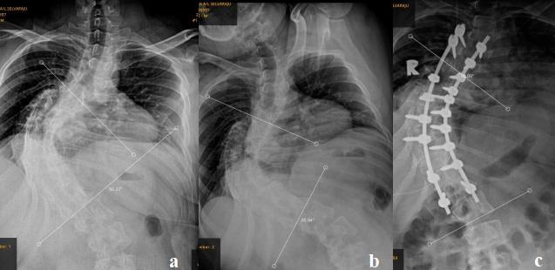

Fig. 1: Whole spine radiograph (Anteroposterior View): (a) Preoperative Cobb angle: 95 degrees. (b) Cobb angle on side bending radiograph: 95 degrees, indicating a rigid, inflexible curvature. (c) Postoperative spine radiograph: Cobb angle improved to 65 degrees

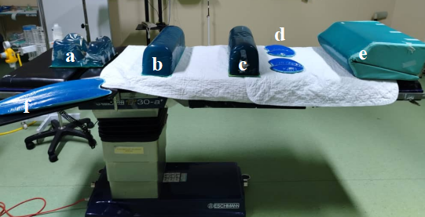
Fig. 2: Positioning Gel Pads: (a) Gel support Headrest. (b) Dome-shaped gel support for anterior chest wall. ( c ) Dome-shaped gel support for iliac crest. (d) Gel pads for knee. ( e ) Gel pad for leg. (f) Gel pad for arm.

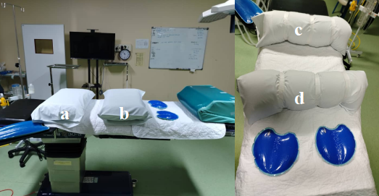
Fig. 3: (a) and (b) Pillow inside operation theatre. ( c ) and (d): Handmade rolled pillow, secured with micropore tape.

