PH as A Key Indicator of Water Quality: A Case Study on Natural and Industrial Water Sources in Malwa region

ABSTRACT

Changes in PH can affect the solubility and availability of nutrients and minerals for aquatic organisms, and low PH values can lead to the release of toxic metals from sediments. Human activities can also alter the PH of water bodies, leading to adverse effects on aquatic life and human health [1]. The relationship between water PH and the physicochemical properties of water while controlling for the influence of heavy metal and bacteriological factors using a nested logistic regression model. The study further sought to assess how these relationships are compared across confined water systems (ground water) and open water system (surface water) [2]. changes in PH can affect the solubility and availability of nutrients and minerals for aquatic organisms and low PH values can lead to the release of toxic metal from sediments. The abstract explores the contrasting nature and management of natural water resources and industrial water usage, highlighting the increasing pressure on water resources due to industrial activities and the need for sustainable water management. The industrial sector plays a significant role in global water consumption and faces mounting pressure to mitigate its environmental impact by integrating the water footprint concept with sustainable development goals (SDGs), a holistic approach to industrial water conservation can be achieved. Ground water pollution has been one of the main topics in the environmental issue of Punjab, northern India. This study was conducted to find out the pollution situation of ground water and the health problem of the surroundings residents. The results clearly determine that the water quality of Ground water may not be in a position to suitable for using domestic purpose. This is indicated by the very low dissolved oxygen (DO) levels and other measured parameters in the river. The maximum recorded values of PH, color, turbidity, biochemical oxygen demand (BOD5), hardness, total dissolved solids (TDS), chloride (Cl-), chemical oxygen demand (COD), turbidity, BOD, hardness, TDS, and COD found in the ground water of Punjab is much higher than the standard permissible limit [3].

Keywords: Natural water, Industrial water, Aquatic life, Bacteriological factors, availability of nutrients, PH of water, Turbidity, TDS, Variation of Chlorides, Variation of hardness, variation of alkalinity.

1. INTRODUCTION

Punjab is one of the leading food grain producing states in India. The studies indicate that drinking water, particularly in the Malwa belt, can be a source of heavy metals, including fluoride and pesticides [4]. The surface and subsurface water become contaminated due to Increasing population and necessities. The indiscriminate use of pesticides, fertilizers, as well as poor groundwater quality is considered to be the main reasons for the high incidence of several diseases in the Malwa belt [5]. The quality of groundwater in southwestern districts of Punjab is deteriorating due to anthropogenic pollution including excessive use of fertilizers and pesticides. The worst example of agriculturally based pollution is the contamination of ground water and drinking water with uranium in the Malwa region of Punjab. According to a report entitled ‘Water Logging in Punjab by Planning Commission’, Government of India (2013), a considerable area of southern and southwestern part of the state has nitrate concentration exceeding the critical level. High fluoride content, i.e., more than 10mg/L has been found in Fazilka, Muktsar, Bathinda, Sangrur, Barnala districts [6]. South- western region of Punjab (Muktsar) in India is known for brackish water and high fluoride content in underground water. The quality of groundwater is deteriorating leading to high TDS, due to industrial and agricultural activities in district of Muktsar, Punjab consumes about 17% of pesticides used in India. There are 234 villages constituting three tehsils (Muktsar, Malout and Gidderbaha) and four blocks (Muktsar, Malout, Lambi and Kot Bhai at Gidderbaha). Gidderbaha is the only source for both drinking and irrigation purposes [7]. Turbidity, important water quality parameter, has also been linked to pH levels. Research by Lee et al. (2013) and Zhang et al. (2019) showed that fluctuations in pH can affect the stability of suspended particles in water, leading to changes in turbidity levels. High turbidity can reduce light penetration, negatively impact aquatic plants disrupt the overall ecological balance. In this literature review shows that pH level has a significant impact on various aspects of water quality. The experimental approach employed in this study aims to further investigate and understand these relationships. By assessing a range of parameters including dissolved oxygen, nutrient availability, microbial activity, heavy metal contamination, algae blooms, turbidity and ecological health, this research provides valuable insight into the complex interactions between pH and water quality [8].

2. material and methods

Table1. Typical characteristics and ranges of iron concentration obtained from ground water samples from Bathinda district [9].
pH | 7.42 | 9.0
Specific conductivity | 312 | 5800 micromhos/cm at 25^{O}
CO₃ | Nil
HCO₃ | 132 | 1463 mg/L
Cl | 7.4 | 752 mg/L
NO₃ | 0.1 | 1140 mg/L
F | 0.14 | 7.5 mg/L
Ca | 6.2 | 189 mg/L
Mg | 2.4 | 257 mg/L
Na | 2.9 | 1450 mg/L
K | 3.9 | 665 mg/L
Total hardness as CaCO₃ | 42 | 1329 mg/L
Total Chemical content | 155 mg/L | 5923 mg/L

The suitability of groundwater for drinking and other purposes may be assessed by comparing heavy metal concentrations of the study area with the guidelines recommended by Bureau of Indian Standards (BIS, 2012). The existence of heavy metals in the groundwater of the Malwa region has been proven by earlier studies. Their origin can be traced back both to natural weathering and to discharges from mining and industrial activities in the region. Due to the toxic nature of Heavy metals, there are reasons to survey the presence of metals in the area [18]. In Malwa region of Punjab, groundwater is often alkaline with PH values ranging from 7.42 to 9.0, and the water table is experiencing fluctuation, with some areas showing declines and others rising. The ground water is moderately hard in nature with hardness value ranging from 102mg/l at Dera Bassi to 490mg/l at Hari Majra with a mean value of 244mg/l.
Turbidity: Turbidity is the measure of suspended matter in water. Suspended matter often includes mud, clay and slit. All the samples analyzed were clear and is within the permissible limit that vary from 0-10 NTU (WRC, 2003). The minimum turbidity value was recorded (0.7 NTU) at GNDT colony plant, Bathinda and maximum turbidity value of 1.47 NTU was recorded in ground water sample of Barnala. Excessive turbidity in water causes problems with water purification process.
Total Dissolved Solids (TDS): The fluctuations in electrical conductivity correlated positively with the total dissolved solids which are the common indicators of polluted water (Jayalakshmi, 2011). Total dissolved solids ranged from 301.63 mg/l (Mohali, bus stand). Sample of Sangrur, Mohali, Mansa and Muktsar shows the TDS value 556.67 mg/l, 580.83 mg/l, 549.40 mg/l and 519.83 mg/l respectively that are beyond the permissible limit of BIS Standard value of 500 mg/l. The permissible limit of TDS of drinking water is 500 mg/l (WHO,2004). The observation shows that the TDS is above the permissible range as prescribed by WHO (2004). [10]
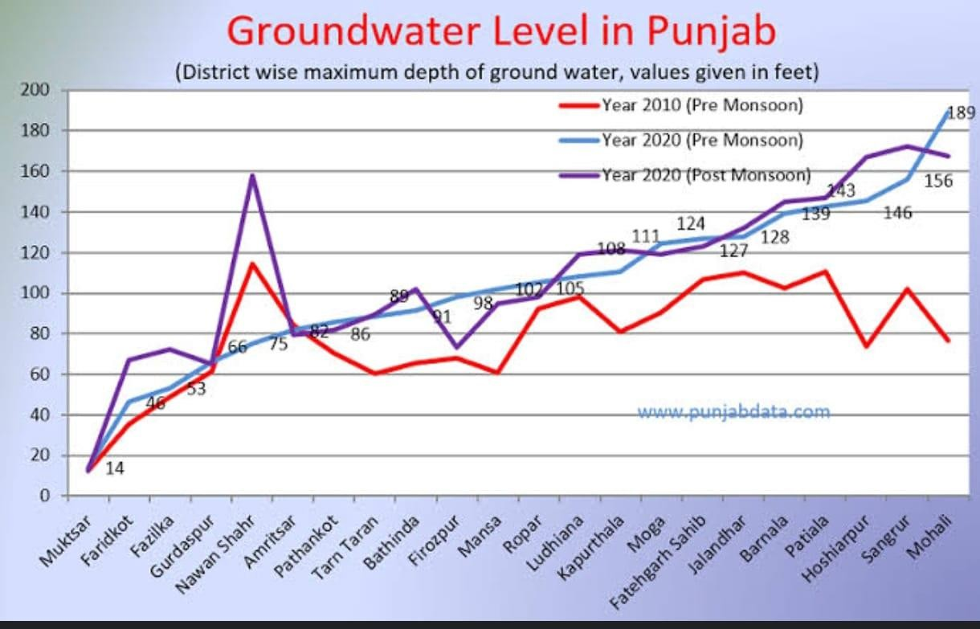
Figure1 Groundwater level in Punjab [11].

3. results and discussion

Wastewater has color, unpleasant smell and highest turbidity. Physical parameters analyzed were PH, temperature, turbidity, conductivity, total dissolved solids (TDS), Total Suspended Solids (TSS) and Total Solids (TS). Chemical characteristics analyzed were order, BOD, COD, chlorides, calcium and heavy metals such as arsenic, cadmium, chromium, nickel, and lead etc. The results were compared with desirable limits of BBIS (998) standards, IS :10500, 1991. All the wastewater samples were colored from light grey to grey and blackish. It was observed that all the samples have unpleasant Snell. PH is a measure of the acidity or alkalinity of water and most of the chemical reactions in aquatic environment are controlled by any change in PH value. PH is the most important factor in deciding the quality of wastewater or effluence. Either highly acidic or alkaline PH would kill marine life [12]-[18]. Human(anthropogenic) activities have increased because of demographic changes, consumer behavior, rapid industrialization, and urbanization, as well as the fast-growing population [13]. Decision – makers in developing countries are confronted with major new issues regarding solid/ liquid waste management. Over the last several years, many communities have increased their efforts to develop long term sustainable solutions to the solid/liquid waste management challenge [14]. Liquid waste factors have been increased such as industrial waste (chemical compound and wastewater) and municipal waste (sanitary sewers). Integrated solid waste has increased such as in the maintenance of sanitary landfills, construction, manufacturing applications, and municipal waste effluents [15]. Wastewater and other toxic compounds (heavy metals) from urban practices and industries have been discharged into surface water, which then infiltrates into ground water through soil/ rock formations. Therefore, many reasons are still unidentified, although there is very little knowledge regarding contaminant types and pathways, particularly in developed countries. Many other types of urban industrial compounds with pollution risks have not been extensively discussed in this study. Although there are still limited publications on this topic regarding human activities, the risk is becoming more widely recognized in the hydrological and environmental sciences. The use of fertilizers and pesticides in agriculture, industrial applications, and some urban practices increases the toxicity in water resources [16]. Natural water typically has a PH between 6.5 to 8.5 while industrial water’s PH can vary significantly depending on the industry and processes, potentially ranging from acidic to alkaline and often outside the natural water range.

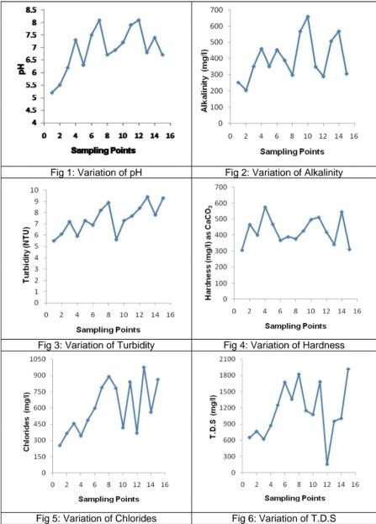
Figure2 Describes the graph between PH and variation of the PH. Turbidity, Chlorides, Alkalinity, Hardnes, T.D.S. [17].
The samples were analyzed to assess various physicochemical parameters according to this Turbidity of a water sample was determined by handheld turbidity meter which is calibrated before taking the reading (common water measurements, from USGS water Science for schools). TDS of water sample were measured using gravimetric method. The fluoride concentration in the samples was measured by fluoride ion –selective electrode method. The calorimetric and electrode method are the most satisfactory at the present time. Water samples were collected in bottles. All the precautions were taken during the sampling. The collected water samples were analyzed for different physic-chemical parameters (Table 2) such as Total solids, turbidity, pH, hardness, chloride ion, dissolved oxygen, iron ion, dissolved oxygen, iron ion and alkalinity by the standard protocols of IS:3025. All the analyses were performed in triplicate to ensure accuracy in the results [19]-[28].

Table 2. Methods used to analyze various water quality parameters.
Sr.  No. | Water quality parameters | Method of analysis
1 | Solid (TDS, TSS and volatile solids) | Water and soil analysis kit model no 161
2 | Turbidity | Turbidity meter
3 | pH | pH meter
4 | Hardness | EDTA method
5 | Chloride | Chemical method

6 | Dissolved oxygen | Winkler’s method
7 | Iron | Chemical method

4. Conclusion

The hydro chemical analysis of the study area in parts of Malwa region, Punjab (India) reveals that the groundwater is highly contaminated except for a few locations. The majority of water samples were found to be beyond desirable limits as prescribed by WHO standards and Indian standards for drinking water. Samples from almost all the location were classified as hard and contained high TDS which indicates its unsuitability for drinking. A wide variation in EC &TDS is observed in samples during both the seasons indicating the influence of climatic factors including rock water interaction as well anthropogenic activities, such as increase in pumping, excessive use of fertilizers, and discharge of industrial effluents on the hydrochemistry of the study area. The study focused on some of the major serious water resources pollution issues resulting from both natural and anthropogenic activities, Such as industrial application and agricultural practices as well as toxic contaminants, have been addressed in this study. Surface water and groundwater interactions are the main natural causes of contamination. There are case studies available that cover various issues such as surface water and groundwater quality and contaminating sources. The multitude of cases demonstrates the wide range of subjective challenges to water systems as a result of long-term supplies for human utilization and environmental protection. Challenges include food production, urban development, increased drug production, and usage, and inadequate sewage facilities, as well as declining scientific evidence on water quality. In such cases, there is a lack of water quality. Transdisciplinary study and practice can serve to gain better knowledge to understand the pollution processes, types, pathways, and their consequences on water resources. This makes for a lot of possibilities for interdisciplinary research area.

References

- Dewangan S.K., Shrivastava S.K., Tigga V., Lakra M., Namrata, Preeti (2023). Review Paper on the role of pH in water quality implications for Aquatic Life, Human Health, and Environment sustainability. Internal Advanced Research Journal in Science, Engineering and Technology.
- Saalidong B.M., Aram S.A., Otu S., Lartey P.O. (2022). Examining the dynamics of the relationship between water PH and other water quality parameters in ground and surface water systems.
- Godara N. (2016) A review study of ground water quality of Malwa region Punjab: Internal journal of applied research 395-398.
- Sharma R., (2012); Aulakh M. Khurana M, Singh D, 2009.
- Sharma R, (2018) Overall Analysis of Ground water Sample for drinking quality in eight districts of the Malwa of Punjab; Internal journal of Engineering research and application pp 53-57.
- Kaur T, Bhardwaj R, Arora S (2016) Assessment of groundwater quality for drinking and irrigating purposes using hadrochemical studies in Malwa region, southwestern part of Punjab, India.
- Sharma R. (2014). A report on ground water quality studies in Malwa region of Punjab, Muktsar. International journal of engineering Research and Application PP 70-77.
- Dewangan S.K., Toper D.N., Kujur A., (2023) Investigating the Impact of PH levels on Water Quality: An Experimental Approach. International Journal for Research in Applied Science & Engineering Technology 756 -759.
- Muhanad A; Ateel B, jatinder G, Kumar S, Singh. G, Mehtas, Rai B, Shai JS, Singh KP, Singh N, Salvastava A uranium in ground water: water lagging in Malwa region.
- Shah J., Sharma R., Sharma I. (2015). Study and Evaluation of Groundwater Quality of Malwa Region, Punjab. Journal of Chemistry, Environmental Sciences and its Application pp 41-58. www.punjabdata.com.
- Shab J., Sharma R., Sharma J. (2016). Study of the wastewater quality of Malwa region, Bathinda, Punjab, India. Internal Journal of scientific research in chemical source volume -3, issue-2, ISSN:2455-3174.
- Akhtar, N, Syakir, M.I.; Rai, S.P.; Saini, R.; Pant, N.; Anees, M.T.; QadirA.; Khan, U. Multivariate Investigation of Heavy Meatls in the Groundwater for Irrigation and Drinking in Garautha Tehsil, Jhansi District, India. Anal. Lett. 2019, 53, 774-794.
- Meffe, R.; de Bustamante, I. Emerging organic contaminants in surface water and groundwater: A first overview of the situation in Italy. Sci. Total. Environ. 2014,481,280-295.
- Abdel-Shafy; H.; Mansour, M.S. Solid waste issue: Sources, composition, disposal, recycling, and valorization. Egypt. J. Pet.2018,27,1275-1290.
- Rehman, M.S. U, Rashid, N.; Ashfaq, M.; Saif, A.; Ahmad, N.; Han, j.-I. Global risk of pharmaceutical contamination from highly populated developing countries. Chemosphere 2015, 138,1045-1055.
- Ashfaq, A., Ahmad, F. (2014). Assessment of drinking water quality: A Case Study: International Journal of Current Microbiology and Applied Sciences. PP 608-611.
- Sharma R., Dr. Datta A., (2017) A Study of heavy metal pollution in groundwater of Malwa Region of Punjab, India: Current Status, pollution and its potential health risk. Internal Journal of engineering research and application vol.7, issue 3, part 3, pp 81-91.
- Chemoinformatic and big data analytics: Revolutionizing chemical research-A review: https://doi.org/10.1063/5.0221539
- CHARACTERIZATION OF AN ENTOMOPHAGOUS MEDICINAL FUNGUS CORDYCEPS SINENSIS (BERK.) SACC. OF UTTARAKHAND, INDIA https://thebioscan.com/index.php/pub/article/view/2282
- Role of Soil Amendments in Dissipation of Chlorpyriphos in Mollisols: https://www.indianjournals.com/article/prj-22-2-009
- Governance Frameworks for Smart Systems https://doi.org/10.1007/978-3-031-76152-2_11
- Groundwater Contamination in Bathinda, India: A Case Study in the Malwa Region https://www.taylorfrancis.com/chapters/edit/10.1201/9781032665443-76/groundwater-contamination-bathinda-india-case-study-malwa-region-rajni-verma-tanu-nimisha-singh
- Effect of soil–solarization integrated with organic amendments and bio agents on population dynamics of soil microbial populations https://thebioscan.com/index.php/pub/article/view/259
- Future Directions in Computational Intelligence: Anticipating the Next Wave: https://doi.org/10.1007/978-3-031-96871-6_3
- Revolutionizing Mental Healthcare with Generative Deep Learning Techniques for Enhanced Diagnosis and Treatment: https://doi.org/10.1007/978-3-031-91147-7_17
- Physio-Chemical Analysis on Assesment of Ground water in Malwa region https://www.thepharmajournal.com/archives/?year=2023&vol=12&issue=1&ArticleId=18344
- Vegetable Grafting: Surgical tool for yield enhancement and nematode resistance under vegetable production systems https://www.thepharmajournal.com/archives/?year=2023&vol=12&issue=1&ArticleId=18324

