Original Research Article
HEALTH RISK REDUCTION OF ORGANOCHLORINE PESTICIDES (OCPs)
VIA SOURCE CONTAMINATION IDENTIFICATION AND CONTROL IN
WATER, SEDIMENT AND FISH IN IKOT EKPENE RIVER, NIGERIA

Abstract
The objective of the study was to determine the levels of organochlorine pesticides (OCPs) in the water, sediment and fish samples in Ikot Ekpene River, identify their sources of contamination and their control for health risk reduction. Water, sediment and fish samples were collected from different sampling locations in wet and dry seasons and analysed using atomic absorption spectrometer (AAS). Concentration of the pesticides obtained varied across sampling locations and seasons. Principal Component Analyses (PCA) and factor loading plots for OCPs sources of contamination in water, sediment and fish showed both positive loading in most cases and negative loadings in few, reflecting similarity and dissimilarity of sources of contamination respectively. PCA and factor loading in water samples during dry season, revealed that p,p’DDT (-.416) and endrine aldehyde (-.481) had same source of contamination. Alpha-BHC (.463) and heptachlor expoxide (.983) had similar source contamination while the source of p,p’DDE (-.077) contamination was different. In wet season, p’p’-DDE (.838), p’p’-DDT (.958) and Alpha-BHC (.744) were the only OCPs with similar source of contamination while the sources of others were different. In sediment samples, during dry season, heptachlor (.989) and beta-BHC (-.622) had different sources of contamination while the other OCPs had same source of contamination. In wet season, Delta-BHC (.867), Dieldrin (.858) and p’ p’-DDE (.865) had same source of contamination but different from source of heptachlor (.867) and heptachlor-expoxide (.665). In fish during dry season, Alpha Chlordane (.983), Dieldrin (.990), Endosulfan 1 (.990) and Endosulfan 11(.990) had similar source of contamination while p’p’-DDE (-.932) , p’p’-DDD (-.337) and Endrin-Ketone (-.340) had different source of contamination. In wet season, all the OCPs in fish had almost same source of contamination as they were in the same quadrant in the loading plot. With the identification of the sources of OCPs in the various matrix and routine monitoring to ensure total compliance to safe and regulated anthropogenic activities around the study area, levels of the OCPs in the samples and the corresponding health risk associated would be drastically reduced.
Keywords: Organochlorine pesticides, Water, Sediment and Fish, Ikot Ekpene River, AAS, Health eisk, Statistical Analysis

1.0: Introduction

Persistent organic pollutants (POPs) and other chemical species abound in aquatic ecosystem from different sources. These sources include industrial discharge of untreated effluents, agricultural runoff, atmospheric deposition, indiscriminate wastes disposal among sources. Persistent organic pollutants are hazardous organic chemical compounds that are resistant to biodegradation and thus remain in the environment for a long time. They are organic compounds that are resistant to environmental degradation, through chemical, biological and photolytic processes. They are chemicals of global concern because of their persistence and bioaccumulating tendencies in food chain and potential adverse effects on humans and the environment. Higher levels of biological and chemicals agents in water, sediment and fish are potentially harmful to humans as a result of exposure (El- Barbary et al., 2008). Persistent organic pollutants find their ways into the aquatic environment from a variety of sources including the naturally occurring biogeochemical cycles such as carbon, nitrogen, water, oxygen (El- Barbary et al., 2008 and Akpan et al., 2024).
Organochlorine pesticides (OCP_{S}) is a class of persistent organic compounds that have been widely used in the past for agriculture to boost food production, storage as pesticides and herbicides but due to their environmental persistence, accumulation in the food chain and associated human health risk, they have been banned over the years. They are among the major types of pesticides notorious for their high toxicity (Darko et al., 2008). Biological samples (fish, aquatic and terrestrial mammals and birds) as well as sediment have higher concentrations of most OCP_{S} than water or air, making them more suitable for routine monitoring and more relevant in the context of exposure of humans and wildlife (Akpan et al., 2024). “Fish accumulates some organic chemicals particularly OCP_{S} in its fatty tissues due to its inability to metabolise them in the food they eat and from the intake of particulates in water and sediment unto which these chemicals have been adsorbed” (Ido et al., 2023). “The region of accumulation of pesticides within fish varies with the route of uptake. The gills are directly in contact with water. Therefore, the concentration of pesticides in gills reflects their concentration in water where the fish live” (Akpan et al., 2025). “The average concentration of these OCP_{S} increases dramatically across a food chain. The bioaccumulation of organochlorines in fish and other animals is the reason most of the human daily intake of such chemicals come from our food supply rather than from water” (Ido et al., 2023; Udombeh et al., 2025).
“The potential use as bio-monitors is therefore significant in the assessment of bioaccumulation and biomagnifications of contaminants within the ecosystem (Ogbaji et al., 2025). It has been found that greater than 80% of the total intake of pesticide residues in human beings is through the food chain” (Akpan et al., 2015). OCP_{S} are carbon based chemicals that last for many years in the environment; are harmful to the environment, wildlife and people; accumulate in the food chain and are passed through it; can be transported for very long distances, all over the world. These chemicals have been used in Ikot Ekpene over the years, both for agricultural and public health purposes, with their residues being detected in water, sediment, food and in humans (Ido et al., 2023; Udosen 2019). Although the production and use of many types of OCPs have been severely limited in many countries including Nigeria, they are nevertheless still being used unofficially in large quantities in parts of ikot Ekpene because of their effectiveness as pesticides and their relatively low cost (Equani et al., 2013; Akpan et al., 2024) as well as inadequate regulation and management on the production, trade and use of these chemicals (HYPREP, 2023).
Ikot Ekpene River is a large river in Akwa Ibom State and an important inland water resource in the State which flows through farming regions where these chemicals have been used for agriculture. The short distance between agricultural field and water ways also increase the probability of agrochemicals reaching water ways via agricultural run-off. The presence of such foreign chemicals including pesticides in the river, could readily affect the vital fish population. This is because fish has the tendency to bioaccumulate these hydrophobic chemicals in its tissues and organs and is a suitable indicator for environmental pollution monitoring (Equani et al., 2013; Ohaturu et al., 2025).
In the assessment of exposure to pollution, the emission pathway has to be determined. Also to be determined are the rate of movement of a substance and its transformation or degradation of the concentration to which human population or environmental species (water, soil or air) may be exposed.
Water, sediment and fish are the ultimate reservoirs of these persistence organic chemicals, they often accumulate them in such a way that can cause health problems such as kidney and liver damage, central nervous system damage, thyroid and bladder damage as well as kidney and liver cancer in animals that depend directly or indirectly on the fish and the water bodies (Akpan et al., 2025; Ohaturu et al., 2025). However, information on sources of the emerging trends of pollutant such as OCP_{S} in the aquatic systems which are water, sediment and fish samples are non existent, therefore, there is every need to determine potential sources of OCP_{S} in water, sediment and fish in the river to determine measures for their control and health risk reduction through sustainability.

2.0: Material and Methods

2.1: Study Area: The study area is Ikot Ekpene River in Akwa Ibom State. It is located between latitude 4o35’0’’ and 4o4’0’’North of theequator and between longititude 7o45’0’’ and 7’’50’’ east of Greenwich Meridian.

2.2: Samples Collection and Methods of Analysis
Samples were collected from three sampling locations namely; Uwa, Nto Nsek Afaha and Afaha Ikot Ebak for one year covering both wet and dry seasons. In the field, the sampling bottles were pre-rinsed many times with water from the different sampling points prior to collection. Water samples were collected with one litre (IL) polyethylene bottles with caps and stored in an ice-box containing ice block and transported immediately to the laboratory for analysis (Ido et al., 2023; Abugu et al., 2023).
.

Map 1: THREE SAMPLING LOCATIONS OF AFRICA - UWA, NTO NSEK AFAHA AND AFAHA IKOT EBAK
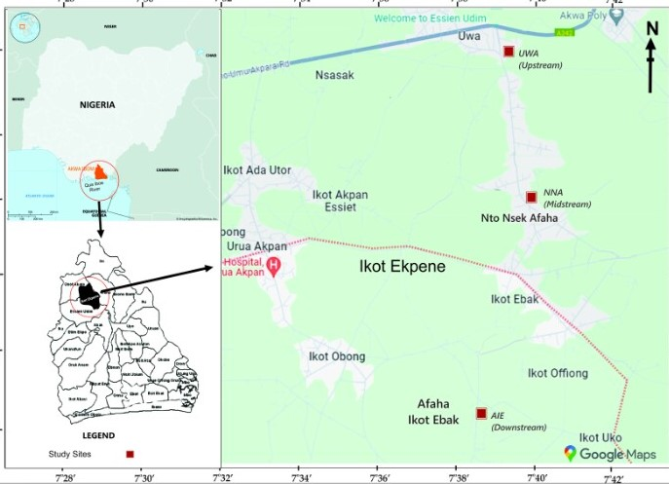

OCPs | Dry season |  |  | Wet season
OCPs | PCA 1 | PCA2 | PCA1 | PCA2 | PCA3
Alpha-BHC | .463 | .861 | .744 | -.149 | .520
Beta-BHC | .485 | -.093 | - | - | -
Heptachlor | .625 | .758 | .095 | -.200 | .830
Delta-BHC | .980 | -.023 | - | - | -
Aldrin | .945 | -.043 | - | - | -
Heptachlor-Epoxide | .983 | -.017 | -.119 | .893 | -.132
Gamma-chlordane | .995 | -.005 | -.303 | .501 | .622
P,P’-DDE | -.077 | .872 | .838 | -.012 | -.079
Dieldrin | .996 | -.008 | - | - | -
P,P’-DDD | .922 | .018 | - | - | -
P,P’-DDT | -.416 | .836 | .958 | -.111 | -.014
Endrin-aldehyde | -.481 | .696 | .652 | .632 | -.030
Eigen value | 6.900 | 3.271 | 2.714 | 1.522 | 1.372
% Variance | 57.497 | 27.258 | 38.776 | 21.748 | 19.603
Cum % | 57.497 | 84.755 | 38.776 | 60.524 | 80.127
Table 1: PCA for the source of OCPs contaminants in surface water in dry and wet seasons

PCA = Principal Component Analysis.

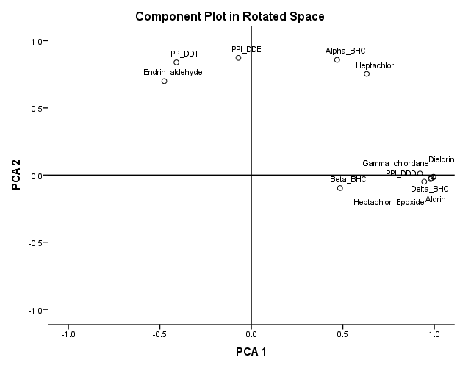
Figure 1: PCA for source of OCPs contaminants in surface water for dry season

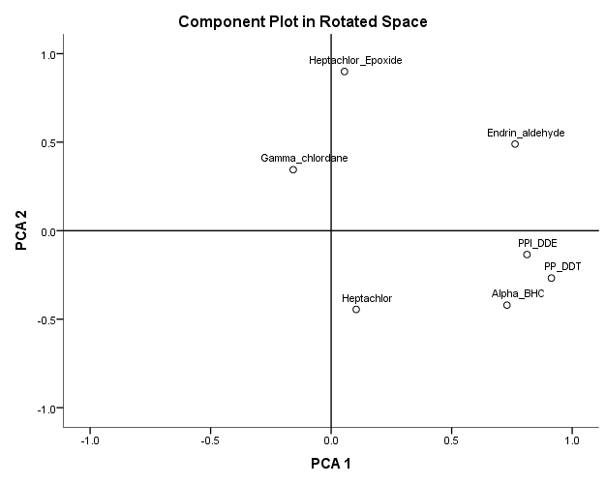
Figure 2: PCA for source of OCPs contaminants in surface water for wet season

Table 2: PCA for the source of OCPs contamination in sediment in dry and wet season
 | Dry season |  | Wet season
 | PC1 | PC 2 | PC1 | PC 2 | PC3
Alpha-BHC | .981 | .012 | .245 | .761 | -.343
Beta-BHC | .718 | -.622 | -.088 | .905 | -.015
Heptachlor | .148 | .989 | .867 | -.324 | -.015
Delta-BHC | .960 | -.151 | .820 | .329 | -.256
Aldrin | .974 | -.155 | .091 | .977 | -.076
Heptachlor-Epoxide | .900 | -.053 | .665 | -.480 | -.476
Gamma-chlordane | .957 | .259 | .524 | .632 | .477
P,P’-DDE | .982 | .105 | .865 | .213 | .027
Dieldrin | .968 | -.229 | .858 | .233 | .378
P,P’-DDD | .895 | .247 | .012 | -.265 | .906
Eigen | 7.800 | 1.606 | 3.700 | 3.364 | 1.609
% variance | 77.999 | 16.065 | 36.998 | 33.641 | 16.087
Cum % | 77.999 | 94.064 | 36.998 | 70.639 | 86.726

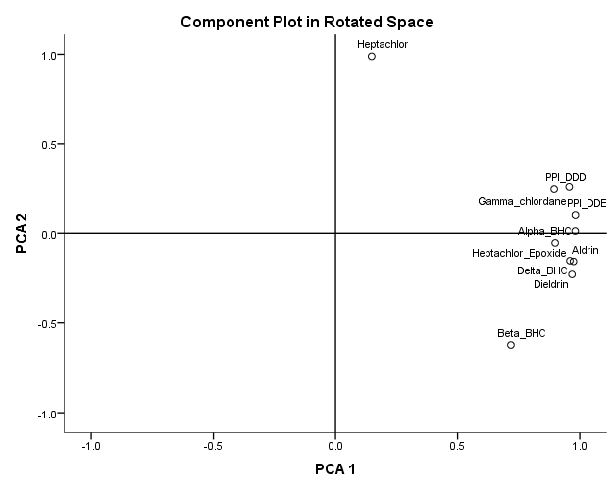
Figure 3: PCA for source of OCPs contaminants in sediment for dry season

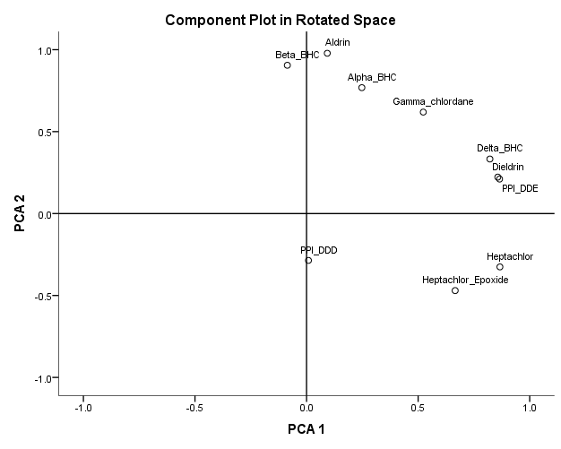 Figure 4: PCA for source of OCPs contaminants in sediment for wet season

Table 3: PCA for the source of OCP contaminants in fish in dry and wet seasons
OCPs | Dry |  |  | Wet
OCPs | PCA1 | PCA 2 | PCA 3 | PCA 1 | PCA 2
Beta-BHC | -.327 | .876 | -.045 | .743 | .230
Delta-BHC | .076 | .794 | .533 | .841 | .447
Aldrin | .266 | .769 | -.117 | .977 | .139
Gamma-chlordane | -.400 | .634 | .298 | .845 | .508
Alpha-Chlordane | .983 | .116 | -.020 | - | -
Endosulfan1 | .990 | .113 | .010 | .956 | .220
P,P’-DDE | -.932 | .157 | -.091 | .368 | .868
Dieldrin | .990 | .102 | -.020 | - | -
Endrin | .289 | .928 | .096 | .228 | .882
P,P’-DDD | -.337 | -.043 | .919 | .299 | .830
Endsulfan ll | .990 | .106 | -.019 | - | -
P,P’-DDT | .159 | .921 | .101 | .545 | .729
Endrin-aldehyde | .307 | .828 | .302 | .098 | .900
Endosulfan-sulphate | .461 | .256 | .830 | .942 | .271
Methoxychlor | -.509 | .748 | -.280 | .712 | .581
Endrin-ketone | -.340 | -.314 | -.256 | .664 | .655
Eigen value | 6.020 | 5.583 | 2.187 | 6.262 | 4.980
% Variance | 37.625 | 34.896 | 13.667 | 48.169 | 38.306
Cum % | 37.625 | 72.521 | 86.188 | 48.169 | 86.475

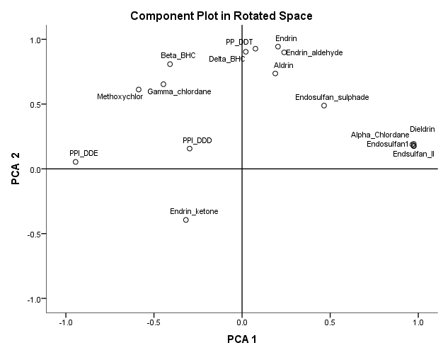
Figure 5: PCA for source of OCPs contaminants in fish for dry season.

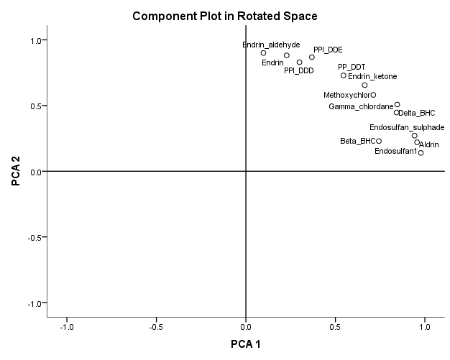
Figure 6: PCA for source of OCPs contaminants in fish for wet season

2.4: Quality Assurance
Quality assurance of the analytical data was guaranteed through the implimantation of standards laboratory quality assurance and laboratory methods, including the use of standard operating procedures and calibrations with standards. All chemicals and reagents used were of analytical grade.

2.5: Statistical Analyses
The data generated in this research were subjected to descriptive statistical analysis using statistical package for social science (SPSS).

3.0: Results and Discussion

3.1: PCA of OCPs Contaminants in Surface Water During Wet and Dry Seasons

Results of OCPs source contamination in water samples for wet and dry seasons are as shown in Table 1 which indicated that two PCAs were extracted in dry season which accounted for 84.755% of the variation in the data set with PCA 1 and PCA 2 accounting for 57.497% and 27.258% respectively. All the OCPs loaded well on PCA 1 with positive high loadings from Dieldrin, Gamma-chlordane, Delta-BHC, Heptachlor-Epoxide, p,p’-DDD, Heptachlor, Beta-BHC, Alpha-BHC, and negative loadings from Endrin-aldehyde and p,p’-DDT. For PCA 2, Alpha-BHC, Heptachlor, p,p’-DDE and Endrin-aldehyde showed positive loadings. The factor loading plot shown in Figure 1 revealed that during dry season, p,p’-DDT and Endrin-aldehyde had the same source of OCPs contamination, Alpha-BHC and Heptachlor had similar source of contamination but the source of p,p’-DDE contamination were different. Other OCPs such as Gamma-chlordane, Dieldrin, p,p’-DDD, Delta-BHC, Heptachlor-Epoxide were also found to have same source of contamination.
For wet season, results of OCPs source contamination established three PCAs with cumulative percentage variance of 80.127% with high positive loadings from p,p’-DDT, p,p’-DDE, Alpha-BHC and Endrin-aldehyde on PCA1, Heptachlor-Epoxide, Endrin-aldehyde and Gamma-chlordane on PCA 2 while Heptachlor and Alpha-BHC showed high positive loading on PCA 3 which accounted for 19.603% of the variation in the data set. The loadings plot in Figure 2 revealed that p,p’-DDE, p,p’-DDT and Alpha –BHC were the only OCPs with similar source of contamination while the sources of other OCPs were different.

3.2: PCA of OCPs Source Contaminants in Sediment for Wet and Dry Seasons

Results in Table 2 revealed OCPs source contamination in sediment in both dry and wet seaons. During dry season, two PCAs were extracted which accounted for 94.064% of the variation in the data set with PCA 1 and PCA 2 accounting for 77.999% and 16.065% respectively. All the OCPs excluding Heptachlor reported high positive loadings on PCA 1 while on PCA 2, Heptachlor showed high positive loadings while Beta-BHC (.989) showed high negative loading (-.622). Loading plot in Figure 3 showed that Heptachlor and Beta-BHC had different sources of contamination while other OCPs had same source of contamination. For wet season, three PCAs with cumulative percentage variance of 86.726% were extracted with high positive loadings from Heptachlor, Delta-BHC, Heptachlor-Epoxide, Gamma-chlordane, p,p’-DDE and Dieldrin on PCA 1, high positive loadings from Alpha-BHC, Beta-BHC, Aldrin and Gamma-chlordane on PCA 2 while on PCA 3, only p,p’-DDD showed high negative loading (.906). The loadings plot in Figure 4 for sediment in wet season showed that Delta-BHC, Dieldrin and p,p’-DDE have same source of contamination, Heptachlor and Heptachlor-Epoxide have same source of OCPs contaminants while the sources of contamination of other OCPs were different.

3.3: PCA of OCPs Source Contaminants in Fish for Wet and Dry Seasons

Results of OCPs source contamination shown in Table 3 revealed that during dry season, three PCAs were extracted which accounted for 86.188% of the variation in the data set with PCA 1 accounting for 37.625% while PCA 2 and PCA 3 explained 34.896% and 13.667% respectively. On PCA 1, Alpha-Chlordane, Endosulfan1, Dieldrin and Endsulfan ll showed high positive loading while p,p’-DDE and Methoxychlor showed high negative loading. On PCA 2, Beta-BHC, Delta-BHC, Aldrin, Gamma-chlordane, Endrin, p,p’-DDT and Endrin-aldehyde, showed high positive loadings while on PCA 3, Delta-BHC, p,p’-DDD and Endosulfan-sulphade showed high positive loadings. The loadings plot in Figure 5 for dry season showed that Alpha-Chlordane, Dieldrin, Endosulfan1 and Endsulfan ll had similar source of contamination. Also Endrin, Aldrin and Endrin-aldehyde had similar source of contaminants while p,p’-DDE, p,p’-DDD and Endrin Ketone had different sources of contaminants. For wet season, two PCAs with cumulative percentage variance of 86.475% were extracted. PCA 1 accounted for 48.169% with high positive loadings from Beta-BHC, Delta-BHC, Aldrin, Gamma-chlordane, Endosulfan1, p,p’-DDT, Endosulfan-sulphade, Methoxychlor and Endrin-ketone while on PCA 2 that accounted for 86.475%, Gamma-chlordane, p,p’-DDE, p,p’-DDD, Endrin-aldehyde, Methoxychlor and Endrin-ketone showed high positive loadings. The loadings plot as shown in Figure 6 revealed that all the OCPs had almost same source of contaminations as all the OCPs are in the same quadrant in the loading plot.

4. Conclusion
The result of the determination of organochlorine pesticides (OCPs) concentration and source of contamination in water, sediment and fish samples from the study area revealed positive loadings of some OCPs, which implies similar source of contamination and negative loadings of few OCPs in all the samples which indicated different sources of contamination. Higher concentrations OCPs were recorded in samples obtained from locations of tremendous anthropogenic activities reflecting their potential sources. The PCA analysis of the OCPs in water, sediment and fish samples showed positive correlation coefficients at P < 0.05 and P < 0.01. Regulation of safe practices of anthropogenic activities across the sampling locations and proper wastes disposal methods by riverine communities would serve as potential measures for reduction of the concentration of the OCPs pollutants to permissible limits in the various matrix with a potential of corresponding risk reduction to exposed population.

References:
- Abugu, H. O., Ezugwu, A. L. and Ihedioha, J. N. (2023). Assessment of Polycyclic Aromatic Hydrocarbon contamination of fruits leaves, and soil within automobile repair worsops in Nsuka Metropolis. Polycyclic Aromatic Compounds, 43(09), 8333 – 8355. https://doi.org/10.1080/10406638.2022.2149567

- Adeyemi, D., Ukpo, G., Anyakora, C. and Unyimadu, J. (2008). Organochlorine Pesticide residues in fish samples from Lagos Lagoon. American Journal of Environmental Sciences, 4, 649 – 659. https://doi.org/10.3844/ajessp.2008.649.653

- Akan, J. C., Chellube, Z. M., Ahmed, I. A. and Abdulraham, F. I. (2013). Organochhlorine and Organophosphorus Pesticides Residues in Water Samples from Alau Dam, Borno State, Nigeria. Cemical Society of Nigeria, 2(2), 328 – 331.
- Akpan, N. A., Udombeh, R. B., Ukpong, M. B., & Iboroakam,E. U. (2024). Effects of human activities on trace metals in Qua Iboe River, Ikot Ekpene stretch, Akwa Ibom State, Nigeria. International Journal of Science Research Archive, 11(01), 2120-2128 https://doi.org/10.30574/ijsra.2024.11.1.0117
- Akpan N. A., Udomeh R. B., Ukpong M. B. and Udosen I. E. (2024). Impacts of Human Activities on Trace metals of Qua Iboe River, Ikot Ekpene Stretch, Akwa Ibom State, Nigeria. International Journal of Science and Research Archieve. 11(01). 2120-2128. https://doi.org/10.30574/ijsra.2024.11.1.0117

- Akpan N. A. (2024) Human Health Risk Assessment of Some Trace Metals through Fish Consumption from Qua Iboe River, Oruk Anam, Nigeria. Asian Journal of Environment and Ecology. 23(05), 19-29 https://doi.org/10.9734/ajee/2024/v23i5544

- Akpan N. A., Rosemary B. U and Mfon B. U. (2025). Human Health Assessment of Organochlorine Pesticides in Commercial Fish from Qua Iboe River, Nigeria. Chemical Science International Journal, 34(02), 86 – 96.
- Darko, G., Akoto, O., Oppong, C (2008). Persistent organochlorine pesticide residues in fish, sediment and water from Lake Bosomtwi, Ghana. Chemosphere, 72, 21 – 24. https://doi.org/10.1016/j.chemosphere.2008.02.052

- El-Barbary, A., Yehia, M., and El-Bouraie, M. (2008). Evaluation of organochlorine pesticides (OCPs) in surface water and bed sediments samples from the Nile River at Rosetta branch, Eygpt. Journal of Applied Science Resources, 4, 1985 – 1993.

- Equani, S. A., Malik, R. N., Cincinelli, A., Zhang, G., Mohammed, A., Qadir, A., Rashid, A., Bokhari, H., Jones, K. and Katsoyiannis, C. (2013). Organochlorine pesticides (OCPs) and Polychhlorinated biphenyls (PCBs) by river water fish: The case of River Chenab. Science of the Total Environment, 45, 83 – 93. https://doi.org/10.1016/j.scitotenv.2013.01.052

- Hydrocarbon Pollution Remediation Project (HYPREP). (2023). Annual progress Report on Ogoniland remediation, Port Harcourt: Federal Minitry of Environment.

- Norman, J. E., Kuirvila, K. M. and Norwell, L. H. (2012). Prioritizing pesticides compounds for analytical methods development. U. S. Geological Survey Scientific Investigations Report 5041, 201. https://pubs.usgs.gov/sir/2012/5045/

- Ogbaji H.O., Akpan N. A., Ijioma C. C., Okpoji A. U., Eze V. C. Obi J. N., Martins N. P and Etesin Monday U. (2025). Seasonal Variation in Hydrocarbon Contamination of Sediments and Biota in Bonny Estuary, Rivers State, Nigeria. Asian Journal of Geographical Research, 08(04), 330 – 338. https://doi.org/10.9734/ajgr/2025/v8i4341

- Ohaturuonye S. O., Okpoji A. U., Akpan N. A., Njoku C. A., Isaac S. C., Etesin M. U. and Ekwere I. O. (2025). Biomarkers Responses in Fish and Crustaceans Exposed to Heavy Metals and Petroleum Hydrocarbons in the Qua Iboe Estuary, Niger Delta. Asian Journal of Research in Zoology, 08(04), 234 – 244. https://doi.org/10.9734/ajriz/2025/233

- Okpoji A. U., Akpan N. A., Eze V. C., Ijioma C. C., Hassan D. H., Kareem M. M., Obi Am I., Aningo G. N. Okoye P. I., Ogbonnaya C. N., Ekwere I. O., Okeke F, and Aligwo M. C. (2025). Toxicity and Bioaccumulation of Heavy Metals and Polycyclic Aromatic Hydrocarbons in Estuarine Fish from the Andini Estuary, Niger Delta, Nigeria. Journal of Applied Physical Science International, 17(02), 10 – 22. https://doi.org/10.56557/japsi/2025/v17i210026

- Rosemary B. U., Akpan, N. A. and Emmanuel I. U. (2025). Human Health Risk Assessment of Polychlorinated Biphenyls (PCBs) in Fish from Eniong River, Nigeria. Asian Journal of Environment and Ecology, 24(10), 85 – 100. https://doi.org/10.9734/ajee/2025/v24i10803

- Rosemary B. U. and Akpan, N. A. (2025). Impact Assessment of Anthropogenic Activities on Heavy Metals in Water and Sediment in Eniong River, Nigeria, International Research Journal of Pure and Applied Chemistry, 26(06), 110 – 119. https://doi.org/10.9734/irjpac/2025/v26i6963

- Udosen, E. D. (2019). Enviro-chemical pollutaqnts: The unwelcome yet unavoidable uman companions (68th inaugural lecture). University of Uyo, University of Uyo press Ltd.

- Ido, U. H., Akpan, N. A., Udombeh, R. B., & Udoidiong, O. M. (2023). Bioaccumulation of trace metals in fish from Issiet River, Uruan, Nigeria. Science Journal of Analytical Chemistry, 11(4), 40-48. https://doi.org/10.11648/j.sjac.20231104.11

