A RESEARCH ON INNOVATING METHODS
FOR ASSESSING CHEMICAL COGNITIVE COMPETENCE IN TEACHING
THE HALOGEN GROUP

.
ABSTRACT

Chemical cognitive competence is fundamental for applying acquired knowledge and skills and for exploring the natural world from a chemical perspective. Innovating methods for assessing chemical cognitive competence contributes to improving the quality of teaching and learning activities, thereby fostering learners’ competencies and qualities. This article presents several innovations in the methods used to assess chemical cognitive competence in teaching the Halogen group.

Keywords: halogen, assessment, process, tools, cognitive competence

1. INTRODUCTION
In 1993, the Ministry of Education and Training conducted a series of activities, including organizing numerous meetings and workshops in collaboration with foreign experts, aimed at researching new forms of testing and assessment. By 1995, the course “Educational Assessment” was officially introduced in teacher training institutions. Proposals for innovating knowledge assessment in the context of fundamental and comprehensive educational reform have since emerged.
Since then, numerous studies have explored assessment methods, such as innovative assessments for developing problem-solving competencies and research on objective testing methods to evaluate learning outcomes, among others.
Specifically in chemistry education, several studies have focused on testing and assessment in teaching chemistry, such as “Assessment of High School Students Based on the Development of Chemistry Competencies and Qualities” and “Developing Problem-Solving and Creativity Skills through Teaching the Halogen Unit”. However, these studies have shown limited effectiveness, and most teachers have not yet had access to these approaches.
Developing a suitable set of assessment tools can effectively monitor both the teaching process and the extent to which learning objectives are achieved. Nevertheless, the number of studies and resources on designing and applying assessment tools remains limited. For these reasons, creating assessment tools for evaluating students’ chemical cognitive competence in teaching the Halogen group is essential for teachers currently engaged in instruction.

2. OVERVIEW OF ASSESSMENT IN EDUCATION
2.1 Some General Issues on Assessment in Education
Assessment in education is a systematic process of collecting, synthesizing, and interpreting information about the subjects being assessed (e.g., learners’ cognition and competencies, curricula, schools, etc.) for the purpose of gaining a deeper understanding and using this information to make decisions related to students, curricula, schools, or educational policies.
In contemporary education, assessment is not only a tool for measuring learning outcomes but also an integral component of the teaching and learning process. Through continuous and well-designed assessment activities, educators can monitor learners’ progress, identify strengths and weaknesses, and adjust instructional strategies to better meet learners’ needs. Assessment data provide valuable evidence for improving curriculum design, teaching methods, and learning environments, thereby enhancing educational quality and effectiveness. In addition, assessment supports learners’ development by offering timely feedback that helps them reflect on their learning processes and outcomes. When aligned with clearly defined learning objectives and competency frameworks, assessment contributes to fostering higher-order thinking skills, problem-solving ability, and the application of knowledge in real-world contexts. Thus, assessment plays a critical role in ensuring coherence between educational goals, instructional practices, and learner development, while also serving as a foundation for informed decision-making at both classroom and policy levels.
In current teaching practice, two main forms of assessment are commonly applied: formative assessment (ongoing assessment) and summative assessment (periodic assessment).
Formative assessment, also referred to as ongoing assessment, is conducted during the teaching and learning process. It provides feedback to both teachers and learners with the aim of improving teaching and learning activities. Commonly used tools include observation sheets, rating scales, checklists, assessment forms, criterion-referenced assessment sheets, questionnaires, portfolios, and various types of oral or written questions.
Summative assessment is the evaluation of learners’ educational outcomes after a period of learning and practice. Its purpose is to determine the extent to which learners have achieved the learning objectives specified in the curriculum and the degree to which their competencies and qualities have been developed. The tools used in summative assessment are similar to those in formative assessment, including observation sheets, rating scales, checklists, assessment forms, criterion-referenced assessment sheets, questionnaires, portfolios, and various types of oral or written questions.
When appropriately combined, formative and summative assessment create a comprehensive framework for monitoring learning progress and evaluating learning outcomes. Formative assessment supports timely instructional adjustment and individualized learning support, while summative assessment provides evidence for certification, grading, and curriculum evaluation. The complementary use of these two forms enhances the reliability and validity of assessment results. Moreover, diversified assessment tools allow teachers to capture learners’ cognitive development from multiple perspectives rather than relying on a single testing method. This integrated approach contributes to improving the overall quality and effectiveness of teaching and learning.
Moreover, assessment serves as a strategic instrument for fostering chemical cognitive competence, enabling learners to transform abstract chemical concepts into meaningful understanding and practical application. Through continuous feedback and reflective assessment activities, students are guided to analyze chemical phenomena, interpret experimental data, and establish logical relationships between structure, properties, and reactivity. Such processes enhance scientific reasoning, conceptual accuracy, and problem-solving capacity in chemistry learning. The integration of authentic assessment forms, including experimental tasks, case-based problems, project-based learning, and digital assessment platforms, creates opportunities for learners to demonstrate higher-order cognitive skills in real-world contexts. These approaches encourage active inquiry, promote evidence-based thinking, and strengthen the ability to apply chemical knowledge flexibly and creatively. In contemporary chemistry education, assessment is no longer viewed merely as a tool for grading, but as a dynamic mechanism that continuously shapes learning pathways, supports competency development, and ensures the alignment between instructional objectives and students’ chemical cognitive growth.
2.2 Current Status of Using Tools to Assess Chemical Cognitive Competence
Through surveys and evaluations of chemical cognitive competence in chemistry teaching at several schools in Hanoi, and by analyzing and statistically processing the collected data, the research team identified critical issues that serve as a foundation for innovating methods to assess chemical cognitive competence. The results provide an overview of the current status of assessment practices, highlighting both existing strengths and limitations in implementation. These findings help clarify practical needs and challenges faced by teachers, thereby offering reliable empirical evidence to support the design and improvement of more effective assessment tools. From a practical perspective, the survey data indicate that assessment in chemistry classrooms remains dominated by traditional testing formats, with limited application of diversified and competency-oriented tools. Many teachers continue to prioritize written examinations because they are convenient to administer and score, although these methods provide limited evidence of students’ deeper cognitive processes and problem-solving abilities. This heavy reliance on conventional assessment reduces opportunities to evaluate analytical thinking, experimental reasoning, and real-life application of chemical knowledge. In addition, inconsistencies in assessment criteria and the absence of standardized tools pose challenges to objectivity, reliability, and comparability across schools. These findings highlight the need to redesign assessment frameworks by integrating formative feedback, authentic tasks, and clear performance indicators.
Survey results on the awareness of the importance of developing chemical cognitive competence (Fig. 1) show that the majority of teachers (84%) have a correct understanding of the significance and necessity of developing students’ competencies, particularly in chemical cognition.
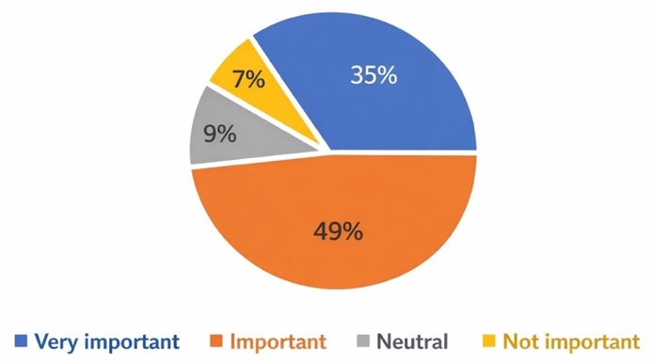
Fig. 1. Awareness of the Importance of Developing Chemical Cognitive Competence
The survey results on the level of interest in changing assessment methods, as illustrated in Fig. 2, indicate that this interest has not been consistent among respondents. Specifically, only about 56% of participants expressed a clear interest in innovating assessment practices, suggesting that a considerable proportion of teachers remain hesitant or insufficiently motivated to move away from traditional assessment approaches. This highlights a potential barrier to educational reform, as teacher engagement is crucial for successful implementation. Encouraging professional development and providing clear examples of effective alternative assessments may help increase willingness to adopt new methods.

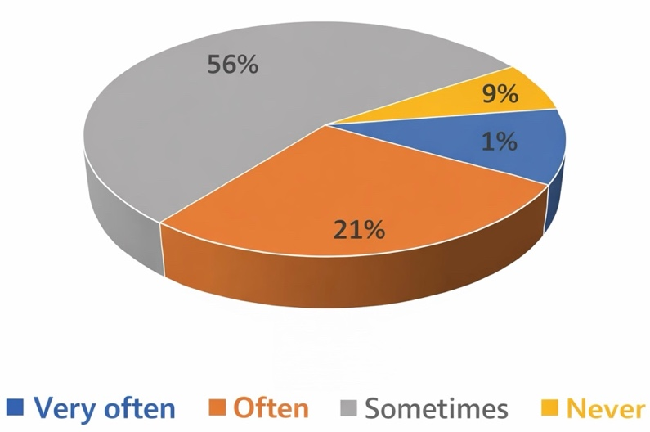
Fig. 2. Level of Interest in Changing Assessment Methods
Most teachers recognize the benefits of changing assessment methods in chemistry teaching to foster learners’ competencies, particularly their chemical cognitive competence. Assessment innovation can be implemented through a variety of approaches rather than relying solely on traditional tests, enabling students to better comprehend knowledge, develop deeper conceptual understanding, and improve long-term retention. These diversified assessment practices also promote active learning, critical thinking, and meaningful engagement in the learning process. As a result, students’ chemical cognitive competence is significantly enhanced, as shown in Table 1.
Table 1. Benefits of Changing Assessment Methods in Chemistry Teaching
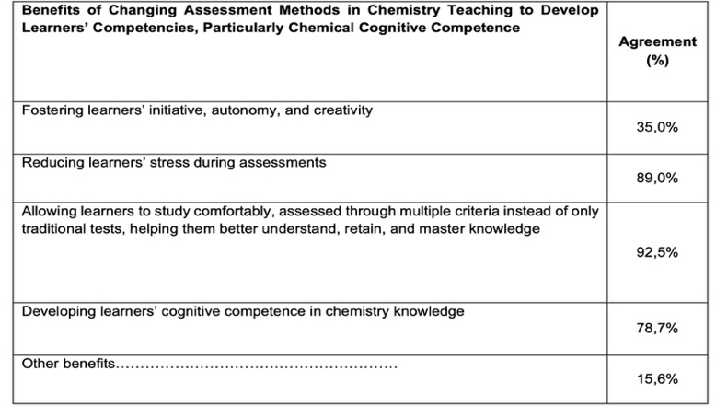
Furthermore, adopting varied assessment strategies can reduce learners’ stress during evaluations, creating a more supportive and motivating learning environment. Encouraging students’ initiative, autonomy, and creativity allows them to take ownership of their learning and explore concepts in depth. Teachers have observed that multiple-criteria assessments help learners retain knowledge longer and understand it more thoroughly. While the majority of educators see these benefits, some remain hesitant, highlighting the need for professional development and guidance in implementing new assessment methods. Ultimately, integrating innovative assessments not only improves academic outcomes but also equips students with essential skills for future scientific problem-solving.
2.3 Challenges and Solutions in Innovating Assessment Methods.
In the same survey, assessing learners’ chemical cognitive competence through tests (oral questions, essay questions, objective tests) and classroom observation activities was still the most commonly and frequently used method by teachers. Other forms of assessment, such as observation checklists, learning portfolios, and evaluation of learners’ products, were not widely applied, especially observation checklists.
This situation reflects a strong dependence on traditional assessment practices that emphasize ease of implementation and scoring rather than a comprehensive evaluation of learners’ cognitive processes. Written and oral tests mainly measure students’ ability to recall knowledge and apply routine procedures, while providing limited insight into higher-order thinking skills, such as analysis, synthesis, and application in real-life contexts. Classroom observation, although valuable, is often conducted informally and lacks clear criteria, which may reduce its objectivity and reliability. In contrast, assessment tools like observation checklists and learning portfolios can capture students’ learning progress, engagement, and problem-solving strategies over time. However, their limited use indicates that teachers face challenges related to time constraints, workload, and insufficient guidance on designing and implementing such tools. Consequently, learners have fewer opportunities to demonstrate their chemical cognitive competence in authentic and diverse learning situations, which may hinder the effective development of this competence in chemistry education.
The main reason is that most teachers consider test-based assessment less time-consuming and labor-intensive, provides concrete scores, and makes it easier to evaluate and classify students. Additionally, teachers often have heavy teaching workloads, are reluctant to conduct research or innovate, and face limitations such as insufficient school equipment and unfamiliarity with new assessment methods, making them difficult to apply. Therefore, these traditional teaching and assessment methods remain widely used among teachers, including both experienced and novice educators (Table 2).
Table 2. Challenges Faced by Teachers in Innovating Assessment Methods to Develop Learners’ Chemical Cognitive Competence
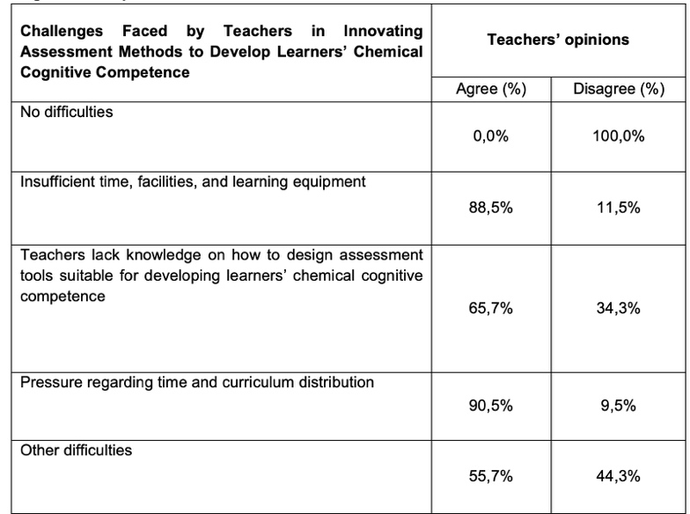
Given this situation, teachers often pay little attention to fostering effective learning methods for students, both at school and at home. Moreover, traditional assessment methods tend to position learners as passive participants in the learning process. As a result, their learning remains mechanical, focused on memorization and reproduction, lacking initiative, autonomy, and creativity. According to the report, the survey investigated several theoretical issues, including modern trends in testing and assessment of learning outcomes; education oriented toward the development of learners’ qualities and competencies; orientations for assessing educational outcomes toward the development of learners’ qualities and competencies in Chemistry; chemical cognitive competence; and the forms, methods, and tools used to assess learners’ chemical cognitive competence. The study also examined the current situation of using assessment tools to evaluate learners’ chemical cognitive competence in several schools in Hanoi. The findings indicate that assessment of learners’ chemical cognitive competence through oral questioning and tests (essay tests and objective multiple-choice tests) remains the most frequently used approach among teachers. Other assessment forms, such as observation checklists, learning portfolios, and assessment based on students’ learning products, are used less often, particularly observation checklists. In addition, the report highlights several difficulties faced by teachers in innovating assessment methods to develop learners’ chemical cognitive competence, including teachers’ limited ability to design appropriate assessment tools, as well as pressures related to time constraints and curriculum allocation.
Therefore, innovating assessment methods to develop students’ chemical cognitive competence presents significant challenges for teachers. Based on these difficulties and the current situation, proposing innovative solutions for designing assessment tools to evaluate learners’ competence, particularly in teaching the Halogen group, is a timely and relevant research direction.
3. INNOVATION IN ASSESSMENT METHODS
3.1 Characteristics of the Halogen Group
The Halogen elements have been studied for their characteristic chemical properties as non-metals. At a more advanced level, the Halogen group is typically the first group of elements studied after learners have acquired foundational theories, such as atomic structure, the periodic law, chemical bonding, and redox reactions. Experiments have confirmed these properties based on the structure of both elemental and compound forms of Halogens.
Chemical cognitive competence in the topic of Halogens is reflected through learners’ ability to conceptualize fundamental chemical knowledge and explain chemical phenomena based on scientific principles. Specifically, learners are expected to generalize the position in the periodic table, electron configuration, and molecular formulas of halogen elements. They should be able to state the natural occurrence of halogens and describe the physical properties of halogen substances, including physical state, color, melting point, and boiling point. In addition, learners are required to explain the variation in melting and boiling points of halogen substances based on Van der Waals interactions. Furthermore, learners should be able to explain the tendency of halogens to gain one electron from metals or share electrons with non-metals to form ionic or covalent compounds, based on electron configuration. They are also expected to write chemical equations for the disproportionation reactions of chlorine with sodium hydroxide solution under room temperature and heating conditions, and to explain the application of these reactions in the production of cleaning agents. In addition, learners should explain the reaction trends of halogen elements with hydrogen in relation to halogen reactivity and H–X bond energy, including reaction conditions, observable phenomena, and the composition of reaction mixtures. Based on boiling point data, learners are also expected to analyze and explain the trend in boiling points of hydrogen halides from HCl to HI in terms of van der Waals interactions, as well as account for the anomalously high boiling point of HF compared to other hydrogen halides.
According to the curricula set by the Ministry of Education and Training, to develop chemical cognitive competence—especially in teaching the Halogen unit—teachers need to provide students with opportunities to actively utilize their prior knowledge and experiences in forming new knowledge. Emphasis should be placed on organizing activities that connect new knowledge with already-learned concepts, such as comparing, classifying, systematizing knowledge, and applying learned concepts to explain phenomena, objects, or to solve simple problems.
In addition, studying Halogens helps students understand factors affecting electronegativity, oxidation ability, and chemical reactivity of these elements. Halogens can form many important compounds, including halide salts and organic halogen compounds, which have wide applications in daily life and industry.
Observing the reactions of Halogens also allows students to practice experimental skills and scientific methodology.
Moreover, teachers should encourage students to explore real-world applications of Halogens, such as in medicine, disinfectants, plastics production, and chemical fuels.
Finally, learning about Halogens not only reinforces chemical knowledge but also develops students’ critical thinking and problem-solving abilities.
3.2 Principles for Developing Assessment Tools in Innovative Methods
Innovating teaching methods must be accompanied by corresponding innovations in assessment throughout the teaching process, as well as in evaluating learners’ academic achievements. For an assessment activity to accurately reflect learners’ competencies and qualities, while providing teachers with useful information about teaching and learning, it must adhere to certain principles. These principles require a shift from traditional rote-memorization tests to more authentic, performance-based evaluations that mirror real-life challenges. Furthermore, integrating digital tools and self-assessment techniques can empower students to take ownership of their own learning journey. When assessment is woven seamlessly into daily instruction, it functions as a diagnostic map that guides both the instructor’s strategy and the student’s efforts. Ultimately, this holistic approach ensures that education goes beyond grades, fostering the essential skills necessary for success in the modern workforce. To develop a set of assessment tools for evaluating chemical cognitive competence in teaching the Halogen unit, the following principles are proposed:
Ensuring Accuracy: Assessment tools must accurately measure the content, knowledge, and skills required by the Halogen unit. The results should truthfully reflect learners’ competencies and qualities. Moreover, the assessment objectives and methods must align consistently with the teaching objectives and methods.
Ensuring Reliability: Assessment tools must precisely quantify the manifestations of learners’ chemical cognitive competence and be flexible enough to be applied at different stages of the teaching process, such as during the introduction of new knowledge, practice lessons, and laboratory exercises within the Halogen unit.
Ensuring Objectivity: The assessment tools must be designed to ensure objectivity and fairness in evaluating learners throughout the teaching of the Halogen unit.
Ensuring Impact: Using the assessment tools during the teaching of the Halogen unit provides timely feedback to learners, allowing them to adjust their learning plans accordingly and contributing to the development of their chemical cognitive competence.
3.3 Procedure for Developing Innovative Assessment Tools
The procedure for developing assessment tools is a systematic process designed to ensure reliability, validity, and meaningful evaluation of students’ learning. In today’s dynamic science classrooms, effectively assessing students’ chemical cognitive competence requires more than traditional testing methods; it calls for innovative assessment tools that actively engage learners, spark curiosity, foster critical thinking, and transform the evaluation process into a meaningful learning experience.
Such a procedure emphasizes the careful alignment between learning objectives, assessment criteria, and instructional activities throughout the teaching process. By clearly defining assessment criteria and performance indicators, teachers can ensure that assessment tools accurately reflect the expected learning outcomes and levels of chemical cognitive competence. Moreover, a systematic development process allows for the integration of both formative and summative assessment approaches, enabling continuous monitoring of students’ learning progress as well as evaluation of final achievements. Innovative assessment tools, including performance tasks, experimental activities, project-based assignments, and reflective tasks, provide learners with opportunities to demonstrate their understanding and apply chemical knowledge in authentic contexts. Through this approach, assessment becomes a supportive mechanism that not only measures learning outcomes but also guides learning, encourages self-reflection, and contributes to the sustainable development of students’ chemical cognitive competence.
Step 1 – Establish Assessment Criteria: To define criteria for evaluating chemical cognitive competence in the Halogen unit, it is necessary to consider the manifestations of the competence as well as the learning outcomes required by the unit.
Step 2 – Plan the Development of Assessment Tools: Planning should be based on the lesson content, expected teaching time, and the established criteria for chemical cognitive competence.
Step 3 – Select and Design Assessment Tools: Choose appropriate tools aligned with the lesson content or topics in the Halogen unit, such as questions, exercises, criterion-referenced assessment sheets, and tests.
Step 4 – Consult Experts and Revise: Seek expert feedback on the suitability and feasibility of the assessment tools and revise them according to the experts’ suggestions.
Step 5 – Pilot Testing: Conduct a trial of the assessment tools to evaluate chemical cognitive competence in teaching the Halogen unit.
Step 6 – Revise and Finalize: Based on the pilot results, review and finalize the assessment tools.
In conclusion, by following this structured and thoughtful approach, educators can create assessment tools that are not only accurate and reliable but also inspire students to think critically, apply their knowledge creatively, and actively participate in the learning process, ultimately turning assessment into a powerful driver of learning.
Based on research on competency-oriented assessment, and in accordance with the principles and procedures for developing assessment tools for chemical cognitive competence as well as the manifestations of this competence, the research team identified the criteria and levels for assessing chemical cognitive competence according to specific criteria. The system of criteria for assessing learners’ chemical cognitive competence is structured into three levels, reflecting a clear progression from basic recognition to higher-order thinking. At the basic level, students are able to recognize and name chemical objects, events, concepts, and processes, as well as present and describe their characteristics under teacher guidance; however, their responses remain unclear and incomplete. At the intermediate level, learners can perform these tasks more clearly and comprehensively with teacher support, while also being able to compare, classify, analyze, and explain chemical relationships according to a certain logic. At the highest level, students demonstrate chemical cognitive competence independently and comprehensively, ranging from presenting and describing to comparing, analyzing, and explaining relationships such as structure–property and cause–effect. In addition, learners at this level are capable of using scientific terminology accurately, logically connecting information, constructing outlines when reading and presenting scientific texts, and participating in discussions to provide clear, well-founded critical judgments related to the learning topic.
4. CONCLUSION
Based on a close integration of theory and practice, this article highlights the innovations in the process of developing assessment tools for evaluating chemical cognitive competence. The study surveyed the current use of assessment tools for chemical cognitive competence in several schools in Hanoi and analyzed the characteristics of the content in the Halogen unit. From this, the article proposes principles and a procedure for developing a set of assessment tools to evaluate chemical cognitive competence in teaching the Halogen unit.

REFERENCES
Central Committee of the Communist Party of Vietnam. (2013, November 4). Resolution No. 29-NQ/TW on fundamental and comprehensive reform of education and training (8th Plenary Session, 11th Term).
Chi, M., Zheng, C., & He, P. (2024). Assessing high school students’ chemical thinking using an essential questions-perspective framework. Chemistry Education Research and Practice, 25, 1143 - 1158.
Dang, T. O. (Ed.), Pham, H. B., Pham, T. B., Pham, T. B. D., & Do, T. Q. M. (2018). Teaching for competence development in high school chemistry. Hanoi National University of Education Publishing House.
Espinosa, A. A., Koperová, D., Kuhnová, M., & Rusek, M. (2024). Preservice chemistry teachers’ conceptual understanding and confidence judgment: Insights from a three-tier chemistry concept inventory. Journal of Chemical Education, 102 (1), 53 - 65.
Le, T. M. T. (2018). Developing problem-solving and creativity skills through teaching the Halogen unit, Chemistry grade 10 (Master’s thesis in Educational Science). Hanoi National University of Education.
Nguyen, X. T. (2006). Using exercises in teaching chemistry at high school. Hanoi: Hanoi National University of Education Publishing House.
Nguyen, X. T. (2006). 385 chemistry questions and answers related to everyday life. Hanoi: Education Publishing House.
Nguyen, X. T. (2009). Chemistry in everyday life: Applied exercises. Hanoi: Hanoi National University of Education Publishing House.
Nguyen, H. T., & Trang, D. T. (2024). Developing the ability to apply chemical knowledge for students through experience of “visiting the clean water supply station”. VNU Journal of Science: Education Research, 40(2), 73–80.
Pham, T. B., et al. (2020). Assessment of high school students in chemistry oriented toward the development of competencies and qualities. Teacher training guidance materials for key teachers (Module 3).
Quellmalz, E. S., et al. (2014). Developing a computer-based assessment of complex problem solving in chemistry. International Journal of STEM Education, 1 (2), 1 - 15.
Sayre, J., Nabua, E., Salic-Hairulla, M., Alcopra, A., & Fernandez, M. J. (2025). Assessing general chemistry learning gaps: A needs assessment of competency mastery among Grade 11 learners. International Journal of Research and Innovation in Social Science, 6(1), 99 - 104.
Vu, T. B. N. (2015). Developing problem-solving competence for students in Dien Bien province through non-metal chemistry exercises in grade 10 (Master’s thesis in Educational Science). Hanoi National University of Education.
Vu T.T.H., Duong N.K. L.,Nguyen M.N. (2019). Using WebQuest in project-based teaching “Investigating the presence of chlorine in domestic water” (Chemistry 10) to develop students’ competence in exploring the natural world. Journal of Education, 457 (1), 53–59.
Ying, Y., & Tiemann, R. (2024). Development of an assessment tool for collaborative problem-solving skills in chemistry. Disciplinary and Interdisciplinary Science Education Research, 6(1), 25.
Ying, Y., & Tiemann, R. (2024). A comparative analysis of collaborative problem-solving skills between German and Chinese high school students in chemistry. Education Sciences, 14 (11), 1198.
Zhu, L. (2025). Chemistry teachers’ knowledge in assessing scientific inquiry competence. Journal of Baltic Science Education, 24 (4), 774 - 793.

