Morphological characterization of okra (Abelmoschus esculentus L. Moench.) in a Sahelian environment in situ

.

ABSTRACT
Okra is a very important plant in Niger for its fruit. However, its cultivation is mainly practiced during the rainy season. Unpredictable weather results in low yields for this rainfed crop. This study focuses on the variability of morphological types of okra accessions in a rural setting in Niger.
Aims: The objective is to characterize the morphological diversity of okra in situ in Tanout department. In the study area, okra exhibits good ecological adaptation.
Place and Duration of Study: the study has been conducted in the field in Tanout department (Niger) from the 1st to 11th of October 2024.
Methodology: A total of 11 quantitative and 5 qualitative variables were used to characterize the morphological diversity of 688 okra plants from 21 production sites. The data collected were analyzed using R 4.3.1 and Minitab 18 software.
Results: Correspondence analysis (CA) was used to categorize the accessions according to production areas. Comparison of the means of quantitative morphological variables for vegetative growth and fruit yielded significant differences between the accessions. Furthermore, variability in qualitative variables was observed between accessions. Conclusion: In the area of the study, okra presents a good ecological adaptation.

Keywords: Okra, Abelmoschus esculentus L., in situ characterization, Tanout.

1. INTRODUCTION

African flora is rich and diverse, encompassing numerous plant species used for food and traditional medicine, including okra (Abelmoschus esculentus L. Moench.) (Kanfon et al., 2018). Okra is an annual crop of major importance in Niger and is cultivated on various soil types that influence its growth and development. Adequate mineral nutrients present in the soil are essential for okra growth (Céline et al., 2021). However, to improve productivity, the application of organic matter or mineral fertilizers (NPK) is often necessary (Abdou et al., 2022a; Muku and Nsamba, 2025). Okra cultivation provides income that helps meet daily household needs (Konate et al., 2016).
Climatic irregularities contribute to the low productivity of rainfed agriculture (Hama et al., 2018). Vertical and radial growth of okra plants, as well as protein content, are negatively affected under water stress conditions (Konate et al., 2016). Okra leaves and fruits have high nutritional value; however, studies in Burundi showed that protein content is higher in leaves than in fruits (Ntakarutimana et al., 2021).
To better assess okra diversity, field measurements were conducted in farmers’ fields across three okra production zones in the Tanout Department. Despite numerous studies on okra, little attention has been given to its ecological adaptation based on morphological traits under current climatic variability in Africa, particularly in Niger. Therefore, this study aimed to characterize in situ the morphological diversity of okra accessions cultivated in the Tanout Department.

2. material and methods
2.1 Study area
The study was conducted throughout the Tanout Department, excluding the pastoral commune of Tenhya, across okra production sites. The study area is located between latitudes 14°00′ and 15°15′ N and longitudes 8°00′ and 9°15′ E (Figure 1).
A total of 27 okra production sites were surveyed, of which 21 were selected for morphological measurements. These sites are distributed across four communes (Falenko, Gangara, Ollélewa, and Tanout). All sites are located in valleys, tributaries, or lowland areas.

.
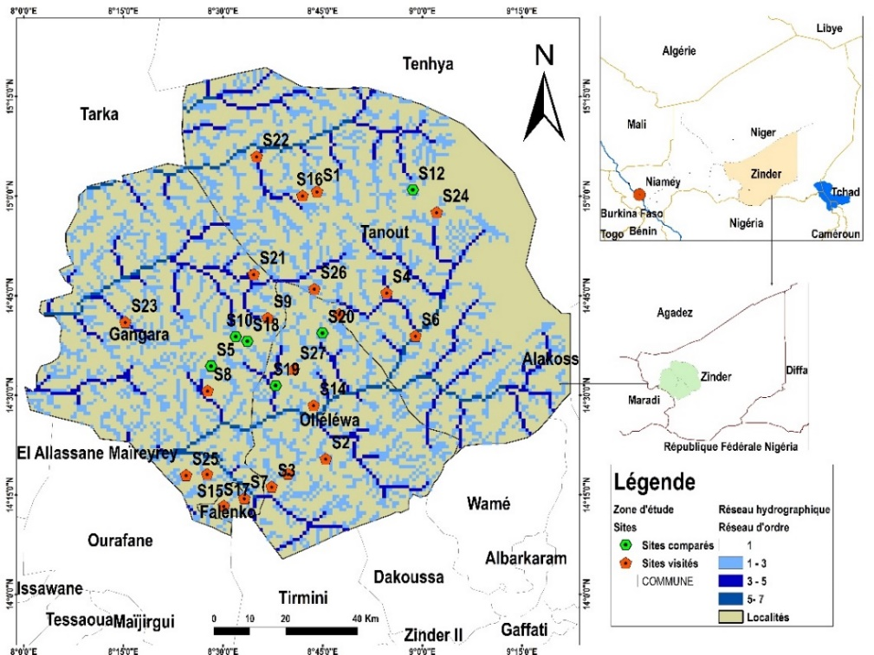
Figure 1: Location of surveyed okra cultivation sites
2.2 Data collection and statistical analysis
Data were collected following a survey conducted from October 1 to October 11, 2024, during the harvest period in four communes of the Tanout Department. After interviews and questionnaires with each farmer, field visits and direct observations were carried out. Data were collected on 5 quantitative vegetative growth traits, 6 quantitative fruit traits (Nkengurutse et al., 2018; Abdou et al., 2022a), and 5 qualitative morphological traits through visual observation (Temam et al., 2021; Ouedraogo et al., 2023; Hamdan et al., 2024).
A total of 688 okra plants were measured. Plants were randomly selected by farmers according to the accessions cultivated, and measurements were performed in situ. A similar methodology was used by Djé et al. (2007) to assess morphological diversity in traditional sorghum varieties in northwestern Morocco.
Collected data were organized using Microsoft Excel. Analysis of variance (ANOVA) was performed using Minitab 18 to identify differences among accessions. Correspondence Factor Analysis (CFA) was conducted using R software version 4.3.1 with the factoshiny package to analyze relationships between production zones and cultivated accessions

3. results and discussion

3.1 Distribution of accessions according to production zones
Accessions were identified directly in farmers’ fields based on local nomenclature criteria. Four (4) okra accessions, namely Dogoua, Gagera, Kahon barewa, and Bagobira, were recorded across three production zones.
Figure 2 presents the Correspondence Factor Analysis (CFA) illustrating the relationships between production zones and the frequency of cited cultivated accessions. The accession Kahon barewa was most frequently cited in the high-production zone, whereas Gagera was the most frequently cited accession in the low-production zone. In contrast, Bagobira was predominantly cited in the medium-production zone. Meanwhile, Dogoua was cited across all production zones.

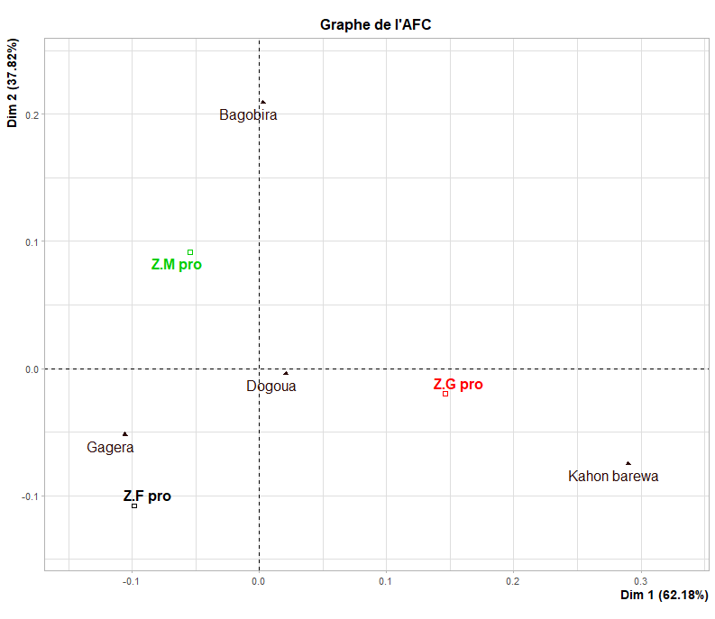
ZG pro: high-production zone; ZM pro: medium-production zone; ZF pro: low-production zone
Figure 2: Correspondence analysis (CA) of production zones according to accessions
Table 1 shows the number of individuals used for morphological data collection. A total of 21 sites (or production areas) were surveyed, yielding 688 individuals, with 52.32% in the high-production area, 29.80% in the medium-production area, and 17.88% in the low-production area (Table 1).
Table 1: Number of individuals collected according to production sites and areas
Production areas | Number of sites | Number of individuals collected | % of individuals collected
Large | 9 | 360 | 52.32
Medium | 7 | 205 | 29.80
Low | 5 | 123 | 17.88
Total | 21 | 688 | 100

3.2. Accession performance
The analysis of okra accession performance revealed substantial variability among accessions (Table 2). Highly significant differences were detected for all measured traits. On average, accessions reached a plant height of 1.30 m and a stem diameter of 26.38 mm. Fruit-related traits showed mean values of 16.72 cm for fruit length, 23.95 mm for fruit diameter, and 99.78 seeds per fruit. Among all variables, the number of seeds per fruit exhibited the highest variability, with a standard deviation of 26.25.
Table 2: Accession Performance
Variables | Mean | Ectyp | Min | Max | Provability | Significance
Haut  DaTg  Lofe  lafe  LoPe  PFr  DaFr  LoFr  NbrGr  PdGr  P100Gr | 1,31  26,38  21,71  26,55  25,44  26,50  23,95  16,72  99,78  9,49  10,35 | 0,75  9,23  5,67  6,57  8,27  16,65  4,38  8,03  26,25  4,40  3,55 | 0,10  4,00  2,39  9,00  5,50  2,90  10,00  2,50  28,00  2,14  2,80 | 3,90  70,00  36,50  44,50  51,00  71,93  37,00  34,10  160,00  23,48  20,50 | 0,000  0,000  0,000  0,000  0,000  0,000  0,000  0,000  0,000  0,000  0,000 | **  **  **  **  **  **  **  **  **  **  **
3.3 Quantitative morphological characteristics of okra accessions
Table 3 summarizes the analysis of vegetative growth traits of okra accessions cultivated in the Tanout Department. Significant differences were observed among accessions for all measured variables. The accession Dogoua exhibited the highest values for plant height, basal stem diameter, and leaf length, followed by Kahon barewa and Bagobira, which showed intermediate performance, whereas Gagera consistently recorded the lowest values. In addition, the accessions Dogoua, Kahon barewa, and Bagobira produced wider leaves and longer peduncles compared with Gagera (Table 3).
Table 3: Variability of Okra Accessions According to Growth Parameters.
Accessions | Haut (m) | DaTg (mm) | Lofe (cm) | lafe (cm) | Lop (cm)
Accessions | Mean±Ectyp | Mean±Ectyp | Mean±Ectyp | Mean±Ectyp | Mean±Ectyp
Bagobira  Gagera  Kahon barewa Dogoua | 0,97±0,36^{b}  0,57±0,24^{c}  0,84±0,19^{b}  2,02±0,51ª | 25,84±9,40^{b}  20,29±8,85^{c}  24,05±6,38^{b}  31,08±7,74ª | 21,76±5,79^{b}  17,71±5,98^{c}  22,01±4,54^{b}  24,07±4,25ª | 27,73±7,27ª  21,93±7,05^{b}  27,25±4,93ª  28,74±4,86ª | 25,81±9,74ª  20,00±7,99^{b}  26,13±7,64ª  28,45±6,19ª
F  P  Sign | 360,81  0,000  ** | 41,78  0,000  ** | 35,26  0,000  ** | 30,86  0,000  ** | 28,28  0,000  **

For each variable, values ​​with the same letter are statistically equal using Tukey's method. **: Highly significant at the α=5% level; High: plant height; Stem diameter; Leaf length; Leaf width; Petiole length.
3.4 Quantitative morphological characteristics of fruits according to accessions
The analysis of variance for fruit-related quantitative traits is presented in Table 4. Significant differences were detected among accessions for all measured variables. The accessions Dogoua and Bagobira exhibited higher mean fruit weights, with values of 34.29 g and 31.58 g, respectively, whereas Gagera and Kahon barewa produced lighter fruits, averaging 17.86 g and 15.48 g, respectively. The largest fruit diameter was recorded for Bagobira, while Dogoua exhibited the smallest fruit diameter. Conversely, Dogoua produced the longest fruits, in contrast to Gagera, which showed the shortest fruit length (Table 4).
Table 4: Variability of Okra Accessions According to Production Parameters
Accessions | PdFr (g) | LoFr (cm) | DaFr (mm) | NbrGr | PdGr (g) | P100Gr (g)
Accessions | Mean±Ectyp | Mean±Ectyp | Mean±Ectyp | Mean±Ectyp | Mean±Ectyp | Mean±Ectyp
Bagobira  Gagera  K. barewa  Dogoua | 35,99±15,30ª  13,80±6,69^{b}  14,66±6,73^{b}  34,66±16,39ª | 12,12±3,74^{c}  9,91±3,01^{d}  15,77±2,71^{b}  21,45±4,88ª | 26,22±2,43ª  23,29±2,84^{b}  19,19±2,82^{c}  25,06±4,91ª | 109,78±18,47ª  85,81±28,05^{b}  78,08±15,64^{b}  111,69±21,32ª | 8,80±2,29^{b}  8,47±3,29^{b}  7,47±3,82^{b}  11,02±5,21ª | 12,30±4,57ª  8,85±2,86^{c}  11,30±1,39^{ab}  10,26±3,57^{b}
F  P  Sign | 82,55  0,000  ** | 393,75  0,000  ** | 42,07  0,000  ** | 52,98  0,000  ** | 14,87  0,000  ** | 15,85  0,000  **
For each variable, values ​​with the same letter are statistically equal using Tukey's method. **: Highly significant at the α=5% level. PdFr: fruit weight; DaFr: fruit diameter; LoFr: fruit length; NbrGr: number of seeds; PdGr: seed weight; P100Gr: weight of one hundred seeds.
Variability of qualitative morphological variables of okra accessions
Table 5 presents the distribution (%) of qualitative morphological traits among four okra accessions observed under farmers’ field conditions. Petiole color exhibited three distinct categories: red upper surface, red, and green. Across all accessions, green petiole coloration was predominant, followed by petioles with a red upper surface.
Stem orientation displayed two contrasting forms. An erect stem habit was observed in 99.69% of Dogoua plants, 69.90% of Kahon barewa plants, and 96.00% of Bagobira plants, whereas a twisted stem form was predominant in Gagera, accounting for 76.76% of the plants (Table 5).
Observations further indicated that 80.00% of Dogoua plants were unbranched. In contrast, branching was highly prevalent in Kahon barewa, Bagobira, and Gagera, with respective frequencies of 96.12%, 84.00%, and 99.46% (Table 5).
Table 5: Percentages of categories for qualitative variables
Variables | Modalities | Accessions
Variables | Modalities | Dogoua | Kahon barewa | Bagobira | Gagera
Stem appearance | Upright  Twisted | 99,69%  0,31% | 69,90%  30,10% | 96,00%  4,00% | 23,24%  76,76%
Stem color | Red  Green | 6,46 %  93,54% | 52,43%  47,57% | 25,33%  74,67% | 76,22%  23,78%
Branching | Absent  Present | 80,00%  20,00% | 3,88%  96,12% | 16,00%  84,00% | 0,54%  99,46%
Leaf Shape | Finger-like  Oval | 90,77%  9,23% | 19,42%  80,58% | 45,33%  54,67% | 10,81%
 |  |  |  |  | 89,19%
Petiole color | Upper suface red  Red  Green | 24,00%  3,69%  72,31% | 42,72%  12,62%  44,66% | 20,00%  24,00%  56,00% | 31,35%  31,89%  36,76%
Discussion
The in situ characterization of okra accessions cultivated in the Tanout Department revealed highly significant differences among accessions for all measured variables. Four accessions (Dogoua, Gagera, Kahon barewa, and Bagobira) were identified in farmers’ fields based on sixteen quantitative and qualitative morphological traits. This level of diversity exceeds that reported by Abdou et al. (2022), who identified only three okra varieties through agromorphological evaluation in the Zinder region using locally sourced seeds.
Comparative analysis of key morphological traits—including plant height and stem diameter, as well as petiole, leaf, and fruit lengths—indicated that the values recorded in the present study were higher than those reported by Abdou et al. (2022) in Niger and Ouedraogo et al. (2024) in Mali. However, the results are comparable to those obtained in Burundi by Nkengurutse et al. (2018), who reported okra genotypes reaching approximately 3.5 m in height and 36 mm in stem diameter under field conditions.
The high values observed in the Sahelian context may be attributed, on the one hand, to favorable edaphic conditions combined with adequate rainfall during the growing season, and on the other hand, to farmers’ harvesting practices, which are known to stimulate vertical growth in okra plants with an erect stem habit. Similar findings were reported by Djé et al. (2007) in Morocco, who demonstrated that environmental conditions strongly influence quantitative traits in sorghum. Consequently, the superior morphological performance observed in the present study reflects a high adaptive potential of okra accessions to their environment, in agreement with observations by Mukendi et al. (2017) on cowpea genotypes in Congo.
Overall, all surveyed sites were located in valleys, tributaries, lowlands, or depressions, typically characterized by clay-rich soils. These soils exhibit high water retention capacity and are generally rich in nutrients derived from the decomposition of crop residues, herbaceous vegetation, and animal manure transported by water, wind, and microbial activity. The combined effects of these factors confer high fertility and moisture availability, enabling okra plants to access sufficient water and nutrients. This favorable soil environment promotes vigorous vegetative growth and effective seed filling. Similar observations were reported by Escadafal et al. (2007), who highlighted the influence of soil texture and surface material cohesion on the development of annual crops. Likewise, Abdou et al. (2022) demonstrated that the application of composted organic manure significantly enhanced vegetative growth in okra.
The observed patterns further indicate a strong interaction between accession performance and environmental conditions. The accession Dogoua consistently exhibited the highest values for most traits, followed by Bagobira, particularly with respect to plant height, despite both accessions displaying an erect stem habit compared with Gagera and Kahon barewa. These findings support the conclusions of Djé et al. (2007), who emphasized that quantitative traits should not be overlooked in diversity studies, as they play a critical role in farmers’ phenotypic selection criteria. Additionally, Escadafal et al. (2007) reported the existence of subtle spatial heterogeneity in soils, including non-uniform distribution of growth-limiting resources, which may further explain intra- and inter-accession variability.
Qualitative traits also exhibited considerable variability among okra accessions. Stem color was represented by two distinct categories, a lower level of variation than that reported by Ouedraogo et al. (2016) in Burkina Faso and Binalfew et al. (2016) in Ethiopia, who observed four and three stem color categories, respectively. Furthermore, the presence of branching on the main stem represents an important agronomic trait associated with yield potential. In the present study, 80% of Dogoua plants lacked branches, whereas more than 80% of plants in the other accessions were branched. This variation is likely attributable to both genetic factors and environmental conditions, particularly when recommended agronomic practices—such as optimal plant density and appropriate spacing—are not strictly applied.
4. Conclusion
This study demonstrated that okra cultivated in the Tanout Department exhibits vigorous vegetative growth, as evidenced by high plant height and stem diameter. Significant differences were observed among accessions for all measured traits. The accession Dogoua consistently showed superior performance, particularly for plant height and stem diameter, leaf and pod length, and seed weight per pod. In addition, the analysis of qualitative traits—including stem color and growth habit, petiole color, and branching pattern—revealed marked variability among accessions.
Based on the measured morphological characteristics, the studied okra accessions can be considered well adapted to the agroecological conditions of the Tanout Department. This area, through its agricultural communes, may therefore be regarded as a favorable ecological zone—and potentially a natural habitat—for okra cultivation in the Zinder region in particular and in Niger more broadly. Further agromorphological evaluation of these accessions represents a promising direction for future research, particularly in the context of varietal improvement and sustainable production under Sahelian conditions.

REFERENCES
Abdou, R., Zango, O., Toudou, A.K., Agbo So, T.K. & Bakasso Y. (2022). Agro Morphological Characterization and Evaluation of Three Okra (Abelmoschus esculentus L. Moench.) from Zinder (Niger) for Yield and Other Variability Components. Agricultural Sciences, 13, 321-329. https://doi.org/10.4236/as.2022.133022
Atakpama, W., Kokou, K. B., Issifou, A., Folega Varieties, F., Agbati, K., Douhadji, A. C. C. M., & Batawila, K. (2024). Agro-ecological approach, a solution to improve maize (Zea mays L.) yields in Togo. Ecosystems and Landscapes Review, 4(1), 1-14, e-ISSN (Online): 2790-3230 DOI: https://doi.org/10.59384/recopays.
Binalfew, T., & Alemu, Y. (2016). Characterization of okra (Abelmoschus esculentus (L.) Moench) germplasms collected from Western Ethiopia. Int J Res Agric For, 3(2). http://www.ijraf.org
Céline, K. K. C., Delphine, D. N., & Simon, N. T. L. (2021). Effects of amendments on the agro-morphological characteristics and entomofauna of Abelmoschus esculentus (L.) Moench (Malvaceae) in Ngaoundéré (Cameroon). IJAR, 7(1), 277-285. https://doi.org/10.22271/allresearch.2021.v7.i1d.8193
Djè, Y., Heuertz, M., Ater, M., Lefebvre, C., & Vekemans X. (2007). Evaluation of the morphological diversity of traditional sorghum varieties from northwestern Morocco. BASE. 11(1), 39-46
Escadafal, R. (2007). The soil surface of arid regions: link between field ecology and remote sensing. Soils of Tunisia, 56.
Hama, O., Adamou, M. M., & Barage M. (2018). Evaluation of irrigation systems for (Abelmoschus esculentus L. Moench.) and (Cucumis sativus L.) crops at the Bougoum market garden site, in the 5th arrondissement of Niamey (Niger, West Africa). African Agronomy, 30(1), 29-44. https://www.ajol.info/index.php/agronaf/article/view/174000
Hamdan, Y., & Salameh, A. (2024). Assessing phenotypic diversity between different landraces of okra (Abelmoschus esculentus L. Moench.). Reproduction and Breeding, 4(3), 113-119. https://doi.org/10.1016/j.repbre.2024.04.002
Kanfon, R. E., Gnawe, M., Dossa, C. P. A., Yedomonhan, H., Wotto, D. V., & Sohounhloue, C. D. (2018). Physicochemical characterization and evaluation of the antiradical activity of extracts from seven okra morphotypes (Abelmoschus spp.) cultivated in Benin. International Journal of Biological and Chemical Sciences, 12(3), 1447-1458. https://doi.org/10.4314/ijbcs.v12i3.30
Konate, B., Nana, R., Nanema, S. L., Badiel, B., Sawadogo, M., & Tamini Z. (2016). Morphophysiological response of okra (Abelmoschus esculentus L. Moench.) subjected to biofertilization and water stress. International Journal of Biological and Chemical Sciences, 10(5), 2108-2122. https://doi.org/10.4314/ijbcs.v10i5.14
Mukendi, R. T., Mutamba, B. T., Kabongo, D. M., Tshilumba, T. M., Mpoyi, M. B., & Munyuli, T. M. (2017). Varietal evaluation of some cowpea genotypes (Vigna unguiculata L. Walp) under agro-ecological conditions of Kabinda, Lomami province, Democratic Republic of Congo. Africa. Science, 13, 24-31. http://www.afriquescience.info/Vol.13,%20N%C2%B02%20(2017)%20-%20Article%203.html
Muku, T. M., & Mutombo, V. N. (2025). Potential of integrated soil fertility management for improving okra yield (Abelmoschus esculentus L. Moench.) in Kinshasa, DR Congo. Congolese Journal of Science and Technology, 4(1), 55-62. https://doi.org/10.59228/rcst.025.v4.i1.131
Nkengurutse J., Nzoyisubiziki J., Bigendako M. J., Nkurunziza M., Mbonihankuye C., and Ntakarutimana V. (2018). Preliminary characterization of the morphology and yield of okra cultivars (Abelmoschus esculentus L. Moench.) grown in Burundi. Future prospects. Annals of Science and Applied Sciences, 184-202. https://www.researchgate.net/publication/328390000_Caracterisation_Preliminaire_de_la_Morphologie_et_du_Rendement_des_Cultivars_du_Gombo_Abelmoschus_esculentus_L_Moench_Cultives_au_Burundi_Perspectives_d'avenir
Ntakarutimana, V., Ndikumana, S., Ndamanisha, J. C., Libérata, L., Mpawenayo, P. C., & Nkengurutse, J. (2021). Determination of proteins and carbohydrates in the fruits and leaves of five okra cultivars (Abelmoschus esculentus L.) grown in Burundi. Exact and Natural Sciences, 2(31), 53-59. https://revue.ub.edu.bi/index.php/sciences_exactes_et_naturelles/issue/view/31
Ouedraogo, M. H., Bougma, L. A., Sawadogo, N., Ouoba, A., Ouedraogo, R., & Sawadogo, M. (2023). Phenotypic variation of okra (Abelmoschus esculentus L. Moench.) genotypes cultivated in Burkina Faso based on qualitative traits. https://doi.org/10.35759/JAnmPlSci.v55-1.3
Ouédraogo, M. H., Bougma, L. A., Sawadogo, N., Kiebre, Z., Ouédraogo, N., Traore, E. R., & Sawadogo, M. (2016). Assessment of agromorphological performances and genetic parameters of okra varieties resulting from participatory selection. International Journal of Advanced Research, 4(3), 1554-1564.
Ouedraogo, O.C., Sognigbé, N., Nzungize, J., Kante, K., Goro, B., Traore, A.S., Dougoune, F., Marico, A. & Schafleitner, R. (2024). Agromorphological Characterization of 260 Okra Accessions (Abelmoschus esculentus L. Moench) in Mali. Agricultural Sciences, 15, 1290-1304. https://doi.org/10.4236/as.2024.1511070
Temam, N., Mohammed, W., & Aklilu, S. (2021). Variability assessment of okra (Abelmoschus esculentus L. Moench.) genotypes based on their qualitative traits. International Journal of Agronomy, 2021(1), 6678561 https://doi.org/10.1155/2021/6678561

