Fecundity of the fiddler crab Uca tangeri (Eydoux, 1835) (Decapoda: Ocypodidae) in the mangrove ecosystem of the Parc National du Delta du Saloum (PNDS) in Senegal

Abstract
The study examined the fecundity of a Uca tangeri population with in the Parc National du Delta du Saloum (PNDS) in Senegal. Ovigerous females (30 individuals) were captured monthly from August 2023 to July 2024 and the following parameters were recorded: carapace width (CW), abdomen width (AW), weight (P) and number of eggs (EN). Fecundity ranged from 4600 (CW = 19.1) to 77867 (CW = 24.16) eggs per female, with an average of 21788 ± 16194 eggs. The relationship between female size and fecundity showed that the largest females did not produce a large number of eggs. The average perimeter of the eggs was 0.753 ± 0.087, while their surface area was 0.040 ± 0.008 and their average diameter 0.247 ±0.028. Egg size increased progressively and significantly during embryonic development, from 0.040 mm² at stage I to 0.042 mm² at stage III. The results obtained are contributions to a better understanding of the reproductive potential and mechanisms of the fiddler crab, Uca tangeri.
Keywords: fecundity, Uca tangeri, mangroves, Saloum Delta, Senegal

Introduction
The fiddler crab, Uca tangeri, is a species of decapod crustacean belonging to the Ocypodidae family. These crabs are characterized by their sexually dimorphic claws; one of the male's chelipeds is much larger than the other, while in females, both chelipeds are the same size (Levinton et al., 1995). U. tangeri is the only species of the genus Uca of fiddler crabs found in the eastern Atlantic (Colpo et al., 2003) and is present in the mangroves of West Africa (Guiral et al., 1999). Its main range is on the eastern Atlantic coast and in the Mediterranean: from Morocco to southern Angola, north to Portugal and Spain (Crane, 1975 and Fischer et al., 1981). Fiddler crabs (genus Uca) are flagship species in intertidal habitats such as mangroves, salt marshes, and sandy beaches worldwide (Crane 1975; Rosenberg 2001) in shallow tropical and subtropical coastal regions and even on some temperate coasts (Christy & Salmon, 1984; Hodgson, 1987; Mouton & Felder, 1995; Costa & Negreiros-Fransozo, 2003). In mangrove forests, fiddler crabs are one of the most important taxa in terms of number of species, density, and total biomass (Hartnoll, 1975; Dahdouh-Guebas et al., 1999; Macia et al., 2001).
These crabs build complex burrows in mud, muddy sand, or sandy areas and exhibit specific behavior associated with the use of these burrows (Costa & Negreiros-Fransozo, 2003). The burrowing and feeding activities of fiddler crabs promote bioturbation of estuarine intertidal mudflats (Colpo & Negreiros-Fransozo, 2004). They also remove large amounts of sediment and alter substrate characteristics, increasing water and organic matter content and altering nutrient dynamics, which affects microbiotic growth and stimulates plant production (Genoni, 1985; Colpo & Negreiros Fransozo, 2004). Fecundity is an important parameter for determining the reproductive potential of a species and the size of its population (Mantelatto & Fransozo, 1997). Information on fecundity is crucial for crab fishery management (Mantelatto & Fransozo 1997; Muino, 2002) and species conservation. Temperature, salinity, food availability, rainfall, photoperiod, and lunar cycles are the main factors that can determine the periodicity and length of the breeding season, fecundity, and size at the onset of sexual maturity of a species (Colpo & Negreiros-Fransozo, 2003; Costa & Negreiros-Fransozo, 2003; Litulo, 2004).
The fecundity of ocypodids has been the subject of a wide variety of studies, by Mouton & Felder, 1995 in U. longissimisgnalis and spinicarpa; (Goshima et al., 1996) for U. tetragonon; (Rabalais & Cameron, 1983 ; Rabalais, 1991 ; Emmerson, 1999) Uca annulipes; (Litulo, 2004) on Uca annulipes ; (Litulo, 2005) on Uca vocans and (Farias et al., 2014) on U. thayeri ; (Yamaguchi, 2001 and Litulo, 2015) on U vocans. However, U. tangeri fecundity is virtually non-existent in West Africa, and the only significant work on this subject is that of (Rodriguez et al. 1997) in Spain. Hence the interest in studying the fecundity of U. tangeri in the Saloum Delta. In addition, comparisons between populations can be an important strategy for verifying the differences between them in order to better understand their environment and the biological constraints that shape them (Fransozo et al., 1999; Oshiro, 1999).
Materials and Methods
Monthly sampling from August 2023 to July 2024 was carried out at low tide in the mangrove ecosystems of the PNDS located in the Fatick region of Senegal (between 13°35 and 14°15 North Latitude and 16°03 and 16°50 Longitude) (Fig. 1).
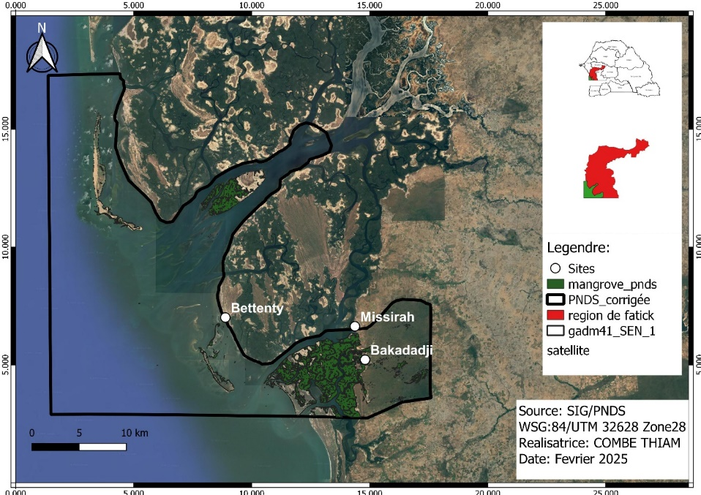
Fig. 1: PNDS map with collection sites (Bakadadji, Missirah and Bettenty)
The specimens were collected on foot along the riverbank and were generally captured by hand in their burrows. The individuals collected were immediately placed in a 500 ml bottle containing formaldehyde at 10°C for 24 hours, then transferred to a bottle of 70° alcohol for preservation and transport. In the laboratory, the following parameters were recorded using a 0.02 mm precision caliper and a 0.01 g precision scale: carapace width (CW), abdomen width (AW), and weight (P). After each ovigerous female's abdomen was removed and stored in 70° alcohol. Before counting the eggs, the egg mass was placed in a Petri dish containing seawater and observed under a binocular magnifying glass at 35x magnification to describe the stages of embryonic development of the eggs. Macroscopic classification of the eggs was performed according to the Rabalais scale (1991). The pleopods were then placed in Petri dishes filled with seawater and the eggs were detached by gradually adding a 2.4% sodium hypochlorite (NaClO) solution. %. Next, the egg-free pleopods were separated by gently shaking them in a beaker filled with 250 ml of seawater. Finally, three 1.5 ml subsamples were taken using a pipette and the eggs were counted using a manual counter under a stereomicroscope. The average value obtained was then extrapolated for the entire suspension to estimate the total number of eggs (Diaz et al., 1983; Ramirez, 2002; Litulo, 2004 and 2005).
To determine the dimensions of U. tangeri eggs, images were digitized using LAZ-EZ software, taking 5 images per egg mass from each individual (Fig. 2a). The diameter, perimeter, and surface area of each oocyte were measured automatically (using a macro) with Image J software. The first step was to adjust the original image, then binarize it to customize the objects in the image (eggs). Next, a series of erosion and dilation functions were used to separate the objects and eliminate artifacts. Subsequently, measurements were performed on the binarized objects (see macro steps in Fig. 2).

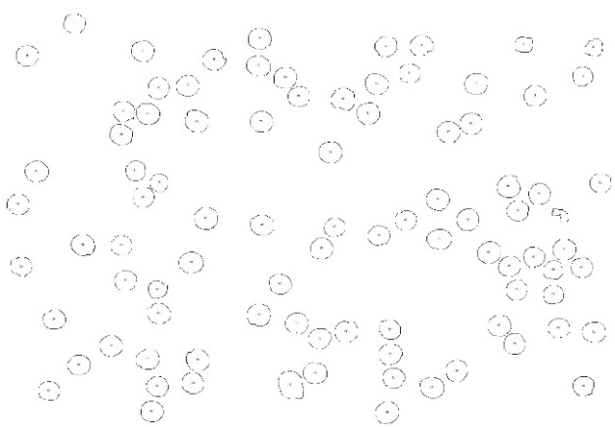
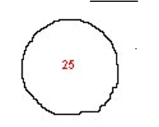
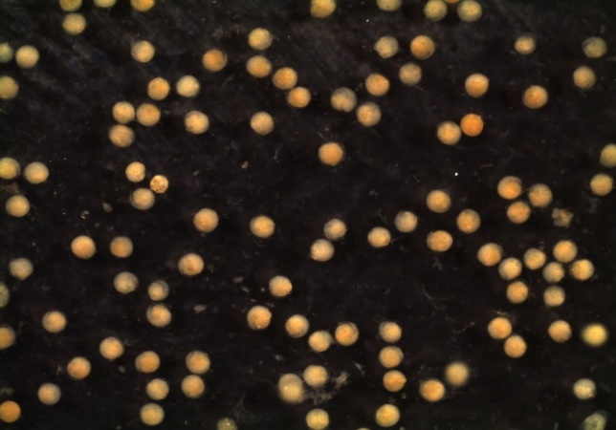

c
d
a
b

Fig. 2: Counting and measuring U tangeri oocytes using Image J software: a) raw image, b) binary image, c) binary contour, d) contour image of an isolated oocyte. Scale bar = 0.5 mm.

Results
Statistical analyses
The data were analyzed using the power function (Y = aXb) and linear regression for estimating parameters a and b (Y = ax + b) (Zar, 1999). Student's t-test was used to see if the values of b were significantly different from 3, using the method of Sokal and Rohlf (1987) : t = ( b – 3)/ SEb, where t is the value of Student's t-test, b is the slope of the regression line, and SEb is the standard error of b . The test was considered significant at the 5% level (p < 0.05) and highly significant at the 1% level (p < 0.01).
I. Description of the developmental stages of Uca tangeri eggs
Based on macroscopic observations of the eggs (Fig. 3), we have described three stages of embryonic development:
Stage I (Initial): eggs laid a few days earlier; the eggs are yellow to light orange in color due to a large amount of yolk (100%) and no visible segmentation. The vitellus is homogeneous, white on the inside and yellowish to orange with darker granules on the surface.
Stage II (Intermediate): halfway through incubation, the eggs are light gray-brown, tending towards gray. The vitellus, which was attached to the embryonic envelope in stage I, gradually detaches and creates an empty space, with the embryo (vitellus) occupying more than 60% of the egg's volume. Two larger symmetrical black spots (cells) appear, forming the compound eyes of the larvae, and a mass of smaller black spots (primordial nucleus) on the upper (polar) part, but the other parts of the body are not defined.
Stage III (final): the larvae are a few days away from hatching and, to the naked eye, the egg is dark brown or dark gray tending towards black. At this stage, the larvae have a large cephalothorax region and an abdomen that is the delaminated area. The nuclear mass (black spots) proliferates throughout the embryo. In the anterior part of the cephalothorax, behind the eyes, two orange-colored cell masses form. The vitellus is almost completely absorbed into the embryo.
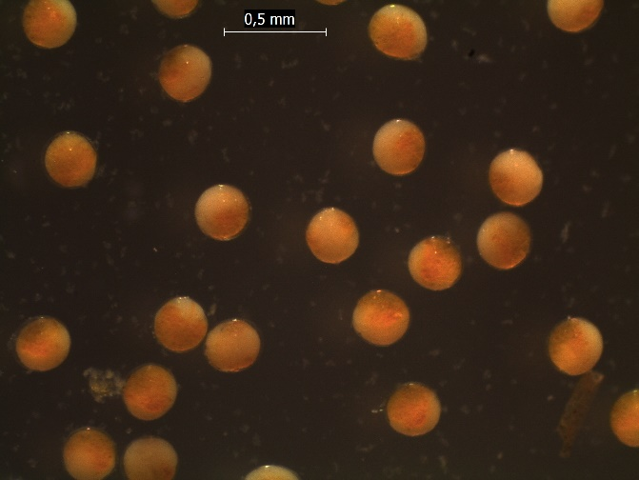
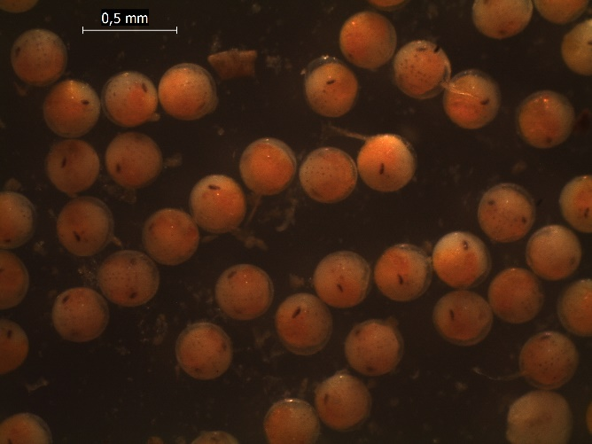
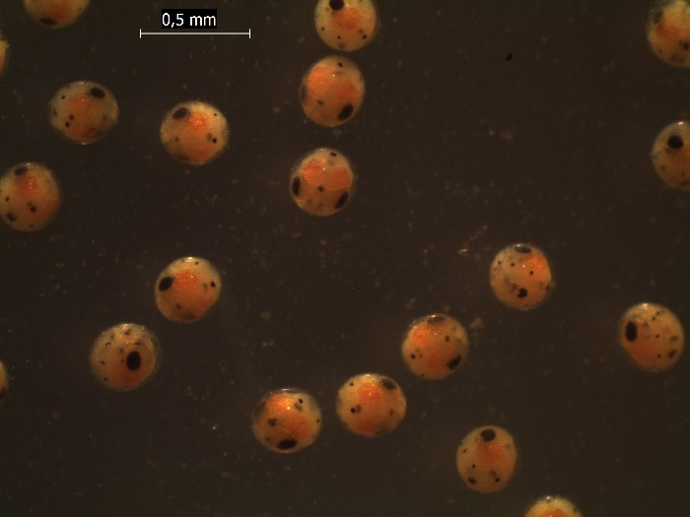
a
b
c

Fig.3: U. tangeri egg development stages a) stage I; b) stage II and c) stage III
II. Analysis of the relationship between fertility and egg size in Uca tangeri
Fertility was estimated in 30 egg-bearing females ranging in size from 15.56 to 29.2 mm (CW) carrying 8,100 and 28,076 eggs on their pleopods, respectively. The number of eggs ranged from 4,937 (CW = 17.34) to 77,867 (CW = 24.16). Average fertility was 21,655 ± 15,317 eggs. The number of eggs was correlated with carapace width (Fig. 4a), indicating a regression slope of b = 3.55 with a confidence interval [2.60;4.50], confirming that the scatter plot shows an isometric trend (b ≈ 3). However, the lack of statistical significance (t-test = 1.20, d.f. = 29, p > 0.05) means that this slope is not statistically different from the theoretical value 3. This follows a proportional increase in the number of eggs relative to carapace width with a coefficient of determination R2 ≈ 0.82. The relationship between the number of eggs and the width of the abdomen (AW) indicates an isometric trend (b = 2.38 close to 3) according to their confidence interval [1.75–3.01], resulting in an increase in the number of eggs that is proportional to the width of the abdomen with a strong correlation of 0.82 (Fig. 4b). However, the p-value (t-test = -1.99, d.f. = 29, p > 0.05) is not statistically significant. On the other hand, the regression between the number of eggs (EN) and the wet weight of females (P) is strongly negative allometric, with a slope of 1.04 (b < 3; CI: [0.74 -1.33]). The very low p-value (t-test = -13.48, df = 29, p < 0.01) indicates that this difference is highly significant. This suggests that the increase in the number of eggs is much smaller than the increase in the weight of females (Fig. 4c).
Table I : Summary of Linear regression
Relation | d.f | a | b | 95% Ic | Et | R2 | Test t | All
EN vs CW | 29 | 0,632 | 3,55 | 2,60 - 4,50 | 0,46 | 0,82 | 1,2 | i
EN vs AW | 29 | 5,564 | 2,38 | 1,75 - 3,01 | 0,31 | 0,82 | -1,99 | i
EN vs P | 29 | 38,334 | 1,04 | 0,74 - 1,33 | 0,14 | 0,8 | -13,48 | -

Fig.4: Regression of the number of eggs (EN) as a function of (a) carapace width (CW); (b) abdomen width (AW) and (c) female wet weight (g).
The average perimeter of the eggs is 0.753 ± 0.087 for an area of 0.040 ± 0.008 and an average diameter of 0.247 ± 0.028 (tab 1). When comparing the average surface area, perimeter, and diameter of eggs at the different sites, Bakadadji 2 has the highest values, with 0.045 ± 0.007, 0.801 ± 0.072, and 0.261 ± 0.022, unlike Bettenty 1, where the average surface area is 0.033 ± 0.005, the perimeter is 0.684 ± 0.057, and the diameter is 0.223 ± 0.018. It should be noted that no ovigerous females were found at Bettenty 2 (tab III). The results also show that the surface area, perimeter, and diameter of the egg increase as the egg develops from 0.040 mm² at stage 1 to 0.042 mm² at stage 3 (tab IV).
Table II : Fecundity parameters of U tangeri : CW = carapace width; AW = abdomen width; P = weight; Nbrs of eggs = number of eggs; Stde of eggs = stage of egg maturity; Area = surface area; Perim = perimeter; Feret = diameter.
Individuals | CW(mm) | AW(mm) | P(g) | Nbrs d'œufs | Std œufs | Area (mm²) | Perim (mm) | Feret (mm)
Bd1-12-11 | 20,32 | 11,18 | 3,06 | 21000 | 3 | 0,044 | 0,799 | 0,262
Bd1-12-13 | 17,32 | 8,9 | 2,03 | 10360 | 1 | 0,042 | 0,775 | 0,257
Bd1-12-14 | 17,34 | 8 | 1,67 | 4937 | 1 | 0,030 | 0,653 | 0,230
Bd1-12-16 | 16,06 | 7,7 | 1,3 | 7267 | 1 | 0,039 | 0,641 | 0,218
Bd1-12-15 | 17,12 | 9,1 | 1,84 | 8221 | 1 | 0,029 | 0,641 | 0,213
Bd1-2-24 | 15,56 | 7,7 | 1,41 | 8100 | 1 | 0,037 | 0,733 | 0,241
Bd1-4-18 | 21,1 | 11,68 | 3,65 | 12240 | 1 | 0,038 | 0,745 | 0,247
Bd1-4-22 | 19,1 | 9,94 | 3,14 | 7600 | 1 | 0,036 | 0,714 | 0,234
Bd1-7-19 | 21,32 | 10,52 | 3,64 | 24900 | 2 | 0,043 | 0,779 | 0,256
Bd1-7-20 | 24,22 | 18,98 | 4,18 | 30700 | 1 | 0,040 | 0,755 | 0,250
Bd1-7-21 | 21,02 | 10,92 | 3,57 | 17400 | 1 | 0,051 | 0,845 | 0,278
Bd1-8-14 | 20,72 | 11,54 | 3,37 | 11600 | 1 | 0,039 | 0,744 | 0,244
Bd1-8-3 | 25,8 | 13,92 | 5,58 | 33100 | 2 | 0,050 | 0,843 | 0,270
Bd1-8-4 | 19,64 | 10,62 | 3,46 | 8050 | 2 | 0,029 | 0,651 | 0,225
Bd2 -10-5 | 20,98 | 12,2 | 3,65 | 16548 | 1 | 0,036 | 0,714 | 0,234
Bd2 -11-5 | 27,72 | 16,78 | 8,25 | 29452 | 1 | 0,040 | 0,750 | 0,235
Bd2 -11-15 | 23,74 | 13,3 | 5,51 | 33790 | 3 | 0,042 | 0,799 | 0,262
Bd2 -12-24 | 24,5 | 13,12 | 7,15 | 39528 | 2 | 0,049 | 0,843 | 0,278
Bd2-7-19 | 20,88 | 11,58 | 3,41 | 15520 | 1 | 0,045 | 0,794 | 0,261
Bd2-7-23 | 23,74 | 13,3 | 5,51 | 42860 | 1 | 0,048 | 0,827 | 0,268
Bd2-8-12 | 20,7 | 11,32 | 4,11 | 15973 | 3 | 0,042 | 0,783 | 0,253
Bt1-2 18 | 24,16 | 15,16 | 6.44 | 42764 | 1 | 0,042 | 0,775 | 0,257
Bt1-1-2 | 21,48 | 11,92 | 4,64 | 16750 | 2 | 0,030 | 0,658 | 0,217
Bt1-1-5 | 20,72 | 11,14 | 4,89 | 15330 | 3 | 0,042 | 0,783 | 0,253
Bt1-12-18 | 20,7 | 15,16 | 6,44 | 77867 | 2 | 0,034 | 0,698 | 0,226
M1-10-16 | 21,58 | 11,12 | 4,36 | 20900 | 1 | 0,049 | 0,839 | 0,273
M1-1-12 | 17,78 | 8,68 | 2,5 | 9120 | 1 | 0,040 | 0,774 | 0,257
M1-1-4 | 20,14 | 11,62 | 3,79 | 25467 | 1 | 0,036 | 0,714 | 0,234
M1-1-5 | 20,2 | 10,08 | 3,57 | 14220 | 2 | 0,050 | 0,843 | 0,270
M2-12-7 | 29,2 | 16,38 | 11,93 | 28076 | 2 | 0,043 | 0,779 | 0,256
Moyenne | 20,74 | 11,73 | 3,78 | 21655 |  | 0,040 | 0,756 | 0,248
Ecartype | 2,45 | 2,51 | 1,29 | 15317 |  | 0,008 | 0,065 | 0,019
Min | 15,56 | 7,7 | 1,3 | 4937 |  | 0,029 | 0,641 | 0,213
Max | 29,2 | 18,98 | 8,25 | 77867 |  | 0,051 | 0,845 | 0,278

Table III : Surface, perimeter and diameter parameters by site
Sites | Area (mm²) | Perim (mm) | Feret (mm)
Bd1 | 0,041 ± 0,008 | 0,757 ± 0,088 | 0,249 ± 0,028
Bd2 | 0,045 ± 0,007 | 0,801 ± 0,072 | 0,261 ± 0,022
Bt1 | 0,033 ± 0,005 | 0,684 ± 0,057 | 0,223 ± 0,018
M1 | 0,042 ± 0,008 | 0,776 ± 0,079 | 0,254 ± 0,026

Table IV : Surface, perimeter and diameter parameters according to egg maturity stage
Stde de M œufs | Area (mm²) | Perim (mm) | Feret (mm)
Stade 1 | 0,040 ± 007 | 0,754 ± 0,066 | 0,247 ± 0,020
Stade 2 | 0,041 ± 0,007 | 0,762 ± 0,068 | 0,249 ± 0,021
Stade 3 | 0,042 ± 0,006 | 0,765 ± 0,066 | 0,251 ± 0,020
Discussion
Fecundity is species-specific and varies considerably depending on latitude, habitat configuration, and food availability, according to Hemni (2003). It can also differ between populations of the same species of fiddler crab living in sites with different environmental conditions at different latitudes. This occurs even within the narrowest latitudinal gradients, suggesting that habitat interferes with brood size (Colpo & Negreiros-Fransozo, 2003 and Castiglioni & Negreiros-Fransozo, 2005). The results show that the ovigerous female of U. tangeri carrying the largest number of eggs (77,867 eggs) broke the record set by (Rodriguez et al. 1997) (77,100 eggs with CW=24 mm) in Cadiz, Spain, and significantly exceeded that of (Feest 1969) (45,915 eggs with CW = 26 mm). On the other hand, we obtained a minimum number of eggs of 4,937 produced by a female (CW = 17.34) compared to the work of (Rodriguez et al., 1997) (9,300 eggs with CW = 15 mm) and (Feest, 1969) (9,442 eggs with CW = 18 mm). These differences in the number of eggs laid could be explained by the different environmental conditions (temperature and food supply). The estimated average fecundity for U. tangeri (21,655 eggs) is much higher than that of other Uca genera in previous studies estimated by (Mouton & Felder, 1995) (nearly 20,000 eggs in U. longisisgnalis and 10,000 in U. spinicarpa); by (Litulo, 2004) (1,599 ± 842 eggs in Uca annulipes in the Costa do Sol Mangrove, Maputo Bay, southern Mozambique); by (Litulo, 2005) (11,045.37 ± 565.7 eggs in Uca vocan in Saco da Inhaca, southern Mozambique); by Farias et al., 2014 (8,829 eggs in U. thayeri in the mangroves of Formoso Rio); by (Costa & Soares-Gomes, 2009) (4,984 ± 2,493.8 eggs in U. rapax in the tropical coastal lagoon, southeastern Brazil) and (Torres et al., 2009) from (1,822 eggs in U. annulipes to 9,667 eggs in U. vocans in the mangroves of Inhaca Island, Mozambique). Conversely, it is smaller than U. rapax (28,500 eggs) according to (Greenspan,1980). The variation in the number of eggs within a species (U. tangeri) and between other species could be a consequence of environmental conditions such as water temperature, salinity, habitat quality, or food availability, which induce growth in crab size, leading to fluctuations in fecundity.
We have noted that fecundity is strongly linked to the wet weight of the animal and the width of its shell and abdomen. We found that at a certain size, larger females produce more eggs than smaller ones. The number of eggs produced by smaller females decreases below 25 cm in width, even if their weight increases. This contrasts with previous studies on brachyure ocypodidea by (Torres et al., 2009 ; Costa & Soares-Gomes, 2009 ; Litulo, 2005 ; Figueiredo et al., 2008 and Castillo et al., 2015), which state that larger females produced many more eggs than smaller individuals. The decline in fecundity among the largest ovigerous females compared to previous results could be due in part to the size of U. tangeri, which is larger than other species of the same genus Uca. For example, the largest female U. tangeri collected (CW max= 29.2 mm) is larger than other species whose maximum size is ≤ 26 mm. It could also be due to their habitats, where the largest individuals are sheltered in higher latitudes, where abiotic and biotic substances tend to diminish, resulting in low productivity. On the other hand, based on the feeding behavior of U. tangeri, whose egg-bearing females remain inside their burrows throughout the brooding period without feeding, as stated by (Henmi, 1989), According to him, ovigerous female fiddler crabs that do not remain inside their burrows and emerge to feed obtain enough energy to produce larger broods than those that remain in their burrows.
The relationship between the number of eggs and size variables in the species Uca tangeri shows isometric growth for carapace and abdomen width but negative allometry for wet weight with a highly elevated correlation of 0.80 to 0.82. This indicates that fecundity increases with the width of the female's carapace and abdomen, suggesting that size is the most relevant factor for predicting the number of eggs. These results corroborate those of (Litulo, 2004) in U. annulipes, ( Litulo, 2005) in U. vocans, (Llodra, 2002), (Figueiredo et al., 2008) in U. rapax, which state that the relationship between female size and fecundity is a major characteristic of reproduction in many crustaceans and is linked to morphological and physiological constraints that influence reproductive capacity in energy allocation and gonadal maturation. Those that could be justified by the accumulation of reserves and gonadal development occur inside the cephalothorax covered by the carapace, and the abdomen supports the mass of eggs laid until hatching. However, the three variables (carapace width, abdomen width, and weight) remain significant indicators of fecundity.
The average diameter of U. tangeri eggs at PNDS is 0.247 ± 0.028 mm ≈ 0.25 mm, ranging from 0.213 to 0.278. (Feest, 1969) stated that the average diameter of U. tangeri is 0.24, slightly lower than that found in this study. In southeastern Brazil, (Costa & Soares-Gomes, 2009) and in Florida-Portugal, (Figueirodo et al., 2008) also measured average egg diameters of U. rapax of 0.24 ± 0.01 mm. The same is true for Uca lactea (Yamaguchi, 2001); U. longisignalis (Rabalais & Cameron, 1983); U. triangularis and annulipes (Feest, 1969). Based on our observations of most species of the genus Uca, the egg diameter is approximately 0.24 mm, although some produce larger eggs, namely U. subcylindrica with an average diameter of 1 mm Thurman (1985), 1.06 ± 0.01 mm (Rabalais & Cameron, 1983); Uca burgesi (Dmoy = 0.36 mm) (Holthuis, 1967 ; Gibbs, 1974) and Uca tetragonon (Dmoy > 0.25 mm) (Gibbs, 1974; Koga et al., 2000). Egg size depends on the species, but for a given species it can depend on environmental conditions (temperature and salinity) that can determine the physiological state of the female during reproduction. The egg diameter found at Bakadadji 2 (0.261± 0.022) is the highest compared to the other sites; One hypothesis proposed in this study to explain the large size of the eggs, but not verified, is that the population of U tangeri inhabiting this area consists of large individuals, as larger females tend to produce larger eggs.
The increase in egg size during egg maturation in our study can be correlated with the work of (Yamagui, 2001) which states that the diameter of U. lactea eggs just before hatching (0.32 mm) is greater than that of the largest diameter eggs (0.24 mm) at stage 1 (Figueirodo et al., 2008) in Florida-Portugal measured egg diameters of U. rapax ranging from 0.2 to 0.29 mm depending on their stage. These data could be explained by the embryonic development that occurs from stage 1 onwards to give rise to the subsequent body structure, or by nutrient intake and interactions with the environment, such as water accumulation in the egg in most aquatic animals.
This study reports the first results on the reproductive biology of Uca tangeri in West Africa in Senegal. It will be followed by other studies on the reproductive cycle, sexual maturity, morphometry, and diet, which are necessary to answer questions about the biology of the species.

COMPETING INTERESTS DISCLAIMER:
Authors have declared that they have no known competing financial interests OR non-financial interests OR personal relationships that could have appeared to influence the work reported in this paper.
Référence :
Castiglioni, D.S., & Negreiros-Fransoso, M. L. (2005). Comparative Population Biology Of Uca rapax (Smith, 1870) (Brachyura, Ocypodidae) From Itamamb Uca And Ubatumirim Mangroves In Ubatuba Littoral, Brazil. Journal Of Natural History 39 (19): 1627-1640. https://doi.org/10.1080/00222930400014247
Castillo, V., Pérez, L.L., Pilar Alonso, M., & Bortolini, J.L. (2015). Population structure and fecundity in Uca virens Salmon & Atsaides, 1968 (Decapoda: Ocypodidae) in southern Tamiahua Lagoon, Veracruz, Mexico. Latin american journal of aquatic research. 43. 14-22. https://doi.org/10.3856/vol43-issue1-fulltext-2
Christy, J.H., & Salmon, M. (1984). Ecology and evolution of mating systems of fiddler crabs (genus Uca). Biological Reviews, 59: 483-509. https://doi.org/10.1111/J.1469-185X.1984.TB00412.X
Colpo, K. D., & Negreiros-Fransozo, M. L. (2003). Reproductive Ouptut Of Uca vocator (Herbst, 1804) (Brachyura, Ocypodidae) From Three Subtropical Mangroves In Brazil. Crustaceana 76: 1–11. https://doi.org/10.1163/156854003321672782
Costa, T., & Soares-Gomes, A. (2009). Population Structure And Reproductive Biology Of Uca rapax (Decapoda: Ocypodidae) In A Tropical Coastal Lagoon, Southeast Brazil, Zoologia 26 (4): 647–657.
Crane, J. (1975). Fiddler crabs of the world: Ocypodidae: genus Uca. Princeton: Princeton University Press.
Dahdouh-Guebas, F.M., Giuggioli, A., Oluoch, M., & Cannicci, S. 1999. Feeding habits of non-ocypodid crabs from two mangrove forests in Kenya. Bulletin of Marine Science 64, 291–297. https://www.rsmas.miami.edu/bms
Emmerson, W.D. (1994). Seasonal Breeding Cycles And Sex Ratios Of Eight Species Of Crabs From Mgazana, A Mangrove Estuary In Transkei, Southern Africa. Journal Of Crustacean Biology, 14: 568-578. https://doi.org/10.1163/193724094X00137
Emmerson, W.D. (1999). Comparative Fecundity And Reproduction In Seven Crab Species From Mgazana, A Warm Temperate African Mangrove Swamp. Crustacean Issues, 12: 499-512.
Farias, A., Castiglioni, D., & Garcia, J. (2014). Structure Of The Population Of The Crab Violoniste Uca thayeri Rathbun, 1900 (Crustacea, Decapoda, Ocypodidae) In A Tropical Mangrove. Thalassas 30(1):21–37. https://dialnet.unirioja.es/servlet/articulo?codigo=4790000
Feest, J. (1969). Morphophysiological Studies Towards Ontogenesis And Reproductive Biology Of Ucaannulipes And Ucatriangularis With Bergleischsbefunden An Ilyoplax Gabetica. Forma Functio 1:159–225.
Figueiredo, J., Penha-Lopes, G., Anto, J., Narciso, L., & Lin, J. (2008). Potential Fertility And Egg Development (Volume, Water, Lipid, And Fatty Acid Content) Through Embryogenesis Of Uca rapax (Decapoda: Brachyura: Ocypodidae) Journal Of Crustacean Biology, 28(3): 528–533https://doi.org/10.1651/07-2937R.1
Fischer, W., Bianchi, G., & Scott (Eds.), W.B. (1981). True Crabs. 6 : pag.var. In FAO species identification sheets for fisheries purposes. East Central Atlantic (fishing zones 34, 47; partly). Canada Trust Fund. Ottawa, Ministry of Fisheries and Oceans Canada, in accordance with the Food and Agriculture Organization of the United Nations, 1-7: pag.var.
Genoni, G.P. (1991). Increased burrowing by fiddler crabs Uca rapax (Smith) (Decapoda: Ocypodidae) in response to low supply. Journal of Experimental Marine Biology and Ecology 147: 267-285. https://doi.org/10.1016/0022-0981(91)90186-Z
Gibbs , P.E. (1974). Notes On Uca burgesi Holthuis (Decapoda, Ocypodidae) From Barbuda, Leeward Islands. Crustacea 27: 84-91. https://doi.org/10.1163/156854074X00253
Goshima, S., Koga, T., & Murai, M. (1996). Mate Acceptance And Guarding By Male Fiddler Crabs Uca tetragonon (Herbst). Journal Of Experimental Marine Biology And Ecology, 196: 131-143. https://doi.org/10.1016/0022-0981(95)00127-1
Greenspan, B.N. (1980). Male Size And Reproductive Success In The Communal Courtship System Of The Fiddler Crab Uca rapax. Animal Behavior 28: 387-392. https://doi.org/10.1016/S0003-3472(80)80047-9
Guiral, D., Albaret, J. J., Baran, É., Bertrand, F., Debenay, J.P., Diouf, P.S., Guillou, J.J., Le Lœuff, P., Montoroi, J.J. & Sow, M. (1999). Southern River Societies and West African Mangroves: Chapter II. Mangrove ecosystems IRD edition. 63–130https://doi.org/10.4000/books.irdeditions.4985
Hartnoll, R.G. (1975). The Grapsidae and Ocypodidae (Decapoda: Brachyura) of Tanzania. Journal of Zoology 177, 305–328. https://doi.org/10.1111/j.1469-7998.1975.tb02235.x
Hemni, Y. (1989). Reproductive Ecology of Three Ocypodid Crabs Ii. Incubation Sites and Egg Mortality. Ecology Research 4: 261-269. https://doi.org/10.1007/BF02348447
Henmi, Y. (2003). Trade-Off between Brood Size and Brood Interval and the Evolution of Underground Incubation in Three Fiddler Crabs (Uca perplexa, U. vocans, And U. dussumieri). Journal Of Crustacean Biology 23 (1): 46-54. https://doi.org/10.1163/20021975-99990314
Hines, A.H. (1982). Allometric constraints and variables of reproductive effort in brachyuran crabs. Mar. Biol. 69: 309–320. https://doi.org/10.1007/BF00397496
Hodgson, A.N. (1987). Distribution and abundance of the macrobenthic fauna of the Kariega estuary. South African Journal of Zoology 22: 153–162.

Holthuis, L. B. (1967). On A New Species Of Uca From The West Indian Region (Crustacea, Brachyura, Ocypodidae). Zoo ¨Logische Mededelingen 42:51-54.
Koga, T., Murai, M., Goshima, S., & Poovachiranon, S. (2000). Underground Mating In The Fiddler Crab Uca Tetragonon: The Association Between Female Life History Traits And Male Mating Tactics. Journal Of Experimental Marine Biology And Ecology 248: 35-52. https://doi.org/10.1016/s0022-0981(00)00154-4
Lardies, M. A., & Castilla, J. C. (2001). Latitudinal Variation In The Reproductive Biology Of The Commensal Crab Pinnaxodes Chilensis (Decapoda: Pinnotheridae) Along The Chilean Coast. Navy. Biology, 139: 1125-1133. https://doi.org/10.1007/s002270100661
Levinton, J. S., Judge, M. L., & Kurdziel, J. P. (1995). Functional differences between the major and minor claws of fiddler crabs (Uca, family Ocypodidae, order Decapoda, subphylum Crustacea): result of selection or developmental constraint? Journal of Experimental Marine Biology and Ecology 193(1–2):147–160. https://doi.org/10.1016/0022-0981(95)00115-8
Litulo, C. (2004). Reproductive Aspects Of A Tropical Population Of The Fiddler Crab Uca annulipes (Brachyura: Ocypodidae) At Costa Do Sol Mangrove, Maputo Bay, Southern Mozambique. Hydrobiologia 525:167-173. https://doi.org/10.1023/b:hydr.0000038864.38435.6a
Litulo, C. (2005). Fecundity And Size At Sexual Maturity Of The Fiddler Crab Uca vocans (Linnaeus, 1758) (Brachyura: Ocypodidae). Thalassas 21(1):59–65. https://doi.org/10.1016/s0065-2881(02)43004-0
Litulo, C. (2005a). Population Biology Of The Fiddler Crab Uca annulipes (Brachyura, Ocypodidae) In A Tropical East African Mangrove (Mozambique). Estuarine, Coastal And Shelf Science 62:283-290.
Llodra, E.R. (2002). Fecundity And Life-History Strategies In Marine Invertebrates Advances In Marine Biology Vol. 43:87-170.
Macia, A., Quincardete, I. & Paula, J. (2001). A comparison of alternative methods for estimating population density of the fiddler crab Ucaannulipes at Saco mangrove, Inhaca Island (Mozambique). Hydrobiologia 449:213–219.
Mantelatto, F.L.M., & Fransozo, A. (1997). Fecundity of the crab Callinectes ornatus Ordway, 1863 (Decapoda, Brachyura, Portunidae) from the Ubatuba region, São Paulo, Brazil. Crustaceana 70:214–224. https://doi.org/10.1163/156854097X00852
Mouton, E. D., & Felder, D. L. (1995). Reproduction of the Fiddler Crabs Uca longisignalis And Uca Spinicarpa in a Gulf Of Mexico Salt Marsh. Estuaries, 18: 469-491. https://doi.org/10.2307/1352365
Muino, R. (2002). Fecundity of Liocarcinus depurator (Brachyura: Portunidae) in the Ria de Arousa (Galicia, north-west Spain). J. Mar. Biol. Ass. U.K. 82:109–116. https://doi.org/10.1017/S0025315402005222
Oshiro, L.M.Y. (1999). Reproductive aspects of caranguejo guaia, Menipe nodifrons Stimpson (Crustacea, Decapoda, Xanthidae) in Baia de Sepetiba, Rio de Janeiro, Brazil. Revista Brasileira de Zoologia 16, 827–834. https://doi.org/10.1590/S0101-81751999000300019
Rabalais, N.N. (1991). Egg Production In Crabs With Abbreviated Development. In: Werner,A. & Kuris, A. (Eds), Crustacean Egg Production, University Of California, Santa Barbara, A.A. Balkema, Santa Barbara, 217-234. https://www.taylorfrancis.com/chapters/edit/10.1201/9781003072560-18/egg-production-crabs-abbreviated-development-nancy-nash-rabalais
Rabalais, N. N., & Cameron, J. N. (1983). Abbreviated Development Of Uca subcylindrica (Stimpson, 1859) (Crustacea, Decapoda, Ocypodidae) Reared In The Laboratory. Journal Of Crustacean Biology 3:519-541. https://doi.org/10.1163/193724083X00193
Rodriguez, A., Drake, P., & Arias, A. M. (1997). Reproductive Periods and Larval Abundance of the Crabs Panopeus africanus And Uca tangeri In a Shallow Inlet (Sw Spain). Tue School Prog. Ser. 149:133–142. https://doi.org/10.3354/meps149133
Rosenberg, M. S. (2013). The nomenclatural status of the two spiny-wristed fiddler crabs: Uca spinicarpa Rathbun, 1900, and U. hesperiae Crane, 1975 (Crustacea: Brachyura: Ocypodidae). Zootaxa 3716:494–500. https://doi.org/10.11646/zootaxa.3716.3.10
Soukal, R. R., & RohlF, F. J. (1987). Introduction to biostatistics. New York: Freman. 363.
Thurman, C. L. (1985). Reproductive Biology And Population Structure Of The Fiddler Crab UcaSubcylindrica (Stimpson). Biological Bulletin. 169:215229. https://doi.org/10.2307/1541399
Torres, P., Penha-Lopes, G., Narciso, L., Macia, A., & Paula, J. (2009). Fecundity And Brood Loss In Four Species Of Fiddler Crabs, Genus Uca (Brachyura: Ocypodidae), In The Mangroves Of Inhaca Island, Mozambique Journal Of The Marine Biological Association Of The United Kingdom, Volume 89, Issue 2, March 2009, 371 – 378. https://doi.org/10.1017/s0025315408002701
Yamaguchi, T. (2001). Incubation of Eggs and Embryonic Development of the F Iddler Crab, Uca lactea (Decapoda, Brachyura, Ocypodidae). Crusta Ceana 74:449-458. https://doi.org/10.1163/156854001750243036
Zar, J. H. (1999). Biostatistical Analysis. 4th Ed. Prentice Hall, Englewood Cliffs, New Jersey. 718.

