Settlement Distribution and Coastal Vulnerability in the Andaman Islands: A Spatial Analysis

Abstract
The Andaman Islands, located in the Bay of Bengal, represent one of India’s most hazard-prone coastal environments. Their proximity to the Andaman–Sumatra subduction zone exposes them to recurrent seismic activity, tsunamis, and coastal flooding. This study employs Geographic Information System (GIS) techniques to analyse the spatial distribution of settlements and to assess coastal vulnerability. Using open-source datasets, including digital elevation models (DEM), tsunami event points, population density, and built-up areas, multi-hazard vulnerability maps were generated. Buffer zones of 500 m, 1 km, and 2 km were created around tsunami points to represent varying degrees of risk, while elevation data below 10 m were classified as highly susceptible. The overlay of these datasets reveals that several major settlements, particularly around Port Blair, fall within critical hazard zones. The results emphasise the essential role of GIS in disaster preparedness, coastal planning, and building resilient island communities.
Keywords: Coastal vulnerability, GIS, Tsunami, Andaman Islands, Settlement mapping, Disaster risk reduction
1. Introduction
Coastal regions are among the most dynamic and densely populated environments on Earth, yet they face growing exposure to natural hazards such as tsunamis, cyclones, and coastal flooding. The Andaman Islands, part of the Andaman and Nicobar archipelago, lie within a tectonically active zone where the Indian and Burmese plates converge, making them highly susceptible to seismic and tsunami-related events (Toushif et al., 2020). The catastrophic 2004 Indian Ocean tsunami devastated large parts of the archipelago, causing massive loss of life and infrastructure, and highlighting the islands’ extreme vulnerability (Kohl et al., 2005).
Over the past two decades, rapid urban growth, increasing population pressure, and infrastructural expansion have intensified coastal occupation, particularly in low-lying areas. Many settlements are located on reclaimed land and coastal plains that are less than 10 m above mean sea level, making them extremely prone to inundation during tsunami events (Ali et., 2020). Therefore, understanding the spatial relationship between settlement distribution and hazard exposure is essential for disaster risk reduction and sustainable land-use planning. Geographic Information Systems (GIS) provide an effective framework for integrating spatial datasets such as elevation, land use, and population to analyse vulnerability patterns (Malczewski et al., 2004). By combining topographic, demographic, and hazard information, GIS-based analysis can identify high-risk zones and support informed decision-making in coastal management. The present study applies GIS techniques to evaluate settlement vulnerability in the Andaman Islands and proposes spatial strategies for improving disaster resilience.
2. Objectives
- To map coastal settlements across the Andaman Islands using GIS.
- To delineate tsunami buffer zones and assess their spatial overlap with human settlements.
- To identify and classify elevation zones below 10 m as highly vulnerable to inundation.
- To integrate all layers to produce a final vulnerability map supporting disaster management and planning.
3. Literature Review
Many researchers have explored coastal vulnerability and tsunami risk in the Andaman and Nicobar Islands, especially after the devastating 2004 Indian Ocean tsunami. (Andrade et al., 2014) conducted one of the earliest GIS-based assessments of tsunami vulnerability in South Andaman. Their study found that areas located below 10 meters in elevation and within one kilometer of the coastline were the most severely affected. This research formed the foundation for later studies that focused on mapping and understanding spatial patterns of vulnerability in the region.
Satellite imagery and digital elevation models to map the zones affected by the 2004 tsunami. several findings revealed that low-lying coastal plains and reclaimed lands were particularly prone to flooding and damage. Similarly, (Dharanirajan et al., 2007) analyzed post-tsunami conditions using IRS satellite data and highlighted the importance of integrating remote sensing and GIS techniques for accurate disaster monitoring and future planning. Beyond the Andaman Islands, several other studies have examined coastal hazards along India’s eastern coast. (Nageswara Rao et al., 2008) assessed cyclone and coastal hazards along the Andra pradesh coast using GIS-based buffer analysis, while (Sood et al., 2025) developed a multi-hazard vulnerability framework for the Chennai coast. Their studies the Fuzzy Analytical Hierarchical Process (FAHP)-based Multi-Criteria Decision Making (MCDM) approach were utilized to demonstrate how GIS can effectively integrate different environmental and human factors to assess risk more precisely. under the ISRO Coastal Zone Studies program, pointed out that island and coastal regions lying below 10 meters are especially vulnerable to extreme coastal events such as tsunamis and storm surges. Supporting this view, NOAA (2015) provided tsunami hazard assessment guidelines that identify coastal areas below 10 meters elevation as critical zones for early-warning systems and evacuation planning. Together, these studies form a strong scientific background for the present research. Building on their findings, the current study focuses specifically on understanding how settlement distribution overlaps with tsunami-prone areas in the Andaman Islands. Using GIS-based techniques, this work aims to map and visualize the most vulnerable zones, providing insights that can support disaster preparedness, safe urban planning, and long-term coastal resilience
4. Study Area
The Andaman Islands are located between 6°–14° N latitude and 92°–94° E longitude, forming a chain of tropical islands surrounded by the Bay of Bengal. The region exhibits hilly terrain in the interior and narrow coastal plains along the shoreline, much of which is fringed by mangroves and coral reefs that serve as natural barriers against storm surges (Andrade et al., 2014). The islands experience a humid tropical climate with an annual rainfall exceeding 3,000 mm and are frequently affected by earthquakes and tsunami events due to their proximity to the Andaman–Sumatra subduction zone (IMD 2016). This study focuses on South Andaman, particularly the Port Blair region, which contains the administrative capital and major settlements. Earlier research has shown that coastal areas of Port Blair and surrounding villages such as Garacharma and Bambooflat lie at elevations below 10 m, making them highly vulnerable to tsunami inundation (Ali et., 2020). According to the NOAA (2015) tsunami hazard guidelines, coastal zones below 10 m elevation and within 1–2 km of the shoreline should be considered critical areas for hazard preparedness and evacuation planning.
5. Database and Methodology
5.1 Data Sources
Data Type | Source | Description
Digital Elevation Model (DEM) | Shuttle Radar Topography Mission (SRTM, 30 m) | Used to extract elevation and identify low-lying areas.
Tsunami Event Points | NCEI/WDS Global Historical Tsunami Database | Historical tsunami locations and intensity data.
Built-up Areas | Copernicus Global Human Settlement Layer | Spatial extent of urban development.
Population Density | WorldPop Dataset | Population distribution and settlement intensity.
Literature | Kumar et al. (2012); Chakraborty et al. (2006); NOAA (2015) | Reference models and vulnerability thresholds.

5.2 Methodology
The study used a step-by-step process in the ArcGIS environment to prepare, analyze, and map the data.
Data Preparation:
All spatial datasets were first converted to the same coordinate system WGS 84 UTM Zone 46 N so that they could align correctly on the map. The data were then clipped to the boundary of the Andaman Islands to focus the analysis only on the study area.
Digitisation of Tsunami Points:
Tsunami event locations were obtained from the NCEI/WDS Global Historical Tsunami Database and verified using published literature and maps. These points were then digitised in python workspace to create a separate tsunami point layer. This layer was used as the main reference for hazard zone mapping and further analysis.
Tsunami Buffering:
Tsunami event points were used to create circular zones, called buffers, at distances of 500 m, 1 km, and 2 km from each point. These buffer zones represent areas that may experience different levels of tsunami impact, the closest areas having the highest risk and the farthest having lower risk.
Elevation Classification:
A Digital Elevation Model (DEM) was analyzed in ArcGIS to identify low-lying areas. Using the Raster Calculator tool, zones below 10 meters in height were selected with the following expression: Con("Fill_M_DEM" < 10, 1)
Areas below 10 m were considered highly vulnerable because they are more likely to be flooded during a tsunami.
Overlay Analysis:
The settlement map was overlaid on the tsunami buffer and elevation maps. This step helped to find which settlements are located inside the high-risk zones and how much of the population is exposed.
Map Preparation:
Finally, all results were combined to prepare clear maps showing the tsunami buffers, elevation zones, and overall hazard vulnerability of the settlements. These maps form the visual output for understanding and comparing the risk levels across the Andaman Islands.
6. Results
6.1 Buffer Zone Analysis
The tsunami buffer analysis revealed a clear gradient of risk around coastal settlements:
- Immediate Zone (0–500 m): Includes Port Blair, Haddo, and Phoenix Bay areas that would experience direct tsunami inundation.
- Moderate Zone (500 m–1 km): Comprises semi-urban belts such as Garacharma, which may be affected by wave run-up.
- Peripheral Zone (1–2 km): Contains smaller villages and inland settlements potentially exposed to secondary effects like infrastructure disruption.
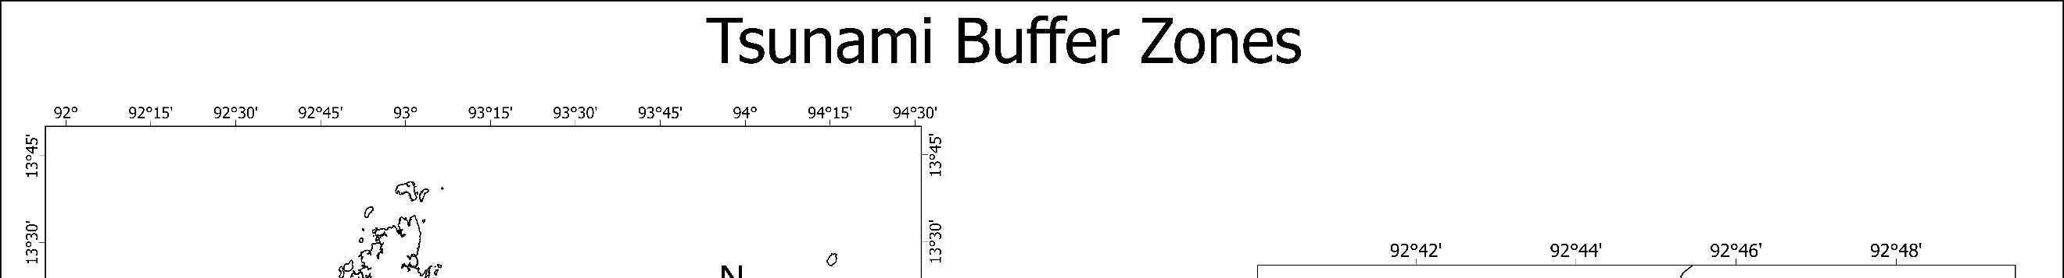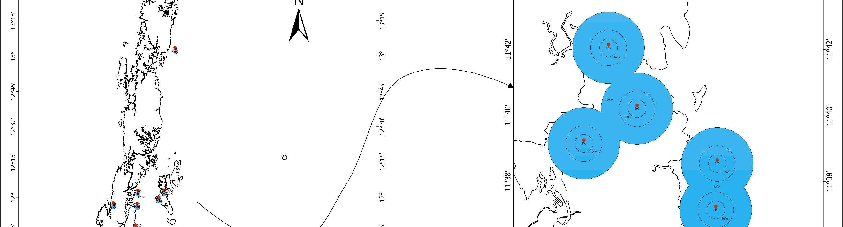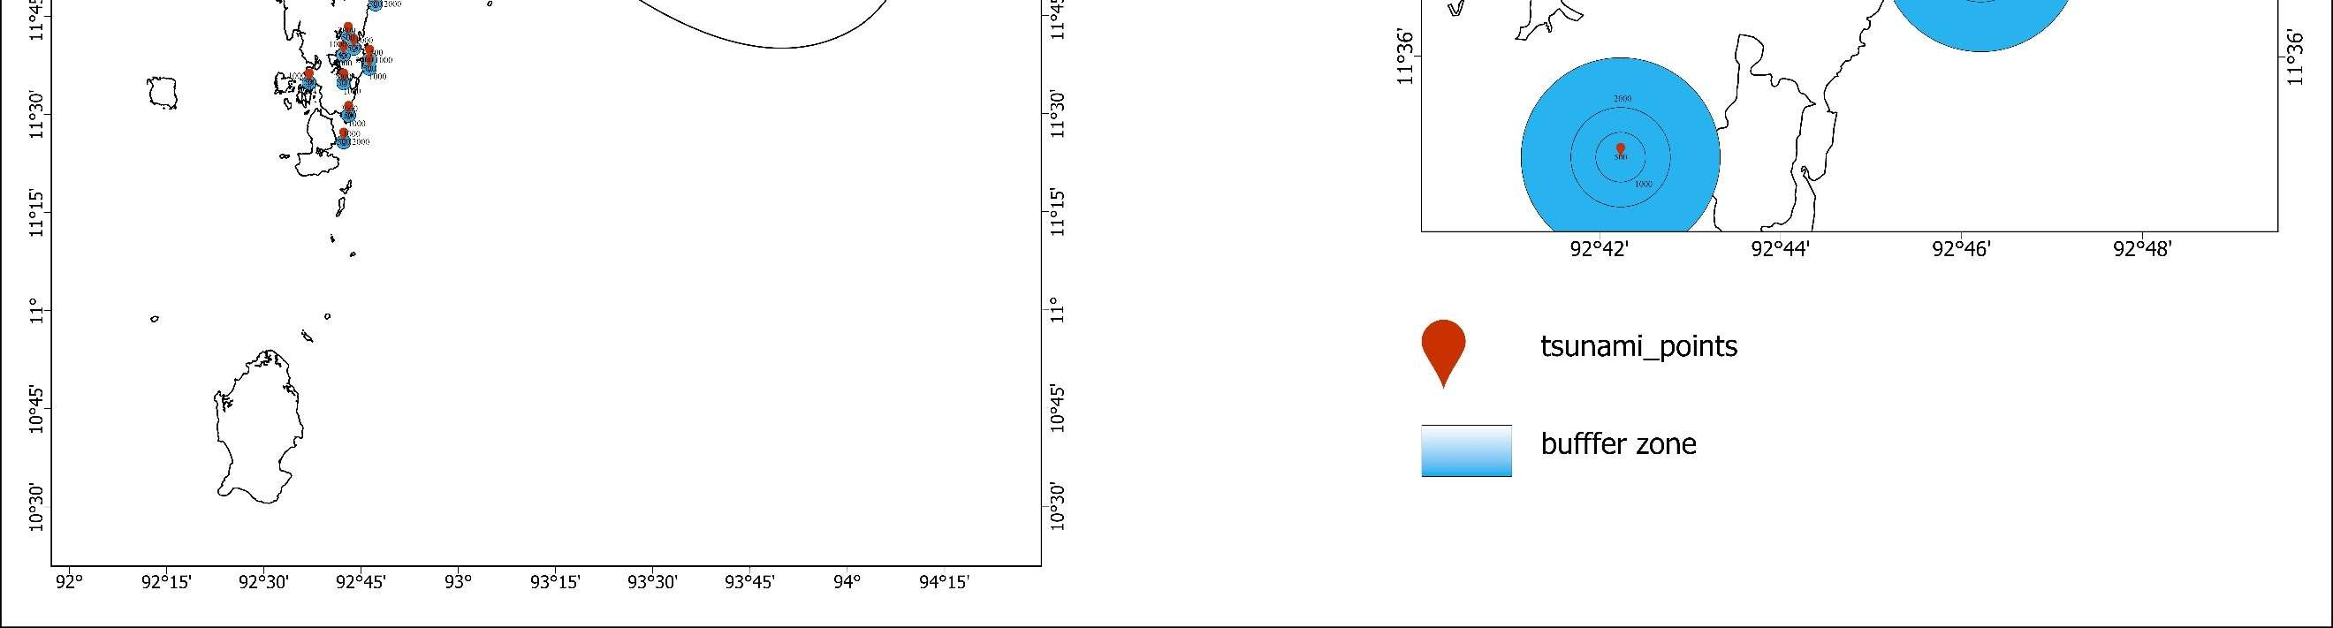
Figure 1. Tsunami Buffer Zones in South Andaman
6.2 Elevation Analysis
The DEM-based elevation model indicated that approximately 40% of South Andaman lies below 10 m. These low-lying areas correspond closely with zones impacted during the 2004 tsunami. The most vulnerable areas include Port Blair’s coastal neighbourhoods, Sippighat, Bambooflat, and parts of Wandoor.
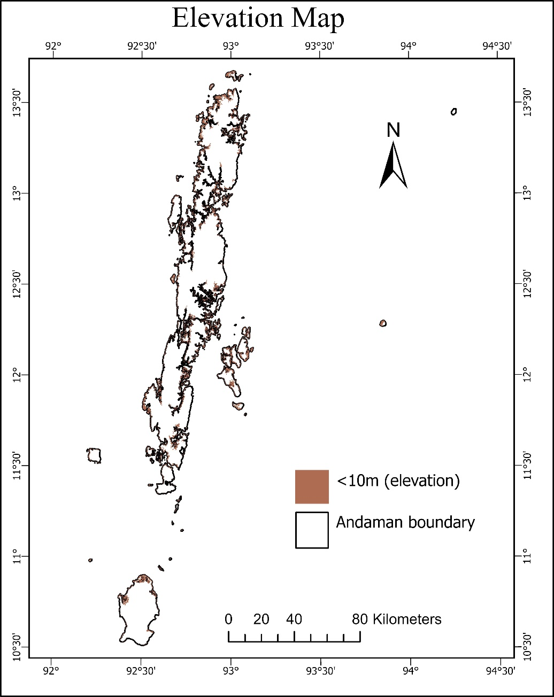
Figure 2. Elevation Map Showing Areas Below 10 m

6.3 Composite Vulnerability Mapping
By integrating elevation and buffer data, a composite vulnerability map was generated. Settlements that met both criteria below 10 m elevation and within 1 km of tsunami points were classified as high risk. The results show that the eastern coastline and the southern fringes of Port Blair are most vulnerable, while inland hilly regions are relatively safer.
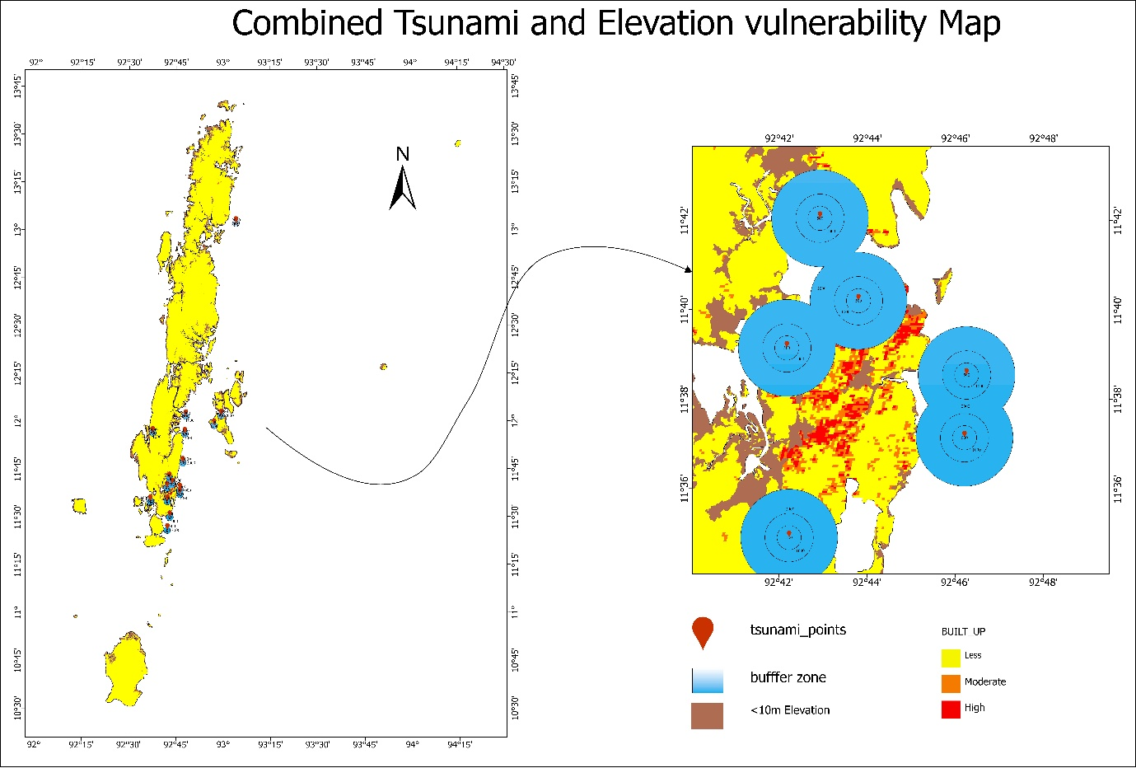
Figure 3. Combined Tsunami and Elevation Vulnerability Map
7. Discussion
The results illustrate a strong spatial correlation between settlement concentration and physical vulnerability. The majority of high-density settlements are situated within the most hazard-prone zones, reflecting the increasing pressure of urbanisation on fragile coastal environments. Previous research, including that of (Ali et al 2020; Malczewski et al., 2004
) identified 10 m elevation as a critical threshold for tsunami inundation. This study reaffirms those findings using updated spatial data and demonstrates how integrating elevation with tsunami proximity provides a more realistic risk profile.
GIS analysis not only allows for efficient mapping but also supports evidence-based decision-making. It enables the identification of safe zones for future development, design of evacuation routes, and prioritisation of high-risk settlements for mitigation. However, the current analysis focuses on physical vulnerability. Incorporating social and economic factors such as income level, building materials, and access to emergency services would provide a more comprehensive understanding of overall risk.
8. Applications and Policy Implications
The findings of this study have several important applications for disaster management and sustainable coastal planning in the Andaman Islands. By identifying high-risk settlements, the study supports more effective disaster preparedness through targeted evacuation planning and the development of early-warning systems. The vulnerability maps can guide urban planners and local authorities in enforcing coastal zoning regulations and strengthening building codes to minimise exposure in hazard-prone areas. Furthermore, safer inland zones located at elevations above 20 meters can be prioritised for resettlement and new infrastructure development, reducing population pressure along the vulnerable coastline. Environmental management also plays a key role, as the protection and restoration of natural barriers such as mangrove forests and coral reefs can significantly reduce wave energy and coastal erosion. In addition, the maps and spatial data generated in this study can be used for community awareness programs, educational outreach, and local training workshops to enhance public understanding of disaster risk and promote a culture of preparedness among island residents.
9. Conclusion
This study demonstrates the usefulness of GIS-based analysis in assessing coastal settlement vulnerability in the Andaman Islands. The integration of elevation and tsunami buffer zones effectively highlights the settlements most at risk from coastal hazards. Port Blair and its adjoining coastal villages emerged as the most vulnerable due to their low elevation and high population density. The findings reinforce the necessity for risk-sensitive urban planning, strengthened disaster management systems, and the incorporation of hazard data into future development projects. By adopting spatial analysis as a planning tool, decision-makers can enhance resilience, reduce exposure, and safeguard communities from future coastal disasters. GIS offers not only analytical precision but also a visual framework for communicating risk, making it an essential component of sustainable coastal management and policy formulation in the Andaman Islands.
References
- Toushif, J., Dharanirajan, K., & Sohel, R. Lehar Cyclone Hazard Impact Assessment for South Andaman using Remote Sensing and GIS.
- Kohl, P. A., O'Rourke, A. P., Schmidman, D. L., Dopkin, W. A., & Birnbaum, M. L. (2005). The Sumatra-Andaman earthquake and tsunami of 2004: The hazards, events, and damage. Prehospital and Disaster Medicine, 20(6), 355-363. https://doi.org/10.1017/s1049023x00002880
- Ali, M. E. (2020). Urbanisation in India: Causes, Growth, Trends, Patterns, Consequences & Remedial Measures. https://doi.org/10.13140/RG.2.19007.05284
- Malczewski, J. (2004). GIS-based land-use suitability analysis: a critical overview. Progress in Planning, 62(1), 3-65. https://doi.org/10.1016/j.progress.2003.09.002
- Andrade, V., Rajendran, K., & Rajendran, C. P. (2014). Sheltered coastal environments as archives of paleo-tsunami deposits: Observations from the 2004 Indian Ocean tsunami. Journal of Asian Earth Sciences. https://doi.org/10.1016/j.jseaes.2014.08.029
- Dharanirajan, K., Kasinatha Pandian, P., Gurugnanam, B., Narayanan, R. M., & Ramachandran, S. (2007). An integrated study for the assessment of tsunami impacts: a case study of South Andaman Island, India using remote sensing and GIS. Coastal Engineering Journal, 49(03), 229-266. https://doi.org/10.1142/s0578563407001617
- Nageswara Rao, K., Subraelu, P., Venkateswara Rao, T., Hema Malini, B., Ratheesh, R., Bhattacharya, S., Rajawat, A. S., & Ajai. (2008). Sea-level rise and coastal vulnerability: An assessment of Andhra Pradesh coast, India through remote sensing and GIS. Journal of Coastal Conservation, 12(4), 195-207. https://doi.org/10.1007/s11852-009-0042-2
- Sood, A., Vignesh, K. S., & Prapanchan, V. N. (2025). Multi-hazard vulnerability zone identification using GIS-based fuzzy AHP and MCDM techniques. Natural Hazards, 121(7), 8501-8539. https://doi.org/10.1007/s11069-025-07125-2
- India Meteorological Department (IMD). (2015). Climatological Tables of Observatories in India (1981–2010). Government of India, Ministry of Earth Sciences, New Delhi. https://www.imdpune.gov.in/library/library.html
- United States National Tsunami Hazard Mitigation Program. (2015). *Maritime Planning and Preparedness Guidelines – Version 5 (7-12-15)*. National Weather Service. https://www.weather.gov/media/nthmp/Maritime_Guidelines_v5_2015.pdf

