An Analysis of NDVI and LULC Status of Present Darrang District, Assam

Abstract:
Aims: Normalized Difference Vegetation Index (NDVI) is a quantitative tool which utilizes satellite based observations to evaluate the condition and coverage of vegetation. Land use describe the land utilize by human for settlements, for agriculture etc and Land cover describe the physical material present on the earth like waterbodies, forest etc The aim of the study is to examine the latest status of NDVI and LULC of the District.
Place and Duration of Study: Darrang District, which is situated in the middle of Assam and towards north of river Brahmaputra has been considered as the location for the study. It extends in between 20.9 N to 26.96 N latitudes and 91.45 E to 92.22 E longitudes. The boundaries of Darrang District are, in the northern side Udalguri district, in the southern side River Brahmaputra, Morigaon & Kamrup District, in the eastern side Sonitpur District and in the western side Kamrup District.
Methodology: During conducting the study, Landsat 8 Operational Land Imager/ Thematic Infrared Sensor (OLI_TIRS) for the year 2025 has been taken from the USGS (United States Geological Survey). Towards carrying out the classification on supervised mode with maximum likelihood method, ERDAS IMAGINE software was utilized to categorize the LULC map. By using the ArcGIS 10.8 software, the bands 4 (red) and band 5 (near-infrared) were utilized from Landsat 8 satellite imagery to carry out the NDVI analysis.
Results: The result shows that NDVI values have been found between -0.09 and 0.40 for the year 2025, which indicates sparse vegetation or moderately green cover during dormant seasons. The result also shows that from the total area cover by Darrang District, land under agriculture occupies the largest portion at 42.47%, followed by built-up areas at 23.98%. The Plantations cover the smallest area at 2.16%, followed by forest cover at 4.82%.
Keywords: NDVI, LULC, Darrang District, GIS.

1. INTRODUCTION:
The Normalized Difference Vegetation Index (NDVI) is popularly utilized to evaluate the remote sensing imagery data, particularly for determining the presence and condition of green vegetation in a specified region. By applying NDVI using multispectral datasets, this enables the identification and mapping of various land-cover features, including areas covered by water, urban zones, vegetation, and areas with dense plant growth (Somayajula et al., 2020). Vegetation in any specific location plays a important role in preserving environmental integrity, particularly in the face of ongoing climate change (Guo et al., 2014). Land use describe the land utilize by human for settlements, for agriculture etc and Land cover describe the physical material present on the earth like waterbodies, forest etc (Lambin et al.2001) Understanding of both the aspects is vital for evaluating environmental health, resource planning, and sustainable development. Elevated NDVI readings generally signal that vegetation is thriving and abundant, which makes the index a useful tool for evaluating crop performance, guiding forest management, and detecting environmental change. Because NDVI provides consistent measurements across different time periods, it allows for dependable analysis of how vegetation evolves. As a result, NDVI is widely used to interpret ecosystem health and monitor shifts in land cover. Singgalen et.al (2024)
NDVI measurements change based on how strongly plant chlorophyll absorbs red light and how much near-infrared radiation is reflected by the water-rich cells in leaves. A satellite sensor records the entire visible spectrum as separate bands, which can be used to identify different features once the NDVI technique is applied. These bands are defined by their wavelengths, typically around 1 μm. Gandhi et.al (2015). Vegetation, being a core component of land-based ecosystems, plays a major role in maintaining environmental balance (Chen et al., 2023). In the 21st century, changes in climate and the environment, together with increasing human activities, have greatly transformed vegetation distribution on the Earth’s surface (Mehmood et al., 2024), intensifying risks to environmentally fragile areas. Vegetation cover forms the essential basis of the food chain for all living creatures. It is one of the most crucial ecosystems, as it contains varied plant species and helps reduce global warming by using solar power to absorb carbon dioxide while releasing the oxygen required by life on Earth. Additionally, it contributes to cleansing the air of pollutants and dust, moderating temperatures to levels suitable for organisms, and maintaining the natural cycles of minerals and organic matter in the soil, which in turn helps prevent soil erosion. Al-Ameri et.al (2024). NDVI is commonly applied in environmental monitoring, land-use management, identifying shifts in vegetation cover, and assessing agricultural output. Coqueia et.al (2024).
LULC assessments assist in understanding the influence of natural processes and human actions such as urban growth, deforestation, and agricultural intensification. LULC approaches are necessary to examine spatial patterns and temporal dynamics of landscapes (Pelorosso et.al 2021). Accurately evaluating land cover (the natural features of the Earth) and land use (how humans interact with the land) is essential for understanding past developments and predicting future trends (Goldewijk et al., 2004). Integrating remote sensing with other geospatial technologies—such as Geographic Information Systems (GIS) and machine learning—can enhance the accuracy and practical use of LULC assessments. To fully capitalize on remote sensing in LULC research, future work should prioritize improving classification techniques, strengthening data-integration processes, and addressing limitations related to spatial and spectral resolution. Although remote sensing has greatly advanced LULC monitoring and management, continued scientific and technological development is needed to tackle existing challenges. Strengthening cross-disciplinary cooperation and applying innovative technologies will play a key role in making LULC change detection more accurate and supporting more effective sustainable land-use planning. Ambhore et.al (2025)
In addition, Use of Geospatial technologies, such as satellite imagery, remote sensing, and Geographic Information Systems (GIS) enable researcher workers and decision-makers to monitor gradual changes over time, predict future trends, and evaluate their environmental and socio-economic impacts.(Selcuk et al., 2003). An effective land management approach must align development objectives with environmental preservation to ensure sustainability over the long term.
Darrang District, which is situated in the middle of Assam and towards north of river Brahmaputra has been considered as the location for the study. It extends in between 20.9 N to 26.96 N latitudes and 91.45 E to 92.22 E longitudes. The boundaries of Darrang District are, in the northern side Udalguri district, in the southern side River Brahmaputra, Morigaon & Kamrup District, in the eastern side Sonitpur District and in the western side Kamrup District. Total 1585.00 sq/km of area is covered by the district. The distance to the district from the state capital Dispur Guwahati is 68km. The district Comprises 5 Nos. Development Block and 5 Nos. Revenue Circle. (District Irrigation Plan Darrang, Assam). The river Brahmaputra is the main river in the boundary of the south of the district flows from the east to west direction. The other tributaries of the Brahmaputra are Barnadi, Nanoi, Saktola, Nowanodi, Mangaldai, Dhansiri, which are the main tributaries flowing through the district and the rivers are perennial in nature. (District Irrigation Plan Darrang, Assam). The Sub-tropical monsoonal climate prevails in the study area, having the average temperature range between 28°C to 34°C during summer and in between 10°C to 25 °C during winter. (District Irrigation Plan Darrang,Assam). The type of the district’s soil are mainly old alluvial to new alluvial, and textures are mainly Sandy loam and have clayey soil mostly at low lying areas. (District Irrigation Plan Darrang,Assam).As per the census done in 2011, the population status of Darrang district are: Total population – 928500, Population Density per sq/km – 856 ( State average is 398), Variation of population from 2001-2011 is 22.19 % more than last several decades, Total population residing in the rural areas - 94%,Total population residing in the urban areas – 5.98 % (state average is 14.1%)(District Census Handbook,2011).As per religious point of view, the population status is 58% are Hindu, 35 % are Muslim and less than 1% are other minority communities (District Irrigation Plan Darrang,Assam). This paper attempts to assess the latest LULC status of the study area and to examine the latest NDVI status of the study area.

4. METHODOLOGY:
The entire methodology for the preparation of this paper is based on collection and analysis of satellite imagery. Landsat 8 Operational Land Imager/ Thematic Infrared Sensor (OLI_TIRS) for the year 2025 has been collected from the USGS (United States Geological Survey). Towards carrying out the classification based on supervised mode with maximum likelihood method, ERDAS IMAGINE software has been utilized for categorize the LULC map. By using the ArcGIS 10.8 software, the bands 4 (red) and band 5 (near-infrared) were utilized from Ladtsat 8 satellite imagery to carry out the NDVI analysis (Table 1and fig. 2).
Table1: Satellite data details
Year | Satellite Imagery | Resolution | Path/Row | Acquisition Date
2025 | Landsat_8 OLI_TIRS | 30 m | 136/042 | 17th-February-2025

Satellite Imagery

Landsat 8 OLI_TIRS (2025)

Band composite Band 4 & 5

LULC Classification NDVI map

Calculation of Area using Arc GIS Software
Fig. 1- Flow chart indicating data analysis
5. ANALYSIS AND FINDINGS:
5.1 Land Use and Land Cover (LULC):
The detailed LULC classes (2025) on the study area has been represented in fig. 3 and the respective area coverage against LULC classes has been indicated in the table 2 .As per the information indicated in table 2 and fig.3, the area under the respective LULC class categories are: 126.43 km² (7.88%) under water bodies, 681.15 km² (42.47%) under agriculture, 384.7 km² (23.98%) under settlements, 77.31 km² (4.82%) under forest cover, 34.57 km² (2.16%) under plantation, and 299.81 km² (18.69%) under sandbars. Out of the area coverage under different LULC classes the maximum area is coved by agriculture 681.15 km² (42.74 %) and minimum coverage by plantation 34.57 km² (2.16 %). The total area coverage under different classes are (1603.97 km²).
Table:2. Total geographical area and percentage under LULC
LULC Class | Area in km2 | Area in %
Water Bodies | 126.43 | 7.88
Agriculture | 681.15 | 42.47
Settlements/ built-up | 384.7 | 23.98
Forest cover | 77.31 | 4.82
Plantation | 34.57 | 2.16
Sandbar | 299.81 | 18.69
Total | 1603.97 | 100

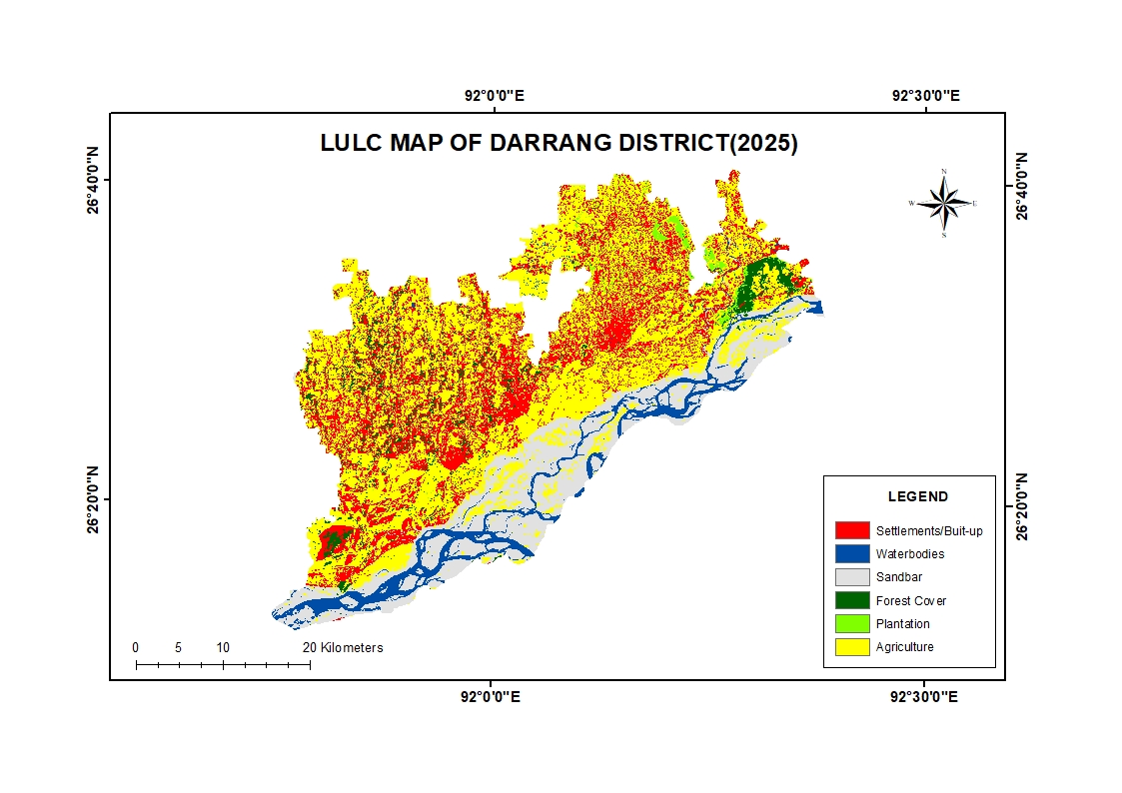

Fig.2 : LULC Map of Darrang District,2025
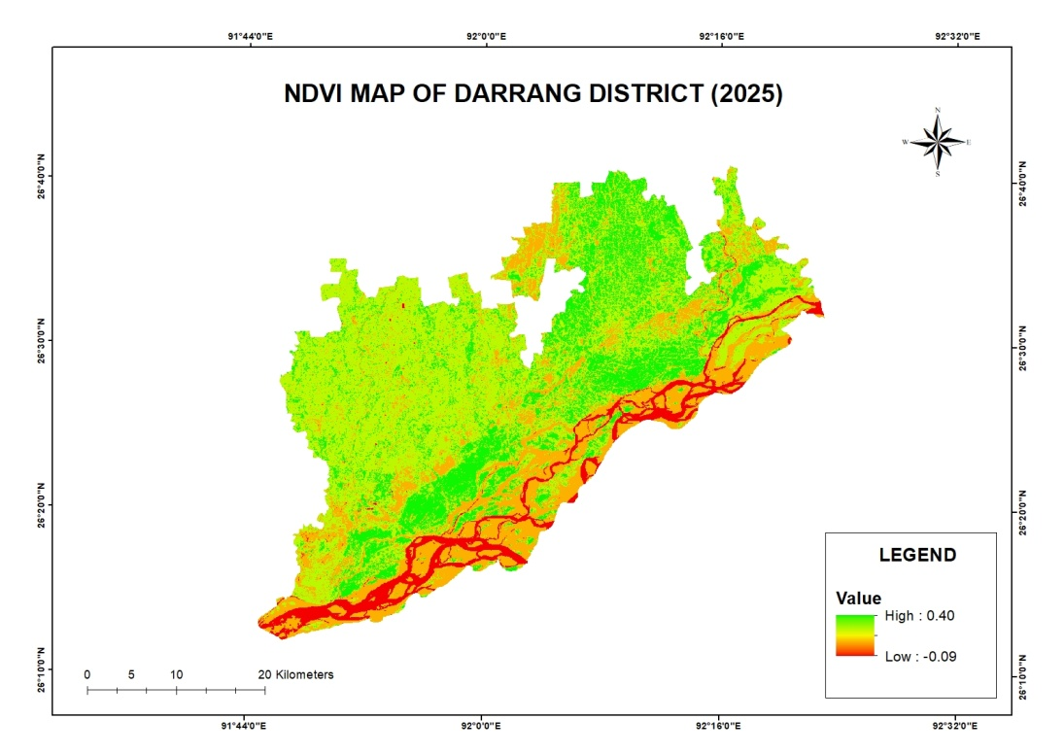

Fig.3 : NDVI map of Darrang District, 2025

5.2 Normalized Difference Vegetation Index (NDVI) of the study area :
The Normalized Difference Vegetation Index (NDVI) is popularly utilized to evaluate the remote sensing imagery data, particularly for determining the presence and condition of green vegetation in a specified region. By applying NDVI using multispectral datasets, this enables the identification and mapping of various land-cover features, including areas covered by water, urban zones, vegetation, and areas with dense plant growth (Somayajula et al., 2020). The different range of NDVI value and the characterized pictorial view of NDVI index for the year 2025 has been shown in fig.4. NDVI index values have been found between -0.09 and 0.40 for the year 2025. NDVI values span from −1 to 1, with readings near zero generally associated with built-up or urban regions, negative values suggesting water bodies, and positive readings corresponding to areas of dense vegetation (Sahana et al. 2016; Babalola and Akinsanola 2016).
The following formula has been used for extraction of NDVI

NDVI= (NIR-RED)/(NIR+RED)

Where, the Red band refers to band 4, which captures visible light, while the Near-Infrared (NIR) band corresponds to band 5 on the Landsat 8 OLI_TIRS sensor.
The Normalized Difference Vegetation Index (NDVI) is a numerical measure derived from the visible and near-infrared portions of the electromagnetic spectrum. In remote sensing, it serves as a key tool for identifying the presence and condition of vegetation. Healthy plants typically absorb most of the light in the visible range while reflecting a high amount of near-infrared radiation. In contrast, vegetation that is weak or sparse reflects more visible light and less near-infrared energy, and bare soil shows relatively balanced reflectance in both ranges. Since scientists have well-established knowledge of how plants reflect light across these wavelengths, NDVI is computed using the red and near-infrared bands captured by satellites. A higher difference between these two reflectance values indicates thicker, healthier vegetation. Kumar et.al (2024)

6. CONCLUSION:

This study evaluates the latest status of NDVI and LULC of Darrang District. As per the objective (i), the finding reveals that maximum area covered by land under agriculture (681.15 km²) followed by settlements (384.7 km²), sandbar (299.81km²), water bodies (126.43 km²) and minimum area covered by plantation (34.57 km²) followed by forest cover (77.31 km²). As per objective (ii), the result shows that the ranges of NDVI values have been found between -0.09 and 0.40 for the year 2025, which indicates sparse vegetation or moderately green cover during dormant seasons. Many other relevant aspects can be analyzed for the study area using Geospatial technology which may be helpful for the future academician and planners.

REFERENCES:
- Al-Ameri, R. A., Sabah, N., & Al-Baaj, G. A. J. (2025). Computing and predicting the vegetation cover using NDVI under the conditions of climate changes, for the period 2000-2024: A case study, Karbala City, Iraq. *International Journal of Advanced Trends in Engineering and Technology*, *10*(1), 5-12. https://www.dvpublication.com/
- Lahane, R., Manza, R. R., Ambhore, S., & Katkade, S. (2025). Remote Sensing and GIS for LULC Change Detection: A Review of Techniques and Findings. International Journal for Research in Applied Science and Engineering Technology. https://doi.org/10.22214/ijraset.2025.72941
- Babalola, O. S., & Akinsanola, A. A. (2016). Change detection in land surface temperature and land use land cover over Lagos Metropolis, Nigeria. Journal of Remote Sensing & GIS, 5(3), 1-7. https://doi.org/10.4172/2469-4134.1000171
- Borah, S. (2024). The Statistical Correlation Between Normalized Difference Vegetation Index and Land Surface Temperature in the Charaideo District of Assam, India. Ecology, Environment & Conservation, 30(4). https://doi.org/10.53550/EEC.2024.v30i04.071
- Bora, R., & Bora, A. K. (2024). Population Pressure and Changing Land Use Land Cover in Morigaon District, Assam, India - A Geospatial Analysis. Indian Journal of Science and Technology, 17(24), 2547-2556. https://doi.org/10.17485/IJST/v17i24.899
- Chen, J., Shao, Z., Deng, X., Huang, X., & Dang, C. (2023). Vegetation as the catalyst for water circulation on global terrestrial ecosystem. Science of the Total Environment, 895, 165071. https://doi.org/10.1016/j.scitotenv.2023.165071
- Coqueia, S., & Paca, A. (2024). Analysis Comparison of the Normalized Difference Vegetation Index (NDVI) of Vegetation Cover from 1996 to 2024 in the Concession Perimeter of Sociedade Mineira de Catoca. International Journal of Scientific Research and Technology.
- Dey, P., Handique, A., & Patnaik, S. K. Assessment and monitoring of vegetation drought conditions in the Tinsukia district of Assam using the Normalized Difference Vegetation Index (NDVI) and the Vegetation Condition Index (VCI).
- Gandhi, G. M., Parthiban, S., Thummalu, N., & Christy, A. (2015). Ndvi: Vegetation change detection using remote sensing and gis – A case study of Vellore District. Procedia Computer Science, 57, 1199-1210. https://doi.org/10.1016/j.procs.2015.07.415
- Garai, S., Khatun, M., Singh, R., Sharma, J., Pradhan, M., Ranjan, A., Rahaman, S. M., Khan, M. L., & Tiwari, S. (2022). Assessing correlation between Rainfall, normalized difference Vegetation Index (NDVI) and land surface temperature (LST) in Eastern India. *Safety in Extreme Environments*, *4*(2), 119-127. https://doi.org/10.1007/s42797-022-00056-2
- Guo, B., Zhou, Y., Wang, S. X., & Tao, H. P. (2014). The relationship between normalized difference vegetation index (NDVI) and climate factors in the semiarid region: A case study in Yalu Tsangpo River basin of Qinghai-Tibet Plateau. Journal of Mountain Science, 11(4), 926-940. https://doi.org/10.1007/s11629-013-2902-3
- Hazarika, A., Saikia, J., & Saikia, S. (2024). Evaluating the scenario of urban blue-green space in Tezpur town of Assam using geo-technical approach. Acta Geophysica, 72(3). https://doi.org/10.1007/s11600-024-01360-0
- Kumar, S. A., Saradhi, B. V., & Rajesh, M. (2024). Extraction Of Vegetation From Satellite Image Using Ndvi And Change Detection Of Vegetation--A Matlab Approach, Ananthapur District, Andhra Pradesh, India. Frontiers in Health Informatics, 13(8). https://www.healthinformaticsjournal.com/index.php/fhi/article/view/3626
- Klein Goldewijk, K., & Ramankutty, N. (2004). Land cover change over the last three centuries due to human activities: The availability of new global data sets. GeoJournal, 61(4), 335-344. https://doi.org/10.1007/s10708-004-5050-z
- Lambin, E. F., Turner, B. L., Geist, H. J., Agbola, S. B., Angelsen, A., Bruce, J. W., Coomes, O. T., Dirzo, R., Fischer, G., Folke, C., George, P. S., Homewood, K., Imbernon, J., Leemans, R., Li, X., Moran, E. F., Mortimore, M., Ramakrishnan, P. S., Richards, J. F., ... Xu, J. (2001). The causes of land-use and land-cover change: Moving beyond the myths. *Global Environmental Change*, *11*(4), 261–269. https://doi.org/10.1016/S0959-3780(01)00007-3
- Liu, M., Hu, Y., Chang, Y., He, X., & Zhang, W. (2009). Land use and land cover change analysis and prediction in the upper reaches of the Minjiang River, China. Environmental management, 43(5), 899-907. https://doi.org/10.1007/s00267-008-9263-7
- Machahary, J. (2024). Spatio-Temporal Detection of Land Use/Land Cover Changes in Kokrajhar District of Assam. International Journal of Innovative Technology and Exploring Engineering (IJITEE), 13(6). https://doi.org/10.35940/ijitee.F9872.13060524
- Mehmood, K., Anees, S. A., Rehman, A., Tariq, A., Zubair, M., Liu, Q., Rabbi, F., Khan, K. A., & Luo, M. (2024). Exploring spatiotemporal dynamics of NDVI and climate-driven responses in ecosystems: Insights for sustainable management and climate resilience. Ecological Informatics, 80, 102532. https://doi.org/10.1016/j.ecoinf.2024.102532
- Niyogi, D., Mahmood, R., & Adegoke, J. O. (2009). Land-Use/Land-Cover Change and Its Impacts on Weather and Climate. Boundary-Layer Meteorology, 133(3), 297–298. https://doi.org/10.1007/s10546-009-9437-8
- Pawe, C. K., & Saikia, A. (2018). Unplanned urban growth: land use/land cover change in the Guwahati Metropolitan Area, India. Geografisk Tidsskrift-Danish Journal of Geography, 118(1), 88-100. https://doi.org/10.1080/00167223.2017.1405357
- Pelorosso, R., Apollonio, C., Rocchini, D., & Petroselli, A. (2021). Effects of land use-land cover thematic resolution on environmental evaluations. Remote Sensing, 13(7), 1232. https://doi.org/10.3390/rs13071232
- Sahana, M., Ahmed, R., & Sajjad, H. (2016). Analyzing land surface temperature distribution in response to land use/land cover change using split window algorithm and spectral radiance model in Sundarban Biosphere Reserve, India. Modeling Earth Systems and Environment, 2(2), 81. https://doi.org/10.1007/s40808-016-0135-5
- Selçuk, R. E. I. S., Nişancı, R., Uzun, B., Yalçın, A., İnan, H., & Yomralıoğlu, T. (2003). Monitoring Land-Use Changes by GIS and Remote Sensing Techniques: Case Study of Trabzon. In Proceedings of 2nd FIG Regional Conference, Marrakech, Morocco. https://www.fig.net/figtree/pub/morocco
- Singgalen, Y. A. (2024). Spatio-temporal analysis through NDVI, NDBI, and SAVI using Landsat 8/9 OLI. Journal of Computer System and Informatics, 5, 815-831. https://doi.org/10.47065/josyc.v5i4.5735
- Singh, R. P., Singh, N., Singh, S., & Mukherjee, S. (2016). Normalized Difference Vegetation Index (NDVI) Based Classification to Assess the Change in Land Use/Land Cover (LULC) in Lower Assam, India. International Journal of Advanced Remote Sensing and GIS, 5(10), 1963-1970. https://doi.org/10.23953/cloud.ijarsg.74
- Somayajula, A., Kiranmai, V. A., Ghai, D., & Kumar, S. (2020). A Review on Classification of Land Use/Land Cover change assessment based on the Normalized Difference Vegetation Index. ournal of Critical Reviews, 7(14), 2416-2431.
- Twisa, S., & Buchroithner, M. F. (2019). Land-use and land-cover (LULC) change detection in Wami River Basin, Tanzania. Land, 8(9), 136. https://doi.org/10.3390/land8090136

