Original Research Article

First record of congaturi Halfbeak, Hyporhamphus limbatus (Valenciennes 1847) from Siang river, Arunachal Pradesh, India (Teleostei: Hemiramphidae)

ABSTRACT
Hyporhamphus limbatus (Valenciennes) a congaturi halfbeak belongs to order Beloniformes and family Hemiramphidae was originally described from Malabar cost of India by Cuvier and Valenciennes (1847). The species is euryhaline as well as potamodromous in nature. It has been reported from costal brackish, fresh water rivers such as Ganges in India but it was never been reported from rivers of Arunachal Pradesh. The present paper deals with first report of Hyporhamphus limbatus from Siang river of Arunachal Pradesh and confirming its wide range of geographical distribution toward far northeastern part of India.
Key words: Range extension, Hyporhamphus limbatus, Siang river, Arunachal Pradesh.
- INTRODUCTION
The halfbeaks fishes of family Hemiramphidae under the order Beloniformes are slender or elongated fishes with lower jaw extending far beyond the upper jaw in most of the species Berra (2001). Under the family Hemiramphidae Nelson et al., (2016) recognized a total of 67 valid species under 8 genera and under the genera Hyporhamphus (including Reporhamphus) a total of 40 species was recorded. Hyporhamphus limbatus was originally described as Hemiramphus limbatus by Valenciennes in Cuvier and Valenciennes (1847) from Malabar cost of India. Hyporhamphus limbatus though it was first describe from Malabar cost of India its range extends from the Persian Gulf to China along with mainland coast Asia Collette & Su (1986). In Asia it is known from India, Sri Lanka, Myanmar, Thailand, China, Vietnam (Talwar & Jhingran 1991; Rainboth 1996; DattaMunshi & Srivastava 1998 and Ramanujam & Anbarasen 2007).
The Siang River of Arunachal Pradesh, also known as Yarlung-Tsangpo River in Tibet China originated from the Angsi glacier on the northern side of the Himalayas. The river enters into Indian Territory near Tuting area of Arunachal Pradesh then flows southwards and ultimately gives off its contents into mighty Brahmaputra in Assam. It is one of the major drainage systems of central Arunachal and main tributary of river Brahmaputra. The river is endowed with rich ichthyo-diversity but the ichthyofaunal resources of the Siang River and its tributaries are poorly explored Darshan et al., (2017).
Lots of work has been done in the field of ichthyofaunal research of lentic and lotic water bodies of Arunachal Pradesh. Begins with the early works of Choudhuri (1913) presented zoological reports of Abor expedition, extensive works of Hora (1921), Choudhury and Sen (1977), Sen (1999), Sen (2006), Geetakumari & Kadu (2011), Kadu & Das (2011),Tesia & Bordoloi (2012), Jha & Chetrry (2014), Darshan et al., (2017), Shangningam et al., (2019), Jha (2020) etc. Apart from them the most comprehensive works on the ichthyofaunal resources of state was done by Nath & Dey (2000) recorded total of 131 fish species, followed by Bagra et al., (2009) recorded 213 fish species, Gurumayum et al., (2016) reported a total of 259 fish species under 105 genera and Darshan et al.,(2018) recorded 213 different fish species. But none of the earlier scholars has reported Hyporhamphus limbatus from any lotic and lentic water bodies of Arunachal Pradesh.
After scanning through the available literature it is also evident that the halfbeak euryhaline fish species Hyporhamphus limbatus were reported to be a frequent visitor of freshwater rivers Day (1878), Misra(1959), Srivastava (1967), Rainboth(1996), DattaMunshi & Srivastava (1988), Mondal & Kaviraj (2009), Sarkar et al., (2012), Sinha et al.,(2014), Shayamsundar et al.,(2017). But on further perusal of related literatures it is evident that the range distribution of Hyporhamphus limbatus has not been reported earlier from far up stream of Brahmaputra river basin and its tributaries of Northeast India.
The present paper deals with the first record of Hyporhamphus limbatus(Valenciennes) from Siang river, Pasighat Arunachal Pradesh, India and extension of geographical distributional range of Hyporhamphus limbatus to north eastern region of India as a whole and Arunachal Pradesh in particular.
- MATERIALS AND METHODS
The halfbeak fish specimen was collected from river Siang near confluence point of Sibo Korong and Siang river at Pasighat (Figure.1) using caste net. The collected fish specimen was preserved in 10% formalin solution and deposited in Jawaharlal Nehru College Museum of Fishes (JNCMF), Jawaharlal Nehru College, Pasighat, Arunachal Pradesh, India.
All morphometric measurements were taken from point to point on the lateral left side of the fish using digital vernier caliper and the data’s were recorded to the nearest millimeter. The body proportion was expressed as a percentage of standard length (SL) and the subunits of head are also separately presented in proportion of head length (HL).
All the morphometric and meristic data generated were compared with the standard references that of Day (1878), Mishra (1959), Jayaram (1981) and DattaMunshi& Srivastava (1988). Identification was done following Day (1878 and 1889), Talwar & Jhingran (1991) and Collete (1984, 1999) FAO species identification sheets. Due to non-availability of museum specimens for comparison the author used the published literature on meristic and morphometric data’s of Hyporhamphus limbatus Johny et al., (2016) and Collette (2004).
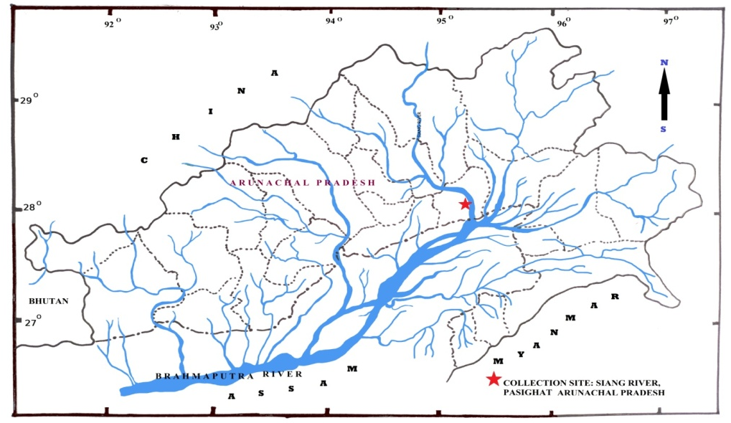
Figure 1. Map showing present collection site (Siang river, Pasighat) of Hyporhamphus limbatus.
- RESULTS
Hyporhamphus limbatus (Valenciennes 1846) (Figure. 2)
Hemiramphus limbatusValenciennes, in Cuvier and Valenciennes 1846,Hist. Nat. Poiss; 19:44 (type locality: India, Malabar Coast, Bombay and Pondicherry).
Hemiramphus limbatus Day 1877, Fishes of India; 516, Pl, 119, Fig 3; Day, 1889, Fauna Br. India, Fishes 1 :426.
Hemiramphus gaimardi Valenciennes Jones and Sujansinghani, 1954, Indian J. Fish., 1:264
Hemiramphus gorakhpurensis Srivastava 1967. Journal of BombayNaturalHistory Society 64(1): 93 (type locality: Gorakhpur, Uttar Pradesh).
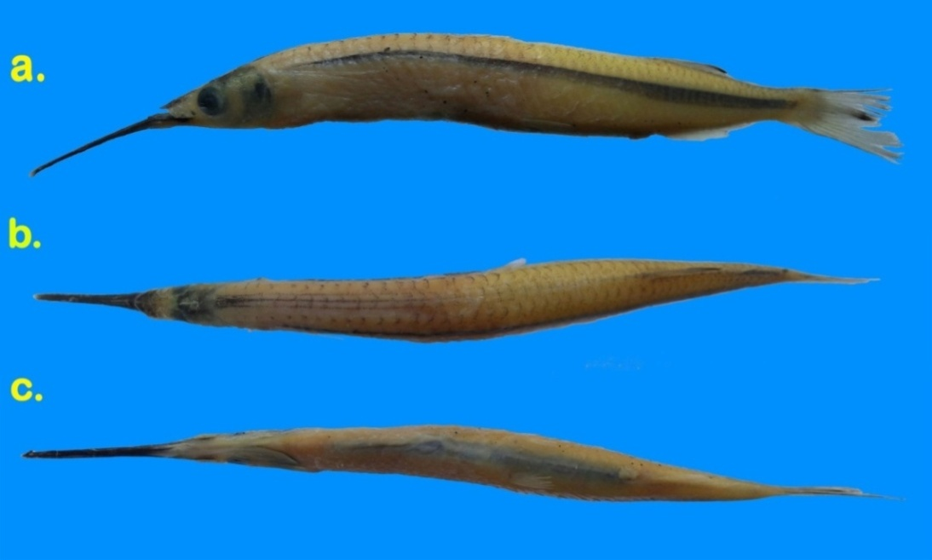

Figure 2. Hyporhamphus limbatus, JNCMF- 491,160.5 mm SL; Siang River, Pasighat, East Siang District, Arunachal Pradesh India. A. Lateral view; B. Dorsal view; C. Ventral view of body.

  - Material examined
JNCMF- 491, 160.5 mm SL, Siang River, near Sibo-Siang confluence at Pasighat, East Siang district Arunachal Pradesh, India. 28° 08′77″N 95°32′ 77″ E, altitude 150 m, Date of collection- 09 July 2019, collected by Kento Kadu.
  - Description
Morphometric measurements and meristic counts are presented in Table.1. Body elongated, slightly cylindrical and somewhat compressed. Abdomen rounded not keeled. Dorsal profile slightly curved, rising slowly from the tip of snout to above the pectoral-fin origin and thereafter runs parallel to the body axis up to dorsal fin insertion point. Whereas ventral profile slightly arched from below the tip of the snout to the base of the caudal fin. Mouth superior, Jaws unequal, lower jaw longer than upper jaw. Lower jaw greatly prolonged into a beak-like structure. Scale less upper jaw appears triangular in dorsal view and its length slightly less than width. Body covered with moderate size cycloid scales. Pre dorsal scales consist of 33 scales and 44 lateral line scales. Anal and dorsal fins base are covered with scales. Eyes are large, positioned slightly nearer to anterior portion of head and not visible when observed from dorsal. Pre-orbital ridge present. Canal absent in between posterior branch to pre orbital area. Nasal papilla fan shaped. Fins are without spines. Dorsal fin inserted in posterior half nearer to caudal origin. It originated slightly ahead of anal fin. Pectoral-fin inserted almost lateral portion of body, when folded forward reaching middle of orbit but not extending beyond anterior margin of orbit. Pelvic-fin short which inserted posterior to mid-body length and not reaching anus or anal fin origin. Anal fin inserted just behind dorsal vertically. Base of anal fin is slightly shorter than dorsal fin base length. Caudal fin emarginated or slightly forked, lower lobe slightly longer than upper lobe. Barbels are absent.
In preserved specimen Dorsal profile is yellow white and ventral profile silvery white in colour. Lateral surface of body silvery white in colour. A dark blue-black lateral stripe runs mid lateral position which originated just near insertion point of pectoral fins and widening posteriorly greatest near anus. Body is devoid of any vertical bars on its lateral sides. Scales on dorsal profile dappled with black, thus imparting a slight black colouration. Three spotted lines on mid dorsal side commencing from occipital region and ending slightly ahead of dorsal fin origin. Fleshy tip of elongated beak is reddish. Pectoral, pelvic, and anal fins translucent with some pigments on fin rays.
Table 1. Morphometric and Meristic data of Hyporhamphus limbatus, JNCMF- 491, 160.5 mm SL; Siang River, Pasighat, East Siang District, Arunachal Pradesh India.

Sl.No | Characters | In mm
1 | Total length | 186.5
2 | Standard body length | 160.5
 | In proportion of standard Body length
3 | Head length (lower jaw tip) | 35.1
4 | Head length (upper jaw tip) | 15.6
5 | Snout length | 25.6
6 | Head height at eye | 6.3
7 | Head width at eye | 4.5
8 | Mouth gape | 3.8
9 | eye diameter | 3.7
10 | Interorbital distance | 4.2
11 | Body depth at pelvic origin | 11.2
12 | Body width at pelvic origin | 7.5
13 | Pre dorsal fin length | 82.2
14 | Pre pectoral fin length | 38.6
15 | Pre pelvic fin length | 65.0
16 | Pre Anal fin length | 82.1
17 | Dorsal fin base length | 12.9
18 | Anal Fin Base length | 12.1
19 | Pectoral fin length | 12.8
2o | Pectoral l fin base length | 3.1
21 | Pelvic fin length | 6.9
22 | Pelvic l fin base length | 1.4
23 | Caudal fin length | 16.1
24 | Caudal peduncle length | 6.5
25 | Caudal peduncle height | 4.4
26 | Distance from Pelvic origin to anus | 15.8
27 | Distance from anus to anal fin origin | 1.7
 | In proportion of standard head length
28 | Snout length | 73.0
29 | Head height at eye | 17.9
30 | Head width at eye | 12.8
31 | Mouth gape | 10.8
32 | eye diameter | 10.5
33 | Interorbital distance | 12.1
 | Meristic counts
34 | Dorsal fin | 14
35 | Pectoral fin | 11
36 | Pelvic fin | 6
37 | Anal fin | 14
38 | Caudal fin | 15
39 | Lateral line scales | 44

- DISCUSSION
A total of 36 species were recognized under the genus Hyporhamphus Gill 1859by Collette (2004) out of which 11 are Indo-pacific marine species where as Nelson et al., (2016)recorded 40 species including species of Reporhamphus. The present specimen shares similarity with most of the characters of Hyporhamphus limbatus. However few morphological and meristic counts variation was observed which may be due to different in measuring techniques. Srivastava (1968) & Jayaram (1981) reported that dorsal fin arises slightly posteriors to anal or dorsal inserted in between pelvic and anal fin origin. Whereas in present species dorsal arises slightly ahead of anal when observed vertically. The same kind of dorsal fin insertion was also observed by (Mishra1959 and DattaMunshi & Srivastava 1988).
After careful review of available literature it is evident that the halfbeak fish species Hyporhamphus limbatus was never recorded from any water bodies of Arunachal Pradesh as well as from north eastern state of India. Hyporhamphus limbatus is basically a marine and euryhaline species, but their potamodromous behaviors toward freshwater is not new. The species was reported from ascend tidal rivers, ascends estuaries & freshwater by Day (1878) and Misra (1959) with a name of Hemirhamphus limbatus and Hemiramphus gaimardi. Jones & Sujansinghani (1954) recorded the species from Chilka lake, David (1954) from Hoogly river between Barrackpore & Nawabganj West Bengal. But the reporting of Hyporhamphus limbatus(as new species H.gorakhpurensis) from purely freshwater resources like Maheshara tal and river Rohini at Gorakhpur Uttar Pradesh by Srivastava (1967) clearly established the wide range of its distributions to freshwater rivers of India, followed by reporting of Hyporhamphus limbatus from purely freshwater zone of river Budhi Gandak in Khagaria district of Bihar by DattaMunshi & Srivastava (1998) which further confirmed the species inclinationtowards upstream migration of freshwater rivers, later on Mondal & Kaviraj (2009) also reported the Hyporhamphus limbatus from two flood plain lakes of Ichhamati river. While working on the Freshwater fish diversity in the river Ganges (India), Sarkar et al., (2012) also reported Hyporhamphus limbatus from Ganga River in between Patna to Bhagalpur including Munger and also from a stretch of Ganga between Bhagalpur to Rajmahal including Khalegaon. Consortium of IITs in its reports on GRB EMP flora and fauna of lower Ganga Farakka to Ganga sagar also reported Hyporhamphus limbatus from lower stretch of Ganga. Sinha et al., (2014) also recorded Hyporhamphus limbatus from Ganga river at Bhagalpur and Rajmahal during their ichthyofaunal study in middle-lower stretch of the river Ganges. The report of Hyporhamphus limbatus from Panagal reservoir of Nalgonda district of Telangana state by Shayamsundar et al., (2017) is another evidence of its migratory behavior towards freshwater bodies. ICAR-CIFRI in its Midterm report (2019) also recorded the species from following stretch of Gnaga viz. Bhagalpur, Balagrah,Tribeni, D Harbor & Frasergang. Rainboth (1996) also encountered Hyporhamphus limbatus from upstream of Mekong river as far as up toStung riverwhich also supports the possible upstream freshwater migration of species. Interestingly Shrestha & Sabina (2008) reported Hyporhamphus limbatus from Koshi & Narayani river of Nepal. Recently Esamin et al., (2018) recoded Hyporhamphus limbatus from Jamuna river of Bangladesh, which is directly connected to Brahmaputra/Siang river of India. Recently, Wanjari et al. (2025) also reported three specimens of Hyporhamphus limbatus from Wainganga river near Kardha village in Bhandra district of Maharastra, India. From the above literature it is evident that Hyporhamphus limbatus frequently use visit the freshwater river but itwas never been reported from any water bodies of Arunachal Pradesh in particular and North East India in general. Some of earlier scholars such as Nath & Dey (2000), Bagra et al., (2009), Gurumayum et al., (2016) and Darshan et al.,(2018) did an extensive survey on ichthyofaunal diversity of Arunachal Pradesh but none of the these scholars has reported Hyporhamphus limbatus from any lotic and lentic water bodies of Arunachal Pradesh.
Few scholars also reported other marine or migratory pipe fish species from Siang river such as Micropis deocata (Ham) by Sen (1999) and Micropis ignoratus by Jha & Chetry (2014) from tributaries of Siang under Mebo circle of Arunachal Pradesh which also indicates the favorable condition of Siang river for such migration of marine species. Talwar & Jhingran (1991) has also reported the breeding behavior of Hyporhamphus limbatus in Chilka lake a brackish water or near boundary of brackish river. The present reporting of Hyporhamphus limbatus from Siang river of Arunachal Pradesh shows the species wide range of distribution to freshwater upstream. However the reasons for their wide upstream migration especially in Brahmaputra basin are not known and further study is necessary in this direction. Further, an in-depth study of the species on its habitat preferences, its migration behavior will definitely enhance the understanding of this halfbeak fish species.

DISCLAIMER (aRTIFICIAL INTELEGENCE)

Author hereby declare that no generative AI technologies such as Large Language Models (ChatGPT, COPILOT, etc) and text-to-image generators have been used during witting or editing of this manuscript.

REFERENCES
- Bagra, K., Kadu, K., Nebeshwar-Sharma, K., Laskar, B. A., Sarkar, U. K., & Das, D. N. (2009). Ichthyological survey and review of the checklist of fish fauna of Arunachal Pradesh, India. Check List, 5(2), 330-350. https://doi.org/10.15560/5.2.330 .
- Berra, T. M. (2001). Freshwater fish distribution. Academic Press. https://doi.org/10.1016/b978-0-12-093156-9.x5026-4
- Chaudhuri, B. L. (1913). Zoological results of the Abor Expedition, 1911-12. XVIII. Fish. Records of the Indian Museum, 8, 243-257. https://doi.org/10.26515/rzsi/v8/i3/1913/163153 .
- Choudhury, S., & Sen, N. (1977). On a collection of fish from Arunachal Pradesh with some new records. Newsletter Zoological Survey of India, 3(4), 217-223. https://faunaofindia.nic.in/ .
- Collette, B.B.(1984). Hemirramphidae. In W. Fischer and G. Bianchi (Eds). FAO Species identification sheets for survey purpose. Western Indian Ocean fishing area 51. FAO, Rome. vol.2.
- Collette, B.B., & Su, J. (1986). The halfbeaks Pisces, Beloniformes, Hemiramphidae of the Far East. Proceeding of the Academy of Natural Sciences of Philadelphia. 138(1):250-301.
- Collette, B. B. (1999). Hemiramphidae. Halfbeaks. In K. E. Carpenter & V. H. Niem (Eds.), *FAO species identification guide for fishery purposes. The living marine resources of the Western Central Pacific. Volume 4. Bony fishes part 2 (Mugilidae to Carangidae)* (pp. 2180-2196). FAO. https://www.fao.org/fishery/docs/CDROM/FAO_Species_Identification_Guide_for_Fishery_Purposes_The_Living_Marine_Resources_of_the_Western_Central_Pacific_Volume_4_Bony_fishes_part_2_Mugilidae_to_Carangidae.pdf .
- Collette, B. B. (2004). Family Hemiramphidae Gill 1859 Halfbeaks. California Academy of Sciences Annotated Checklists of Fishes, (22). https://www.calacademy.org/sites/default/files/Documents/ichthyology/annotated_checklists/Collette_2004_Hemiramphidae.pdf .
- Cuvier, G., & Valenciennes, A. (1847). Histoire naturelle des poissons. Tome dix-neuvième. Suite du livre dix-neuvième. Brochet sou Lucioïdes. Livre vingtième. De quelques familles de Malacoptérygiens, intermédiaires entre les Brochets et les Clupes. Histoire naturelle des poissons. https://doi.org/10.5962/bhl.title.12283 .
- Darshan, A., Dutta, R., Abujam, S., & Das, D.N. (2017). First Record of Batasio Spilurus Ng from the Siang River of Arunachal Pradesh, Northeastern India (Teleostei: Bagridae). Journal of FisheriesSciences.com, 11(2), 021-027. https://www.itmedicalteam.pl/journals/journal-of-fisheries-sciences/volume-11-issue-2/first-record-of-batasio-spilurus-ng-from-the-siang-river-of-arunachal-pradesh-northeastern-india-teleostei-bagridae .
- Darshan, A., Abujam, S., & Das, D.N. (2018). Biodiversity of fishes in Arunachal Himalaya: Systematics, classification, and taxonomic identification. Academic Press. https://www.elsevier.com/books/biodiversity-of-fishes-in-arunachal-himalaya/singh/978-0-12-815556-1 .
- Datta Munshi, J.S., & Srivastava, M.P. (1988). Natural History of Fishes and Systematics of Freshwater Fishes of India. Narendra Publishing House. https://nphindia.com/catalogue/natural-history-of-fishes-and-systematic-of-freshwater-fishes-of-india/ .
- Day, F. (1878). The fishes of India: Being a natural history of the fishes known to inhabit the seas and fresh waters of India, Burma, and Ceylon. Bernard Quaritch. .
- David, A. (1954). A preliminary survey of the fish and fisheries of a five-mile stretch of the Hooghly river near Barrackpore. Indian Journal of Fisheries, 1(1&2), 231-255. https://epubs.icar.org.in/index.php/IJF/article/view/11113 .
- Easmin, M. N., Habib, A. H. M. S., Akter, S., & Majumder, K. (2018). Status and diversity of ichthyofauna of Jamuna river, Bangladesh. Jagannath University Journal of Life and Earth Sciences, 4(1), 12-24. https://jnu.ac.bd/journal/portal/archives/lifescience.jsp .
- Geetakumari, K., & Kadu, K. (2011). Badis singenensis, a new fish species (Teleostei: Badidae) from Singen River, Arunachal Pradesh, northeastern India. Journal of Threatened Taxa. https://doi.org/10.11609/JoTT.o2531.2085-9 .
- Gurumayum, S. D., Kosygin, L., & Tamang, L. (2016). Ichthyofaunal diversity of Arunachal Pradesh, India: A part of Himalaya biodiversity hotspot. International Journal of Fisheries and Aquatic Studies, 4(2), 337-346. https://www.fisheriesjournal.com/archives/2016/vol4issue2/PartE/4-1-71.pdf
- Hora, S.L. (1921). On some new record and rare species of fish from the Eastern Himalayas. Records of Indian Museum, 22(5), 731-744. https://www.biodiversitylibrary.org/item/109000#page/7/mode/1up .
- ICAR-CIFRI Midterm report (2019) Assessment of fish and fisheries of the Ganga river system for developing suitable conservation and restoration plan. 177 P.
- Jayaram, K.C. (1981). A handbook of the freshwater fishes of India, Pakistan, Bangladesh, Burma and Sri Lanka.Publsihed by Director ZSI, Calcutta. 475 +xxii P
- Jha, K.K., & Chetri, K. (2014). New record of threatened ornamental freshwater pipefish Dorichthys martensii (Peter 1868) or Micropis ignoratus (vaillant 1902) from Indian sub-continent: Arunachal Pradesh India. Africa journal of Advance agricultural research. 2(2): 19-23.
- Jha, K.K.(2020).Schizothoraxsikusirumensis(teleostomi: cyprinidae: schizothrocinae), a new fish species from river SikuSirum, Arunachal Pradesh, India. Journal of Global Bioscience. 9(5): 7339-7351.
- Johny, S., Inasu, N.D., & Dominic, A.D. (2016). Morphometric and meristic characters of Dayella Malabarica (Day 1873) & Hyporhamphus Limbatus (Val 1847). International Journal of Zoology Studies, 1(6), 33-37. https://www.zoologyjournals.com/download/1/6/1-6-10-101.pdf .
- Jones, S., & Sujansinghani, K. H. (1954). Fish and fisheries of the Chilka Lake with statistics of fish catches for the years 1948-1950. Indian Journal of Fisheries, 1(1&2), 256-344. https://epubs.icar.org.in/index.php/IJF/article/view/11115 .
- Kadu, K., & Das, D. N. (2011). NEW RECORD OF FRESHWATER ERITHISTID CATFISH CONTA CONTA (HAMILTON, 1822) (TELEOSTEI: ERETHISTIDAE) FROM ARUNACHAL PRADESH (BIODIVERSITY HOTSPOT), INDIA. The Bioscan, 6(3), 413–416. https://thebioscan.com/index.php/pub/article/view/1852 .
- Misra, K. S. (1959). An aid to the identification of the common commercial fishes of India and Pakistan. *Records of the Zoological Survey of India*, *57*(1-4), 1–320. https://doi.org/10.26515/rzsi/v57/i1-4/1959/161986 .
- Mondal, D. K., & Kaviraj, A. (2009). Distribution of fish assemblages in two floodplain lakes of North 24-Parganas in West Bengal, India. Journal of Fisheries and Aquatic Science. https://doi.org/10.3923/jfas.2009.12.21 .
- Nath, P., & Dey, S.C. (2000). Fish and Fisheries of North-East India (Arunachal Pradesh).Narendra Publishing House, Delhi. 217 P.
- Nelson, J. S., Grande, T. C., & Wilson, M. V. H. (2016). Fishes of the world (5th ed.). John Wiley and Sons. https://doi.org/10.1002/9781119174844
- Rainboth, W. J. (1996). Fishes of the Cambodian Mekong. FAO Species Identification Field Guide for Fishery Purposes. FAO. https://www.fao.org/fishery/docs/CDROM/V8731E/V8731E00.HTM .
- Ramanujam, M. E., & Anbarasan, R. (2007). A preliminary report on the vertebrate diversity of the Kaliveli watershed region. Zoo’s Print Journal, 22(3), 2608-2616. https://www.zoosprint.zooreach.org/index.php/zp/article/view/1000 .
- Sarkar, U. K., Pathak, A. K., Sinha, R. K., Sivakumar, K., Pandian, A. K., Pandey, A., Dubey, V. K., & Lakra, W. S. (2012). Freshwater fish biodiversity in the River Ganga (India): Changing pattern, threats and conservation perspectives. Reviews in Fish Biology and Fisheries, 22(1), 251-272. https://doi.org/10.1007/s11160-011-9218-6 .
- Sen, N. (1999). On a collection of fishes from Subansiri and Siang Districts of Arunachal Pradesh. Records of the Zoological Survey of India, 97(1), 141-144. https://doi.org/10.26515/rzsi/v97/i1/1999/160261 .
- Sen, T.K. (2006).Fauna of Arunachal Pradesh, State Fauna Series (Pisces).. Zoological Survey of India, Kolkata, Series 13(1):317-396 pp.
- Sinha, B. (2019). Ichthyofauna of Lower Subansiri district, Arunachal Pradesh w.s.r. to Ranga River. Records of the Zoological Survey of India, 119(2), 128–164. https://doi.org/10.26515/rzsi/v119/i2/2019/142748 .
- Sinha, R. K., Sinha, R. K., & Kedia, D. K. (2014). Spatial and temporal variation in Ichthyofaunal diversity in the middle–lower stretch of the river Ganges. In B. Ahmed & R. K. Sinha (Eds.), *Rivers for life: Proceedings of the international symposium on river biodiversity: Ganges-Brahmaputra-Meghna river system* (pp. 241-255). IUCN. https://portals.iucn.org/library/node/45000 .
- Shangningam, B., Kosygin, L.,& Gopi, K.C. (2019). Psilorhynchus bichomensis, a new species of torrent minnow from Arunachal Pradesh, northeast India (Teleostei: Psilorhynchidae). Fish Taxa 4(3):130-139.
- Shrestha, T. K., & Shrestha, S. (2008). Ichthyology of Nepal: A study of fishes of the Himalayan waters. Himalayan Ecosphere. https://agris.fao.org/agris-search/search.do?recordID=NP2009000001 .
- Shyamsundar, R., Prasad, K.K., & Srinivasulu, C. (2017). Ichthyofauna of Udayasamudram Reservoir in Nalgonda District, Telangana State, India. Journal of Threatened Taxa. https://doi.org/10.11609/jott.3417.9.12.11087-11094 .
- Srivastava, C.B. (1966). On a collection of fishes from Tirap Frontier division. Indian Journal of Zoological Society of India.18: 122-128.
- Srivastava, G. J. (1967). A new species of freshwater fish of the genus Hemiramphus Cuv. from Gorakhpur, Uttar Pradesh, India. Journal of the Bombay Natural History Society, 64(1), 93–94. https://biostor.org/reference/19818 .
- Talwar, P.K., & Jhingran, A.G. (1991). Inland Fishes of India and Adjacent Countries, Volume 2. Oxford & IBH Publishing Company. .
- Tesia, C., & Bordoloi, S. (2012). Ichthyofaunal diversity of Charju River, Tirap District, Arunachal Pradesh, India. Asian Journal of Experimental Biological Sciences, 3(1), 82-86. http://www.ajebs.com/ .
- Wanjari, R. N., Shah, T. H., Telvekar, P. A., & Mathialagan, D. (2025). New distribution record of the congaturiHalfbeak Hyphorhampus limbatus (Valenciennes, 1847) from Wainganga River of Maharashtra, India. National Academy Science Lett. https://doi.org/10.1007/s40009-025-061575-6

