EFFECTIVENESS OF EXPERIENTIAL LEARNING ON ACHIEVEMENT IN SOCIAL SCIENCE

Abstract

National Education Policy 2020 endorses experiential learning as an innovative pedagogical strategy aiming to cultivate desired competencies across various curricular areas at all the stages of schooling. Considering this, a study was conducted to explore the effectiveness of experiential learning strategies on students' achievement in social science and their reactions to these strategies. A quasi-experimental design was employed using a non- randomized pre-test post-test control group design. A sample of 60 Grade IX students—30 in the experimental group and 30 in the control group—was drawn from a school in the Giridih District of Jharkhand. In the experimental group, students participated in experiential learning activities—such as nature walks, role-plays, group presentations, and hands-on practical tasks—each accompanied by ample opportunities for reflection, whereas, the control group was taught by using conventional teaching methods. Data was collected using an achievement test and a reaction scale. Findings indicate that the experimental group showed significant improvement in achievement in social science compared to the control group. Additionally, students expressed positive reactions towards the experiential learning activities. The study suggest that experiential learning can be an effective pedagogical approach for enhancing students' achievement in social science. It underscores the importance of incorporating such strategies into school curricula to cultivate a more interactive and engaging social science learning environment.

Keywords:

Experiential Learning, Achievement in Social Science, Pedagogical Strategies, Nature Walk, Role Play, Group Presentations

Introduction
The learning process is rapidly changing over time and so the focus has been shifted from content to competency-based education. The primary concern of all educationists in 21st century is to develop the problem-solving skills, decision making power, critical thinking, creativity and imagination of students (Adeoye et al., 2024). NEP 2020 also emphasizes on development of life skills among students which are necessary to fulfil the needs and demands of the society and to effectively survive in the society. The National Curriculum Framework for School Education (NCFSE, 2023) highlights experiential learning as an essential pedagogical strategy, acknowledging that methods such as field trips, projects, and role play foster active student engagement and meaningful real-world connections in classroom learning. Drawing on the framework outlined in the NCFSE (2023), the social science curriculum—encompassing economics, geography, history, and political science—requires a comprehensive, integrated teaching approach to effectively cover its diverse disciplinary dimensions. As a school subject, it is very important to develop core skills among students (Russell & Waters, 2021). It gives students the insight of their surrounding and creates sense of belongingness towards the society and environment (Yadav, 2023). The study of geography offers a wealth of knowledge and insight that is crucial for improving our comprehension of the world (Pereira & Zhao, 2025). Geography is often given less importance, and one of the key problems is the lack of linkage between geographical concepts and real-life issues (Srinivasan, 2019). Traditional method of teaching geography was lecture driven method in which teachers used to teach students the content of textbook, content mastery was primary focus of teaching learning this led students towards rote memorization of the content (National Focus Group on Teaching of Social Sciences, 2006). The findings of the study by Alam (2021) reveals that teachers rely solely on textbooks in the classroom and follow the lecture method in the classroom which hinders students understanding of abstract and complex concepts of geography. Given the evolving demands of our nation and society, it’s vital to revise teaching approaches and pedagogies to nurture students’ geographical skills effectively.
Experiential learning (EL) has been recognized as an effective approach for enhancing students' academic achievement, engagement and acquisition of knowledge, understanding and skills (Ranken et al. 2024). As Karthiyayeni (2021) has also found positive impacts of Experiential Learning in development of geographical skills among students. Experiential Learning is a new method which is based on providing experiences both formal and informal to the students, which help them to reflect and construct new knowledge. According to Kolb’s learning theory, learning is the process that involves four learning stages such as concrete experiences, reflective observation, abstract conceptualization and active experimentation (Kolb,2014). In the first stage, the teacher provides a direct experience to children such as a field trip or a role play; in the second phase, opportunities are given for personal and group reflections of students based on their direct experiences, in the third phase students understand the meaning of experience leading to conceptualization and in the final stage, students apply this understanding in their real-life situations (kolb & kolb 2018; Wijnen- Meijer et.al 2022; Chiu, 2019; Chan, 2012; Morris 2020). In the present study, lessons are developed based on Kolb’s experiential learning model with specific activities aligned to each phase. Activities such as nature walk and role play was conducted for first stage. Reflection sheet was used by the researcher to collect the reflections of students and in the third phase group presentations were done by students. Finally in last stage students were given opportunity to apply their understanding and create some posters on the theme as an application of their learning.

Rationale of the study
NEP 2020 is emphasizing on use of experiential learning in all stages of school education, including hands-on learning, art-integrated, sports-integrated, and storytelling-based pedagogy (NEP,2020). According to an empirical study, students generally lack a basic comprehension of world geography, discipline, and fundamental geographic concepts (Alam & Alam, 2021) however students like geography when teachers use teaching-learning methods other than the traditional lecture method (Pandey, 2018). Experiential Learning as a pedagogy has demonstrated numerous benefits across diverse educational contexts, promoting active engagement, 21st century skills, and cognitive growth among learners (Putri & Dewi, 2025; Jeet & Pant, 2023) Studies have shown that EL methods such as virtual reality, fieldwork, geocaching, and reflective thinking strategies significantly enhance students’ understanding and engagement (Abdullah et al., 2024). For instance, the use of an EL-based VR approach has been found to foster behavioral, cognitive, and social dimensions of learning (Li et al., 2022). Fieldwork consistently emerges as a crucial tool in developing observation skills, cognitive understanding, and positive attitudes toward Geography while bridging theory and practice (Bukola, 2025; Firomumwe, 2019; Kaya et al., 2010). Activities like geocaching not only improve spatial thinking, directional abilities, and spatial overlay but also make learning more enjoyable and engaging compared to traditional lectures (Flynn, 2018). In some studies, it has been found that activities of the experiential learning programme engage and motivate students leading to better learning outcomes (Kong, 2021) and the implementation of experiential learning method received the overwhelming response from the students as they felt that this approach has made them understand better compared to the conventional approach (Deng & Yi, 2024). While numerous studies have explored experiential learning, only a handful have examined its effectiveness within secondary-level social science. Therefore, this study seeks to find the effectiveness of experiential learning on achievement in social science of students at secondary stage. Additionally, a reaction scale was employed to assess students’ enjoyment of these activities.
Objectives of the Study
- To find out the effectiveness of experiential learning on achievement in social science of class 9 students
- To analyse the reaction of students on experiential learning in social science

Hypothesis of the Study

H₀₁. There is no significant difference in post-test achievement scores in social science between Grade IX students taught using experiential learning strategies and those taught using traditional lecture-based methods.

Research Question
What are the reactions of students towards experiential learning in social science?

Operational Definitions of the term
  - Experiential Learning – In this study experiential learning means the pedagogical strategy of social science which provides students the opportunities to acquire experiences and reflect on those experiences with the help of group activities, discussions, ICT integration, presentations etc.

Delimitations of the study
  - The present study was delimited to one of the private schools of Giridih, Jharkhand.
  - The experiential learning strategy planned and implemented was only for concepts in Geography.

Method
A quasi-experimental pretest- posttest non-randomized method was used in this study. Before the intervention, a pretest was given to both the experimental and control groups, and the same test was given as posttest to both the groups after the experimental intervention. This method made it possible to assess how well the intervention affected the dependent variable. In the current study, the pedagogical strategy was considered as the independent variable in which experiential learning has been used for teaching social science whereas, achievement of students in social science was taken as dependent variable. The population consisted of students of class 9 of Jharkhand. The sample of the present study was selected from one of the secondary schools comprises of 60 students of two sections of ninth grade having 30 students in each section. Non- randomized purposive sampling was used for this study and sample was drawn purposely from available two sections of class 9, consisting 30 students in each section. Both the groups were taught the Unit -5- Natural vegetation and wildlife of grade 9 during the intervention. The major concepts covered are
1. Factors affecting distribution of flora and fauna
2. Types of vegetation
3. Wild life
4. Importance of forests and wildlife
5. Bio reserves

Table 1

The phases followed in the study
Phase1: Content analysis, preparation of unit plan and lesson plan | Independent variable Experiential Learning Dependent variable  Achievement in social science
Phase2: Development of Achievement test and reaction scale | Preparation of the following tools:  - An achievement test was designed to assess students' achievement in social science. This test was utilized in both the pretest and post-test phases to evaluate the effectiveness of the intervention.  - A scale developed to analyze students' reactions a toward the experiential learning approach.
Phase 3: Pre – experimental stage: - | - Administration of pretest for both the groups.  - Collection of pretest score of both the groups.
Phase 4: -Experimental Intervention in the Experimental group and Conventional teaching in the Control group | - Experimental group was taught through Experiential Learning strategy including nature walk, role play, group presentation etc.  - After completion of each experiential learning activity, students shared their reflections on reflection sheets.  - Control group was taught through the old conventional methods.
Phase: - 5 post experimental treatment | - Post test to both the groups  - Reaction scale consisting of 5 levels such as (strongly agree, agree, neutral, disagree, strongly disagree,) filled by the students of experimental group.

Tools of Data Collection
Followings tools were developed or used by the researcher and content validity of the tools was established by taking expert opinion from the faculty members of RIE (NCERT), Bhubaneswar and from the teachers teaching social science in Jharkhand.
- Achievement Test included items that assess the knowledge, understanding, application, skill, analysis and creation levels of students. The questions in the achievement test included formats such as multiple-choice questions (MCQs), true/false and fill-in-the-blank items. The test consists of 15 questions of 30 marks. Test questions are developed by framing the blue print according to the revised blooms taxonomy.
- Reaction scale- Items included reaction of students of experimental group towards content and time management, execution of activities, participation of students and the difficulties faced.

Details on Experiential Learning activities, Assessment Procedures and Learning Resources
Unit plan was prepared by analysing the content and writing about the learning points, learning outcome, learning objectives, and previous knowledge. A concept and activity mapping were done with specific inputs on reflective activity as given below.

Table :2

Details on Experiential Learning activities, Assessment Procedures and Learning Resources

Concept | Experiential Learning strategy | Reflection on these activities | Learning resources | Assessment
Factors affecting distribution of flora and fauna in India | Field engagement (Nature Walk) Soil activity | Reflection sheet was given to students to write about what they are  observing. | School garden with variety of trees. | Participatory observation by the teacher
Types of  Vegetation | Group activity followed by presentation of students | Presentation of students in group | Blackboard, chalk, ICT resources | Performance of students in group activities
Wildlife | Group presentation by students | Presentation and group activity | Blackboard, chalk, ICT resources | Performance of students in group activities
Importance of  forests and wildlife | Role plays by students | Reflection sheet was given to students. | Script for role play | Role-play performance of students
Bio reserves | Use of ICT videos | Group presentation | ICT  Resources | Oral questioning

Experimental Intervention
Lesson plan: Lessons were organized by using Kolb Experiential Learning model:
Table: 3

Outline of Kolb’s Experiential Learning strategy

Stage 1: Experiencing (Concrete Experience): The learner was provided with opportunities for experiencing a situation or concept followed by  - Nature walk  - Problem solving  - Discussion/ debates  - Practical exercises, e.g. making a presentation, engage in role play Activities.  - Engaging in Soil collection Activity  - Watching videos | Stage 2: Examining (Reflective Observation): To find meaning, the learner thinks about and analyses the novel experience from different perspectives and come out with reflective input on the themes.  - Write a brief self-reflective report on the concepts based on the observation  - Reflection sheet for responding to 3-4 critical items.
Stage 3: Explaining (Abstract Conceptualization): The learner considers what has been learned and makes logical inferences about its implications for the future while searching for patterns, developing concepts, and testing theories.  - Present models  - Give facts  - Give answers in between the presentation. | Stage 4: Applying (Active Experimentation) The student applies ideas to fresh, tangible experiences and makes judgments based on prior knowledge.  - Projects  - Draws maps on blackboard and outline the areas of different types of vegetation.  - Preparation of poster on importance of the concepts

Experiential Learning Strategies (with examples) implemented in the Experimental Group
- Nature Walk: Students visited the school garden, observed various plants and birds, and reflected on their observations. For an example, one student noticed yellow coconuts and, after discussion, they concluded that this was due to insufficient nitrogen, temperature, and rainfall. This process reflects Kolb’s stage of Concrete Experience, as the activity connected classroom learning with real-world observations.
- Group Presentation: Students were divided into six groups to present on topics like types of natural vegetation in India. Initially, students relied on notes, but by the second and third presentations, they improved significantly, even demonstrating concepts on the blackboard. This progression indicates not only increased confidence but also Abstract Conceptualization, where students internalized concepts enough to present them in their own words.
- Role Play: Each group prepared a script and performed a role play on the importance of forests and wildlife. Topics included deforestation, hunting, and endangered animals. Students used props like masks and posters to enhance their performances. According to Kolb, this represents Active Experimentation, where learners apply knowledge in new contexts.
- Analysis (Soil Activity): Students brought soil samples to discuss and identify soil types, exploring how soil differences affect the distribution of flora and fauna in India. This activity encouraged group discussion and helped students understand environmental factors.

Illustrative example of a lesson in the experimental group
Unit 5- Natural vegetation and wildlife
Topic – Factors affecting the distribution of flora and fauna.
Learning Objectives
  - Describe biodiversity of India
  - Classify relief and climate as factors affecting flora and fauna
In the first stage for providing direct experience, students were taken for a nature walk. Students visited their school garden and observed minutely they had to fill the reflection sheet provided which include the information such as
- Name the plant species or medicinal plant that you have observed during your nature walk?
- Is same type of trees and animals are found in all parts of the country?
- Mention one interesting thing that you have observed during your nature walk.
- Why trees are different at different places?

Figure: 1
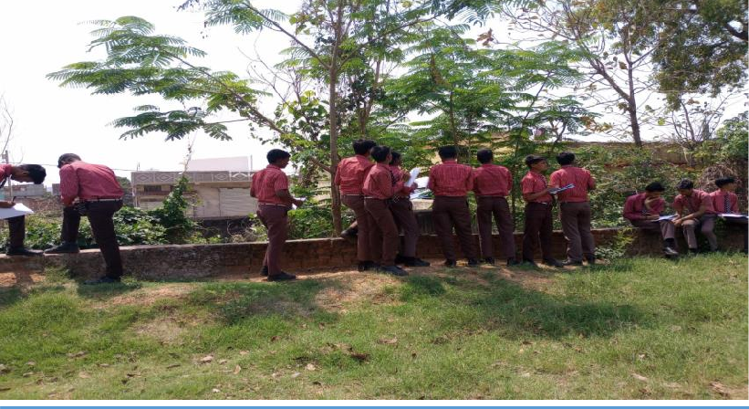
Students visit to their school garden
Teacher showed the data of 5 years of data on decline of flora and fauna in India for students to analyze and they identified that some of the animals are extinct from India. The showed data developed the interest of students towards learning. This curiosity was the trigger for the introduction to the lesson. Students were divided into 6 groups- each consisting 5 members and they were given opportunities to present their views. Some of the new terms were introduced to the students. This was followed by discussion on different types of landforms and lives around them using visual clues. This helped them to infer that there are differences in trees which are available at different places because of differences in landforms, soils, temperature found in one region to another. They attributed the factors such as Relief factors (Land, Soil) and climatic factors (temperature, photoperiod, precipitation) leading to the diversity in flora and fauna. The teacher showed the picture of different types of vegetation found in different states for students to analyze and inferred that as the type of landforms is different, amount of rainfall differs, temperature varies so the flora and fauna distributed accordingly.

Reflection sheet
After completion of each experiential learning activity such as nature walk, group presentation by students, role plays etc., reflection sheet consisting 4-5 questions filled by the students which helped students to reflect on their learning and present/ write their views. An example is given below.

Figure: 2

Example of reflection sheet

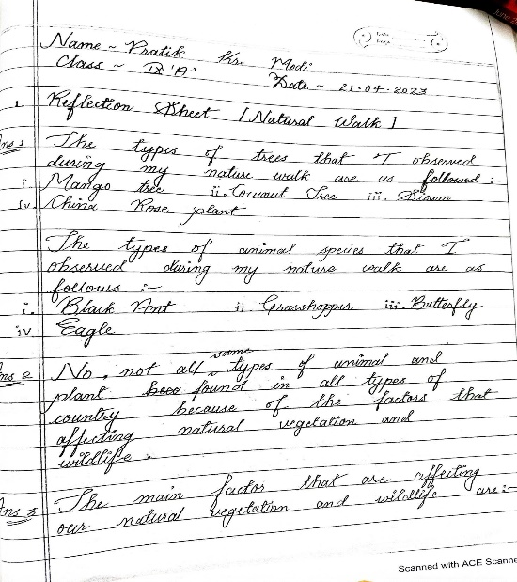

Reflective Diary

A reflective diary was also maintained by the researcher to note some of the challenges and interesting facts of the experiment. Some of the major challenges faced were preparing students for presentations, managing time, and satisfying their curiosity with limited resources.

Figure: 3

Sample page from the reflective diary maintained by the researcher

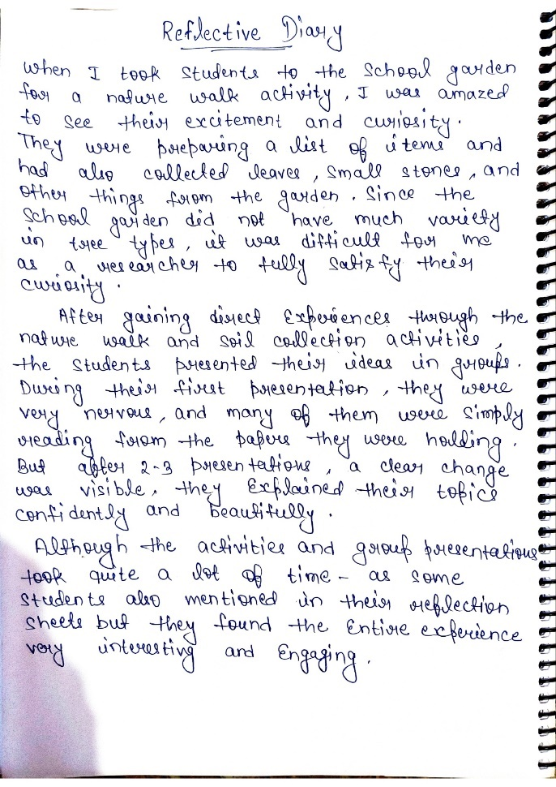

Illustrative example of pedagogy used in control group
Learning objectives – The learners: -
    - Define biodiversity of India
    - Classify relief and climate as factors affecting distribution of flora and Fauna in India.
Before introducing the topic, the teacher asked some questions related to the previous knowledge of students: -
    - What are the things you have observed in your school surrounding?
    - The type of trees that you are observing are same at all places or they differ?
    - Why type of animals and trees differ from one place to another?
After asking a few questions on the factors affecting distribution of flora and fauna in India, the teacher explained the factors, type of landform affect the distribution of flora and fauna-common and fertile land is suitable for agriculture while in undulating land grassland grows, soils also differ geographically etc. Different vegetation kinds, based on different types of soil were explained. While damp, marshy, and deltaic soils sustain mangroves and deltaic flora, the sandy soils of the desert are home to cacti and prickly bushes. The teacher asked students why trees are different in mountains. Students answered that because of temperature and rainfall, trees are different in mountains so temperature plays very important role in affecting the distribution of flora and fauna in India. After explanation part teacher asked some questions to assess the learning of students.

Results
The researcher employed both descriptive and inferential statistics to analyse pretest and posttest scores of the dependent variable. Descriptive statistics, including mean, median, mode, and standard deviation, were calculated for both experimental and control groups. ANCOVA was used to compare the adjusted mean posttest scores. Additionally, students' reactions to learning social science through experiential learning strategies were qualitatively analysed to capture their experiences, perceptions, and challenges.
Analysis of the data by using descriptive statistics are presented below.
Objectives of the study: - To find out the effectiveness of Experiential Learning on achievement of grade 9 students in social science.

H₀₁. There is no significant difference in post-test achievement scores in social science between Grade IX students taught using experiential learning strategies and those taught using traditional lecture-based methods.

Table-4
Descriptive Statistics for Pre-test and Post-test Scores

Measure | Group | N | Mean | SD
Pre test | Experimental | 30 | 10.60 | 3.03
Pre test | Control | 30 | 9.13 | 3.50
Post test | Experimental | 30 | 23.10 | 2.63
Post test | Control | 30 | 17.20 | 3.06

Figure:4
Pre-test and post-test mean scores of both groups
Mean
25
20
15
10
Mean
5
0
Pre-test Control
Group
Post-test Control
Group
Pre-test
Post-test
Experimental Group Experimental Group
(EG) (EG)

Table 4 presents the descriptive statistics for the pre-test and post-test scores of the control and experimental groups. The pre-test mean score of the experimental group (M = 10.60, SD = 3.03) and that of the control group (M = 9.13, SD = 3.50) indicate that both groups were comparable in their initial achievement levels prior to the intervention.
A substantial difference is observed in the post-test scores. The experimental group, which received instruction through experiential learning strategies, obtained a higher post-test mean score (M = 23.10, SD = 2.63) compared to the control group (M = 17.20, SD = 3.06). The mean difference of 5.90 in Favor of the experimental group suggests a notable improvement in students’ achievement in social science as a result of the experiential learning intervention.

Table 5-
ANCOVA results of achievement: - Experimental and Control group with pre-test scores as a covariate.
Source | Sum of square | df | Mean square | F | P
Group | 437.04 | 1 | 437.04 | 55.63 | <.01
Pre-test (covariate) | 23.4 | 1 | 23.44 | 2.98 | 0.089
Error | 448.13 | 57 | 7.86

The ANCOVA results indicate a statistically significant effect of instructional strategy on post-test achievement scores after controlling for pre-test differences, F (1, 57) = 55.63, p < .01. This shows that the type of instructional strategy (experiential learning vs. lecture-based teaching) had a significant impact on students’ post-test achievement.
The covariate, pre-test scores, was not a significant predictor of post-test achievement, F (1, 57) = 2.98, p = .089, suggesting that initial achievement differences did not significantly influence the adjusted post-test scores. Since the adjusted mean post-test achievement score of the experimental group was significantly higher than that of the control group, the null hypothesis (H₀₁), which stated that there is no significant difference between the two groups, is rejected. These findings demonstrate that experiential learning strategies were more effective in improving Grade IX students’ achievement in social science compared to traditional lecture-based methods.
By participating in the nature walk activity, the students engaged in direct experiential learning. They worked in groups, where their task was to prepare a list of the things such as trees, soil, plants etc. they observed. The children were actively engaged and recorded different types of natural vegetation. They even started peer discussions - for example, when they noticed that a coconut was yellow, one student explained that it was due to high temperature. In this way, they demonstrated curiosity and engaged in collaborative decision making. In the end, each group presented their observations, and the teacher summarized that multiple factors such as temperature, soil, and weather affect natural vegetation.
In the soil collection activity, the students brought soil samples from their homes and sat in groups to examine soil characteristics and identify suitable vegetation. Later, each group reported their analyses while the other students documented key points. Finally, the researcher linked students’ observations to common soil types in Jharkhand and emphasized soil as an important determinant of natural vegetation.
The students actively participated in the activity. They even used to utilize digital resources to further explore soil properties and every member demonstrated consistent engagement. On the day of the role play, when the students performed a role play on the theme “Importance of Trees” all groups developed their own scripts. Even with prompts, they delivered their performances effectively. In their reflections, many students reported reduced presentation anxiety and increased confidence following repeated opportunities to present. Initially, they expressed initial apprehension about, but by the end of each activity, they reported increased confidence and perceived learning progress. They also learned to enhance collaboration and group coordination skills.

This indicates that after controlling for pre-test scores, the teaching strategy- experiential learning- had a statistically significant effect on students’ achievement in social science. The experimental group, which was taught using experiential learning, performed significantly better than the control group, demonstrating the effectiveness of experiential learning as a teaching strategy.
From a theoretical perspective, this finding aligns with Kolb’s experiential learning cycle, where students moved from Concrete Experience (hands-on activities and group projects), to Reflective Observation (discussing and analyzing experiences), to Abstract Conceptualization (understanding concepts in social science through real-life connections), and finally to Active Experimentation (applying concepts in new contexts). This cyclical process promoted deeper understanding and retention, explaining the superior performance of the experimental group.

Items | Agree  N (%) | Strongly agree  N (%) | Neutral N (%) | Disagree N (%) | Strongly disagree N (%)
1. students enjoyed the Experiential Learning activities | 15  (50) | 15  (50)
2. Better understanding of topics through Experiential Learning activities | 16  (53) | 10  (33.33) | 4  (13.33)
3. Reaction towards participation in group  Activities | 18  (60) | 11  (36.66) | 1  (3.33)
4. Experiential Learning activities are more time taking | 10  (33.33) |  | 8  (26.66)
5. Experiential Learning strategies are important for teaching learning | 14  (46.66) | 12  (40) | 2  (6.66) | 2  (6.66)
6. Reaction towards sensitization to the environment through EL strategies. | 25  (83.33) | 1  (3.33) | 4  (13.33)
Objective 2) To analyse the reaction of students on Experiential Learning in social science.
Table: 6
Responses of students for close ended questions based on 5 rating scales

From the above table it is found that 50 percentage of students strongly agreed that they enjoyed learning the concepts in group work and activities. However, remaining 50 percentage of students are agreed to that point. 86.33% of students a that they have easily understood the topics with the help of Experiential Learning activities.

Statement | Agree | Strongly agree | Neutral | Disagree | Strongly disagree
Enjoyed learning through Experiential Learning strategies | (50%) | (50%)
Better understood the topic | 53% | 33.33% | 13.33%

60% of students said that they got the equal opportunity to participate in group activities while 37% students strongly agreed on this statement. 87% of students considered experiential learning strategies as important for teaching learning of students. 83% of students agreed that experiential learning activities were organized for teaching learning of topic natural vegetation and wildlife sensitized them or helped them to think more about environmental issues.
These reactions indicate that experiential learning increased student engagement, motivation, and participation, which are essential components of Kolb’s model. Students actively engaged in group activities, discussions, and real-life applications of knowledge, thereby deepening their conceptual understanding.
However, some students felt that experiential learning activities were time-consuming, highlighting a practical classroom challenge. This reflects broader concerns in literature about balancing experiential and traditional teaching strategies within rigid timetables.

Analysis of Qualitative Responses: -
The responses of the qualitative items were analyzed and interpreted under the following broader themes: -
Coverage of contents through Experiential Learning activities: -
83% of students agreed that it is not difficult to cover and complete all the contents through EL activities. 91% of students agreed that these activities help them to understand the concept easily. While some of them said that these are time taking activities.

Challenges faced by students while learning through Experiential Learning activities and ways to overcome these challenges: -
- Lack of group coordination in group presentation activities.
- Most of the students agreed that they faced difficulties while working in group because of their lack of experiences in doing group activities.

Challenges faced by students
Lack of sufficient time to practice in group but managed the situation by practicing in leisure time.
Faced challenges of communicating with group members.
It was difficult to write the script for role play but by talking with group members and taking their ideas, it becomes possible.
Fear to act and perform in role play was managed by practicing again and again in group.
- To convince and motivate the group members for better performance in activities and done by continuously talking to them and helping each other.
Students noted that EL activities are time-consuming; teachers faced time and resource constraints and assessment complexity. These practical challenges suggest the need for scheduling flexibility, material support, and assessment rubrics aligned with experiential tasks.”

Discussion
The study demonstrated that Experiential Learning (EL) significantly improved the academic achievement of students in Geography. The experimental group showed a higher posttest mean score (23.1) compared to the control group (17.2), indicating a positive effect of EL also supported by findings of (Ranken et al. 2024; Putri & Dewi, 2025; Rigdel & Thapa, 2024; Karthiyayeni 2021) emphasizing positive impact of experiential learning pedagogies on students’ achievement.
Students in the experimental group found EL activities more effective in understanding social science concepts. 86.33% of students agreed that EL helped them better grasp topics, which is also supported by the findings of (Parker 2024; Yulianti 2024; Putri & Dewi, 2025; Noor et al., 2020; Leal- Rodriguez &Albort- Morant 2019) which shows that experiential learning-based activities enhances students understanding of geographical concepts through direct engagement.
However, students also faced challenges in group work and role-playing, with issues such as coordination, stage fear, and time management, as noted by Voukelatou (2019).
The qualitative data collected from students' feedback on their experiences with EL strategies revealed generally positive responses. Half of the students strongly agreed, and another half agreed, that they enjoyed learning Geography through group work and activities. This aligns with previous research, such as that of (Sendra 2025, Jeet & Pant, 2023; Li et al., 2022; Thote &Gowri, 2020), which focuses on the effectiveness of interactive and engaging methods in creating joyful learning environment and enhancing interest among students.
Students also noted that EL activities helped them become more sensitized to environmental issues, with 83.33% agreeing that these activities improved their awareness of topics such as natural vegetation and wildlife. This is consistent with findings like EL strategies in environmental education helped improve students' ethical awareness and their ability to relate to environmental concerns (Sivagamesundary, 2021; Mahapatra & Vijayalatha, 2024).

Educational Implications
- Experiential Learning strategy can be used as an innovative pedagogical approach for teaching Social Science.
- Experiential Learning activities can be included in pre-service activities of Teacher Education Programme.
- Social Science curriculum may suggest experiential learning strategies to develop competencies.
- In-service Training Programmes may conduct skill development activities in experiential learning strategies.
- The study can be a pathway for teachers to get a clear vision on implementation of Experiential Learning strategies as a pedagogic tool in classroom teaching – learning process in order to support students’ involvement, Exploration, Creativity for a deeper understanding of concepts.

Conclusion
This study aimed to investigate the effectiveness of Experiential Learning (EL) strategies on secondary school students' achievement in social science. The findings indicate that EL strategies significantly enhance students' academic performance, foster learning process, and promote greater engagement in learning. Additionally, students provided positive learning experiences, reporting a better understanding of the subject, greater enjoyment in learning, and increased awareness of environmental issues. The results underscore the importance of incorporating active, hands- on learning approaches in the teaching social science. By engaging students in real-world applications through group activities, field trips, and practical tasks, EL strategies help to deepen understanding, promote critical thinking, and enhance problem-solving skills. The study also highlights the challenges students may face, such as group coordination issues and performance anxiety, however, these can be overcome through collaboration and practice.

COMPETING INTERESTS DISCLAIMER:
Authors have declared that they have no known competing financial interests OR non-financial interests OR personal relationships that could have appeared to influence the work reported in this paper.

REFERENCE
Abdullah, S. A., Sharif, S. I., & Qolamani, K. I. B. (2024). The value of field trips and experiential learning in social studies. Polytechnic Journal of Humanities and Social Sciences, 5(1), 354-361. https://doi.org/10.25156/ptjhss.v5n1y2024.pp354-361
Adeoye, M. A., Prastikawati, E. F., & Abimbowo, Y. O. (2024). Empowering learning: Pedagogical strategies for advancing 21st-century skills and quality education. Journal of Nonformal Education, 10(1), 10–21. https://doi.org/10.15294/jone.v10i1.1451
Alam, T., & Alam, A. (2021). A Study of Learning Difficulties in Geography Faced by Senior Secondary School Students of Araria Districs of Bihar. Shodh Sarita: An International Bilingual Peer Reviewed Refereed Research Journal, 193-197.
Bukola, O. O. (2025). Fieldwork: A foundational instrument in the teaching and learning of geography. *Ondo Journal of School of Arts and Social Sciences*, *24*(1). https://www.nigerianjournalsonline.com/index.php/ojass/article/view/100
Chan, C. K. Y. (2012). Exploring an experiential learning project through Kolb's Learning Theory using a qualitative research method. European Journal of Engineering Education, 37(4), 405-415. https://doi.org/10.1080/03043797.2012.706596
Chiu, S. K. (2019). Innovative experiential learning experience: Pedagogical adopting Kolb’s learning cycle at higher education in Hong Kong. Cogent Education, 6(1), 1644720. https://doi.org/10.1080/2331186X.2019.1644720
Deng, X., & Yi, S. (2024). A Case Study of Integrating the Train-the-Trainer and Experiential Learning Models in Computer Skills Training. Hawaii International Conference on System Sciences 2024 (HICSS-57). https://aisel.aisnet.org/hicss-57/sj/stem/2
Firomumwe, T. (2019). Experiences out of the classroom: The importance of fieldwork in learning geography at secondary school. i-manager's Journal on School Educational Technology, 14(3), 16-24. https://doi.org/10.26634/jsch.14.3.15169
Flynn, K.C. (2018). Improving spatial thinking through experiential-based learning across international higher education settings. International Journal of Geospatial and Environmental Research, 5(3), Article 4. https://dc.uwm.edu/ijger/vol5/iss3/4
Jeet, G., & Pant, S. (2023). Creating joyful experiences for enhancing meaningful learning and integrating 21st century skills. International Journal of Current Science Research and Review, 6(02), 900–903. https://doi.org/10.47191/ijcsrr/v6-i2-05
Karthiyayeni, S. (2021). Effect of experiential learning (EL) in teaching social science. International Journal of Creative Research Thoughts, 9(2), 1818. https://www.ijcrt.org/
Kaya, H., Demirkaya, H., & Ayd n, F. (2010). Undergraduate students’ experiences in a geographyfieldwork. Middle-East Journal of Scientific Research, 6(6), 637–641.
Kolb, D. A. (2014). Experiential learning: Experience as the source of learning and development. FT press. https://www.pearson.com/us/higher-education/program/Kolb-Experiential-Learning-Experience-as-the-Source-of-Learning-and-Development-2nd-Edition/PGM200000000679.html Kolb, A., & Kolb, D. (2018). Eight important things to know about the experiential learning cycle. Australian educational leader, 40(3), 8-14.
Kong, Y. (2021). The role of experiential learning on students’ motivation and classroom engagement. Frontiers in psychology, 12, 771272. https://doi.org/10.3389/fpsyg.2021.771272
Li, Y., Ying, S., Chen, Q., & Guan, J. (2022). An Experiential Learning-Based Virtual Reality Approach to Foster Students' Vocabulary Acquisition and Learning Engagement in English for Geography. Sustainability, 14(22), 15359. https://doi.org/10.3390/su142215359
Leal-Rodríguez, A. L., & Albort-Morant, G. (2019). Promoting innovative experiential learning practices to improve academic performance: Empirical evidence from a Spanish Business School. Journal of Innovation & Knowledge, 4(2), 97-103. https://doi.org/10.1016/j.jik.2019.04.001
Mahapatra, S., & Vijayalatha, D. R. (2024). Assessing the Impact of Experiential Learning in Promoting Environmental Education and Sustainable Practices. International Journal of Emerging Knowledge Studies, 3(8), 501-508. https://doi.org/10.70333/ijeks-03-08-012
Ministry of Education, Government of India. (2020). National Education Policy 2020. https://www.education.gov.in/sites/upload_files/mhrd/files/NEP_Final_English_0.pdf
Morris, T. H. (2020). Experiential learning – a systematic review and revision of Kolb’s model. Interactive Learning Environments, 28(8), 1064-1077. https://doi.org/10.1080/10494820.2019.1570279
National Council of Educational Research and Training. (2023). National curriculum framework for school education 2023. Ministry of Education, Government of India. https://ncf.ncert.gov.in/
National Council of Educational Research and Training. (2006). *Position paper: National focus group on teaching of social sciences*. https://ncert.nic.in/pdf/focus-group/social_sciencel.pdf
Noor, N. A. M., Ariffin, K., Darus, N. A., & Alias, A. (2020). The perceptions of students’ experiential learning in relation to theoretical concept with real practice. International Journal of Academic Research in Progressive Education and Development, 9(4). https://doi.org/10.6007/IJARPED/v9-i4/8176
Pandey, A. (2018). India: Global Understanding in Geography Education. In A. Demirci, R. de Miguel González, & S. W. Bednarz (Eds.), Geography Education for Global Understanding (pp. 215-221). Springer. https://doi.org/10.1007/978-3-319-77216-5_18
Parker, L. (2024). Exploring Geography Through Outdoor Learning. In S. W. Bednarz & J. T. Mitchell (Eds.), Handbook of Geography Education (pp. 569-605). Springer Nature Switzerland. https://doi.org/10.1007/978-3-031-72366-7_26
Pereira, P., & Zhao, W. (2025). Geography and geographical knowledge contribute decisively to all sustainable development goals and targets. Geography and Sustainability, 6(1), Article 100267. https://doi.org/10.1016/j.geosus.2025.100267
Putri, K. A. A. K., & Dewi, N. L. P. E. S. (2025). The Impact of Experiential Learning on Student Engagement and Outcomes: A case study in a National School of Bali, Indonesia. In 6th International Conference on Education and Social Sciences (ICESS 2024) (pp. 278-291). Atlantis Press. https://doi.org/10.2991/978-2-38476-392-4_21
Ranken, E., Wyse, D., Manyukhina, Y., & Bradbury, A. (2024). The effect of experiential learning on academic achievement of children aged 4–14: A rapid evidence assessment. The Curriculum Journal. https://doi.org/10.1002/curj.304
Rigdel, K. S., & Thapa, M. R. (2024). Exploring the opportunities and challenges of using community as classroom for learning geography. International Journal of Instruction, 17(3), 61-78. https://doi.org/10.29333/iji.2024.1734a
Russell III, W. B., & Waters, S. (2021). Essentials of elementary social studies. Routledge. https://doi.org/10.4324/9781003123934
Sivagamesundary (2021), “Effectiveness of Experiential Learning in Enhancing Environmental ethics among prospective teachers”; https://shodhganga.inflibnet.ac.in:8443/jspui/handle/10603/360315.

Sendra, E. (2025). Joyful learning inside and beyond the classroom: integrating guided field trips to festivals and events in higher education. Journal of Learning Development in Higher Education, (35). https://doi.org/10.47408/jldhe.vi35.1359
Srinivasan, M. V. (2019). Social science education in Indian schools: review of research and public discourse. Indian Educational Review, 57(1), 5-36. https://ejournals.ncert.gov.in/index.php/ier/article/view/290/282
Thote, P., & Gowri, S. (2020). Experiential learning: Tool for joyful learning. International Journal of Research - GRANTHAALAYAH, 8(5), 100–107. https://doi.org/10.29121/granthaalayah.v8.i5.2020.88
Voukelatou, G. (2019). The contribution of experiential learning to the development of cognitive and social skills in secondary education: A case study. Education Sciences, 9(2), 127. https://doi.org/10.3390/educsci9020127
Wijnen-Meijer, M., Brandhuber, T., Schneider, A., & Berberat, P. O. (2022). Implementing Kolb's experiential learning cycle by linking real experience, case-based discussion and simulation. Journal of Medical Education and Curricular Development, 9, 23821205221091511. https://doi.org/10.1177/23821205221091511
Yulianti, T. (2024). Investigating the impacts of inquiry-based learning on students' understanding of geographical concepts. Future Space: Studies in Geo-Education, 1(1), 56-72. https://doi.org/10.69877/fssge.v1i1.9
Yadav, S. (2023). Pedagogy for social science education. International Journal of Current Science (IJCSPUB), 13(2), 24–26. https://rjpn.org/IJCSPUB/papers/IJCSP23B1004.pdf

