Review Article
Antibiotic Resistance in Environmental Microbiomes: Molecular Mechanisms, Implications, and Mitigation Strategies. A Review

ABSTRACT
The ambient microbiome serves as a crucial reservoir for antibiotic resistance genes (ARGs), acting as a catalyst for their evolution and a pathway for global distribution. The discharge of antibiotic resistance genes (ARGs) from clinical and agricultural environments into ecosystems through wastewater, soil, and aquatic systems diminishes antimicrobial effectiveness and poses a significant One Health concern. This study consolidates existing knowledge about the emergence, persistence, and fate of antibiotic resistance genes in environmental compartments. It elucidates the molecular underpinnings of resistance, including horizontal gene transfer, efflux pumps, and enzymatic drug inactivation. It identifies significant ecological reservoirs, such as wastewater treatment facilities and manure-amended soils. The study assesses sophisticated molecular detection and surveillance technologies, ranging from droplet digital PCR to metagenomic sequencing, crucial for delineating the ambient resistome. The connections between environmental ARGs and human health hazards are outlined, with emphasis on exposure pathways and the growing clinical burden. Moreover, the research evaluates a range of mitigation and remediation measures designed to disrupt the resistance cycle. This includes engineered wastewater and potable water treatments, soil bioremediation via Verm remediation, and manure management, as well as innovative medicinal methods such as phage therapy, CRISPR-mediated gene editing, and fecal microbiota transplantation. This synthesis underscores the critical need for coordinated surveillance and targeted interventions within a comprehensive One Health framework to prevent the environmental spread of antibiotic resistance and safeguard public health.

Keywords: Antibiotic Resistance Genes (ARGs); Environmental Resistome; One Health; Wastewater Treatment; Public Health

1. Introduction
The discovery of penicillin by Alexander Fleming in 1928 ushered in a transformative era in modern medicine, dramatically reducing mortality from previously untreatable bacterial infections (Fig. 1) [1]. The subsequent "golden age" of antibiotic discovery, spanning the 1940s to the 1960s, fostered a perception that infectious diseases had been conquered. However, this optimism was short-lived. The relentless and often indiscriminate use of these miracle drugs imposed an immense selective pressure, driving the rapid evolution and global dissemination of antibiotic resistance[2]. Today, antimicrobial resistance (AMR) stands as one of the most pressing public health crises of the 21st century, threatening to dismantle the very foundation of our healthcare systems.
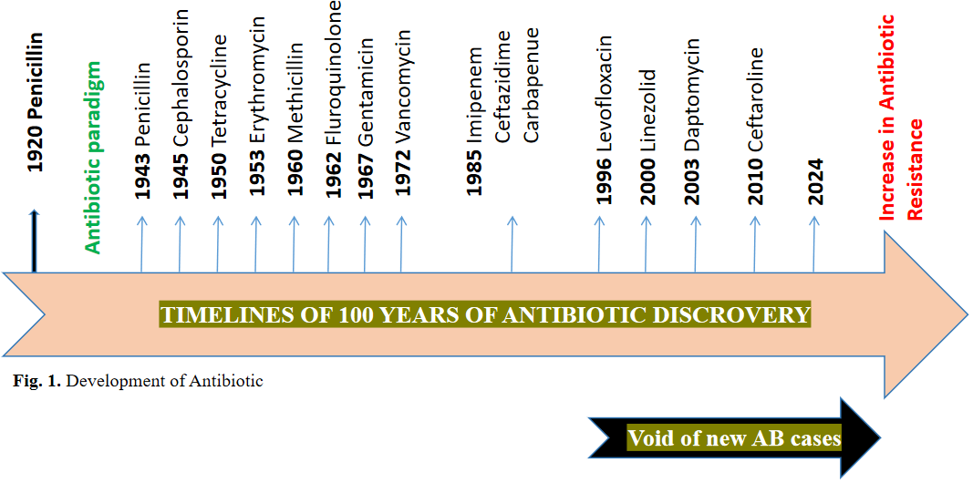
Figure 1. Timeline of antibiotic discovery and the onset of resistance.

Antibiotic-resistant bacteria are implicated in over 23,000, 58,000, 38,000, and 25,000 annual deaths in the United States, India, Thailand, and the European Union, respectively [3-5]. Without concerted intervention, this number is projected to escalate to 10 million deaths per year globally by 2050, eclipsing cancer as a leading cause of mortality and inflicting catastrophic economic damage[6]. The rise of multidrug-resistant pathogens, epitomized by the ESKAPE group (Enterococcus faecium, Staphylococcus aureus, Klebsiella pneumoniae, Acinetobacter baumannii, Pseudomonas aeruginosa, and Enterobacter species), has created a scenario where common infections are once again becoming untreatable [7].
While the clinical burden of antibiotic microbe resistance (AMR) is clear, the critical role of the environment as a central actor has recently been fully appreciated. Environmental matrices—including soil, water, wastewater, and manure are not merely passive recipients of antibiotic residues and resistant bacteria from human and agricultural activities. They are dynamic, gene-rich ecosystems that serve as vast reservoirs and furnaces for the evolution of antibiotic resistance genes (ARGs) [8, 9]. The environmental resistome, a collection of all ARGs in a given microbiome, represents an ancient and diverse genetic pool from which pathogens can acquire resistance through horizontal gene transfer (HGT) via mechanisms such as conjugation, transformation, and transduction [10].
This continuous exchange bridges environmental and clinical settings. Wastewater treatment plants (WWTPs), for instance, are hotspots where urban and hospital effluent mix, creating ideal conditions for genetic exchange between environmental and clinically relevant bacteria [11]. Similarly, the use of antibiotic-laden manure in agriculture disseminates resistance determinants into soils and, through runoff, into aquatic systems, creating a pervasive cycle of contamination [12].
Therefore, a solid focus on clinical resistance is insufficient. Combating AMR demands a holistic "One Health" approach that recognizes the inextricable linkages among human, animal, and environmental health. This review seeks to synthesize current understanding of antibiotic resistance in environmental microbiomes. The paper delves into the molecular mechanisms underpinning resistance, the primary environmental reservoirs of ARGs, and evaluates molecular techniques for their detection and surveillance. Furthermore, the paper critically examined the implications of environmental AMR for human health. It synthesized a comprehensive overview of emerging mitigation strategies to break the transmission chain within these critical environmental compartments.

2. Molecular mechanisms underlying antibiotic resistance
Pathogens have rapidly evolved numerous defense mechanisms against the effects of antimicrobial medications. Four major categories include the primary mechanisms in bacteria that lead to antibiotic resistance (Fig. 2) [11].
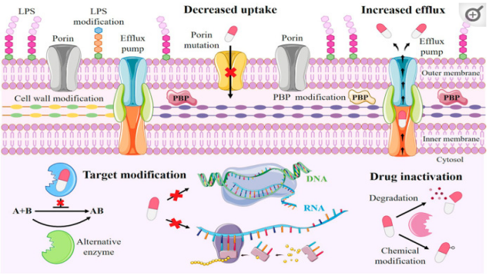
Figure 2. Fundamental molecular mechanisms of bacterial antibiotic resistance.

2.1 Limiting drug uptake
This process is important for Gram-negative bacteria, as they have an outer membrane (OM) composed primarily of lipopolysaccharides (LPS), whose hydrophobicity forms an impenetrable barrier to most small medication molecules. Thus, porin proteins facilitate the diffusion of several hydrophilic antibiotics throughout the OM. By increasing the thickness and stickiness of the biofilm matrix, which protects bacteria from both antibiotic penetration and the host immune system, biofilms can form that reduce antibiotic permeability [11].

2.2 Increase efflux
Drugs are extruded from cells via overexpression of efflux pumps that depend on proton flow. For instance, in Staphylococcus aureus, drug extrusion is NorA confers an efficient resistance mechanism where the efflux pump, Fluoroquinolone antibiotic resistance; cationic lipophilic medicines, such as biocides like benzalkonium chloride, are exported by the QacA MFS transporter; and a range of compounds, including lincomycin, linezolid, chloramphenicol, and trimethoprim, are exported by the LmrS MFS efflux pump [12].

2.3 Target site modification
To develop broad resistance to ordinary antibiotics, multidrug-resistant bacteria often express multiple antibiotic resistance genes. Staphylococcus aureus acquired the mecA gene, which encodes the penicillin-binding protein PBP-2A and confers resistance to methicillin and most other β-lactam antibiotics. Due to their roles in the synthesis and assembly of peptidoglycan (PGN), 9 PBPs are prime candidates for targeted alteration [12].

2.4 Drug inactivation
Alterations or inactivation of the antimicrobial medication itself are standard mechanisms of resistance in many harmful bacteria. Since enzymes are usually responsible for this, no essential bacterial cell components are altered, which can be advantageous because fitness costs are less likely than with other mechanisms, like drug target mutation or alteration. Antibiotic modification can be broadly classified into two mechanisms: chemical group transfer modification or antibiotic inactivation through degradation [13]. Bacterial enzymes chemically break down and inactivate antibiotics, which is the most common mechanism of bacterial resistance. For instance, β-lactamases primarily hydrolyze β-lactam drugs, while other antibacterial agents undergo different chemical modifications [11]. The list of characterized β-lactamases continues to increase; the Beta Lactamase DataBase records over 7,000 distinct β-lactamases [14]. The WHO identified three "critical" priority infections in 2017; all were carbapenem-resistant [15]. Penicillins, cephalosporins, and carbapenems can all be hydrolyzed by carbapenemases, such as those of the KPC (class A), NDM (class B), and OXA (class D) kinds [16, 17]. This significantly reduces the number of medications available to treat a specific illness.

3. Molecular methods for quantifying ARGs in the environment
Given the ubiquity of ARGs in aquatic ecosystems, molecular methods to examine their occurrence, transit, and fate are needed. Measuring environmental ARGs helps understand their distribution, prevalence, and public health impacts.

3.1 Droplet digital polymerase chain reaction (ddPCR)
Droplet digital polymerase chain reaction (ddPCR) quantifies nucleic acids, including antibiotic resistance genes (ARGs), in water, soil, and sediments with high sensitivity and accuracy. The method divides a material into thousands of nanoliter-sized droplets to identify and detect nucleic acids at low concentrations [18]. Due to its absolute quantification without reference curves, ddPCR may be better than quantitative polymerase chain reaction (qPCR) in environmental samples. It is instrumental in complex sample matrices where inhibitors may affect qPCR. Environmental samples are chemically and biologically complex, making data interpretation difficult. Therefore, ddPCR experiments for environmental material require tailored methodologies and ideal procedures to ensure precision and reproducibility [18]. Despite environmental PCR inhibitors, ddPCR can accurately quantify ARGs. This makes it an excellent tool for detecting environmental antibiotic resistance [19].

3.2 Quantitative polymerase chain reaction (qPCR)
Real-time qPCR is the ideal method for detecting and quantifying microorganisms in various environmental samples, including complex matrices such as wastewater, soil, and sewage [20, 21]. qPCR tests are more sensitive, specific, and rapid than conventional culture-based approaches [22]. As stated in [23]. It is applicable for risk assessment and monitoring disease sources. Furthermore, research by [24] demonstrates its extensive application in microbial ecology for elucidating the ecological roles of microorganisms across various environments and for assessing the distribution and abundance of specific functional microbial groups, as illustrated in Fig. 3.

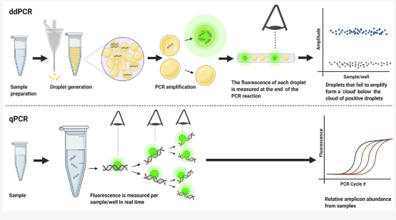
Figure 3. Comparative schematic of ddPCR and qPCR techniques.

3.3 Metagenomic sequencing
This approach assesses ARGs present in water, soil, and sediments. It involves assembly algorithms that connect whole-metagenome sequencing (WMS) results with reference databases to identify and quantify ARGs. This approach is superior for evaluating the resistome in the environment, as it eliminates the need for culturing organisms [25]. Furthermore, long-read metagenomic sequencing techniques, such as nanopore sequencing, have been employed to characterize ARGs and their adjacent elements. This approach evaluates the quantity, genetic loci, mobility potential, and associated bacterial hosts of ARGs in activated sludge and influent sewage to ascertain their fate [26].

3.4 Fluorescence in situ hybridization (FISH)
This technique effectively identifies and quantifies specific DNA or RNA sequences, including ARGs, in diverse environmental matrices such as water, soil, and sediments. The technique employs fluorescent probes that bind to complementary DNA sequences of the target ARGs in the sample. Upon binding, these probes can be seen and measured by fluorescence microscopy [27].
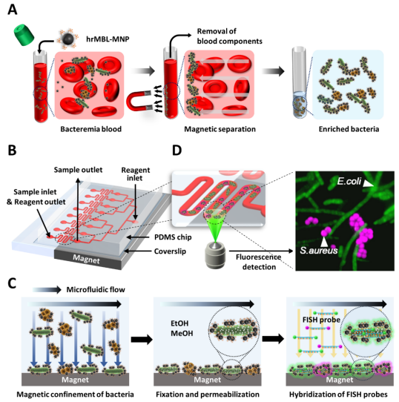
Figure 4. Quantitative bacteremia identification method using opsonin-coated MNPs and μFISH.

3.5 Mass spectrometry (MS) method
Quantifying ARGs in water, soil, and sediments requires mass spectrometry. The primary methods are: MS detects and quantifies small molecules associated with antibiotic resistance, not the genes (ARGs), making it an indirect yet efficient tool for studying antibiotic resistance. This entails accurately quantifying antibiotic residues and their transformation products in environmental matrices, which contribute to the selective pressure that increases ARGs [28]. LC-MS/MS can identify and quantify non-volatile, thermally labile chemicals, such as ARGs, in complex environmental samples [29]. High-Resolution MS is widely used in non-targeted screening to identify new compounds and provide a complete overview of antibiotic exposure in specific environments [30]. Due to their potential as vectors, microplastics and nanoplastics can be used to study ARGs using time-of-flight mass spectrometry (ToF-MS) and other methods [28].

3.6 Hybridization-based techniques
Microarrays and other hybridization-based methods can quantify ARGs in water, soil, and sediments. These approaches use nucleic acid hybridization to detect and quantify ARG-corresponding DNA or RNA sequences. DNA microarray analysis is faster, more sensitive, and higher-throughput than other molecular methods. DNA microarrays can detect antibiotic resistance in isolates and provide comprehensive, therapeutically relevant information by detecting multiple ARGs in a single experiment [31]. The microarray technique can uncover antibiotic resistance determinants in hours, reducing time and improving resistance detection [32]. The microarray technique has been extensively used to detect antibiotic resistance in Salmonella enterica [33], H. pylori [34], E. coli [35], and S. aureus [36, 37].

4. Implications of AMR and ARGs to human health
Antivirals, antifungals, antibiotics, and antiparasitics treat and prevent illnesses in agriculture, aquaculture, animals, and humans. The therapeutic efficacy of several antimicrobials is threatened by bacterial resistance. Superbugs are antimicrobial-resistant. UNEP published the 2023 significant essay "Bracing for Superbugs: Strengthening Environmental Action in the 'One Health' Response to Antimicrobial Resistance". AMR occurs when bacteria, viruses, parasites, and fungi develop resistance to antibiotics. Antibiotic resistance hinders the treatment of common bacterial infections worldwide. The Antimicrobial Resistance and Use Surveillance System (GLASS) 2022 research demonstrates alarming levels of resistance to prevalent bacterial illnesses. Concerningly, 42% of 76 countries have third-generation cephalosporin-resistant E. coli, and 35% have methicillin-resistant Staphylococcus aureus. E. coli urinary tract infections were 20% less sensitive to ampicillin, co-trimoxazole, and fluoroquinolones in 2020 [38]. Increased use of carbapenems may cause resistance in other areas. When last-resort drugs fail, incurable infections increase. By 2035, the OECD anticipates last-resort antibiotic resistance to double from 2005 levels [39]. Strong antimicrobial management and global surveillance are needed. Antimicrobial overuse and pollution can induce microbial resistance in humans and the environment. After contact with resistant microorganisms, soil, water, and air, bacteria can become resistant. Humans can contract AMR bacteria from food, water, fungal spores, and other environmental sources. Globally, in 2019, drug-resistant diseases killed 1.27 million. By 2050, 10 million people may die each year. Fig. 5 shows that unchecked antimicrobial resistance (AMR) could push 24 million people into extreme poverty and reduce GDP by $3.4 trillion [40]. HIV, malaria, tuberculosis, and viral antimicrobial resistance are rising, threatening human suffering.
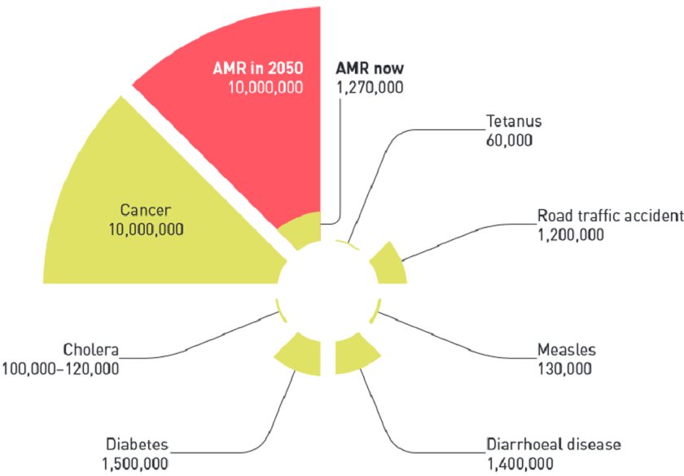
Figure 5. AMR and ARGs diseases impacting human health

5. Strategies to eliminate antibiotic resistance from the environment
To halt the progression and dissemination of antibiotic resistance, therapeutic strategies can eliminate antibiotic resistance genes by incapacitating the microorganisms that harbor them (Fig. 6).
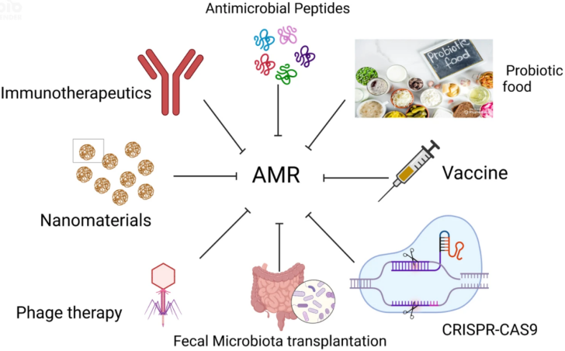
Figure 6. Strategies to counteract antibiotic resistance.

5.1 Treatment for wastewater and drinking water
In wastewater treatment, anaerobic and anoxic processes within MBR systems effectively reduce ARG concentrations by lowering microbial bioactivity, whereas aerobic conditions can increase them. Membrane bioreactors (MBRs) overall achieve significant ARG removal, with correlations observed between reductions in genes such as tetW and intI1 and decreases in 16S rDNA [41]. Constructed wetlands also remove antibiotics and ARGs through substrate adsorption and plant uptake [42, 43]. The concentration of intI1 is strongly linked to ARG levels in these wetlands, implicating mobile genetic elements in their spread [44]. Disinfection via chlorination or UV/chlorination sequences inactivates ARGs like sul1 and tetG, with efficacy depending on dose and contact time [45]. Antimicrobial nanotechnology offers dual mechanisms: the release of toxic ions from nanomaterials and combined attacks on ARBs and ARGs, demonstrating potential against multidrug-resistant pathogens without fostering NM-resistant strains [46]. For drinking water, conventional physicochemical processes such as coagulation with polyferric chloride (FeCl₃) are particularly effective. They achieve a 0.5-log to 3.1-log reduction in key ARGs (sul1, sul2, tetO, tetW, tetQ, intI1), outperforming methods such as constructed wetlands or UV disinfection in treated wastewater effluent, while also removing dissolved organic compounds and nutrients [47].

5.2 Soil treatment
Earthworms enhance the removal of antibiotics and antibiotic resistance genes (ARGs) in soil through vermiremediation. They introduce and disperse specific antibiotic-degrading bacteria, such as Microvirga and Sphingomonas, via their casts [48]. Earthworms significantly reduce ARG abundance by altering the bacterial community, suppressing potential ARG hosts, and enriching degraders like Flavobacterium [49]. Species like Metaphire guillelmi accelerate the breakdown of chlortetracycline and its metabolites, while earthworms also promote the degradation of oxytetracycline by increasing ammonia-oxidizing bacteria [50]. These processes collectively reduce selective pressure and limit ARG propagation in soil.

5.3 Manure treatment
Contemporary livestock farms employ various manure treatments to mitigate the presence of antibiotics and ARGs. Anaerobic digestion stabilizes waste, reduces zoonotic bacteria by at least one log, and generates methane [51]. Combining pasteurization pretreatment with anaerobic digestion (PPAD) enhances the removal of tetracyclines and increases methane yield (PPAD, 17.238 to 0 and methane 244.07 to 254.06 in 20-25 days technical digestion time (T80)) [52]. Microwave (MW) radiation can be used to treat dairy manure for 30 to 300 seconds at 2450 MHz. It was discovered that the moisture removal rate (U) of dairy manure can reach 0.63 g of water/min/gram, reducing ARGs such as sul1 and intI1 [53]. Finally, thermophilic composting, particularly when amended with biochar derived from mushrooms or straw, is an effective method for controlling ARGs [54].

5.4 Therapies by phages or bacteriophages
One of the newest technologies in gene therapy is the CRISPR-associated (Cas) gene editing tool. It modifies genes responsible for antibiotic resistance or provides recombinant phages with antibacterial proteins. Phages, however, cannot be used as empirical treatments for acute infections because they target specific host bacterial species. Libraries need to be updated often to ensure their effectiveness against bacteriophages resistant to antibiotics [55]. Spacers are brief sequences that function as CRISPR arrays and are inserted into bacteria's genomes by bacteriophages or plasmids. The spacer guide RNAs will be utilized by the Cas protein machinery to precisely target the invader's nucleic acid with similar sequences [56]. CRISPR-CAS is a selective targeting technology for AMR genes in plasmids and chromosomes. It is delivered via phagemids and conjugative plasmids. A plasmid, pBD114, was created to target the kanamycin resistance gene aph-3. This plasmid was transformed into S. aureus RN4220 or RNK, resulting in Cas9-mediated killing of Staphylococci and other bacteria [57]. Nano-sized CRISPR complexes, which are polymer-derivatized Cas9 complexes with single guide RNA, have also been used to eliminate resistance genes, targeting mecA, which is implicated in methicillin resistance [58].

5.5 Therapies by probiotics
Probiotics have been found to harbor ARGs like vancomycin, rifampicin, streptomycin, bacitracin, and erythromycin [59, 60]. Research using next-generation sequencing and genetic engineering is enabling the development of modified probiotics, or pharmabiotics, as biotherapeutic strategies against infection. These bioengineered probiotics can be specifically designed to deliver therapeutic agents, offering a targeted alternative to conventional drug delivery methods [56].

5.6 Fecal microbiota transplant (FMT)
Fecal microbiota transplantation (FMT) or human probiotic infusion involves transferring processed stool from a healthy donor to a recipient to restore the recipient's gut microbiota. It is clinically successful, particularly for recurrent C. difficile infections [61]. As illustrated in Fig. 7, the process involves two phases: preparing a donor slurry for cold storage in a stool bank, followed by its administration to a patient via oral or rectal delivery [55].
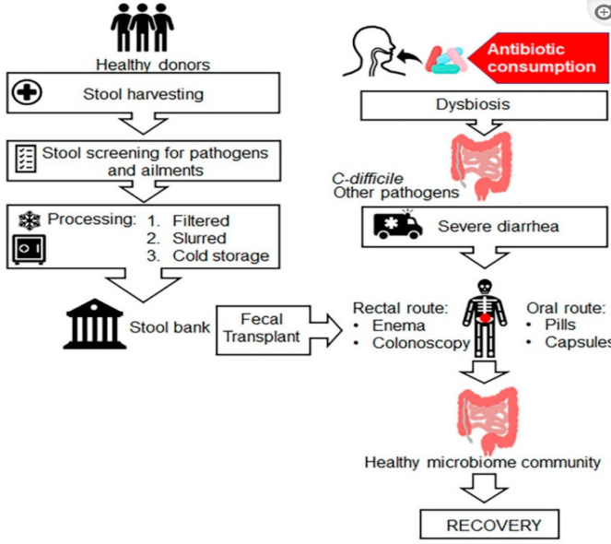
Figure 7. Process of faecal microbiota transplantation (FMT)
It is imperative to address antibiotic resistance by implementing preventive measures and policies alongside efficacious medications to prevent and manage infectious illnesses [62, 63].

6. Conclusion
The growing epidemic of antimicrobial resistance (AMR) is inherently linked to environmental processes in which antibiotic resistance genes (ARGs) develop, persist, and spread. This study emphasizes that the environment is not simply a repository but a dynamic reactor for resistance, with hotspots such as wastewater treatment facilities and agricultural soils acting as crucial hubs for gene exchange between environmental and clinical microorganisms. The molecular mechanisms facilitating this dissemination (horizontal gene transfer by mobile genetic elements, enzymatic drug inactivation, and efflux pumps) are now thoroughly delineated, uncovering a complex resistome that predates the therapeutic application of antibiotics.
Advanced molecular techniques, such as high-throughput qPCR, droplet digital PCR, and metagenomic sequencing, have become essential for monitoring the resistome, providing the precision needed to trace the fate and movement of antibiotic resistance genes (ARGs). The ramifications for human health are immediate and grave, as ambient ARGs penetrate clinical environments, undermining therapeutic alternatives and increasing mortality rates.
This challenge is surmountable. A comprehensive mitigation approach is being developed. Engineered solutions for wastewater and potable water treatment, including advanced membrane bioreactors and enhanced coagulation, can substantially reduce ARG burdens. Terrestrial techniques such as Verm remediation for soil and pasteurization-integrated anaerobic digestion for manure disrupt the agricultural resistance cycle. Promising innovative biotherapeutic approaches include precision phage therapy, CRISPR-Cas gene editing to neutralize resistance pathways, and fecal microbiota transplantation to restore microbial equilibrium.
Finally, mitigating the environmental aspect of AMR necessitates a paradigm shift towards proactive, integrated management within the One Health framework. Success relies on integrating human, animal, and environmental health through continuous observation, strong legislation, and the use of breakthrough remediation technologies from study to practice. The evidence is unequivocal: safeguarding the effectiveness of our antimicrobial resources necessitates a vigorous initiative in the environment.

COMPETING INTERESTS DISCLAIMER:
Authors have declared that they have no known competing financial interests OR non-financial interests OR personal relationships that could have appeared to influence the work reported in this paper.

References
1. Tan, S.Y. and Y. Tatsumura, Alexander Fleming (1881–1955): discoverer of penicillin. Singapore Medical Journal, 2015. 56(7): p. 366.
2. Hayden, G.E., et al., Triage sepsis alert and sepsis protocol lower times to fluids and antibiotics in the ED. The American journal of emergency medicine, 2016. 34(1): p. 1-9.
3. Boucher, H.W., et al., Bad bugs, no drugs: no ESKAPE! An update from the Infectious Diseases Society of America. Clinical infectious diseases, 2009. 48(1): p. 1-12.
4. Laxminarayan, R., et al., Antibiotic resistance—the need for global solutions. The Lancet Infectious Diseases, 2013. 13(12): p. 1057-1098.
5. ECDC, E., EMEA and SCENIHR (European Centre for Disease Prevention and Control, European Food Safety Authority, European Medicines Agency and European Commission's Scientific Committee on Emerging and Newly Identified Health Risks), 2009. Joint Opinion on antimicrobial resistance (AMR) focused on zoonotic infections, 2009.
6. Holmberg, S.D., S.L. Solomon, and P.A. Blake, Health and economic impacts of antimicrobial resistance. Reviews of infectious diseases, 1987. 9(6): p. 1065-1078.
7. de Kraker, M.E., A.J. Stewardson, and S. Harbarth, Will 10 million people die a year due to antimicrobial resistance by 2050? PLoS Medicine, 2016. 13(11): p. e1002184.
8. Gillings, M., et al., The evolution of class 1 integrons and the rise of antibiotic resistance. Journal of Bacteriology, 2008. 190(14): p. 5095-5100.
9. Baquero, F., et al., Gene transmission in the one health microbiosphere and the channels of antimicrobial resistance. Frontiers in microbiology, 2019. 10: p. 2892.
10. Ebmeyer, S., E. Kristiansson, and D.J. Larsson, A framework for identifying the recent origins of mobile antibiotic resistance genes. Communications biology, 2021. 4(1): p. 8.
11. Reygaert, W.C., An overview of the antimicrobial resistance mechanisms of bacteria. AIMS microbiology, 2018. 4(3): p. 482.
12. Annunziato, G., Strategies to overcome antimicrobial resistance (AMR) making use of non-essential target inhibitors: A review. International journal of molecular sciences, 2019. 20(23): p. 5844.
13. Forsberg, K.J., et al., The tetracycline destructases: a novel family of tetracycline-inactivating enzymes. Chemistry & biology, 2015. 22(7): p. 888-897.
14. Naas, T., et al., Beta-lactamase database (BLDB)–structure and function. Journal of enzyme inhibition and medicinal chemistry, 2017. 32(1): p. 917-919.
15. WHO, O., One health. World Health Organization, 2017. 736.
16. Tooke, C.L., et al., β-Lactamases and β-Lactamase Inhibitors in the 21st Century. Journal of molecular biology, 2019. 431(18): p. 3472-3500.
17. Queenan, A.M. and K. Bush, Carbapenemases: the versatile β-lactamases. Clinical microbiology reviews, 2007. 20(3): p. 440-458.
18. Kokkoris, S., et al., ICU-acquired bloodstream infections in critically ill patients with COVID-19. The Journal of Hospital Infection, 2021. 107: p. 95.
19. Cavé, L., et al., Efficiency and sensitivity of the digital droplet PCR for the quantification of antibiotic resistance genes in soils and organic residues. Applied microbiology and biotechnology, 2016. 100: p. 10597-10608.
20. Aw, T.G. and J.B. Rose, Detection of pathogens in water: from phylochips to qPCR to pyrosequencing. Current opinion in biotechnology, 2012. 23(3): p. 422-430.
21. Knappik, M., et al., Evaluation of molecular methods to improve the detection of Burkholderia pseudomallei in soil and water samples from Laos. Applied and Environmental Microbiology, 2015. 81(11): p. 3722-3727.
22. Colinon, C., et al., Detection and enumeration of Pseudomonas aeruginosa in soil and manure assessed by an ecfX qPCR assay. Journal of Applied Microbiology, 2013. 114(6): p. 1734-1749.
23. Oster, R.J., et al., Bacterial pathogen gene abundance and relation to recreational water quality at seven Great Lakes beaches. Environmental science & technology, 2014. 48(24): p. 14148-14157.
24. Bae, H.-S., et al., Distribution, activities, and interactions of methanogens and sulfate-reducing prokaryotes in the Florida Everglades. Applied and Environmental Microbiology, 2015. 81(21): p. 7431-7442.
25. Daw Elbait, G., et al., Comparison of qPCR and metagenomic sequencing methods for quantifying antibiotic resistance genes in wastewater. Plos one, 2024. 19(4): p. e0298325.
26. Dai, D., et al., Long-read metagenomic sequencing reveals shifts in associations of antibiotic resistance genes with mobile genetic elements from sewage to activated sludge. Microbiome, 2022. 10(1): p. 20.
27. Lee, M.S. et al., Quantitative fluorescence in situ hybridization (FISH) of magnetically confined bacteria enables rapid determination of early-stage human bacteremia. medRxiv, 2021: p. 2021.02. 19.21251962.
28. Wu, P. et al., Mass spectrometry-based multimodal approaches for the identification and quantification analysis of microplastics in food matrix. Frontiers in Nutrition, 2023. 10: p. 1163823.
29. Holton, E. and B. Kasprzyk-Hordern, Multiresidue antibiotic-metabolite quantification method using ultra-performance liquid chromatography coupled with tandem mass spectrometry for environmental and public exposure estimation. Analytical and Bioanalytical Chemistry, 2021. 413: p. 5901-5920.
30. Schulze, B. and S.L. Kaserzon, Quality Assurance and Quality Control (QA/QC) for High-Resolution Mass Spectrometry (HRMS) Non-target Screening Methods. 2024, Springer.
31. Gilbride, K., D.-Y. Lee, and L. Beaudette, Molecular techniques in wastewater: understanding microbial communities, detecting pathogens, and real-time process control. Journal of Microbiological Methods, 2006. 66(1): p. 1-20.
32. Antwerpen, M.H., et al., DNA microarray for detection of antibiotic resistance determinants in Bacillus anthracis and closely related Bacillus cereus. Molecular and cellular probes, 2007. 21(2): p. 152-160.
33. Guard-Bouldin, J., et al., Detection of Salmonella enterica subpopulations by phenotype microarray antibiotic resistance patterns. Applied and environmental microbiology, 2007. 73(23): p. 7753-7756.
34. Chen, S., Y. Li, and C. Yu, Oligonucleotide microarray: a new rapid method for screening the 23S rRNA gene of Helicobacter pylori for single-nucleotide polymorphisms associated with clarithromycin resistance. Journal of gastroenterology and hepatology, 2008. 23(1): p. 126-131.
35. Zhu, L.-X., et al., Development of a base stacking hybridization-based microarray method for rapid identification of clinical isolates. Diagnostic microbiology and infectious disease, 2007. 59(2): p. 149-156.
36. Zhu, L.-X., et al., Use of a DNA microarray for simultaneous detection of antibiotic resistance genes among staphylococcal clinical isolates. Journal of Clinical Microbiology, 2007. 45(11): p. 3514-3521.
37. Spence, R.P., et al., Validation of virulence and epidemiology DNA microarray for identification and characterization of Staphylococcus aureus isolates. Journal of Clinical Microbiology, 2008. 46(5): p. 1620-1627.
38. Fernandez, G., Turning the juggernaut. 2022, ELSEVIER SCI LTD THE BOULEVARD, LANGFORD LANE, KIDLINGTON, OXFORD OX5 1GB …. p. E75-E75.
39. Popoola, O.O., et al., A national survey of the antibiotic use, self-medication practices, and knowledge of antibiotic resistance among graduates of tertiary institutions in Nigeria. Scientific African, 2024. 23: p. e01978.
40. Desai, B.H., 14. United Nations Environment Program (UNEP). Yearbook of International Environmental Law, 2018. 29: p. 441-448.
41. Du, J., et al., Variation of antibiotic resistance genes in municipal wastewater treatment plant with A 2 O-MBR system. Environmental Science and Pollution Research, 2015. 22: p. 3715-3726.
42. Chen, J., et al., Removal of antibiotics and antibiotic resistance genes from domestic sewage by constructed wetlands: effect of flow configuration and plant species. Science of the Total Environment, 2016. 571: p. 974-982.
43. Barancheshme, F. and M. Munir, Strategies to combat antibiotic resistance in the wastewater treatment plants. Frontiers in Microbiology, 2018. 8: p. 299736.
44. Fang, H., et al., Occurrence and elimination of antibiotic resistance genes in a long-term operation integrated surface flow constructed wetland. Chemosphere, 2017. 173: p. 99-106.
45. Sharma, V.K., et al., A review of the influence of treatment strategies on antibiotic-resistant bacteria and antibiotic resistance genes. Chemosphere, 2016. 150: p. 702-714.
46. Aruguete, D.M., et al., Antimicrobial nanotechnology: its potential for the effective management of microbial drug resistance and implications for research needs in microbial nanotoxicology. Environmental Science: Processes & Impacts, 2013. 15(1): p. 93-102.
47. Sanganyado, E. and W. Gwenzi, Antibiotic resistance in drinking water systems: Occurrence, removal, and human health risks. Science of the Total Environment, 2019. 669: p. 785-797.
48. Zhang, Y., et al., Removal of sulfamethoxazole and antibiotic resistance genes in paddy soil by earthworms (Pheretima guillelmi): Intestinal detoxification and stimulation of indigenous soil bacteria. Science of The Total Environment, 2022. 851: p. 158075.
49. Yang, S., et al., Removal of chlortetracycline and antibiotic resistance genes in soil by earthworms (epigeic Eisenia fetida and endogeic Metaphire guillelmi). Science of The Total Environment, 2021. 781: p. 146679.
50. Pu, Q., et al., Enhanced removal of ciprofloxacin and reduction of antibiotic resistance genes by earthworm Metaphire vulgaris in soil. Science of the Total Environment, 2020. 742: p. 140409.
51. Checcucci, A., et al., Exploring the animal waste resistome: the spread of antimicrobial resistance genes through the use of livestock manure. Frontiers in Microbiology, 2020. 11: p. 536406.
52. Yin, F., et al., Additional function of pasteurisation pretreatment in combination with anaerobic digestion on antibiotic removal. Bioresource technology, 2020. 297: p. 122414.
53. Luo, T., Y. Wang, and P. Pandey, The removal of moisture and antibiotic resistance genes in dairy manure by microwave treatment. Environmental Science and Pollution Research, 2021. 28: p. 6675-6683.
54. Liu, B., et al., Key factors driving the fate of antibiotic resistance genes and controlling strategies during aerobic composting of animal manure: A review. Science of The Total Environment, 2021. 791: p. 148372.
55. Kumar, S.B., S.R. Arnipalli, and O. Ziouzenkova, Antibiotics in the food chain: The consequences for antibiotic resistance. Antibiotics, 2020. 9(10): p. 688.
56. Kumar, M., et al., Futuristic non-antibiotic therapies to combat antibiotic resistance: A review. Frontiers in Microbiology, 2021. 12: p. 609459.
57. Bikard, D. et al., Exploiting CRISPR-Cas nucleases to produce sequence-specific antimicrobials. Nature Biotechnology, 2014. 32(11): p. 1146-1150.
58. Kang, Y.K., et al., Nonviral genome editing based on a polymer-derivatized CRISPR nanocomplex for targeting bacterial pathogens and antibiotic resistance. Bioconjugate chemistry, 2017. 28(4): p. 957-967.
59. Liu, Y., et al., Changes in microbial community structure during pig manure composting and its relationship to the fate of antibiotics and antibiotic resistance genes. Journal of Hazardous Materials, 2020. 389: p. 122082.
60. Stanley, D., R. Batacan Jr, and Y.S. Bajagai, Rapid growth of antimicrobial resistance: the role of agriculture in the problem and the solutions. Applied Microbiology and Biotechnology, 2022. 106(21): p. 6953-6962.
61. Khoruts, A., C. Staley, and M.J. Sadowsky, Faecal microbiota transplantation for Clostridioides difficile: mechanisms and pharmacology. Nature Reviews Gastroenterology & Hepatology, 2021. 18(1): p. 67-80.
62. Kumar, S.G., et al., Antimicrobial resistance in India: A review. Journal of natural science, biology, and medicine, 2013. 4(2): p. 286.
63. Metz, M. and D.M. Shlaes, Eight more ways to deal with antibiotic resistance. Antimicrobial agents and chemotherapy, 2014. 58(8): p. 4253-4256.

