Sustainable Tourism for Regional Revitalization in Saiki City: Balancing the Utilization of Local Resources and Environmental Conservation

.
ABSTRACT

Aims: The study explores strategies for regional revitalization in Saiki City by promoting sustainable tourism, focusing on the effective utilization of local resources while ensuring environmental conservation.
Place and Duration of Study: The fieldwork survey was conducted at Saiki City, Oita Prefecture, Japan in March 2025.
Methodology: The research employed field observations to examine Saiki City’s historical resources, natural landscapes, and food-related resources. Additionally, informal conversations were held with local residents and stakeholders provided an initial understanding of local conditions. Subsequently, follow-up interviews were conducted to obtain detailed insights into current practices on resource management and public awareness regarding sustainable tourism.
Results: The findings demonstrate that Saiki City possesses abundant local resources that possess significant potential as tourism assets, including the historically valuable shishigaki (traditional stone fences), the strikingly rugged and scenic ria coastline (deeply indented bays and inlets), and a diverse array of fresh, high-quality food ingredients. However, the study also identifies several challenges and shortfalls in the management of historical resources and public awareness, which hinder the realization of sustainable tourism.
Conclusion: The study poses key challenges and proposes practical strategies for promoting sustainable tourism in Saiki City. It emphasizes the need to balance between the effective utilization of local resources with the conservation of the natural environment to achieve long-term regional revitalization.

Keywords: sustainable tourism, rural revitalization, natural resources, Saiki City, environmental conservation, shishigaki, community engagement, ecotourism

1. INTRODUCTION

This study is primarily based on the results of an on-site fieldwork conducted in Saiki City, Oita Prefecture, from March 2 to 5, 2025. The fieldwork was conducted by a team from the Kobe City University of Foreign Studies (KCUFS) with coordination support from the Amabe Institute of Culture located in Saeki City. The KCUFS team comprise three undergraduates and two supervisors, namely, Associate Professor Rajeev Kumar Singh and Associate Professor Yumi Matsuda of the Department of International Relations (Figure 1). The primary value of this research is its exploration of potential sustainable development opportunities for Saiki City by conducting an analysis of current challenges and proposing potential solutions for the promotion of sustainable tourism.

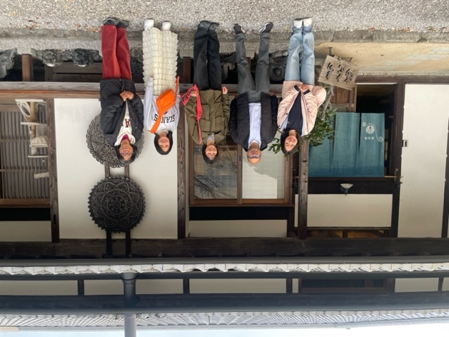

Fig. 1 Group photo in front of the Amabe Institute of Culture
Source: Author, 2025

1.1 Significance of Sustainable Tourism and Japan’s Efforts
The United Nations (UN) World Tourism Organization defines sustainable tourism as “tourism that takes full account of its current and future economic, social, and environmental impacts, addressing the needs of visitors, the industry, the environment, and host communities” (UN, 2025). In other words, sustainable tourism refers to the process of ensuring harmony between the needs of a wide range of stakeholders—residents, governments, tourism operators, travelers, and related populations such as nongovernment organizations (NGOs)—and preserving the natural environment while minimizing environmental degradation. Therefore, sustainable tourism is indispensable for the long-term development and revitalization of regional communities (Japan Tourism Agency, 1992).
In response to these challenges, the Japanese government has developed the Japan Sustainable Tourism Guidelines, which are aligned with international standards, to provide direction for local governments and tourism related businesses (Japan Tourism Agency, 2002). However, questions remain regarding the applicability of these guidelines to the approximately 1,700 municipalities in Japan, including how each region can effectively incorporate their unique characteristics within this framework (Japan Tourism Agency, 2019). Therefore, to promote regional revitalization through tourism in Saiki City, examining the utilization of local resources while ensuring alignment with the government’s sustainable tourism policy is important.

In recent years, the concept of a related population (kankei jinko)—individuals engaging with a region without permanently residing in it—has gained increased scholarly attention. In the case of Saiki City, these persons hold great potential to stimulate local employment and economic development. The city is experiencing a steady outflow of its population to other areas. Therefore, attracting and retaining related populations has become increasingly important through initiatives such as local support projects and short-term workation programs, which allow people to combine remote work with tourism by temporarily living and working in the region. These approaches offer opportunities for ushering external human capital into the community on a recurring basis and for strengthening long-term revitalization efforts.

1.2 Tourism Resources in Saiki City
Saiki City is located in the southern part of Oita Prefecture (Figures 2 and 3). With a total area of approximately 903 km² and a population of approximately 66,850, it offers a calm and peaceful atmosphere compared with Oita City—the prefectural capital, which has a population of approximately 470,000 and a total area of approximately 502 km² (Saiki City, 2024; Oita City, 2024). Saiki City is widely recognized as a city of the sea. It accounts for approximately 80% of aquaculture production and approximately 65% of fishery output in the prefecture (Saiki City, 2020). The city’s rich natural environment, including mountains with abundant forest resources and clear rivers (e.g., Saiki, Ono, and Banzyo River), supports this abundance of marine resources. In particular, the water of the Banjo River is known for its exceptional taste; in 2008, it was officially certified as mineral-water quality, thus further highlighting the pristine condition of natural water systems in the region (The Asahi Shinbun Digital, 2008). Clean water generated by healthy mountain ecosystems flows into these rivers, which is further purified before it reaches the sea, thereby contributing to the sustainability of coastal marine environments and local fisheries.

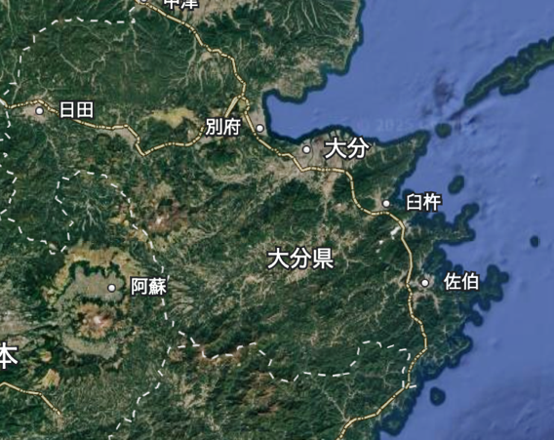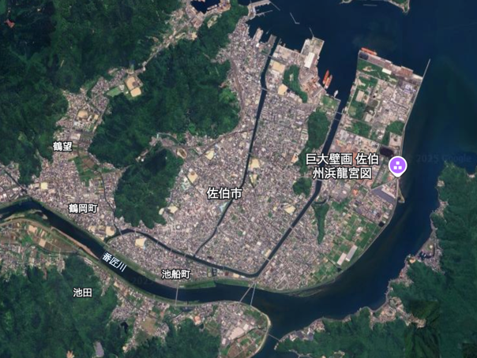

Figs. 2 and 3 Map of Saiki City
Source: ?

The city is also known for its wide variety of local cuisine, which incorporates fresh seafood from the surrounding sea and agricultural products from its mountains. A particularly popular dish among locals is Ryukyu, a type of sashimi marinated in a soy-based sauce (Figure 3). Made using freshly caught horse mackerel (aji), yellowtail (buri), or mackerel (saba) and seasoned with the characteristically sweet soy sauce of Kyushu, this dish pairs excellently with rice and is a favored accompaniment to sake. Saiki City also produces various agricultural goods, including strawberries (Figure 4), kabosu (a local citrus fruit), banpeiyu (a large citrus fruit similar to pomelo), and daikon radish, which are widely available in supermarkets and roadside markets (Japan Crops, 2025).

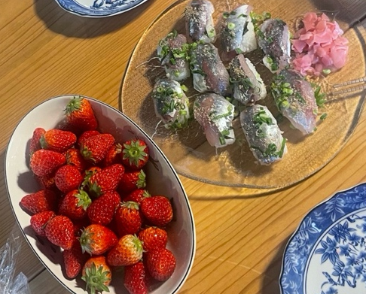

Fig. 4. Ryukyu and strawberries
Source: Author, 2025

In addition to its natural bounty, Saiki City is home to numerous historical and cultural heritage sites. A notable example is the shishigaki in Tsurumi, Saiki City, historic stone fences built to protect farmland from wild boars, which hold significant historical and cultural value (Figures 5 and 6). Stretching across several kilometers, these dry stone walls were constructed between the mountains and farmland to protect crops from wild animals such as boars and deer (Saiki City Sightseeing Navigation, 2019). Built by local residents from the late Edo period to the Meiji era, many of these structures remain primarily intact and serve as valuable historical records of harmony between communities and the natural environment (Sakyo Corporation, 2024). Saiki City’s shishigaki are among the largest in Japan and are also valued as trekking routes that offer scenic views throughout the year.

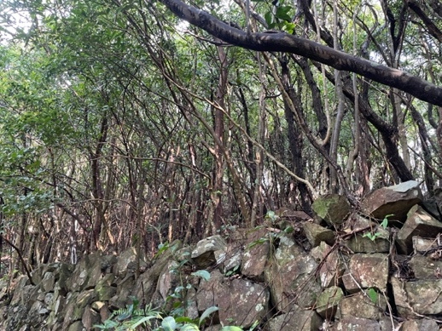
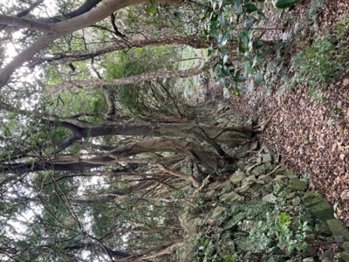
Figs. 5 and 6 Shishigaki
Source: Author, 2025

The Saiki City Historical Museum provides further insights into the city’s past, showcasing models and rare documents whose history can be traced from the Paleolithic and Jomon periods to the modern era. Additionally, the museum is located on a historically significant site, having previously served as administrative offices of the Saiki Domain during the Edo period and as the residence of the former Mori clan during the Meiji period. Visitors can engage the five senses in the immersive historical experience it provides.
While many approaches can be used for the development of tourism, Saiki City is particularly well positioned to pursue a model of tourism-based regional revitalization—capitalizing on its rich natural and cultural resources (Saiki City, 2024). In fact, the city, along with local tourism operators and residents, has implemented several initiatives to enhance its appeal as a tourist destination. For instance, in 2023, the city launched the “Let’s go to Saiki from Beppu” campaign, distributing coupons to visitors who stayed in Beppu, which could be used at local shops in Saiki. This initiative aimed to promote tourism across the prefecture (Saiki City, 2024). Local tourism operators have also formulated programs that enable visitors to experience rural life by staying in traditional kominka (old folk houses) while participating in agricultural and fishing activities (Nagisa-haku, 2025). Additionally, residents proposed the “Walking Journey Through the Remote South” project, which aims to promote the creation of relational populations through the theme of slow-paced, walking-based tourism (Saiki City, 2024).

2. methods

The researchers conducted interviews with local residents and detailed on-site field observations and social media review. Additionally, two follow-up online interviews were held with local experts after completion of the fieldwork. The results indicated that utilizing local resources as tourism assets in a strategic and sustainable manner is essential to effectively promote regional revitalization in Saiki City through tourism. Taking these methods together, the study captured not only observable field conditions but also the perspectives and concerns of individuals directly engaged in local revitalization. This section discusses key challenges identified during the fieldwork that must be addressed in pursuing sustainable tourism development.

2.1 Management of Tourism Resources
One of the key findings of the fieldwork pertains to the management of shishigaki. Evidently, current management practices are insufficient for preserving these vital heritage assets.
First, the area surrounding the shishigaki lacks maintenance, as overgrown weeds obscure the original boundary between the mountains and farmlands that these stone walls previously demarcated (Figure 7). Historically, the shishigaki served as a form of buffer or breakwater, protecting agricultural land from wild animals. However, visitors find difficulty in visually understanding or appreciating this historical role due to the current overgrowth. In addition, infrastructure around the shishigaki, such as stairways and benches, exhibit signs of deterioration. According to local residents, travelers and locals previously used benches situated at scenic points as places for rest or picnics. Today, however, these benches are weathered and no longer serve as relaxing spots. Similarly, stairways along the shishigaki produce creaking noises when used by several adults simultaneously, which leads to heightened concerns about structural integrity and safety.

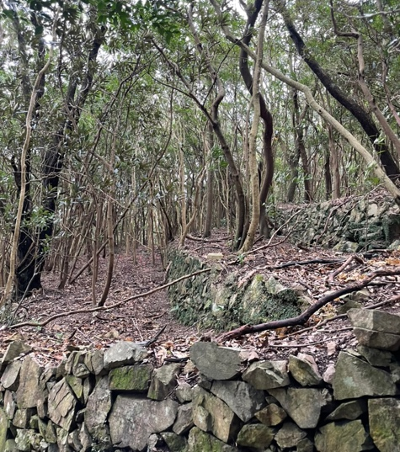

Fig. 7 Shishigaki
Source: Author, 2025

Furthermore, signage and parking facilities in the area are inadequate. At the entrance to the shishigaki trail, a small parking area accommodates only a few vehicles. The lack of clear markings or signage leads to difficulty for new visitors in recognizing it as a designated parking space (Figure 8). Additionally, the absence of informational signage along the trail limits visitors’ full understanding of the historical and cultural significance of the shishigaki without expert guidance. Collectively, these conditions reduce the accessibility and educational value of the shishigaki, which limits its potential as a sustainable tourism resource.

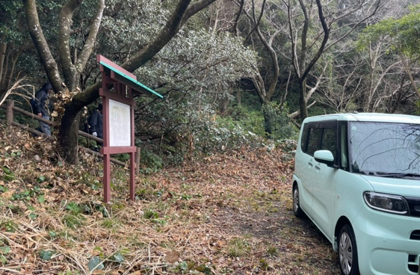

Fig. 8. Parking area near shishigaki
Source: Author, 2025

2.2 Public Awareness and Recognition
Another key issue is the relatively low level of public awareness of Saiki City as a tourist destination. During the four-day fieldwork, the researchers did not encounter apparent tourists at various scenic locations—including the shishigaki, the Saiki City Historical Museum, local markets, hot springs, and restaurants offering menus based on local specialties. This absence indicates that opportunities for tourism have yet to be fully explored.
Further evidence of low exposure can be observed through social media analytics. A search on Instagram using hashtags—commonly utilized by users to categorize content—revealed that the number of posts tagged with “#佐伯” (Saiki) reached approximately 115,000. In comparison, neighboring destinations within the prefecture displayed significantly higher figures: “#別府” (Beppu) had approximately 1.1 million posts, while “#湯布院” (Yufuin) had approximately 614,000. These figures imply that Saiki considerably lags behind other local destinations in terms of visibility and popularity on social media platforms.
There is also room to improve Oita Prefecture’s overall promotion of tourism. For example, its official travel website features a “Recommended Information” section that highlights different areas. However, Saiki City is not current featured. Without visibility on social media or official platforms, the chance for potential visitors to discover the city may be slim. Given the increased influence of digital platforms in destination choice, strengthening Saiki’s online presence is essential for future tourism development.

2.3 Transportation Accessibility
Saiki City boasts numerous tourist attractions; however, these sites are widely dispersed throughout the city. For instance, the shishigaki located in the Tsurumi area are accessible by car within approximately 40 min from the Saiki Umi no Ichiba (Sea Market), a venue offering a wide selection of local specialty products. Given the considerable distances and prevalence of steep slopes, traveling on foot is impractical, which makes car travel the most viable option. This finding poses significant implications on the attraction of certain tourist populations such as the elderly and people with mobility issues.
The city currently lacks rental car services, which restricts tourists’ transportation choices. While exploring certain areas using a bicycle is possible—advertisements that promote cycling trips around Oonyuu Island were observed within the city—the availability of rental bicycles is limited, as only one rental location was identified near Saiki Station. To ensure a convenient and comfortable tourism experience in Saiki City, improving transportation infrastructure and accessibility is crucial for facilitating ease of mobility between key sites for visitors. In particular, improvements in accessibility are important for elderly tourists and people with mobility issues, both of whom represent significant segments of domestic tourism.

2.4 Multilingual Support
Currently, information on public transportation in Saiki City—such as bus timetables, taxi stands, train ticket machines, and platform signs—is available only in Japanese. This lack of multilingual guidance leads to significant inconvenience for foreign tourists. Moreover, advertisements, brochures, maps, and signage at tourist sites within the city predominantly contain information solely in Japanese. According to the interviews with local residents, Saiki City has welcomed only a few international tourists thus far. However, given the sharp increase in foreign visitors to the neighboring Beppu, expecting that more tourists will explore Saiki in the near future is reasonable. The lack of multilingual support reflects an important structural barrier, as international visitors typically rely on clear language guidance to ensure a safe and enjoyable travel.

2.5 Stakeholders in Regional Revitalization
Residents of Saiki City have been actively engaged in efforts to promote regional revitalization. However, according to the individuals involved, a notable imbalance exists in the number of participants who support these activities and their demographic composition. Currently, approximately 15 residents—primarily individuals aged in their 40s to 60s—are involved and mainly contribute during spare time outside of work commitments. Consequently, their available time and capacity for activities are limited, which led a number of participants to express dissatisfaction with the extent and quality of their involvement.
Moreover, younger residents tended to be less involved in community activities, which poses difficulties for tasks that require physical labor or specific expertise such as digital literacy. For example, senior residents reported difficulties and reluctance to participate in activities such as utilizing translation applications, using social media, and producing flyers. This limited participation among the youth could impede the promotion of community attachment and pride, which are critical for sustainable regional revitalization. Furthermore, the involvement of younger generations is indispensable for the preservation and transmission of local traditions and arts. Thus, expanding the scale and demographic range of local residents engaged in regional promotion should be a strategic priority. In this regard, increasing youth involvement is essential not only for operational capacity but also for the long-term continuity of Saiki City’s cultural identity.

2.6 Tourism Infrastructure
During visits to multiple tourist facilities within Saiki City, the study observed the inadequate provision of public restrooms and garbage bins throughout the city. If the number of tourists increases, then littering in parks, trails, and coastal areas may also increase. This pollution can damage the natural landscape and disrupt the balance of local ecosystems. Additionally, inappropriate disposal of human waste could lead to unpleasant odors and sanitary issues. Therefore, the provision of these basic facilities should be considered.
Furthermore, the study found no tourist information centers within the city. Given that travelers frequently face unexpected situations in unfamiliar environments, the absence of a dedicated support desk indicates that visitors lack a reliable point of contact for assistance during their stay. This aspect also impedes effective information collection. Moreover, although Saiki Station provides tourist brochures, the absence of interactive communication limits its ability to offer personalized recommendations on attractions and travel plans tailored to visitors’ needs. To improve tourist satisfaction, developing support services that facilitate information dissemination and problem resolution is essential. Strengthening basic infrastructure is foundational to improving visitor satisfaction and ensuring the environmental sustainability of tourism activities.

3. Results and discussions

This section presents an analysis of key factors of sustainable tourism development in Saiki City using two approaches, namely, a stakeholder matrix and SWOT (strengths, weaknesses, opportunities, and threats) analysis. These frameworks can help differentiate the roles of diverse actors and the internal and external conditions that influence sustainable tourism in the region. Taken together, these tools provide a structured basis for facilitating the formulation of a more sustainable and inclusive tourism strategy in Saiki City.

3.1 Stakeholder Matrix
To promote effective and inclusive tourism development, the study conducted a stakeholder analysis to identify the key actors involved, assess their respective levels of interest and influence, and define their potential roles in the process. Table 1 summarizes this analysis using the stakeholder matrix.

Table 1. Stakeholder Matrix

Stakeholder Group | Level of Interest | Level of Influence | Potential Role
Local Government | High | High | Policy-making, funding, and promotion
Farmers and Craftspeople | Low | Medium | Hosts for workshops and cultural activities
Schools and Educators | Medium | Medium | Education programs and student engagement
Tourists and Visitors | Medium | Low | Feedback and revenue generation

Source: Author, 2025

The matrix reveals a range of stakeholders, from local government—highly influential in policy-making and funding—to farmers and craftspeople who, while moderately influential, offer essential cultural and experiential contents. Schools support educational initiatives; NGOs contribute their expertise in sustainability; and tourists, although their level of influence is low, are central to the tourism economy through participation and feedback. This distribution of influence and interest also highlights gaps in engagement, particularly among local producers who may benefit from tourism but remain partially involved. This matrix serves as a strategic tool for designing approaches for improving engagement tailored to the position of each group. High-influence stakeholders should be actively involved in planning, while high-interest but low-influence groups can be mobilized through participation and empowerment strategies. This alignment ensures that that tourism development reflects the priorities of communities and practical decision-making structures.

3.2 SWOT Analysis
To better understand the current situation and the potential of sustainable tourism development in Saiki City, the study conducted SWOT analysis—a strategic planning tool for identifying internal and external factors that may impact projects or organizations. It comprises four components, namely, strengths, weaknesses, opportunities, and threats. This analysis aids in elucidating the advantages and challenges of promoting sustainable tourism in Saiki City by evaluating internal resources and external environments. Figure 9 presents the results.

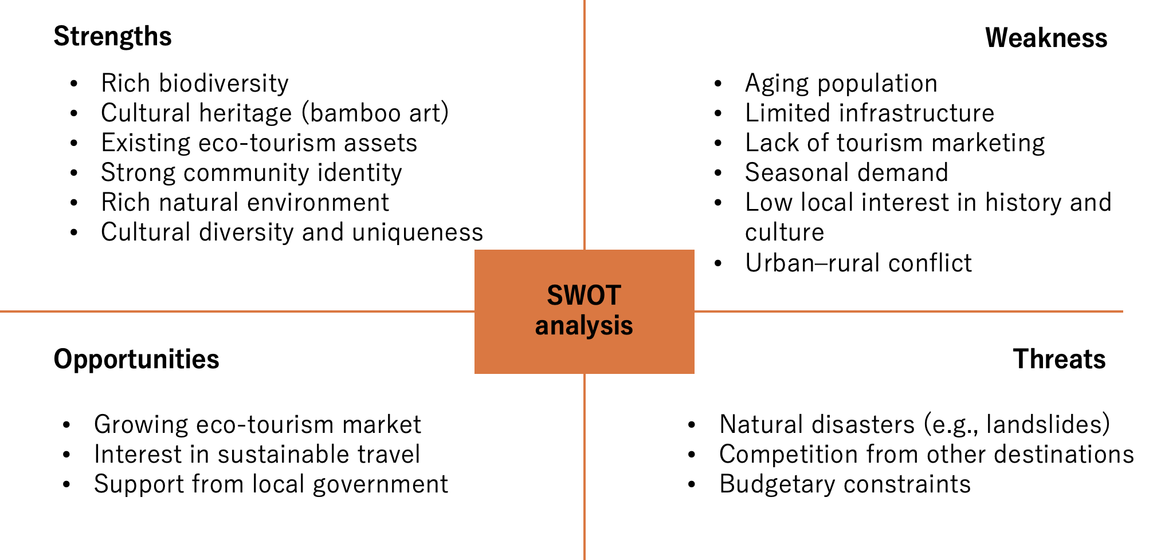

Figure 9. SWOT Analysis of Saiki City
Source: Author, 2025

Based on this analysis, Saiki City evidently possesses significant natural and cultural resources (strengths) but faces various challenges such as limited infrastructure and aging population (weaknesses). At the same time, trends in ecotourism and the increased scholarly interest in sustainable travel present unique opportunities, while natural disasters and competition from other regions pose threats. Recognizing these dynamics can help in which targeted investments and community-led actions can yield the greatest impacts. Taken together, these findings inform the strategic approach proposed in this paper.

4. Interview

As part of this research, follow-up interviews were conducted with two local experts actively involved in the revitalization and promotion of Saiki City in Oita Prefecture. The first interviewee, Reiko Iwasa, is the Head of the Amabe Institute of Culture—a local research institute that operates a unique facility functioning as a community space and accommodation, thereby contributing to community development in the city. The second interviewee,
Koji Shibata, is actively engaged in raising awareness of Saiki City’s cultural and historical assets, including the shishigaki. Their insights provided valuable perspectives on local initiatives, challenges, and the potential for sustainable regional development.
The interviews revealed three key themes regarding the interviewees’ approaches to community revitalization. First, they were driven by strong personal motivations and diverse backgrounds. Shibata’s deep affection for his hometown led him to independently study Saiki’s history and culture in an effort to rediscover its unique value and share it with a wider audience. Iwasa, who has been committed to the promotion of the sustainable development of the Global South for many years abroad, developed a renewed appreciation for Japan’s regional traditions and environments upon his return to the country. Her academic expertise and experience in development and environmental research have driven her commitment to promote grassroots sustainability in rural communities. Their personal narratives illustrated that individual agency can become a driving force in regional development.
Second, both emphasized the importance of strengthening community-based initiatives. Shibata envisioned passing his knowledge to the next generation by documenting local history and involving residents in the process, with the objective of nurturing future leaders. Iwasa highlighted the role of self-governance and noted that Saiki City is gradually deviating from administrative dependency through the establishment of neighborhood-based councils that empower residents to initiate and manage local projects.
Third, the discussions revealed challenges and opportunities in the use of local cultural and natural resources for sustainable tourism. Both interviewees emphasized the potential of underutilized assets such as the rias coastline, traditional shishigaki, and local festivals. They advocated for tourism models that prioritize meaningful exchange over mass visitation such as agricultural experiences and community-operated accommodations. They also underscored the need for strong local networks, strategic promotion, and long-term planning to ensure that these initiatives generate long-term economic and cultural benefits for the region. These insights reinforced the major roles of local knowledge and grassroots leadership in the formulation of sustainable tourism policies.
In summary, the insights shared by Iwasa and Shibata highlighted the importance of the integration of local knowledge, cultural heritage, and community agency in regional revitalization efforts. Their works illustrate that deeply rooted personal motivations combined with strategic planning and inclusive participation can foster sustainable and culturally meaningful development. Saiki City’s unique assets—landscapes, traditions, and people—hold great potential not only for tourism but also for cultivating a renewed sense of identity and pride among residents. In the future, expanding collaboration with external stakeholders, empowering younger generations, and investing in long-term cultural initiatives will be key for ensuring that efforts toward regional revitalization are resilient and reflective of the values of the community. These findings complement previous reports by demonstrating the influence of local narratives and stakeholder values on the feasibility of proposed strategies.

5. Conclusion

This study examined potential strategies that Saiki City in Oita Prefecture can utilize to promote regional revitalization through tourism while ensuring sustainability. Specifically, it identified key challenges in transforming the environmental assets of the city into sustainable tourism resources and proposed actionable solutions tailored to various stakeholder groups.
The fieldwork revealed several critical issues: weak management of historical tourism resources such as the shishigaki; low levels of external recognition of the city; limited accessibility in transportation; lack of multilingual support services; insufficient number and diversity of individuals involved in regional revitalization; and underdeveloped tourism infrastructure. In particular, the low level of participation among the youth in local revitalization efforts was a significant concern. Given the challenges faced by the city—including population decline and weakening cohesion within communities—youth involvement is essential for ensuring the success and sustainability of tourism-driven revitalization. These findings were supported by stakeholder and SWOT analyses, which highlighted the levels of interest and influence, as well as role of local governments and communities, in the development of sustainable tourism. The analyses also revealed several strengths and key structural challenges such as limited infrastructure and an aging population. This study primarily focused on fieldwork and interviews with local residents; however, evidently, regional revitalization must be examined from broader perspectives. The concept of the related population (kankei jinko) is increasingly important for regional revitalization. In Saiki City, these individuals could strengthen local employment and community activities through programs such as local support initiatives and short-term workations. Further research is required to explore their effective integration into long-term revitalization efforts. Moreover, while this study examined the role of related populations, it only partially explored their current engagements or the challenges they encounter. Future studies should conduct in-depth investigations into these aspects to enhance the effectiveness of revitalization efforts.
Tourism offers more than economic benefits—it also serves as a powerful medium for rediscovering local value and passing this value on to future generations. This study hopes that Saiki City’s future initiatives will serve as an exemplary model of sustainable tourism and provide inspiration for similar efforts in other regions. Ultimately, sustainable revitalization will depend on the alignment among community values, environmental stewardship, and inclusive participation across generations.

6. Recommendations

To promote the revitalization of Saiki City through tourism that leverages its rich natural environment, addressing the abovementioned challenges is essential. Specifically, efforts must focus on improving the management of tourism resources, enhancing external recognition, increasing transportation accessibility, promoting multilingual support services, and diversifying stakeholders involved in regional revitalization. These initiatives should be pursued in a strategic and sustainable manner. To move forward, elucidating the roles and responsibilities of all parties involved in the revitalization process is crucial. The following section outlines the potential contribution of local governments, tourism operators, and residents to Saiki City’s development by utilizing their unique strengths.

Proposal 1: Utilizing the Shishigaki as a Tourism Resource
The first proposed solution involves the strategic use of the shishigaki as a tourist attraction. Given its significant historical value and scenic location (Takahashi & Takahashi, 2005), the shishigaki possess considerable potential for sustainable tourism. Its durability—requiring only the re-stacking of stones for restoration in the case of damage—leads to minimal maintenance costs. Therefore, promoting tourism related to the shishigaki offers an opportunity for attracting visitors with relatively low environmental impact. In fact, increased interaction between tourists and nature could serve as a catalyst for increasing environmental awareness (Takahashi&Takahashi, 2005). This proposal outlines potential contributions from four major stakeholder groups: the local government, residents, tourism operators, and local universities.
The local government, as the entity overseeing public services and infrastructure, can support tourism by installing public restrooms, renovating benches, and installing trash bins. Furthermore, it can enhance tourist experience by improving signage, adding parking indicators, and maintaining the surrounding environment through tasks such as weeding and removing fallen leaves whenever necessary. Residents, as the people who are most familiar with the shishigaki (Takahashi&Takahashi, 2005), are best positioned to convey its appeal. They can contribute by creating tourist maps that ensure visitors enjoy the shishigaki in a safe and meaningful manner. These maps could highlight recommended walking routes, scenic viewpoints, and practical information, such as locations of restrooms and trash bins installed by the municipality. Local tourism operators, given their solid understanding of the industry and customer preferences, are well positioned to respond to market needs and work closely with the community. They can contribute to the promotion of tourism related to the shishigaki by distributing the maps created by residents and offering rental bicycles. Through collaboration with other stakeholders, they can design unique travel experiences that include various routes and activities. KCUFS, with its strong linguistic knowledge and experience, can play a vital role in the translation of the maps into multiple languages such as English, Chinese, and Spanish. Doing so would render the materials more accessible to international visitors and promote inclusive tourism.
While each actor’s role is distinct, collaboration among these stakeholders would greatly enhance the scope and effectiveness of this initiative (Morishige, 2010). Through coordinated actions, the shishigaki can be transformed into a sustainable, multifaceted tourism asset.

Proposal 2: Enhancing External Public Relations for Saiki City
The second proposed solution involves strengthening external public relations to increase Saiki City’s. social media presence compared with nearby well-known tourist destinations such as Beppu and Yufuin, Saiki City is less recognized, which is a key factor that affects destination choice. To attract more visitors, effective promotion of the city’s image is essential. Given the need to minimize environmental impact, digital outreach via social media is preferable over traditional paper-based materials such as brochures with multilingual support.
Different stakeholders can play distinct roles in tourism promotion. For instance, local governments manage official social media accounts that are perceived as trustworthy and have a broader reach (Cross Marketing, 2025). Doing so will enable them to disseminate accurate information to a wider audience. Alternatively, residents—although their social media contents may be more subjective—can offer personal and relatable perspectives that resonate with potential visitors. Among residents, different age groups can contribute varying skills and strengths to PR efforts. Younger generations may also contribute by utilizing popular platforms such as Instagram and TikTok to engage similarly aged demographics (Goso, 2021) and help foster long-term interest in the city. Conversely, adults can share local knowledge and skills via social media with technical support from young people, thereby contributing to the preservation and dissemination of regional traditions and cultures. Additionally, these efforts can foster intergenerational community networks. Tourism operators, many of whom are experienced in social media marketing, can play a vital role in the development of targeted promotional content that aligns with users’ interests and behavioral patterns (Hanawa, 2017).
Although social media outreach is seemingly tedious and incremental, it holds the potential for exponential impact. One post can unexpectedly go viral, thus attracting significant attention and transforming the local tourism landscape (Sayama, 2021). A notable example is the sudden influx of international tourists to a convenience store near Mt. Fuji following a viral social media post. An event that may seem ordinary to locals can be perceived as fresh and fascinating by outsiders; thus, everyday moments in Saiki City can generate widespread interest.

Proposal 3: Broadening the Base of Community Engagement in Regional Revitalization
The third proposed strategy focuses on the expansion of demographic diversity and the number of local residents involved in the revitalization of Saiki City. Sustainable tourism inherently requires a long-term perspective, which, in turn, necessitates multifaceted approaches and the participation of a diverse array of stakeholders (Nakano & Takanashi, 2024). In particular, achieving regional revitalization while minimizing environmental impact requires the strategic use of digital technology such as generative AI and translation applications, and the implementation of cost-effective initiatives.
Currently, the lack of youth engagement among residents participating in community development efforts in Saiki City is notable. To address this concern, the study proposes greater collaboration between schools and regional initiatives. By incorporating local tourism resources into educational curricula and extracurricular activities, schools can function as entry points for raising awareness and encouraging participation among younger generations. Senior citizens also can contribute to these efforts by visiting classrooms as resource persons. Young people are typically highly attuned to trends and are typically more adept in utilizing modern technologies and applications compared with older generations. Thus, their involvement could significantly enhance the effectiveness of public relations efforts by leveraging tools such as generative AI for image creation and translation apps for multilingual communication. Furthermore, collaboration between youth and older generations—such as through the preservation and transmission of cultural traditions—can contribute to long-term regional revitalization by fostering intergenerational exchange, strengthening community identity, and most importantly, boosting pride for their community.

References

United Nations. (n.d.). *Sustainable tourism*. Sustainable Development Knowledge Platform. https://sdgs.un.org/topics/sustainable-tourism

Japan Tourism Agency. (1992). White paper on the environment. https://www.env.go.jp/policy/hakusyo/h04/8278.html

Japan Tourism Agency. (2022). Case studies for the implementation of sustainable tourism content. https://www.mlit.go.jp/kankocho/content/001595025.pdf

Japan Tourism Agency. (2019). 1st meeting on sustainable tourism indicators. https://www.mlit.go.jp/kankocho/content/810002873.pdf

Saiki City. (2024). City emblem, geography, population, and households. https://www.city.saiki.oita.jp/kiji0033204/index.html

Oita City. (2024). Outline of Oita city. https://www.city.oita.oita.jp/o029/shisejoho/annai/1269431035754.html

Oita City. (2024). Statistics of Oita city. https://www.city.oita.oita.jp/o001/shisejoho/annai/tokei-jinko.html

Saiki City. (2020). 農林水産業、商工業、食のまち. https://www.city.saiki.oita.jp/kiji0033209/index.html

Japan Crops. (2025). Crops in Saiki city, Oita prefecture. JapanCROPs. https://japancrops.com/municipalities/oita/saiki-shi/crops/

Saiki City Sightseeing Navigation. (2019). Shishigaki. https://www.visit-saiki.jp/spots/detail/8dffc628-aa66-4a1d-832f-57dceda450fc

Wang, L. (2024). 龍の背に乗る旅. Food104. https://www.food104.com/food104/post-7467/

Saiki City. (2024). Saiki tourism strategy 2024-2028. https://www.city.saiki.oita.jp/kiji0039506/3_9506_36125_up_vnzjou0y.pdf

Saiki City. (2024). Let’s go to Saiki from Beppu campaign. https://www.visit-saiki.jp/events/detail/af14ff52-59a5-4fe2-bbdd-46466b4c2683

Nagisa-haku. (2025). Saeki old private house Renacido-hamaya. https://storage.googleapis.com/studio-design-asset-files/projects/Z9qpRJB7WP/s-1x1_9a5d712a-de6e-4c75-98ad-861494539e45.pdf

Saiki City. (2024). Document collection for the themed tour: “A Journey to Walk in the Remote Southern Mahoroba”. https://www.city.saiki.oita.jp/kiji0039707/3_9707_up_zvzxrb8o.pdf

Saiki City. (2024). Document collection for the themed tour: “A Journey to Walk in the Remote Southern Mahoroba”. https://www.city.saiki.oita.jp/kiji0039707/3_9707_up_zvzxrb8o.pdf

Morishige, M. (2010). Mechanisms and characteristics of accepting external stakeholders in tourism-based community development. Sauvage: Graduate Student Journal of International Public Relations, Media and Tourism, Hokkaido University, 6, 105–116.

Cross Marketing. (2025). Reliable sources of information are the official website of public institutions, SNS, NHK TV, and newspapers. The Internet usage time on holidays is 20% “more than 10 hours” among those aged 18–29. https://www.cross-m.co.jp/hubfs/Report/release_files/news_release_20250930.pdf

Goso, M. (2021). A practical report on student-led support for tourist destinations during the COVID-19 pandemic: Tourism promotion using SNS in Ashikaga City, Tochigi Prefecture. Annual Report of the Teikyo University Regional Revitalization Research Center, 5, 80–86.

Cross Marketing Inc. (2025). 情報収集に関する実態・意識調査（2025年9月定点ココロスタイルリサーチ）. https://www.cross-m.co.jp/hubfs/Report/release_files/news_release_20250930.pdf

Sayama, K., & Wang, Y. (2021). The influence of SNS usage trends on motivations to visit tourist destinations: Measures to encourage Taiwanese tourists to revisit Otaru during the COVID-19 pandemic. Proceedings of the 85th Annual Convention of the Japanese Psychological Association, PC-061.

Nakano, H., & Takanashi, H. (2024). Strategic development of tourism policies in Veneto region, Italy: Focusing on collaborative initiatives with stakeholders. Proceedings of the 39th Annual Conference of the Japan Tourism Research Association, 111–115. https://www.jstage.jst.go.jp/article/jitrproceedings/39/0/39_111/_pdf/-char/ja

