Regenerative Hospitality Through Biophilic Design: Enhancing Guest Well-Being in Urban Hotels

Abstract

This paper examines the influence of biophilic design on guest well-being and sustainability in urban hotels, emphasizing its capacity to improve emotional health and environmental effectiveness. The study employs both qualitative and quantitative methodologies to examine guest perceptions and behavioural responses to biophilic elements, such as natural lighting, indoor vegetation, and organic materials. The results show that biophilic elements make guests feel more relaxed, less stressed, and happier overall, while also lowering the hotel's energy use and environmental impact (Guzzo et al., 2022; Courtney et al., 2024). The research highlights the dual advantages of incorporating biophilic design in urban hospitality environments: enhancing guest well-being and helping sustainable development objectives. The study emphasises the requirement for industry stakeholders to implement widespread design strategies that promote ecological management and improve the experiential quality for urban hotel guests. This paper, based on empirical data, supports the intense integration of natural elements in hotel architecture to foster a sustainable and health-oriented hospitality environment.

Keywords: Biophilic Design, Guest Well Being, Urban Hotel, Sustainable Hotels, Psychological Well-being

Introduction
Biophilic design, which uses natural elements and principles in built spaces, has become more popular since it can improve people's health and promote sustainability (Kellert, 2008). This design philosophy aims to create healing and harmonious environments in urban hotels that reconnect visitors with nature, improving their overall experience and mental health (Guzzo et al., 2022). As cities get bigger, it's more crucial than ever to build hotels that are good for the environment and don't make guests feel bad (Suess et al., 2024). Recent research shows that biophilic features like natural light, plants inside, and views can greatly reduce stress, improve mood, and create a sense of peace for hotel visitors (Courtney et al., 2024). According to the principles of responsible tourism (Peters & D'Penna, 2020), adding sustainable practices to biophilic design makes guests happier and lowers environmental footprints. This research examines the impact of biophilic design in urban hotels on visitor health and its role in promoting ecologically sustainable hospitality practices. This approach utilises individuals' natural likeness for nature, commonly referred to as "biophilia," to create environments that are aesthetically pleasing and functional for residents (Begalievna et al., 2023; Caruso, 2023). This fundamental connection underscores the fundamental human necessity for engagement with natural elements, especially within urban settings (Caruso, 2023) (Lee, 2019). The fact that people naturally want to be around nature is what makes regenerative hospitality models possible. In these models, hotels become places where people may go to improve their health and the health of the environment (Caruso, 2023). These kinds of models do more than just keep things going; they actively restore and improve natural systems. This makes city hotels into regenerative centres that help both the environment and the happiness of guests (Caruso, 2023). This means adopting nature-based solutions and well-planned green infrastructure to fix problems in cities, especially ones that are very crowded (Caruso, 2023).
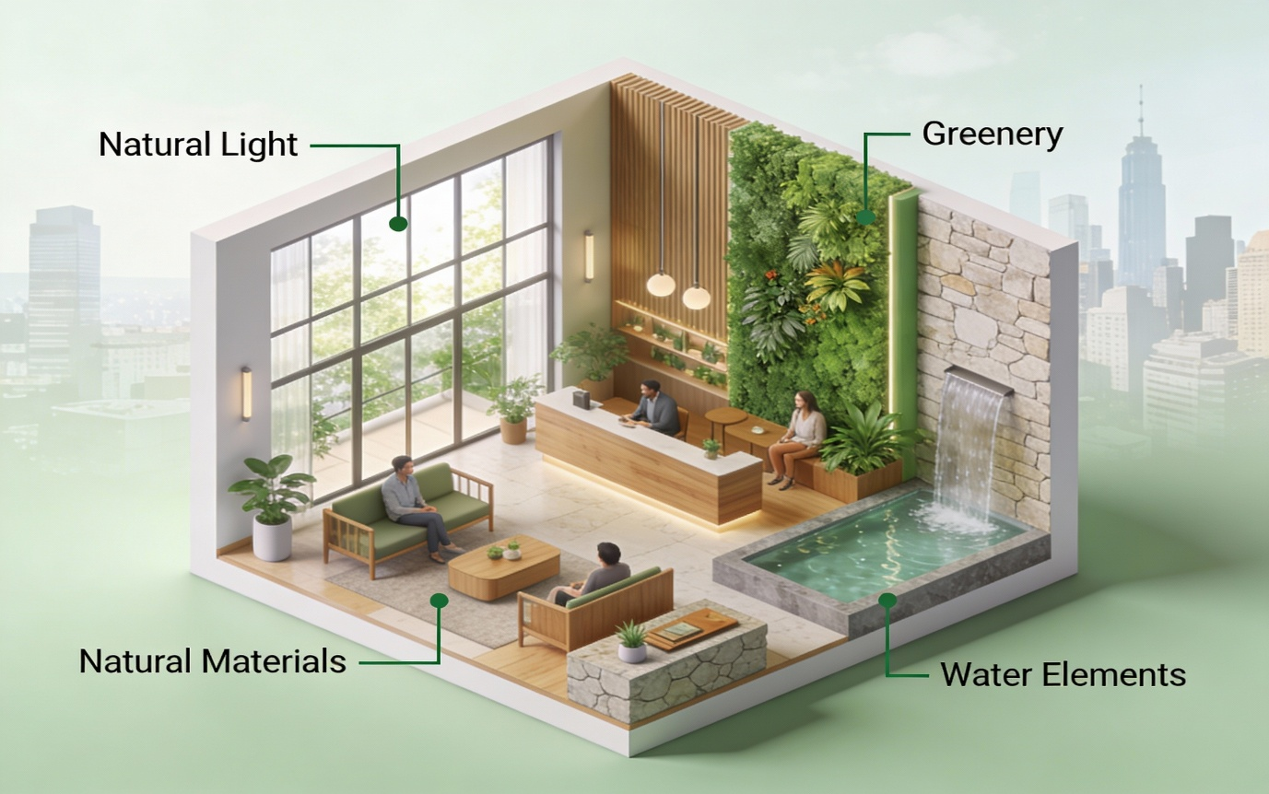
Figure 1. Biophilic Hotel Room/Lobby Design
Moreover, including green spaces and natural materials into hotel properties can really enhance local biodiversity and ecosystem services, promoting a more resilient urban environment (Caruso, 2023) (Abraham et al., 2023). This integrated strategy not only enhances the aesthetic and psychological experience for guests but also fosters a more inclusive environmental ethic within the hospitality industry (Begalievna et al., 2023; Yun & Kim, 2022). Biophilic design in this context supports the biophilia theory, which says that humans naturally want to connect with natural systems. This improves well-being and helps achieve long-term architectural goals (Abraham et al., 2023; Agboola, 2024).
Review of the Literature
The theoretical foundations of biophilic design are based on the idea that humans have an evolutionary tendency to connect with nature, which affects both their physical and mental health (Abraham et al., 2023). This inherent connection, termed "biophilia," indicates that exposure to natural elements can elicit favourable emotional reactions and mitigate stress, hence improving guest experiences in hospitality environments (ELghani et al., 2020). This viewpoint emphasises the beneficial effects on occupants of architectural design that includes natural light, vistas of natural landscapes, and the use of natural materials such stone and wood (Kuponiyi & Akomolafe, 2024). Furthermore, a regenerative approach to hospitality rise above mere aesthetic and psychological advantages, highlighting the comprehensive well-being of all stakeholders, including the local community and the earth (Inversini et al., 2023). This regenerative pattern, which focusses on making positive changes, is different from traditional sustainability in that it actively restores ecosystems and encourages beneficial relationships between people and the environment instead of only reducing harm (Inversini et al., 2023). This means that businesses need to change their basic way of doing things to focus on regenerative sustainability instead of maximising profits (Caruso, 2023). This new regenerative business model for hospitality is meant to help the environment by increasing biodiversity in cities, improving air quality, and lessening the consequences of climate change. It is part of a larger commitment to the health of the earth and the well-being of society (Caruso, 2023). These kinds of concepts generally use nature-based solutions and green infrastructure, such landscape design and environmental design, to create a mutual link between the hotel setting and the ecology around it. This helps urban biodiversity (Caruso, 2023). This method involves carefully using tactics like living walls and green roofs, which make city hotels seem better, give urban wildlife important places to live, and help cool the city (Caruso, 2023). When used together, these biophilic solutions can lower the urban heat island effect and make the air quality better in specific areas, which will help both hotel guests and the city (Caruso, 2023). In the end, these design ideas come together to provide a complete framework for urban hotels that not only makes visitors more comfortable and healthy right away but also helps the environment and the community in a big way (Caruso, 2023). This paper examines the diverse effects of biophilic design and regenerative hospitality practices on guest well-being and environmental sustainability in the urban hotel industry. It specifically examines the implementation of biophilic aspects and regeneration methodologies to attain quantifiable enhancements in guest happiness, physiological well-being, and the ecological impact of urban hotels. (Carusso, 2023) (Inversini et al., 2023).
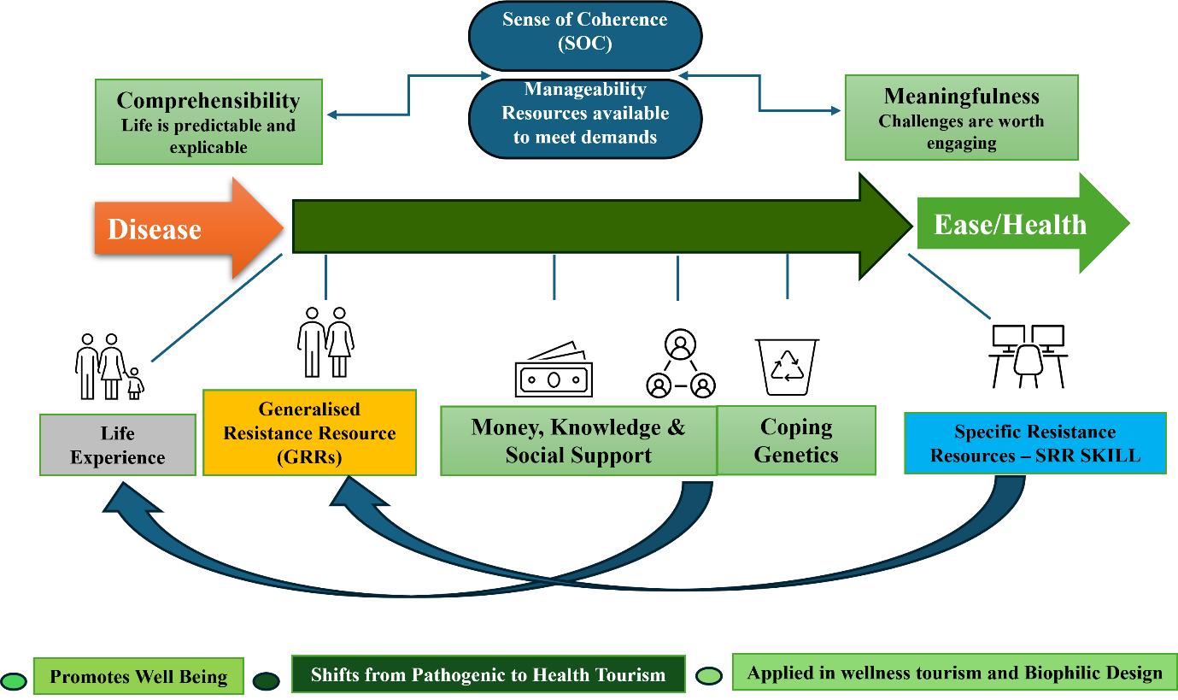
Figure 2. Salutogenic Model - Origin of Health

The study investigates whether these strategies are economically viable and whether they have long-term benefits, such as a better brand reputation and more competition in the market. The research looks into the policy effects and possible rules that need to be in place to speed up the use of biophilic and regenerative practices in the urban hospitality industry. It also outlines the main challenges and chances for implementation, using information from current people using the services and suggestions from experts to give hotels useful advice. This study clarifies the incorporation of nature-based solutions into hotel operations to improve employee burnout and improve well-being, thereby fostering a healthier and more efficient workforce (Yu et al., 2020). This means looking at how certain biophilic design elements can be added to the inside of buildings to make visitors happier and make the hotel business run more smoothly, which is in line with the overall goal of sustainability in the hotel industry (Nanu & Rahman, 2023). This integration improves the mental health and cognitive performance of people who live in the building. It also helps to meet the goals of sustainable construction by lowering energy use and improving indoor air quality (Agboola, 2024). Using biophilic ideas in the design of urban hotels can help you create a unique brand identity that will appeal to customers who care about their health, happiness, and the environment. This strategic difference can lead to higher occupancy rates and higher prices, which shows the real economic benefits of investing in biophilic and regenerative design (Lee, 2019). However, to get these benefits, you need to fully understand some design elements and how they affect different types of people, like guests and staff (Han et al., 2020). Studies indicate that natural lighting, outdoor greenery, and indoor landscaping are vital biophilic elements influencing the preparedness of prospective hospitality employees to work for a hotel, although the perceived importance of these factors may vary among individuals (Guchait & Ann, 2022). Thus, an advanced strategy for biophilic integration is essential, tailoring design choices to specific environments and target demographics to maximise their restorative advantages and economic benefits (Suess et al., 2024). This in-depth study shows how important it is to go beyond traditional sustainability standards and use regenerative design, which aims for net-positive social and environmental results (Caruso, 2023; Kumar et al., 2025). This means looking at the whole life cycle of a project, including how it uses resources, how much waste it makes, and how it affects people and the economy, to make sure that design changes improve, not just maintain, human and environmental health (Caruso, 2023). This change in thinking means that buildings need to have adaptive features that can change to fit new conditions. This makes sure that buildings stay strong in the face of climate change while also making the experience of the people who live in them better (Pistore et al., 2023). This expanded perspective aligns with the growing body of research demonstrating the quantifiable benefits of biophilic interventions on human health and environmental effectiveness (Panagopoulos et al., 2021; Usip et al., 2025). Biophilic elements, such as indoor plants and natural light, have shown the ability to improve social cohesion and productivity in the workplace, leading to indirect economic benefits through increased employee satisfaction and performance (Agboola, 2024). Additionally, the incorporation of biophilic design principles can extend beyond mere aesthetics to encompass operational strategies that foster a regenerative ethos, highlighting symbiotic relationships with local ecosystems and communities (Inversini et al., 2023). This strategy goes beyond just reducing negative effects to actively creating positive ones, which makes the built environment more resilient and alive (Kumar et al., 2025). This change from "green" or "sustainable" to "regenerative" design means not only doing less harm, but also actively making socio-ecological systems better, which is a more advanced way to take care of the environment (Panagopoulos et al., 2021). This necessitates a reevaluation of traditional construction metrics to include qualitative assessments of human welfare and ecological health, moving beyond inflexible standards to embrace flexible, context-aware approaches (Brajković, 2022; Dervishaj, 2023). This advanced methodology posits that structures must provide greater advantages than they utilise, striving for net-positive outcomes that improve a regenerative built environment (Kumar et al., 2025; Panagopoulos et al., 2021). This requires a shift from conventional sustainable design paradigms centred on "enhancement and harm reduction" to a framework that seeks measurable improvements in both ecological and social net benefits (Birkeland, 2022). This regenerative development and design paradigm, evolving for over two decades, transitions from merely mitigating environmental impacts to actively fostering positive contributions and facilitating the revitalisation of both built and natural systems (Dervishaj, 2023; Kumar et al., 2025). This regenerative approach sees buildings as living things that work together with their surroundings to restore ecosystem capital and improve the health of the people who live in them (Pistore et al., 2023). This shows that the design process is well thought out and considers the whole life cycle of a building, from getting materials to tearing it down. This will have a lasting positive effect on both the local environment and the larger ecological system (Kumar et al., 2025). This change is necessary because traditional sustainability often doesn't meet the needs of both people and the environment, while regenerative design is meant to restore and improve them (Kumar et al., 2025). Regenerative design not only protects and preserves ecosystems, but it also tries to bring back lost abundance, aiming to improve ecosystems beyond their pre-development state (Plessis, 2011). This ecological viewpoint emphasises a cooperative design methodology that fosters sustainable restoration and development, transitioning from static performance indicators to adaptive system feedback monitoring (Plessis & Brandon, 2014). This all-encompassing approach necessitates a departure from an equilibrium model of resilience, which might perpetuate suboptimal conditions, and instead advocates for a more proactive and deliberate regenerative development that leverages systemic collapse as a catalyst for new developmental trajectories (Plessis, 2011). A lot of homestays in tourist areas are using biophilic designs to attract niche tourists (Ahmad et al., 2025).

The oldest known design for a Himalayan home and guest house is a perfect example of biophilic design (Chandel, 2024). This ancestral knowledge, deeply rooted in the Himalayas, illustrates an inherent understanding of the interconnectedness between humanity and nature, which contemporary regenerative design principles are striving to re-establish in modern urban hospitality (Bhalla & Chowdhary, 2022; Toner et al., 2023). This represents a significant shift from merely mitigating negative impacts to actively enhancing natural and social systems, promoting continuous co-evolution and progress (Caruso, 2023; Plessis, 2011). This paradigm transcends basic sustainability by highlighting the interdependence of architectural elements, human well-being, and the broader natural ecosystem, aiming for net-positive outcomes.

Research Methodology

A survey was sent out to travel agents and young travellers who were interested in hotels and regenerative tourism. Bhalla and Chowdhary (2022). This methodology enabled the collection of diverse perspectives from industry professionals and the target audience, resulting in a comprehensive understanding of the perceived benefits and challenges of integrating biophilic design into regenerative hospitality models (Inversini et al., 2023). The questionnaire was carefully designed to collect information about what visitors like, how much they are willing to pay for biophilic facilities, and how well they understand the principles of regenerative tourism. This will give researchers a lot of useful data to work with in the future. The study aimed to ascertain how biophilic enhancements promote guest well-being and align with the principles of regenerative hospitality, exceeding conventional sustainability standards (Caruso, 2023). The survey investigated the possible correlations between tourist rehabilitation and biophilic design as a salutogenic framework, addressing a recognised deficiency in current wellness tourism research (Sachin & Dash, 2022). This study investigated the influence of biophilic design experiences in urban hotels on post-COVID-19 visitor preferences and perceptions of restorative environments, considering the increased demand for nature-integrated accommodations (Khozaei et al., 2022). This all-encompassing strategy aligns with extensive research indicating that environmental awareness and dedication to sustainable practices improve tourist satisfaction and loyalty (Karagianni et al., 2025). The research employed a Likert scale to evaluate respondents' perceptions of various sustainable solutions and their importance, thereby augmenting the quantitative analysis (Floričić, 2020). Qualitative data, derived from focus group interviews with experts in biophilic concepts, enriched the survey results by providing in-depth insights into the direct and indirect benefits of incorporating natural elements into architectural design (Agboola, 2024). This mixed-methods approach enabled a comprehensive understanding of the impact of biophilic design on visitor well-being and sustainability in urban hotels, offering a nuanced perspective that integrates quantitative data with qualitative insights (Lee, 2019).

Results and Discussions
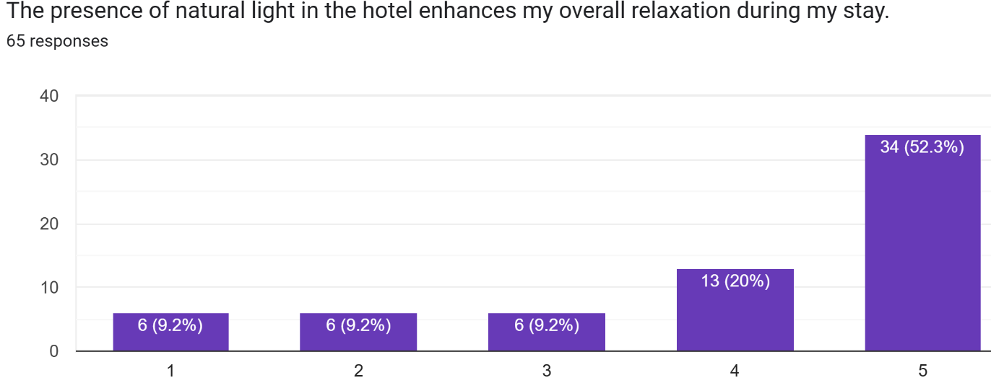
Chart 1. Guests’ preferences for natural light
The chart shows that most respondents believe natural light in hotels greatly enhances their relaxation during a stay. Over half (52.3%) gave the highest rating (5), indicating strong agreement, while 20% chose rating 4, signifying positive impact. Only a small minority responded with low or neutral scores (9.2% each for ratings 1, 2, and 3), suggesting very few guests disagree or feel neutral about the effect of natural light. These results clearly point to natural light as a critical biophilic design feature contributing to guest well-being and satisfaction in urban hotels. Most guests associate it with higher levels of relaxation and a more enjoyable stay experience.
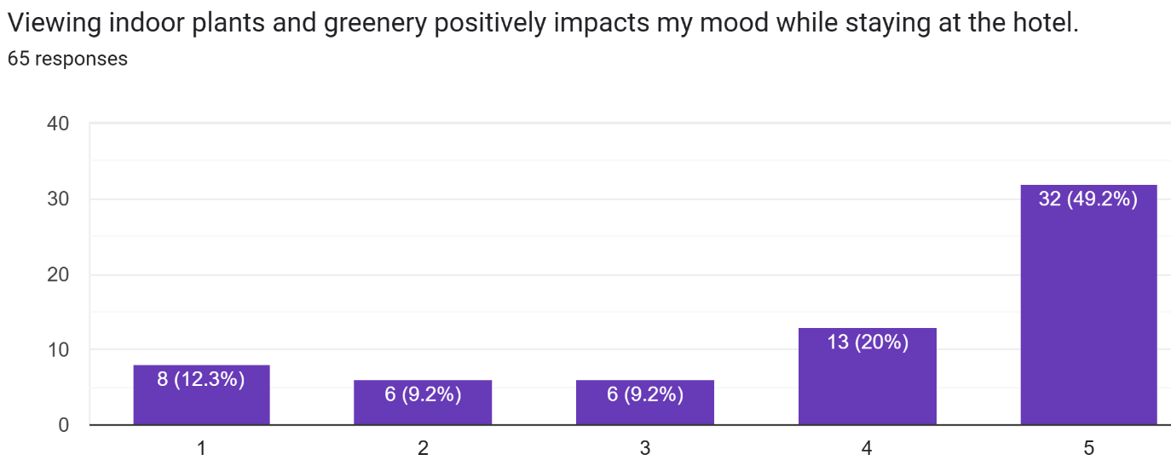
Chart 2. Guests’ preferences for indoor plants and greenery
The bar chart indicates that a clear majority of guests feel that viewing indoor plants and greenery has a positive impact on their mood while staying at the hotel. Most respondents chose the highest rating (5), followed by rating 4, showing strong agreement with the statement. Only a relatively small proportion selected ratings 1, 2, or 3, suggesting that negative or neutral perceptions are limited and that greenery is broadly appreciated as a mood-enhancing feature in the hotel environment
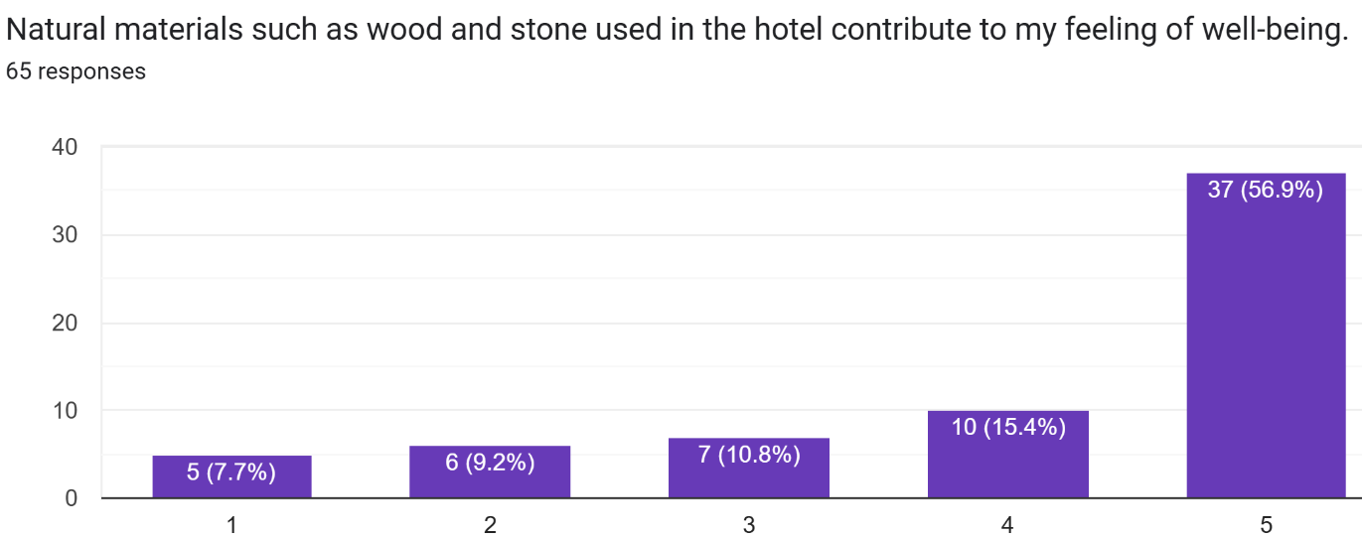
Chart 3. Guests’ preferences for natural materials such as wood and stone in the hotel
The chart demonstrates that most guests feel that natural materials such as wood and stone in the hotel significantly contribute to their well-being. A clear majority (56.9%) selected the highest rating of 5, with a further 15.4% choosing 4, indicating strong overall agreement with the statement. Only a small proportion of respondents chose ratings 1, 2, or 3, showing that negative or neutral views are limited and that the use of natural materials is widely perceived as beneficial for guest comfort and well-being in the hotel setting.
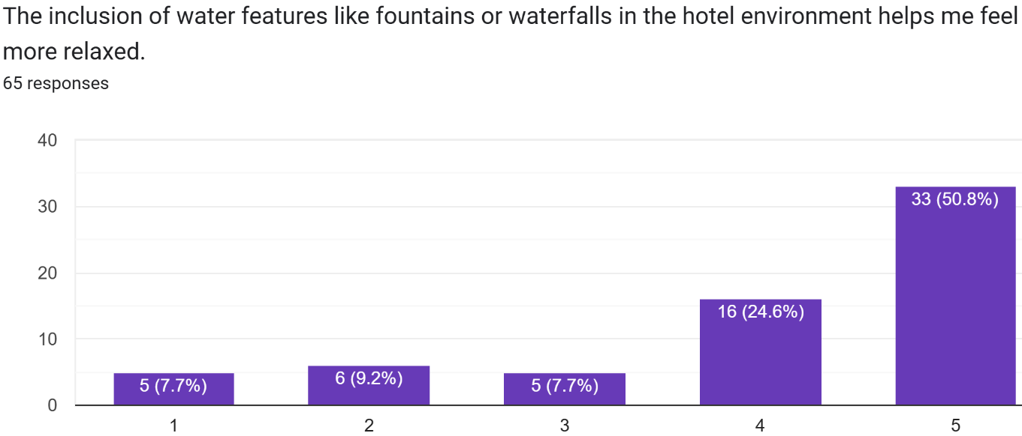
Chart 4. Guests’ preferences for water features such as fountains or waterfalls
The bar chart indicates that most guests perceive water features such as fountains or waterfalls as helping them feel more relaxed in the hotel environment. A majority of respondents selected ratings 4 and 5, with 50.8% choosing the highest rating, showing strong agreement with the statement. Only a small proportion selected ratings 1, 2, or 3, which suggests that negative or neutral views are minimal and that water elements are widely regarded as beneficial for enhancing relaxation in hotels.
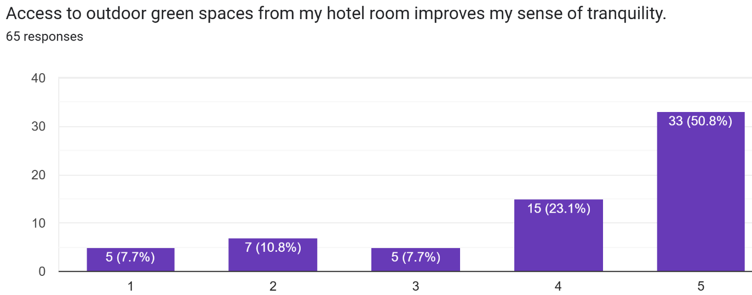
Chart 5. Guests’ preferences for access to outdoor green spaces
The chart shows that most guests perceive access to outdoor green spaces from their hotel room as significantly enhancing their sense of tranquillity. A clear majority chose ratings 4 and 5, with 50.8% selecting the highest rating, indicating strong agreement with the statement. Only a small number of selected ratings 1, 2, or 3, which suggests that negative or neutral opinions are limited and that visual and physical connection to outdoor greenery is widely valued for promoting calmness and relaxation in the hotel context.
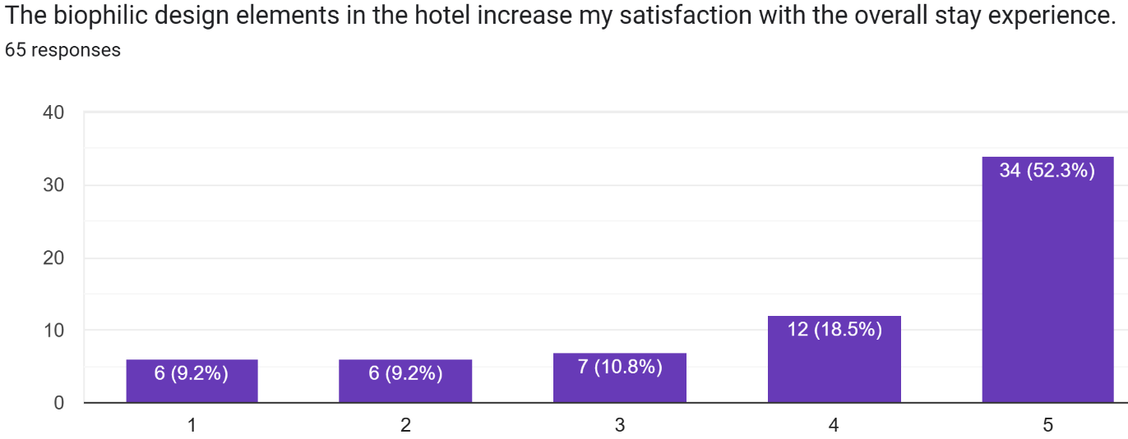
Chart 6. Guests’ preferences for the availability of biophilic design elements
The chart indicates that biophilic design elements in the hotel strongly enhance guests’ overall satisfaction with their stay experience. A majority of respondents chose the highest rating (5), accounting for 52.3%, while a further 18.5% selected rating 4, reflecting high agreement with the statement. Only a small portion opted for ratings 1, 2, or 3, suggesting that negative or neutral perceptions are limited and that incorporating nature-based features is broadly recognised as adding substantial value to the overall hotel stay.
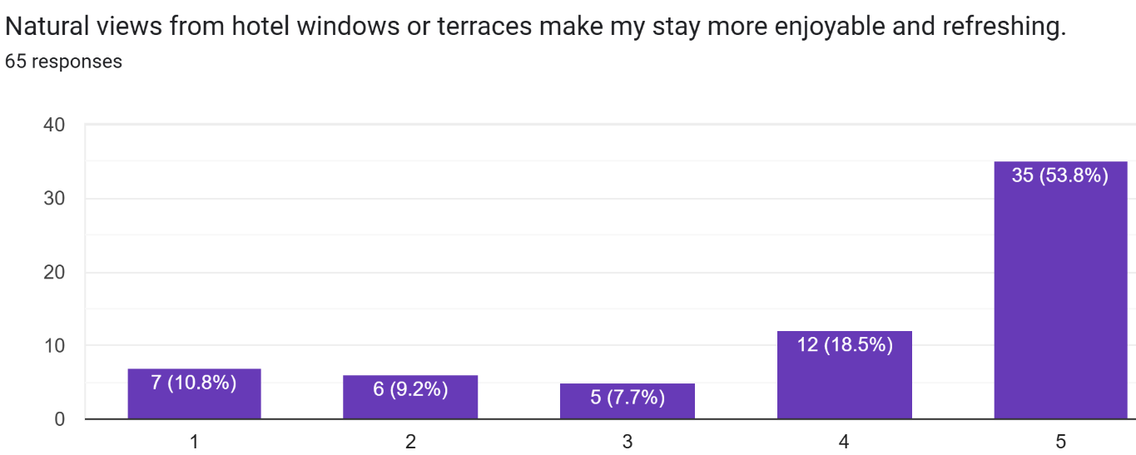
Chart 7. Guests’ preferences for natural views from hotel windows or terraces
The chart demonstrates that natural views from hotel windows or terraces strongly enhance guests’ enjoyment and sense of refreshment during their stay. A clear majority of respondents selected rating 5 (53.8%), with a further 18.5% choosing rating 4, indicating high agreement with the statement. Only a small share opted for ratings 1, 2, or 3, suggesting that negative or neutral opinions are limited and that visual connection to nature is widely perceived as an important contributor to a more pleasant and revitalising hotel experience.
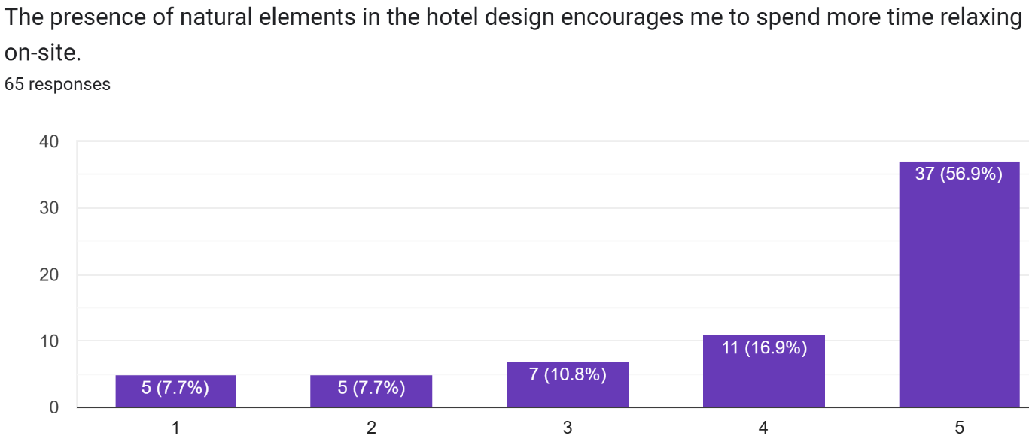
Chart 8. Guests’ preferences for natural elements in the hotel to feel more relaxed
The chart indicates that natural elements in the hotel design strongly encourage guests to spend more time relaxing on-site. A majority of respondents selected rating 5 (56.9%), with a further 16.9% choosing rating 4, showing high agreement that such features promote on-site relaxation. Only a small share chose ratings 1, 2, or 3, suggesting limited negative or neutral views and reinforcing that biophilic elements are seen as enhancing both the attractiveness of the property and guests’ readiness to linger within the hotel premises.
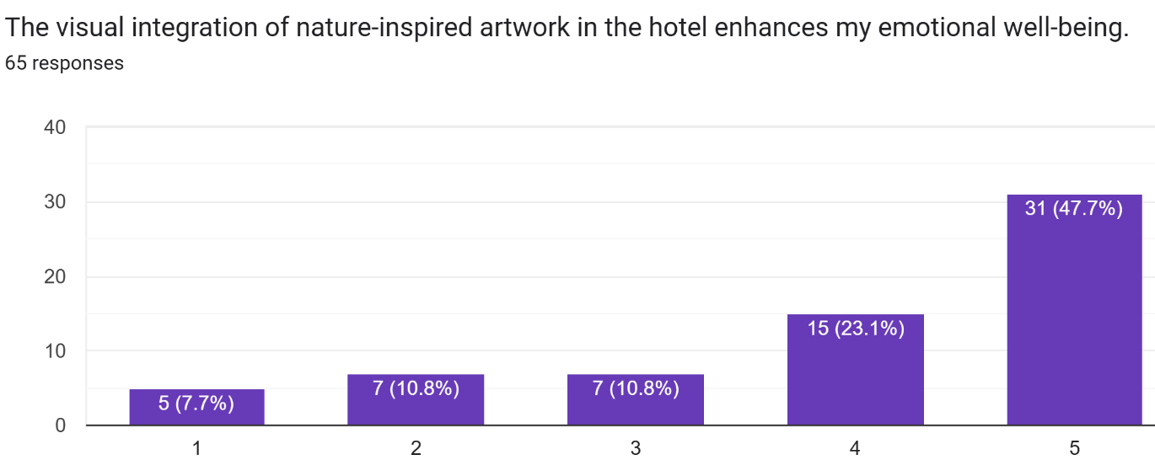
Chart 9. Guest’s preferences for nature-inspired artwork
The chart indicates that nature-inspired artwork in the hotel is perceived as an important contributor to guests’ emotional well-being. A substantial proportion of respondents selected ratings 4 and 5, with 47.7% choosing the highest rating, showing strong agreement that such visual elements enhance how they feel during their stay. Only a minority chose ratings 1, 2, or 3, suggesting limited negative or neutral views and highlighting that incorporating nature-themed art is widely valued as a supportive feature for emotional comfort and positive mood in the hotel environment.
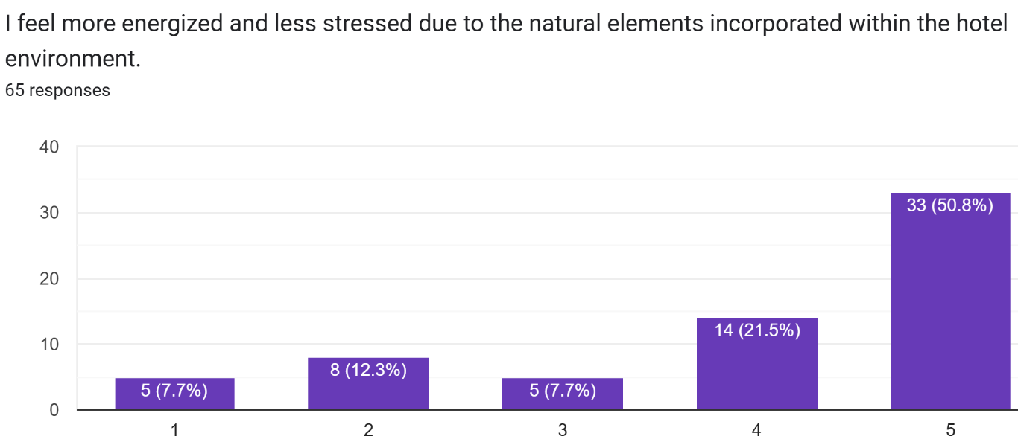
Chart 10. Guests’ preferences for natural elements within the hotel to feel more energised
The chart shows that natural elements within the hotel environment are strongly associated with guests feeling more energised and less stressed. A majority of respondents selected rating 5 (50.8%), with a further 21.5% choosing rating 4, indicating high agreement that these features enhance both vitality and stress reduction. Only a small proportion opted for ratings 1, 2, or 3, suggesting limited disagreement and reinforcing that biophilic elements are widely perceived as effective in promoting psychological restoration and positive affect during the hotel stay.
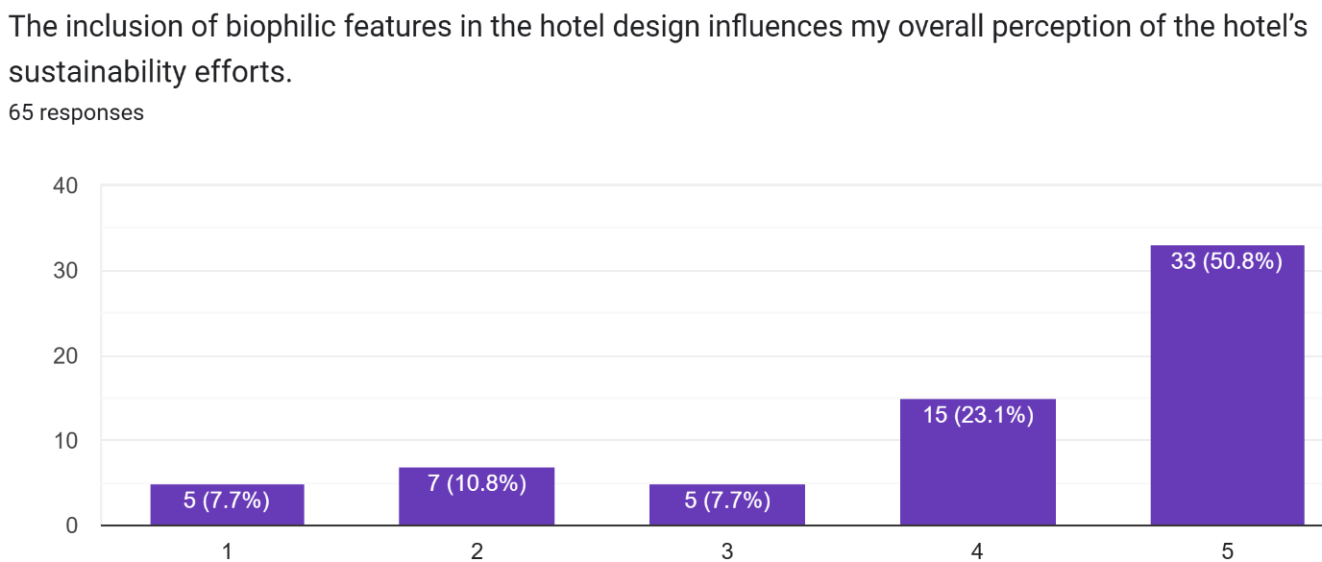
Chart 11. Guests’ responses to the hotel’s sustainability efforts based on biophilic features
The chart indicates that biophilic features in hotel design substantially shape guests’ perceptions of the property’s sustainability efforts. A majority of respondents selected rating 5 (50.8%), with a further 23.1% choosing rating 4, demonstrating strong agreement that visible natural elements signal stronger environmental commitment. Only a small proportion opted for ratings 1, 2, or 3, suggesting limited disagreement and highlighting that incorporating biophilic features not only benefits well-being but also enhances the hotel’s sustainability image in the minds of guests.
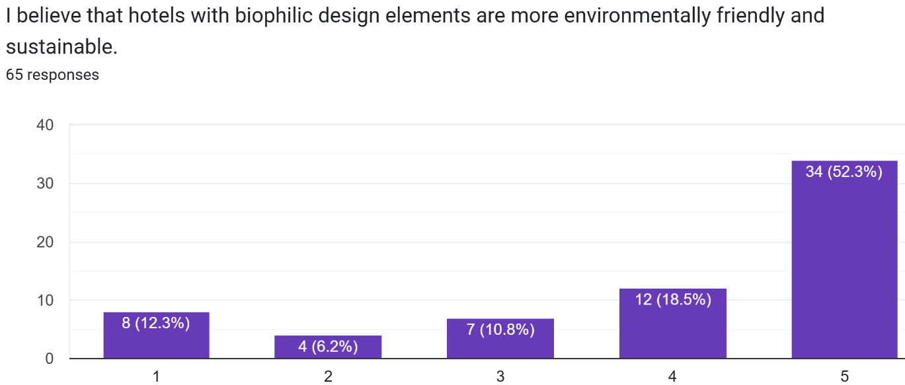
Chart 12. Guests’ responses to the environmental friendliness and sustainability of hotels
The chart indicates that guests strongly associate biophilic design elements with higher environmental friendliness and sustainability of hotels. A majority selected rating 5 (52.3%), with a further 18.5% choosing rating 4, showing high agreement that such features signal greener practices. Only a small proportion opted for ratings 1, 2, or 3, suggesting limited disagreement and confirming that visible natural elements play a key role in shaping guests’ perceptions of a hotel as environmentally responsible and sustainable.
Interpretation and Discussion
The findings reveal that biophilic design features substantially influence guests’ emotional comfort, relaxation, and satisfaction in urban hotels. Elements like natural light, greenery, and natural materials received the highest ratings, underlining their central role in creating restorative and inviting environments. These features trigger positive psychological responses through visual and sensory engagement with nature, leading to enhanced relaxation and perceived well-being. The consistent pattern across variables—where over half of respondents selected the highest possible ratings—demonstrates a broad appreciation for the presence of natural elements in hospitality spaces.
Table 1. Different Biophilic Elements and their ratings given by the guests
Biophilic Element | Highest Rating (5) % | Rating 4% | Neutral/Low Ratings (1-3) % | Key Interpretation
Natural light | 52.3 | 20 | 27.7 | Strong impact on relaxation
Indoor greenery | Majority (50+) | Next high (20) | Low | Enhances mood and comfort
Natural materials | 56.9 | 15.4 | Low | Promotes well-being and comfort
Water features | 50.8 | 20 | Low | Boosts relaxation and calmness
Outdoor green space | 50.8 | 20 | Low | Facilitates tranquillity
Overall satisfaction | 52.3 | 18.5 | Low | Increases stay enjoyment
Natural views | 53.8 | 18.5 | Low | Refreshing and revitalising
On-site relaxation | 56.9 | 16.9 | Low | Encourages longer stay duration
Nature-inspired art | 47.7 | 20 | Low | Improves emotional well-being
Stress reduction | 50.8 | 21.5 | Low | Enhances vitality and rest
Sustainability perception | 50.8 | 23.1 | Low | Indicates environmental awareness
Eco-friendliness image | 52.3 | 18.5 | Low | Reinforces sustainability image
The high ratings for natural views, water features, and access to outdoor green areas show how important it is to be able to see and touch nature. Guests not only feel calmer and more energised, but they also think that these kinds of hotels are better for the environment. The findings corroborate principal theories of biophilic design and environmental psychology, indicating that exposure to nature diminishes stress, enhances well-being, and facilitates cognitive restoration. The connection between natural design elements and sustainability perception also shows that guests are increasingly choosing eco-friendly hotels, where aesthetics and environmental ethics are both important for a memorable and meaningful stay.
Conclusion
This study shows that biophilic design substantially improves guest experiences and perceptions in hotels. Respondents strongly agreed that natural light, plants, water features, and eco-friendly materials all had a positive effect on relaxation, mood, and satisfaction. The consistently high ratings show that being around natural things not only makes people feel better, but it also makes them more aware of the environment and their own well-being. Guests now connect biophilic aesthetics with both emotional renewal and the hotel's eco-friendly image. This shows that designs inspired by nature can serve two purposes: improving the guest experience and boosting the brand's environmental credibility. Hotel owners can use these ideas by adding more natural materials, light-filled spaces, and connections between indoor and outdoor areas to their buildings and interiors. These kinds of design strategies could help build guest loyalty, set your business apart from the competition, and make sure that your business is sustainable in the long run. The results show that biophilic design is not a luxury, but a necessary part of modern hospitality. It meets the needs of modern travellers for comfort, health, and environmental responsibility, giving hoteliers a way to make spaces that are good for both people and the planet.

References

- Abraham, A. O., Oluwatayo, A. A., & Nduka, D. M. (2023). Embracing Nature in the Built Environment: Evaluation of Biophilic Design Patterns in Selected Resorts. Journal of A Sustainable Global South, 7(2), 26-35. https://doi.org/10.24843/jsgs.2023.v07.i02.p01
- Agboola, O. P. (2024). Assessing the effectiveness of biophilic design approach in contribution to sustainable architectural goals. New Design Ideas, 8, 144. https://doi.org/10.62476/ndisi144
- Albattat, A., Singhal, V., Parashar, A., Agarwal, P., & Chandel, P. S. (2025). Exploring Sustainable Food and Tourist Experiences in Homestay Tourism: A Case Study. In Global Practices and Innovations in Sustainable Homestay Tourism (pp. 25-40). IGI Global. https://doi.org/10.4018/979-8-3373-0427-4.ch002
- Begalievna, M. N., Tercan, T., & A, Z. A. (2023). Biophilic Approach In The Hospitality Industry. Migration Letters, 20(S6), 689–694. https://doi.org/10.59670/ml.v20iS6.4214
- Bhalla, R., & Chowdhary, N. (2022). Green workers of Himalayas: evidence of transformation induced regeneration. Journal of Tourism Futures, 8(3), 380–392. https://doi.org/10.1108/jtf-12-2021-0273
- Birkeland, J. (2022). Nature Positive: Interrogating Sustainable Design Frameworks for Their Potential to Deliver Eco-Positive Outcomes. Urban Science, 6(2), 35. https://doi.org/10.3390/urbansci6020035
- Brajković, J. (2022). Rethinking sustainability towards a regenerative economy. Urban Research & Practice, 15(2), 317-319. https://doi.org/10.1080/17535069.2022.2072613
- Caruso, L. (2023). Toward Regenerative Hospitality Business Models: The Case of “Hortel”. Tourism and Hospitality, 4(4), 618-641. https://doi.org/10.3390/tourhosp4040038
- Chandel, P. S., Agarwal, P., Parashar, A., & Indolia, U. (2024). A critical assessment of Uttarakhand’s all-weather road project on tourism, environment, and local livelihoods. Journal of Emerging Technologies and Innovative Research. http://www.jetir.org/papers/JETIR2412572.pdf
- Dervishaj, A. (2023). From Sustainability to Regeneration: a digital framework with BIM and computational design methods. Architecture Structures and Construction, 3(3), 315-336. https://doi.org/10.1007/s44150-023-00094-9
- Abd ELghani, R., el Aidi, D. M., Kassim, O., & Awaad, I. (2020). Towards a methodological approach to apply Biophilic Interior Design in hospitality spaces. Journal of Design Sciences and Applied Arts, 1(2), 177-191. https://doi.org/10.21608/jdsaa.2020.28494.1011
- Floričić, T. (2020). Sustainable Solutions in the Hospitality Industry and Competitiveness Context of “Green Hotels.” Civil Engineering Journal, 6(6), 1104-1113. https://doi.org/10.28991/cej-2020-03091532
- Guchait, P., & Ann, S. (2022). Guest editorial: The past, present and future of hospitality research. International Journal of Contemporary Hospitality Management, 34(8), 2801–2806. https://doi.org/10.1108/ijchm-08-2022-062
- Han, H., Lee, J., & Koo, B. (2020). Impact of green atmospherics on guest and employee well-being response, place dependence, and behavior in the luxury hotel sector. Journal of Sustainable Tourism, 29(10), 1613-1634. https://doi.org/10.1080/09669582.2020.1861456
- Inversini, A., Saul, L., Balet, S., & Schegg, R. (2024). The rise of regenerative hospitality. Journal of Tourism Futures, 10(1), 6-20. https://doi.org/10.1108/jtf-04-2023-0107
- Karagianni, V., Kalantonis, P., Tsartas, P., & Sdrali, D. (2025). Sustainable Dimensions of Wellness Tourism: Exploring Environmental Sensitivity, Tourist Engagement, and Life Satisfaction. International Journal of Accounting and Economics Studies. https://doi.org/10.14419/2t36c202
- Khozaei, F., Carbon, C. C., Hosseini Nia, M., & Kim, M. J. (2022). Preferences for Hotels with Biophilic Design Attributes in the Post-COVID-19 Era. Buildings, 12(4), 427. https://doi.org/10.3390/buildings12040427
- Kumar, S., Sakagami, K., & Lee, H. P. (2025). Beyond Sustainability: The Role of Regenerative Design in Optimizing Indoor Environmental Quality. Sustainability, 17(6), 2342. https://doi.org/10.3390/su17062342
- Kuponiyi, A., & Akomolafe, O. O. (2024). Biophilic Design: Health, Well-being, and Sustainability. International Journal of Multidisciplinary Research and Growth Evaluation, 5(1), 1746-1753. https://doi.org/10.54660/.IJMRGE.2024.5.1.1746-1753
- Lee, S. H. (2019). Effects of biophilic design on consumer responses in the lodging industry. International Journal of Hospitality Management. https://doi.org/10.1016/j.ijhm.2019.05.006
- Nanu, L., & Rahman, I. (2023). The biophilic hotel lobby: Consumer emotions, peace of mind, willingness to pay, and health-consciousness. International Journal of Hospitality Management. https://doi.org/10.1016/j.ijhm.2023.103520
- Panagopoulos, T., Sbarcea, M., & Herman, K. (2021). A biophilic mind-set for a restorative built environment. Landscape Architecture and Art, 17, 68. https://doi.org/10.22616/j.landarchart.2020.17.08
- Pistore, L., Konstantinou, T., Pasut, W., & Naboni, E. (2023). A framework to support the design of a regenerative indoor environment. Frontiers in Built Environment, 9. https://doi.org/10.3389/fbuil.2023.1225024
- du Plessis, C. (2012). Towards a regenerative paradigm for the built environment. Building Research & Information, 40(1), 7-22. https://doi.org/10.1080/09613218.2012.628548
- Du Plessis, C., & Brandon, P. (2014). An ecological worldview as basis for a regenerative sustainability paradigm for the built environment. Journal of Cleaner Production. https://doi.org/10.1016/j.jclepro.2014.09.098
- Sachin, A., & Dash, S. P. (2022). A Systematic Review on Implications of Biophilic Design as a Salutogenic Approach to Wellness Tourism. ECS Transactions. https://doi.org/10.1149/10701.17395ecst
- Suess, C., Legendre, T. S., & Hanks, L. (2024). Biophilic Urban Hotel Design and Restorative Experiencescapes. Journal of Hospitality & Tourism Research, 48(8), 1572-1593. https://doi.org/10.1177/10963480241244720
- Toner, J., Desha, C., Reis, K., Hes, D., & Hayes, S. (2023). Integrating Ecological Knowledge into Regenerative Design: A Rapid Practice Review. Sustainability https://doi.org/10.3390/su151713271
- Usip, E., Essien, E. A., & Ema, I. B. (2025). Biophilic Architecture: Integrating Nature Into Contemporary Built Environments - A Critical Analysis of Nature-Based Design Strategies and Their Impact on Human Wellbeing. https://doi.org/10.21203/rs.3.rs-7318659/v1
- Yu, J., Ariza-Montes, A., Hernández-Perlines, F., Vega-Muñoz, A., & Han, H. (2020). Hotels’ Eco-Friendly Physical Environment as Nature-Based Solutions for Decreasing Burnout and Increasing Job Satisfaction and Performance. International Journal of Environmental Research and Public Health. https://doi.org/10.3390/ijerph17176357
- Yun, S.-M., & Kim, T. (2022). Can Nature-Based Solutions (NBSs) for Stress Recovery in Green Hotels Affect Re-Patronage Intention? Sustainability. https://doi.org/10.3390/su14063670

