A Leadership Report on Fundamentals of Leadership: Power, Influence, and Best Practices for Effective Leadership

Abstract
Effective Leadership is significant for success of the organization, demanding a combination of strategic decision-making, influence, and interpersonal competencies. This report examines the fundamentals of leadership, exploring dynamic power, leadership approaches, communication, motivation, and emotional intelligence. This evaluates the use of power and influence as a leader, assessing their effectiveness in influencing teams. Most importantly, the situational leadership model has been examined, highlighting its adaptability in different organizational contexts. The best practices for leadership communication have been explored, with a focus on overcoming the challenges of leading virtual teams. Additionally, Maslow’s Hierarchy of Needs analyzed as a motivational framework, and the role of emotional intelligence in leadership is discussed in relation to decision-making, conflict resolution, and team engagement. The report concludes that effective leadership requires a balance of adaptability, emotional intelligence, and communication, demonstrating that no single leadership style fits all situations. Instead, the most successful leaders are those who can adjust their strategies to meet the evolving needs of their teams and organizations.

Keywords: Effective Leadership, Power and Influence in Leadership, Situational Leadership, Leadership Communication and Emotional Intelligence in Leadership

1.0 Introduction
1.1 Concept of Leader, Leadership, and Effective Leadership:
“A leader who knows the way, goes the way, and shows the way” (John C. Maxwell, as cited in Srivastava et al., 2016, p. 11). Maxwell emphasizes the crucial role of leadership by example. This quote states that a leader not only understands a particular path forward but also personally knows the correct way to go and guides for team to follow. Leadership is a skill of a leader who interacts between two or more individuals of a team to achieve a common goal for an organization (Bass 1990, as cited in Silva, 2016). Moreover, Handy (1992) highlighted a leader shapes and shares vision, whereas Rost (1993) emphasized leadership as a mutual goal-oriented relationship. Yukl (2012) refers to effective leadership as a leader's capability to motivate and influence people or teams toward acquiring common goals by effective, sustainable, adaptive, and ethical manner. He also defines effective leadership as a combination of strategic thinking, cognitive skills, interpersonal abilities, and emotional intelligence. According to Northouse (2018), it includes influencing and directing groups or individuals to achieve shared goals by creating a good working atmosphere.

2.0 Utilizing power and influence in leadership role as a leader
In leadership, utilizing power and influence as a leader that can be allowed to control the behaviors of others and the capacity to shape the actions or decisions of teams for organizational success. According to Yukl (2006), power refers to the ability to control by influencing others. Power operates within various contexts that involve political, social, economic, and cultural spheres. The most popular framework for understanding power dynamics has been supplied by French and Raven’s in 1959 typology of power bases, including reward, legitimate, coercive, referent, and expert power. Leaders can use those powers in different situations, in this critical discussion, will critically examine and evaluate the effectiveness and appropriateness of the reward and expert power bases for leaders to adopt.

2.1 Reward power base:
Based on reward power bases for leaders to adopt, French and Raven (1959) and Raven (1965) emphasizes this context as a significant element of the reward power base, wherein the target’s desire to obtain these rewards controlled by the agent becomes a great factor in shaping decision making and behavior. On the other hand, it is essential to recognize that the scope of formal authority may be limited, thereby constraining the agent's ability to leverage rewards effectively for influence. Reward power bases from a leader's capability to provide rewards, including promotions, bonuses, or praise, to influence the behavior of the followers (French & Raven, 1959). While rewards can indicate as powerful motivators, the indiscriminate use of reward power may lead to dependency and undermine intrinsic motivation (Deci et al., 1999). Additionally, relying on rewards to motivate performance might overlook other factors, such as job satisfaction and working atmosphere, which are crucial for long-term commitment and engagement (Ryan & Deci, 2000). Thus, while reward power may be effective in certain conditions, leaders must use it judiciously and complement it with other forms of power and motivation.

2.2 Expert power base
Expert power base indicates a leader expertise such as knowledge, skills in a certain domain (Yukl, 2012). Consequently, leaders who acquire expertise are often perceived as credible and trustworthy, making it easier for them to influence others (French & Raven, 1959). Expert power is particularly appropriate in knowledge-intensive environments where technical proficiency is valued. However, leaders must be mindful of the limitations of expert power, as excessive reliance on expertise may alienate team members and inhibit collaboration (Vecchio, 2007). Additionally, leaders should continually update their knowledge and skills to maintain their credibility and effectiveness as experts. As an illustration, Mark Parker, as the CEO of Nike, likely possesses expert power base, he has given his extensive experience, likely commands indispensable influence due to his expertise (Greenfeld, 2015). On the contrary, numerous scholarly sources and industry analyses recognize his deep understanding of the athletic apparel and footwear market, as well as his strategic vision for Nike's product design, innovation and brand development (Keller & Richey, 2006). Parker's tenure as CEO was marked by initiatives such as the introduction of groundbreaking technologies like Nike Flyknit and the expansion of Nike's digital capabilities, demonstrating his acumen in driving innovation within the company (Barnes, 2020).

3.0 Leadership Approaches (Situational Leadership)
3.1 Defining Situational Leadership
According to Hersey and Blanchard (1988), situational leadership is a theory of leadership which was develop by Ken Blanchard and Paul Hersey in the late 1960s, that was outlined in their seminal work “Management of Organizational Behavior: Utilizing Human Resources”. Based on this theory, effective leadership has been contingent upon aligning leadership approach with the maturity level of the followers in a given situation (Hersey & Blanchard, 1988). This theory providing that there is no one-size-fits-all approach to leadership role and emphasizes the importance of flexibility and adaptability in leadership. Instead, leaders must adapt their behavior based on the certain circumstances and situations they encounter and the abilities of their followers (Northouse, 2018).

3.2 Effectiveness of Situational Leadership
Effective Leadership is a combination of both supportive and directive dimensions. To meet the changing demands of their followers, leaders should dynamically modify the degree of directive guidance and supporting behavior they exhibit. This necessitates aligning leadership style to the followers’ degree of competence and commitment (Northouse, 2018; Yukl, 2013). Hersey and Blanchard (1969) state that a leader’s ability to be both supportive and directive is essential to the success of the role of situational leadership. Directive behaviors focus on taking actions by leaders to control and guide the group members toward the purposes, providing instructions, establishing objectives and techniques of evaluation, setting deadlines, defining responsibilities, and demonstrating pathways to goal attainment. To make these behaviors clearer, one-way communication on procedures, duties, and tasks is frequently required (Blanchard et al., 1985). Conversely, supportive behaviors facilitate group members to feel good regarding themselves, their colleagues, and the circumstances. These behaviors involve giving and receiving feedback that extend emotional and social support to followers. Instances comprise asking for feedback, resolving stance, offering praise, disclosing personal information, and paying attention to other members of the group (Hersey & Blanchard, 1977).

Situational Leadership Effectiveness based on the SLII model
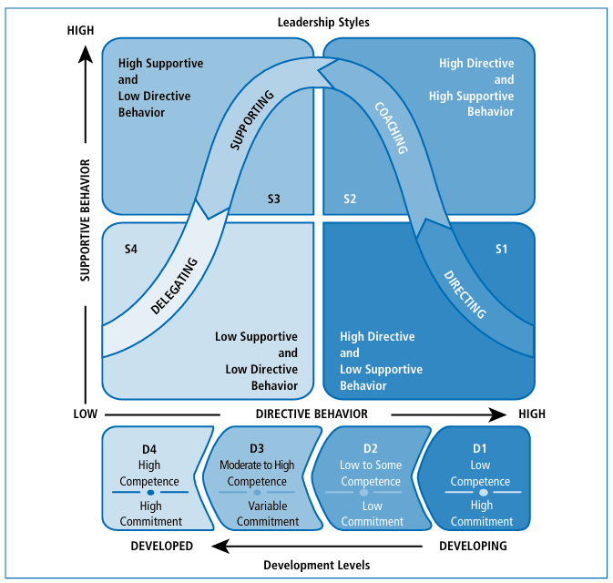

Figure 1: Situational Leadership II
Source: Leadership: Theory and practice by Northouse, (2018, 8th ed.).

The first style (S1) is identified by high directive-low supporting behaviors, and focuses on goal achievement with minimal supportive interactions (Hersey & Blanchard, 1982). The second style (S2) is a coaching technique, combines high-directive and high-supportive behaviors to meet both goal attainment and socio-emotional needs (Hersey & Blanchard, 1982). The third style (S3) of Situational Leadership II entails a high-supportive and low directive style, emphasizing supportive behaviors such as listening, praising, and providing feedback, while granting followers control over day-to-day decisions (Hersey & Blanchard, 1982). Conversely, the fourth style (S4) is known as a delegating strategy, uses a low supportive and low directive style, in which the leader offers limited goal input and social support, empowering followers to assume responsibility for achieving goals autonomously (Blanchard et al., 1985). Most notably, the development levels are classified into four categories: D1, D2, D3, and D4, which range from developing to developed. D1 followers exhibit low skill but high commitment, expressing passion for the goal while being new to it. D2 followers have some competence but lack commitment, having started to learn the work but feeling less motivated. D3 followers have moderate to high competence but may depict varying levels of commitment, having acquired the necessary abilities but remaining uncertain about attaining the goal independently. Finally, D4 followers are the most developed, demonstrating both high skill and commitment to achieving goals (Blanchard et al., 1985).

4.0 Leadership Communication
4.1 Definition and Explanation of Leadership Communication
According to Daft (2008), Leaders communicate with the goal of sharing their vision, motivating, and influencing them to pursue that vision, and creating trust and establishing the values for boosting effective working relationships and achieving goals. Based on new realities of leadership communication, there are many trends shifting communication those need to utilize leaders in every situation. Firstly, according to Van Eerde and Thierry (1996), leadership communication is evolving significant shifts owing to various trends such as economic, organizational, generational, global, and technological changes are mostly influencing leaders’ communication. Economic changes affect communication techniques and strategies regarding financial reporting and resource allocation. Organizational changes emphasize leaders must endure clear communication about new processes and company structures (Schleicher et al., 2018). While global changes focus the need for cross-cultural communication capabilities (Dickmann & Mills, 2019). Generational changes involve the necessity of adapting different communication methods to different age level groups (Böckerman et al., 2020). Technological changes require the leaders to utilize various communication platforms (such as email, audio & video conference, social media etc.). Those platforms will help the leaders to communicate effectively (Deci et al., 2017). Secondly, effective leadership communication consists of two components: content and delivery (Conger 1991). Content encompasses the message itself, including its clarity, accuracy, and relevance. It involves what the leader is communicating, such as strategic plans, goals, expectations, and feedback. Whereas delivery involves how information is being communicated (Choudhury & Srivastava, 2020), encompassing the leader's tone, body language, timing, and choice of communication channel. Effective delivery ensures that the message is conveyed clearly, persuasively, and resonates with the audience (Furrer et al., 2019). Last but not least, Conger (1991) suggests that two things those assist leaders to communicate effectively, like framing, the social constructing of a social event helps leaders to relate goals, values, and beliefs, influencing followers’ perceptions and supplying a road map for acting. On the other hand, rhetorical crafting involves metaphors, analogies, and stories that allow leaders to promote engagement, and active listening for effective communication (Conger, 1991).

4.2. Identifying the requirements and issues involved in leading virtual teams
There are many requirements to lead virtual teams, but it requires certain skills and awareness for leading virtual team members in virtual environments. Firstly, leaders must possess persuasive communication abilities to overcome the issues of e-communication effectively (Trivedi & Desai, 2012). According to Lipnack and Stamps (2000), leaders need to foster a sense of cohesion and trust among group members, particularly consideration the potential for feelings of isolation and non-reliance. In addition, leaders must have a good knowledge and skills of adaptation of using technological tools and maintaining geographically separated team members (Jones et al., 2005). Most interestingly, leaders need the capabilities to reduce perceived distance by managing personal relationships and strengthening cohesion (Jarvenpaa & Leidner, 1999), they must also address the diversity within virtual teams by boosting team building, responding to the certain needs of group members (Trivedi & Desai, 2012).

One of the main challenges and issues in leading virtual teams is the lack of technological expertise among some senior managers, leading to a generation gap (Lipnack & Stamps, 2000). Additionally, assessing, motivation, and evaluating can be challenging when team members geographically dispersed (Cascio & Shurygailo, 2003). Another significant issue is communication with team members, as face-to-face communication is considered superior owing to its richness in non-verbal social presence and cues (Trivedi & Desai, 2012). Physical, operational, and cultural differences may also be considered as challenges for leaders to communicate effectively (Lilian, 2014).

5.0 Leadership and Motivating Others
5.1 Definition of Needs Theory
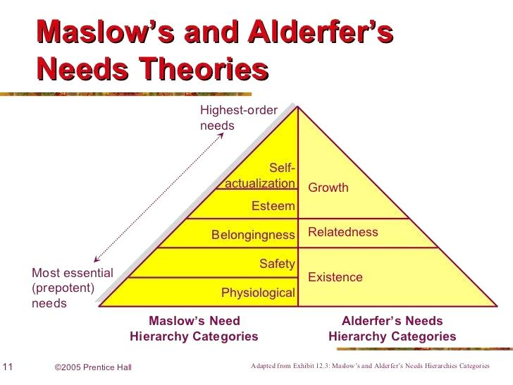
The hierarchy of needs first proposed by American humanist psychologist Abraham Maslow in 1954, humans are motivated by a hierarchy of needs that influence their actions and behavior (Maslow, 1943). This theory outlines a five-level hierarchy of human needs, namely, physiological, safety, social, self-esteem, and self-actualization needs. This theory emphasizes that individual’s progress sequentially through these levels, when lower-level needs are satisfied, higher level needs have been emerged. However, it is significantly noted that individuals follow this hierarchy rigidly, and elements such as personal values, culture, and life experiences can impact the fulfillment and prioritization of these needs (Liu, et al., 2022).
Figure 2: Maslow’s and Alderfer’s Needs Theories
(Source: World of Work Project, 2020)

Alderfer’s ERG theory of motivation expands upon Maslow’s Hierarchy of needs and states that people have three core needs, namely Existence, Relatedness, and Growth. Unlike Alderfer’s and Maslow’s hierarchy theory states that these needs may vary in different individuals in different circumstances over time ( Alderfer, 1972).

5.2 Critically evaluate and discuss the effectiveness of Maslow’s Hierarchy of Needs Theory
Needs theory is a foundation concept in understanding human behavior and motivation (Maslow, 1943). Maslow’s hierarchy of needs has been applied in many fields of study, societal issues and industries. For example, effectiveness of this theory in education, some educationists utilize this theory to help offspring reach their potential of learning. In 2020, during the COVID-19 pandemic, educators applied Maslow’s Hierarchy of Needs to support children learning at home. In this situation, children have experienced a unique challenge and may feel unsafe owing to the changes happening around them. Some authors in Institutes of Education Science (2020) elucidate that how caregivers can address and meet children’s physiological, safety, social, esteem, and personal growth needs, particularly in challenging circumstances such as the COVID-19 pandemic.

However, its effectiveness has many debate and scrutiny in contemporary literature. While Maslow’s hierarchy of needs theory provides a comprehensive framework by categorizing human needs, critics argue several limitations. Lack of empirical evidence supporting is one criticism of this theory which proposed by Maslow (Wahba & Bridwell, 1976). An empirical study has been depicted that people may prioritize needs in many ways based on societal, cultural, and individual factors (Alderfer, 1972). In addition, progression of one level must be satisfied before going to next level, however, in reality often illustrate that humans may naturally pursue multiple needs (Wahba & Bridwell, 1976).

Moreover, critics argue that this theory oversimplifies the complexity of people motivation by emphasizing on humans needs while avoiding situational and contextual factors (Deci & Ryan, 2000). Alderfer (1972) states that this theory for its failure to consider societal factors and cultural variations in inspiring humans, thus limiting its applicability in diverse settings. Despite criticisms, this theory emphasizes significant in management and organizational psychology, offering insights into job satisfaction, employee motivation and organizational behavior (Robbins & Judge, 2019). Deci and Ryan (200) argue that while Maslow’s hierarchy of needs theory cannot fully elucidate individual’s motivation, it has offered an insightful framework for identifying and recognizing human needs in various contexts.

6.0 Leadership and Emotional Intelligence
6.1 Definition of Emotional Intelligence
Initially conceptualized by Mayer and Salovey (1990) as the ability to use and monitor emotions and feelings effectively. Later, Emotional intelligence (EI) was defined by Goleman (1999) as a range of abilities including self-control, self-motivation, and persistence. These abilities have been categorized into five major elements such as understanding and managing self-emotions, maintaining self-motivation, recognizing others' emotional states, and handling relationships (Goleman, 1999). Leadership is an emotional process where a leader can recognize and manage followers effectively, influencing team morale and fostering effective social awareness (Humphrey, 2002; Pescosolido, 2002). Emotionally intelligent leaders can develop effectiveness of the company at all levels (George, 2000), enhance group interactions (Mayer et al., 2000a; Salovey et al., 1999). However, a growing number of researchers claim that EI and Leadership performance are interrelated with each other to work effectively (Lindebaum & Cartwright, 2010).

6.2 Critically discuss and evaluate the role of emotional intelligence in Leadership
Emotional Intelligence plays a vital role in leadership effectiveness by influencing different aspects of organizational behavior and performance. Goleman (1995) suggests that leaders with high EI can demonstrate superior abilities in understanding, identifying, and managing feelings and emotions, both in themselves and in others. In 1998, he also states that this ability allows boosting a positive working environment, progressing team morale, enhancing strong relationships with their followers.

A growing number of literatures suggest that leaders with high EI have been more adept at motivating and inspiring their groups, leading to enhanced workers engagement and job satisfaction (Mayer & Salovey, 2016). Most importantly, emotionally intelligent leaders have better decision making skills, with high EI in leader are able to recognize and regulate emotions in critical situations (Côté, 2000). This capability can lead conflict regulation and effective problem-solving within the organization (Jordan & Troth, 2004). Green (2009) states that the importance emotional abilities for leaders, asserting that these skills enable leaders to allow both verbal and nonverbal clues in any communication. As an illustration, as discussed in George's research (2000), the role of EI in leadership may be seen a scenario where a leader demonstrates social awareness and empathy by identifying the emotional states of their group members during a challenging project. By acknowledging their concerns and proving support, the leaders boost trust, improve morale, and enhance team performance. This depicts how a leader with high EI can effectively influence group dynamics and outcomes.

On the other hand, it has been essential to identify and recognize that though EI is an important asset for a leader, it is not sole determinant of leadership success (Joseph & Newman, 2010). Other elements including personality traits, cognitive skills, and situational factors also have been played a great role in leadership effectiveness (Côté & Miners, 2006). While emotional intelligence has been a significant aspect of effective leadership, it should be examined beside other elements to fully recognize its influence on organizational performance and leadership outcomes.

7.0 Conclusion
In conclusion, from the above analytical discussion of the stance by considering positive and negative consequence of various dimensions of the leadership, including the concept of leadership, the utilization of power and influence, leadership approaches such as situational leadership, leadership communication, motivating others and the role of emotional intelligence. Moreover, it evaluates the efficacy of Maslow’s Hierarchy of needs and its applicability, assessing the role of emotional intelligence in leadership effectiveness. In addition, it examines the situational leadership, emphasizing adaptive leadership approaches. The synthesis highlights the overall effectiveness of leadership in different situations.

Reference(s)
Alderfer, C. P. (1972). Existence, relatedness, and growth: Human needs in organizational settings. Free Press. https://www.ncbi.nlm.nih.gov/nlmcatalog/0326613

Barnes, B. (2020). Mark Parker: 10 Must-Know Facts About the Former Nike CEO.
Retrieved from https://footwearnews.com/2020/business/executive-moves/mark-parker-nike-ceo-retirement-1202912545/

Blanchard, K., Oncken, B., & Burrows, H. (1990). One minute manager meets the monkey.
Leadership Excellence, 7(3), 3.

Blanchard, K. H., Zigarmi, P., & Zigarmi, D. (1985). Leadership and the One Minute
Manager: Increasing Effectiveness Through Situational Leadership. William Morrow & Co.

Böckerman, P., Bryson, A., & Ilmakunnas, P. (2012). Does high involvement management improve worker wellbeing? Journal of Economic Behavior & Organization, 84(2), 660–680. https://doi.org/10.1016/j.jebo.2012.09.005

Cascio, W. F., & Shurygailo, S. (2003). E-leadership and virtual teams. Organizational Dynamics, 31(4), 362-376. https://doi.org/10.1016/S0090-2616(02)00130-4

Choudhury, M. M., & Srivastava, S. (2020). Leadership communication in the 21st century:
Challenges and opportunities. IIMB Management Review, 32(4), 295–310. https://doi.org/10.1016/j.iimb.2020.04.002

Conger, J. A. (1991). Inspiring others: The language of leadership. Academy of Management Perspectives, 5(1), 31-45. https://doi.org/10.5465/ame.1991.4274713

Daft, R. L., & Lane, P. G. (2008). The leadership experience (4th ed.). Thomson South-Western. https://books.google.com/books/about/The_Leadership_Experience.html?id=2_12AAAACAAJ

Ryan, R. M., & Deci, E. L. (2017). Self-determination theory: Basic psychological needs in motivation, development, and wellness. The Guilford Press. https://doi.org/10.1521/978.14625/28806

Deci, E. L., & Ryan, R. M. (2000). The "what" and "why" of goal pursuits: Human needs and the self-determination of behavior. Psychological Inquiry, 11(4), 227-268. https://doi.org/10.1207/S15327965PLI1104_01

Dickmann, M., & Sparrow, P. (Eds.). (2008). International human resource management: A European perspective. Routledge. https://doi.org/10.4324/9780203891391

French, J. R. P., & Raven, B. (1959). The Bases of Social Power. In D. Cartwright (Ed.),
Studies in Social Power (pp. 150-167). University of Michigan Press.

Furrer, O., Liu, B. S. C., & Sudharshan, D. (2019). Impact of leadership communication on
organizational commitment in the hospitality industry. Journal of Hospitality & Tourism Research, 43(5), 716–737. https://doi.org/10.1177/1096348017729307

George, J. M. (2000). Emotions and leadership: The role of emotional intelligence. Human Relations, 53(8), 1027-1055. https://doi.org/10.1177/0018726700538001

Goleman, D. (1995). Emotional intelligence: Why it can matter more than IQ. Bloomsbury Publishing. https://www.bloomsbury.com/uk/emotional-intelligence-why-it-can-matter-more-than-iq-9781408806222/

Greenfeld, K. T. (2015). How Mark Parker Keeps Nike in the Lead. WSJ. Magazine. https://www.wsj.com/articles/how-mark-parker-keeps-nike-in-the-lead-1446689666

Hersey, P., & Blanchard, K. H. (1969). Management of Organizational Behavior: Utilizing
Human Resources. Prentice Hall. https://doi.org/10.1177/105960117700200419

Hersey, P., & Blanchard, K. H. (1969). Life Cycle Theory of Leadership. Training and Development Journal, 23, 26–34.

Humphrey, R. H. (2002). The many faces of emotional leadership. The Leadership Quarterly, 13(5), 493-504. https://doi.org/10.1016/S1048-9843(02)00140-6

Johansson, C. (2018). Leadership communication. In R. L. Heath & W. Johansen (Eds.), The international encyclopedia of strategic communication (pp. 1–16). https://doi.org/10.1002/9781119010722.iesc0099

Jones, C., Kirkup, G., Kirkwood, A., & McLean, M. (2005). Leading the e-learn way. Journal
of Workplace Learning, 17(5/6), 298-310 https://doi.org/10.1108/13665620510612726
Keller, K. L., & Richey, K. (2006). The importance of corporate brand personality traits to a successful 21st century business. Journal of Brand Management, 14(1-2), 74-81. https://doi.org/10.1057/PALGRAVE.BM.2550055

Lilian, S. C. (2014). Virtual teams: Opportunities and challenges for e-leaders. Procedia - Social and Behavioral Sciences, 110, 1251-1261. https://doi.org/10.1016/j.sbspro.2013.12.972

Lindebaum, D., & Cartwright, S. (2010). A critical examination of the relationship between emotional intelligence and transformational leadership. Journal of Management Studies, 47(7), 1317-1342. https://doi.org/10.1111/j.1467-6486.2010.00933.x

