Case report
BURIED BENEATH THE SURFACE: CT Limitations in Detecting Dry Wooden Facial Foreign Bodies

ABSTRACT
Background: Organic foreign bodies in the maxillofacial region are often missed due to their radiolucent nature. Dry wood is particularly challenging as its density on CT scans can mimic air or fat.
Case Description: A 62-year-old female presented with persistent facial swelling and pus discharge two weeks after colliding with a tree. Despite clinical suspicion, a preoperative CT scan showed no detectable foreign object.
Management: Based on the traumatic history and persistent infection, surgical exploration was performed. A 3.5 cm wooden fragment was identified and extracted from the subcutaneous tissue. The patient recovered fully following debridement and antibiotic therapy.
Discussion: Dry wood typically exhibits low Hounsfield Units, making it nearly invisible on standard CT settings. While adjusted CT windowing or MRI can improve detection, these materials are frequently overlooked during initial assessment.
Conclusion: A negative CT scan does not rule out wooden foreign bodies. Clinicians must maintain a high index of suspicion in organic trauma cases; surgical exploration remains the definitive diagnostic and therapeutic approach.

INTRODUCTION:
Foreign body impaction within the oral and maxillofacial region remains a frequently encountered challenge in clinical practice. (1) These cases often result from traumatic events, iatrogenic causes, or inadvertent insertion, and can involve a wide array of materials including metal fragments, wood, glass particles, and even components from dental instrumentation. (2)The buccal mucosa is particularly vulnerable, especially in instances of blunt facial trauma where embedded objects may go unnoticed initially, leading to delayed diagnosis and potential complications such as infection, fibrosis, or chronic irritation .(3)
While cases of foreign body ingestion or aspiration have been widely reported in dental and medical literature(4) (5), soft tissue embedment, particularly in the extraoral or facial submucosal layers, remains relatively uncommon and underrepresented in publications. Injuries sustained outdoors, such as collisions with vegetation or tree branches, may lead to non-radiopaque material impaction(6) , which can be easily overlooked during initial clinical assessment, especially in the absence of overt symptoms.
This report presents a rare and intriguing case of foreign body impaction on the right side of the face, following an accidental collision with a tree. The delayed presentation, diagnostic approach, and successful surgical management are discussed, highlighting the importance of a high index of clinical suspicion, comprehensive imaging, and timely intervention in atypical soft tissue injuries.
CASE REPORT:
A 62-year-old female patient presented with complaints of pain and swelling on the right side of her face, ongoing for the past two weeks. She reported being asymptomatic prior to the onset of symptoms, which began following an accidental collision with a tree. The trauma resulted in a localized injury to the facial region. Initially, the swelling was minor but gradually increased in size over several days. Approximately one week after the incident, the patient sought first aid at a local government hospital, where she received empirical medical treatment. While there was a temporary reduction in swelling following medication, she noted the presence of constant pus discharge. Within two days of initial resolution, the swelling recurred and continued to progress to its current size.
On extraoral examination, the patient exhibited marked facial asymmetry due to right-sided cheek swelling. The affected area was tender upon palpation, with no signs of erythema or increased warmth. Mild ecchymosis was visible over the right cheek, and the swelling was soft, mobile, and non-fluctuant. The swelling extended superiorly up to the level of the tragus of the ear, inferiorly to the inferior border of the mandible, posteriorly to the posterior border of the mandible, and anteriorly to a point approximately 2 cm lateral to the commissure of the lip. Intraorally, no breech in anatomy was noted. These findings raised suspicion of a soft tissue foreign body impaction, likely retained during the initial trauma. Further imaging and surgical evaluation were initiated to confirm the diagnosis and proceed with appropriate management.
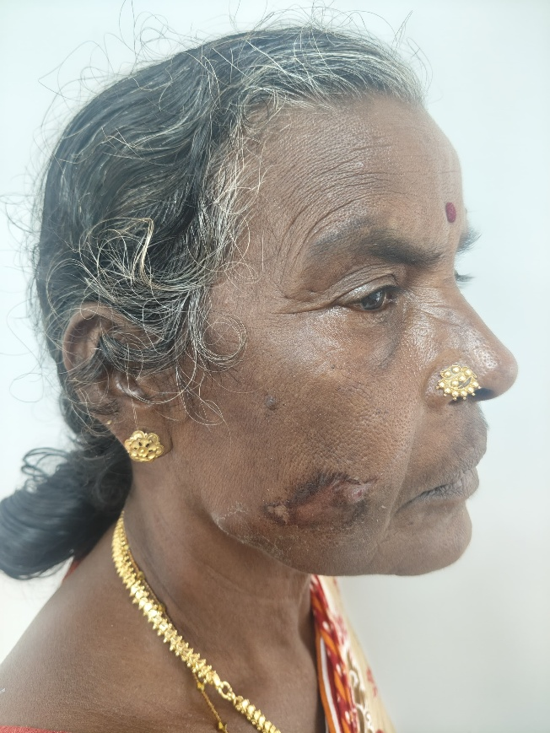

Figure 1: Swelling noted at right side of the face
INVESTIGATION:
A computed tomography (CT) scan of the facial region was performed to assess the extent of swelling and rule out underlying pathology. Despite clinical suspicion, no radiopaque foreign object was visualized on CT. The soft tissue density appeared unremarkable, and the wooden fragment remained undetected—likely due to its low attenuation and radiolucent nature, consistent with literature describing Hounsfield Unit values of dry wood around –170 to –214.(7) Based on persistent symptoms and clinical findings, surgical exploration was pursued for definitive evaluation

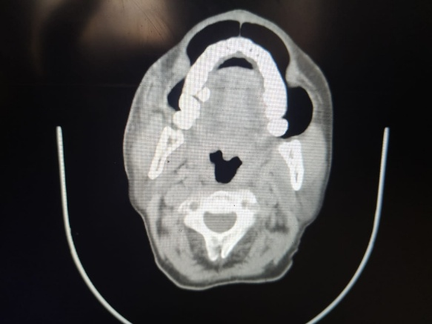

Figure 2: Preoperative CT

SURGICAL PROCEDURE:
Under local anesthesia, a small incision was made over the swelling on the right cheek, approximately 2 cm lateral to the oral commissure. After blunt dissection through the subcutaneous tissue, a 3.5 cm wooden fragment was identified and carefully extracted. The cavity was irrigated with saline and betadine, followed by debridement of necrotic tissue. Hemostasis was achieved and closure was performed with 3-0 silk sutures. The patient received postoperative antibiotics, and sutures were removed uneventfully during follow-up.

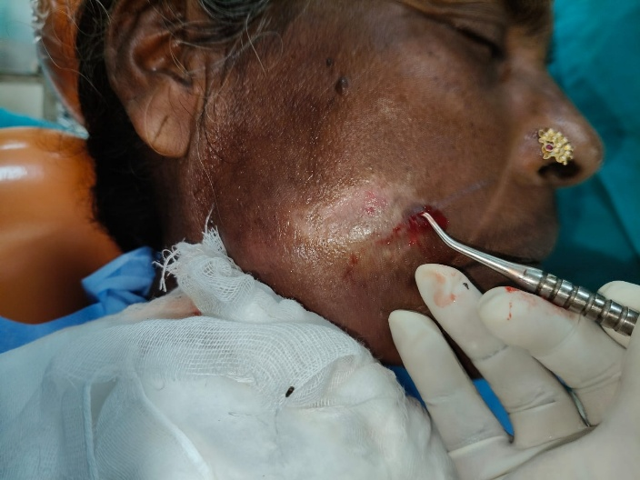

Figure 3: The foreign body was removed through exploration of the incision site

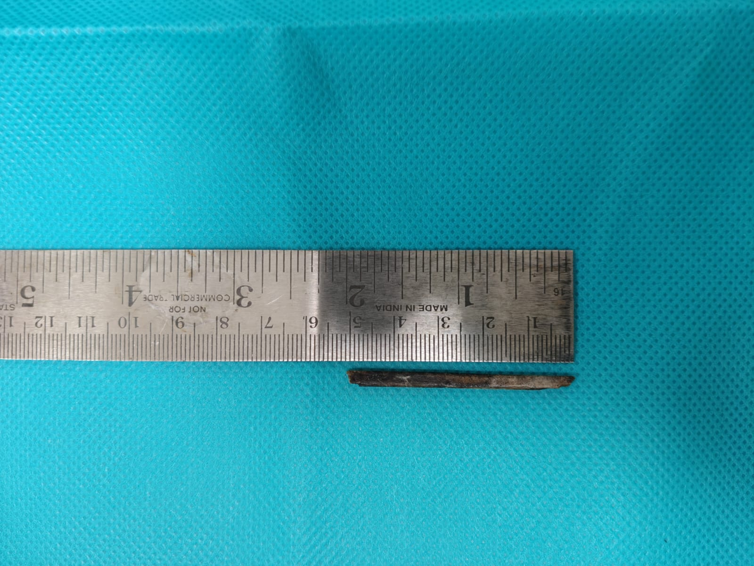

Fig 4: Foreign body (twig) measuring 5 cm in length

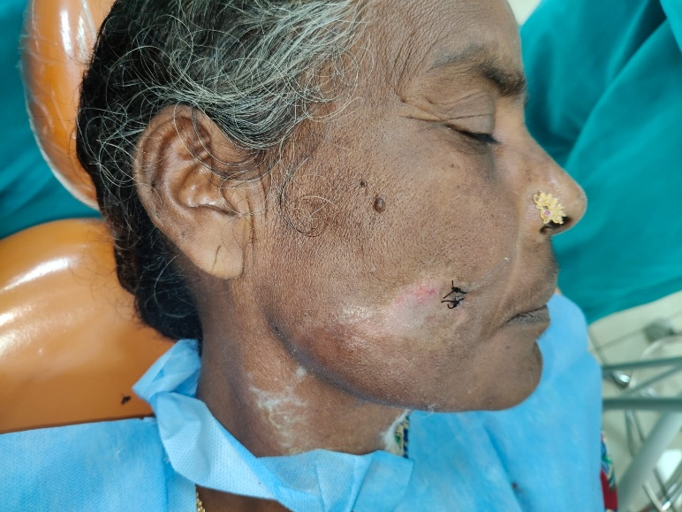

Fig 5: Suturing done with 3-0 silk
DISCUSSION:
Foreign body impaction in the maxillofacial region presents a diagnostic and therapeutic challenge, particularly when the object is radiolucent and embedded in soft tissue. In this case, the delayed onset of symptoms following blunt trauma underscores the importance of maintaining a high index of suspicion, even in the absence of overt clinical signs. Wooden foreign bodies, such as the one suspected in this patient, are notoriously difficult to detect using conventional radiography due to their radiolucent nature (Sharma et al., 2016). (8)Studies have shown that approximately one-third of foreign bodies are missed during initial clinical evaluation (Aregbesola & Ugboko, 2013) (9), especially when the trauma occurs outdoors and involves organic materials like vegetation (Khandelwal et al., 2018) (10). In such cases, ultrasonography and computed tomography (CT) are more effective in localization and characterization (Nilesh & Kshirsagar, 2021)(11) but in a study by Ho, McGuckin Jr., and Smergel (1996) (7) , a wooden intraorbital foreign body was nearly invisible on CT under standard window settings (214 HU width, 19 HU level), appearing similar to air (HU ≈ –214). Visibility improved when the window width was increased to 1000 HU and level to 2500 HU, allowing clearer distinction. This highlights the need for tailored CT settings when imaging dry wood, which typically shows low HU values (–170 to –214), while aged or hydrated wood may range from +100 to +160 HU due to fluid absorption over time. Yamashita et al. (2007) reported a case of a wooden foreign body with an initial CT attenuation of –170 HU, which increased to +160 HU after 24 days due to fluid absorption. They emphasized that HU values vary over time and visibility improves with appropriate CT settings. (McGuckin et al., 1996) (12) (13) Careful windowing may reveal a characteristic striated pattern aiding identification. Awareness of this imaging feature is crucial to avoid missed diagnosis and complications (Ginsberg et al., 1993).(14) The buccal region is particularly vulnerable to foreign body embedment due to its anatomical exposure and soft tissue composition. Impactions in this area may remain asymptomatic for extended periods or present with nonspecific signs such as swelling, pain, or pus discharge (Altan et al., 2015)(15). Chronic irritation and infection, as seen in this patient, are common sequelae of retained organic material, which can lead to fibrosis or abscess formation if not promptly addressed (Joshna et al., 2022)(16) Similarly, Kumar et al. (2023)(17) reported a missed diagnosis of a metallic foreign body in the zygomatic region, reinforcing the importance of maxillofacial expertise and advanced imaging. Retained wooden foreign bodies in facial trauma are often missed due to their radiolucency on X-rays and variable CT appearance. MRI is more sensitive for detecting chronic wooden fragments, showing characteristic signal changes (Ochiai et al., 1999) (Laor & Barnewolt, 1999)(18) (19) MRI should be avoided when metallic objects are suspected due to the risk of migration and tissue damage (Hunter & Taljanovic, 2003)(20).Surgical exploration remains the gold standard for definitive diagnosis and management, especially when imaging is inconclusive. Intraoperative findings often reveal the true extent of impaction and associated tissue response. Thorough debridement and removal of the foreign body are essential to prevent recurrence and promote healing .
This case highlights the need for comprehensive evaluation in facial trauma, particularly when initial treatment fails to resolve symptoms. Clinicians should consider foreign body impaction in their differential diagnosis and utilize advanced imaging modalities when conventional methods fall short.

CONCLUSION:
This report presents a rare case of a foreign body embedded in the right cheek, underscoring the need for a high index of suspicion when assessing atypical facial swellings. Organic materials like wooden fragments are frequently radiolucent on standard radiographs and can be missed on CT scans, especially when dry and exhibiting low attenuation values (–170 to –214 HU). This diagnostic challenge may lead to delayed treatment if not carefully addressed. Importantly, optimizing CT window settings can enhance visualization by differentiating wooden foreign bodies from air or fat, while MRI offers superior soft tissue contrast, revealing characteristic signal changes that aid in detection. Therefore, clinicians should integrate these advanced imaging techniques with thorough clinical evaluation to ensure accurate diagnosis and timely intervention, particularly when initial imaging is inconclusive. In situations where imaging results remain inconclusive, prompt surgical exploration continues to be the definitive method for both diagnosis and treatment.

REFERENCES
1. Eggers G, Haag C, Hassfeld S. Image-guided removal of foreign bodies. Br J Oral Maxillofac Surg. 2005 Oct;43(5):404–9.
2. Khan, Imran & Singhal, Anshul & Mds, Anurag. (2015). MANAGEMENT OF FOREIGN BODIES IN THE MAXILLOFACIAL REGION: DIAGNOSTIC MODALITIES, TREATMENT CONCEPTS WITH REPORT OF TWO CASESManagement of foreign bodies in the maxillofacial region: Diagnostic modalities, treatment concepts with report of 2 cases: Journal of. Journal of Head & Neck Physicians and Surgeons. 3. 15-22.
3. Tobgyel K, Gyeltshen T. Marble in the buccal mucosa: A rare finding of foreign body impaction in the cheek. International Journal of Case Reports and Images (IJCRI). 2022 Jun 10;13(1):15–9.
4. Figueiredo RR, Azevedo AA, Kós AO de A, Tomita S. Nasal foreign bodies: description of types and complications in 420 cases. Braz J Otorhinolaryngol. 2006;72(1):18–23.
5. Arango L, Sierra L, Gutiérrez DC, Grisales M. Incidental foreign body in the gastrointestinal tract: Report of three cases and literature review. In 2011
6. Peterson JJ, Bancroft LW, Kransdorf MJ, Peterson JJ, Bancroft LW, Kransdorf MJ. Wooden Foreign Bodies. American Journal of Roentgenology . 2012 Nov 23 7. Ho VT, McGuckin JF. Intraorbital Wooden Foreign Body: CT and MR Appearance.
7. Ho VT, McGuckin JF. Intraorbital Wooden Foreign Body: CT and MR Appearance. AJNR Am J Neuroradiol 1996, 17 (1) 134-136
8. Sharma M. Diagnostic Dilemma in Foreign Body Impaction in Maxillofacial Surgey– A Case Report and a Brief Literature Review. Journal of Dental Sciences. 2016;4(4).
9. Aregbesola SB, Ugboko VI. Unusual foreign bodies in the orofacial soft tissue spaces: a report of three cases. Niger J Clin Pract. 2013;16(3):381–5.
10.Khandelwal P, Dhupar V, Akkara F, Hajira N. Impacted Foreign Bodies in the Maxillofacial Region-A Series of Three Cases. J Cutan Aesthet Surg. 2018;11(4):237–40.
11.Nilesh K, Kshirsagar AY. Large impacted foreign body in maxillofacial region: an occupational hazard. BMJ Case Rep, 2021.
12.Yamashita K, Noguchi T, Mihara F, Yoshiura T, Togao O, Yoshikawa H, et al. An intraorbital wooden foreign body: description of a case and a variety of CT appearances. Emerg Radiol. 2007 May 1;14(1):41–3.
13. McGuckin JF, Akhtar N, Ho VT, Smergel EM, Kubacki EJ, Villafana T. CT and MR evaluation of a wooden foreign body in an in vitro model of the orbit. AJNR Am J Neuroradiol. 1996 Jan;17(1):129–33.
14. Ginsberg LE, Williams DW, Mathews VP. CT in penetrating craniocervical injury by wooden foreign bodies: reminder of a pitfall.
15. Turgay B. Case Report Unusual Foreign Bodies in the Oral Cavity: A Report of Three Cases. 2015 Aug 7
16. Joshna EK, Poorna TA, Bobby J, Mohan S. Embedded Foreign Bodies in the Maxillofacial Region: Our Experience. Indian J Otolaryngol Head Neck Surg. 2022 Dec;74(Suppl 3):4802-4806. doi: 10.1007/s12070-022-03111-3. Epub 2022 Jun 20. PMID: 36742923; PMCID: PMC9895343.
17. Kumar KS, Ramachandran V, Babu J. A Case of Impacted Foreign Body in Zygomatic Region- A Missed Diagnosis. Journal of Clinical and Diagnostic Research. 2023 Sep 1;17(09):19–21.
18. H O, Y Y, T F, H Y. Neuroimaging of a wooden foreign body retained for 5 months in the temporalis muscle following penetrating trauma with a chopstick--case report. Neurologia medico-chirurgica. 1999 Oct
19. Laor T, Barnewolt CE. Nonradiopaque penetrating foreign body: “a sticky situation.” Pediatr Radiol. 1999 Sep;29(9):702–4.
20. Hunter TB, Taljanovic MS. Foreign bodies. Radiographics. 2003;23(3):731–57.

