Original Research Article
COMPARATIVE EVALUATION OF SCALING AND ROOT PLANING WITH AND WITHOUT 980 nm DIODE LASER–ASSISTED NEW ATTACHMENT PROCEDURE IN STAGE II GRADE B PERIODONTITIS AMONG TOBACCO CHEWERS: A RANDOMIZED CONTROLLED TRIAL

ABSTRACT
BACKGROUND:
Periodontal disease is a significant public health concern influenced by multiple local and systemic risk factors. Tobacco chewing adversely affects periodontal tissues by altering inflammatory responses and impairing healing, which may compromise outcomes of conventional non-surgical therapy. Scaling and root planing (SRP) remains the standard treatment for periodontitis; however, adjunctive diode laser therapy using Laser-Assisted New Attachment Procedure (LANAP) has been proposed to enhance clinical outcomes. Evidence regarding its effectiveness in tobacco chewers with Stage II Grade B periodontitis is limited.
MATERIALS AND METHODS:
This randomized split-mouth clinical study included eight tobacco chewers aged 30–60 years diagnosed with Stage II Grade B periodontitis. Each participant received SRP alone in one quadrant and SRP followed by LANAP using a 980-nm diode laser in another quadrant. Clinical parameters assessed were Plaque Index, Gingival Index, Probing Pocket Depth, Clinical Attachment Level, Sulcus Bleeding Index, and the Fagerström Nicotine Dependence Scale for Smokeless Tobacco. Measurements were recorded at baseline, one month, and three months post-treatment. Statistical analysis was performed using paired tests with significance set at p < 0.05.
RESULTS:
Both treatment modalities showed significant improvements in plaque accumulation, gingival inflammation, bleeding scores, probing depth, and attachment levels over three months. Adjunctive diode laser therapy demonstrated superior outcomes.
CONCLUSION:
Within study limitations, adjunctive 980-nm diode laser therapy with SRP provides additional clinical benefits over SRP alone for managing Stage II Grade B periodontitis among tobacco chewers. Larger studies with longer follow-up are recommended, clinically meaningful.
KEYWORDS: Diode laser, LANAP, Non-surgical periodontal therapy, Scaling and root planing, Stage II Grade B periodontitis, Tobacco chewers.
INTRODUCTION:
Periodontitis is recognised as a chronic and multifactorial inflammatory disorder that results in destruction of the periodontal ligament, supporting bone and adjacent soft tissues, eventually predisposing affected teeth to loss. Scaling and root planing (SRP) is considered the primary non-surgical approach for debridement; however, microbial endotoxins and bacteria can remain within deeper periodontal sites or dentinal irregularities and may hinder complete inflammatory resolution and attachment gain(Quadri MF et al,2024).
Tobacco exposure, including smokeless forms commonly used in various regions, further intensifies periodontal breakdown. Individuals who habitually chew tobacco have been reported to present with deeper pockets, more pronounced attachment loss and heightened gingival recession than non-chewers. A recent meta-analysis estimated that smokeless-tobacco users exhibit nearly a three-fold higher likelihood of developing periodontitis(Quadri MF et al,2024), and studies from Indian populations have shown a clear association between chewing products such as gutkha and unfavourable periodontal parameters including increased probing depths and clinical attachment loss (Siddiqui LT,2025).
As these factors may reduce the response following routine SRP, several adjunctive modalities have been explored. Semiconductor diode lasers, particularly the 980-nm wavelength, have received growing attention due to their ability to act on pigmented bacterial species, modulate inflamed soft tissues and enhance subgingival decontamination(Caruso U et al,2008). Randomised investigations have suggested possible improvements in probing-depth reduction when diode lasers are applied after SRP(Dukić W et al,2013), although some trials have reported non-significant differences in clinical outcomes when compared with SRP alone(Balasubramaniam AS et al,2014).
Overall, existing evidence remains variable and only a limited number of studies have examined laser-assisted periodontal management in people who chew tobacco, despite their compromised healing potential and greater risk profile(Samulak R, 2021). The present randomised split-mouth study was therefore designed to compare SRP alone with SRP combined with 980-nm diode laser-assisted New Attachment Procedure in Stage II Grade B periodontitis among habitual tobacco chewers, with emphasis on probing depth, attachment level and gingival inflammatory parameters.
MATERIALS AND METHODS
Study design
A randomized split-mouth clinical trial was conducted to compare the clinical outcomes of non-surgical periodontal therapy using scaling and root planing (SRP) alone and SRP combined with Laser-Assisted New Attachment Procedure (LANAP) using a 980-nm diode laser among tobacco-chewing patients diagnosed with Stage II Grade B periodontitis. The study duration was six months.
Study population
Eight systemically healthy individuals aged 30–60 years reporting to the Department of Periodontology, KVG Dental College and Hospital, Sullia, Karnataka, who fulfilled the inclusion criteria and provided written informed consent were enrolled.
Inclusion criteria
- Age 30–60 years
- Systemically healthy individuals
- Subjects diagnosed with Stage II Grade B periodontitis having probing depth 4–5 mm and CAL 3–4 mm
- Regular tobacco chewers (≥5 years, smokeless forms)
- Minimum 20 natural teeth
- No periodontal therapy in previous 6 months
- Willingness to undergo the full study duration and follow-up
Exclusion criteria
- Systemic diseases influencing periodontal status
- Medications affecting healing (bisphosphonates, immunosuppressants)
- Stage III/IV periodontitis or furcation involvement
- Periodontal treatment within the last 6 months
- Pregnancy or lactation
- Previous laser therapy to the oral cavity
Randomization and allocation
A split-mouth design was used where one sextant was allocated to SRP alone (Subgroup-A) and the contralateral sextant received SRP + LANAP (Subgroup-B). Allocation was randomized using the chit-method. All clinical measurements were recorded by a single calibrated examiner to minimize inter-examiner variability.
Eight subjects with Stage II Grade B periodontitis of age group 30-60 years who were systemically healthy and cooperative , tobacco chewers (chewing/smokeless tobacco for ≥5 years) were included. Patients were divided into two subgroups using split mouth study design.
Group : Includes Tobacco chewers , which was further divided on the treatment modality into two subgroups, the procedure was done with split mouth technique.
Subgroup A: Scaling and root planing (SRP) only
Subgroup B: SRP + Laser-Assisted New Attachment Procedure (LANAP) using 980 nm diode laser.
Clinical parameters
The following clinical parameters were recorded at baseline, 1-month, and 3-month intervals:
- Plaque Index (PI) (Silness and Löe, 1964)
- Gingival Index (GI) (Löe and Silness, 1963)
- Probing pocket depth (PPD)
- Clinical attachment level (CAL)
- Sulcus Bleeding Index (SBI) (Mühlemann and Son, 1971)
- Pain assessment using Visual Analogue Scale (VAS) (Hayes and Patterson, 1921)
- Fagerstrom Nicotine Dependence Scale- Smokeless Tobacco (FTND-ST) (Boyle , Jensen et al 1995)
- Healing Index (Landry et al 1988)
PROCEDURE:
Chart 1 : Steps of the Group Allocation
8 subjects with Stage II Grade B periodontitis of age group 30-60 years who were systemically healthy and cooperative , tobacco chewers(chewing/smokeless tobacco for ≥5 years) were included.
An intraoral clinical photograph was taken prior to the procedure
Tobacco chewers were considered for the treatment

Subgroup A(8) Subgroup B(8)
(One sextant) (Contralateral sextant)
SRP alone SRP + LANAP

The parameters were noted at baseline and after 1 month, 3 months postoperatively((Faragalla AI et al ,2021).

SRP-only sites (Subgroup-A)
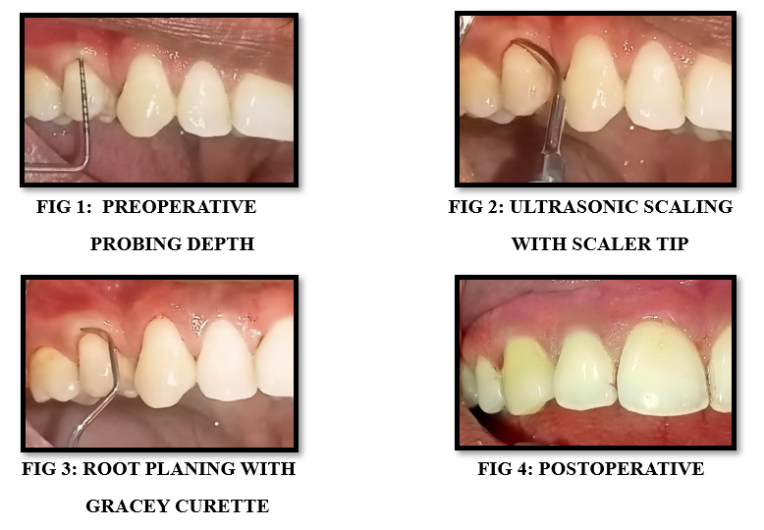
Conventional non-surgical periodontal therapy including ultrasonic scaling and meticulous root planing using Gracey curettes was performed under local anesthesia whenever required. Standard oral hygiene instructions were reinforced.

SRP + LANAP sites (Subgroup-B)
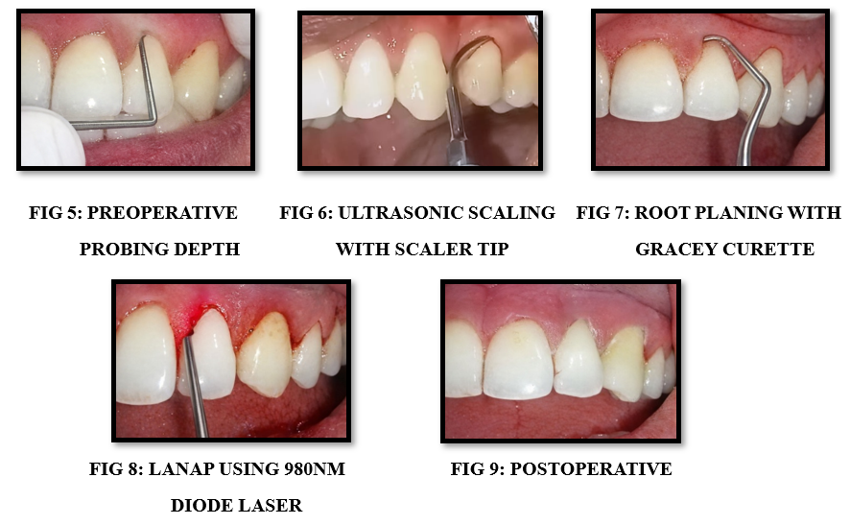
After completion of SRP, LANAP was performed using a 980-nm diode laser (continuous wave, appropriate periodontal fiber tip) in curettage mode for 30sec per tooth(Yukna RA et al ,2022) . Laser irradiation was applied circumferentially along the pocket epithelium according to suggested clinical guidelines ensuring controlled ablation and decontamination of pocket epithelium. Laser safety protocols were strictly followed throughout the procedure.

Postoperative instructions
All patients were advised to rinse twice daily with 0.12% chlorhexidine for two weeks, avoid tobacco usage, and adhere to oral hygiene instructions. No systemic antibiotics were routinely prescribed.
Follow-up: Clinical parameters were recorded at:
- Baseline
- 1 month
- 3 months post-treatment
Standardized intra-oral photographs were obtained at each visit.
Statistical analysis
Data were analyzed using SPSS version 27. Descriptive statistics (mean and standard deviation) were obtained. Intragroup comparison across time points was performed using paired t-test, and intergroup comparison was evaluated using Wilcoxon Signed Rank test when normality assumptions were unmet. A p-value <0.05 was considered statistically significant.
Ethical clearance
The study protocol was approved by the Institutional Ethical Committee of KVG Dental College and Hospital, Sullia, Karnataka. All procedures followed the Declaration of Helsinki guidelines.
RESULTS:
The present split-mouth randomized controlled trial included 8 patients with Stage II Grade B periodontitis who were habitual tobacco chewers(FIG 10). Each patient received both treatment modalities: Group A (Scaling and Root Planing alone) and Group B (SRP combined with 980-nm diode Laser-Assisted New Attachment Procedure) in different quadrants.

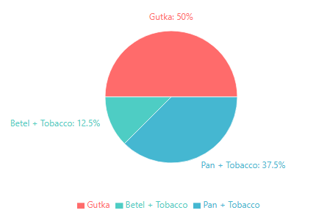
FIG 10: DISTRIBUTION OF TOBACCO HABITS AMONG STUDY PARTICIPANTS

At baseline, both groups demonstrated comparable clinical parameters, confirming successful randomization in this split-mouth design (Table 1). The mean Plaque Index was 2.25 ± 0.32 in both groups, indicating poor oral hygiene with significant plaque accumulation and high risk for gum disease according to the Löe and Silness criteria. The Gingival Index was 2.25 ± 0.43, reflecting severe gingival inflammation. The Sulcus Bleeding Index was 3.50 ± 0.50, indicating bleeding on probing with colour changes and slight to obvious edema, consistent with active periodontal disease. Probing Pocket Depth measured 4.81 ± 0.24 mm and Clinical Attachment Level was 3.81 ± 0.24 mm. These baseline values indicated moderate to severe periodontal inflammation and destruction, typical of Stage II Grade B periodontitis in tobacco users.
Table 1: Clinical Parameters Before and After LANAP and SRP Procedures
Mean ± SD values at different time intervals
Parameters | Group A (SRP Only) |  |  | Group B (SRP + LANAP)
Parameters | Baseline | 1 Month | 3 Months | Baseline | 1 Month | 3 Months
Plaque Index (PI) | 2.25 ± 0.32 | 1.68 ± 0.26 | 1.30 ± 0.22 | 2.25 ± 0.32 | 1.26 ± 0.24 | 0.84 ± 0.16
Gingival Index (GI) | 2.25 ± 0.43 | 1.75 ± 0.31 | 1.43 ± 0.27 | 2.25 ± 0.43 | 1.26 ± 0.24 | 0.91 ± 0.16
Probing Pocket Depth (PPD) | 4.81 ± 0.24 | 4.36 ± 0.27 | 3.95 ± 0.40 | 4.81 ± 0.24 | 3.90 ± 0.17 | 3.33 ± 0.20
Clinical Attachment Level (CAL) | 3.81 ± 0.24 | 3.46 ± 0.24 | 3.26 ± 0.24 | 3.81 ± 0.24 | 3.01 ± 0.15 | 2.64 ± 0.18
Sulcus Bleeding Index (SBI) | 3.50 ± 0.50 | 2.50 ± 0.50 | 1.50 ± 0.50 | 3.50 ± 0.50 | 1.50 ± 0.50 | 0.50 ± 0.50
Both treatment modalities demonstrated significant improvements in all clinical parameters from baseline to 1 month and 3 months follow-up (Table 2). In Group A (SRP only), the Plaque Index decreased from baseline to 3 months with a mean difference of 0.95 (t = 19.00, p < 0.001), improving from poor (2.25) to fair oral hygiene status (1.30). The Gingival Index reduced by 0.82 (t = 9.82, p < 0.001), transitioning from severe inflammation (2.25) to moderate inflammation (1.43). The Sulcus Bleeding Index showed a reduction of 2.00 points (p < 0.001), improving from bleeding on probing with colour changes and edema (score 3.5) to healthy-appearing gingiva with bleeding on probing (score 1.5), indicating substantial reduction in gingival inflammation. Probing Pocket Depth decreased by 0.86 mm (t = 8.48, p < 0.001), and Clinical Attachment Level improved by 0.55 mm (t = 16.80, p < 0.001).
Table 2: Within-Group Comparison of Clinical Parameters (Paired t-test)
Group A: SRP Only
Parameters | Comparison | Mean Diff | t-value | p-value
Plaque Index (PI) | Baseline vs 1 Month | 0.57 | 18.35 | < 0.001***
Plaque Index (PI) | Baseline vs 3 Months | 0.95 | 19.00 | < 0.001***
Plaque Index (PI) | 1 Month vs 3 Months | 0.37 | 15.00 | < 0.001***
Gingival Index (GI) | Baseline vs 1 Month | 0.50 | 7.07 | < 0.001***
Gingival Index (GI) | Baseline vs 3 Months | 0.82 | 9.82 | < 0.001***
Gingival Index (GI) | 1 Month vs 3 Months | 0.33 | 19.86 | < 0.001***
Probing Pocket Depth (PPD) | Baseline vs 1 Month | 0.45 | 13.75 | < 0.001***
Probing Pocket Depth (PPD) | Baseline vs 3 Months | 0.86 | 8.48 | < 0.001***
Probing Pocket Depth (PPD) | 1 Month vs 3 Months | 0.41 | 3.89 | < 0.01**
Clinical Attachment Level (CAL) | Baseline vs 1 Month | 0.35 | 10.69 | < 0.001***
Clinical Attachment Level (CAL) | Baseline vs 3 Months | 0.55 | 16.80 | < 0.001***
Clinical Attachment Level (CAL) | 1 Month vs 3 Months | 0.20 | 36.0 | < 0.001***
Sulcus Bleeding Index (SBI) | Baseline vs 1 Month | 1.00 | Infinity | < 0.001***
Sulcus Bleeding Index (SBI) | Baseline vs 3 Months | 2.00 | Infinity | < 0.001***
Sulcus Bleeding Index (SBI) | 1 Month vs 3 Months | 1.00 | Infinity | < 0.001***

Group B (SRP + LANAP) demonstrated even more pronounced improvements across all parameters (Table 2). From baseline to 3 months, the Plaque Index decreased by 1.41 (t = 18.44, p < 0.001), achieving excellent to good oral hygiene status (0.84) compared to the baseline poor status. The Gingival Index reduced by 1.34 (t = 11.49, p < 0.001), reaching minimal to mild inflammation (0.91) from severe inflammation at baseline. The Sulcus Bleeding Index demonstrated a dramatic reduction of 3.00 points (p < 0.001), improving from bleeding on probing with colour changes and edema (score 3.5) to near-healthy gingiva (score 0.5), approaching complete resolution of gingival inflammation. Probing Pocket Depth decreased by 1.49 mm (t = 33.75, p < 0.001), and Clinical Attachment Level improved by 1.17 mm (t = 25.93, p < 0.001). All improvements were statistically significant at each time interval (baseline vs 1 month, baseline vs 3 months, and 1 month vs 3 months), indicating progressive healing throughout the observation period.
Group B: SRP + LANAP
Parameters | Comparison | Mean Diff | t-value | p-value
Plaque Index (PI) | Baseline vs 1 Month | 0.99 | 20.59 | < 0.001***
Plaque Index (PI) | Baseline vs 3 Months | 1.41 | 18.44 | < 0.001***
Plaque Index (PI) | 1 Month vs 3 Months | 0.42 | 11.61 | < 0.001***
Gingival Index (GI) | Baseline vs 1 Month | 0.99 | 11.29 | < 0.001***
Gingival Index (GI) | Baseline vs 3 Months | 1.34 | 11.49 | < 0.001***
Gingival Index (GI) | 1 Month vs 3 Months | 0.35 | 9.26 | < 0.001***
Probing Pocket Depth (PPD) | Baseline vs 1 Month | 0.91 | 22.92 | < 0.001***
Probing Pocket Depth (PPD) | Baseline vs 3 Months | 1.49 | 33.75 | < 0.001***
Probing Pocket Depth (PPD) | 1 Month vs 3 Months | 0.57 | 23.00 | < 0.001***
Clinical Attachment Level (CAL) | Baseline vs 1 Month | 0.80 | 17.28 | < 0.001***
Clinical Attachment Level (CAL) | Baseline vs 3 Months | 1.17 | 25.93 | < 0.001***
Clinical Attachment Level (CAL) | 1 Month vs 3 Months | 0.38 | 22.91 | < 0.001***
Sulcus Bleeding Index (SBI) | Baseline vs 1 Month | 2.00 | Infinity | < 0.001***
Sulcus Bleeding Index (SBI) | Baseline vs 3 Months | 3.00 | Infinity | < 0.001***
Sulcus Bleeding Index (SBI) | 1 Month vs 3 Months | 1.00 | Infinity | < 0.001***
Note: Paired t-test was used to compare clinical parameters at different time intervals within each group. Degrees of freedom (df) = 7 for all comparisons (n=8). Significance levels: * p less than 0.05; ** p less than 0.01; *** p less than 0.001
The comparative analysis between the two treatment groups revealed statistically significant differences favoring Group B at both 1-month and 3-month follow-up periods (Table 3)(FIG 11). At baseline, no significant differences existed between groups, confirming comparable starting conditions (p > 0.05 for all parameters), with both groups presenting poor plaque control, severe gingival inflammation, and bleeding on probing with associated color changes and edema.

Table 3: Between-Group Comparison of Clinical Parameters (Paired t-test)
Comparison of Group A (SRP) vs Group B (SRP + LANAP)
Parameters | Time Point | Group A | Group B | Mean Diff | t-value | p-value
Plaque Index (PI) | Baseline | 2.25±0.32 | 2.25±0.32 | 0.00 | NA | 1
Plaque Index (PI) | 1 Month | 1.68±0.26 | 1.26±0.24 | 0.41 | 11.77 | < 0.001***
Plaque Index (PI) | 3 Months | 1.30±0.22 | 0.84±0.16 | 0.46 | 10.04 | < 0.001***
Gingival Index (GI) | Baseline | 2.25±0.43 | 2.25±0.43 | 0.00 | NaN | 1
Gingival Index (GI) | 1 Month | 1.75±0.31 | 1.26±0.24 | 0.49 | 12.25 | < 0.001***
Gingival Index (GI) | 3 Months | 1.43±0.27 | 0.91±0.16 | 0.51 | 9.94 | < 0.001***
Probing Pocket Depth (PPD) | Baseline | 4.81±0.24 | 4.81±0.24 | 0.00 | NaN | 1
Probing Pocket Depth (PPD) | 1 Month | 4.36±0.27 | 3.90±0.17 | 0.46 | 9.29 | < 0.001***
Probing Pocket Depth (PPD) | 3 Months | 3.95±0.40 | 3.33±0.20 | 0.62 | 5.53 | < 0.001***
Clinical Attachment Level (CAL) | Baseline | 3.81±0.24 | 3.81±0.24 | 0.00 | NaN | 1
Clinical Attachment Level (CAL) | 1 Month | 3.46±0.24 | 3.01±0.15 | 0.45 | 8.42 | < 0.001***
Clinical Attachment Level (CAL) | 3 Months | 3.26±0.24 | 2.64±0.18 | 0.63 | 13.79 | < 0.001***
Sulcus Bleeding Index (SBI) | Baseline | 3.50±0.50 | 3.50±0.50 | 0.00 | NaN | 1
Sulcus Bleeding Index (SBI) | 1 Month | 2.50±0.50 | 1.50±0.50 | 1.00 | Infinity | < 0.001***
Sulcus Bleeding Index (SBI) | 3 Months | 1.50±0.50 | 0.50±0.50 | 1.00 | Infinity | < 0.001***
Note: Paired t-test was used for between-group comparison as this is a split-mouth design where each patient served as their own control. Degrees of freedom (df) = 7 for all comparisons (n=8).
Significance: * p less than 0.05; ** p less than 0.01; *** p less than 0.001, 1 Not significant
Interpretation: Positive mean difference indicates Group A values are higher than Group B.
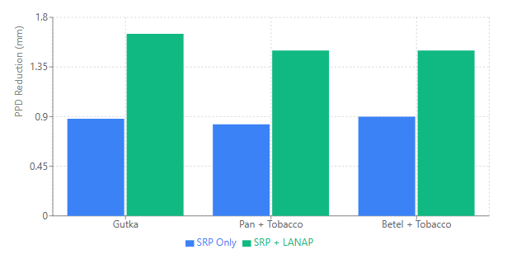

FIG 11: TREATMENT EFFECT ON DIFFERENT TOBACCO HABITS -PPD REDUCTION AT 3 MONTHS(VISUAL COMPARISON OF TREATMENT OUTCOMES)
At 1 month post-treatment, Group B showed significantly better outcomes compared to Group A: Plaque Index difference of 0.41 (t = 11.77, p < 0.001), with Group B achieving good oral hygiene (1.26) while Group A remained in the fair category (1.68). Gingival Index difference of 0.49 (t = 12.25, p < 0.001), with Group B demonstrating moderate inflammation (1.26) compared to Group A which also showed moderate inflammation but at higher levels (1.75). The Sulcus Bleeding Index showed a difference of 1.00 (p < 0.001), with Group B achieving healthy-appearing gingiva with bleeding on probing (score 1.5) while Group A showed bleeding on probing with color changes but no edema (score 2.5). Additional significant differences were observed in Probing Pocket Depth reduction advantage of 0.46 mm (t = 9.29, p < 0.001) and Clinical Attachment Level gain advantage of 0.45 mm (t = 8.42, p < 0.001).
At 3 months, the superiority of Group B over Group A was maintained and in some parameters became more pronounced (Table 3). The Plaque Index difference increased to 0.46 (t = 10.04, p < 0.001), with Group B maintaining good oral hygiene (0.84) while Group A showed fair oral hygiene (1.30). The Gingival Index difference was 0.51 (t = 9.94, p < 0.001), with Group B achieving minimal to mild inflammation (0.91) compared to Group A's moderate inflammation (1.43). Most notably, the Sulcus Bleeding Index maintained a difference of 1.00 point (p < 0.001) between the groups, with Group B demonstrating near-healthy gingiva with minimal bleeding (score 0.5) while Group A showed healthy-appearing gingiva with bleeding on probing (score 1.5). Probing Pocket Depth reduction advantage increased to 0.62 mm (t = 5.53, p < 0.001), and Clinical Attachment Level gain advantage increased to 0.63 mm (t = 13.79, p < 0.001) (FIG 12).

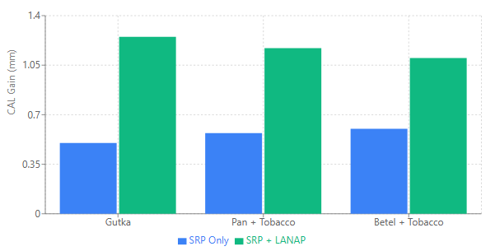

FIG 12: TREATMENT EFFECT ON DIFFERENT TOBACCO HABITS-CAL GAIN AT 3 MONTHS

By 3 months, Group A achieved mean values representing fair oral hygiene (PI = 1.30 ± 0.22), moderate gingival inflammation (GI = 1.43 ± 0.27), and healthy-appearing gingiva with bleeding on probing (SBI = 1.5 ± 0.50), with PPD = 3.95 ± 0.40 mm and CAL = 3.26 ± 0.24 mm. In contrast, Group B demonstrated superior outcomes with good oral hygiene (PI = 0.84 ± 0.16), minimal to mild gingival inflammation (GI = 0.91 ± 0.16), and near-healthy gingiva with minimal bleeding tendency (SBI = 0.5 ± 0.50), along with PPD = 3.33 ± 0.20 mm and CAL = 2.64 ± 0.18 mm (Table 1). The positive mean differences in Table 3 consistently indicate that Group A values remained higher than Group B values, signifying better periodontal health outcomes in the laser-assisted treatment group(FIG 13, 14).

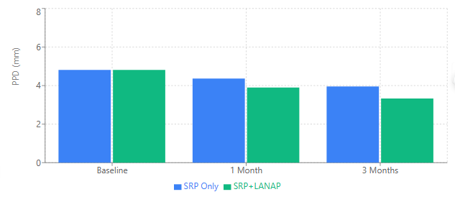

FIG 13: OVERALL PROBING DEPTH COMPARISON OVER TIME
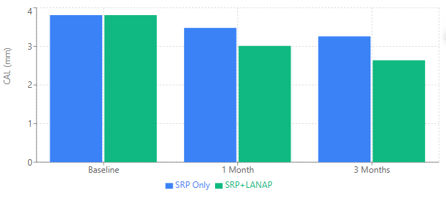

FIG 14: OVERALL CLINICAL ATTACHMENT LEVELCOMPARISON OVER TIME
Notably, Group B achieved clinically meaningful improvements across all inflammatory indices, transitioning patients from poor plaque control, severe gingival inflammation, and bleeding with edema at baseline to good oral hygiene, minimal inflammation, and near-healthy gingival tissue at 3 months, representing a shift across multiple clinical categories toward periodontal health. Group A, while showing significant improvement, only advanced from poor to fair plaque control, from severe to moderate inflammation, and from bleeding with edema to healthy-appearing tissue with persistent bleeding on probing, representing less dramatic but still clinically meaningful improvements.
The resolution of edema and color changes in both groups, with near-complete elimination in Group B (SBI 0.5) versus persistent bleeding on probing in Group A (SBI 1.5), demonstrates the superior anti-inflammatory effect of laser-assisted therapy. This is particularly noteworthy given the challenging patient population of habitual tobacco chewers, in whom periodontal healing is typically compromised(FIG 15,16).
FIG 15: Changes in Probing Pocket Depth over time
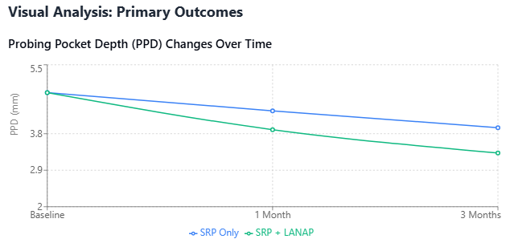

FIG 16: Changes in Clinical Attachment Level over time
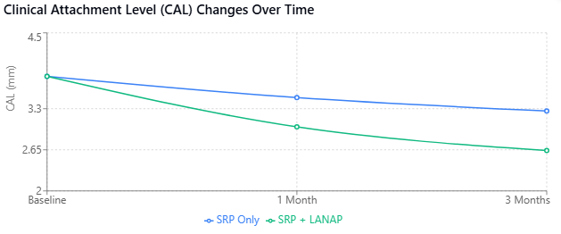

These results demonstrate that while conventional SRP alone provides significant periodontal improvements in tobacco chewers with Stage II Grade B periodontitis, the addition of 980-nm diode laser-assisted therapy (LANAP) produces statistically and clinically superior outcomes in terms of plaque control, gingival inflammation reduction, bleeding control, pocket depth reduction, and clinical attachment gain. All improvements were highly significant (p < 0.001) and were evident as early as 1 month post-treatment, with sustained benefits at 3 months follow-up.
DISCUSSION:
The present split-mouth randomized clinical study evaluated the adjunctive effect of a 980-nm diode laser–assisted new attachment procedure (LANAP) in comparison with conventional scaling and root planing (SRP) alone in tobacco chewers diagnosed with Stage II Grade B periodontitis. Tobacco use is a well-established risk factor for periodontal destruction and impaired healing, often resulting in a reduced response to conventional non-surgical periodontal therapy(Quadri MF et al, 2024).
Romanos G et al in their study assessed soft-tissue wound healing after using a 980-nm diode laser in oral surgical procedures. Suggested that, the laser provided precise incisions, good hemostasis, minimal postoperative pain, swelling, bleeding, and scarring, with satisfactory wound healing. The findings suggest that diode laser use is a beneficial and practical option for routine oral soft-tissue surgery(ROMANOS G et al,1999).
Castro GL et al in their study suggested that, histological analysis showed no surface damage, debris retention, or thermal side effects. The findings indicate that adjunctive use of a 980-nm diode laser with SRP is safe and suitable for routine non-surgical periodontal therapy without harming cementum(Castro GL et al,2006).
Seyyedi SA et al conducted a study which highlights the role of lasers in periodontal therapy, noting that different laser systems are used for specific soft and hard tissue applications Overall, lasers offer advantages such as effective tissue ablation, good hemostasis, bactericidal effects, faster healing, and reduced postoperative discomfort in periodontics(Seyyedi SA et al, 2012).
Raymond A. Yukna et al evaluated LANAP using a 1064-nm Nd:YAG laser as a sole treatment for moderate to severe periodontitis significant improvements were seen in probing depth, clinical attachment level, and furcation involvement, with minimal gingival recession. The findings suggest that LANAP is an effective and minimally invasive laser-based surgical option for advanced periodontitis(Yukna RA et al 2022).
Yiyang Jiang et al assessed Clinical and biochemical effect of laser as an adjunct to non-surgical treatment of chronic periodontitis. The study showed that showed that adding laser therapy to scaling and root planing resulted in superior clinical improvements compared to SRP alone, particularly in non-smoking patients with chronic periodontitis. No significant biochemical advantages or adverse effects were reported, indicating that adjunctive laser therapy is a safe and beneficial option for enhancing periodontal treatment outcomes(Jiang Y, 2022).
Kishore Kumar Katuri et al in their study assessed Clinical Effectiveness of Laser Assisted New Attachment Procedure as an Adjunct to Non surgical Periodontal Treatment in which adjunctive LANAP therapy using an Nd:YAG laser demonstrated better clinical outcomes than scaling and root planing alone, particularly in moderate periodontal pockets. Improvements were observed across all clinical parameters, and favourable results in deeper pockets suggest the need for further studies to confirm the broader benefits of the LANAP protocol in periodontal therapy (Katuri KK,2015).
Siddiqui et al in their split-mouth randomized controlled trial evaluated diode laser–assisted new attachment procedure (LANAP) in treating moderate to deep periodontal pockets. Compared to SRP alone, sites treated with SRP plus diode laser showed significantly greater reductions in probing pocket depth and gains in clinical attachment at 6 and 24 weeks. The findings suggest that LANAP is a beneficial adjunctive approach for managing moderate-to-deep periodontal pockets(Siddiqui A et al ,2024).
Edwin Sever Bechir et al in their comparative split-mouth study evaluated scaling and root planing (SRP) and laser-assisted new attachment procedure (LANAP) in the management of periodontitis. Both treatments improved periodontal health over time; however, LANAP produced greater and more stable reductions in pocket depth, bleeding on probing, and attachment loss from six weeks to one year. Overall, LANAP demonstrated superior and longer-lasting clinical outcomes compared to SRP alone in patients with chronic periodontitis(Bechir ES et al 2025).
Fadime Kaya Dadas et al in their randomized controlled trial evaluated the adjunctive effects of LANAP and low-level laser therapy (LLLT) with scaling and root planing in periodontitis patients. Laser-treated groups showed significantly greater reductions in pocket depth and clinical attachment loss in moderate and deep pockets compared to SRP alone. While biochemical markers showed no significant differences, LANAP demonstrated superior bone fill, and LLLT had a favourable effect on gingival recession. Overall, laser therapy provided added clinical benefits, especially in deep periodontal pockets(Kaya Dadas F et al,2025).
Amel I Faragalla et al in their split-mouth randomized trial evaluated the adjunctive use of a 980-nm diode laser with scaling and root planning in which the laser-treated sites showed significantly greater reductions in probing pocket depth, plaque, and sulcus bleeding compared to SRP alone. Overall, combining diode laser with SRP effectively improved clinical periodontal parameters and reduced gingival inflammation in moderate pockets(Faragalla AI et al ,2021).
The present study evaluated that, both treatment approaches led to significant improvements in plaque, gingival inflammation, bleeding, probing depth, and clinical attachment from baseline to 1- and 3-month follow-ups.
Sites receiving adjunctive diode laser therapy showed superior outcomes compared with SRP alone. Greater reductions in plaque and gingival indices may result from the laser’s bactericidal action on pigmented pathogens and its root surface detoxification. Improved sulcus bleeding scores indicate enhanced anti-inflammatory effects, which are particularly valuable in tobacco chewers with compromised vascular and immune responses.
Previous randomized clinical trials have reported comparable findings, indicating that diode lasers used as an adjunct to SRP can enhance periodontal stability and attachment gain without increasing patient morbidity. Additional probing depth reduction and attachment gain in laser-treated sites may be due to more effective pocket epithelium removal, coagulation of inflamed tissues, and possible biostimulatory effects promoting fibroblast activity and tissue healing.
The additional probing depth reduction and clinical attachment gain noted in the laser-treated sites may be explained by improved pocket epithelium removal, coagulation of inflamed tissues, and potential biostimulatory effects that promote fibroblast activity and wound healing. Previous randomized clinical trials have reported comparable findings, indicating that diode lasers used as an adjunct to SRP can enhance periodontal stability and attachment gain without increasing patient morbidity.
Despite the encouraging results, certain limitations should be acknowledged. The small sample size and relatively short follow-up period restrict the generalizability of the findings. Furthermore, microbiological and biomarker assessments were not included, which could have provided additional insight into the biological mechanisms underlying the observed clinical improvements.
Within these limitations, the present study suggests that adjunctive 980-nm diode laser therapy may offer additional clinical benefits over SRP alone in the management of Stage II Grade B periodontitis among tobacco chewers.
Conclusion:
Within the scope of this randomized controlled clinical design, the adjunctive use of a 980-nm diode laser in combination with SRP may offer additional clinical benefit when compared with SRP alone in the management of Stage II Grade B periodontitis among tobacco chewers. Further studies with a larger sample size and extended follow-up are recommended to validate these preliminary observations.
REFERENCES:
- Quadri MF, Kamel AM, Nayeem M, John T, Thacheril A, Tartaglia G, Tadakamadla S. Smokeless tobacco and periodontitis: A systematic review with meta‐analysis. Journal of Periodontal Research. 2024 Dec;59(6):1062-70.
- Siddiqui LT, Yadadi SS, Acharya A, Mohammed MM, Shehadat SA, Vineet Vinay D, Desai V, Shetty RM. Prevalence of smokeless tobacco use and its impact on periodontal health among adults in Rajnandgaon, Chhattisgarh, India: a cross-sectional study. Frontiers in Oral Health. 2025 Sep 5;6:1659319.
- Caruso U. Use of diode laser 980 nm as adjunctive therapy in the treatment of chronic periodontitis. A randomized controlled clinical trial. The new microbiologica. 2008 Jan 1.
- Dukić W, Bago I, Aurer A, Roguljić M. Clinical effectiveness of diode laser therapy as an adjunct to non‐surgical periodontal treatment: a randomized clinical study. Journal of periodontology. 2013 Aug;84(8):1111-7.
- Balasubramaniam AS, Thomas LJ, Ramakrishnanan T, Ambalavanan N. Short-term effects of nonsurgical periodontal treatment with and without use of diode laser (980 nm) on serum levels of reactive oxygen metabolites and clinical periodontal parameters in patients with chronic periodontitis: a randomized controlled trial. Quintessence International. 2014 Mar 1;45(3).
- Samulak R, Suwała M, Dembowska E. Nonsurgical periodontal therapy with/without 980 nm diode laser in patients after myocardial infarction: a randomized clinical trial. Lasers in medical science. 2021 Jul;36(5):1003-14.
- Faragalla AI, Awooda AM, Bolad AK, Ghandour IA. Efficacy of Diode Laser (980 Nm) and Non-Surgical Therapy on Management of Periodontitis–A Randomized Clinical Trial. Journal of Research in Medical and Dental Science. 2021 Jul;9(7):166-72.
- ROMANOS G, NENTWIG GH. Diode Laser (980 nm) in Oral and Maxillofacial Surgical Procedures: Clinical Observations Based on Clinical Applications. J Clin Laser Med Surg. 1999;17(5):193–7.
- Castro GL, Gallas M, Nunez IR, Borrajo JL, Varela LG. Histological evaluation of the use of diode laser as an adjunct to traditional periodontal treatment. Photomed Laser Surg. 2006;24(1):64–72.
- Seyyedi SA, Khashabi E, Falaki F. Lasers in periodontology cases. J Laser Med Sci. 2012;3(1):174–8.
- Yukna RA. Clinical evaluation of Laser-Assisted New Attachment Procedure®(LANAP®) surgical treatment of chronic periodontitis: a retrospective case series of 1-year results in 22 consecutive patients. Journal of Periodontal & Implant Science. 2022 Nov 15;53(3):173.
- Jiang Y, Feng J, Du J, Fu J, Liu Y, Guo L, Liu Y. Clinical and biochemical effect of laser as an adjunct to non‐surgical treatment of chronic periodontitis. Oral diseases. 2022 May;28(4):1042-57.
- Katuri KK, Bollepalli AC, Sunkireddy HK, Chilakalapudi HC, Kurapati S, Vinnakota NR. Clinical effectiveness of laser assisted new attachment procedure as an adjunct to nonsurgical periodontal treatment: a randomized clinical study. Journal of International Oral Health. 2015 Nov 1;7(11):57.
- Siddiqui A, Chowdhary Z, Gupta D, Loitongbam M, Singh V. Laser assisted new attachment procedure: an adjunct to scaling and root planing in moderate to deep periodontal pockets treatment. Journal of Pharmacy and Bioallied Sciences. 2024 Dec 1;16(Suppl 4):S3877-9.
- Bechir ES, Bechir F, Suciu M, Bechir A, Nicolau AC. Twelve-Month Follow-Up After the Treatment of Periodontal Conditions Using Scaling and Root Planning Alone vs. Laser-Assisted New Attachment Procedure. Diagnostics. 2025 Jul 16;15(14):1799.
- Kaya Dadas F, Genc Kocaayan S, Saglam M, Dadas OF, Koseoglu S. Evaluating efficacy of laser-assisted new attachment procedure and adjunctive low-level laser therapy in treating periodontitis: A single-blind randomized controlled clinical study. Lasers in Medical Science. 2025 Apr 22;40(1):208.
- Johnson GK, Guthmiller JM. The impact of cigarette smoking on periodontal disease and treatment. Periodontology 2000. 2007 Jun 1;44(1).
- Bergström J. Tobacco smoking and chronic destructive periodontal disease. Odontology. 2004 Sep;92(1):1-8.
- Everett JD, Rossmann JA, Kerns DG, Al-Hashimi I. Laser assisted non-surgical periodontal therapy: a double blind, randomized clinical trial. The open dentistry journal. 2017 Feb 14;11:79.
- Dembowska E, Samulak R, Jędrzychowska A, Dołęgowska B. Effects of a 980 nm Diode Laser as an Adjunct to Nonsurgical Periodontal Therapy on Periodontal Status and Inflammatory Markers in Patients After Myocardial Infarction: A Randomized Controlled Trial. Photobiomodulation, Photomedicine, and Laser Surgery. 2022 Aug 1;40(8):532-42.
- Grzech-Leśniak K. Making use of lasers in periodontal treatment: a new gold standard?. Photomedicine and Laser Surgery. 2017 Oct;35(10):513-4.

