Case report
Primary Umbilical Endometriosis mimicking many Umbilical pathologies – A Rare Case Report

Abstract
Endometriosis is a benign gynaecological condition characterised by the presence of functional endometrial glands and stroma outside the uterine cavity. It commonly develops in the pelvis but can be found in other extra-pelvic sites. Umbilical endometriosis is rare and primary (spontaneous) umbilical endometriosis associated with umbilical hernia can present a diagnostic challenge to the surgeon as the presenting painful swelling may mimic an obstructed hernia. A 38-year-old lady presented to our General Surgery OPD with a small, nodular swelling in her navel, which had increased in size over two years and involved the entire umbilicus. Since 1 year, she experienced severe cyclical pain around the umbilicus during menstruation. The nodule turned black and began bleeding during menstruation over the last six months. On clinical examination, a black swollen umbilical nodule of 2cm x 1.5cm was observed. It was normal temperature, non-tender, and no discharge except for cyclical bleeding. It was firm on palpation with no visible or palpable cough reflex, no features of intestinal obstruction, and a negative straight leg raising test. The sensitivity and specificity of USG, computerized tomography (CT), and MRI are low in diagnosing umbilical endometriosis. USG can provide some information on the size of the nodule and its cohesion to adjacent tissues.
Keywords: Endometriosis, computerized tomography, MRI, obstructed hernia

Introduction
Endometriosis is a benign disorder defined by the presence of functional endometrial-like tissue outside the uterus, affecting about 5-10% of reproductive-aged women [1]. The most common location for endometriotic deposits is pelvic cavity. Umbilical endometriosis (UE) or Villar’s nodule is a rare form of endometriosis with a frequency of around 0.4–4% of extragenital lesions and around 0.5–1% of all cases of endometriosis [2].
UE is divided into primary and secondary types. Primary umbilical endometriosis occurs spontaneously with unknown etiology. This type accounts for around 70% of all cases of umbilical endometriosis. Secondary umbilical endometriosis is considered to develop iatrogenically in surgical scars following a cesarean section or a laparoscopy [3].
Most patients have cyclical worsening of symptoms during menstruation. Swelling, pain, and bleeding are most often seen in the affected area. The nodule is often pigmented and usually manifests in the 30s. The differential diagnosis includes benign and malignant tumours, metastatic deposits (Sister Mary Joseph nodule), polyps, granulomas, umbilical hernias, and keloids. Among complications, the risk of malignant transformation is minimal, around 3% [4].
Due to the low frequency of the condition, limited data are available on the prevalence of UE and its associated symptoms. This report describes one such rare case.
Case presentation
A 38-year-old lady presented to our General Surgery OPD with a small, nodular swelling in her navel, which had increased in size over two years and involved the entire umbilicus. Since 1 year, she experienced severe cyclical pain around the umbilicus during menstruation. The nodule turned black and began bleeding during menstruation over the last six months (Fig. 1).
Her past history included an uneventful per vaginal delivery 14 years ago, and she had no issues like dysmenorrhea, dyspareunia, or dysuria.
On clinical examination, a black swollen umbilical nodule of 2cm x 1.5cm was observed. It was normal temperature, non-tender, and no discharge except for cyclical bleeding. It was firm on palpation with no visible or palpable cough reflex, no features of intestinal obstruction, and a negative straight leg raising test. The patient didn't present any features of upper or lower gastrointestinal or any form of malignancy thus reducing the chances of it being a metastatic umbilical nodule.
She underwent abdominal wall ultrasonography (USG), which revealed a swollen umbilicus with few blood vessels; and excluded any umbilical or paraumbilical hernia. To check the extent of the disease, she further underwent Magnetic Resonance Imaging (MRI), which revealed a lesion 23 x 12 x 11mm below the umbilicus in the subcutaneous fatty plane with no other anomaly elsewhere.
The patient underwent excision of the umbilical nodule via a transverse elliptical incision under spinal anaesthesia. Superior and inferior skin flaps were raised, and the entire mass was excised. Furthermore, a neo-umbilicus was created (Fig. 2). Histopathological examination (HPE) of the nodule confirmed the diagnosis of UE (Fig. 3). She underwent an uneventful recovery and was on an oral contraceptive pill for 4 months and showed no problem in further follow-ups.
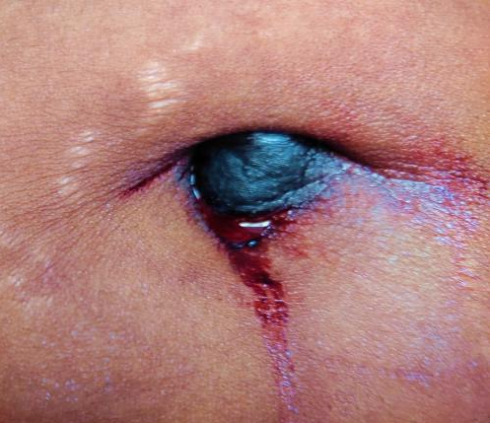
Fig. 1 – Blackish swollen bleeding umbilical nodule
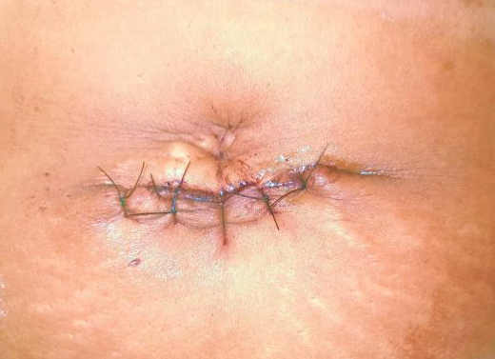
Fig. 2 – Post-operative period with neo-umbilicus formed
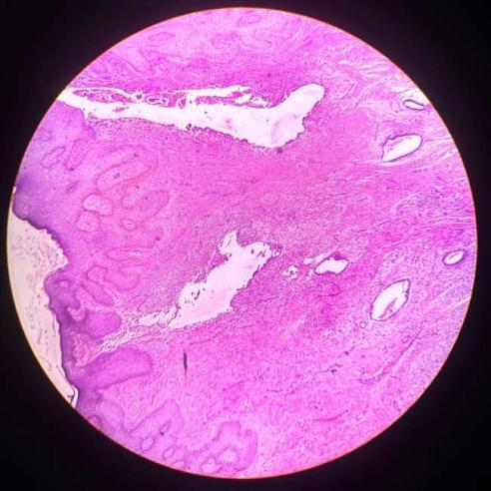
Fig. 3 – HPE of the nodule showed skin-covered (black arrow) endometrial glands (red arrow), endometrial stroma (white arrow) with areas of hemorrhage, and a few hemosiderin-laden macrophages (seen at higher magnification)

Discussion
Villar first described umbilical endometriosis in 1886. The etiopathogenesis of UE is frequently debated. Sampson’s retrograde menstruation theory, coelomic metaplasia, direct spread, iatrogenic spread, lymphatic or hematogenous spread, genetic predisposition, and immunologic defects are few described in the literature [5]. Secondary umbilical endometriosis occurs through iatrogenic spread of endometrial cells after operations such as laparoscopy and cesarean section.
The diagnosis is often made based on clinical presentation. Mostly, patients present with umbilical swelling associated with cyclical pain and bleeding. Pain is due to tissue inflammation, distension, and cyclical changes. Discoloration occurs as a result of bleeding into the lesion with hemosiderin deposition, which can also be seen at histopathological examination [6].
The sensitivity and specificity of USG, computerized tomography (CT), and MRI are low in diagnosing umbilical endometriosis. USG can provide some information on the size of the nodule and its cohesion to adjacent tissues. MRI features of UE include a homogeneous hypointense lesion on a T1-weighted sequence with low signals on a T2-weighted MRI [7].
Due to a limited number of cases, the treatment of UE has not been standardized yet. Medical treatment, including progesterone, danazol, norethisterone, and gonadotropin-releasing hormone analogues, has not provided reliable results. In the review by Victory et al., almost 70% of patients required surgical treatment [8]. Total resection of the umbilicus is mostly performed by achieving an adequate edge of the surrounding normal tissue to avoid local recurrence.

References
[1] Santos Filho PVD, Santos MPD, Castro S, Melo VA. Primary umbilical endometriosis. Rev Col Bras Cir. 2018 Jun 21;45(3):e1746. English, Portuguese. doi: 10.1590/0100-6991e-20181746. PMID: 29947647.
[2] Reimer M, Ravndal CM. Umbilikal endometriose [Umbilical endometriosis]. Tidsskr Nor Laegeforen. 2022 Sep 26;142(13). Norwegian. doi: 10.4045/tidsskr.22.0126. PMID: 36164798.
[3] Huang QF, Jiang B, Yang X, Yu B, Hu XP. Primary versus secondary cutaneous endometriosis: Literature review and case study. Heliyon. 2023 Sep 26;9(10):e20094. doi: 10.1016/j.heliyon.2023.e20094. PMID: 37867870; PMCID: PMC10585216.
[4] Al-Khalili AA, Billick R. Umbilical Endometriosis. Sultan Qaboos Univ Med J. 2017 Aug;17(3):e371-e372. doi: 10.18295/squmj.2017.17.03.023. Epub 2017 Oct 10. PMID: 29062568; PMCID: PMC5642375.
[5] Lamceva J, Uljanovs R, Strumfa I. The Main Theories on the Pathogenesis of Endometriosis. Int J Mol Sci. 2023 Feb 21;24(5):4254. doi: 10.3390/ijms24054254. PMID: 36901685; PMCID: PMC10001466.
[6] Boesgaard-Kjer D, Boesgaard-Kjer D, Kjer JJ. Primary umbilical endometriosis (PUE). Eur J Obstet Gynecol Reprod Biol. 2017 Feb;209:44-45. doi: 10.1016/j.ejogrb.2016.05.030. Epub 2016 Jun 18. PMID: 27374811.
[7] Hartigan CM, Holloway BJ. Case report: MR imaging features of endometriosis at the umbilicus. Br J Radiol. 2005 Aug;78(932):755-7. doi: 10.1259/bjr/68622762. PMID: 16046431.
[8] Victory R, Diamond MP, Johns DA. Villar's nodule: a case report and systematic literature review of endometriosis externa of the umbilicus. J Minim Invasive Gynecol. 2007 Jan-Feb;14(1):23-32. doi: 10.1016/j.jmig.2006.07.014. PMID: 17218225.

