Case report

Plantar Myositis Ossificans: A Rare Case Report and Review of the Literature

Abstract
Myositis ossificans (MO) is a benign heterotopic ossification process most commonly affecting large skeletal muscles following trauma. Non-traumatic forms and atypical localizations are uncommon and often pose diagnostic challenges. Plantar involvement is exceptionally rare and may closely mimic malignant soft tissue tumors. We report a rare case of long-standing plantar myositis ossificans of the heel in a 45-year-old man with a 12-year evolution. This case highlights the limitations of biopsy, the contribution of imaging, and the decisive role of complete surgical excision with histopathological confirmation. A focused review of the literature is provided.
Keywords: Myositis ossificans; Plantar foot; Heterotopic ossification; Soft tissue tumor; Case report

Introduction
Myositis ossificans (MO) is a benign pathological entity characterized by heterotopic bone formation within soft tissues. It has traditionally been regarded as a post-traumatic condition, typically affecting large skeletal muscles of the extremities in young adults. However, non-traumatic forms are increasingly recognized and represent a distinct subset that frequently leads to diagnostic uncertainty, particularly when arising in unusual anatomical locations [1,2].
Histopathologically, myositis ossificans is defined by a characteristic zonal maturation phenomenon, consisting of a central fibroblastic or myofibroblastic proliferation surrounded by progressively maturing osteoid and peripheral lamellar bone. This organized architecture reflects a reactive, non-neoplastic process and constitutes the key feature distinguishing MO from malignant bone-forming tumors, particularly extraskeletal osteosarcoma [1,3].
Plantar localization of myositis ossificans is exceedingly rare due to the paucity of skeletal muscle tissue in the plantar region, which is composed predominantly of fibroadipose tissue and specialized weight-bearing structures. When MO occurs in this location, it is rarely suspected clinically and may closely mimic aggressive soft tissue tumors, leading to delayed diagnosis or overtreatment [4,5].

Case Presentation
A 45-year-old male presented with a slowly progressive mass located at the plantar aspect of the right heel, first noticed approximately 12 years prior to consultation. The patient denied any history of acute trauma, repetitive sports injury, infection, or systemic inflammatory disease.
Clinical examination revealed a firm, well-circumscribed, polylobulated nodular mass at the plantar heel. The lesion was non-tender, mobile relative to the deep planes but adherent to the superficial tissues, and caused progressive discomfort during weight-bearing activities (Figure 1).
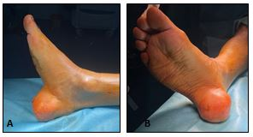
Figure 1: Preoperative clinical photographs showing a plantar heel mass.
A) Lateral,B)frontal
Magnetic resonance imaging demonstrated a well-defined heterogeneous lesion within the plantar soft tissues of the heel, containing areas of low signal intensity consistent with calcifications, without cortical bone involvement or invasion of adjacent structures (Figure 2). Although these features favored a benign calcified soft tissue lesion, malignancy could not be definitively excluded.

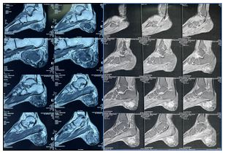
Figure 2 : MRI showing a heterogeneous plantar soft tissue lesion with calcified components and no bone involvement.
An initial biopsy revealed fibrous tissue with chronic inflammatory infiltrate and focal dystrophic calcifications, without evidence of neoplastic proliferation. Given the long-standing evolution, functional impairment, and persistent diagnostic uncertainty, complete surgical excision was indicated. Intraoperatively, a firm, lobulated mass embedded within the plantar soft tissues was identified and carefully dissected and excised in total. (Figure 3).
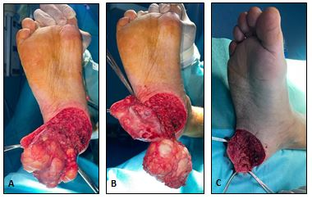
Figure 3: Intraoperative photographs showing dissection of the lobulated plantar mass.
(A)exposure of the lesion
- careful circumferential dissection
(C) complete mobilization prior to excision.

Histopathological Findings
Histological examination of the initial biopsy demonstrated non-specific fibrous tissue with chronic inflammatory infiltrate and dystrophic calcifications, illustrating the limitations of partial sampling in suspected cases of myositis ossificans [6].
Gross examination of the excised specimen revealed a lobulated fibro-fatty mass (Figure 4).
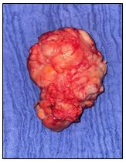
Figure 4: Gross specimen after complete surgical excision.
Microscopic analysis demonstrated a well-organized fibro-osteo-cartilaginous lesion within fibroadipose tissue, displaying a classic zonal architecture characterized by peripheral mature lamellar bone, intermediate osteoid deposition, and a more cellular central zone composed of spindle-shaped myofibroblastic cells arranged in fascicles. No cytological atypia, necrosis, or abnormal mitotic figures were observed, and surgical margins were free of disease. These features were diagnostic of myositis ossificans.

Postoperative Outcome and Follow-up
Postoperative recovery was uneventful. At 10 days, clinical examination demonstrated satisfactory wound healing without complications (Figure 5).
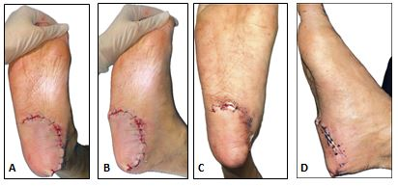
Figure5:Postoperative clinical aspect (frontal and lateral views).
- B):Immediatly
- D): at 10 days

At 6-month follow-up, the patient was asymptomatic, had resumed normal weight-bearing activities, and showed no clinical evidence of recurrence (Figure 6).
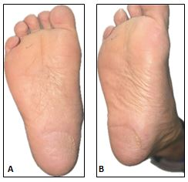
Figure 6: Clinical outcome at 6-month follow-up showing no recurrence.

Discussion
Myositis ossificans is a benign heterotopic ossification process that follows a predictable biological and histological evolution. Although trauma is the most commonly reported etiological factor, non-traumatic cases are well documented and may result from repetitive microtrauma, ischemia, or aberrant differentiation of mesenchymal cells [2,3].
Plantar localization of myositis ossificans is exceptionally rare. The majority of reported cases involve large skeletal muscles of the thigh, arm, or shoulder girdle [3]. The plantar region contains minimal skeletal muscle tissue, which likely explains the scarcity of reported cases and contributes to frequent misdiagnosis as malignant soft tissue tumors [4,5]. Only isolated case reports of plantar or foot involvement have been published to date [7].
Radiological assessment plays an important role but may be misleading, particularly in early or intermediate stages of lesion maturation. MRI findings of myositis ossificans may overlap significantly with those of soft tissue sarcomas, including heterogeneous signal intensity and surrounding edema [3,8]. Consequently, histopathological examination remains the gold standard for diagnosis.
The defining histological feature of myositis ossificans is the zonal phenomenon, which allows reliable differentiation from extraskeletal osteosarcoma, a malignant entity characterized by infiltrative growth, cytological atypia, and absence of organized maturation [1,9]. An important diagnostic pitfall is the limitation of biopsy, as early or partial sampling may fail to demonstrate this architecture, resulting in non-specific findings [6].
Surgical excision is indicated in cases of diagnostic uncertainty, functional impairment, or progressive growth. Complete excision is both diagnostic and curative, provided that resection is complete. Recurrence is rare, and long-term prognosis is excellent, with no metastatic potential [10,11].

Conclusion
Plantar myositis ossificans is a rare benign condition that may closely mimic malignant soft tissue tumors. Awareness of this entity, careful interpretation of imaging findings, and recognition of its characteristic histopathological features are essential to avoid misdiagnosis and overtreatment. Complete surgical excision remains both diagnostic and curative, with excellent functional outcomes.
Patient Consent
Written informed consent was obtained from the patient for publication of this case report and accompanying images. A copy of the written consent is available for review by the Editor-in-Chief of this journal.

Ethical Approval

Ethical approval was not required for this case report in accordance with institutional policies.

References
1. Ackerman LV. Extra-osseous localized non-neoplastic bone and cartilage formation. J Bone Joint Surg Am. 1958;40(2):279–298. Available from: https://jbjs.org/reader.php?rsuite_id=263983
2. Walczak BE, Johnson CN, Howe BM. Myositis ossificans. J Am Acad Orthop Surg. 2015;23(10):612–622. https://doi.org/10.5435/JAAOS-D-14-00269
3. Kransdorf MJ, Meis JM, Jelinek JS. Myositis ossificans: MR appearance with radiologic-pathologic correlation. AJR Am J Roentgenol. 1991;157(6):1243–1248. https://doi.org/10.2214/ajr.157.6.1950874
4. Tyler P, Saifuddin A. The imaging of myositis ossificans. Semin Musculoskelet Radiol. 2010;14(2):201–216. https://doi.org/10.1055/s-0030-1253161
5. Hendifar AE, Johnson D, Arkfeld DG. Myositis ossificans: a case report. Arthritis Rheum. 2005;53(5):793–795. https://doi.org/10.1002/art.21456
6. Russo R, Hughes M, Manolios N. Biopsy diagnosis of early myositis ossificans without radiologic evidence of calcification. J Clin Rheumatol. 2010;16(8):385–387. https://doi.org/10.1097/RHU.0b013e3181fe8c30
7. Al-Timimy QAH, Al-Edani MS. Myositis ossificans: a rare location in the foot. Int J Surg Case Rep. 2016;26:84–87. https://doi.org/10.1016/j.ijscr.2016.07.005
8. Wang XC, Zhang L, Lin JB, et al. Imaging diagnosis and differential diagnosis of extraskeletal osteosarcoma. BMC Cancer. 2024;24:11. https://doi.org/10.1186/s12885-023-11731-3
9. Lindberg MR. Diagnostic pathology: soft tissue tumors. 4th ed. Philadelphia: Elsevier; 2023. Available from: https://shop.elsevier.com/books/diagnostic-pathology-soft-tissue-tumors/lindberg/978-0-443-10936-2
10. Stammer A, Ashwood N, Amara V, et al. The anatomical basis for surgical intervention in myositis ossificans: a systematic review. Clin Anat. 2024. https://doi.org/10.1002/ca.24238
11. Sun E, Hanyu-Deutmeyer AA. Heterotopic ossification. In: StatPearls [Internet]. Treasure Island (FL): StatPearls Publishing; 2023. Available from: https://www.ncbi.nlm.nih.gov/books/NBK519029/

