Case report
Surgical Management of an Abdominal Wall Desmoid Tumor in a Young Woman: The Role of Dual-Mesh Reconstruction

Abstract
Background:
Desmoid tumors, also known as aggressive fibromatosis, are rare benign fibroblastic neoplasms characterized by locally aggressive behavior and a high risk of recurrence. Involvement of the abdominal wall is uncommon and may present significant reconstructive challenges following wide surgical excision.
Case Presentation:
We report the case of a 22-year-old woman with no significant medical history who presented with a one-year history of constipation associated with right lower quadrant and lumbar pain. Physical examination revealed a large, mobile parietal mass in the right iliac fossa. Abdominal magnetic resonance imaging demonstrated a large right-sided mass arising from the right rectus abdominis muscle. An ultrasound-guided core needle biopsy confirmed the diagnosis of a desmoid tumor. The patient underwent complete surgical resection with wide margins, including total excision of the infraumbilical portion of the right rectus abdominis muscle. Abdominal wall reconstruction was performed using a dual-face prosthetic mesh fixed to the peritoneum and covered by the remaining aponeurosis. Postoperative recovery was uneventful, and the patient was discharged on postoperative day three. Histopathological examination of the surgical specimen confirmed the diagnosis. Follow-up at 15 days was satisfactory.
Conclusion:
This case underscores the value of dual-mesh prostheses in abdominal wall reconstruction after extensive resection of desmoid tumors, enabling safe coverage of large parietal defects with favorable short-term outcomes.

Keywords: Desmoid tumor; Aggressive fibromatosis; Abdominal wall; Rectus abdominis; Dual-mesh; Surgical reconstruction.

Introduction
Desmoid tumors, also referred to as aggressive fibromatosis, are rare soft tissue neoplasms arising from musculoaponeurotic structures. Although histologically benign and devoid of metastatic potential, these tumors are characterized by infiltrative growth and a high propensity for local recurrence. Abdominal wall desmoid tumors predominantly affect young women and may occur sporadically or in association with familial adenomatous polyposis [1].
The optimal management of desmoid tumors remains a subject of ongoing debate, with treatment strategies ranging from active surveillance and medical therapy to surgical intervention. When surgery is indicated, wide excision with negative margins can result in substantial abdominal wall defects, posing significant reconstructive challenges. In this report, we describe a case of a large abdominal wall desmoid tumor managed surgically, with particular emphasis on the role of dual-mesh prosthetic reconstruction in addressing extensive parietal tissue loss [1,2].

Case Presentation
A 22-year-old woman with no significant past medical history was admitted to the visceral and digestive surgery department for evaluation of an abdominal mass. Her symptoms had begun approximately one year prior to admission and were characterized by progressive constipation associated with localized pain in the right iliac fossa and right lumbar region.
Physical examination was unremarkable except for the presence of a large, palpable, mobile parietal mass in the right iliac fossa. There were no signs of intestinal obstruction or systemic illness (Figure 1).
Abdominal magnetic resonance imaging demonstrated a well-defined right-sided pelvic mass adherent to the abdominal wall and arising from the right rectus abdominis muscle. The lesion had irregular margins, intermediate signal intensity on T1-weighted images, heterogeneous hyperintensity on T2-weighted images, and heterogeneous contrast enhancement. The mass measured 9 × 11 cm on axial sections and 16 cm in craniocaudal dimension (Figure 2).
An ultrasound-guided core needle biopsy was subsequently performed. Histological and immunohistochemical analyses were consistent with a diagnosis of desmoid tumor.
Following multidisciplinary team discussion, surgical management was recommended. The patient underwent complete tumor resection with oncological safety margins, including total excision of the infraumbilical portion of the right rectus abdominis muscle (Figure 3). Reconstruction of the resulting abdominal wall defect was achieved using a dual-face prosthetic mesh fixed to the peritoneum and covered by the remaining rectus sheath aponeurosis. Subcutaneous tissues and skin were closed in layers (Figure 4).
Postoperative recovery was uneventful, and the patient was discharged on postoperative day three. At 15-day follow-up, clinical examination showed good wound healing with no early complications. Final histopathological examination of the surgical specimen confirmed the diagnosis of desmoid tumor with clear surgical margins.

Discussion
Desmoid tumors, also referred to as desmoid-type fibromatosis, are rare benign fibroblastic neoplasms arising from musculoaponeurotic structures. They represent less than 3% of all soft tissue tumors and predominantly affect young adults, with a clear female predominance, particularly when the abdominal wall is involved [1–3]. Despite their benign histology and absence of metastatic potential, these tumors are characterized by locally aggressive and infiltrative growth, which accounts for their associated morbidity and relatively high rates of local recurrence [3].
Several factors have been implicated in the pathogenesis of desmoid tumors, including hormonal influences, previous surgery or trauma, and genetic alterations. Most sporadic cases harbor activating mutations of the CTNNB1 gene, resulting in β-catenin accumulation and dysregulated fibroblastic proliferation. Certain mutations, especially the S45F variant, have been associated with an increased risk of recurrence [3]. In the present case, no identifiable predisposing factor was found, which is consistent with many reported sporadic presentations.
Clinically, abdominal wall desmoid tumors often present with slowly progressive symptoms related to mass effect, such as localized pain, discomfort, or digestive complaints. Magnetic resonance imaging remains the reference modality for diagnosis and preoperative evaluation, typically demonstrating iso- to hypointense signal on T1-weighted images and heterogeneous hyperintensity on T2-weighted images, with variable contrast enhancement [4]. Histological confirmation by core needle biopsy is essential to establish the diagnosis and guide therapeutic decision-making [1–4].
Over recent years, the management of desmoid tumors has shifted toward a more conservative approach, with active surveillance increasingly recommended for asymptomatic or stable lesions [5]. Nevertheless, surgical resection remains indicated for symptomatic, progressive, or functionally limiting tumors, particularly those arising from the abdominal wall, where complete excision is often technically feasible and associated with favorable local control [4,5]. Although the prognostic impact of margin status remains debated, wide resection is still commonly pursued in young patients with large and symptomatic tumors.
Extensive surgical excision frequently results in significant abdominal wall defects, necessitating complex reconstruction. Dual-face prosthetic meshes offer effective parietal reinforcement while reducing the risk of visceral adhesions through their anti-adhesive surface [5]. In the present case, the use of a bifacial mesh enabled secure reconstruction following complete resection of the infraumbilical portion of the rectus abdominis muscle, providing adequate coverage of a large tissue defect with satisfactory early postoperative outcomes [6,7].
Local recurrence remains the principal long-term concern following surgical treatment, with recurrence rates varying according to tumor location and biological behavior. Abdominal wall desmoid tumors generally exhibit lower recurrence rates than intra-abdominal or extra-abdominal lesions; however, long-term clinical and radiological follow-up remains essential due to the unpredictable natural history of the disease [7].
This case is noteworthy for several reasons. It illustrates the presentation of a large abdominal wall desmoid tumor in a young woman without identifiable risk factors, supports the role of complete surgical resection in selected symptomatic cases, and highlights the effectiveness of dual-mesh prosthetic reconstruction in managing extensive abdominal wall defects while preserving parietal integrity and achieving favorable early outcomes.

Conclusion
Abdominal wall desmoid tumors in young patients present both diagnostic and therapeutic challenges. In carefully selected cases, complete surgical resection remains an appropriate and effective treatment option. Dual-mesh prosthetic reconstruction represents a safe and reliable technique for the management of large abdominal wall defects, allowing restoration of abdominal wall integrity with favorable postoperative outcomes.

References
- Kasper, B., Baumgarten, C., Garcia, J., Bonvalot, S., Haas, R., Haller, F., Hohenberger, P., Penel, N., Messiou, C., van der Graaf, W. T., Gronchi, A., Bauer, S., Blay, J. Y., van Coevorden, F., Dileo, P., Dürr, H. R., Fiore, M., Grünwald, V., Jones, R., ... Wartenberg, M. (2017). An update on the management of sporadic desmoid-type fibromatosis: a European Consensus Initiative between Sarcoma PAtients EuroNet (SPAEN) and European Organization for Research and Treatment of Cancer (EORTC)/Soft Tissue and Bone Sarcoma Group (STBSG). *Annals of Oncology*, *28*(10), 2399–2408. https://doi.org/10.1093/annonc/mdx323
- Desmoid Tumor Working Group. (2020). The management of desmoid tumours: A joint global consensus-based guideline approach for adult and paediatric patients. European Journal of Cancer, 127, 96–107. https://doi.org/10.1016/j.ejca.2019.11.013
- Mullen, J. T., DeLaney, T. F., Kobayashi, W. K., Szymonifka, J., Yeap, B. Y., Chen, Y. L., Rosenberg, A. E., Harmon, D. C., Choy, E., Yoon, S. S., Raskin, K. A., Nielsen, G. P., & Hornicek, F. J. (2012). Desmoid Tumor: Analysis of Prognostic Factors and Outcomes in a Surgical Series. Annals of Surgical Oncology, 19(13), 4028–4035. https://doi.org/10.1245/s10434-012-2638-2
- Colombo, C., Miceli, R., Le Péchoux, C., Palassini, E., Honoré, C., Stacchiotti, S., Mir, O., Casali, P. G., Dômont, J., Fiore, M., Le Cesne, A., Gronchi, A., & Bonvalot, S. (2015). Sporadic extra-abdominal wall desmoid-type fibromatosis: surgical resection can be safely limited to a minority of patients. European Journal of Cancer, 51(2), 186–192. https://doi.org/10.1016/j.ejca.2014.11.019
- Atema, J. J., Furnée, E. J., Maeda, Y., Warusavitarne, J., Tanis, P. J., Bemelman, W. A., Vaizey, C. J., & Boermeester, M. A. (2017). Major complex abdominal wall repair in contaminated fields with use of a non-cross-linked biologic mesh: A dual-institutional experience. World Journal of Surgery, 41(8), 1993–1999. https://doi.org/10.1007/s00268-017-3962-2
- Wilkinson MJ, Chan KE, Hayes AJ, Strauss DC. Surgical outcomes following resection for sporadic abdominal wall fibromatosis. Ann Surg Oncol. 2014;21(7):2144–2149. https://link.springer.com/article/10.1245/s10434-014-3618-5
- Catania, G., Ruggeri, L., Iuppa, G., Di Stefano, C., Cardì, F., & Iuppa, A. (2012). Abdominal wall reconstruction with intraperitoneal prosthesis in desmoid tumors surgery. Updates in Surgery, 64(1), 43–48. https://doi.org/10.1007/s13304-011-0109-0

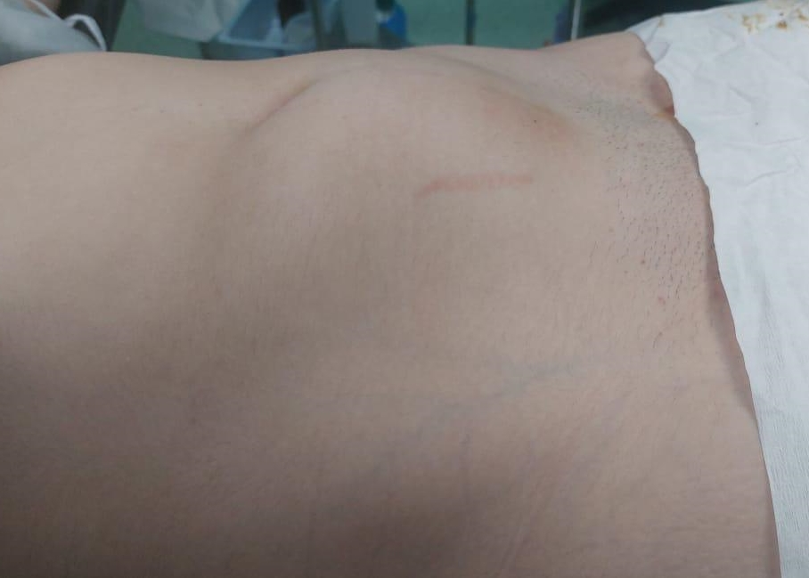
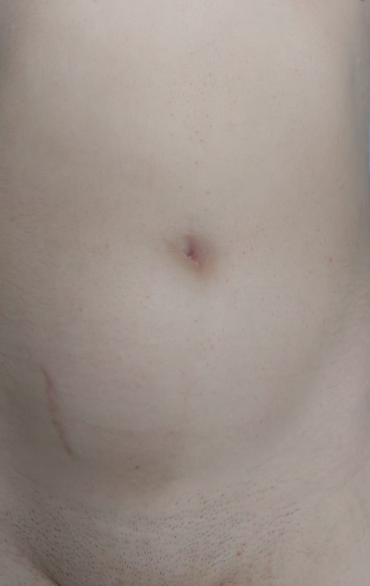
Figure1(a,b): A right iliac fossa mass.

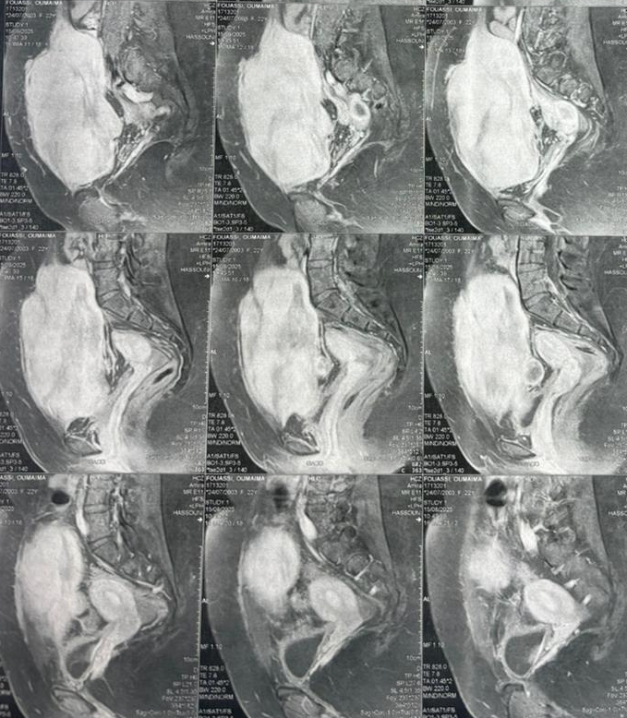
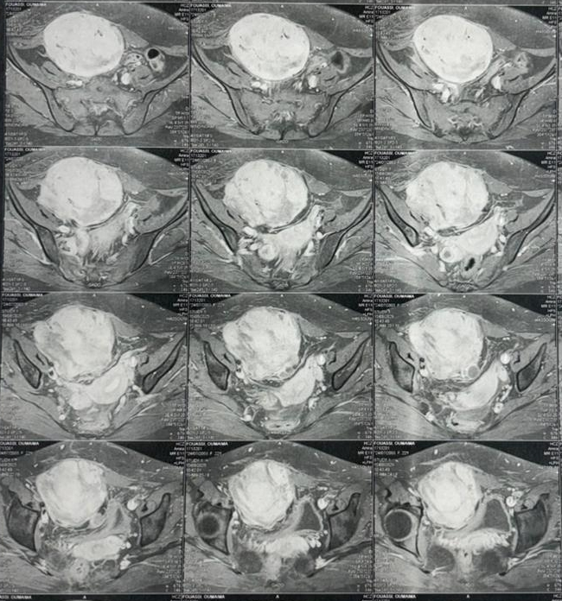
Figure 2(a,b): Abdominal MRI demonstrating a large abdominal mass

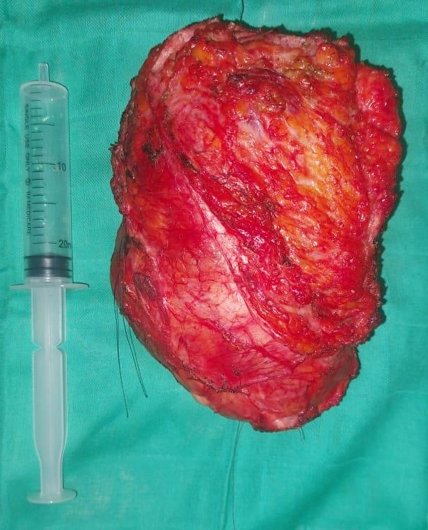
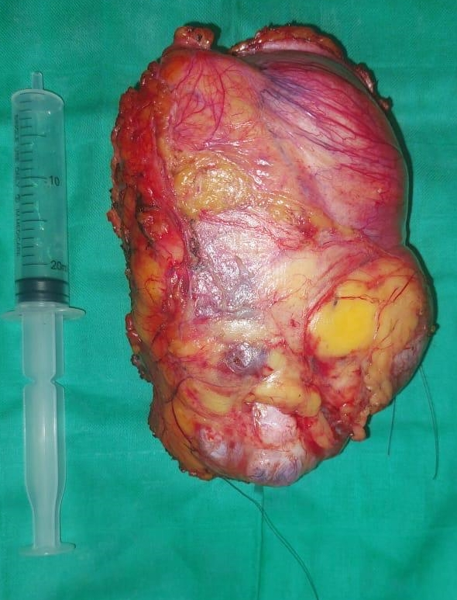
Figure 3(a,b): Gross specimen of the totally excised mass

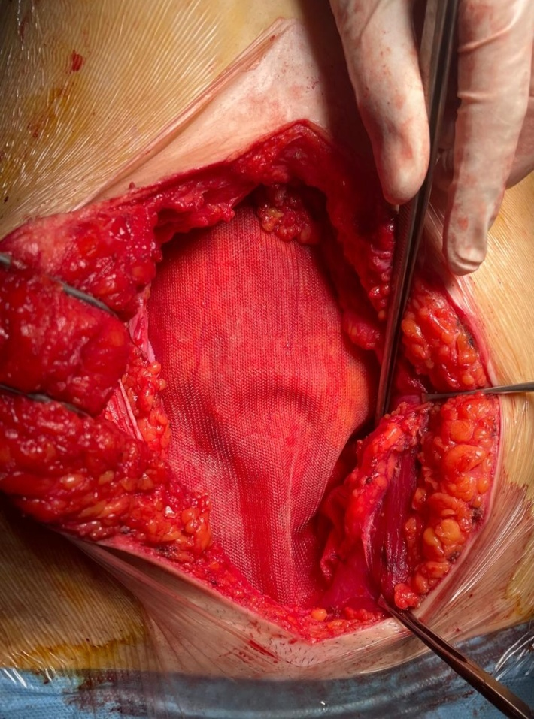
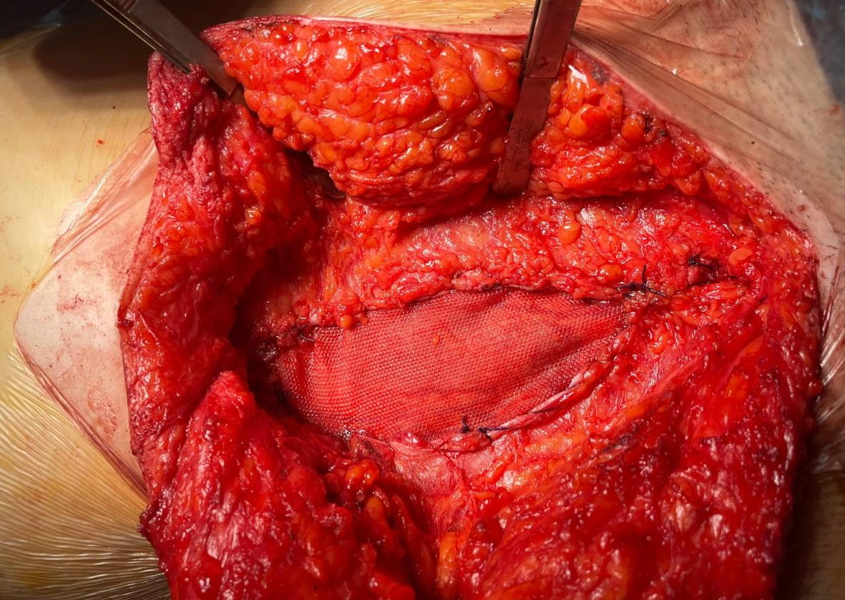
Figure 4(a,b): Intraoperative image showing reconstruction of the abdominal wall defect with a dual-face prosthetic mesh

