Case report

When a Lumbar Mass Is Not Renal: A Rare Adrenocortical Oncocytic Neoplasm

ABSTRACT
Introduction: Adrenocortical oncocytic neoplasms (AONs) are rare tumors of the adrenal cortex characterized by oncocytic histology. Due to their rarity, variable malignant potential, and nonspecific clinical presentation, preoperative diagnosis remains challenging.
Case Presentation: A 38-year-old female presented with back pain to Orthopedics OPD for which Contrast-enhanced computed tomography was done. It revealed a large, well-defined left adrenal mass without evidence of invasion. After which she was referred to surgery OPD and then to Urology OPD for further management. Clinical evaluation and hormonal workup suggested a non-functioning adrenal tumor. The patient underwent open left adrenalectomy. Histopathological examination confirmed an adrenocortical oncocytic neoplasm of uncertain malignant potential based on Lin–Weiss–Bisceglia criteria. The postoperative period was uneventful, and the patient remains disease-free on follow-up.
Conclusion: AONs are rare adrenal tumors that may present with mass effect rather than hormonal symptoms. Complete surgical excision is the treatment of choice. Long-term follow-up is essential due to unpredictable biological behavior.

Keywords: Adrenocortical oncocytic neoplasm; Adrenal tumor; Lumbar mass; Adrenalectomy; Rare adrenal neoplasm

INTRODUCTION
Oncocytic neoplasms are tumors composed predominantly of oncocytes—large polygonal cells with abundant eosinophilic granular cytoplasm rich in mitochondria. While oncocytic tumors are commonly described in organs such as the kidney, thyroid, and salivary glands, their occurrence in the adrenal cortex is extremely rare. Adrenocortical oncocytic neoplasms (AONs) represent a distinct pathological entity first described in the late 1980s and account for a very small percentage of adrenal tumors.^{[1,2]}
AONs are classified into benign, malignant, and tumors of uncertain malignant potential using the Lin–Weiss–Bisceglia (LWB) criteria, which modify the traditional Weiss criteria to account for oncocytic histology.^{[2,3]} Most reported AONs are non-functional and are incidentally detected; however, large tumors may present with abdominal or lumbar pain due to mass effect.^{[1,3]}
Given their rarity and lack of characteristic clinical or radiological features, AONs pose diagnostic and therapeutic challenges. We report a rare case of a non-functional adrenocortical oncocytic neoplasm presenting as a left lumbar mass in a 38-year-old female, highlighting diagnostic considerations, surgical management, and histopathological features.

CASE REPORT
A 38-year-old female presented to the orthopedics OPD with complaints of back pain for which CT lumbar spine was done. On CT, incidental left reteroperitoneal mass was seen for which she was referred to general surgery OPD. Afterwhich she was referred to urosurgery department for further evaluation and management. She presented to urosurgery opd with complaints of intermittent, dull-aching left flank pain for the past 3 months, which progressed to a feeling of fullness in the left lumbar region over the last 2 months. There was no history of fever, weight loss, anorexia, hematuria, trauma or gastrointestinal symptoms such as vomiting or altered bowel habits.
There were no symptoms suggestive of hormonal excess such as hypertension, episodic headaches, palpitations, excessive sweating, weight gain, menstrual irregularities, hirsutism, or virilization. The patient had no significant past medical illness and no significant prior surgical history. Family history was non-contributory.
Clinical Examination
On general physical examination, the patient was hemodynamically stable with normal vital signs. No features of Cushing’s syndrome or virilization were observed.
Abdominal inspection revealed a firm, ill-defined swelling measuring approximately 15×8×5 cm in the left lumbar region, extending into the left hypochondrium and flank as seen in Fig. 1. The overlying skin was normal, and the mass did not move with respiration. No visible pulsations or dilated veins were noted.
On palpation, the mass was mildly tender, non-reducible, with ill-defined margins. The upper margin extended into the left hypochondrium, medial up to the umbilicus, and laterally into the flank. There was no hepatosplenomegaly or ascites.
Routine hematological and biochemical investigations were within normal limits. 24 hours urine Vanillyl Mandelic Acid, Plasm free metanephrins, free normetanephrins and serum cortisol were also within normal limits. These findings suggested a non-functioning adrenal mass.
A Fine needle aspiration cytology(FNAC) of the left retroperitoneal pararenal mass was performed. The IHC panel showed that the lesional cells expressed Calretinin, Melan A, Inhibin (focal), Chromogranin A, and Cytokeratin (focal). The tumor cells were negative for GATA-3, Pax8, HepPar-1, and CD10.The MIB-1 proliferation index was approximately 4–6%.


Fig. 1: Visible swelling over left lumbar and left hypochondrium region
Radiological Evaluation
Contrast-enhanced computed tomography (CECT) of the abdomen revealed a well-defined, heterogeneously enhancing mass measuring approximately 15×8×5 cm arising from the left adrenal gland, displacing adjacent structures (Fig.2). No evidence of local invasion, vascular involvement, lymphadenopathy, or distant metastasis was noted.
Based on clinical and radiological findings, a diagnosis of a left adrenal neoplasm with suspicion of malignancy was considered due to the large tumor size.
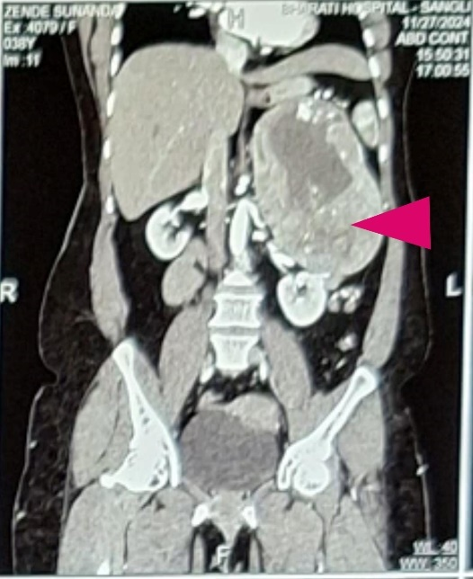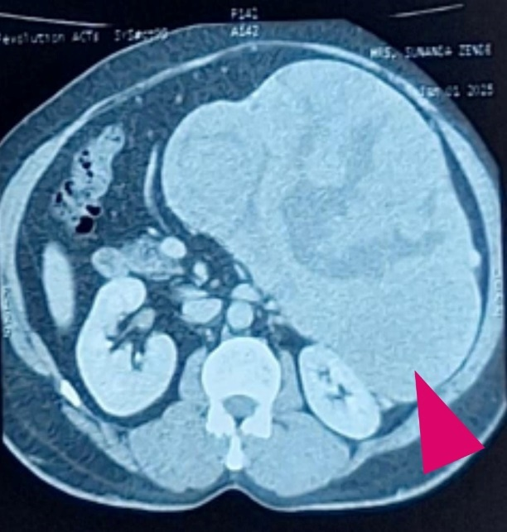
Fig. 2: shows adrenal mass on CECT scan coronal and transverse sections respectively

Surgical Management
Given the size of the tumor and the potential for malignancy, the patient was planned for surgical excision. An open left adrenalectomy was performed via a transabdominal approach.
Intraoperatively, a large, well-encapsulated mass arising from the left adrenal gland was identified. The tumor was firm in consistency and showed no gross invasion into surrounding organs or major vessels. Complete excision of the tumor along with the adrenal gland was achieved as seen in Fig.3. The specimen was sent for histopathological examination which revealed Adrenocortical oncocytic neoplasm of uncertain malignant potential (according to Lin–Weiss–Bisceglia criteria) as seen in Fig.4.

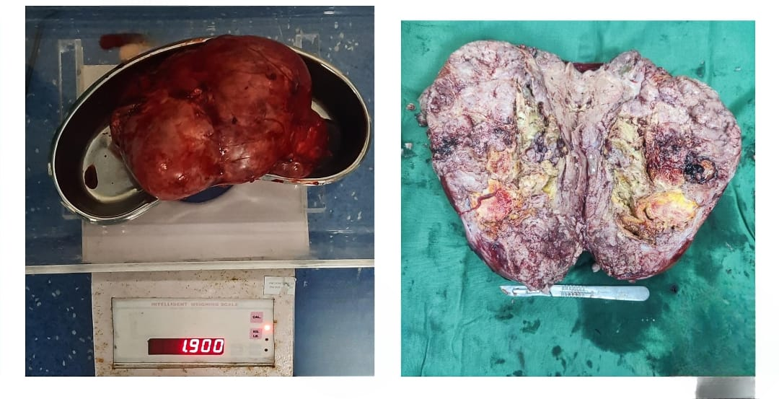
Fig. 3: shows excised specimen of adrenal mass weighing 1.9kg with its cross section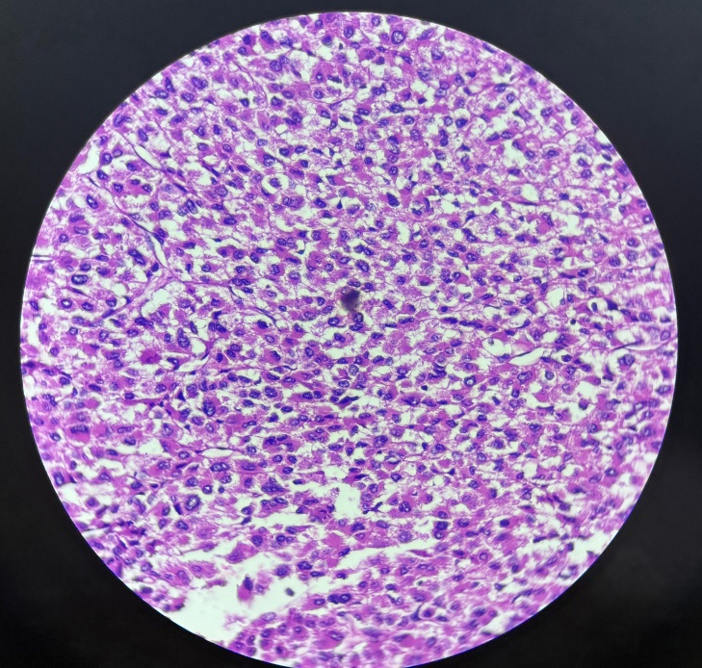
Fig. 4: shows H&E slide of the mass on 10x magnification shows all tumor cells

Postoperative Course and Follow-Up
The postoperative period was uneventful. The patient was started on oral feeds on postoperative day 2 and was discharged on postoperative day 10 in stable condition. At follow-up visits upto three months, the patient remained asymptomatic.

DISCUSSION
Adrenocortical oncocytic neoplasms are rare tumors with fewer than a few hundred cases reported worldwide.^{[1,3]} These tumors predominantly affect adults, with a slight female preponderance, and are usually detected in the fourth to fifth decade of life.^{[2]} The majority of AONs are non-functional^{[3]}, as observed in the present case.
Clinically, AONs may remain asymptomatic and are often discovered incidentally during imaging for unrelated conditions. When symptomatic, presentations are usually due to mass effect, including abdominal or lumbar pain^{[3]}, as seen in our patient.
Adrenocortical neoplasms are rare and require meticulous preoperative evaluation to rule out functional tumors, especially pheochromocytoma, due to perioperative hemodynamic risks.^{[5]} In this case, biochemical screening including plasma metanephrines and urinary catecholamines was unremarkable, effectively excluding pheochromocytoma.
Although the tumor was non-functional, awareness of potential adrenal crisis during adrenal surgery is essential. If encountered, adrenal insufficiency can be managed with prompt corticosteroid, ionotropic support and fluid resuscitation.^{[5]}
Radiological differentiation between benign and malignant adrenal tumors remains difficult. Features such as large size, heterogeneity, and delayed contrast washout may raise suspicion of malignancy but are not definitive.^{[4,7]} Therefore, histopathological examination remains the gold standard for diagnosis.^{[1,4]}
The Lin–Weiss–Bisceglia criteria are specifically designed for oncocytic adrenal tumors and classify them into benign, malignant, and borderline (uncertain malignant potential) categories. Surgical excision is recommended for all large adrenal tumors (>6 cm) or when malignancy cannot be excluded.^{[7]}
Complete surgical resection offers excellent prognosis for benign and borderline tumors. However, due to unpredictable behavior, long-term follow-up with periodic imaging is advised.^{[6,8]}

CONCLUSION
Adrenocortical oncocytic neoplasms are rare adrenal tumors with variable malignant potential. They may present as a lumbar mass without hormonal manifestations. Surgical excision remains the cornerstone of management, and histopathological evaluation is essential for definitive diagnosis. This case underscores the surgical approach to a rare adrenal oncocytic neoplasm presenting as a left-sided retroperitoneal mass. Early diagnosis and prompt surgical excision lead to favorable outcomes. Long-term follow-up is recommended due to the risk of recurrence.

PATIENT CONSENT
Written informed consent was obtained from the patient for publication of this case report and accompanying images.

CONFLICTS OF INTEREST
The authors declare no conflicts of interest.

REFERENCES
- Bisceglia, M., Ludovico, O., Di Mattia, A., Ben-Dor, D., Sandbank, J., Pasquinelli, G., Lau, S. K., & Weiss, L. M. (2004). Adrenocortical oncocytic tumors: report of 10 cases and review of the literature. *International Journal of Surgical Pathology*, *12*(3), 231-243. https://doi.org/10.1177/106689690401200304
- Lin, B. T., Bonsib, S. M., Mierau, G. W., Weiss, L. M., & Medeiros, L. J. (1998). Oncocytic adrenocortical neoplasms: A report of seven cases and review of the literature. American Journal of Surgical Pathology, 22(5), 603-614. https://doi.org/10.1097/00000478-199805000-00012
- Wong, D. D., Spagnolo, D. V., Bisceglia, M., Havlat, M., McCallum, D., & Platten, M. A. (2011). Oncocytic adrenocortical neoplasms—a clinicopathologic study of 13 new cases emphasizing the importance of their recognition. Human Pathology, 42(4), 489-499. https://doi.org/10.1016/j.humpath.2010.08.010
- Aubert, S., Wacrenier, A., Leroy, X., Devos, P., Carnaille, B., Proye, C., Wemeau, J. L., Lecomte-Houcke, M., & Leteurtre, E. (2002). Weiss system revisited: A clinicopathologic and immunohistochemical study of 49 adrenocortical tumors. American Journal of Surgical Pathology, 26(12), 1612-1619. https://doi.org/10.1097/00000478-200212000-00009
- Erickson LA. Adrenocortical carcinoma: update on pathology and molecular genetics. Endocr Pathol. 2010;21(3):123-132.
- Kebebew, E., Reiff, E., Duh, Q. Y., Clark, O. H., & McMillan, A. (2006). Extent of disease at presentation and outcome for adrenocortical carcinoma: Have we made progress?. World Journal of Surgery, 30(5), 872-878. https://doi.org/10.1007/s00268-005-0329-x
- Sturgeon, C., Shen, W. T., Clark, O. H., Duh, Q. Y., & Kebebew, E. (2006). Risk assessment in 457 adrenal cortical carcinomas: how much does tumor size predict the likelihood of malignancy? Journal of the American College of Surgeons, 202(3), 423-430. https://doi.org/10.1016/j.jamcollsurg.2005.11.005
- Medeiros LJ, Weiss LM. New developments in the pathologic diagnosis of adrenal cortical neoplasms. Adv Anat Pathol. 2000;7(2):125-144.

