Case study
Diverse Therapeutic Approaches to Ankyloglossia in Children: A Case Series

ABSTRACT
Ankyloglossia is a congenital developmental anomaly characterized by a short or thick lingual frenulum, resulting in restricted tongue mobility and functional impairments, particularly speech difficulties. Early recognition and timely intervention are essential to improve oral function and quality of life in affected children. This case series describes the management and outcomes of three pediatric patients with severe ankyloglossia treated using different surgical modalities.
All cases presented to the Department of Pediatric and Preventive Dentistry, Goa Dental College and Hospital, with speech impairment and limited tongue movement. Clinical examination confirmed severe Class III ankyloglossia according to Kotlow’s classification. The children exhibited difficulty in articulating lingual and alveolar phonemes. Surgical management included conventional scalpel frenectomy, diode laser–assisted frenectomy, and electrocautery-assisted frenectomy, each performed under local anesthesia following standard aseptic protocols.
Postoperatively, all patients demonstrated satisfactory hemostasis and uneventful healing. Suturing was required only in the scalpel-treated case, while laser and electrocautery techniques achieved adequate coagulation without sutures. Complete wound healing was observed at the one-month follow-up. Tongue mobility exercises were advised to enhance postoperative functional outcomes.
This case series demonstrates that all three techniques are effective for managing severe pediatric ankyloglossia, with laser and electrocautery offering reduced bleeding and improved postoperative comfort.

KEYWORDS: Ankyloglossia, tongue-tie, frenectomy, diode laser, electrocautery, case series

INTRODUCTON
Ankyloglossia is a congenital developmental anomaly of the tongue characterized by a short, thick lingual frenulum, leading to restricted tongue mobility (partial ankyloglossia) or an apparent fusion of the tongue to the floor of the mouth (total ankyloglossia) (Vellore et al., 2024). The prevalence of ankyloglossia reported in the literature shows wide variability, ranging from 0.1% to 10.7% (Lestari et al., 2024). Its prevalence in newborns ranges from approximately 4.4% to 4.8%, with a male-to-female ratio of about 3:1 (Junqueira et al., 2014). In the Indian population, the reported prevalence ranges from 0.02% to 0.4% (Vellore et al., 2024).
This condition may contribute to skeletal maldevelopment, malocclusion, and gingival recession on the lingual aspect of the mandibular anterior teeth. It can also interfere with swallowing, cause feeding difficulties in infants, and lead to problems with eating in young children, as well as social concerns in school-aged children. Speech articulation may be affected, with difficulty in pronouncing consonants such as d, t, n, ch, z, and l, and in rolling the “r” in syllables (Garrocho-Rangel et al., 2019; Segal et al., 2007).
According to Kotlow’s classification (1999), the severity of ankyloglossia is determined by the length of the “free tongue,” defined as the distance from the insertion of the lingual frenulum at the base of the tongue to the tip of the tongue, and is categorized into four classes: Class I (mild ankyloglossia), 12–16 mm; Class II (moderate ankyloglossia), 8–11 mm; Class III (severe ankyloglossia), 3–7 mm; and Class IV (complete ankyloglossia), less than 3 mm (Kotlow, 1999).
Management of ankyloglossia depends on the severity of the condition, patient age, and the presence of functional limitations. Mild cases without significant symptoms may be managed conservatively with observation and periodic review. Surgical options include frenotomy, frenectomy, and frenuloplasty, which aim to release or remove the restrictive lingual frenulum. These procedures can be performed using conventional scalpel techniques, lasers, or electrocautery (Gyawali et al., 2021). While scalpel techniques are widely used and economical, laser and electrocautery approaches offer advantages such as improved hemostasis, reduced postoperative discomfort, and faster wound healing (Lestari et al., 2024; Vellore et al., 2024).
This case series presents the management of ankyloglossia in children utilizing three distinct surgical modalities—conventional scalpel, laser, and electrocautery—highlighting their clinical application, efficacy, and outcomes.
PRESENTATION OF CASES
All three cases presented to the Department of Pediatric and Preventive Dentistry at Goa Dental College and Hospital.
CASE 1
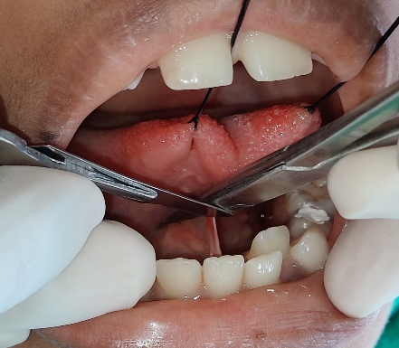
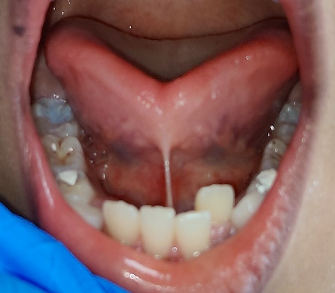
A 10-year-old female patient diagnosed with ankyloglossia was referred to the Department of Paediatric and Preventive Dentistry with a primary complaint of speech impairment. The patient exhibited difficulty in articulating the phonemes /d/, /t/, /r/, and /z/. Intraoral examination revealed a heart-shaped appearance of the tongue upon protrusion and a short lingual frenum, consistent with severe (Class III) ankyloglossia, as per Kotlow’s classification (Figure 1A).

B
A

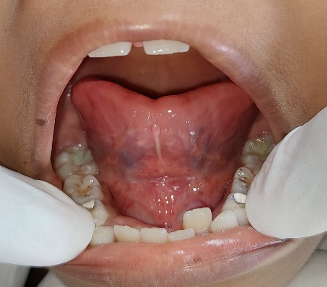
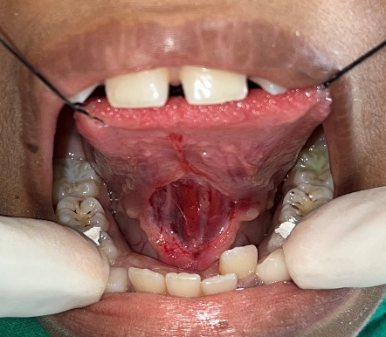

C
D

Figure 1: Conventional surgical frenectomy with scalpel (A) Preoperative image; (B) Intraoperative image; (C) Immediate postoperative image; (D) One-month postoperative image
Following preoperative antisepsis, local infiltration with 2% lidocaine containing 1:80,000 epinephrine was administered on ether sides of the frenum. Two 3-0 silk sutures were placed bilaterally at the tip of the tongue to facilitate traction. A hemostat was then applied to the lingual frenum, and a frenectomy was performed using a #11 scalpel blade (Figure 1B). The frenum was excised, resulting in a diamond-shaped surgical wound (Figure 1C). Primary closure was achieved with sutures, which were removed after seven days.
Postoperatively, the patient was prescribed antibiotics and analgesics, and advised to adhere to a soft, cold diet for the initial 48 hours. Tongue mobility exercises were recommended. Complete wound healing was evident at the one-month follow-up (Figure 1D).
CASE 2
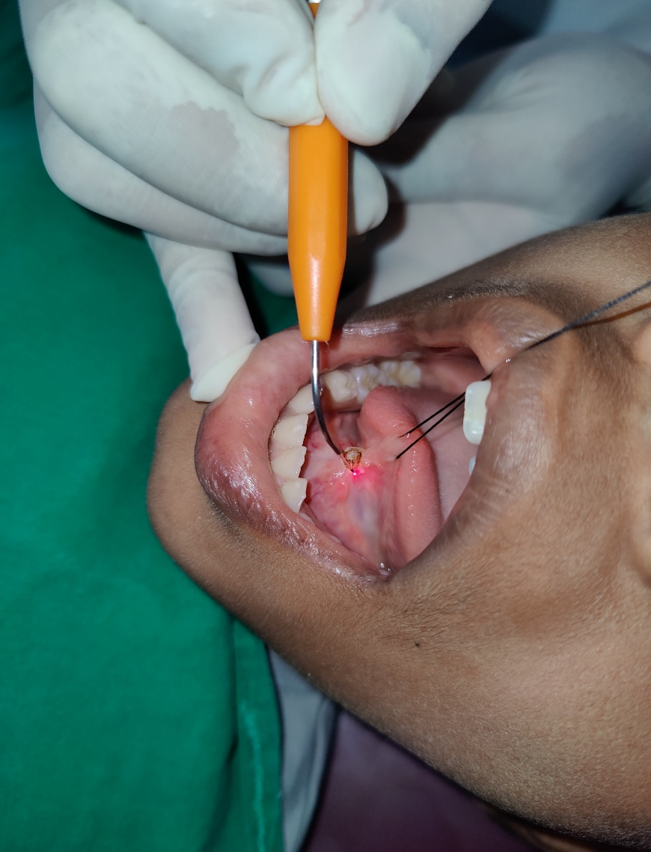
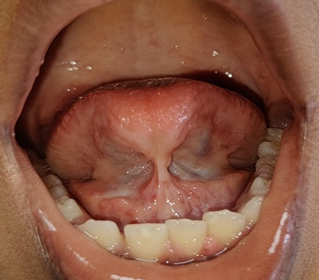
A 10-year-old male patient was referred to the Department of Paediatric and Preventive Dentistry with a complaint of speech impairment secondary to a short lingual frenum. Clinical examination confirmed Class III ankyloglossia (3–7 mm) according to Kotlow’s classification (Figure 2A). The tongue exhibited a bifid appearance, restricted mobility, and difficulty in articulating the phonemes /z/, /t/, /d/, /ʃ/ (sh), and /tʃ/ (ch).

B
A
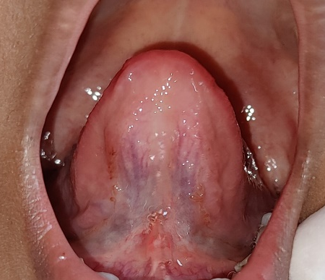
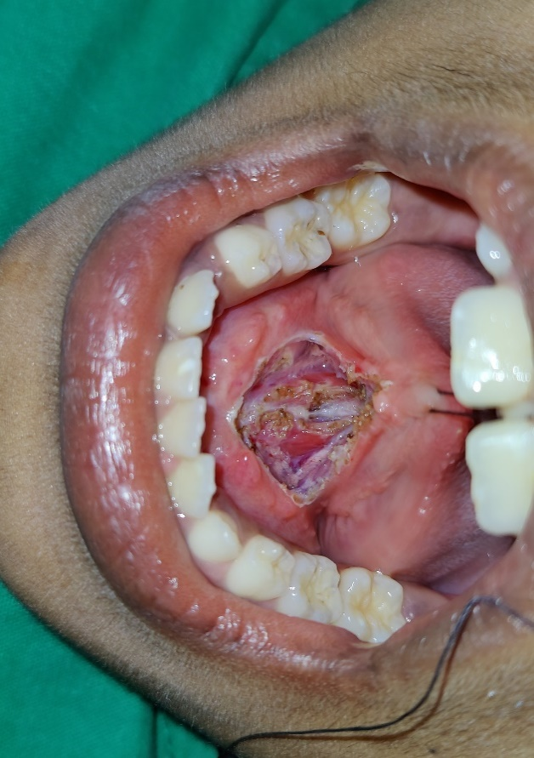

D
C

Figure 2: Frenectomy with diode laser (A) Preoperative image; (B) Intraoperative image; (C) Immediate postoperative image; (D) One-month postoperative image
Following intraoral antisepsis, local anesthesia was administered bilaterally to the frenum using 2% lidocaine with 1:80,000 epinephrine. Both the patient and the operator wore protective eyewear prior to the procedure. A diode laser was employed for the frenectomy, operating at a wavelength of 980 nm, 330 mJ energy, 50 Hz frequency, average power of 2 W, and a pulse interval of 30 ms, in contact mode. Laser application commenced at the frenum insertion closest to the tip of the tongue and progressed distally toward the oral floor, parallel to the long axis of the tongue, using gentle brushing movements (Figure 2B). The procedure resulted in a clean, well-defined diamond-shaped surgical wound with minimal intraoperative bleeding, thereby eliminating the need for suturing (Figure 2C).
The patient tolerated the procedure well, and adequate hemostasis was achieved immediately, consistent with the coagulative properties of diode lasers. Postoperatively, the patient reported minimal discomfort, and no clinically evident edema or infection was observed. Tongue mobility exercises were advised to enhance functional recovery. At the one-month follow-up, complete and uneventful wound healing was evident (Figure 2D), supporting the role of laser-assisted frenectomy in promoting favorable healing outcomes in pediatric patients.
CASE 3
A 10-year-old male patient with ankyloglossia was referred to the Department of Paediatric Dentistry with a chief complaint of speech impairment, characterized by difficulty in articulation, secondary to a short lingual frenum. Clinical evaluation confirmed severe Class

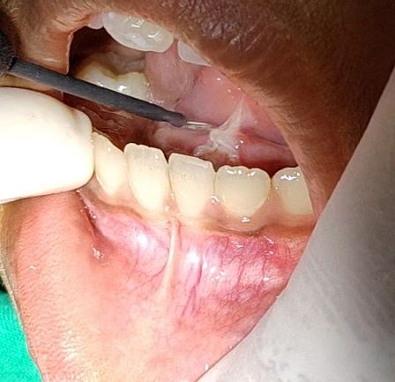
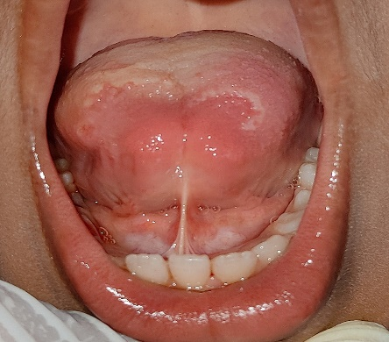
III ankyloglossia, as per Kotlow’s classification (Figure 3A). Intraoral examination revealed restricted tongue mobility, which contributed to the observed speech difficulties.

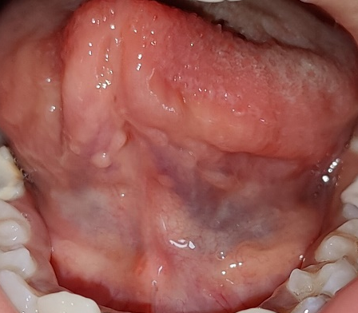
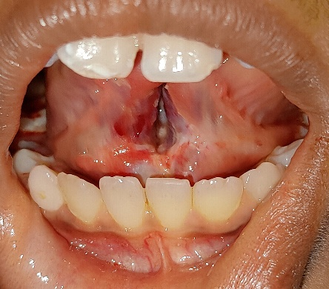

Figure 3: Frenectomy with electrocautery (A) Preoperative image; (B) Intraoperative image; (C) Immediate postoperative image; (D) One-month postoperative image
The frenectomy was performed using electrocautery. The operative site was anesthetized with 2% lignocaine containing 1:80,000 adrenaline. An incision was made using a loop electrode with gentle brushing movements in the “cut + coagulate” mode. The fibrous bands of the frenulum were released, resulting in a blunt surgical incision (Figure 3B). To minimize thermal damage and manage charred tissue, the ablated area was continuously wiped with moist gauze, and the frenum attachment to the alveolar ridge was also excised to prevent gingival tension.
Immediate postoperative assessment demonstrated adequate hemostasis, and suturing was not required (Figure 3C). Postoperative instructions were provided accordingly. Tongue mobility exercises were advised. Complete healing was noted at the one-month follow-up (Figure 3D).
DISCUSSION
Ankyloglossia is a congenital anomaly that may adversely affect oral functions such as speech, mastication, swallowing, and oral hygiene maintenance, particularly in pediatric patients (Segal et al., 2007; Garrocho-Rangel et al., 2019). While mild cases may remain asymptomatic and require no intervention, moderate to severe forms associated with functional impairment often necessitate surgical management (Kotlow, 1999; Junqueira et al., 2014). In accordance with CARE guidelines, all three cases in the present series demonstrated clear clinical indications for intervention, namely severe (Class III) ankyloglossia and associated speech impairment.
Speech articulation difficulties are among the most commonly reported functional consequences of ankyloglossia in school-aged children. Restricted tongue elevation and protrusion limit precise tongue placement required for articulation of alveolar and palatal consonants such as /t/, /d/, /n/, /l/, /r/, /z/, /ch/, and /sh/ (Segal et al., 2007; Garrocho-Rangel et al., 2019). All patients in this case series exhibited difficulty in articulating similar phonemes, reinforcing previous findings that severe ankyloglossia can compromise speech clarity. Surgical release of the lingual frenulum improves tongue mobility and may contribute to enhanced speech outcomes, particularly when supplemented with postoperative tongue exercises or speech therapy (Messner & Lalakea, 2002).
Surgical management includes procedures such as frenotomy, frenectomy, and frenuloplasty. A frenotomy involves a simple incision of the lingual frenulum and is commonly performed in infants, particularly to address breastfeeding difficulties. Frenectomy entails complete excision of the frenulum and is often indicated in older children or adolescents with more pronounced restriction. Frenuloplasty involves surgical alteration and repositioning of the frenulum, frequently combined with suturing, and is preferred in cases requiring functional and anatomical correction (Cortés et al., 2025).
This case series highlights three commonly used surgical techniques for frenectomy—conventional scalpel, diode laser, and electrocautery—allowing comparison of their clinical performance and outcomes, as recommended by case series reporting standards. The scalpel frenectomy performed in Case 1 remains a widely accepted and cost-effective technique, offering precise tissue removal and predictable healing (Gyawali et al., 2021). However, it is often associated with increased intraoperative bleeding, the need for suturing, and relatively longer operative time when compared to advanced modalities (Lestari et al., 2024). Despite these drawbacks, satisfactory wound healing and improved tongue mobility were achieved, supporting its continued relevance in clinical practice.
Laser-assisted frenectomy, demonstrated in Case 2, has gained increasing acceptance in pediatric dentistry due to its minimally invasive nature and improved patient comfort. Diode lasers provide excellent hemostasis, reduced postoperative pain, minimal edema, and elimination of suturing, which is particularly advantageous in pediatric patients (Vellore et al., 2024; Solanke et al., 2025). Additionally, the bactericidal effect of laser irradiation may promote favorable wound healing (Gyawali et al., 2021). The favorable intraoperative and postoperative outcomes observed in this case align with existing literature supporting laser frenectomy as a child-friendly alternative.
Electrocautery, as utilized in Case 3, offers the advantage of simultaneous cutting and coagulation, resulting in effective intraoperative hemostasis, improved surgical field visibility, and reduced operative time, which is particularly beneficial in pediatric patients where minimizing procedure duration is desirable (Gyawali et al., 2021; Frezza et al., 2023). The ability of electrocautery to achieve immediate coagulation often eliminates the need for suturing and contributes to efficient soft-tissue management. However, the application of thermal energy carries a potential risk of collateral tissue damage if inappropriate power settings or uncontrolled movements are used, which may adversely affect wound healing (Mazzoni et al., 2022). In the present case, the use of controlled brushing movements and continuous debridement of charred tissue helped limit lateral thermal spread, thereby minimizing tissue injury and promoting satisfactory healing.
Postoperative tongue mobility exercises are an important adjunct to surgical release of ankyloglossia, as they help reinforce the increased range of motion achieved with frenectomy and promote neuromuscular coordination of the tongue. These exercises typically include protrusion, elevation, lateral movements, and circular motions of the tongue performed multiple times daily, and are designed to enhance kinesthetic awareness and prevent reattachment of the lingual frenulum. Evidence from recent case reports and clinical observations supports the value of structured tongue exercises following frenectomy, demonstrating improved tongue mobility and functional outcomes when exercises are combined with surgical release in children and young adults (Dodal et al., 2024). In the present case series, all patients were advised postoperative tongue mobility exercises as part of the rehabilitation protocol, which likely contributed to the satisfactory healing, absence of reattachment, and improved tongue mobility observed at the one-month follow-up.
CONCLUSION
Ankyloglossia can significantly affect tongue mobility and speech in children, necessitating timely diagnosis and appropriate intervention. This case series demonstrates that conventional scalpel, diode laser, and electrocautery techniques are all effective modalities for the surgical management of severe (Class III) ankyloglossia in pediatric patients. While the scalpel technique remains a reliable and cost-effective option, laser and electrocautery approaches offer advantages such as superior hemostasis, reduced need for suturing, and improved postoperative comfort. All patients in this series exhibited satisfactory healing and improved tongue mobility following surgery, particularly when supplemented with postoperative tongue mobility exercises. The choice of surgical technique should be guided by clinical severity, operator expertise, and available resources to achieve optimal functional outcomes.

CONSENT
Written informed consent was obtained from the parents and has been retained by the authors.
ETHICAL APPROVAL
Not applicable
REFERENCES
Cortés, I. G. G., Ramirez, F. L. M., Quintero, M. T. P., Ramirez, E. N., Villarreal, M. M., Arreozola, H. Q., & Solis Soto, J. M. (2025). Ankyloglossia in pediatric dentistry: A case report and literature review. International Journal of Applied Dental Sciences, 11(3), 156–160. https://doi.org/10.22271/oral.2025.v11.i3c.2200
Dodal, A. A., Shelke, A. U., Subhadarsanee, C., Gaikwad, S. P., Patil, K. S., & Bajaj, P. (2024). Postoperative tongue exercises for ankyloglossia following lingual frenectomy: A case report. Cureus, 16(9), e69806. https://doi.org/10.7759/cureus.69806
Frezza, A., Ezeddine, F., Zuccon, A., Gracco, A., Bruno, G., & De Stefani, A. (2023). Treatment of Ankyloglossia: A Review. Children, 10(11), 1808. https://doi.org/10.3390/children10111808
Garrocho-Rangel, A., Herrera-Badillo, D., Pérez-Alfaro, I., Fierro-Serna, V., & Pozos-Guillén, A. (2019). Treatment of ankyloglossia with dental laser in paediatric patients: Scoping review and a case report. European Journal of Paediatric Dentistry, 20(2), 155–163. https://doi.org/10.23804/ejpd.2019.20.02.15
Gyawali, N., Sundas, S., Sah, B. K., & Dhakal, N. (2021). Conservative Management of Ankyloglossia by Diode Laser: A Case Report. J Nepal Assoc Pediatr Dent. https://doi.org/10.3126/jnapd.v2i1.41599
Junqueira, M. A., Cunha, N. N. O., Costa e Silva, L. L., Araújo, L. B., Moretti, A. B. S., Couto Filho, C. E. G., & Sakai, V. T. (2014). Surgical techniques for the treatment of ankyloglossia in children: A case series. Journal of Applied Oral Science, 22(3), 241–248. https://doi.org/10.1590/1678-775720130629
Lestari, A. R., Puteri, M. M., Tedjosasongko, U., Oktaviani, P. D., Rahmawati, L., & Purnamasari, S. (2024). Management of familial ankyloglossia in pediatric patient under electrocautery procedure. International Journal of Scientific Advances, 5(5). https://ijscia.com/volume-5-issue-5-page-5/
Kotlow, L. A. (1999). Ankyloglossia (tongue-tie): A diagnostic and treatment quandary. Quintessence International. https://pubmed.ncbi.nlm.nih.gov/10635253/
Messner, A. H., & Lalakea, M. L. (2002). The effect of ankyloglossia on speech in children. Otolaryngology--Head and Neck Surgery, 127(6), 539–545. https://doi.org/10.1067/mhn.2002.129731
Mazzoni, A., Navarro, R. S., Fernandes, K. P. S., Mesquita-Ferrari, R. A., Horliana, A. C. R. T., Silva, T., Santos, E. M., Sobral, A. P. T., Júnior, A. B., Nammour, S., Motta, L. J., & Bussadori, S. K. (2022). Comparison of the effects of high-power diode laser and electrocautery for lingual frenectomy in infants: A blinded randomized controlled clinical trial. Journal of Clinical Medicine, 11(13), 3783. https://doi.org/10.3390/jcm11133783
Segal, L. M., Stephenson, R., Dawes, M., & Feldman, P. (2007). Prevalence, diagnosis, and treatment of ankyloglossia: Methodologic review. Can Fam Physician. http://www.cfp.ca/cgi/content/full/53/6/1027
Solanke, S. H., Jawdekar, A., Mistry, L. N., Kale, S., Saraf, T., & Tafti, F. (2025). Lingual frenectomy in 3–9-year-old children using diode laser: A case series. Cureus, 17(11). https://doi.org/10.7759/cureus.97893
Vellore, K. P., Kondamadugu, S., Challa, S. K., Ganesh, M., Kumari, K., Sharma, D., & Bartarya, T. (2024). A closer look at ankyloglossia in children—A case series. Journal of Dr. YSR University of Health Sciences, 13, 157–161. https://doi.org/10.4103/jdrysruhs.jdrysruhs_154_23

