Case report
Imaging of Pediatric Venous Vascular Malformation in a 6 year old Patient: A case report

Abstract:
Venous Vascular Malformations[1] are typically congenital, that means they are present by birth. However, they may not always be apparent until later in childhood or even adulthood. We present a case of 6 year old patient with Venous Vascular Malformation on Left Axilla of the arm which was diagnosed[2] using imaging studies with High Resolution Real Time Ultra sonography and Magnetic Resonance Imaging. This confirms the presence of Venous Vascular Malformation. This case highlights the importance of early detection and prevent complications such as pain and discomfort, swelling and inflammation, Bleeding or hemorrhage and sometimes infection. Hence Sclerotherapy[3] is managed which is a common treatment for venous vascular malformations.
Keywords:
Venous Vascular Malformations, Sclerotherapy, Ultra sonography and Magnetic Resonance Imaging
Introduction:
Venous Vascular Malformations occur due to abnormal development of the venous system. Generally these malformations anywhere in the body and are characterized by an abnormal network of veins which sometimes cause fever, pain in that area accompanied by swelling. In 6 year old, imaging helps in diagnosing and managing Venous vascular Malformations. It determines the presence and to how much extent the swelling in the affected area. It also evaluate the size , location ,and depth of the Malformation. A treatment plan is made such as Sclerotherapy[4] and surgery
Case Presentation:
A 6 year old girl presented with sudden swelling[fig1] on the left axilla followed with high fever. The swelling increased in size over a time period resembling a lump in external appearance. The physical examination revealed soft compressible tissue which reduces in size when applied pressure. Imaging studies were done such as Ultra sound, High Resolution Real time Ultrasonography, and MRI. Finally by doing these Imaging tests confirmed the presence of Venous Vascular Malformations[5].
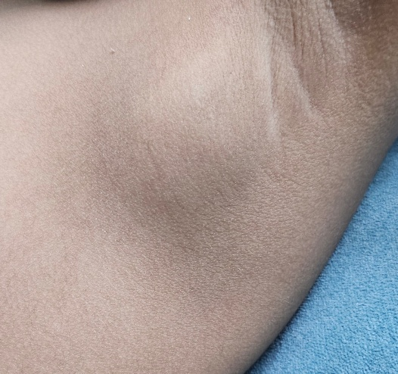
Fig 1: sudden swelling on the left axilla of 6 year old girl.
Image studies:
Ultra sound:
In ultra sound scan Conglomerate left axillary lobulated suppurative lymphadenopathy was seen measuring ~36x26x40mm. It showed thin peripheral wall and predominantly liquefied anechoic fluid component with fine mobile internal vascularity was observed. Echogenic internal debris also seen[6]]. Perilesional soft tissues showed mild inflammatory edema. No mass lesion seen.
High resolution Real time Ultrasonography:
Evidence of well defined multi-loculated subcutaneous cystic mass lesion of 56x34x44mm(vol-45cc)in the left axilla with inter- muscular extension seen. Maximum size of loculation is 33x21x29mm(vol-11cc[7]). color Doppler shown no demonstrable flow in the lesion. Right axilla observed normal.
Magnetic Resonance Imaging:
Techniques applied:
T1, T2STIR,T2SPAIR and GRE coronals.
T2 , T2 SPAIR axials.
Post contrast dynamic scan, T1 SPIR axials, coronals and sagittals.
Discussions
Well defined T1,T2 and STIR hyperintense lesion with multiple cystic areas with thick septations observed. Ill defined interposed soft tissue involving the entire left axilla approximately measuring 7.3x3.2x4.3cm seen. The larger cystic area showed fluid levels with blooming in the dependent hypointense fluid content[8]. Findings suggests Hemorrhage. The non dependent fluid shows hyperintense signals. There was no infiltration into the surrounding muscles or chest wall. Medially it is abuttingthe ribcage. Posteriorly it is abutting the sub capularis muscle. Superiorly it displace the neurovascular bundle with no evidence of grossly dilated vascular structures. Mild surrounding the lesion observed. Visualised bones showed normal signal intensity gleno-humeral joint space was observed normal. Acromioclavicular joint space observed normal. Visualised muscles show signal intensity. No evidence of any synovial effusion in the shoulder joint.
Impressions:
In Ultra sound impressions are conglomerate[9] left axillary lobulated suppurative lymphadenopathy with predominantly drainable liquefied abscess components observed. Suggesting infection.
In high density ultra sound well defined multi loculated subcutaneous cystic mass lesion in the Lt axilla with inter-muscular extension seen. There was no demonstrable flow on color Doppler showing possibilities of Lymphangioma.
In Magnetic Resonance imaging: Well defined large T1,T2 and STIR hyperintense lesion with multiple cystic areas showed thick blood fluid levels with septations[10]. There were ill defined enhancing interposed softtissue involved the entire left axilla with extensions described suggesting Highly suggestive of VENOUS VASCULAR MALFORMATION.
Treatment:
The patient underwent sclerotherapy [11]sessions by taking sodium tetracyl sulfate with general Anesthesia[fig2]. After the therapy the patient was good in condition and discharged on the same day. The swelling in the patient slowly decreased showing reduction in size of the malformation. The following appointments showed good improvement and patient abled to resume normal activities.
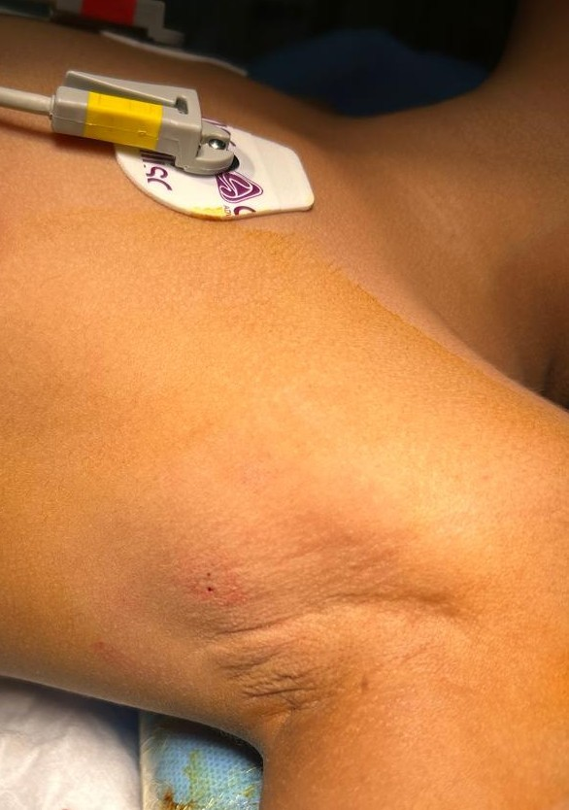

Fig 2: Sclerotherapy procedure injected on the left axilla of 6 year old girl patient.
After Treatment:
Sclerotherapy[12] is usually performed in multiple sittings, with a gap of several weeks apart. The number of sittings required depending on size, and extent of the Malformations. The patient responded well with the treatment. As the Sclerosing agent injected into the affected vessels little bruising will be seen around the treated area. Itching and irritation was also observed in the patient after the treatment. Three sittings of Sclerotherapy[13] sessions typically 4-6 weeks apart reduced the swelling on the left axilla of the patient[fig3]. There was significant improvement with response to treatment.
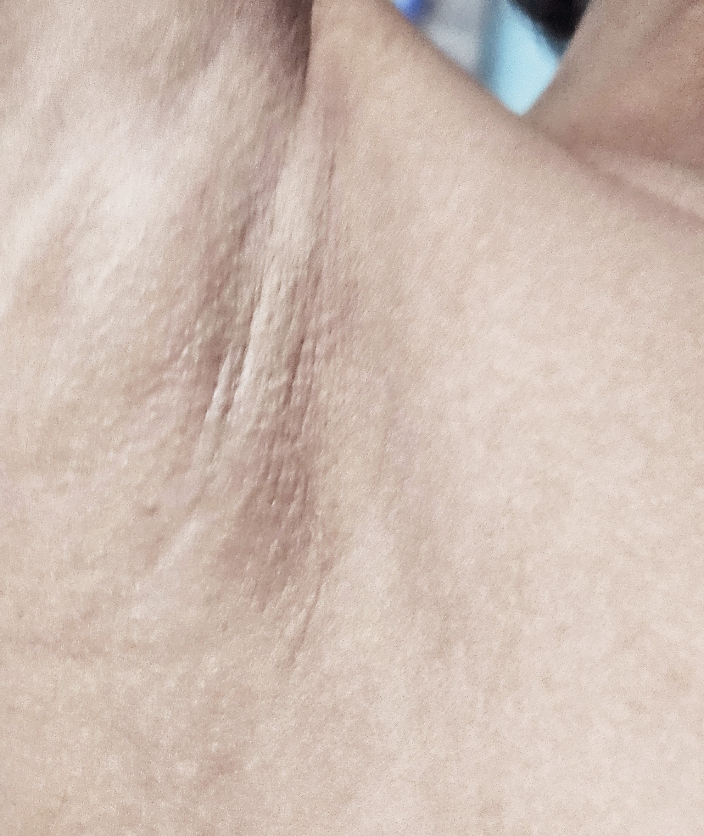
Fig 3: After three sittings of Sclerotherapy patient responded well with reduced swelling on the left axilla of the patient.

The Venous Vascular Malformations are rare congenital malformations. They require early diagnosis to prevent from further complications. Such rare cases in pediatrics highlights the importance of getting to know by birth. Hence such disorders have multidisciplinary approach in managing Venous Vascular Malformations which involve pediatricians, radiologists and surgeons[14]. Sclerotherapy is a safe and effective treatment in children. Though the procedure is safe it has side effects associated with sclerotherapy .Patient felt little irritation, discomfort, redness and inflammation at the injection site. The treated area was elevated to promote blood flow and Compression bandages were used to reduce swelling. The patient was advised to avoid strenuous activities, and maintained clean the treated area and monitor the signs of complications such as increased pain, swelling, and redness. Patient was monitored regularly to the treated area for signs of recurrence. Hence early diagnosis play crucial role in managing the patient to avoid complications.
Conclusion:
With High Resolution Ultra sound and Magnetic Resonance imaging played effective role in diagnosis. These imaging helped confirming the diagnosis of Venous Vascular Malformations[15] and distinguishing them from other vascular anomalies. The Identification of feeding vessels was seen by MRI which helps sclerotherapy treatment[16] there by guiding treatment planning. The use of sclerotherapy treatment is very valuable because of less side effects giving pediatric patients with Venous Vascular Malformations. Multidisciplinary care is also taken in the form of Pediatrics, Intraventional radiologist and surgeon. During Sclerotherapy treatment[17] pain management specialist helped manage pain and discomfort. Further studies are needed to optimize treatment[18] protocols and improve outcomes.

COMPETING INTERESTS DISCLAIMER:
Authors have declared that they have no known competing financial interests OR non-financial interests OR personal relationships that could have appeared to influence the work reported in this paper.
References:
1. *Colmenero, I., & Knöpfel, N. (2021). Venous Malformations in Childhood: Clinical, Histopathological and Genetics Update. Dermatopathology. https://doi.org/10.3390/dermatopathology8040050
2. *Diagnosis and Management*: A review of diagnosis and management of venous malformations in children, including clinical features, imaging, and treatment options (Lee et al., 2015) ².
3. *Zhuo, K. Y., Russell, S., Wargon, O., & Adams, S. (2017). Localised intravascular coagulation complicating venous malformations in children: Associations and therapeutic options. *Journal of Paediatrics and Child Health*, *53*(8), 737–741. https://doi.org/10.1111/jpc.13461

4. *Aronniemi, J., Castrén, E., Lappalainen, K., Vuola, P., Salminen, P., Pitkäranta, A., & Pekkola, J. (2016). Sclerotherapy complications of peripheral venous malformations. Phlebology, 31(10), 712–722. https://doi.org/10.1177/0268355515613740
5. *Surgical Resection*: A review of surgical resection of venous malformations in children, including outcomes and complications (Laurian et al., 2017) ².

6. *Nguyen, H. L., Boon, L. M., & Vikkula, M. (2014). Genetics of vascular malformations. Seminars in Pediatric Surgery, 23(4), 221–226. https://doi.org/10.1053/j.sempedsurg.2014.06.014³.
7. *Vikkula, M., Boon, L. M., & Mulliken, J. B. (2001). Molecular genetics of vascular malformations. Matrix Biology, 20(5-6), 327-335. https://doi.org/10.1016/s0945-053x(01)00150-0

8. *Sepúlveda, P., Zavala, A., & Zúñiga, P. (2017). Factors associated with thrombotic complications in pediatric patients with vascular malformations. *Journal of Pediatric Surgery*, *52*(3), 400–404. https://doi.org/10.1016/j.jpedsurg.2016.10.048⁵.
9. *Dompmartin, A., Acher, A., Thibon, P., Tourbach, S., Hermans, C., Deneys, V., Pocock, B., Lequerrec, A., Labbé, D., Barrellier, M.-T., Vikkula, M., & Boon, L. M. (2008). Association of localized intravascular coagulopathy with venous malformations. Archives of Dermatology, 144(7), 873–877. https://doi.org/10.1001/archderm.144.7.873³.

10. *Aronniemi, J., Långström, S., Mattila, K. A., Mäkipernaa, A., Salminen, P., Pitkäranta, A., Pekkola, J., & Lassila, R. (2021). Venous Malformations and Blood Coagulation in Children. *Children (Basel)*. https://doi.org/10.3390/children8040312
11. *Foam Sclerotherapy*: A study on foam sclerotherapy for venous malformations in children, including efficacy and safety (Bergan et al., 2016) ⁵.
12. *Hung, P. C., Chen, C. H., & Hsieh, C. S. (2017). Venous Malformation and Localized Intravascular Coagulopathy in Children. European Journal of Pediatric Surgery, 27(2), 181–184. https://doi.org/10.1055/s-0036-1582241
13. *Palo, N., Chauhan, V. S., Lakhanpal, M., Dey, P. C., & Malik, C. (2023). Scattered Musculoskeletal Venous Malformations in Children: A Rare Report on Clinical Evaluation and Sclerotherapy with Adjunctive Stasis of Efflux. Journal of Orthopaedic Case Reports. https://doi.org/10.13107/jocr.2023.v13.i07.3774
14. Dasgupta, R., & Fishman, S. J. (2014). ISSVA classification. Seminars in Pediatric Surgery, 23(4), 158-161. https://doi.org/10.1053/j.sempedsurg.2014.06.016
15. Dompmartin, A., Ballieux, F., Thibon, P., Lequerrec, A., Hermans, C., Clapuyt, P., Barrellier, M. T., Hammer, F., Labbé, D., Vikkula, M., & Boon, L. M. (2009). Elevated D-dimer level in the differential diagnosis of venous malformations. Archives of Dermatology, 145(11), 1239-1244. https://doi.org/10.1001/archdermatol.2009.296

16. Koo, K. S. H., Dowd, C. F., Mathes, E. F., Rosbe, K. W., Hoffman, W. Y., Frieden, I. J., & Hess, C. P. (2015). MRI phenotypes of localized intravascular coagulopathy in venous malformations. Pediatric Radiology, 45(11), 1690-1695. https://doi.org/10.1007/s00247-015-3389-6
17. Markovic, J. N., & Shortell, C. K. (2021). Venous malformations. Journal of Cardiovascular Surgery, 62(5), 456-466. https://doi.org/10.23736/S0021-9509.21.11911-1
18. Seront, E., Van Damme, A., Boon, L. M., & Vikkula, M. (2019). Rapamycin and treatment of venous malformations. Current Opinion in Hematology, 26(3), 185-192. https://doi.org/10.1097/MOH.0000000000000498

