Case report
Epithelial-Myoepithelial Carcinoma of Parotid Gland : A Diagnostic and Therapeutic Conundrum

Abstract:
Introduction:
Epithelial-Myoepithelial Carcinoma (EMC) is a rare biphasic salivary gland tumour primarily affecting the parotid gland with an oddly high tendency to recur locally after surgical excision.. Owing to its infrequent incidence, there are no established treatment protocols, however, wide local excision with adequate margins remains the mainstay of therapy, often supplemented by radiotherapy, particularly in cases with high-risk features.

Case Report:
A 60-year-old female presented with a painless, progressive swelling in the right pre-auricular region. Imaging and Cytological examination suggested pleomorphic adenoma. She underwent right superficial parotidectomy. Histopathological examination revealed EMC with capsular invasion. Immunohistochemistry confirmed biphasic epithelial- myoepithelial differentiation. Adjuvant radiotherapy (60Gy/30#) was delivered owing to close margins and perineural invasion. Patient is currently disease free since last 3 years.

Conclusion:
EMC poses a diagnostic challenge due to its morphological resemblance to benign counterparts. Complete excision with or without adjunctive radiotherapy, offers excellent local control and long term disease-free survival.

Keywords :
Epithelial-myoepithelial carcinoma, rare tumour, parotid gland, salivary gland tumour

Introduction:
Epithelial-myoepithelial carcinoma (EMC) is a rare biphasic tumour of salivary glands. With an incidence of less than 1 %, of all salivary neoplasms, parotid is most frequently implicated with few cases reported in submandibular and minor salivary glands as well.¹ Patients usually present with a painless slow growing mass that progresses over months to years. The tumour may exhibit rapid growth leading to pain and facial nerve dysfunction as sighted in sporadic instances. Accurate diagnosis mandates prudent histopathological examination & immunohistochemical analysis. A peculiar characteristic of this tumour is its tendency to recur locally post-surgical excision, with an incidence of 23-50%.¹ Given its infrequent occurrence, there are no established treatment protocols. This report illustrates a case of EMC of the parotid gland in a 60 year old female managed with surgery followed by adjuvant radiotherapy.

Case Presentation:
A 60 year old female with a known history of hypertension presented to the surgery OPD with chief complaints of a solitary painless progressive swelling in the right pre-auricular region since four years. There was no history of facial asymmetry, overlying skin changes or variation in size with salivation. General physical examination was non-contributory. Local examination revealed a firm, non-tender, well defined, freely mobile 3 cm x 2 cm swelling in the right pre-auricular region. Right facial nerve examination was within normal limits. There were no clinically palpable cervical lymph nodes or lumps elsewhere in the body. Based on these findings, a working diagnosis of benign tumour of parotid gland was established. Contrast-enhanced Magnetic Resonance Imaging (CE-MRI) scan of the face and neck revealed a well-defined hyperintense, solid lesion in the superficial lobe of the parotid gland.(Figure. 1). Fine needle aspiration cytology (FNAC) was performed thereafter and microscopic features were suggestive of pleomorphic adenoma.

The patient subsequently underwent a Right Superficial Parotidectomy. With an unusual turn of events, post-operative histopathological examination led to a definitive diagnosis of epithelial-myoepithelial carcinoma of parotid gland with capsular invasion. The tumour was composed of a dual cell population with an array of inner ductal epithelial cells surrounded by clear cells in a background of myxoid changes. Immunohistochemistry further added weight to the diagnosis. Epithelial cells were positive for cytokeratin, while the clear cells were positive for S100, p63 and smooth muscle actin (SMA), corroborating with their myoepithelial origin (Figure. 2-4). The closest margin was 0.5cm. Three lymph nodes were isolated and none were positive for tumour deposits.

Owing to the locally aggressive growth pattern of the tumour, inadequate LN dissection along with unfavourable histological features such as capsular invasion, perineural invasion and close margins, the case was re-evaluated in a multidisciplinary tumour board. It was decided to give adjuvant radiotherapy to the tumour bed to a total dose of 60 Gy in 30 fractions using a 3D conformal technique. The patient tolerated radiotherapy well. Post-treatment imaging done at 12 weeks post completion of RT had no evidence of residual disease. The patient is currently on regular follow-up, since last 3 years.

Discussion:
Salivary gland neoplasms account for less than 5% of all head and neck malignancies², with approximately 70% of them occurring in the parotid gland. Majority of them are benign They exhibit diversity in histological subtypes with overlapping microscopic features. The most common histological variants include Mucoepidermoid Carcinoma, Adenoid Cystic Carcinoma, Acinar Cell Carcinoma, Carcinoma ex Pleomorphic Adenoma etc.³ Epithelial-myoepithelial carcinoma (EMC) is an exceptionally rare tumour with low malignant potential, compromising less than 1% of all salivary gland tumours.^{3,4}

Owing to its exquisite histopathological morphology , early literature described this neoplasm under various epithets such as Adenomyoepithelioma, Clear Cell Adenoma, Tubular Solid Adenoma, Glycogen-rich Adenoma etc. In 1972 however, Doneth et al formally recognised it as a distinct entity and the term was henceforth incorporated into the World Health Organization (WHO) classification of salivary gland tumours in 1991.⁵

The parotid gland is the most frequently implicated site, as highlighted in the present case. However, it can also occur in the submandibular glands, minor salivary glands, palate, base of the tongue, maxillary sinus, trachea etc. Other less commonly reported sites are breast, lungs, kidneys, and uterus.⁶ EMC most commonly affects females in 6th to 7th decade of life.⁷ A similar scenario was seen in our case.

Clinically, EMC typically presents as a slow-growing, mobile mass within the parotid gland, ranging from 2- 12 cm in size.⁵ It can spread locally to regional lymph nodes as well.⁷ Although distant metastases to organs such as the lung, bone, brain and kidney have been reported, such cases tend to culminate in fatality.⁷ As far as radiological assessment is concerned, CT and MR appearances of EMC are highly nonspecific and cannot differentiate it from more common parotid neoplasms. Fine Needle Aspiration Cytology (FNAC) provides certain diagnostic cues but is often insufficient alone for definitive diagnosis as demonstrated by Arora et al. in their study where four cases of EMC had a provisional diagnosis of a benign tumor based on pre-op FNAC.⁸ Thus, accurate diagnosis mandates prudent histopathological evaluation and immunohistochemistry analysis.⁹

Microscopically, tumour is composed of biphasic cell population- an outer layer of large, clear & polygonal myoepithelial cells and an inner layer of eosinophilic, cuboidal epithelial cells. The lumen often contains Periodic Acid-Schiff (PAS) positive eosinophilic material. Despite of the well differentiated histology and slow growing nature, EMCs lack a capsule and rather exhibit a multinodular locally invasive growth pattern, with a high predilection for perineural spaces, as evident in our case too.¹⁰
In a few rare instances, EMCs may undergo high-grade transformation in either it’s epithelial or myoepithelial component, leading to a more aggressive clinical course.¹¹

Immunohistochemistry further validates the diagnosis of EMC. Tumour cells frequently show positivity for epithelial markers such as CK7, CK14, CK5/6, S100 protein, EMA, and SMA.¹² Additionally, calponin and GFAP are under scrutiny as reliable markers for identifying myoepithelial differentiation in salivary gland lesions.¹³

Standard treatment guidelines are yet to be established due to the unusual incidence of this tumour. Wide surgical excision along with adjacent lymph node dissection is the most frequently employed management technique. Recurrences have been documented anywhere from 9 months to 28 years post-surgery at reported rates of about 23-50%. Therefore, achieving negative soft-tissue margins during resection is desirable.¹⁴ Certain histopathologic features such as solid growth patterns, nuclear atypia, DNA aneuploidy, necrosis, positive surgical margins, high proliferative index etc. are often associated with more aggressive tumour biology in terms of increased loco-regional recurrences and distant metastasis. In fact, Seethala et al. in their study even correlated positive margin status, angiolymphatic invasion, necrosis, and anaplasia of myoepithelial cells with reduced survival.¹⁵ Surgery alone may not be adequate in such scenarios- making them potential prospects for adjuvant radiotherapy.^{15,16}

A combination of surgery and radiotherapy is recommended for tumours > 4cm.The role of chemotherapy in treating this neoplasm remains unclear.¹⁷ In our patient, on account of the locally aggressive nature of the tumour, inadequate LN dissection along with unfavourable histological features such as capsular invasion, perineural invasion and close margins, PORT at a dose of 60 Gy over 30 fractions was given to the post-operative tumour bed. Currently the patient is free of any symptoms or disease.

Conclusion:
EMC is an unusual salivary gland tumour that primarily affects old women. Its clinical and radiological presentations are often similar to benign neoplasms, thus making diagnosis challenging without histopathology and immunohistochemistry. Due to its infrequency, standardized treatment protocols have not been established yet. However, surgical resection, with or without adjunctive radiotherapy, remains the most commonly employed treatment approach. Despite being classified as a low-grade malignancy, EMC poses a significant risk of local recurrence and distant metastasis, necessitating close follow-up.

References:
- Politi M, Robiony M, Avellini C, Orsaria M. Epithelial–myoepithelial carcinoma of the parotid gland: clinicopathological aspect, diagnosis and surgical consideration. Ann Maxillofac Surg. 2014;4:99–102.

- Halperin EC, Wazer DE, Parez CA, Brady LW. Perez and Brady’s principles and practice of radiation oncology. 6. Philadelphia: Lippincott Williams & Wilkins; 2013.

- Taş A, Yağiz R, Altaner S, Koten M, Karasalihoğlu AR. A case of epithelial–myoepithelial carcinoma of the parotid gland. Kulak Burun Boğaz Ihtis Derg. 2003;10(4):171–4.

- Sharma S, Patankar S. An unusual case of epithelial–myoepithelial carcinoma of the parotid gland radiologically simulating a benign lesion. J Oral Maxillofac Pathol. 2014;18(1):118–20.

- Simpson RH, Clarke TJ, Sarsfield PT, Gluckman PG. Epithelial–myoepithelial carcinoma of salivary glands. J Clin Pathol. 1991;44(5):419–23.

- Batsakis JG, El-Naggar AK, Luna MA. Epithelial–myoepithelial carcinoma of salivary glands. Ann Otol Rhinol Laryngol. 1992;101(6):540–2.

- Noel S, Brozna JP. Epithelial–myoepithelial carcinoma of salivary gland with metastasis to lung: report of a case and review of the literature. Head Neck. 1992;14(5):401–6.

- Arora SK, Sharma N, Bhardwaj M. Epithelial myoepithelial carcinoma of head and neck region. Indian J Otolaryngol Head Neck Surg. 2013;65(1):163–6.

- Silvers AR, Som PM, Brandwein M. Epithelial-myoepithelial carcinoma of the parotid gland. Am J Neuroradiol. 1996 Mar 1;17(3):560-2.

- Manteghi A, Centric A, Zwillenberg S, Minimo C. Submandibular Gland Epithelial-Myoepithelial Carcinoma with Osseous Metastasis: A First Reported Case and Review of the Literature. Spartan Med Res J. 2016;1(1).

- Roy P, Bullock MJ, Perez-Ordoñez B, Dardick I, Weinreb I. Epithelial–myoepithelial carcinoma with high grade transformation. Am J Surg Pathol. 2010;34(9):1258–65.

- Cosentini TB, Brasao MT, Nascimento Souza KC, De Faria PR, De Moraes S, Loyola Mota A, Da Silva SJ and Cardoso SV: Myoepithelial carcinoma of the submandibular gland: report of a case with multiple cutaneous metastases of epithelial tumours. Oral Surg Oral Med Oral Pathol Oral Radiol Endod 2008;106(2):26-9.

- Hornick JL and Fletcher CD: Myoepithelial tumors of soft tissue: a clinicopathologic and immunohistochemical study of 101 cases with evaluation of prognostic parameters. Am J Surg Pathol 2003;27(9):1183-96.

- Morrow TA, Chun T, Mirani N. Epithelial myoepithelial carcinoma of the parotid gland. Ear Nose Throat J 1990;(69):646 – 8

- Seethala RR, Barnes EL, Hunt JL. Epithelial-myoepithelial carcinoma: a review of the clinicopathologic spectrum and immunophenotypic characteristics in 61 tumors of the salivary glands and upper aerodigestive tract. Am J Surg Pathol. 2007;31(1):44-57.

- Tralongo V, Daniele E. Epithelial–myoepithelial carcinoma of the salivary glands: a review of literature. Anticancer Res. 1998;18(1B):603–8.

- Witterick IJ, Noyek AM, Chapnik JS, Heathcote JG and Bedard YC: Observations on the natural history of a parotid epithelialmyoepithelial carcinoma of intercalated ducts. J Otolaryngol.1993;22(3):176-9.

Figure 1- Contrast-enhanced MRI of the face and neck (coronal sections) showing a well-defined hyperintense solid lesion in the superficial lobe of the right parotid gland without invasion of adjacent structures

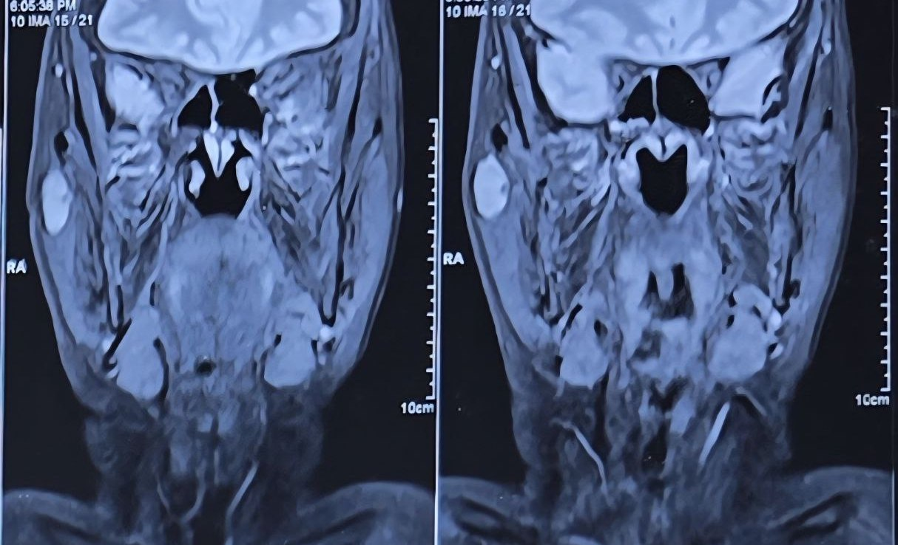
Figure 2- Hematoxylin and eosin (H&E) stained section of the parotid tumour (×200) showing biphasic architecture with inner ductal epithelial cells surrounded by clear myoepithelial cells in a background of hyalinised and myxoid stroma, characteristic of epithelial-myoepithelial carcinoma.
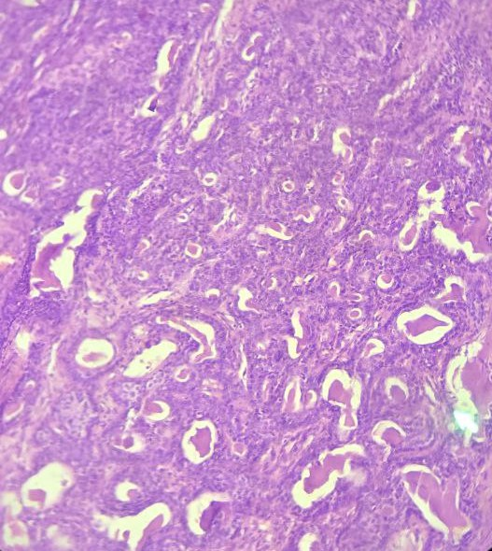

Figure 3-Immunohistochemistry (IHC) for Cytokeratin (×200) demonstrating strong cytoplasmic positivity in the inner ductal epithelial cells, highlighting the epithelial component of epithelial-myoepithelial carcinoma.
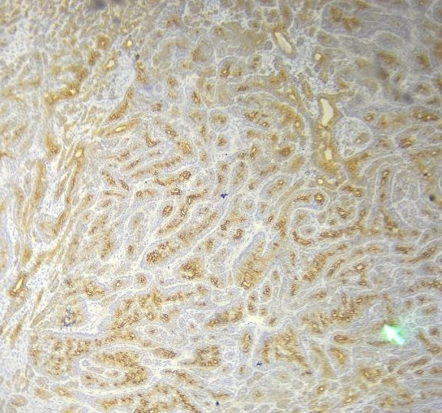

Figure 4- Immunohistochemistry (IHC) section (×200) showing strong positivity in the peripheral clear myoepithelial cells, confirming their myoepithelial origin in epithelial-myoepithelial carcinoma of the parotid gland.
