Culture-Dependent Isolation and Characterization of Lignocellulose Degrading Bacteria from the Gut of Mole Crickets

ABSTRACT
Background:
Lignocellulose, composed of cellulose, hemicellulose, and lignin, forms the main structural component of plant biomass and represents a major renewable resource for bioenergy and bio-based products. Its biodegradation is mediated by diverse microbial communities possessing carbohydrate-active enzymes (CAZymes). The gut microbiota of soil-dwelling insects such as mole crickets (Gryllotalpidae) offers a specialized environment rich in lignocellulolytic microorganisms with potential applications in biotechnology and sustainable agriculture.
Objective:
This study aimed to isolate and characterize lignocellulose-degrading bacteria from the gut of mole crickets.
Materials and Methods:
Male and female grass- and mushroom-feeding mole crickets were manually collected from a farm in Major Porter (Leng) village, Barkin Ladi Local Government Area, Plateau State, Nigeria. The insects were surface sterilized, dissected aseptically, and the gut contents homogenized and serially diluted. Bacteriological and biochemical analyses were carried out to identify lignocellulose-degrading bacteria. Molecular characterization was performed using PCR amplification of 16S rRNA and gyrB genes, followed by sequencing and phylogenetic analysis to determine bacterial identity and relatedness.
Results:
Five lignocellulose-degrading bacterial isolates were successfully obtained from male and female mole crickets. The isolates exhibited significant enzymatic potential for lignocellulose breakdown. Molecular and phylogenetic analyses confirmed the distinct identities and relationships among the isolates, demonstrating diverse lignocellulolytic capacities.
Conclusion:
The gut bacteria of mole crickets possess strong lignocellulose-degrading abilities and can serve as effective bioinoculants to enhance soil organic matter decomposition, improve fertility, and reduce fertilizer dependency. These findings highlight their potential in biotechnological and sustainable agricultural applications.

Keywords: Mole crickets; Lignocellulose; Polymerase chain reaction; culture dependent;16S gene; Gyrase B gene.

1.0 INTRODUCTION
Lignocellulose is the plant cell-wall complex composed of cellulose, hemicellulose, and lignin. Today, cellulose Earth’s most abundant biopolymer is a central feedstock for the circular bioeconomy, underpinning bio-based materials (e.g., nanocellulose), chemicals, and advanced biofuels. Rapid progress in biorefinery science and pretreatment (including ionic liquids and deep-eutectic solvents) is improving fractionation and valorization of all three lignocellulosic polymers, expanding applications from energy to sensors, water treatment, and regenerative medicine (Sulis et al., 2025; Verdía et al., 2025; Kamdem et al., 2025; Madhushree et al., 2024; Woźniak et al., 2025).
Lignocellulose biodegradation remains governed by both environmental factors (e.g., oxygen, pH, temperature) and the composition, functional potential and interactions of the microbial community: which taxa are present, their enzyme repertoires, and community organization largely determine degradation rates and pathways. (Chen et al., 2025)
Historically fungi (especially white-rot basidiomycetes) dominated lignin depolymerization studies, and bacterial lignin degradation was considered slow and limited. Recent metagenomic, biochemical and cultivation work, however, shows bacteria (Proteobacteria, Actinobacteria, certain Firmicutes, etc.) encode diverse lignin-acting enzymes (dye-decolorizing peroxidases, laccases, and β-etherases) and can both depolymerize lignin fragments and funnel the resulting aromatics into central catabolic pathways narrowing the functional gap between fungi and bacteria. (Gu et al.,2024)
New classes of bacterial enzymes that cleave key lignin linkages (notably β-O-4 aryl-ether bonds) e.g., LigE/LigF family β-etherases and other stereospecific etherases — have been cloned, biochemically characterized, and shown to be active under mesophilic, engineered conditions. These findings explain how some bacteria can attack oligomeric/monomeric lignin fragments produced by fungal or abiotic depolymerization. (Robles-machuca et al., 2023)
Actinobacteria (including Streptomyces and other actinomycetes) remain important bacterial lignocellulose degraders; they can attack both grass and woody substrates, and several studies confirm substantial lignin and carbohydrate losses under actinomycete activity consistent with earlier observations that grasses can be more readily attacked but also showing actinomycetes can degrade wood components under the right conditions. (Gu et al.,2024)
Lignocellulose refers to plant biomass predominantly composed of the cell wall, which is a heterogeneous matrix of cellulose, hemicellulose, and lignin. In addition to these major polymers, plant cell walls also contain minor structural components such as pectins, proteins, extractives (e.g., waxes, lipids), and inorganic minerals that influence biomass recalcitrance and processing efficiency. This structural complexity makes lignocellulose both a promising renewable feedstock for bioenergy and biomaterials, and a challenging substrate for bioconversion (Madhushree et al., 2024; Woźniak et al., 2025; Sulis et al., 2025).
Lignocellulosic biomass is widely utilized across industries as a renewable raw material for the production of pulp, paper, bio-based chemicals, bioplastics, and advanced biofuels. Its industrial use is particularly advantageous because it is derived mainly from agricultural residues, forestry by-products, and dedicated energy crops, which are not primary human food sources. This minimizes competition with food production and enhances its role as a sustainable feedstock in the emerging circular bioeconomy (Madhushree et al., 2024; Woźniak et al., 2025; Sulis et al., 2025).
Lignocellulose can be converted into biofuels, platform chemicals, and renewable biomaterials through diverse processing strategies. Current lignocellulosic biorefineries employ thermal (e.g., pyrolysis, gasification), mechanical (e.g., milling, extrusion), chemical (e.g., acid/alkali pretreatment, organosolv, ionic liquids), and biological (enzymatic hydrolysis and microbial fermentation) methods, often in integrated cascades to improve efficiency. Recent advances highlight the use of green solvents such as deep eutectic solvents and ionic liquids, alongside consolidated bioprocessing and engineered microbial consortia, to enhance delignification, saccharification, and product yields. These integrated and sustainable conversion pathways are central to the transition toward a circular bioeconomy (Woźniak et al., 2025; Verdía et al., 2025; Madhushree et al., 2024). Biological treatment uses microorganisms for the degradation and conversion of a material. This study is focus on biological conversion of lignocellulose streams because it offers a method by which specific products can be produced with minimal energy input.
Lignin is a complex, heterogeneous aromatic polymer that constitutes about 20–30% of terrestrial plant biomass and represents the most abundant renewable source of aromatics on Earth. It is primarily deposited in secondary cell walls of vascular plants, where it provides mechanical strength, structural integrity, and hydrophobicity to xylem tissues. Beyond its structural role, lignin is increasingly recognized as a multifunctional biopolymer involved in plant defense against pathogens, wound response, water transport regulation, and the formation of apoplastic diffusion barriers in roots. Owing to its recalcitrance and abundance, lignin is now viewed not only as a challenge in biorefining but also as a valuable feedstock for renewable chemicals, biomaterials, and carbon-based products (Sulis et al., 2025; Liu et al., 2025; Woźniak et al., 2025).
Lignin, a recalcitrant aromatic polymer, is notoriously resistant to microbial degradation due to its irregular structure, high molecular weight, and the abundance of stable C–C and C–O linkages. While fungi, particularly white-rot and brown-rot basidiomycetes, have long been considered the primary lignin degraders, recent research shows that bacteria also play important and often leading roles in lignin turnover, especially in aquatic and soil ecosystems. Bacterial taxa such as Actinobacteria and Proteobacteria employ diverse oxidative enzymes, including dye-decolorizing peroxidases (DyPs), multicopper oxidases (bacterial laccases), and β-etherases, to depolymerize lignin and funnel released aromatic monomers into central metabolic pathways. These discoveries highlight bacteria not only as auxiliary degraders but also as key contributors to global carbon cycling and promising candidates for lignin valorization in biorefineries (Gu et al., 2024; Ding et al., 2025; Liu et al., 2025).

Lignin is a heterogeneous, water-insoluble, and chemically stable aromatic biopolymer that covalently links with cellulose and hemicellulose in the plant cell wall, thereby contributing to structural integrity and recalcitrance. It is formed through the oxidative combinatorial polymerization of three primary monolignols—p-coumaryl, coniferyl, and sinapyl alcohols—giving rise to hydroxyphenyl (H), guaiacyl (G), and syringyl (S) units in varying proportions depending on plant species and tissue type (Liu et al., 2025; Sulis et al., 2025; Zhao et al., 2024).

Lignin is predominantly deposited in secondary thickened cell walls of vascular plants, particularly in wood and bark, where it provides rigidity, hydrophobicity, and resistance against microbial and enzymatic degradation. Beyond mechanical strength, lignin plays key roles in water transport regulation, pathogen defense, and stress adaptation. Its structural complexity and abundance make it both a barrier to efficient lignocellulose utilization and a valuable renewable source of aromatic compounds for sustainable biomaterials, chemicals, and bioenergy (Liu et al., 2025; Sulis et al., 2025; Zhao et al., 2024).

2.0 MATERIALS AND METHODS
2.1 Sample collection and preparation
Male and female grass and mushroom feeding crickets were collected by manual digging for isolation of lignin degrading bacteria from a farm in major porter (leng) village in Barkin Ladi Local Government of plateau state, Nigeria. Samples were transported to the lab in sterile containers. The crickets were cooled in refrigerator prior to dissection. The guts were collected by dissecting the crickets in a PBS at pH 7.4 in a sterile condition.
2.2 Sample culture
Two ml of the crushed cricket gut was poured into 6 Petri dishes (F₁,F₂,F₃ –for female cricket and M₁,M₂,M₃ –for male cricket),20ml of the prepared nutrient agar was poured into the crushed guts. The guts were cultured into 20ml nutrient Agar (NA) and incubated at 37ºc for 24 hours. Serial dilution was carried out in order to reduce the concentration of the bacterial growth and to avoid over flooded growth of the isolates. Samples were collected from the groups assigned and carboxymethylcellulose was poured on the plates containing 1ml of the cricket’s guts, it was incubated at 30ºc for 48 hours.
2.2. 1 Biochemical analysis
All bacterial isolates were identified using conventional
cultural, phenotypic characters (Gram staining, citrate, urease, catalase, oxidase and indole tests) to confirm the presence of the microorganisms.
DNA extraction was carried out using zymoBeadTm DNA extraction kit.
PCR Analysis. The reaction was carried out through 22.5µl of the mixture including 2.5µl deoxyribonucleic acid,12.5 µl of the master mix` was dispensed into each of the mixture (nucleus free water,2x master mix, forward and reverse primer) and the PCR for 16S rRNA was performed by forward and reverse primers which were constituted by dispensing 48µl of the stock into 20µl DNA. The amplification was performed in a thermocycling system (Eppendorf master cycler, Germany) The amplification of 16S rRNA and Gyrase B gene was performed using PCR. The amplification conditions are as follows; Stage 1:94º, 3 minutes; Stage 2: 35 cycles of 94º,1 minute; 55º,30 minutes; 72º, 2 minutes and Stage 3: 72º,10 minutes.The PCR products were electrophoresed (Cleaver scientific Ltd., Taiwan) through a 1.5% agarose gel pre-exposed to ethidium bromide. Then products of PCR were visualized under a UV imager (Vilber, France).

3.0 RESULTS AND DISCUSSION
The present study aims to identify lignocellulose degrading bacteria from the guts of mole crickets
Bacterial colonies capable of utilizing lignocellulose as sole source of carbon were isolated and pour plate into fresh CMC media to obtain pure culture. The use of CMC specialized media as an indicator for lignocellulose degradation in an agar medium provides the basis for a rapid and sensitive screening test for lignocellulosic bacteria.
Colonies showing discoloration on CMC media are taken as positive lignocellulose-degrading bacterial colonies.
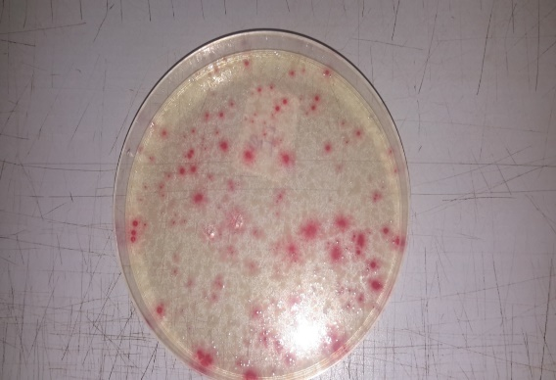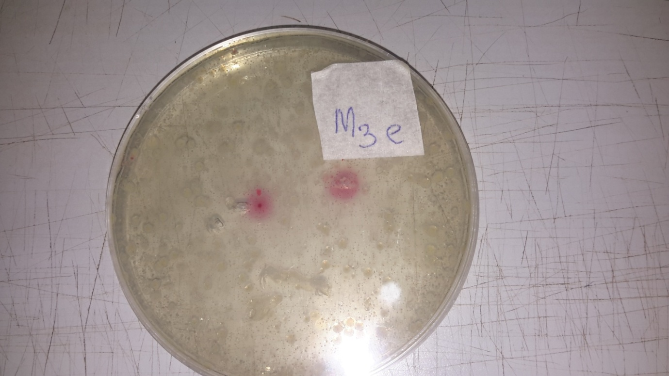
b
a
Figure 1 a; female, b; male Isolates of female and male crickets gut sub cultured on CMC media- isolates showed discoloration indicating that the bacteria used cellulose as the only source of carbon.

Biochemical analysis carried out indicated that the bacterial isolates contain certain enzymes that aid in the degradation of lignocellulose biomass. Blue turbid medium indicated the presence of enterobacter species and other bacteria (citrate test) because citrate is the only source of carbon that produces an alkaline reaction with a color change as seen in figure 2. Deep purple color on reagent paper showed the presence of oxidase enzyme and pseudomonas species, Neisseria pasteurella sp.
The representation of the bacterial isolates showed migration band at different distance from the well during agarose gel electrophoresis as seen in figure 4

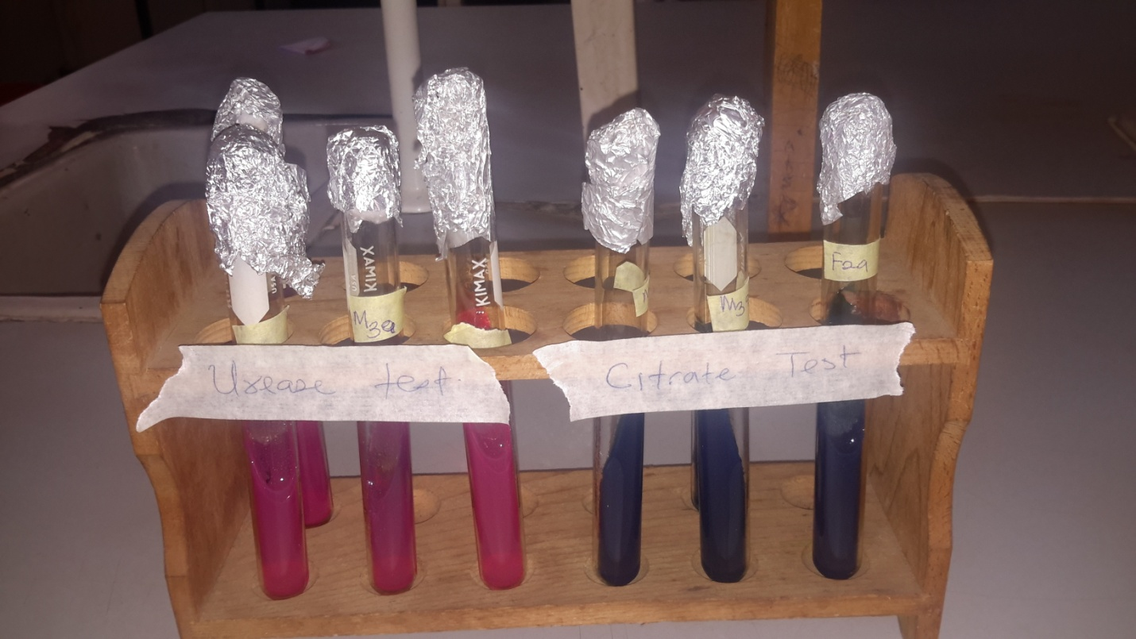
Figure 2 .pink color change:urease positive, 2b blue and turbid color: citrate posive.

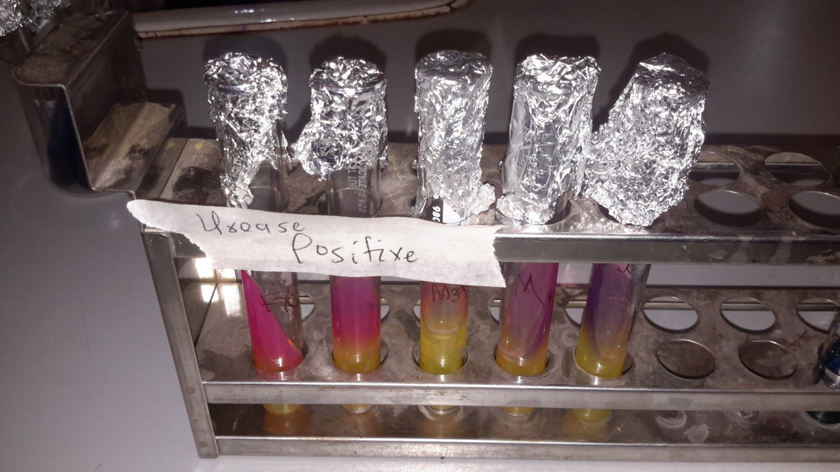
Figure 3 Urase positive

Figure 4 16S rRNA gene for selected samples of bacterial isolates

The representation of the bacterial isolates showed migration band at different distance from the well during agarose gel electrophoresis. The horizontal bands represent isolates migration band while the vertical bands represent DNA ladder at 50kb each.
M3a------bacteria isolate from male cricket gut (group 3), F1e------bacteria isolate from female cricket gut (group 1), M1a-----bacteria isolates from male cricket gut (group 1), M3e-----bacteria isolates from male cricket gut (group 3), F2a-----bacteria isolates from female cricket gut (group 2

Figure 5 Graphical representation of the amplicons

Figure 6 : Gyrase B gel electrophoresis for selected bacteria isolates.
The bacterial isolates showed migration bands at different distance from the well during agarose gel electrophoresis. The size of the DNA ladder used was 50kb.

Lignocellulose degrading bacteria were isolated from the gut of mole crickets obtained from a farm in leng (major porter) village of Barkin Ladi local government, Plateau State, Nigeria using nutrient agar (NA) media and carboxymethylcellulose (CMC) media for confirmation as shown in figure 1 and 2 respectively. Two morphologically distinct bacterial isolates were selected and named as F1e and F2a lignocellulose degrading bacteria.
Microbial analysis of the isolates showed that certain bacteria species utilized carboxymethylcellulose as their carbon source. Biochemical analysis of these isolates showed that certain enzymes are responsible for lignocellulose degradation by bacteria in the guts of mole crickets. In the study, it showed that both male and female mole crickets contain the lignocellulose bacteria capable of degrading lignocellulose. The different discoloration demonstrates that all the isolates contain certain bacteria with the ability to degrade carboxymethylcellulose as their only source of carbon.
This study is similar to the findings of Bugg et al., 2011 who also observed that certain bacteria have the ability to utilize carboxymethylcellulose.
In the past studies, most of the bacterial isolate has been from soil with less lignocellulose degrading bacteria observed in comparison to the findings of Ramanathan et al, who observed comparatively large number of lignocellulose degrading bacteria from sundarban mangroves of west Bengal, india. Behera et al, 2013.
This study is also similar to that of Behera et al 2013 who isolated 15 distinct cellulose degrading bacteria from mangrove soil of Mahanadi River delta and their cellulase production capacity using CMC agar medium, in the study, they observed that the clearing zone size and colony diameter of the isolates were measured when incubated aerobically at 37º C, demonstrating that all the isolates have the ability to degrade carboxymethylcellulose.

5.0 CONCLUSION
From the study, it can be concluded that all the lignocellulose degrading bacteria isolated from the gut of mole cricket could effectively degrade lignocellulose biomass which could probably help some molecular biologists and enzymologists study the potential of these bacteria in producing enzymes that are responsible for lignocellulose degradation.
The use of these lignocellulose degrading bacteria as bioinoculants can be incorporated to enhance organic matter decomposition in soil to increase fertility and minimize fertilizer application. They can also be applied to reduce environmental pollution and promotes sustainable agriculture.
ETHICAL CLEARANCE
The experimental design was conducted by the guidelines approved by the Institutional Animal Ethics Committee of the University of Jos, Nigeria.

COMPETING INTERESTS DISCLAIMER:
Authors have declared that they have no known competing financial interests OR non-financial interests OR personal relationships that could have appeared to influence the work reported in this paper.

REFERENCES
Antai, S. P., & Crawford, D. L. (1981). Susceptibility of grasses and woods to actinomycete attack. Applied and Environmental Microbiology, 41(4), 1007–1010.
Behera, B. C., Parida, S., Dulta, S. K., & Thatoi, H. N. (2014). Isolation and identification of cellulose degrading bacteria from mangrove soil of Mahanadi River Delta and their cellulose production ability. American Journal of Microbiology Research, 2(2), 41–46.
Bugg, T. D. H. (2024). The chemical logic of enzymatic lignin degradation. Chemical Communications, 60(7), 804–814. https://doi.org/10.1039/D3CC05298B
Bugg, T. D. H., Ahmad, M., Hardiman, E. M., & Singh, R. (2011). The emerging role for bacteria in lignocellulose degradation and bioproduct formation. Current Opinion in Biotechnology, 22(3), 394–400.
Chen, M., Li, Q., Liu, C., Meng, E., & Zhang, B. (2025). Microbial degradation of lignocellulose for sustainable biomass utilization and future research perspectives. Sustainability, 17(9), 4223. https://doi.org/10.3390/su17094223
Coelho, C. (2025). Isolation of lignocellulosic biomass-degrading bacteria from soil invertebrate guts. Applied Microbiology and Biotechnology.
Ding, J., Liu, F., Zeng, J., Gu, H., Huang, J., Wu, B., Shu, L., Yan, Q., He, Z., & Wang, C. (2025). Depth heterogeneity of lignin-degrading microbiome and organic carbon processing in mangrove sediments. npj Biofilms and Microbiomes, 11(5). https://doi.org/10.1038/s41522-024-00638-x
Fu, R., Han, L., Li, Q., Li, Z., Dai, Y., & Leng, J. (2025). Studies on the concerted interaction of microbes in the gastrointestinal tract of ruminants on lignocellulose and its degradation mechanism. Frontiers in Microbiology, 16, 1554271. https://doi.org/10.3389/fmicb.2025.1554271
Gu, J., Qiu, Q., Yu, Y., Sun, X., Tian, K., Chang, M., Wang, Y., Zhang, F., & Huo, H. (2024). Bacterial transformation of lignin: Key enzymes and high-value products. Biotechnology for Biofuels and Bioproducts, 17, Article 2. https://doi.org/10.1186/s13068-023-02447-4
Hsin, K.-T., Lee, H., Huang, Y.-C., Lin, G.-J., Lin, P.-Y., Lin, Y.-C. J., & Chen, P.-Y. (2025). Lignocellulose degradation in bacteria and fungi: Cellulosomes and industrial relevance. Frontiers in Microbiology, 16, 1583746. https://doi.org/10.3389/fmicb.2025.1583746
Kamdem Tamo, A., Doench, I., Deffo, G., Zambou Jiokeng, S. L., Doungmo, G., Fotsop, C. G., & Osorio-Madrazo, A. (2025). Lignocellulosic biomass and its main structural polymers as sustainable materials for (bio)sensing applications. Journal of Materials Chemistry A, 13, 24185–24253. https://doi.org/10.1039/D5TA02900G
Li, W., Zhang, M., & Lee, H. J. (2009). Cellulose as a renewable resource for sustainable materials and energy. Renewable Energy Reviews, 13(6–7), 1321–1334.
Liu, J., Liu, X., Xu, W., Zhang, Y., Wang, J., & Yuan, T. (2025). Advances in lignin structure, biosynthesis, and valorization for a sustainable future. Biotechnology for Biofuels and Bioproducts, 18(1), 14. https://doi.org/10.1186/s13068-025-02531-1
Madhushree, M., Vairavel, P., Mahesha, G. T., & Bhat, K. S. (2024). A comprehensive review of cellulose and cellulose-based materials: Extraction, modification, and sustainable applications. Journal of Natural Fibers, 21(1), 2418357. https://doi.org/10.1080/15440478.2024.2418357
Nargotra, P., Sharma, V., Lee, Y.-C., Tsai, Y.-H., Liu, Y.-C., Shieh, C.-J., Tsai, M.-L., Dong, C.-D., & Kuo, C.-H. (2023). Microbial lignocellulolytic enzymes for the effective valorization of lignocellulosic biomass: A review. Catalysts, 13(1), 83. https://doi.org/10.3390/catal13010083
Robles-Machuca, M., Avilés-Mejía, L., Romero-Soto, I. C., Rodríguez-González, J. A., Armenta-Pérez, V. P., & Camacho-Ruiz, M. A. (2023). Cloning, expression, and biochemical characterization of β-etherase LigF from Altererythrobacter sp. B11. Heliyon, 9(10), e21006. https://doi.org/10.1016/j.heliyon.2023.e21006
Salgado, J. F. M., Hervé, V., Vera, M. A. G., et al. (2024). Unveiling lignocellulolytic potential: A genomic exploration of bacterial lineages within the termite gut. Microbiome, 12, 201. https://doi.org/10.1186/s40168-024-01917-7
Sulis, D. B., Lavoine, N., Sederoff, H., Jiang, X., Marques, B. M., Lan, K., Cofre-Vega, C., Barrangou, R., & Wang, J. P. (2025). Reprogramming secondary cell wall biosynthesis in plants and microbes for sustainable biomaterials and fuels. Nature Communications. https://www.nature.com/collections/hdabccacfa
Verdía, B. P., Choudhary, H., Nakasu, P. S., Al-Ghatta, A., Han, Y., Hopson, C., Aravena, R. I., Mishra, D. K., Ovejero-Pérez, A., Simmons, B. A., & Hallett, J. P. (2025). Ionic liquids and deep eutectic solvents for a sustainable future: A modern perspective on historical alchemy. Chemical Reviews, 125(9), 5461–5524. https://doi.org/10.1021/acs.chemrev.4c00754
Vicuna, R. (2000). Bacterial degradation of lignin. Enzyme and Microbial Technology, 26(3–4), 178–188. https://doi.org/10.1016/S0141-0229(99)00138-7
Waldrop, M. P., Balser, T. C., & Firestone, M. K. (2000). Linking microbial community composition to function in a tropical soil. Soil Biology and Biochemistry, 32(13), 1837–1846. https://doi.org/10.1016/S0038-0717(00)00157-7
Wiley Review. (2024). Exploring the potential of insect gut microbes for advancing renewable energy production. Wiley Online Library.
Woźniak, A., Kuligowski, K., Świerczek, L., & Cenian, A. (2025). Review of lignocellulosic biomass pretreatment using physical, thermal and chemical methods for higher yields in bioethanol production. Sustainability, 17(1), 287. https://doi.org/10.3390/su17010287
Zhao, C., Chen, L., Li, W., & Liu, Z. (2024). Recent advances in lignin biosynthesis, structure, and industrial applications. Industrial Crops and Products, 210, 117291. https://doi.org/10.1016/j.indcrop.2024.117291

