Investigating the Therapeutic Effects of Commelina diffusa (Dayflower) Aqueous Extract on Doxorubicin-Induced Hepatic Dysfunction in Rats

Abstract
This study investigated the effect of aqueous extract of Commelina diffusa on doxorubicin-induced hepatic dysfunction in rats. Twenty five Wistar rats weighing between 160 and 200g were used for this study. The rats were divided into five groups of five rats per group. Group 1 and 2 served as normal and negative controls, received rat feed and 50mg/kg doxorubicin once respectively. Rats in group 3-5 were intraperitoneally administered 50mg/kg doxorubicin and treated with Commelina diffusa extract at 166, 250, and 500mg/kg body weight for 21 days. All renal makers were determined based on standard methods. The mean total protein level of the negative control were 29.80±0.02g/L while the mean homogenate AST, ALP, and ALT activities were 107.54±0.03U/L, 87.69±0.02U/L, and 71.85±0.03U/L respectively and were significantly decreased in comparison to the normal control. The mean total protein level of the extract treated at 500mg/kg for 21 days were 31.63±0.04g/L while those of AST, ALP, and ALT activities were 64.36±0.03U/L, 46.26±0.03U/L, and 41.65±0.03U/L respectively and were significantly increased in comparison to the negative control. The mean homogenate GPx, CAT, and SOD activities of the negative control were 25.04±0.03IU/g, 31.53±0.03mg/pro.min, and 3.64±0.03mg/g respectively. The mean homogenate GPx, CAT, and SOD activities of rats treated with extract at 500mg/kg for 21 days were 28.33±0.02IU/g, 37.43±0.02mg/pro.min, and 5.74±0.03mg/g respectively and were significantly different from the negative control. Commelina diffusa extract at 500mg/kg ameliorated the damage toxic elicited on the liver tissue by doxorubicin, hence could serve as a herbal agent in the treatment of liver dysfunction.
Keywords: Commelina diffusa, doxorubicin, liver homogenate, liver biomarker, lipid profile, Wistar rats

- INTRODUCTION
Doxorubicin (DOXO) is one of the most dreaded antineoplastic medicaments often recommended for many malignancies (Renu et al., 2022). Although DOXO is a considerably effective chemotherapeutic agent, its clinical usage is hindered by its toxic impact on normal cells (Prasanna et al., 2020). DOXO is shown to fundamentally results in hepatotoxicity in approximately 30% of breast cancer patients (Damodar et al., 2014; Shivakumar et al., 2012; Alherz et al., 2023). In numerous pathological conditions, including virus infection, the aggregation of damaged DNA, and the consumption of toxic drugs, may induce protein misfolded or unfolded proteins to aggregate in the ER lumen, leading to hepatotoxicity (Lemmer et al., 2021). There are scientific evidence on how DOXO caused cytotoxicity by upregulating UPR markers and apoptosis induced by ER stress (Lukas et al., 2019; Yarmohammadi et al., 2021; Kim et al., 2022; Kaymak et al., 2022).
The exploration of medicinal plants for therapeutic agents continues to be a focal point of biomedical research, driven by the increasing recognition of their potential to address unmet medical needs. Medicinal plants have garnered attention for their potential to modulate key biological pathways involved in these diseases (Zhou et al., 2020; Cavé et al., 2021). Liver diseases, encompassing a range of conditions such as hepato-dysfunction is a significant global health concern. The liver plays a crucial role in detoxification, metabolism, and various biosynthetic functions, making its impairment particularly detrimental to overall health. Clinical studies have confirmed medicinal plant extract possess efficacy in alleviating liver inflammation and promoting regeneration (Ghasemian et al., 2021; Hosseini et al., 2021). Cynara cardunculus has shown promise in reducing liver fat accumulation and improving liver enzyme levels. Zhuo et al. (2021) have proven that berberine extract improves liver function by regulating lipid metabolism and reducing hepatic fat accumulation while Wang et al. (2022) reported that licorice extracts, especially glycyrrhizin, exhibit hepatoprotective effects by reducing inflammation, oxidative stress, and hepatic fibrosis. Commelina diffusa is locally used in the mitigation of inflammatory condition in Nigeria. Wellington et al. (2025) have investigated the bioactive and Nutritional Potential of Commelina diffusa: A Comprehensive Study. Wellington et al. (2025) verified the acute, sub-acute and chronic hepatotoxicity profiling of Commelina diffusa aqueous extract in Wistar rats: a comprehensive OECD 425 TG Study, where they showed that Commelina diffusa extract enhanced the metabolism of all the assayed parameters, hence it is less toxic at 500mg/kg. Meanwhile, scientific evidence validating its efficacy against doxorubicin-induced liver injury remains limited. This study is therefore designed to investigate the therapeutic potential of Commelina diffusa aqueous extract in attenuating doxorubicin-induced hepatic dysfunction in Wistar rats. By evaluating key biochemical markers of liver function, oxidative stress, and histopathological changes, this study seeks to provide empirical data on the hepato-ameliorative efficacy of C. diffusa.

- MATERIALS AND METHODS
2.1 Chemical/Reagents
The reagents employed in this research were purchased from commercial industries and the manufacturers’ standard methods and procedure were strictly adhered with respect to this work.
2.2 Source and Identification of Plant
The fresh Commelina diffusa leaf and stem were obtained from Toru-Orua and Ebedebiri Communities, in Sagbama Local Government Area of Bayelsa State, Nigeria. The plant sample was identified and authenticated at the Herbarium Unit of the Department of Agriculture, University of Africa Toru-Orua. The sample was registered with Voucher Number UAT/A/3011.
2.3 Source of Experimental Wistar Albino Rats
Twenty five (25) adult male Wistar rats weighing 160 and 200g were purchased from the Biochemistry Animal House, University of Port Harcourt. The rats were acclimatized for weeks , giving free access to rat feed and water. The rats were fed with standard animal feeds produced by Grand Cereals and Oil Mills Ltd., Yenagoa, and water ad libitum. They were treated following the principles and standard protocols for the use of laboratory animals for experiments.
2.4 Animals and Approval from Animal Ethical Committee
Healthy adult Wistar albino rats (160-200g) between 10 and 15 weeks old were used for all investigations. The animals were maintained under standard husbandry conditions in the animal house of ‘College of Health Sciences, University of Africa Toru-Orua, Nigeria (temperature 25 ± 2 °C) in a natural light-dark cycle and fed with standard rodent diet and water ad libitum. Ethical committee clearance was obtained from Institutional Animal Ethics Committee of UPH/CEREMAD/REC/MM72/011 .Ref. No. UPH20/03/01/1377.
2.5 Experimental Design
Twenty five (25) Wistar rats weighing between 160 and 200g were used for this study. They were be purchased from the Biochemistry Animal House, University of Port Harcourt Choba and be acclimatized for 14 days, giving free access to rat feed and water. The rats were then be divided on basis of body weight into five groups of five rats per group and treated as shown in the table below.

Table 1 experimental design
Groups | Treatment | Duration
1 | Normal control: Received rat feed H₂O only, serving as normal control | 21 days
2 | Negative control: Received one dose of 50mg/kg doxorubicin + rat feed+ H₂O only | 21 days
3 | Received 50mg Doxorubicin+166mg/kg C. diffusa+ rat feed+ H₂O only | 21 days
4 | Received 50mg Doxorubicin+ 250 mg/kg C. diffusa+ rat feed+ H₂O only | 21 days
5 | Received 50mg Doxorubicin+ 500 mg/kg C. diffusa+ rat feed+ H₂O only | 21 days
Exactly, 24 hours after the last day of oral treatment with the extract, the rats were humanly sacrificed through cervical dislocation, blood sample were be collected for biochemical assays. The liver of the rats in each group were harvested and was cut into two equal halves. Half of the organs was homogenized for estimation of liver biomarkers while the other half was used for histological examination.
2.6 Biochemical Determination
The biochemical parameters as touching this study were estimated adopting ELISA and Randox kits. The parameters studied for liver function were total protein, albumin, bilirubin, AST, ALT, and ALP activities. The oxidative plasma cardiac and kidney homogenate biomarkers determined were malondialdehyde (MDA), glutathione (GSH), glutathione peroxidase (PDx), superoxide dismutase (SOD) and catalase (CAT). Lipid profile parameters estimated were total cholesterol, LDL, HDL, VLDL, and triglyceride.
2.7 Histopathological Examination of Liver Tissues
The liver isolated from the sacrificed Wistar rats was fixed in 10% formalin, then after processing embedded in paraffin wax. Paraffin sections were made at 5 mm and stained with hematoxylin and eosin. The slides were studied under a light microscope and captured the magnified images of liver tissues structure for further examination.
2.8 Statistical Analysis
All Data are represented as means ± error of mean (M±E) and were analyzed using Statistical Package foe Social Sciences (SPSS) for window version 20.0 USA. Descriptive statistics was done by one way analysis of variance (ANOVA) and multiple comparison was done using Turkey Post hoc at (p≤0.05) confidence interval.
- RESULTS
Table 2 showed the effect of aqueous extract of the aerial parts of Commelina diffusa on liver homogenate biomarkers in doxorubicin-induced hepatic dysfunction in Wistar rats. The effect of Commelina diffusa aqueous extract in doxorubicin-induced hepatic dysfunction in Wistar rats were examined in comparison to the normal and negative control.
Table 2 Effect of aqueous extract of the aerial parts of Commelina diffusa on liver homogenate biomarkers in doxorubicin-induced hepatic dysfunction in Wistar rats (n=5)
Group | TP  (g/L) | Albumin  (mmol/L) | AST  (U/L) | ALP  (U/L) | ALT  (U/L) | BIL (𝛍m/L)
N/Control | 58.61±0.03^{f} | 58.61±0.03^{f} | 41.56±0.02 ^{f} | 37.82±0.02^{f} | 31.82±0.02^{f} | 15.45±0.04 ^{f}
Ne/Control | 29.80±0.02e | 4.93±0.03 e | 107.54±0.03e | 87.69±0.02e | 71.85±0.03e | 78.33±0.03 e
50mg/kg Dx+166mg/kg CD 21Days | 19.55±0.02^{h} | 1.98±0.03 ^{h} | 97.84±0.03 ^{h} | 83.94±0.02 ^{h} | 27.14±0.05^{h} | 75.93±0.03 ^{h}
50mg/kg Dx+250mg/kg CD 21 Day | 24.04±0.04^{h} | 2.19±0.03 ^{h} | 76.86±0.03 ^{h} | 64.74±0.03 ^{h} | 58.36±0.03 ^{h} | 75.04±0.03 ^{h}
50mg/kg Dx+500mg/kg CD 21 Days | 31.63±0.04^{h} | 2.39±0.04 ^{h} | 64.36±0.03 ^{h} | 46.26±0.03 ^{h} | 41.65±0.03 ^{h} | 67.26±0.04 ^{h}
Definition of symbols: TP= Total protein, BIL= Bilirubin, AST= Aspartate transaminase, ALP= Alkaline phosphatase, ALT= Alanine amino transferase. Values are reported as mean ± standard error of mean (M±SEM) (n =5). Values bearing superscript (^{“e”}) were significantly different (p≤ 0.05) from the normal control down the groups. Values with similar superscript (^{“h”}) were not significantly (p≤ 0.05) different from the negative control down the groups.

Table 3 Effect of aqueous extract of the aerial parts of Commelina diffusa on oxidative stress biomarkers of liver homogenate in doxorubicin-induced liver damage in rats. The effect of Commelina diffusa aqueous extract on the plasma total GPx, CAT, and SOD activities in doxorubicin-induced hepatic dysfunction in Wistar rats were examined in comparison to the normal and negative control.

Table 3 Effect of aqueous extract of the aerial parts of Commelina diffusa on oxidative stress biomarkers of liver homogenate in doxorubicin-induced liver damage in rats (n=5)
Group | MDA  (mmol/l) | GSH  (μg/mg protein) | GPx  (IU/g) | CAT  (mg/pro. min) | SOD  (mg/g)
N/Control | 6.14±0.04^{f} | 51.03±0.02 ^{f} | 75.44±0.03 ^{f} | 108.64±0.03 ^{f} | 35.93±0.03 ^{f}
Ne/Control | 96.23±0.03e | 13.91±0.02 e | 25.04±0.03 e | 31.53±0.03 e | 3.64±0.03 e
50mg/kg Dx+ 166mg/kg CD 21 Days | 82.89±0.02^{h} | 19.21±0.01 ^{h} | 28.16±0.01 ^{h} | 37.15±0.01 ^{h} | 5.05±0.02 ^{h}
50mg/kg Dx+ 250mg/kg CD 21 Days | 83.83±0.03 ^{h} | 19.44±0.02 ^{h} | 28.16±0.01 ^{h} | 37.15±0.02 ^{h} | 5.05±0.02 ^{h}
50mg/kg Dx+ 500mg/kg CD 21 Days | 83.64±0.03 ^{h} | 19.64±0.02 ^{h} | 28.33±0.02 ^{h} | 37.43±0.02 ^{h} | 5.74±0.03 ^{h}
Values are reported as mean ± standard error of mean (M±SEM) (n =5). Values bearing superscript (^{“e”}) were significantly different (p≤ 0.05) from the normal control down the groups. Values with similar superscript (^{“h”}) were not significantly (p≤ 0.05) different from the negative control down the groups.
Table 4 Effect of aqueous extract of the aerial parts of Commelina diffusa on lipid profile in doxorubicin-induced hepatic dysfunction in Wistar rats. The effect of Commelina diffusa aqueous extract on the plasma total cholesterol, high density lipoprotein cholesterol, low density lipoprotein cholesterol, very low density lipoprotein cholesterol, and triglyceride levels in doxorubicin-induced hepatic dysfunction in Wistar rats were examined in comparison to the normal and negative control.

Table 4 Effect of aqueous extract of the aerial parts of Commelina diffusa on lipid profile in doxorubicin-induced hepatic dysfunction in Wistar rats (n=5)
Group | Total  Cholesterol  (mg/dl) | HDL  (mg/dl) | LDL  (mg/dl) | VLDL  (mg/dl) | TG  (mg/dl)
N/Control | 83.04±0.03^{f} | 47.36±0.04 ^{f} | 57.13±0.02 ^{f} | 10.54±0.03 ^{f} | 52.73±0.01^{f}
Ne/Control | 29.81±0.02e | 18.55±0.03 e | 82.14±0.04 e | 3.72±0.02 e | 22.64±0.03e
50mg/kg Dx+ 166mg/kg CD 21 Days | 36.56±0.03^{h} | 27.85±0.03 ^{h} | 76.93±0.04 ^{h} | 3.94±0.02 ^{h} | 3.94±0.02 ^{h}
50mg/kg Dx+ 250mg/kg CD 21 Days | 43.05±0.04 ^{h} | 31.54±0.03 ^{h} | 68.53±0.03 ^{h} | 5.73±0.02 ^{h} | 32.44±0.02^{h}
50mg/kg Dx+ 500mg/kg CD 21 Days | 56.25±0.03 ^{h} | 38.04±0.01 ^{h} | 61.93±0.04 ^{h} | 8.11±0.07 ^{h} | 49.62±0.03 ^{h}
Values are reported as mean ± standard error of mean (M±SEM) (n =5). Values bearing superscript (^{“e”}) were significantly different (p≤ 0.05) from the normal control down the groups. Values with similar superscript (^{“h”}) were not significantly (p≤ 0.05) different from the negative control down the groups.
Plate 1-5 in this present study, shows the effects of Commelina diffusa extract at 166, 250, and 500mg/kg body weight for 21 days on doxorubicin-induced hepatic dysfunction in rats. The effect of Commelina diffusa extract on the histopathology of the liver in doxorubicin-induced toxicity were evaluated in comparison to the negative and normal control as shown in plate 1-5.

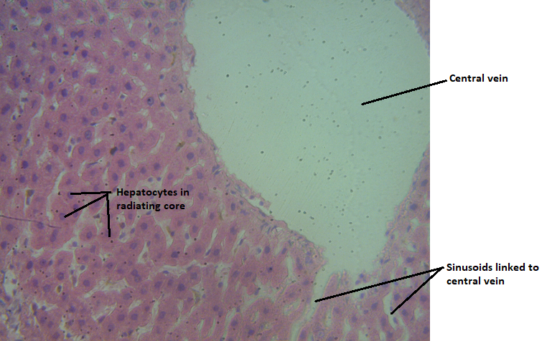
Plate 1. Photomicrograph of liver tissue of the normal control, showing normal central vein, hepatocytes in radiating core, and sinusoide linked to central vein
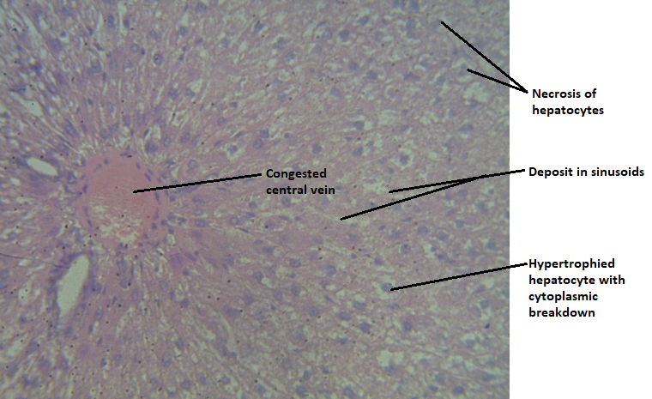
Plate 2. Photomicrograph of liver tissue of the negative control, showing congested central vein, severe necrosis of hepatocytes, deposits in sinusoide, and hypertrophied hepatocytes with cytoplasmic break down
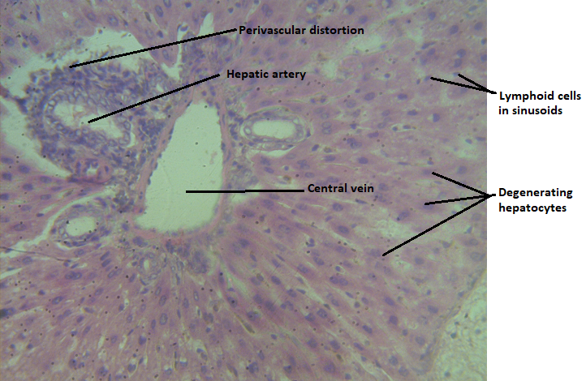
Plate 3. Photomicrograph of the liver tissue of doxorubicin-induced renal damage rats, treated with166 mg/kg b.wt of aqueous extract of the aerial parts of Commelina diffusa for 21 days, showing perivascular distortion, regeneration of hepatic artery, lymphoid cells in sinusoide, mild inflammation and degenerating hepatocytes.
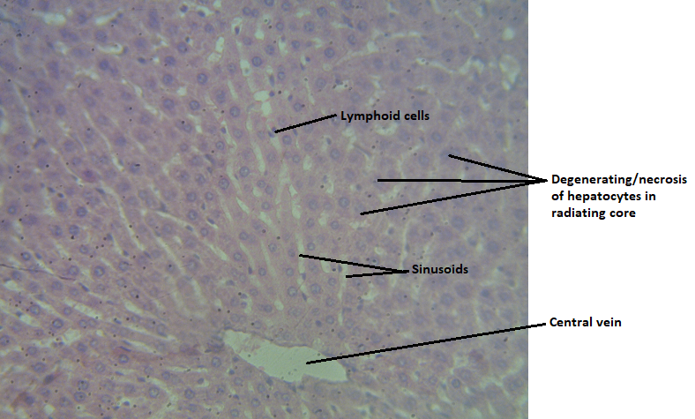
Plate 4. Photomicrograph of the liver tissue of doxorubicin-induced renal damage rats, treated with 250 mg/kg b.wt of aqueous extract of the aerial parts of Commelina diffusa for 21 days, showing mild inflammation, almost normal lymphoid cells, hepatic kuffer cells, sinusoide, mild necrosis of hepatocytes in radiating cores, and central vein.
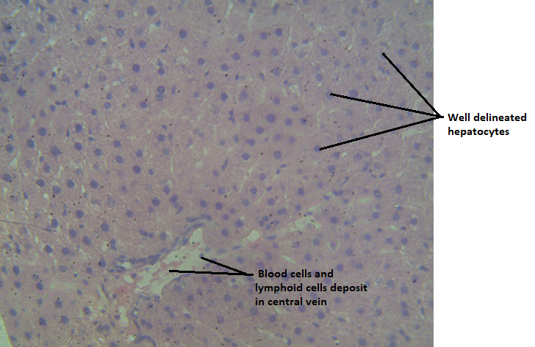
Plate 5. Photomicrograph of the liver tissue of doxorubicin-induced renal damage rats, treated with 500 mg/kg b.wt of aqueous extract of the aerial parts of Commelina diffusa for 21 days, showing normal blood cells and cell deposit in central vein, mild inflammation, mild inflammation, and well delineated hepatocytes.

- DISCUSSION OF FINDINGS
The search for hepato-curative agents has led researchers to explore the potential of aqueous plant extracts, known for their antioxidant and anti-inflammatory properties, in mitigating DOX-induced liver damage. Aqueous extracts of medicinal plants enhancing the activity of endogenous antioxidant enzymes such as superoxide dismutase, catalase, and glutathione peroxidase, thereby reducing oxidative stress. Catherin et al. (2021) investigated the protective role of aqueous leaf extracts of Chromolaena odorata and Tridax procumbens against DOX-induced hepatotoxicity in Wistar rats. The extracts attenuated alterations in hepatic biomarkers of oxidative stress, lipid and electrolyte profiles, and plasma biomarkers of liver function, maintaining them near normal values. Ikewuchi et al. (2021) demonstrated the effects of aqueous extracts from Pleurotus tuberregium sclerotia and Cnidoscolus aconitifolius leaves on DOX-treated Wistar rats. The extracts restored plasma levels of liver enzymes and improved protein profiles, indicating hepatoprotective potential. In Table 2, the mean homogenate total protein and albumin levels of the negative control were considerably lower than those of the normal control. The mean bilirubin level of the negative control was significantly increased in comparison to the normal control. The significantly decreased mean homogenate total protein and albumin levels as well as the increased mean homogenate bilirubin concentration of negative control points to compromised in cellular functioning of the hepatocytes facilitated by doxorubicin administration. Treatment with Commelina diffusa extract at 166, 250, and 500mg/kg body weight for 21 days, resulted in significant increases on the mean homogenate total protein and albumin levels when compared to the negative control (Table 2). Significantly decreased mean homogenate bilirubin level occurred after treatment with the extract at 166, 250, and 500mg/kg body weight when compared to the negative control. The mean homogenate AST, ALP, and ALT activities of the negative control were significantly increased after intraperitoneal exposure to 50mg/kg body weight of doxorubicin when compared to the normal control. The considerable increases noticed on the mean homogenate AST, ALP, and ALT activities points to damage to the hepatocytes due to doxorubicin exposure. Significant decreases were observed on the mean homogenate AST, ALP, and ALT activities of the rats treated with Commelina diffusa extract at 166, 250, and 500mg/kg body weight for 21 days when compared to the negative control (Table 2). Commelina diffusa extract at 500mg/kg body weight elicited a more significant effect on the mean homogenate total protein, albumin, and bilirubin levels as well as AST, ALP, and ALT activities, next was 250mg/kg while the least was dose at 166mg/kg body weight. The observed significant decreases on the mean homogenate AST, ALP, and ALT activities in rats treated with the extract at 166, 250, and 500mg/kg body weight for 21 days is suggestive of the ameliorative effect of the extract against doxorubicin-induced heaptic damage in rats. Wellington et al. (2021) reported similar result on the effect of aqueous extract of the aerial parts of Leonurus cardiaca on cisplatin-induced hepato-renal damage in Wistar albino rats.
Studies have explored the protective effects of various aqueous plant extracts against doxorubicin (DOX)-induced hepatotoxicity in rats. These studies focus on the modulation of oxidative stress biomarkers in liver homogenates. Alaa et al. (2024) investigated the hepatoprotective effects of Syzygium aromaticum extract (SAE) in DOX-treated rats. The extract was found to restore biochemical alterations, mitigate ferroptosis, and upregulate the NRF-2–SLC7A-11–GPX-4 signaling pathway. These effects are attributed to the antioxidant properties of SAE, which helped alleviate DOX-induced liver damage. Ikewuchi et al. (2021) evaluated combined aqueous leaf extracts of Chromolaena odorata and Tridax procumbens for their hepatoprotective effects. In Table 3, the mean homogenate MDA level of the negative control was significantly increased in comparison to the normal control. The mean homogenate GSH of the negative control was significantly decreased when compared to the normal control rats (Table 3). The increased mean homogenate MDA level and decreased homogenate GSH level seen in negative control suggest increased lipid peroxidation and compromised in glutathione defense capacity against free radicals due to doxorubicin exposure. Treatment with Commelina diffusa extract at 166, 250, and 500mg/kg body weight for 21 days yielded significantly decreased MDA level as well as increased GSH level when compared to the negative control values (Table 3). Also, the meanhomogenate MDA level of rats treated with the extract at 166, 250, and 500mg/kg for 21 days were significantly lower than that of the negative control (Table 3). The mean homogenate GSH level after treatment with the extract at 166, 250, and 500mg/kg body weight for 21 days were significantly increased in comparison to the negative control (Table 3). The mean homogenate GPx, CAT, and SOD activities of rats treated at 166, 250, and 5000mg/kg body weight of Commelina diffusa extract for 21 days, were significantly increased in comparison to the negative control (Table 3). Commelina diffusa extract at 500mg/kg body weight elicited a more significant effect on oxidative stress biomarkers of liver homogenate, followed by 250mg/kg while the least was 166mg/kg body weight. The significantly increased mean homogenate GPx, CAT, and SOD activities observed after treatment with the extract is indicative of the antioxidant potential of Commelina diffusa extract against doxorubicin administration.

Scientific studies on the effects of aqueous plant extracts on lipid profiles in Wistar rats with doxorubicin-induced hepatic dysfunction have been verified. Afsar et al (2019) examined the hepatoprotective effects of aqueous leaf extracts from Chromolaena odorata and Tridax procumbens. Doxorubicin administration led to elevated hepatic cholesterol and triglyceride levels. Pretreatment with these plant extracts significantly reduced these lipid levels, suggesting their potential in mitigating doxorubicin-induced lipid profile disturbances. In Table 4, the mean plasma LDL cholesterol level of the negative control was significantly increased when compared to the normal control, suggesting compromised in the metabolism of bad cholesterol due to intraperitoneal administration of doxorubicin. The mean plasma total cholesterol, HDL, VLDL, and triglyceride concentration of the negative control were significantly decreased in comparison to the normal control values (Table 4). The significantly raised plasma LDL level as well as the significantly lowered total cholesterol, HDL, VLDL, and triglyceride concentration of the negative control rats is reflective of toxicological consequences of doxorubicin administration. More so, the mean plasma LDL level of rats treated at 166, 250, and 500mg/kg body weight with aqueous extract of Commelina diffusa extract for 21 days was significantly reduced when compared to the normal control. The mean plasma total cholesterol, HDL, VLDL, and triglyceride concentrations were significantly increased after treatment with the extract at the stated doses for 21 days. Extract of Commelina diffusa at 500mg/kg body weight yielded more reduction effects on the lipid profile of the rats, followed by 250mg/kg while the least was the dose at 166mg/kg body weight. The significant increases observed on the mean plasma total cholesterol, HDL, VLDL, and triglyceride levels after treatment with Commelina diffusa extract at 166, 250, and 500mg/kg body weight for 21 days is indicative of the anti-lipidemic effect of the plant’s extract against doxorubicin-induced lipid disorder.

Multifarious studies have explored the ameliorative potential of various medicinal plants on liver histology in doxorubicin (DOX)-induced hepatic damage. Karim et al. (2023) evaluated the hepatoprotective effects of Artemisia annua leaf extract (AALE) in male rats subjected to DOX-induced hepatic toxicity. The administration of AALE resulted in significant restoration of liver architecture, including normalization of central veins and hepatocyte morphology. Plate 1-5 in this present study, show the effects of Commelina diffusa extract at 166, 250, and 500mg/kg body weight for 21 days on doxorubicin-induced hepatic dysfunction in rats. The liver tissue of the normal control indicatednormal central vein, hepatocytes in radiating core, and sinusoide linked to central vein (Plate 1). The liver tissue of the negative control, negative control, showing congested central vein, severe necrosis of hepatocytes, deposits in sinusoide, and hypertrophied hepatocytes with cytoplasmic break down in comparison to the normal control (Plate 2). The liver tissue of doxorubicin-induced hepatic dysfunction rats, treated with166 mg/kg b.wt of aqueous extract of the aerial parts of Commelina diffusa for 21 days, showing perivascular distortion, regeneration of hepatic artery, lymphoid cells in sinusoide, mild inflammation and degenerating hepatocytes when compared to the negative control (Plate 3). The liver tissue of doxorubicin-induced hepatic dysfunction in rats, treated with 250mg/kg b.wt of aqueous extract of the aerial parts of Commelina diffusa for 21 days, showing mild inflammation, almost normal lymphoid cells, hepatic kuffer cells, sinusoide, mild necrosis of hepatocytes in radiating cores, and central vein in comparison to the negative control tissue (Plate 4).The liver tissue ofdoxorubicin-induced hepatic dysfunction in rats, treated with 500 mg/kg b.wt of aqueous extract of the aerial parts of Commelina diffusa for 21 days, showing normal blood cells and cell deposit in central vein, mild inflammation, mild inflammation, and well delineated hepatocytes in comparison to the negative control liver tissue (Plate 5). Treatment aqueous extract of Commelina diffusa extract at 500mg/kg body weight for 21 days, ameliorated the damage caused by doxorubicin on the liver architecture.

- CONCLUSION
The search for hepato-curative agents has led researchers to explore the potential of aqueous plant extracts, known for their antioxidant and anti-inflammatory properties, in mitigating DOX-induced liver damage. Intraperitoneal administration of DOXO resulted in significantly increased plasma MDA level and AST, ALT, ALP as well as decreased the plasma CAT, SOD, and GPx activities. Commelina diffusa aqueous extract upon treatment for 21 days significantly countered doxorubicin-induced hepatotoxicity in Wistar rats, as shown by the substantial decrease in serum transaminases (AST, ALT), alkaline phosphatase (ALP), lipid profile disturbances (LDL), and oxidative stress markers (CAT, SOD, GPx). The extract's ability to improve tissue integrity highlights its potential as a complementary therapy in the management of drug-induced liver toxicity. Future studies should explore the molecular mechanisms underlying the hepatoprotective effects of Commelina diffusa, particularly its interaction with oxidative stress pathways, inflammatory mediators, and apoptotic markers

Competing Interests
Authors have declared that no competing interests exist.

COMPETING INTERESTS DISCLAIMER:
Authors have declared that they have no known competing financial interests OR non-financial interests OR personal relationships that could have appeared to influence the work reported in this paper.

REFERENCES
Renu, K., V G, A., P B, T., Arunachalam, S., & Vellingiri, B. (2022). Toxic effects and
molecular mechanism of doxorubicin on different organs – An update. Toxin Reviews, 41(2), 650–674.
Prasanna, P. L., Renu, K. & Valsala, D., & Gopalakrishnan, A. (2020). New molecular and
biochemical insights of doxorubicin-induced hepatotoxicity. Life Sci, 250, 117599.
Damodar, G., Smitha, T., Gopinath, S., & Vijayakumar, S.(2014). An evaluation of
hepatotoxicity in breast cancer patients receiving injection doxorubicin. Annals of Medical and Health Sciences Research, 4(1), 74–79.
Shivakumar, P., Rani, M. U., Reddy, A. G., & Anjaneyulu, Y. (2012). A study on the toxic
effects of doxorubicin on the histology of certain organs. Toxicology International, 19(3), 241–244.
Alherz, F. A., Aljohani, A. S., Al-Amin, M. M., & Abdel-Wahab, B. A. (2023). The potential
beneficial role of Ginkgetin in doxorubicin-induced hepatotoxicity: Elucidating the underlying claim. Biomedicine & Pharmacotherapy, 165, 115010.
Liu, X., & Green, R. M. (2019). Endoplasmic reticulum stress and liver diseases. Liver Res,
3(1), 55–64 (2019).
Lemmer, I. L., Willemsen, N., Hilal, N., Bartelt, A., & Schlein, C. (2021). A guide to
understanding endoplasmic reticulum stress in metabolic disorders. Molecular Metabolism, 47, 101169.
Lukas, J., Pospech, J., Mraz, M., & Haluzik, M. (2019). Role of endoplasmic reticulum stress
and protein misfolding in disorders of the liver and pancreas. Advances in Medical Sciences, 64(2), 315–323.
Yarmohammadi, F., Rezaei, N., Rezaei, S., Hashemzadeh, M. S., Khonakdar-Tarsi, A., &
Khoshnood, S. (2021). Endoplasmic reticulum stress in doxorubicin-induced cardiotoxicity may be therapeutically targeted by natural and chemical compounds: A review. Pharmacological Research, 164, 105383.
Kim, B. S., Lee, H., Kim, H. J., Lee, C. J., Lee, H. Y., Park, J. B., Kim, I. C., Choi, D. J., & Park,
J. H. (2022). Sacubitril/valsartan reduces endoplasmic reticulum stress in a rat model of doxorubicin-induced cardiotoxicity. Archives of Toxicology, 96(4), 1065–1074.
Kaymak, E., Yildirim, S., Caglayan, C., Aydin, M., & Demir, S. (2022). Thymoquinone
alleviates doxorubicin-induced acute kidney injury by decreasing endoplasmic reticulum stress, inflammation, and apoptosis. Biotechnology and Histochemistry, 97(8), 622–634.
Cavé, C., Rousseau, A., & Veyrat, A. (2021). Antioxidant and anti-inflammatory properties of
medicinal plants: The role of phytochemicals. Frontiers in Pharmacology, 12, 623232.
Zhou, X., Zhang, J., & Liu, Z. (2020). Adaptogenic herbs in metabolic diseases. Frontiers in
Pharmacology, 11, 314.
Zhao, X., Malik, A., & Xing, Y. (2021). Epigenetic mechanisms involved in HCV-induced
hepatocellular carcinoma. Frontiers in Immunology, 12, 681.
Ghasemian, M., Sahraian, M. A., & Taheri, M. (2021). Milk Thistle in liver diseases: A review
of clinical trials and outcomes. Phytotherapy Research, 35(8), 4587–4599.
Hosseini, S. M., Karami, S., & Salehi, B. (2021). Artichoke as a potential hepatoprotective herb:
A review of its clinical and experimental studies. Biomedicine & Pharmacotherapy, 142, 112031.
Zhao, X., Malik, A., & Xing, Y. (2021). Epigenetic mechanisms involved in HCV-induced
hepatocellular carcinoma. Frontiers in Immunology, 12, 681.
Wang, S., Li, Y., & Zhang, Y. (2022). Licorice in liver diseases: A potential hepatoprotective
agent. Journal of Ethnopharmacology, 281, 114616.
Wellington, E. O., Felagha, I., & Otobo, M. B. (2025). Bioactive and Nutritional Potential of
Commelina diffusa: A Comprehensive Study. Asian Journal of Research in Botany, 8, (1), 115-122.
Wellington E. O., & Teke, E. C. (2025).Acute, Sub-acute and Chronic Hepatotoxicity Profiling
of Commelina diffusaAqueous Extract in Wistar Albino Rats: A Comprehensive OECD 425 TG Study. International Journal of Biochemistry Research & Review, 34(3), 19-31.
Catherin, C.K., Jude, C. I., Mercy, O. I., Damiete, P.J., Caleb, N. I., Samuel, E., & Tosin, B .A.
(2021). Protective effect of aqueous leaf extracts of Chromolaena odorata and Tridax procumbens on doxorubicin-induced hepatotoxicity in Wistar rats. Porto Biomed J, 36(6), e143.
Ikewuchi, C.C., Ikewuchi, J.C., & Ifeanacho, M.O.(2021). Restoration of plasma kidney and
liver biomarkers in doxorubicin-treated Wistar rats by aqueous extracts of Pleurotus tuberregium sclerotia and Cnidoscolus aconitifolius leaves. BioTechnologia (Pozn), 102(3):297-306.
Wellington, E. O., Onyeike, E.N., Peters, D.E., & Joshua, D. (2021). Effect of aqueous extract of
the aerial parts of Leonurus cardiac on cisplatin-induced Hepato-Renal damage in Wistar albino rats. Journal of Applied Life Science International, 24(11), 10-22.
Alaa, M. A., Amal, S. A-A., Maha, A. A., Salwa, A., Ibtisam, A., Aljazi, A. A., Najlaa, Y.A.,
Sahar, A. A., Maysa, A. M., Tahiyat, A.,Thamir, M. E., & Karim, S. E-S. (2024). Syzygium aromaticum Extract Mitigates Doxorubicin-Induced Hepatotoxicity in Male Rats. Int. J. Mol. Sci, 25(23), 12541.
Ikewuchi, C.C., Ikewuchi, J.C., Ifeanacho, M.O., Jack, D.P., Ikpe, C.N., Ehiosun, S., & Ajayi,
T.B. (2021).. Protective effect of aqueous leaf extracts of Chromolaena odorata and Tridax procumbens on doxorubicin-induced hepatotoxicity in Wistar rats. Porto Biomed J, 6(6), e143.
Afsar, T., Razak, S., & Almajwal, A. (2019). Effect of Acacia hydaspica R. Parker extract on
lipid peroxidation, antioxidant status, liver function test and histopathology in doxorubicin treated rats. Lipids Health Dis, 18(1), 126
Karim, S. E-S., Ahmed, A. H., Maysa, A. M., Arwa, I. A. K., Afnan, S., Noorah, S. A-S.,
Ibrahim, O. B., & Reham, A. M. (2023). Artemisia annua Extract Attenuate Doxorubicin-Induced Hepatic Injury via PI-3K/Akt/Nrf-2-Mediated Signaling Pathway in Rats. Int. J. Mol. Sci, 24(21), 15525.

