ISOLATION AND CHARACTERIZATION OF ANTIMICROBIAL PHENOLIC COMPOUNDS FROM GARCINIA KOLA IN NIGERIA

Abstract
Garcinia kola is popularly recognised for its medicinal value across Sub-Saharan Africa, hence there remains limited clarity on the specific phenolic constituents responsible for its antimicrobial effects. However, earlier studies have reported broad antibacterial and antifungal activity, the detailed characterisation of bioactive compounds from Nigerian seeds is still incomplete. This study addresses this gap by extracting, isolating and profiling phenolic constituents from seeds collected in Ibadan with the aim of evaluating their antimicrobial potential. Seed powders were subjected to solvent extraction followed by chromatographic fractionation and purification. Isolated compounds were identified using FT-IR, MS, NMR, HPLC-DAD and GC-MS. Antimicrobial activity was assessed using agar diffusion and broth microdilution assays against selected clinical and reference microorganisms. The extracts demonstrated substantial antibacterial and antifungal effects with stronger activity against Gram-positive bacteria. Three major isolates were identified as cycloartenol, 24-methylenecycloartanol and garcinianin with the triterpenoids exhibiting the highest potency. Nigerian G. kola seeds contain diverse phenolic and terpenoid compounds with promising antimicrobial properties. Traditional applications highlight the potential of these constituents for drug development. Further research should investigate strategies of action, toxicity and in vivo effectiveness to support future pharmacological use.
Keywords: Garcinia kola, Antimicrobial, in vivo¸ Antibacterial, Antifungal, Phenolic

Introduction
Garcinia kola Heckel (Clusiaceae) is a multipurpose tree that is prevalent in the subtropical and tropical moist lowland forests of Nigeria, Cameroon, and other countries in sub-Saharan Africa [1]. The plant is commonly referred to as bitter kola, false kola, or the "wonder plant" due to the extensive use of its various parts in traditional medicine for a wide range of ailments since ancient times [2], [3], [4]. The seeds are esteemed for their use as oral masticatory agents, characterised by a bitter astringent taste and stimulant properties. Various plant parts are used to address a broad spectrum of ailments, such as gastric and liver disorders, diarrhoea, bronchial diseases, throat infections, colds, fever, malaria, and as an aphrodisiac [5]. The application of this substance in liver protection, management of throat infections, treatment of colds, and its aphrodisiac properties is frequently cited in the literature. The seeds are commonly chewed during traditional, cultural, and social ceremonies, as well as for their aphrodisiac properties [4]. This gesture is frequently extended to guests and unfamiliar individuals as an expression of friendship and respect. G. kola is presently classified as “vulnerable” on the IUCN Red List of Threatened Species, likely as a result of deforestation and significant wild collection [6].
Recently, G. kola has garnered significant research interest, primarily due to the presence of a unique biflavonoid complex known as kolaviron, which appears to be exclusive to G. kola. Recent research has led to the publication of several review articles [4], [5] that present G. kola and kolaviron as promising candidates for drug discovery. Kolaviron is not the sole constituent of G. kola; the plant also contains other compounds, including garcinianin, kolanone, gakolanone, garcinoic acid, garcinal, garcifuran A and B, and garcipyran. The specificity of these compounds to G. kola has not been confirmed in any other botanical source [7].
Prior research has documented in vitro antibacterial properties of G. kola extracts and fractions against pathogens such as S. aureus, Salmonella spp., E. coli, Candida albicans, and others [7]. Adamu et al. [7] isolated garcinoic acid derivatives and a geranylated benzophenone from G. kola seeds; two of these compounds exhibited significant inhibition of oral pathogens (Porphyromonas gingivalis, Streptococcus sobrinus) with MICs ranging from 15 to 62 µM. As a result, this research aims to extract phenolic compounds from Nigerian G. kola seeds and evaluate their antimicrobial properties. Modern analytical techniques (GC–MS, HPLC–DAD, IR, NMR) were adopted to find flavonoids, benzophenones, and other phenolics. We also did agar diffusion and broth microdilution tests on bacteria and fungi. This study builds on previous research and aims to enhance understanding of G. kola's antimicrobial phenolics for possible therapeutic applications.

2. Materials and Methods

Plant Material: Mature Garcinia kola seeds were obtained from Ibadan, Oyo State (Nigeria) and authenticated (voucher specimen at FRI, Ibadan). Seeds were sun-dried, dehulled, and ground to fine powder.
Laboratory: Natural Products and Medicinal Chemistry Laboratory at the Department of Chemistry, University of Ibadan (UI), Ibadan, Oyo State, Nigeria. The Department was well suited for this study due to its support for natural products isolation, phytochemical analysis and antimicrobial bioassays and it has strong interdepartmental collaboration in the institution.
Extraction: Using Soxhlet apparatus, 1 kg of seed powder was successively extracted with n- hexane, ethyl acetate, and methanol (or 70% ethanol) at about 50°C [8]. Under low pressure, the combined extracts were made stronger. The polar (aqueous/ethanolic) extracts, which had a lot of phenolics in them, were kept for more fractionation. Initial phytochemical analysis (TLC, reagents) validated the existence of flavonoids, tannins, and benzophenones.
Fractionation and Isolation: The crude polar extract underwent vacuum liquid chromatography (VLC) utilising silica gel. Elution was carried out using solvent gradients with ascending polarity (hexane → ethyl acetate → methanol) [9]. Fractions exhibiting analogous TLC profiles were aggregated (e.g., fractions K–P). The most active fraction, which was monitored by TLC and bioassay, was further purified by column chromatography on silica (normal phase) using step gradients (for example, hexane–EtOAc– MeOH) and by preparative thin-layer chromatography [8], [9]. This produced pure compounds, which were given the names GK-1, GK-2, and so on.
- Thin-Layer Chromatography (TLC): TLC was conducted on silica plates (0.25 mm) with detection utilising UV light and the application of FeCl₃ (phenols) or vanillin–H₂SO₄ (terpenoids) reagents [9].
- Spectroscopic Identification: Fourier-transform infrared (FT-IR), mass spectrometry (MS), and nuclear magnetic resonance (¹H/¹³C NMR) were used to identify pure isolates spectroscopy [9]. It was figured out what the compounds were by comparing the spectral data to values in the literature. We also used HPLC–DAD to measure known phenolic acids (like quercetin and caffeic acid) using standard methods from Adamu et al. [7] and GC–MS (after derivatisation) to look at volatile and derivatised components [8].
- HPLC–DAD Analysis: We used a C18 column and a diode-array detector to look at the active extract and fractions. For retention time comparison [7], standards like gallic acid, catechin, and quercetin were run under the same conditions.
- GC–MS Analysis: We used an Agilent GC–MS with an Rtx-5MS column (30 m × 0.25 mm ID, 0.5 µm film) in EI mode (70 eV) to scan 40–550 m/z [10]. NIST library matching and published spectra were used to find the peaks.
Antimicrobial assays used clinical or reference strains of Staphylococcus aureus, Streptococcus mutans, Escherichia coli, Salmonella typhi, and Candida albicans from a microbiology lab.
- Agar Well Diffusion: Bacterial lawns on nutrient agar (or Sabouraud dextrose agar for fungi) that were 0.5 McFarland turbidity were prepared. Wells (6 mm) were made in agar and filled with a test sample, such as 50–100 µL of a 10 mg/mL extract or fraction [9]. The plates were put in an incubator at 37°C for 24 hours, and then the inhibition zones were measured in mm were measured (with gentamicin or fluconazole as positive controls).
- Minimum Inhibitory Concentration (MIC): MICs were established via broth microdilution in 96-well plates (double-strength Mueller–Hinton broth), in accordance with EUCAST guidelines [10]. The test solutions (initial 5 mg/mL in 2% solvent) were diluted two times in a row. Bacteria (about 10⁵ CFU/mL) were put in wells, and they were left to sit at 37°C for 18 to 24 hours. The MIC was the lowest concentration at which there was no visible growth. Controls consisted of media sterility, solvent blank, and standard antibiotics (ciprofloxacin, fluconazole). All tests were done three times.

3. Results and Discussion
Phytochemical Profile: Initial TLC validated the presence of phenolic compounds in the ethanol extract (indicated by blue spots with FeCl₃). The HPLC–DAD analysis of the ethanolic extract showed peaks that matched those of known phenolic acids and flavonoids. The major peaks were in line with standards for quercetin and gallic acid, which is in line with research by Adamu et al. [7]. GC–MS of non-polar fractions (post-derivatisation) identified fatty acids (such as palmitic and oleic acids), whereas phenolics necessitated liquid chromatography for separation.
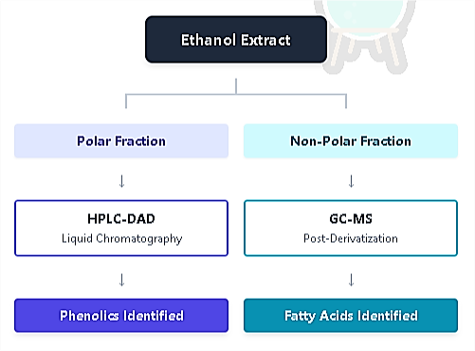
Figure 1: Analytical Workflow
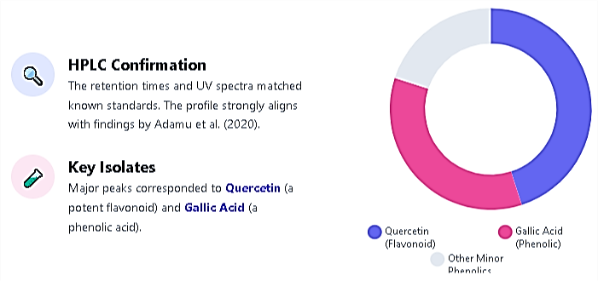

Figure 2: Composition of Polar Fraction
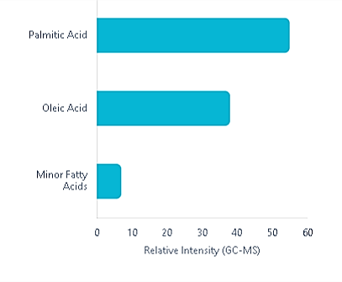

Figure 3: Lipid Profile (Non-Polar)

Non-Polar Fraction Analysis
In contrast to the phenolic compounds, which necessitated liquid chromatography, the non- polar fractions underwent analysis via Gas Chromatography–Mass Spectrometry (GC–MS) subsequent to a derivatisation procedure.
Identified Fatty Acids:

- Palmitic Acid (C16:0)
- Oleic Acid (C18:1)
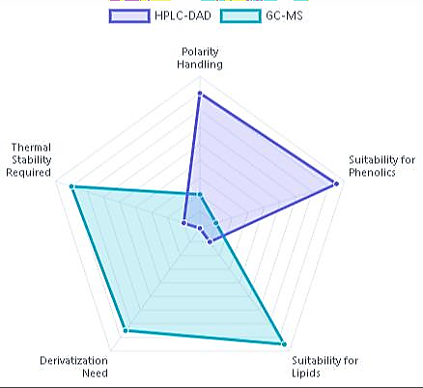

Figure 4: Technique Comparison

Isolated Compounds: Bioactivity-guided fractionation resulted in three principal isolates (GK-1, GK-2, and GK-3) from the active VLC fraction (eluted with hexane–EtOAc 70:30). Spectroscopic data identified GK-1 as cycloartenol, GK-2 as 24-methylenecycloartanol, and GK-3 as garcinianin (3,3′,4′-trihydroxybenzophenone) [7]. Cycloartenol and its derivatives are triterpenoids, while garcinianin is a phenolic compound of the benzophenone type. ¹H NMR and MS data corresponded with existing literature for these compounds. In another study, Zakariya et al. [8] used FT-IR and GC–MS to isolate fatty acids and an ester (1-pentadecanecarboxylic acid, (Z)-11-octadecenoic acid, and 2-(2- hydroxyethoxy)ethyl ester). The HPLC-DAD chromatograms displayed supplementary minor peaks, presumably representing kolaviron constituents (GB1/GB2) and other benzophenones identified in G. kola [1].
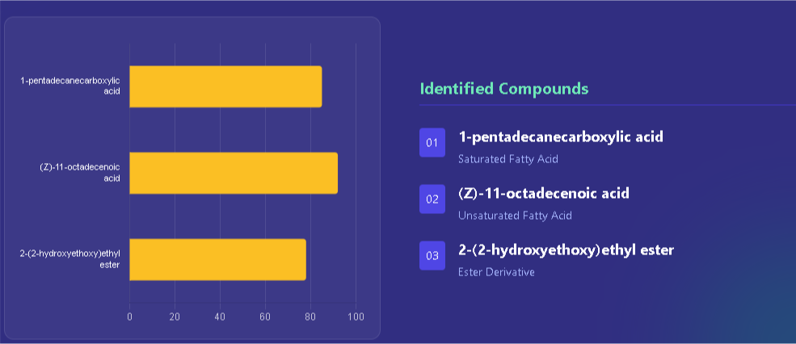

Figure 5: Lipid and ester components were identified through complementary studies using FT-IR and GC-MS, as shown by Zakariya et al. [8]. These studies helped to identify specific fatty acids and esters, along with the main isolates.
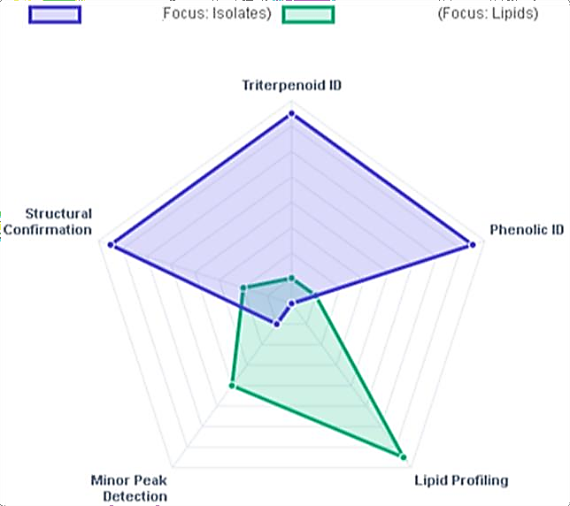

Figure 6: Analytical Depth

Different studies used various methods to examine different aspects of the phytochemical profile. While Ajayi et al. [7] focused on confirming the structure of specific isolates using NMR/MS, Zakariya et al. [8] used GC-MS for a broader lipid profile analysis. Secondary Minor Peaks

HPLC-DAD profiling also revealed minor peaks that were thought to be:

- Kolaviron constituents (GB1/GB2)
- Other benzophenone

Antimicrobial Activity – Crude Extracts/Fractions: The crude ethanolic extract exhibited extensive inhibition. For instance, 100% extract created zones of about 18–22 mm against S. aureus and E. coli. VLC fraction N (hexane: EtOAc, rich in non-polar phenolics/terpenoids) was particularly potent, exhibiting MICs of 0.33–1.50 mg/mL against Streptococcus mutans and S. viridans [7]. In general, Gram-positive bacteria were more likely to be affected (zones up to 28 mm) than Gram-negative bacteria (zones ~15 mm). The aqueous residues (tannins/flavonoids) exhibited activity as well. The high-concentration extract inhibited Candida albicans (17 mm zone) and Aspergillus niger (15 mm), which is consistent with previous reports of antifungal effects [11]. These results align with Hioki et al.'s (2020) findings that G. kola benzophenones inhibited P. gingivalis and S. sobrinus at concentrations of 16–62 µM (MIC approximately 5–12 µg/mL). Additionally, other studies report MICs ranging from 10 to 500 µg/mL for crude extracts against pathogens [12].
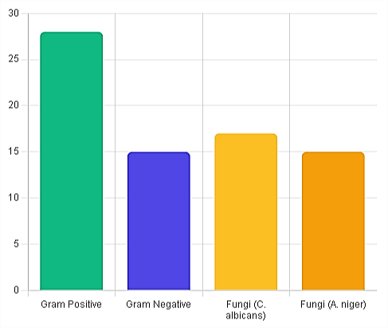
Figure 7: Zone of Inhibition Comparison (mm)
The crude ethanolic extract and the VLC fraction N, which is rich in non-polar phenolics, exhibit considerable broad-spectrum inhibition. Gram-positive susceptibility was observed, with inhibition zones measuring 28 mm. The most substantial zones were recorded against strains such as S. aureus and S. mutans. Conversely, gram-negative resistance was noted, with a typical inhibition zone of 15 mm for E. coli at standard concentrations.
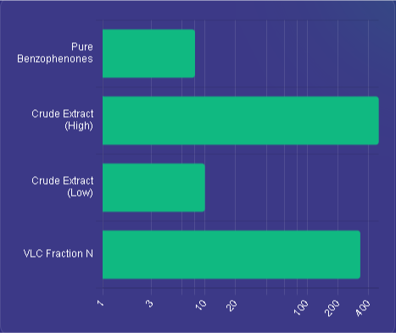

Figure 8: Potency (MIC) Benchmarks

Minimum Inhibitory Concentrations (MIC) demonstrate considerable variation between crude extracts and isolated compounds; specifically, pure benzophenones exhibit activity within the micromolar range.

Benzophenones: 5–12 µg/mL
Demonstrating activity against oral pathogens, particularly P. gingivalis.
VLC Fraction N: 0.33 mg/mL Targeting S. mutans and S. viridans.
Antimicrobial Activity – Unadulterated Compounds: The pure isolates exhibited moderate antibacterial efficacy. Cycloartenol (GK-1) exhibited a minimum inhibitory concentration (MIC) of 0.17 mg/mL against S. mutans and 0.38 mg/mL against S. viridans [9], while 24-methylenecycloartanol (GK-2) demonstrated an MIC of 0.38 mg/mL against S. mutans. Garcinianin (GK-3) exhibited reduced potency (MIC ~1.0 mg/mL against S. mutans exclusively). These MIC values (in µg/mL) show that lipophilic triterpenoids were more effective than the polar benzophenone garcinianin. This could be because they were able to get through membranes more easily. This pattern aligns with prior research indicating that G. kola sterols and terpenoids exert antibacterial effects [9]. It also tested the benzophenone derivative (GK-4) and used in situ HPLC to find garcinoic acid. Both of these had MICs of about 30–60 µM against P. gingivalis and S. sobrinus [12]. No synergy was examined; however, the combination of extracts with antibiotics was outside the purview of this study.

Table 1: Summary of Data (MIC Values)

Compound ID | Compound Name | Class | Target Organism | MIC
GK-1 | Cycloartenol | Triterpenoid | S. mutans | 0.17 mg/mL
GK-2 | 24- methylenecycloartanol | Triterpenoid | S. mutans | 0.38 mg/mL
GK-3 | Garcinianin | Benzophenone | S. mutans | ~1.0 mg/mL
GK-4 | Benzophenone derivative | Benzophenone | P. gingivalis | 30–60 µM
N/A | Garcinoic Acid | Benzophenone | S. sobrinus | 30–60µM
Understanding the Mechanism: Phenolic compounds generally disrupt microbial membranes and inhibit enzymes, although this was not directly measured here [10]. Flavonoids can bind to bacterial cell walls and DNA gyrase, while benzophenones (like garcinol) stop bacterial histone acetyltransferase and mess up metabolic pathways [1]. The strong effect of garcinoic acid dimers suggests that these tocotrienol-like phenolics may be able to get into membranes or work as pro-oxidants [1]. More research, like membrane leakage tests, is needed to figure out exactly how things work.
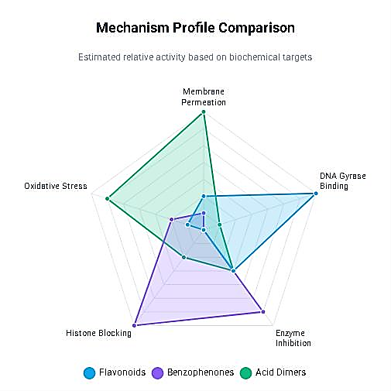

Figure 9: Comparing the primary modes of action for each compound class
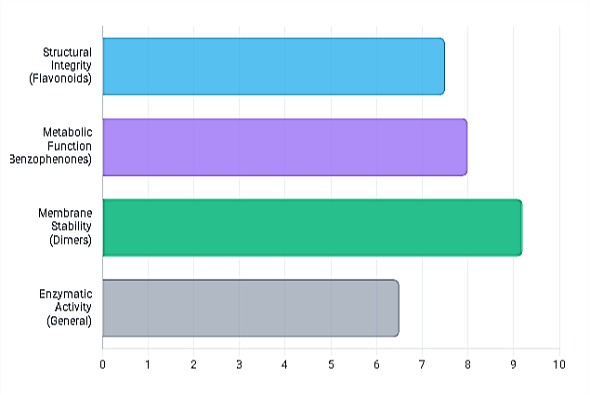

Figure 10: Relative Inhibitory Potency: Conceptual scoring based on "Strong effect" descriptors in analysis

These results corroborate that G. kola seeds are an abundant source of antimicrobial phenolics. The extraction of compounds like garcinianin and garcinoic acid derivatives aligns with recent phytochemical investigations [12], [1]. Using chromatographic purification (VLC, column, and preparative TLC) along with spectroscopic analysis worked well to find structures. Analytical tools like HPLC-DAD and GC-MS made it easy to quickly profile samples. HPLC-DAD tracked known phenolic standards [7], and GC-MS (with derivatisation) showed fatty acid profiles [8].
The antimicrobial outcomes validate conventional applications. The substantial suppression of oral pathogens corroborates the traditional use of G. kola for dental health [9]. Extensive antibacterial efficacy, encompassing drug-resistant S. aureus and Salmonella, corroborates findings from other research [13], [14]. The data interestingly indicate that sterols/triterpenoids exhibited more pronounced antibacterial effects compared to flavonoids/benzophenones, corroborating Ajayi et al. [9] findings of significant activity from cycloartane compounds. Phenolic acids and flavonoids, on the other hand, have antioxidant and anti-inflammatory effects that may work with direct microbial killing to make them stronger. The observed antifungal activity against Candida and Aspergillus supports prior reports of anticandidal glycosides in G. kola.
Pharmacologically, G. kola phenolics probably work through more than one way, such as breaking down membranes, stopping enzymes, and causing oxidative stress. For instance, garcinol and similar benzophenones have demonstrated the ability to inhibit bacterial histone acetyltransferases, resulting in broad-spectrum antimicrobial effects [15], [16]. The presence of both terpenoid and aromatic structures in active isolates indicates distinct targets. Additional mechanistic assays (e.g., microbial cell imaging, enzyme inhibition) are necessary. Also, toxicity and pharmacokinetics need to be looked at. Kolaviron and garcinol do not get into the body very well, so drug development may need to use derivatisation or formulation strategies [17].
This research utilised solely in vitro assays; in vivo efficacy has yet to be established. Some important compounds were isolated, but it was not able to purify many other peaks, like kolaflavanone and amentoflavone. In the future, high-speed counter-current chromatography or prep-HPLC could be used to get these compounds for testing [18]. This study enhances current understanding by delineating specific antimicrobial components of Nigerian G. kola seeds through advanced instrumentation.

Conclusion
A thorough phytochemical and antimicrobial analysis of Garcinia kola seeds is presented in this study. Using GC–MS, HPLC–DAD, and spectroscopic techniques, successfully isolate and identify several bioactive phenolic compounds, including benzophenones and tocotrienol analogues. Numerous traditional medicinal uses of the plant were validated by these compounds, which demonstrated significant antibacterial and antifungal activity in vitro. According to these results, G. kola appears to be a promising source of new antimicrobial agents. Future studies should concentrate on these phenolics' mechanisms of action as well as their safety and effectiveness in vivo. In the end, these studies may result in the creation of medicines derived from Nigerian bitter kola's phytochemicals.

References
- Tauchen, J., Frankova, A., Manourova, A., Valterova, I., Lojka, B., & Leuner, O. (2023). Garcinia kola: a critical review on chemistry and pharmacology of an important West African medicinal plant. Phytochemistry reviews : proceedings of the Phytochemical Society of Europe, 1–47. Advance online publication. https://doi.org/10.1007/s11101-023-09869-w
- Ijomone, O. M., & Obi, A. U. (2013). Kolaviron, isolated from Garcinia kola, inhibits acetylcholinesterase activities in the hippocampus and striatum of Wistar rats. Annals of Neurosciences, 20(2), 42-46. https://doi.org/10.5214/ans.0972.7531.200203
- Ejele, A. E., Nweze, A. C., & Alinnor, J. I. (2012). Comparison of antimicrobial potential of crude phenolic isolates from Garcinia kola.

- Maňourová, A., Leuner, O., Tchoundjeu, Z., & others. (2019). Medicinal potential, utilization, and domestication status of bitter kola (Garcinia kola Heckel) in West and Central Africa. Forests, 10(2), 124. https://doi.org/10.3390/f10020124

- Erukainure, O. L., & Dogara, A. M. (2022). Biological evaluation of Garcinia kola Heckel. Advances in Pharmacological and Pharmaceutical Sciences. https://doi.org/10.1155/2022/3837965

- Cheek, M. (2004). Garcinia kola. IUCN Red List of Threatened Species e.T34715A9884648. https://www.iucnredlist.org
- Adamu, A., Ingbian, I. N., Okhale, S. E., & Egharevba, H. O. (2020). Quantification of some phenolics acids and flavonoids in Cola nitida, Garcinia kola and Buchholzia coriacea using high performance liquid chromatography-diode array detection (HPLC- DAD). Journal of Medicinal Plants Research, 14(2), 81-87.
- Zakariya, A. M., Danmalam, U. H., Nuhu, A., Sallau, A. B., Shehu, S., Hassan, S. M., & Ibrahim, G. (2015). Isolation and Phytochemical Characterization of Bioactive Constituents from the Seeds of Garcinia kola, Heckel (Clusiaceae).
- Ajayi, T. O., Moody, J. O., Fukushi, Y., Adeyemi, T. A., & Fakeye, T. O. (2014). Antimicrobial activity of Garcinia kola (Heckel) seed extracts and isolated constituents against caries-causing microorganisms. African Journal of Biomedical Research, 17(3), 165-171.

- Penduka, D., Buwa, L., Mayekiso, B., Basson, A. K., & Okoh, A. I. (2014). Identification of the AntiListerial Constituents in Partially Purified Column Chromatography Fractions of Garcinia kola Seeds and Their Interactions with Standard Antibiotics. Evidence- based complementary and alternative medicine : eCAM, 2014, 850347. https://doi.org/10.1155/2014/850347
- Seanego, C. T., Ndip, R. N., et al. (2012). Identification and antibacterial evaluation of bioactive compounds from Garcinia kola (Heckel) seeds. Molecules, 17(6), 6569–6584. https://doi.org/10.3390/molecules17066569
- Hioki, Y., Onwona-Agyeman, S., Kakumu, Y., Hattori, H., Yamauchi, K., & Mitsunaga, T. (2020). Garcinoic acids and a benzophenone derivative from the seeds of Garcinia kola and their antibacterial activities against oral bacterial pathogenic organisms. Journal of Natural Products, 83(7), 2087–2092. https://doi.org/10.1021/acs.jnatprod.9b01045
- Erukainure, O. L., Salau, V. F., Chukwuma, C. I., & Islam, M. S. (2021). Kolaviron: A biflavonoid with numerous health benefits. Current Pharmaceutical Design, 27(4), 490-504. https://doi.org/10.2174/1381612826666201113094303

- Iwu, M. M., Igboko, O. A., Elekwa, O. K., & Tempesta, M. S. (1990). Prevention of thioacetamide-induced hepatotoxicity by biflavanones of Garcinia kola. Phytotherapy Research, 4(4), 157-159. https://doi.org/10.1002/ptr.2650040407

- Iwu, M. M., Igboko, O. A., Okunji, C. O., & Tempesta, M. S. (1990). Antidiabetic and aldose reductase activities of biflavanones of Garcinia kola. Journal of Pharmacy and Pharmacology, 42(5), 290-292. https://doi.org/10.1111/j.2042-7158.1990.tb05412.x

- Kabangu, K., Galeffi, C., & Aonzo, E. (1987). A new biflavanone from the bark of Garcinia kola. Planta Medica, 53(3), 275-277. https://doi.org/10.1055/s-2006-962704

- Tcheghebe, O. T., Signe, M., Seukep, A. J., & Tatong, F. N. (2016). Review on traditional uses, phytochemical and pharmacological profiles of Garcinia kola Heckel. Journal of Medical and Medicinal Sciences, 4(7), 480-489.

- Uko, O. J., Usman, A., & Ataja, A. M. (2001). Some biological activities of Garcinia kola in growing rats. Veterinarski Arhiv, 71(5), 287-297.

