Original Research Article

AGRICULTURAL WASTE ANNONA SQUAMOSA L. YOUNG FRUIT EXTRACT: PREPARATION AND ANTIBACTERIAL ACTIVITY OF SILVER NANOPARTICLES

Abstract
In the present study, we have developed an eco-friendly method to synthesize nanoparticles using the aqueous young fruit extract of Annona squamosa. Unlike conventional syntheses, which often involve toxic reagents and energy-intensive processes, our approach is sustainable, using agricultural waste as a reducing agent. Notably, an estimated 500kg per hectare of young fruit is discarded annually in the Tay Ninh Province, Vietnam, simply because it does not meet the quality standard. By converting this waste into raw materials for nanoparticle synthesis, we address both waste management and resource utilization. For the synthesis, a 1:1 (v/v) ratio of aqueous young fruit extract was combined with 50 mL of 5 mM silver nitrate. The formation of silver nanoparticles was determined using various characterization methods, including ultraviolet–visible spectroscopy (UV-Vis), field-emission scanning electron microscopy (FE-SEM), and dynamic light scattering (DLS). The antibacterial efficacy of these nanoparticles was tested against two bacteria, Salmonella enteria and Escherichia coli.
Keywords: Annona squamosa, young fruit extract, silver nanoparticles, E. coli, Salmonella.
Introduction
Custard apple (Annona squamosa L.), also known as sitaphal, sharifa, sugar apple, is a nutritious, edible fruit of the family Annonaceae. Annonaceae fruits originated in tropical America and are widely distributed in the tropics and sub-tropics. In this study, we leverage the pruning waste from young fruits of this species to synthesize valuable nanomaterials, establishing a significant connection between agricultural practices and materials science [1].
Tay Ninh province in southeastern Vietnam is the nation's leading custard apple producer, with approximately 5,100 hectares yielding over 74,000 tonnes annually. Renowned for its Ba Den Mountain custard apple, certified with geographical indication status, the province ensures high quality and market competitiveness through strict cultivation standards [2]. Viet-GAP (Vietnamese Good Agricultural Practices) provides detailed guidelines for safe and sustainable crop production in Vietnam. Applying GAP in safe crop production has been global trend [3-5]. Therefore, it is possible to step up to apply certification GAP such as Viet GAP from Basic GAP according to the production condition of the zone (body), and target of the market. One key practice is removing young fruits that do not meet these standards, which produces up to 500kg per hectare of unused material. This commonly wasted resource provides a significant opportunity for nanoparticle synthesis, highlighting an innovative approach to reducing agricultural waste and promoting resource efficiency [1].
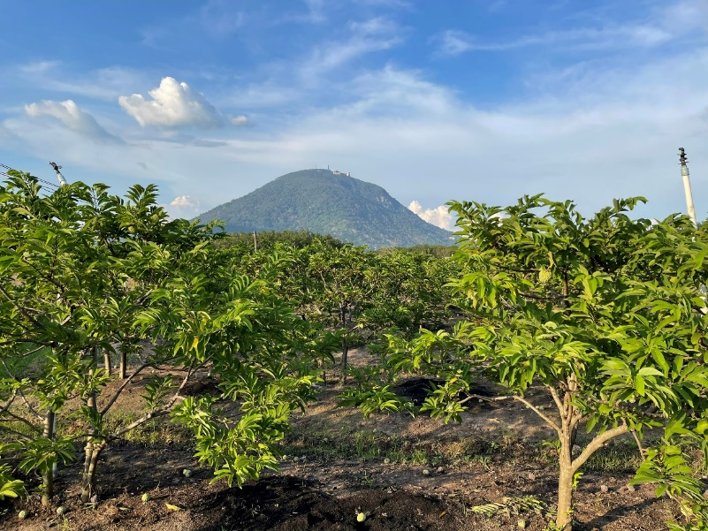
Figure 1. Custard apples are grown to Viet-GAP standards in Tây Ninh province
Nanoparticles, commonly thought of as particles up to 100 nm in size, exhibit unique or improved properties compared to the bulk material from which they are derived, based on specific characteristics such as size, distribution, and morphology [6]. Silver nanoparticles have captured significant attention due to their excellent broad-spectrum antimicrobial activity. Silver nanoparticles are renowned for being effective antimicrobial agents against bacteria, viruses, and other eukaryotic microorganisms. However, many conventional approaches to silver nanoparticle synthesis rely on chemical reducers that are not environmentally friendly. In contrast, our method using the extract from Annona squamosa young fruit not only avoids these harmful chemicals but also mitigates the environmental impact. By leveraging this plant extract, we create a more sustainable nanoparticle production method, highlighting the reduced environmental footprint and offering a significant advancement in green nanotechnology [7].
In this method, two elements are required for nanoparticle growth: a silver salt and a reducing agent [8]. The silver ions are derived from silver salts such as silver nitrate, silver citrate, and silver acetate. A reducing agent first reduces the ions to atoms, then the atoms are nucleated and grow into particles [9].
Enol ↔ keto + 2e + 2H⁺ (1)
Ag⁺ + e ↔Agº (2)
In our process, the reduction of silver ions (Ag⁺) to elemental silver (Agº) is facilitated by the polyphenolic compounds found in the Annona squamosa young fruit extract. These compounds, primarily flavonoids and phenolic acids, act as biological reducing agents, donating electrons that drive the redox reaction forward. The presence of specific functional groups within these compounds, such as hydroxyl groups, contributes significantly to their reducing potential. This mechanistic insight not only underscores the effectiveness of our eco-friendly synthesis approach but also highlights the potential for utilizing natural, renewable resources for nanoparticle production.
The study aimed to explore three main hypotheses: (1) that polyphenols can be effectively extracted from the young fruit of Annona squamosa L.; (2) that the extracts can be utilized to synthesize silver nanoparticles with specific size properties, characterized by UV-VIS, FE-SEM, and DLS techniques; and (3) that these extract-mediated silver nanoparticles will exhibit significant antibacterial activity, inhibiting Escherichia coli and Salmonella enteria by 99% or more.
Materials and methods
Custard apple young fruit hot extract
Fresh young fruits were purchased from farms in Tay Ninh and collected and washed with double-distilled water. The young fruit samples were packed and stored at 20°C in a dark storage room before chemical analyses were performed. To ensure freshness, the fruits were classified based on appearance and firmness, with any overly ripe or damaged fruits excluded. Sampling was conducted in triplicate across different seasonal batches to account for potential compositional variability. This methodological rigor offers reproducibility and reliability in our results.
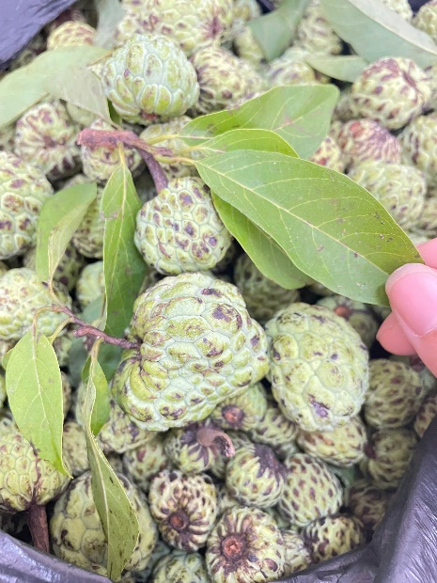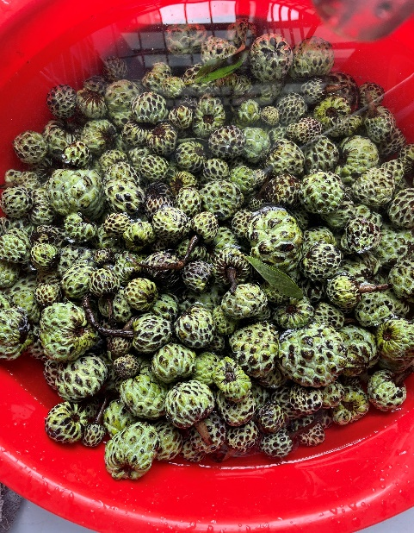
Figure 2. The young fruit of Annona squamosa
The young fruits of Annona squamosa were washed several times with tap water, then with double-distilled water, to remove dust and other foreign particles. A quantity of 500g of fresh young fruit was completely dissolved in 2 L of distilled water. The resultant mixture was subsequently heated to 100 °C for 3 hours. The extract was stored in amber coloured reagent bottles at 4ºC for further use [10].
Phytochemical Screening
Phytochemical screening was carried out in the aqueous extract of Annona squamosa young fruit using standard procedures [11-13]. In order to study the chemical composition of the extract, qualitative test have been done according to Mali et al. to detect the presence of primary and secondary metabolites in the fresh young Annona squamosa fruit.
Test for alkaloids: a small amount of the extract was treated with 3 drops of Wagner’s reagent and the formation of reddish-brown precipitate show the presence of alkaloid.
Test for flavonoids: Crude extract mixed with 2ml of 2% solution of NaOH. An intense yellow color was formed which tuned colorless or addition of few drops of dilute acid which indicates the flavonoids.
Test for carbohydrates: Crude extract when mixed with 2ml of iodine solution. A dark blue or purple coloration indicates that presence of carbohydrate.
Test for tannins and phenols: Crude extract mixed with 2ml of 2% solution of FeCl₃. A blue green or black coloration indicates the presence of phenol and tannin.
Test for terpenoids: To 5ml of extract few drops of chloroform and conc H₂SO₄ was added carefully along the sides of the test tube to form a layer and observed for the presence of reddish-brown coloration.
Synthesis of silver nanoparticles
Based on the method of Nguyen et al., for the synthesis of silver nanoparticles, the extract was added dropwise into the samples with AgNO₃ concentrations of 1 mM, 2.5mM, 5mM, 7.5mM, and 10mM solution at a ratio of 1:1 (v/v). The mixture was stirred continuously for 5 hours using a magnetic stirrer at 300rpm [14-15]. A change in the color of the solution indicated that the reaction had taken place and nanoparticles had formed. The young fruit extract was used as a reducing and stabilizing ingredient for the solution of silver nitrate [16].
Characterization Techniques
UV-Vis spectral analysis was measured using HACH - DR6000 at the range of 300 – 600nm, all UV-Vis absorption spectra were read against distilled water. Field emission scanning electron microscopy (FE-SEM Hitachi-S4800N - Japan) analysis of silver nanoparticles analysis was done. The shape and size distribution of silver nanoparticles were characterized by Dynamic Light Scattering (Horiba - LB550 - Japan) and Scanning Electron Microscopy (Hitachi - S4800N - Japan).
Antibacterial activity
The antibacterial activity was determined using the AOAC 966.04 method of the Vietnam Pharmacopoeia and BS EN 1040:2005 by Viet Tin Testing Company, Ltd. Each carrier is individually inoculated with spore suspension of Escherichia coli ATCC 25922 and Salmonella enterica subsp. Enterica serovar Typhimurium ATCC 14028. For AOAC sporicidal tests, inoculum size should be adjusted to 1.0×10⁶ spores/ carrier.
Results and discussion
Phytochemical screening of the aqueous extract of young fruit of Annona squamosa confirmed the presence of alkaloids, flavonoids, carbohydrate, phenols and tannins while terpenoids were absent. These bioactive constituents act as potent reducing and stabilizing agents, facilitating the synthesis of metallic nanoparticles through the reduction of metallic ions followed by controlled atom agglomeration. Flavonoids possess a wide range of functional groups that augment their reductive potential through transform the enol-form into the keto-form and release the reactive hydrogen atom, resulting in the conversion of metal ions into stable atoms [17-18]; Thus, flavonoids present in Annona squamosa extract might play a vital role for the formation of silver nanoparticles.
Table 1. Phytochemical screening of the aqueous extract of young Annona squamosa fruits
No. | Phytochemicals | Added reagent | Aqueous extract
1 | Alkaloids | Wagner’s reagent | +
2 | Flavonoids | NaOH (2%) | +
3 | Carbohydrates | iodine solution | +
4 | Tannins | FeCl₃ (2%) | +
5 | Phenols | FeCl₃ (2%) | +
6 | Terpenoids | Chloroform, H₂SO₄ | -
Note: “+” present; “-” absent.
We present the chemical composition, particle characterization, and antibacterial efficacy of the synthesized nanoparticles. Total polyphenol content of Annona squamosa young fruit extract was measured by Folin - Ciocalteu method 6mg GAE/L. Therefore, custard apple young fruit rich in phenolic compounds were used in the synthesis of nanoparticles in this study [16]. The result was similar to the previous studies that using leaves, peel and seed extract to prepare silver nanoparticles [19]. However, the utilization of Annona squamosa young fruit extract for the green synthesis of silver nanoparticles has not been previously reported. Silver nanoparticles synthesized using young fruit extract show the reaction changes color of the solution from white to yellowish-brown color and explained the transformation as occurring with the reduction of Ag⁺ ions to Agº [9].
According to UV-Vis results where the silver nanoparticles synthesized using water extracts display absorption peaks in the range of 420 – 460nm, reflecting particle formation and stability. Figure 4 shows concentration of AgNO₃ changes from 1 to 10mM with Annona squamosa young fruit extract. The maximum absorption wavelength increases with the rising concentration of AgNO₃, primarily due to the formation of more silver nanoparticles. Previous studies have reported that the synthesized silver nanoparticles were in the range of 444nm [20-22]. The UV-Vis peak is more pronounced for higher AgNO₃ concentrations, indicating that more nanoparticles per unit volume are formed when this concentration increases. The silver nanoparticles 5mM have been stored at room temperature for 03 months without any decomposition or aggregation.
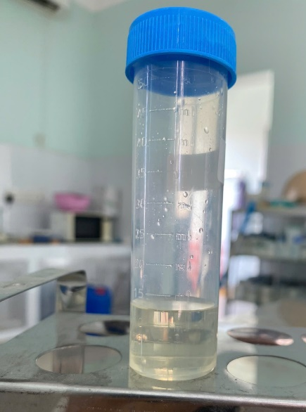
Figure 3. Synthesis of silver nanoparticles using Custard apple young fruit extract
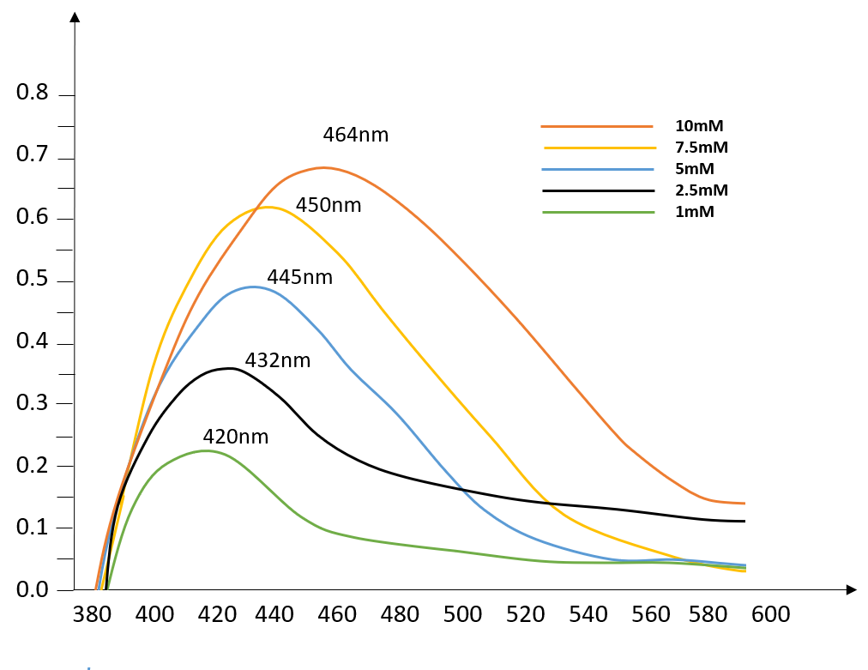
Figure 4. UV – Visible absorption spectra of the silver nanoparticles that were synthesized
FE-SEM and DLS analysis
The morphology, dispersion and size of silver nanoparticles can be observed via FE-SEM. As shown in Figure 6, the FE-SEM image shows different particle sizes ranging from 40nm to 75nm. Similar results were reported elsewhere [21,23], the DLS result showed that the diameter of the silver nanoparticles is in the range of 70nm to 300nm (Figure 5). Thus, the DLS and FE-SEM data collectively indicate the formation of small, moderately polydisperse silver nanoparticles with limited aggregation in the solution.
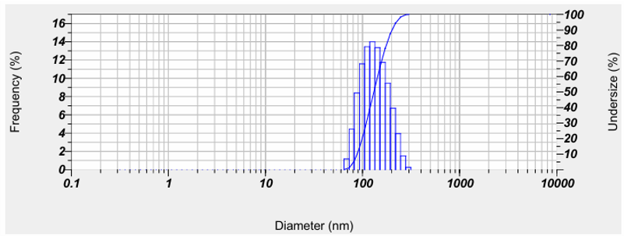
Figure 5. DLS image of synthesized silver nanoparticles
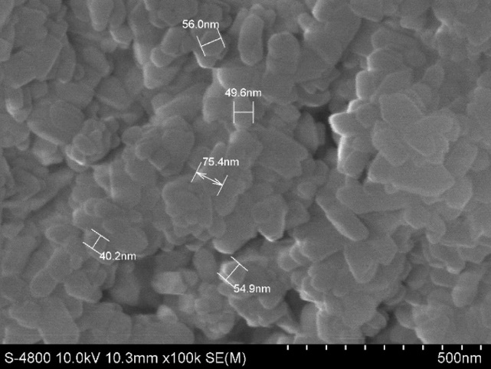
Figure 6. FE-SEM images of silver nanoparticles
Antibacterial activity was applied the method of Vietnam Pharmacopoeia AOAC 966.04, BS EN 1040:2005, the silver nanoparticles that were synthesized showed strong antibacterial action against Salmonella enteria and Escherichia coli (Enterobacteriaceae). Silver is known to have a broad-spectrum antibacterial action and has been used in dentistry [21,24]. We studied the antibacterial activity of silver nanoparticles at the concentration of 5mM, against Salmonella enterica and E. coli. The nanoparticles achieved an inhibition rate of 99.98% and 99.99%, respectively. Similarly, Bharti et al. examined the bactericidial efficiency of silver nanoparticles against E. coli, P. aeruginosa, Bacillus subtilis, and S. aureus.
Conclusion
Green chemistry approaches toward the synthesis of nanoparticles have many advantages, such as ease of scalability and economic viability. We have developed a fast, eco-friendly, and convenient method for the synthesis of silver nanoparticles using agro-based waste of Annona squamosa extract. No chemical reagent or surfactant template was required in this method, which consequently enables the bioprocess to be environmentally friendly. The size distribution for silver nanoparticles ranges up to 200 nm. Finally, FE-SEM and DLS techniques confirmed the presence of silver nanoparticles.
Looking forward, these silver nanoparticles have potential applications in real-world systems, such as enhancing the antibacterial properties of food packaging and improving the efficacy of water filtration systems. For future research, a concrete next step could involve exploring the integration of these nanoparticles into polymer surfaces for food packaging, aiming to extend shelf life and reduce spoilage. Such studies could serve as a springboard for further exploration into commercial applications, harnessing the full potential of this green synthesis method.

References
Kolekar, Y. S., Tamboli, F. A., Gaikwad, D. T., Memon, S., Gulavani, S. S., Alaskar, K., Mali, D., & Pawar, V. T. (2023). Biosynthesis of silver nanoparticles using Annona squamosa L Seed and Leaves Extract: Evaluation of the Anti-inflammatory, Antifungal, and Antibacterial Potency. International Journal of Pharmaceutical Quality Assurance, 14, 377-387. https://doi.org/10.25258/ijpqa.14.2.23
Cục Thống kê tỉnh Tây Ninh. (2025). Niên giám thống kê tỉnh Tây Ninh 2024. Thống kê.
Maughan, T., Drost, D., Olsen, S., & Black, B. (2016). Good agricultural practices (GAP): Certification basics. https://digitalcommons.usu.edu/extension_curall/804
Dao, Q. T., & Dung, D. V. (2019). The efficiency of development investment in agricultural production applying good agricultural practices (GAP) standard of household—Case study of grapes and apple in Ninh Thuan Province, Vietnam. Journal of Business Management and Economic Research, 3(1), 8-16. https://doi.org/10.29226/TR1001.2018.98
Manning, L., Keogh, J. G., Saunders, T. P., Bihn, E. A., Monaghan, J., Wortmann, C., Grassini, P., Elmore, R. W., & Staver, C. (2025). *Instant Insights: Good agricultural practices* (Vol. 112). Burleigh Dodds Science Publishing. https://shop.bdspublishing.com/store/bds/detail/workgroup/3-190-145553
Nguyen, N. P. U., Dang, N. T., Doan, L., & Nguyen, T. T. H. (2023). Synthesis of Silver Nanoparticles: From Conventional to 'Modern' Methods—A Review. Processes, 11(9), 2617. https://doi.org/10.3390/pr11092617
Javed, M. A., Ali, B., Sarfraz, M. H., Ali, S., Liaqat, E., Afzal, M. S., ... & Elshikh, M. S. (2024). Biosynthesis and characterization of silver nanoparticles from Cedrela toona leaf extracts: An exploration into their antibacterial, anticancer, and antioxidant potential. Green Processing and Synthesis, 13(1), 20230248.
Nguyen, N. P. U., Dang, N. T., Doan, L., & Nguyen, T. T. H. (2023). Synthesis of Silver Nanoparticles: From Conventional to 'Modern' Methods—A Review. Processes, 11(9), 2617. https://doi.org/10.3390/pr11092617
Alviar-Agnew, M., & Agnew, H. (2022). Oxidation and Reduction—Some Definitions. Chemistry LibreTexts. https://chem.libretexts.org/Courses/Taft_College/CHEM_1510:_Introductory_College_Chemistry/18:_Oxidation_and_Reduction/18.1:_Oxidation_and_Reduction-_Some_Definitions
Jose, V., Raphel, L., Aiswariya, K. S., & Mathew, P. (2021). Green synthesis of silver nanoparticles using Annona squamosa L. seed extract: characterization, photocatalytic and biological activity assay. Bioprocess and Biosystems Engineering, 44(9), 1819-1829. https://doi.org/10.1007/s00449-021-02562-2
Mali, M. B., Mali, M. B., Raut, N., Patil, D., Bhosale, S., & Chougule, N. (2025). A Review: On Phytochemical Profile and Therapeutic Uses of Annona Squamosa Plant. International Journal of Research Publication and Reviews, 6(3), 10191-10197. https://www.ijrpr.com/volume-6-issue-3-march-2025/
Jamdhade, P. B., & Kamble, L. H. (2022). Phytochemical Screening of Aqueous and ethanolic, stem extract of Annona squamosa Linn. Paripex - Indian Journal Of Research. https://doi.org/10.36106/paripex/9704032
Sabbah, A., Nasser, M., Hijazi, A., Rammal, H., & Nasser, G. (2017). Phytochemical screening and cytotoxic activity of two extracts from seeds of Lebanese Annona squamosa L. International Journal of Pharma Research and Health Sciences, 5(1), 1586-1591. https://www.ijprhs.com/issue/2017/jan-feb/1586-1591.pdf
Nguyen, T. H. T., Nguyen, T. T. L., Le, S. N., Nguyen, H. T. L., Pham, T. H. V., & Pham, Q. T. (2018). Biosynthesis of Silver Nanoparticles Using Coconut Fiber Extraction and Study of Antimicrobial Effects in Vitro. Journal of Technical Education Science, 13(6), 88-95. https://jte.edu.vn/index.php/jte/article/view/317
Kiranmayi, G. V. N. (2021). Synthesis of silver nanoparticles using ethanolic extract of Annona squamosa fresh leaves and investigation of antioxidant, anti-arthritic, and thrombolytic activities. *International Journal of Green Pharmacy (IJGP)*, *15*(2). https://doi.org/10.22377/ijgp.v15i2.3096
Nguyen, V. T., Nguyen, N. Q., Muoi, N. V., & Mai, H. C. (2020). Effect of Extraction Conditions on Total Polyphenol and Flavonoid Content of Sugar Apple Seeds (Annona squamosa L.). Asian Journal of Chemistry, 32, 1741-1745. https://doi.org/10.14233/ajchem.2020.22265
Malik, M., Iqbal, M. A., Malik, M., Raza, M. A., Shahid, W., Choi, J. R., & Pham, P. V. (2022). Biosynthesis and characterizations of silver nanoparticles from Annona squamosa leaf and fruit extracts for size-dependent biomedical applications. Nanomaterials, 12(4), 616. https://doi.org/10.3390/nano12040616
Aigbe, U. O., & Osibote, O. A. (2024). Green synthesis of metal oxide nanoparticles, and their various applications. Journal of hazardous materials advances. https://doi.org/10.1016/j.hazadv.2024.100401
Harsha, L., Jain, R. K., & Prasad, A. S. (2022). Synthesis, characterization, and antimicrobial activity of silver nanoparticles derived from Mentha X piperita + Ocimum tenuiflorum: An in vitro study. Journal of Advanced Pharmaceutical Technology & Research. https://doi.org/10.4103/japtr.japtr_181_22
Jibrin, F., Fanoro, O. T., Maluleke, R., Lebepe, T. C., Mgedle, N., Mbaz, G. I. M., Aladesuyi, O. A., Kalimuthu, R., Odeku, O. A., & Oluwafemi, O. S. (2024). Biosynthesis, Characterization, and Antibacterial Activity of Gold, Silver, and Bimetallic Nanoparticles Using Annona squamosa L. Leaves. Antibiotics, 13(12), 1199. https://doi.org/10.3390/antibiotics13121199
Aldayel, M. F. (2024). Biofabrication of Silver Nanoparticles Using Pergularia tomentosa Extract and Evaluation of Their Antibacterial, Antioxidant, and Cytotoxic Properties. Life, 14(12), 1639. https://doi.org/10.3390/life14121639
Jose, V., Raphel, L., Aiswariya, K. S., & Mathew, P. (2021). Green synthesis of silver nanoparticles using Annona squamosa L. seed extract: characterization, photocatalytic and biological activity assay. Bioprocess and Biosystems Engineering, 44(9), 1819-1829. https://doi.org/10.1007/s00449-021-02562-2
Jose, V., Raphel, L., Aiswariya, K. S., & Mathew, P. (2021). Green synthesis of silver nanoparticles using Annona squamosa L. seed extract: characterization, photocatalytic and biological activity assay. Bioprocess and Biosystems Engineering, 44(9), 1819-1829. https://doi.org/10.1007/s00449-021-02562-2
Bharti, S., Mukherji, S., & Mukherji, S. (2021). Enhanced antibacterial activity of decahedral silver nanoparticles. Journal of Nanoparticle Research, 23(2), 36. https://doi.org/10.1007/s11051-020-05106-z

