Review Article

Epigenetics, Neuropharmacology, and Biochemical Modifications in Brain Disorders: Molecular Mechanisms and Therapeutic Perspectives

ABSTRACT
Brain disorders represent a major global health burden, encompassing neurodegenerative, neuropsychiatric, and neurodevelopmental conditions. Increasing evidence highlights the crucial roles of epigenetic regulation, neuropharmacological mechanisms, and biochemical modifications in the onset and progression of these disorders. Epigenetic processes such as DNA methylation, histone modification, and non-coding RNA regulation dynamically modulate gene expression without altering DNA sequences and are profoundly influenced by environmental factors. Neuropharmacology provides insight into how drugs interact with neural systems to modify neurotransmission, behavior, and cognition. Furthermore, biochemical alterations including oxidative stress, neuroinflammation, mitochondrial dysfunction, protein aggregation, and neurotransmitter imbalance critically disrupt neuronal homeostasis. This review comprehensively discusses the interplay between epigenetics, neuropharmacology, and biochemical modifications in brain disorders, emphasizing molecular mechanisms, disease implications, current research techniques, and emerging therapeutic strategies. Understanding these interconnected pathways may facilitate the development of targeted, personalized, and disease-modifying treatments for neurological and psychiatric disorders.
Keywords: Epigenetics, Neuropharmacology, Brain Disorders, DNA Methylation, Neuroinflammation, Oxidative Stress, Neurodegeneration
GRAPHICAL ABSTRACT
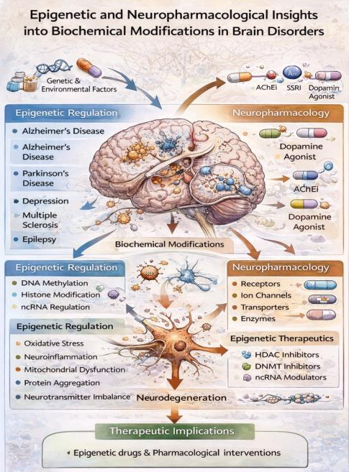

INTRODUCTION
Brain disorders affect millions of individuals worldwide and represent a leading cause of disability and mortality. These disorders arise from complex interactions between genetic susceptibility, environmental exposures, epigenetic regulation, and biochemical dysregulation. While genetic mutations contribute to disease risk, they alone cannot explain disease heterogeneity, variable onset, or treatment response. Epigenetic modifications and biochemical changes provide additional regulatory layers that shape neuronal function and dysfunction. [1,2]
Recent advances in neuroscience have demonstrated that epigenetic mechanisms influence neural development, synaptic plasticity, learning, memory, and behavior. Neuropharmacology complements these findings by elucidating how drugs interact with neural targets to restore or modify altered signaling pathways. Furthermore, biochemical modifications such as oxidative damage, inflammatory signaling, and protein misfolding are increasingly recognized as central contributors to neurodegenerative and psychiatric disorders. This review integrates these perspectives to provide a comprehensive overview relevant to pharmaceutical and biomedical research.[3]

EPIGENETICS

Epigenetics refers to heritable and reversible changes in gene expression that occur without alterations in the DNA sequence. Derived from the Greek term “epi,” meaning “on” or “above,” epigenetics describes regulatory mechanisms beyond the genetic code. The collective epigenetic modifications across the genome constitute the epigenome, which determines when, where, and to what extent genes are expressed. Epigenetic regulation enables cellular differentiation and tissue specificity by controlling protein production. Environmental factors such as diet, stress, toxins, drugs, and lifestyle can induce epigenetic changes that persist through cell divisions and, in some cases, across generations. These features make epigenetics particularly relevant to complex brain disorders. [4,5]

The epigenome encompasses all chemical modifications to DNA and histones that regulate gene expression. Unlike the genome, the epigenome is dynamic, tissue-specific, and responsive to environmental stimuli, making it a key determinant of brain plasticity and disease risk.[6]

Importance of epigenetics:

Epigenetics provides a dynamic interface between genes and the environment and is essential for:

Development and cellular specialization

Disease pathogenesis and therapeutic intervention

Environmental adaptation and stress responses

Personalized medicine approaches

Understanding complex neurological traits
Fig. No. 1 Schematic representation of epigenetic regulation showing DNA methylation, histone modification, and non-coding RNA–mediated control of gene expression.
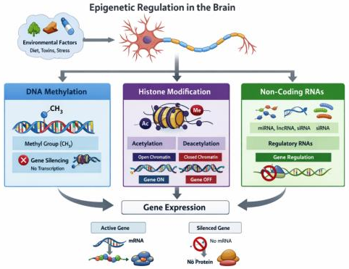

Mechanisms of Epigenetic Regulation

DNA Methylation:
DNA methylation involves the covalent addition of a methyl group to the 5-position of cytosine residues, primarily within CpG dinucleotides. This modification is catalyzed by DNA methyltransferases and generally leads to transcriptional repression. In the brain, DNA methylation plays a crucial role in neuronal development, synaptic plasticity, and memory formation.[7] Aberrant methylation patterns have been associated with neurodegenerative diseases, psychiatric disorders, and brain tumors Fig. 1, Table 1.
Table I Role of DNA methylation in normal brain function and disease
Aspect | Physiological Role | Pathological Consequences
Gene regulation | Neuronal differentiation | Gene silencing of neuroprotective genes
Synaptic plasticity | Memory formation | Cognitive impairment
Development | Brain patterning | Neurodevelopmental disorders

Histone Modification:

Histones are core proteins around which DNA is wrapped to form chromatin. Post-translational modifications of histone tails, including acetylation, methylation, phosphorylation, and ubiquitination, regulate chromatin structure and gene accessibility. Histone acetylation is generally associated with transcriptional activation, whereas histone deacetylation leads to gene repression. Dysregulation of histone-modifying enzymes has been implicated in neurodegenerative and psychiatric disorders.[8]
Figure 2 Chromatin remodeling through histone acetylation and deacetylation and its impact on gene transcription
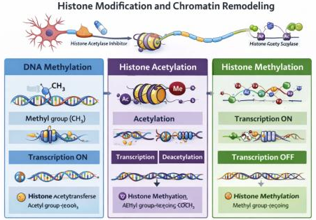

Non-Coding RNA:
Non-coding RNAs (ncRNAs), including microRNAs and long non-coding RNAs, regulate gene expression at transcriptional and post-transcriptional levels. ncRNAs influence epigenetic machinery by modulating DNA methylation and histone modification. Abnormal ncRNA expression has been linked to tumorigenesis, neurodevelopmental disorders, and neurodegeneration.[9]
Developmental Significance:
Epigenetic mechanisms guide embryonic brain development, neuronal differentiation, and synaptic connectivity. Environmental insults during critical developmental periods can induce persistent epigenetic changes, predisposing individuals to neurological and psychiatric disorders later in life. Environmental factors such as nutrition, stress, toxins, and pharmacological agents can reshape the epigenome. These changes influence chromatin structure and gene accessibility, thereby modulating neuronal function and disease vulnerability.[10]

Disease Implications of epigenetic dysregulation:
Epigenetic alterations contribute to a wide range of diseases, including cancer, metabolic disorders, neurological illnesses, and cardiovascular conditions. In the brain, epigenetic dysregulation affects neuronal survival, synaptic plasticity, and cognitive function. [11]
Therapeutic Potential of Epigenetic Modulation:
Epigenetic therapies aim to reverse abnormal DNA methylation and histone modification patterns. Drugs targeting DNA methyltransferases and histone deacetylases have shown promise in cancer and are being explored for neurodegenerative and psychiatric disorders.
Table II Examples of epigenetic drug targets and therapeutic applications
Target | Drug Class | Potential Application
DNMTs | DNMT inhibitors | Cancer, neurodegeneration
HDACs | HDAC inhibitors | Cognitive disorders, depression

Research Techniques in Epigenetics:
Key techniques include chromatin immunoprecipitation (ChIP), bisulfite sequencing, and RNA sequencing. These methods enable genome-wide analysis of protein–DNA interactions, DNA methylation patterns, and transcriptomic changes. [12]
Figure 3 Overview of major epigenetic research techniques used in neuroscience
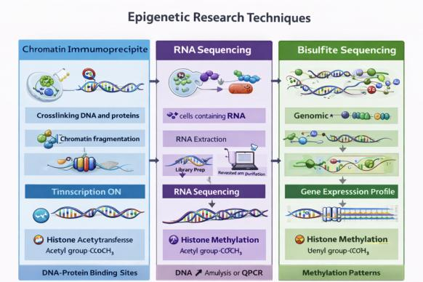

NEUROPHARMACOLOGY
Neuropharmacology is a specialized branch of pharmacology that focuses on the study of drug actions on the nervous system, encompassing the brain, spinal cord, and peripheral nerves. It investigates how pharmacological agents influence neuronal function, synaptic transmission, neurochemical signaling, and behavior, as well as how alterations in neural circuits contribute to neurological and psychiatric disorders. Neuropharmacology integrates principles from neuroscience, molecular biology, biochemistry, physiology, and pharmacokinetics to understand both therapeutic and adverse effects of drugs acting on the nervous system. [13,14]
Broadly, neuropharmacology can be divided into molecular neuropharmacology and systems/behavioral neuropharmacology. Molecular neuropharmacology examines drug interactions at the level of receptors, ion channels, transporters, enzymes, and intracellular signaling pathways, whereas systems neuropharmacology evaluates how these molecular effects translate into changes in neural networks, cognition, emotion, and behavior.[15]
The CNS is characterized by highly specialized cellular architecture and tightly regulated homeostasis. Drugs targeting the CNS must overcome the blood–brain barrier (BBB), interact selectively with neural targets, and maintain an appropriate balance between efficacy and neurotoxicity. Consequently, neuropharmacology plays a crucial role in the development of treatments for neurodegenerative diseases, psychiatric disorders, epilepsy, pain, stroke, and neurodevelopmental conditions.[16]

Scope and Importance of Neuropharmacology
Neuropharmacology is fundamental to understanding the pathophysiology and management of a wide range of brain disorders. Alterations in neurotransmitter systems, receptor sensitivity, synaptic plasticity, and neuronal survival mechanisms are hallmarks of conditions such as Alzheimer’s disease, Parkinson’s disease, schizophrenia, depression, anxiety disorders, and epilepsy. Pharmacological modulation of these pathways remains the cornerstone of clinical management.
Advances in neuropharmacology have enabled:
- Identification of novel drug targets within neurotransmitter and neuromodulatory systems
- Development of disease-modifying therapies rather than purely symptomatic treatments
- Understanding of drug tolerance, dependence, and addiction mechanisms
- Integration of pharmacogenomics and personalized medicine approaches
Moreover, neuropharmacology provides essential tools for probing normal brain function, as many neurotransmitter systems were first characterized using selective agonists and antagonists.[17,18]

Neurotransmitter Systems Targeted in Neuropharmacology
Neuropharmacological agents primarily act by modulating neurotransmitter synthesis, release, receptor binding, reuptake, or degradation. Major neurotransmitter systems include:

Dopaminergic System
The dopaminergic system regulates motor control, motivation, reward, and cognition. Dysregulation is implicated in Parkinson’s disease, schizophrenia, and substance use disorders. Drugs such as levodopa, dopamine agonists, and antipsychotics exert their effects by altering dopamine synthesis or D₁/D₂ receptor activity.[19]

Serotonergic System
Serotonin (5-HT) influences mood, anxiety, sleep, appetite, and cognition. Selective serotonin reuptake inhibitors (SSRIs), serotonin–norepinephrine reuptake inhibitors (SNRIs), and 5-HT receptor modulators are widely used in the treatment of depression and anxiety disorders.

Glutamatergic System
Glutamate is the primary excitatory neurotransmitter in the CNS and plays a key role in learning and memory. Excessive glutamatergic activity leads to excitotoxicity, contributing to neurodegeneration and stroke. NMDA and AMPA receptor modulators are important targets in neurodegenerative and psychiatric disorders.[20,21]

GABAergic System
γ-Aminobutyric acid (GABA) is the major inhibitory neurotransmitter. Benzodiazepines, barbiturates, and certain antiepileptic drugs enhance GABAergic neurotransmission to control anxiety, seizures, and insomnia.
Figure 4 Mechanism of synaptic transmission and pharmacological modulation
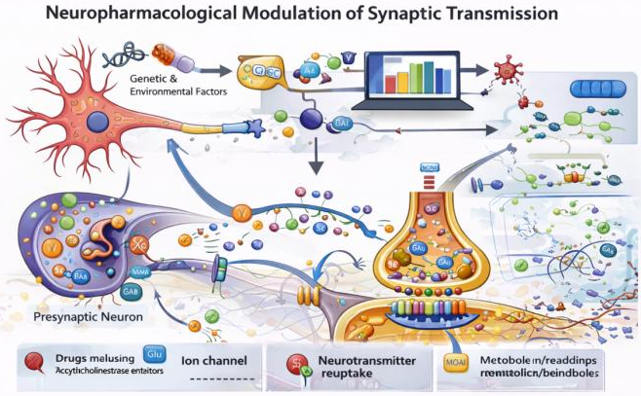

Mechanisms of Drug Action in the Nervous System
Neuropharmacological drugs exert their effects through several mechanisms:
- Receptor agonism or antagonism: altering synaptic signaling
- Ion channel modulation: affecting neuronal excitability
- Enzyme inhibition: modifying neurotransmitter synthesis or degradation
- Transporter inhibition: influencing neurotransmitter reuptake
- Intracellular signaling modulation: impacting gene expression and synaptic plasticity
These mechanisms often interact with epigenetic regulation and biochemical pathways, highlighting the multidimensional nature of CNS drug action.[22]

Neuropharmacology and Synaptic Plasticity
Synaptic plasticity, including long-term potentiation (LTP) and long-term depression (LTD), underlies learning and memory. Neuropharmacological agents can enhance or impair plasticity by modulating glutamatergic and GABAergic signaling, calcium dynamics, and transcriptional regulation. Emerging evidence suggests that many CNS drugs exert long-term effects through epigenetic modulation of synaptic genes. [23,24]

BIOCHEMICAL MODIFICATIONS IN BRAIN DISORDERS
Biochemical modifications in brain disorders represent a complex network of molecular and cellular alterations that disrupt neuronal homeostasis, synaptic integrity, and neural network function. These changes often precede overt clinical symptoms and play a central role in disease initiation, progression, and therapeutic response. Major biochemical pathways implicated include neuroinflammation, oxidative stress, mitochondrial dysfunction, protein misfolding and aggregation, neurotransmitter imbalance, and impaired cellular clearance mechanisms.[25]

Neuroinflammation
Neuroinflammation is a sustained inflammatory response within the central nervous system mediated primarily by microglia and astrocytes. While acute neuroinflammation may serve protective roles, chronic or dysregulated inflammation contributes to neuronal injury and synaptic dysfunction. Activated glial cells release pro-inflammatory cytokines such as tumor necrosis factor-α (TNF-α), interleukin-1β (IL-1β), and interleukin-6 (IL-6), along with reactive oxygen and nitrogen species. These mediators alter neuronal signaling, compromise synaptic plasticity, and accelerate neurodegeneration in disorders such as Alzheimer’s disease, Parkinson’s disease, multiple sclerosis, and depression.[26]

Oxidative Stress
Oxidative stress arises from an imbalance between the generation of reactive oxygen species (ROS) and the antioxidant defense systems of the brain. Due to its high oxygen consumption, lipid-rich membranes, and limited antioxidant capacity, the brain is particularly vulnerable to oxidative damage. Excess ROS induce lipid peroxidation, protein oxidation, and DNA damage, leading to impaired neuronal function and cell death. Oxidative stress is strongly implicated in neurodegenerative diseases, ischemic brain injury, epilepsy, and psychiatric disorders.[27]

Mitochondrial Dysfunction
Mitochondria play a pivotal role in neuronal energy metabolism, calcium homeostasis, and apoptosis regulation. Mitochondrial dysfunction results in reduced ATP production, increased ROS generation, impaired calcium buffering, and activation of apoptotic pathways. These alterations contribute to synaptic failure and neuronal loss, particularly in neurodegenerative disorders such as Parkinson’s disease, Alzheimer’s disease, and amyotrophic lateral sclerosis. Evidence suggests that mitochondrial dysfunction acts both as a cause and consequence of oxidative stress and neuroinflammation.[28]

Protein Misfolding and Aggregation
Protein aggregation is a hallmark of many neurodegenerative diseases and arises from improper protein folding, impaired degradation, or excessive protein production. Aggregated proteins such as amyloid-β plaques and tau neurofibrillary tangles in Alzheimer’s disease, α-synuclein in Parkinson’s disease, and TDP-43 in amyotrophic lateral sclerosis disrupt cellular homeostasis and synaptic communication. These aggregates exert toxic effects by impairing proteasomal and autophagic pathways, inducing oxidative stress, and triggering neuroinflammatory responses.[29]

Neurotransmitter Imbalance
Neurotransmitter imbalance is a critical biochemical feature underlying many neurological and psychiatric disorders. Alterations in dopamine, serotonin, glutamate, GABA, and acetylcholine signaling can disrupt synaptic transmission and neural circuitry. For instance, dopamine depletion characterizes Parkinson’s disease, glutamate excitotoxicity contributes to neurodegeneration and epilepsy, and monoamine deficiencies are linked to depression and anxiety disorders. Neuropharmacological interventions primarily aim to restore neurotransmitter balance and synaptic function.[30]

Therapeutic Implications
Targeting biochemical pathways offers promising therapeutic opportunities. Antioxidants, anti-inflammatory agents, mitochondrial protectants, protein aggregation inhibitors, and neurotransmitter modulators are being actively explored to slow disease progression and improve clinical outcomes. Integration of biochemical insights with epigenetic and neuropharmacological approaches may facilitate the development of disease-modifying and personalized therapies for brain disorders. [16]

Figure 5: Biochemical pathways in neurodegeneration
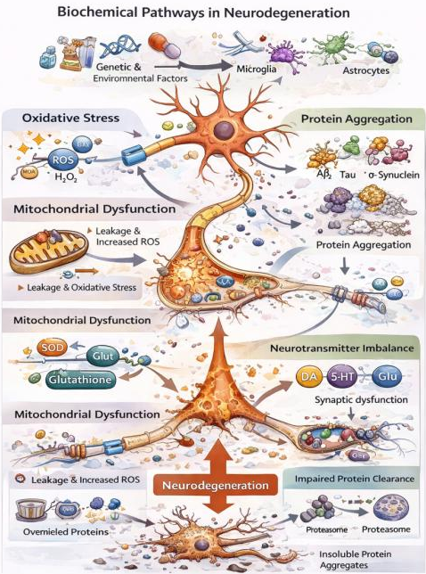

BRAIN DISORDERS
Brain disorders comprise a heterogeneous group of neurological and psychiatric conditions characterized by progressive or episodic dysfunction of neuronal circuits. Accumulating evidence indicates that epigenetic dysregulation, neuropharmacological alterations, and biochemical modifications collectively contribute to disease pathogenesis and progression.

Alzheimer’s Disease
Alzheimer’s disease (AD) is a progressive neurodegenerative disorder and the leading cause of dementia worldwide. It is pathologically characterized by the extracellular accumulation of amyloid-β (Aβ) plaques and intracellular neurofibrillary tangles composed of hyperphosphorylated tau protein. These abnormalities disrupt synaptic communication, impair neuronal plasticity, and ultimately lead to neuronal loss and cognitive decline. Biochemical mechanisms underlying AD include oxidative stress, mitochondrial dysfunction, chronic neuroinflammation, and impaired proteostasis. Epigenetic modifications, such as altered DNA methylation and histone acetylation, further influence the expression of genes involved in amyloid processing and synaptic function. Neuropharmacological strategies aim to enhance cholinergic transmission, reduce amyloid burden, and modulate neuroinflammatory pathways.[31,32]
Fig. No. 6 Neurodegenerative and Neuropsychiatric Brain Disorders with Key Pathological Features
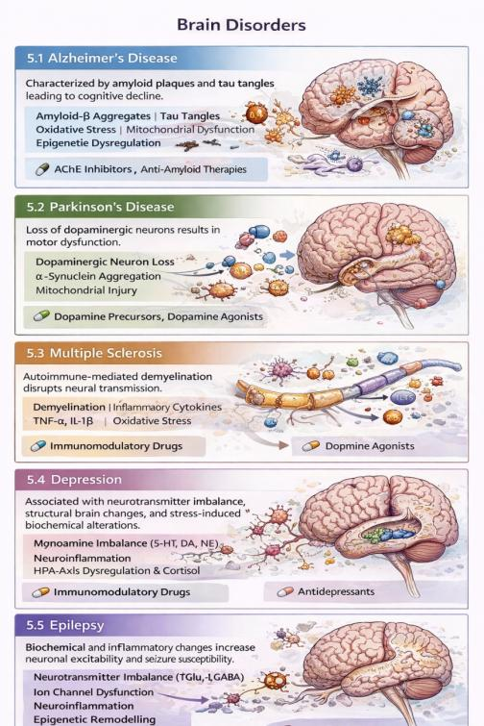

Parkinson’s Disease
Parkinson’s disease (PD) is a neurodegenerative movement disorder primarily characterized by the selective loss of dopaminergic neurons in the substantia nigra pars compacta. This neuronal degeneration leads to dopamine deficiency within the basal ganglia, resulting in hallmark motor symptoms including tremor, rigidity, bradykinesia, and postural instability. Biochemical alterations in PD include mitochondrial dysfunction, oxidative stress, α-synuclein aggregation, and neuroinflammatory responses. Epigenetic dysregulation has been implicated in dopaminergic neuron vulnerability, while neuropharmacological therapies such as levodopa, dopamine agonists, and MAO-B inhibitors aim to restore dopaminergic signaling and alleviate motor symptoms.[33,34]

Multiple Sclerosis
Multiple sclerosis (MS) is a chronic autoimmune-mediated disorder of the central nervous system characterized by inflammation, demyelination, and axonal degeneration. Immune-mediated attacks on myelin sheaths disrupt saltatory conduction, leading to impaired neural transmission and diverse neurological deficits. Biochemical changes in MS include elevated inflammatory cytokines, oxidative stress, mitochondrial injury, and altered neurotransmitter signaling. Epigenetic mechanisms are increasingly recognized as modulators of immune cell differentiation and inflammatory gene expression. Current neuropharmacological treatments focus on immunomodulation, neuroprotection, and symptom management.[35]

Depression
Depression is a complex psychiatric disorder associated with persistent low mood, cognitive impairment, and altered emotional regulation. It is linked to imbalances in monoamine neurotransmitters such as serotonin, dopamine, and norepinephrine, along with structural and functional changes in brain regions including the hippocampus and prefrontal cortex. Biochemical alterations such as oxidative stress, neuroinflammation, dysregulated hypothalamic–pituitary–adrenal (HPA) axis activity, and reduced neurotrophic support contribute to disease pathology. Epigenetic modifications influenced by stress and environmental factors play a critical role in regulating genes associated with mood and stress responses. Neuropharmacological interventions primarily target monoaminergic systems and emerging inflammatory pathways.[36]

Epilepsy
Epilepsy is a neurological disorder characterized by recurrent, unprovoked seizures resulting from abnormal neuronal excitability and synchronization. Biochemical and molecular changes underlying epilepsy include excitatory–inhibitory neurotransmitter imbalance, altered ion channel function, neuroinflammation, and oxidative stress. Chronic seizures can induce long-term epigenetic modifications that affect gene expression related to synaptic transmission and neuronal excitability. Neuropharmacological management involves antiepileptic drugs that modulate ion channels, enhance inhibitory neurotransmission, or suppress excitatory signaling to reduce seizure frequency and severity.[37]

CHALLENGES IN NEUROPHARMACOLOGICAL DRUG DEVELOPMENT
Despite significant advances, neuropharmacology faces several challenges:
- Limited BBB permeability of many therapeutic agents
- Off-target effects and neurotoxicity
- High failure rates in clinical trials for neurodegenerative diseases
- Inter-individual variability in drug response
Addressing these challenges requires integrated approaches combining neuropharmacology, epigenetics, systems biology, and advanced drug delivery strategies.[38]

FUTURE PERSPECTIVES
Modern neuropharmacology is shifting toward precision medicine, with increasing emphasis on biomarker-driven therapy, epigenetic drug targets, and combination treatments. The integration of neuropharmacology with epigenetic regulation and biochemical pathway analysis holds promise for developing safer and more effective therapies for complex brain disorders.[39]

CONCLUSION
Epigenetic regulation, neuropharmacology, and biochemical modifications collectively play a central role in the onset, progression, and therapeutic management of brain disorders. Accumulating evidence demonstrates that dynamic epigenetic mechanisms, including DNA methylation, histone modifications, and non-coding RNA regulation, critically influence neuronal gene expression, synaptic plasticity, neuroinflammation, and cellular resilience. These epigenetic alterations act as a molecular interface between genetic susceptibility and environmental factors such as stress, aging, toxins, and lifestyle, thereby shaping disease vulnerability and progression.
Neuropharmacological interventions have traditionally focused on symptomatic relief by modulating neurotransmitter systems; however, emerging strategies increasingly target upstream molecular and epigenetic pathways. Drugs that influence chromatin remodeling enzymes, DNA methyltransferases, histone deacetylases, and inflammatory mediators offer promising disease-modifying potential. Likewise, advances in precision pharmacology and epigenetic editing tools hold significant promise for restoring disrupted neural circuits and biochemical homeostasis in disorders such as Alzheimer’s disease, Parkinson’s disease, multiple sclerosis, depression, and epilepsy.
Biochemical dysregulation, including oxidative stress, mitochondrial dysfunction, excitotoxicity, and chronic neuroinflammation, represents a shared pathological hallmark across diverse neurological conditions. Understanding the convergence of these biochemical pathways with epigenetic and neuropharmacological mechanisms provides a more integrated framework for disease modeling and therapeutic discovery. Future research should prioritize multi-omics approaches, translational epigenetic biomarkers, and personalized treatment strategies to enhance clinical efficacy and reduce adverse effects.
In conclusion, an integrated understanding of epigenetics, neuropharmacology, and biochemical modifications offers a comprehensive and forward-looking perspective on brain disorders. This holistic approach not only deepens mechanistic insight but also paves the way for innovative, targeted, and personalized therapeutic interventions in neurological and psychiatric diseases.

References
- Houston, I., Peter, C., Mitchell, A. et al. Epigenetics in the Human Brain. Neuropsychopharmacol 38, 183–197 (2013). https://doi.org/10.1038/npp.2012.78
- Berger SL, Kouzarides T, Shiekhattar R, Shilatifard A. An operational definition of epigenetics. Genes Dev. 2009 Apr 01;23(7):781-3. https://doi.org/10.1101/gad.1787609
- Allis CD, Jenuwein T. The molecular hallmarks of epigenetic control. Nat Rev Genet. 2016 Aug;17(8):487-500. https://doi.org/10.1038/nrg.2016.59
- Feinberg AP. The Key Role of Epigenetics in Human Disease Prevention and Mitigation. N Engl J Med. 2018 Apr 05;378(14):1323-1334. https://doi.org/10.1056/NEJMra1402513
- Li B, Carey M, Workman JL. The role of chromatin during transcription. Cell. 2007 Feb 23;128(4):707-19. https://doi.org/10.1016/j.cell.2007.01.015
- Kazanets A, Shorstova T, Hilmi K, Marques M, Witcher M. Epigenetic silencing of tumor suppressor genes: Paradigms, puzzles, and potential. Biochim Biophys Acta. 2016 Apr;1865(2):275-88. https://doi.org/10.1016/j.bbcan.2016.04.001
- Bannister AJ, Kouzarides T. Regulation of chromatin by histone modifications. Cell Res. 2011 Mar;21(3):381-95. https://doi.org/10.1038/cr.2011.22
- Tobi EW, Lumey LH, Talens RP, Kremer D, Putter H, Stein AD, Slagboom PE, Heijmans BT. DNA methylation differences after exposure to prenatal famine are common and timing- and sex-specific. Hum Mol Genet. 2009 Nov 01;18(21):4046-53. https://doi.org/10.1093/hmg/ddp353
- Heard E, Martienssen RA. Transgenerational epigenetic inheritance: myths and mechanisms. Cell. 2014 Mar 27;157(1):95-109. https://doi.org/10.1016/j.cell.2014.02.045
- Purnell, B.S., Hur, J., Ruskin, D. et al. Commonalities in gene expression and methylation changes across two rat models of acquired epilepsy. Sci Rep (2026). https://doi.org/10.1038/s41598-026-35826-6
- Becker, A.L., Borges, S.G., Pinheiro, L.G.R. et al. Analysis of DNA methyltransferase 3 alpha expression during respiratory syncytial virus strain A infection. Sci Rep (2025). https://doi.org/10.1038/s41598-025-34030-2
- Okhovat, M., Layman, C.E., Davis, B.A. et al. Epigenetic and transcriptomic alterations precede amyloidosis in the Alzheimer’s disease App^{NL-G-F} knock-in mouse model. Sci Rep 15, 44934 (2025). https://doi.org/10.1038/s41598-025-28244-7
- García-Cerro, S., Gómez-Garrido, A., Soria, F.N. et al. Clozapine induces perineuronal net remodeling in a developmental mouse model exhibiting schizophrenia-relevant phenotypes. Neuropsychopharmacol. 50, 2026–2039 (2025). https://doi.org/10.1038/s41386-025-02210-3
- Soles A, Selimovic A, Sbrocco K, Ghannoum F, Hamel K, Moncada EL, et al. Extracellular matrix regulation in physiology and in brain disease. Int J Mol Sci. 2023;24:7049. https://doi.org/10.3390/ijms24087049
- Rief W, Barsky AJ, Bingel U, Doering BK, Schwarting R, Wöhr M, et al. Rethinking psychopharmacotherapy: the role of treatment context and brain plasticity in antidepressant and antipsychotic interventions. Neurosci Biobehav Rev. 2016;60:51–64. https://doi.org/10.1016/j.neubiorev.2015.11.008
- Murlanova K, Pletnikov MV. Modeling psychotic disorders: environment x environment interaction. Neurosci Biobehav Rev. 2023;152:105310. https://doi.org/10.1016/j.neubiorev.2023.105310
- Powell SB, Sejnowski TJ, Behrens MM. Behavioral and neurochemical consequences of cortical oxidative stress on parvalbumin-interneuron maturation in rodent models of schizophrenia. Neuropharmacology. 2012;62:1322–31. https://doi.org/10.1016/j.neuropharm.2011.01.049
- Martínez-Cué C, Martínez P, Rueda N, Vidal R, García S, Vidal V, et al. Reducing GABAA α5 receptor-mediated inhibition rescues functional and neuromorphological deficits in a mouse model of Down syndrome. J Neurosci. 2013;33:3953–66.
- Meyer U, Knuesel I, Nyffeler M, Feldon J. Chronic clozapine treatment improves prenatal infection-induced working memory deficits without influencing adult hippocampal neurogenesis. Psychopharmacology. 2010;208:531–43. https://doi.org/10.1007/s00213-009-1754-6
- Schiavone S, Morgese MG, Bove M, Colia AL, Maffione AB, Tucci P, et al. Ketamine administration induces early and persistent neurochemical imbalance and altered NADPH oxidase in mice. Prog Neuropsychopharmacol Biol Psychiatry. 2020;96:109750. https://doi.org/10.1016/j.pnpbp.2019.109750
- Jeevakumar V, Driskill C, Paine A, Sobhanian M, Vakil H, Morris B, et al. Ketamine administration during the second postnatal week induces enduring schizophrenia-like behavioral symptoms and reduces parvalbumin expression in the medial prefrontal cortex of adult mice. Behav Brain Res. 2015;282:165–75. https://doi.org/10.1016/j.bbr.2015.01.010
- Potkin SG, Kane JM, Correll CU, Lindenmayer JP, Agid O, Marder SR, et al. The neurobiology of treatment-resistant schizophrenia: paths to antipsychotic resistance and a roadmap for future research. npj Schizophr. 2020;6:1–10. https://doi.org/10.1038/s41537-019-0090-z
- Kaushik R, Lipachev N, Matuszko G, Kochneva A, Dvoeglazova A, Becker A, et al. Fine structure analysis of perineuronal nets in the ketamine model of schizophrenia. Eur J Neurosci. 2021;53:3988–4004. https://doi.org/10.1111/ejn.14853
- Klimczak P, Alcaide J, Gramuntell Y, Castillo-Gómez E, Varea E, Perez-Rando M, et al. Long-term effects of a double hit murine model for schizophrenia on parvalbumin expressing cells and plasticity-related molecules in the thalamic reticular nucleus and the habenula. Transl Psychiatry. 2024;14:450. https://doi.org/10.1038/s41398-024-03166-6
- Sahu S, Nag DS, Swain A, Samaddar DP. Biochemical changes in the injured brain. World J Biol Chem. 2017 Feb 26;8(1):21-31. doi: 10.4331/wjbc.v8.i1.21.
- Patel PM, Drummond JC, Lemkuil BP. Cerebral physiology and the effects of anaesthetic drugs. In: Miller RD, editor. Miller’s Anaesthesia. 8th ed. Philadelphia: Elsevier;; 2015. pp. 387–409.
- Allsopp G, Gamble HJ. An electron microscopic study of the pericytes of the developing capillaries in human fetal brain and muscle. J Anat. 1979;128:155–168.
- Ballabh P, Braun A, Nedergaard M. Anatomic analysis of blood vessels in germinal matrix, cerebral cortex, and white matter in developing infants. Pediatr Res. 2004;56:117–124. doi: 10.1203/01.PDR.0000130472.30874.FF
- Cristante E, McArthur S, Mauro C, Maggioli E, Romero IA, Wylezinska-Arridge M, Couraud PO, Lopez-Tremoleda J, Christian HC, Weksler BB, et al. Identification of an essential endogenous regulator of blood-brain barrier integrity, and its pathological and therapeutic implications. Proc Natl Acad Sci USA. 2013;110:832–841. doi: 10.1073/pnas.1209362110.
- Murai T, Müller U, Werheid K, Sorger D, Reuter M, Becker T, von Cramon DY, Barthel H. In vivo evidence for differential association of striatal dopamine and midbrain serotonin systems with neuropsychiatric symptoms in Parkinson’s disease. J Neuropsychiatry Clin Neurosci. 2001;13:222–228. doi: 10.1176/jnp.13.2.222.
- L. Devi, B.M. Prabhu, D.F. Galati, N.G. Avadhani, H.K. Anandatheerthavarada accumulation of amyloid precursor protein in the mitochondrial import channels of human Alzheimer’s disease brain is associated with mitochondrial dysfunction J. Neurosci., 26 (2006), pp. 9057-9068. DOI: 10.1523/JNEUROSCI.1469-06.2006
- C. Veyrat-Durebex, P. Corcia, E. Piver, et al. Disruption of TCA Cycle and Glutamate Metabolism Identified by Metabolomics in an In Vitro Model of Amyotrophic Lateral Sclerosis Mol. Neurobiol., 53 (2016), pp. 6910-6924. https://doi.org/10.1007/s12035-015-9567-6
- Wang, D., Shi, Y., Pang, J. et al. Data-driven subtyping of early Parkinson’s disease via mutual cross-attention fusion of EEG and dual-task gait features. npj Parkinsons Dis. (2026). https://doi.org/10.1038/s41531-026-01258-2
- Olson, J., Wahid, S.S., Irwin, Z.T. et al. Subthalamic nucleus in patients with Parkinson’s disease encodes changes and magnitude of applied force. npj Parkinsons Dis. (2026). https://doi.org/10.1038/s41531-025-01237-z

- Boutitah-Benyaich, I., Eixarch, H., Villacieros-Álvarez, J. et al. Multiple sclerosis: molecular pathogenesis and therapeutic intervention. Sig Transduct Target Ther 10, 324 (2025). https://doi.org/10.1038/s41392-025-02415-4
- Cui, L., Li, S., Wang, S. et al. Major depressive disorder: hypothesis, mechanism, prevention and treatment. Sig Transduct Target Ther 9, 30 (2024). https://doi.org/10.1038/s41392-024-01738-y
- Purnell, B.S., Hur, J., Ruskin, D. et al. Commonalities in gene expression and methylation changes across two rat models of acquired epilepsy. Sci Rep (2026). https://doi.org/10.1038/s41598-026-35826-6
- Howes, O.D., Mehta, M.A. Challenges in CNS drug development and the role of imaging. Psychopharmacology 238, 1229–1230 (2021). https://doi.org/10.1007/s00213-021-05838-3
- Raguzin EV, Yudin MA, Glushenko DD, Vengerovich NG, Raguzina OG, Pechurina TB, et al. Analysis and Evaluation of Modern Approaches to Development of Medical Drugs Using Micro- and Nanotechnologies. I. P. Pavlov Russian Med Biological Herald. 2022;30(3):397-410.

