Original Research Article
ASHA’s are Empowered Feminist Workers in Indian Healthcare Sector: Truths and Myths from Case Studies in West Bengal

Abstract
Introduction: Community participation in Primary Healthcare in rural areas was missioned to be accomplished by implementation of Accredited Social Health Activist (ASHA) Programme under National Rural Health Mission in 2005. Primary Healthcare system expected ASHA the female squads to be an optimal vehicle for extending primary healthcare in rural areas by promoting immunization, referral and escort services for reproductive and child health and other health delivery programmes. To fulfil this responsibility ASHAs need to transform into ray of hope by lot of training and empowerment.
Aim: In this context, the present paper aims to identify in short and long term the actual empowerment level achieved by ASHA’s to cater to the deprived communities.
Objective: To fulfill this aim, the paper examines the whole arena of current provisions of the assignments, roles and responsibilities, recruitments, training, remuneration of ASHA’s in Khargram Block of Murshidabad District in West Bengal.
Method: The analysis is based on primary survey through questionnaires of 200 ASHA’s in Khargram Block (100 % enumeration). Factor analysis, Performance Index and Logistic Regression is used to summarize the existing gap between the expected and actual performance of ASHA’s.
Result: Results show that non-recognition, excessive focus on curative care, priorities of work as extended arm of Primary Healthcare system, lack of induction training and demotivation due to performance-based incentive instead of fixed income, lack of basic infrastructure has hindered ASHA’s from being “an interface between the rural community and rural healthcare delivery system”.
Key words: Community, Healthcare, Immunization, Performance, Training, Rural.

1. Introduction:
The vision of National Rural Health Mission (NRHM) is to provide an equitable and affordable primary healthcare services to the community. It is possible by empowering the community to gain more power and control over the functioning of primary healthcare service delivery. The community in this study is divided into two broad groups. The first group is the Accredited Social Health Activist (ASHA). The community health workers programme was initiated in India during the post-independence era like Mitanin, Jamkhed in 1970, Pochad in 1977 (Dyalchand and Soni 1983, Arole and Arole 1975). The ASHA programme is the latest of all. This community-based health programme was started in 2005 with certain basic aims. One of the keys aims of NRHM is to sustain the empowerment of ASHA workers through unceasing training and capacity building by the Primary Healthcare System. Presently a total of 873759 ASHAs are recruited in India and 47655 in West Bengal.
ASHA workers are a group of women preferably married or widowed selected as voluntary health activist who stay in the same village where they need to cater healthcare services. Accourding to Indian Public Health Standard (IPHS) all the ASHA’s need to have a minimum educational achievement up to class 8 standard. One ASHA will cater to one thousand population i.e. a ratio of 1:1000 (IPHS). ASHAs are mainly link workers between the Primary Healthcare System and the community. Since ASHAs belong to the same village where they provide service therefore community can approach them twenty-four hours. ASHA’s role has been crucial in institutional delivery thus reducing the pregnancy risk and infant mortality. Although critical appraisal has been done regarding the functioning of ASHAs and their ability to perform (PHRN 2007) but another aspect has been neglected that whether the ASHAs are becoming truly empowered and whether their empowerment is increasing the community empowerment or not. ASHAs are the first port of call ‘for’ the community, selected ‘from’ the community to cater ‘to’ the community. Hence measuring their empowerment status is crucial. Moreover, the selection of ASHAs directly from the village they belong to will increase community empowerment in healthcare delivery system. Thus, ASHAs and community are two interdependent parts of the society who will be empowered by each other for their future betterment. Accourding to Joshi and George 2012, the idea of community participation becomes the fundamental point of Community Health Worker Programme globally after 2000 A.D.
2. Conceptual Framework
The Community-Based Health Worker scheme is accommodated from time to time in India’s Public Healthcare Delivery System and the latest programme of ASHA is operational in all the States of India (Maru 1983). However, there are some crucial dimensions of empowerment of these community-based health workers. As Rifkin 2008 pointed out that empowerment of Community Health Workers (CHW) can be achieved by enhancing the training, responsibilities, role, competency and financial support by the healthcare system on one hand and whether the working condition empowers the ASHAs to become ‘agents of change’ without being trapped into political pressures or socio-economic setbacks on the other. Moreover, the acceptance of the ASHAs by the community and whether they can address the healthcare needs of the community will determine the level of empowerment of ASHAs. The ASHA programme is a process of increasing the empowerment of ASHA, who in turn also empowers the community and improves reproductive and child health care. ASHAs as members of village attain empowerment at individual level and community level. At individual level she is expected to be financially independent, has decision making capacity, can negotiate skills and mobilize community. At community level she gains insight about health issues, impact health outcomes and assist in community’s health behavior. Since the initiation of NRHM in 2005, ASHAs have been working in almost all the states of India. While evaluating the performance of ASHA from 2005-2015 various studies have identified problems like lack of knowledge, perception, more interest in incentive-based jobs etc. It is likely that although ASHA is an important strategy of community as well as women empowerment as she acts as an interface between the community and Primary Healthcare System appointed by Panchayat yet the nomenclature ‘Activist’ and not staff or worker hints on the partial allowance of the decisions of ASHAs in the health system. Thus, in its initiation and nomenclature the light of empowerment is blurred as the position of ASHA is honorary. In certain scenarios the community perceives ASHAs as an extended force of Primary Healthcare System and not a member of their own village hence acceptance of ASHA’s becomes difficult. ASHA’s interventions have been regarded by WHO as a key strategy of empowerment of women as extenders of health services, paramedical staffs, health educators from time to time.
However, it is still a realization that ASHAs don’t feel empowered because the process of enhancement of their self-esteem is slow. Although the evaluation of ASHAs have shown a positive influence on the health of mothers, more ANC visits and universal coverage of basic immunization all over the country yet the issue of whether they are empowered at individual level or whether they can empower at community level still has remained less answered. Dinesh, P et.al. 2013 in their study observed that ASHA’s lack knowledge on the criteria under Janani Surakhya Yojana such as cash assistance for two live births, cash assistance for third live birth and cash assistance for transport cost. Study in Bijapur Taluk of Karnataka State in India by Shashank, K. J. et.al. 2015 on the performance of ASHA and their knowledge on health outcome points out that ASHA’s are more likely to work for incentive-based works like institutional delivery, anti-natal care and post-natal care but are reluctant in other non-incentive work like counselling and family planning. Karir, S. et.al. 2015 highlighted that ASHA’s lack interest in non-incentive-based jobs like ANC and more motivation of ASHA’s in non-institutional work needs to be done. Accourding to Sprii et.al. (2015) ASHAs in North East like Manipur has performed well in maternal health and health education. However, a study during the same time by Fathima et.al. 2015 stated that ASHA’s lack their performance as social activist and mobilization of community for collective action and right. Desai 2016 in his study focused on the role of ASHAs in the improvement of health sector of villagers in Kolhapur District in Maharashtra shows significant impact of ASHA programmes on rate of institutional deliveries, malnutrition and infant mortality. Nagraj.S et.al (2017) mentioned that the effectiveness of NRHM depends on the efficiency of ASHAs at community level. Though NRHM acknowledge the potential of ASHAs in improving the health outcomes of remote and rural population in every village of India but very few studies reflect the role of Primary Healthcare System in enhancing the rate of empowerment of ASHA.
The State Rural Statistics of 2016 states that Crude Death rate of West Bengal is 5.8, Infant Mortality rate is 25, Maternal Mortality Rate is 101 and life expectancy at birth is 68.5 for males and 71.6 for females. Thus, ASHA Programme was launched in 2005 by NRHM to improve the rural health outcomes. Recruitment of ASHA till date is 54406. The recruitment shows two major phases of recruitment of ASHAs in 2007-08 and 2010-11. Except for 2013-14 the recruitment of ASHAs in West Bengal has been steady (Fig 1.1). This is probably because the role of ASHA’s has been recognized by healthcare system as a crucial step towards an accountable and equitable health service delivery. The States, other than Non-High Focus States in India show almost ninety percent appointment of ASHA workers against its target by 2016. Except for Karnataka (83%) and the lowest is in West Bengal (78%). (Fig 1.2).
The appointment of ASHA in West Bengal is lesser than even the North East States and also the High Focus States under NRHM.This gap in recruitment has been ascribed to the difficult geographical terrain like forest, hilly or tribal areas and to the ever-increasing population density in West Bengal. Though, the Indian Public Health Standard sets the standard of ASHA population ratio as 1:1000. However, in West Bengal each ASHA on average is catering to three hundred fifty more population, which makes ASHA’s work tedious and overburdening, affecting their performance (Fig 1.3).
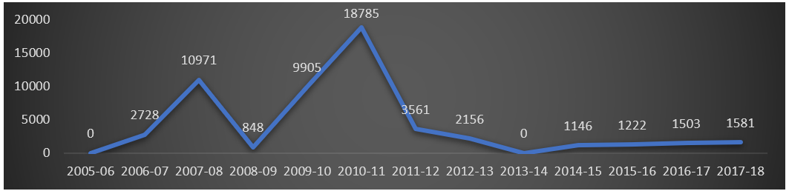
Figure 1.1 Appointment of ASHAs in West Bengal
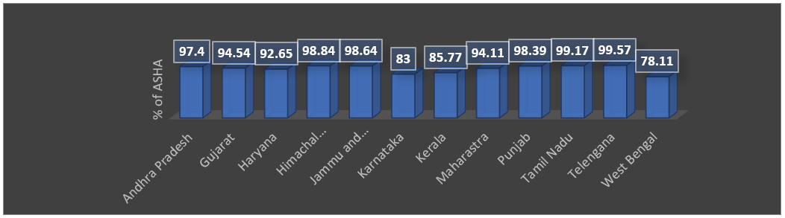
Figure1.2 Recruitment of ASHA in States other Than High Focus States in India

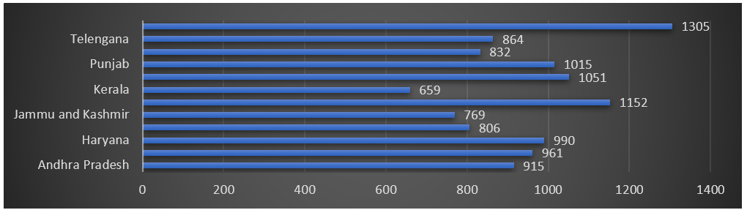
Figure1.3 State-wise Number of Population Served by ASHAs
3. Objectives
- To examine gap in evaluation of ASHA by ANM and self-evaluation of ASHA in terms of performance of ASHA (assignments, recruitment, training, medicament and remuneration) in the periphery of Primary Healthcare System.
- To measure the empowerment level of ASHA achieved in study area.
- To understand the community’s satisfaction towards ASHA as empowered feminist worker in Indian Healthcare Sector.
4. Data and Methodology
4.1 Study Design-This is a quantitative survey-based case study to explore, analyze and explain the level of empowerment achieved by ASHA workers and how far the current provisions of the assignments, roles and responsibilities, recruitments, training, remuneration of ASHAs is helping them in gaining empowerment.
4.2 Study Area- The survey is conducted in Khargram Block of Murshidabud District of West Bengal. One of the means for selection of Khargram Block is that it is the most backward Block in providing primary healthcare not only in Murshidabad District but also in entire State of West Bengal according to past evidences (Health Management Information System). Khargram Block is a Muslim minority-concentrated Block with backward socio-economic indicators of quality of life. This area also demands special attention because Polio-Miletus is prevalent in this Block and many people refuse to give polio vaccine to their children (BMOH office, Khargram Block) Fig 1.4.
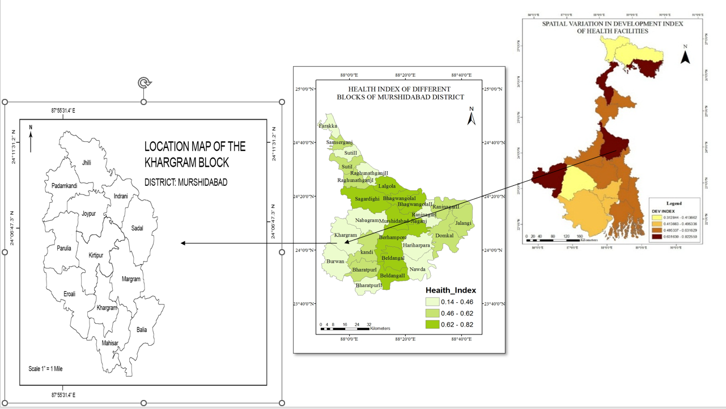
Figure 1.4 Study Area
4.3 Sample Size- Complete enumeration of 200 ASHAs in all the Sub-centres of Khargram Block are surveyed with the help of questionnaires. The response of ASHAs provision is collected based on two criteria: self-evaluation of ASHAs and evaluation of provisions provided to ASHAs by Auxiliary Nurse Mid-wives (ANMs) as their supervisors. 35 Auxiliary Mid-wives of all the 35 sub-centres are surveyed as supervisors to whom ASHAs report for their work and training.

4.4 Data Collection- Secondary data is collected from CMOH office and all the PHCs and sub-centres of Khargram Block. Primary survey is conducted on field sites and in each and every sub-centre where ASHAs are appointed. 591 respondents were surveyed from the village to evaluate the performance of ASHAs at community level.

4.5 Methods Used:
4.5.1 Student’s t-test was conducted to understand whether there is any significant gap in perception of ASHAs and ANMs regarding the provisions entitled for ASHA.
4.5.2 Health Worker’s Empowerment Index: The domains of Women Empowerment in Agriculture Index are adapted and modified according to the research objective (Alkire et.al. 2013). It is a survey-based technique to measure the empowerment of women in agriculture Since health empowerment index is not constructed in past literatures therefore same domains are adopted for construction of Community Health Empowerment Index.
Through respondents (ASHA), observation data is collected. After information is collected, the response is given a value, based on the response. The value is ranked as 1 for nothing, 2 for poor, 3 for fair, 4 for good and 5 for excellent. Thus, each ASHA received a rank ranging between 1 to 5 for each variable in each index. As Alkire 2005 suggested that empowerment measurement should be domain specific. Community Health Empowerment Index has nine domains (Table 1.1). The domains of empowerment index are i) production, ii) autonomy, iii) ownership of resource, iv) financial autonomy, v) leadership, vi) social prestige, vii) group membership and viii) workload. Another domain is ix) Knowledge which is included because acquisition of knowledge also empowers community health workers.
The standardization of the ranks is done (Shevky and Bell in 1955, Markides and Macfarland 1982) to reduce the extreme values in an index. The formula used for standardization was:
Where: Xv= the value of each selected variable, Lv= the lowest value of the selected variable, Hv= the highest value of selected variable. The score ranges from 0 to 100
Factor Analysis (Krishnan V 2010) is used to compute Factor Score Coefficient for each domain. Using factor score as weight Factor Score Coefficient also known as Component Score were estimated. To compute the factor scores for given case or given factor, the case’s standardized score is multiplied by the corresponding factor loading of the variable and summed the products. This calculation is carried out in SPSS procedures. Now, suppose the factors explained 55.7 percent of the total variation, 16.3 percent by first factor, 14.7 percent by second factor, 9.2 percent by third factor, 8.9 percent by forth factor and 6.7 percent by fifth factor. This means not all the factors are equally important. Using proportion of these percentages as weight on factor score, a Non-standardized Index (NSI) is developed by formula:
NSI= (16.25/55.69) (Factor Score) +(14.68/55.69) (Factor Score) +…………. +(6.69/55.69) (Factor Score) …………………2
The index measures the empowerment of ASHA workers. The value of index can be positive or negative making interpretation difficult; therefore, a Standardized Index was developed, the value of which range from0 to 100.
This procedure was adopted by (Hightower 1978; Sekhar, Indrayan and Gupta, 1991).
The individual values are grouped into five classes i.e. Highly empowered (5 Quintile), Moderately Empowered (4 Quintile), Lowly Empowered (3 Quintile), Slightly empowered (2Quintile) and Not Empowered (1 Quintile).
This index is a survey-based index hence it depends on the primary data. As a result, the true state of empowerment of ASHA workers will be reflected at present and overtime. Moreover, this index will also highlight the key areas where empowerment is much needed and also how many ASHA’s still lack empowerment.
Table 1.1 Selected Indicators for Measurement of ASHA’s Health Empowerment
Production | No of pregnant women registered by ASHA | ANC visit by ASHA before Delivery | Tetanus Toxoid shot given by ASHA | Birth registered in past one year by ASHA | Mobilizing community in accessing health service | ASHA can take decision on health needs of Community
Autonomy | Ability to answer queries of patients | Can take action on sudden complication of pregnant women | Can reach to higher officials by themselves in financial and incentive-based disputes | Can take decision on distance of referred Institutional Place of Delivery
Resource | ASHA owns her Drug Kit | ASHA gets her Drug Kit restocked | ASHA have access to first-aid- medicine | ASHA have access to Birth Control Medicine | ASHA have access to Reproductive and child health medicine
Financial autonomy | ASHA receive compensation for attending training | ASHA obtain incentive from Janani Surakha Yojana Scheme | ASHA obtain incentive from Janani Surakha Yojana Scheme | ASHA receive timely performance-based incentive | ASHA can demand regular monthly salary
Leadership | ASHA’s participation in Group Discussion | Speaking in Village Health and Nutrition Day meeting | Addressing in Mother’s meet on Childcare | Can address the community on Family Planning Measures
Social prestige | ASHA’s feel enhanced opportunity and exposure | ASHA’s feel social prestige from community | ASHA’s feel their contribution in improvement of health facility | Permanency of work defining security
Group Membership | Receiving support from Panchayati Raj Institution/Village Health Sanitation Nutrition Committee | Receiving Support for PRI/VHSC for cleanliness and Sanitation | Feels peer pressure
Workload | Population size served by ASHA | Number of Households visited per week | Number of hours worked per week | Number of villages covered for field visit
Knowledge | Level of schooling | Number of trainings attended | Knowledge of common medicine in emergency | Years of Experience
4.5.3 Logistic Regression with Odd Ratio and Marginal Effect was done to estimate the community’s satisfaction towards ASHAs functioning. For this study the dependent variable (Y) is coded as binary variable as follows:
(Y)= Community Satisfaction
Y=1 if the respondents are satisfied with ASHA’s performance
Y=0 if the respondents are not satisfied with ASHA’s Performance
Dependent Variable (Y): For this analysis communities’ satisfaction towards functioning of ASHA is considered.
Independent Variable(X): For this analysis 17 explanatory variables are considered to explain satisfaction of community towards ASHA workers. They are ASHA's role in informing about health services (X1), creating awareness on health and hygiene (X2), providing antenatal services (X3), providing postnatal care (X4), providing new born care (X5), providing mother's immunization (X6), guiding on sanitation (X7), providing care for illness and fever (X8), helping in birth preparedness (X9), guidance towards breastfeeding(X10),performing child immunization(X11),guidance on contraceptives (X12), guidance in family planning (X13), assisting in personal hygiene and sanitation (X14), accompanying pregnant women to health facility (X15), informing about birth and death in the village (X16), informing about disease outbreak (X17).
Model: Y= f (X1, X2, X3, X4, X5, X6, X7, X8, X9, X10, X11, X12, X13, X14, X15, X16, X17)
The logistic regression was performed using STATA. Results are represented in terms of Odd Ratios with significance level. The Logistic: Likelihood-ratio test is done to see the chi square and P values. Marginal Effect is also calculated.
5. Results and Discussion of Students T-Test
In order to understand how far the ASHAs have gained personal capacity, information has been collected from the ASHA of a sub centre and response of ANM about same ASHA in a particular sub centre. The response of ANM is crucial because the ANMs work in close association with the ASHA’s, assign them field visits, scrutinize their allotted duties, evaluate their incentive-based performances and prepare them for receiving training. Response was taken from both provider side (ANM) and receiver side i.e. ASHA to bring out the existing gap in capacity building of ASHAs by Primary Healthcare System.
Student’s t-test is a statistical test used to test whether the difference between the response of two groups is statistically significant or not. In this case the two groups are ASHA and ANMs.
For understanding the process of selection of ASHA workers and what role the Primary Healthcare System play to make the selection process transparent and effective, five variables were selected for ASHAs and ANMs to respond. The five criteria were i) whether Focused Group Discussion was held in village for ASHA selection, ii) whether IPHC norms are the basis of selection for shortlisted ASHAs, iii) Gram Sabha passed the ASHA for selection, iv) does Primary Healthcare System play active role in selection of ASHA, v) is preference given to candidates having prior experience of community work.
Table 1.2: Probability of ANM-ASHA Response on Selection of ASHA in Khargram Block
Variables related to selection of ASHAs | t | 95% C. I |  | p value
 |  | Lower | Upper
Focused Group discussion held in Village for ASHA Selection | -10.83 | -28.8593 | -20.099 | .000 ***
Candidates short listed for ASHA by IPHS | -27.43 | -20.707 | -17.9358 | .000***
Gram Sabah held during ASHA selection | -8.43 | -24.4047 | -15.1786 | .000***
Did Primary health system played major role in ASHA selection | -5.0 | -5.15754 | -2.24986 | .000***
Candidate worked as a community-based worker before joining ASHA | -12.78 | -31.5494 | -23.1381 | .000***
*P<0.10, **P<0.05, ***P<0.01
Results of Student T-Test is significant at 99% Confidence Level which reflects huge gap in response of ASHAs and ANMs in regard to the selected indicators. Experience from field shows that although ANMs respond that selection of ASHA’s follow all the directions of NRHM, ASHAs respond that no transparent selection procedure like group discussion, meeting of Gram Sabah or prior experience of community-based workers are implemented. (Table 1.2). Ten variables are selected for estimating the response of ASHA and ANMs towards duties assigned to ASHA. Results show all ten variables are significant at 99% Confidence level. This significance states that there is huge gap between ASHA-ANM response regarding the duties actually assigned to ASHAs. (Table 1.3)
Table 1.3: Probability of ANM-ASHA Response on Duties Assigned of ASHA in Khargram Block
Variable related to Duties of ASHAs | _{t} | _{95% C. I} |  | _{p value}
 |  | _{Lower} | _{Upper}
_{Group Discussion} | _{-11.314} | _{-14.8226} | _{-10.4336} | _{.002***}
_{Pregnant Women Registered} | _{-19.575} | _{-19.016365} | _{-15.5449} | _{.000***}
_{Level of ANC visits by ASHAs} | _{21.02227} | _{15.9930883} | _{19.29337} | _{.000***}
_{ANC Visit of ASHA} | _{-14.4304} | _{-14.5272} | _{-11.0432} | _{.004***}
ASHA's Guidance on Optimal Breast Feeding | _{17.021} | _{29.0222} | _{36.6028} | _{.000***}
_{ASHA's gave Two TT shots} | _{-37.359} | _{-33.774592} | _{-30.3973} | _{.000***}
_{Birth registered by ASHA} | _{-19.2821} | _{-18.810958} | _{-15.3297} | _{.001***}
New -born baby visited in one week by ASHA | _{-24.3086} | _{-23.38113} | _{-19.8818} | _{.000***}
Referring Patients to institutional place of delivery | _{-16.6827} | _{-21.274559} | _{-16.7885} | _{.000***}
Incentives received by ASHA under JSY Scheme | _{-31.4226} | _{-33.658179} | _{-29.6941} | _{.000***}
*P<0.10, **P<0.05, ***P<0.01

15 variables are selected to evaluate the training of ASHAs. 14 variables are significant at 99% Confidence level, except training organized by Primary Health Centres. The main reason of no significant difference is that both ASHA’s and ANMs responded that all trainings are organized by Primary Health Centres. Primary Health Centres are in charge of the training modules and total rounds of trainings to be provided to ASHAs. According to IPHC, ASHAs should attain upto 6th Module. (Table 1.4)
Table 1.4: Probability of ANM-ASHA Response on Training of ASHA in Khargram Block
Variables related to Training of ASHAs |  | 95% C. I
Variables Related to Training | t | Lower | Upper | p value
No. of full training days given by PHCs/SCs to ASHA | -3.85945 | -9.82712 | -3.19372 | 0.000***
Training day not attended by ASHA | -19.1385 | -33.8553 | -27.5472 | .000***
No. of ASHA trainees in the training session | -30.6055 | -22.5751 | -19.8496 | .000***
Trainer was from Primary Healthcare System | -58.2418 | -22.5751 | -19.8496 | .000***
ASHA faced problem with Training Instruction | -9.52165 | -26.3921 | -17.3579 | .000***
Clarification of doubts to ASHAS by the trainer | 6.557425 | 11.12234 | 20.6485 | .000***
Uses of diagrams/other teaching aids by the trainer | -0.50982 | -6.32373 | 3.719561 | .000***
Training was appropriate | 14.17834 | 18.72934 | 24.76024 | .000***
Training organized at primary healthcare centres | -0.10193 | -5.2837 | 4.762863 | 0.918
Commute to training centre is <6 hours | 3.414472 | 3.645156 | 13.54234 | 0.001***
Provision for food and accommodation during training | 58.24182 | 45.7958 | 48.99586 | .000***
Receiving compensation for attending training by ASHA | 6.084259 | 10.04687 | 19.64063 | .000***
Refresher training for ASHA | 5.967496 | 9.7784 | 19.38827 | .000***
Training was provided by Medical Professionals | 37.23292 | 44.39174 | 49.35826 | .000***
Difficulties encountered by ASHAS in daily works is addressed | -11.6162 | -29.8405 | -21.2011 | .000***
*P<0.10, **P<0.05, ***P<0.01

Medicament supply and other medical kits to ASHA is considered crucial as the ASHAs are first port of call for any medical help of community. Medical kit availability is also crucial for ASHAs to cater to patients at night. 16 variables are selected to perform Student’s t test. Results show no significant difference in Drug kit availability by ASHA’s, as all the ASHA’s and ANMs responded that ASHA’s received drug kits in 2009. Rest fifteen variables show significant difference in ASHA and ANM response. (Table 1.5)
Table 1.5: Probability of ANM-ASHA Response on Medicament Supplied to ASHA in Khargram Block
Variable Selected About Supply of Medicaments |  | _{95% C. I}
 | _{t} | _{Lower} | _{Upper} |  | _{p-value}
_{ASHS has a drug kit} | _{1.298076} | _{-1.29565} | _{6.330373} |  | _{0.195}
_{Drug Kit Restocked} | _{-6.12482} | _{-12.1552} | _{-6.24758} |  | _{.000***}
_{Drugs Supplied from PHCS} | _{8.329976} | _{11.87062} | _{19.20577} |  | _{.000***}
_{ORS is supplied} | _{4.263939} | _{5.192357} | _{14.07848} |  | _{.000***}
_{Thermometers are supplied} | _{4.279451} | _{5.114615} | _{13.809} |  | _{.000***}
Oral Contraceptives is supplied | _{3.548633} | _{3.445149} | _{12.00624} |  | _{.000***}
_{Condoms are supplied} | _{-45.1558} | _{-45.8361} | _{-42.0111} |  | _{.000***}
Disposable delivery kits are supplied | _{-15.7135} | _{-33.2069} | _{-25.8209} |  | _{.000***}
_{Bandages are supplied} | _{0.283547} | _{-3.60586} | _{4.821135} |  | _{.000***}
Cotton absorbent roll is supplied | _{1.746} | _{-.4715} | _{7.9368} |  | _{0.082*}
_{Paracetamol is supplied} | _{25.90386} | _{29.6802} | _{34.55591} |  | _{.000***}
_{Iron tablets are supplied} | _{28.75767} | _{30.89257} | _{35.42687} |  | _{.000***}
Folic Acid tablets are supplied | _{24.86695} | _{29.33872} | _{34.37655} |  | _{.000***}
_{Dicyclomin are supplied} | _{-27.1812} | _{-41.2365} | _{-35.6732} |  | _{.000***}
_{Ointment tubes are supplied} | _{-30.5363} | _{-42.4092} | _{-37.2783} |  | _{.000***}
_{Choloquinnine is supplied} | _{-31.4332} | _{-42.7972} | _{-37.7584} |  | _{.000***}
*P<0.10, **P<0.05, ***P<0.01

To understand the consistency of payment, incentives and honorarium provided by Primary Healthcare System ,7 variables are selected for the Student’s T Test. Panchayat members involvement in ASHAs functioning is also estimated. Out of 7 variables 5 reflects significant difference in response from ASHAs and ANMs. ASHA and ANM responded negatively in case of Panchayats support in various cleanliness drives at village level and Panchayat’s active support to ASHAs in difficult situations. (Table 1.6)
Table 1.6: Probability of ANM-ASHA Response on Payment and Support from Panchayat in Khargram Block
Variable | t | 95% C. I |  | p-value
 |  | Lower | Upper
Experiencing delay in getting incentives | 7.041162 | 16.92708 | 12.20036 | .000***
Satisfied with incentives given under programme | -5.16558 | -12.7604 | -17.6174 | .000***
Actively involved with local PRI/Health and Sanitation Committee | 39.45137 | 44.79167 | 42.55934 | .000***
Support from PRI/VHSC for cleanliness and sanitation programmes | 0.918371 | 2.34375 | -2.67408 | .359
Panchayat solve difficulties faced by ASHA in functioning | -0.81614 | -2.08333 | -7.10232 | .415
Satisfied with career prospect as ASHA | -1950.12 | -49.5521 | -49.602 | .000***
Receiving support from PRI/VHSC | 6.084 | 14.84375 | 10.0469 | .000***
*P<0.10, **P<0.05, ***P<0.01
Out of twelve GPs, only
6. Discussion
6.1 Assessment of Selection of ASHAs -In Khargram Block, ASHAs stated that selection is often biased and depends on candidate’s cordiality with Panchayat members (Table 1.5). Field survey reveals many ASHAs are the wives or relatives of Panchayat members. Although ANMs as members of Primary Healthcare Systems is supposed to be present in meeting for selection of ASHA, 80% of ANMs were never present for the selection of ASHA’s in Khargram Block. Hence the role of transparent selection of ASHAs by Primary Healthcare System becomes questionable. The success of Community-Based Health Worker Programme is based on proper selection of the ASHA’s. In Khargram Block the selection process of ASHA needs to be more transparent, community based and both Panchayat and Primary Healthcare System need to play fair and active roles. Primary Healthcare System should restrain from being passive audience because if the selection of the ASHA’s become biased then the true essence of ASHA programme will be at stake.
6.2 Assessment of Duties Assigned to ASHAs-According to ANMs, ASHAs perform only incentive based works while shows reluctance for other assigned jobs like health education, health awareness, nutritional advice to mothers and assisting ANMs in preparation of Village Health Plan. However, majority of ASHAs stated that they perform both promotive and curative healthcare. Some activities are incentive based but they also perform door to door promotive healthcare which is field intensive and physically exhaustive. 80% ASHAs also opined that ANMs often force them to perform works that are assigned to ANMs hence they feel exploited.
6.3 Assessment of Training of ASHAs-Fifteen variables are considered regarding the training of ASHA workers in Khargram Block. All aspects of training have been considered for the opinion of ASHA and ANMs. The training of ASHA should be provided by Primary Healthcare System in joint collaboration with Panchayat members.
In Khargram Block the gap in response of ASHA and ANM exists in all the variables except regarding organization of training. Organization of training is done by PHCs. Since the training is held according to the State schedule in all the districts so trainings are held in District Headquarters. Many ASHA’s have to travel more than three-four hours to reach the venue of training, the accommodation given to ASHA’s is overcrowded. ASHAs mainly receive theory-based training more than hands on training. ASHAs of Khargram are not much familiar with the teaching aids and diagrams. 30 percent of ASHA in Khargram have not received refresher training yet. 34 percent of ASHA’s have not received compensation for attending training. The District ASHA facilitator of Murshidabad did not visit the ASHAs of Khargram Block. There is no formal platform to address the daily difficulties faced by ASHAs. The success of ASHA programme can happen if they can improve their capacity through continuous training and refresher training organized by Primary Healthcare System. Only organizing training by PHCs will be halfhearted because many lacunae still exist in the training processes. The health system needs to redesign the training sessions so that ASHAs feel motivated and attracted towards training sessions. Field visits and hands on training will empower ASHAs to handle critical health needs on their own. Adequate food, proper accommodation and compensation will draw them to receive training more. Thus, if the existing lacunae in training is lessened, ASHAs will truly become the ‘agents of change’.
6.4 Assessment of Medicaments Supply to ASHAs- All the ASHAs received Drug Kit in 2009 so no significant difference is observed in response of ASHAs and ANMs. Rest fifteen variables show significant difference. It is interesting to note that there is significant difference between response of ASHAs and ANMs on restocking of drug kits which according to ASHAs are not restocked. According to 90% ASHAs vital medicaments like thermometer, oral contraceptives, bandages, general medicines are not provided to them. In contrast ANMs responded that there is frequent restocking of the drug kits with all essential medicaments. 87% of ASHAs face rage and disbelief from community due to lack of medicaments. Often community members ask ASHAs for medicine and contraceptives which ASHAs fail to provide due to irregular restocking mechanism. 97% of ASHAs have to completely depend on ANMs for medicine.
6.5 Assessment of Financial Support provided to ASHAs- All the ASHAs in Khargram has responded that they face delay in getting performance-based incentives from BMOH office but get honorarium timely. They experience delay of even three months to receive incentives. Since incentives are based on performance of ASHAs, delay leads to lack of motivation to perform, in turn reducing their financial autonomy. All ASHAs feel the honorarium of Rs 4500 which was Rs 2000 previously in West Bengal is too less as they perform equal duties like ANM and demand “equal work, equal pay with leave”. Moreover, the honorarium of ASHAs reveal massive disparity across other states in India.
6.6 Spatial Depiction of ASHA-ANM Disparity Index-The Sopher-Kundu disparity index is used for mapping the differential response of ASHA and ANM based on the formula:
DI- log(X2/X1) +Log(100-X1/100-X2), Where, DI= Disparity Index, X2= Percentage of ANM response, X1= Percentage of ASHA Response.
Greater the value of Disparity, higher the extent of disparity and lower the value, lower is the disparity. The mapping by Sopher-Kundu Disparity Index reveals (Fig 1.5) that only three-Gram Panchayat i.e. Khargram, Mohisar and Balia have low disparity regarding the selection of ASHAs. In Khargram Gram Panchayat, there was dispute in ASHA appointment which was delayed from 2008 to 2014 and Court had to intervene. Balia and Mohisar Gram Panchayats are in close vicinity of the Block Medical Officer of Health hence the selection procedure is more transparent and methodical here. Out of thirty-six sub centres, twenty-one sub centres show moderate to high disparity in ASHA and ANM response. It means 58 percent of the subcenters are present in Khargram where ASHAs are not satisfied with the selection procedure by Primary Healthcare System.
In case of Duties assigned to ASHAs Purulia, Khargram and Balia Gram Panchayat have low disparity. The main reason of better performance of ASHA’s here is due to greater monitoring and supervision of Higher Medical Officials. The close proximity of these Panchayat to rural Hospital situated at Khargram Gram Panchayat increases vigilance over the needs and performance of ASHAs. In Khargram Gram Panchayat ASHAs are recruited in 2014 after High Court’s verdict hence Primary Healthcare System is pro-active here. (Fig 1.5)
In case of training Indrani, Sadal and Margram Gram Panchayats face extreme rurality in terms of communication and access to healthcare services. Being far from the Rural Hospital (average 30-35 kms) the timely dispersal of information about trainings don’t reach to these regions. Kirtipur, Eraoli, Khargram, Margram, Mohisar and Balia show moderate ANM-ASHA disparity regarding training of ASHA. In these Gram Panchayats, ANMs do not provide support to the ASHAs in day-to-day problems of field.
Although five GPs show acute disparity in response to supply of medicaments in entire area of Khargram Block, ASHAs general response is that there is acute deficiency in supply of drug kits and medicaments. Villagers don’t find ASHA’s accountable due to lack of medicine. Jhilli, Joypur, Kirtipur, Sadal, Margram Gram Panchayat show highest disparity.
Regarding the remuneration of ASHAs Sopher’s disparity index highlights that most of the Gram Panchayat have very high disparity regarding remuneration. Only Jhilli, Parulia and Margram shows low disparity.
Mapping of differential response of ASHAs and ANM project that the ASHAs are not assisted by the primary healthcare system in gaining expertise to perform their duty. The crippled selection procedures, the apathy in training ASHAs, overburdening ASHAs with ANMs duty and lack of performance-based incentives are hindrance towards building ASHAs as empowered health workers in Indian Primary Healthcare system. Extensive field surveys also reveal that ANMs response is more system-biased and technically correct towards Health Centres blurring the true situations of ASHAs. The spatial mapping also depicts that more the distance of Gram Panchayats from BMOH office the greater is the lack of provisions received by ASHAs due to distance decay effect.
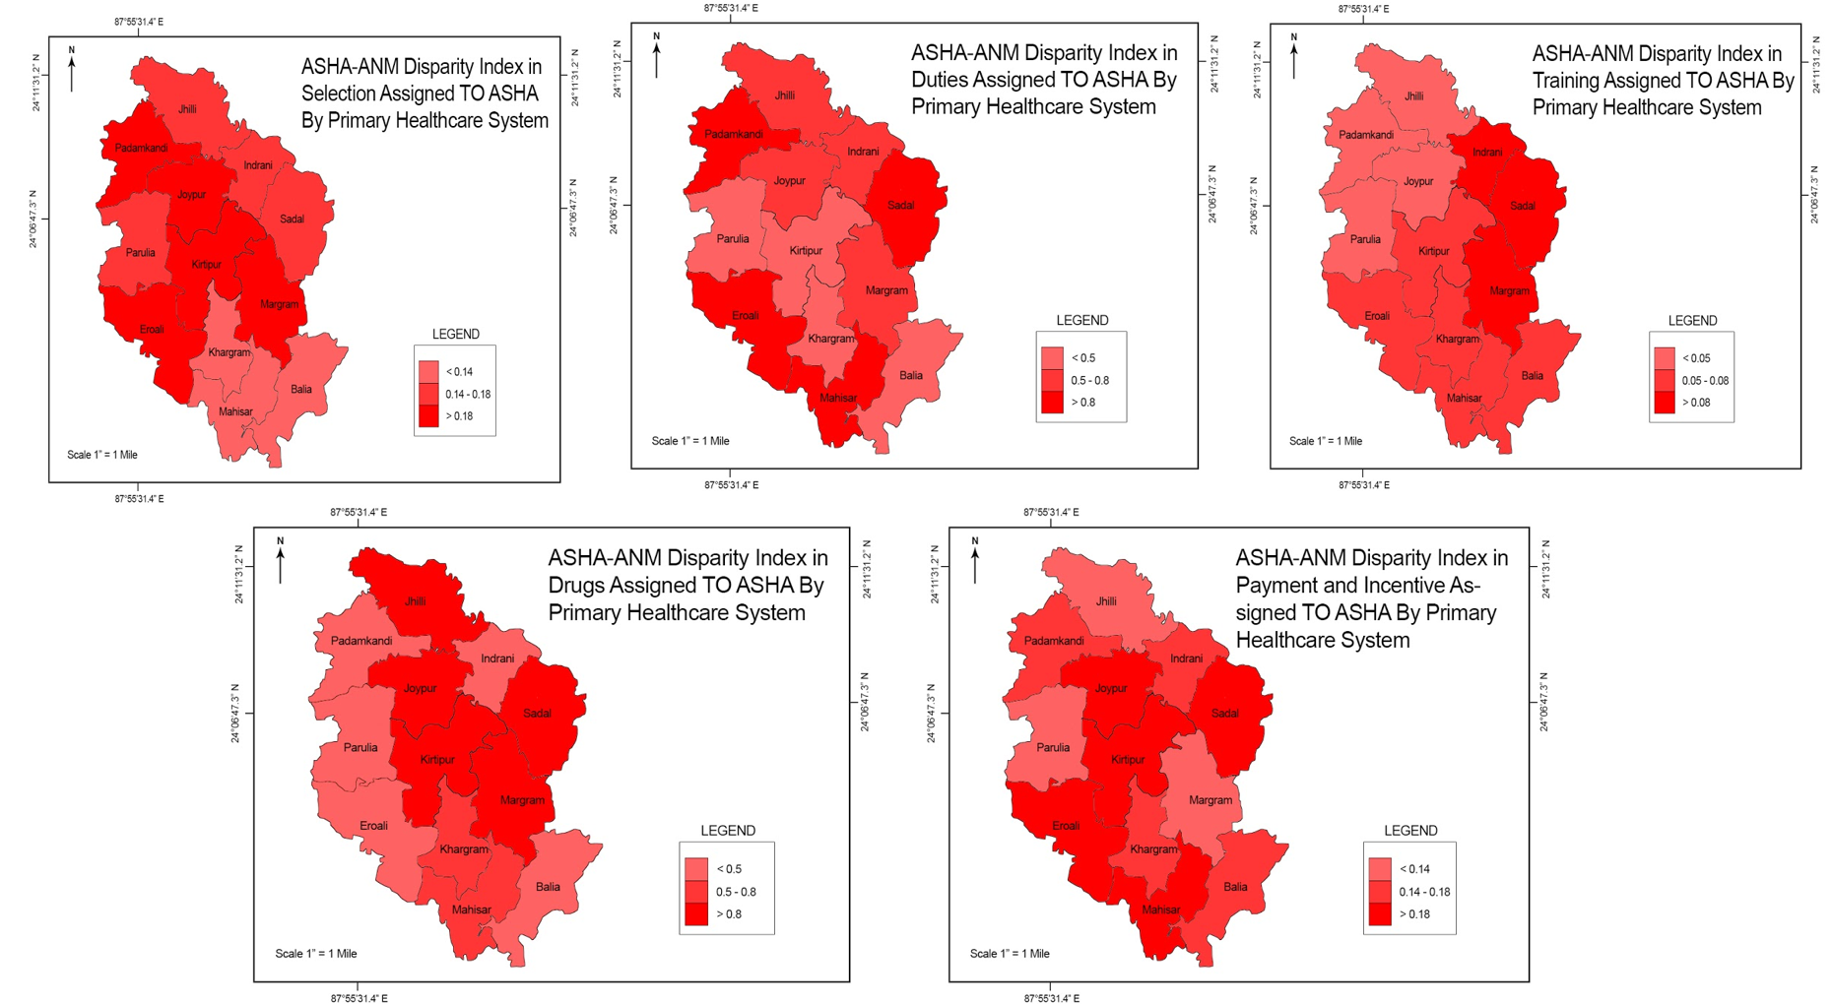
Figure1. 5 Spatial Depiction of ASHA-ANM Disparity Index

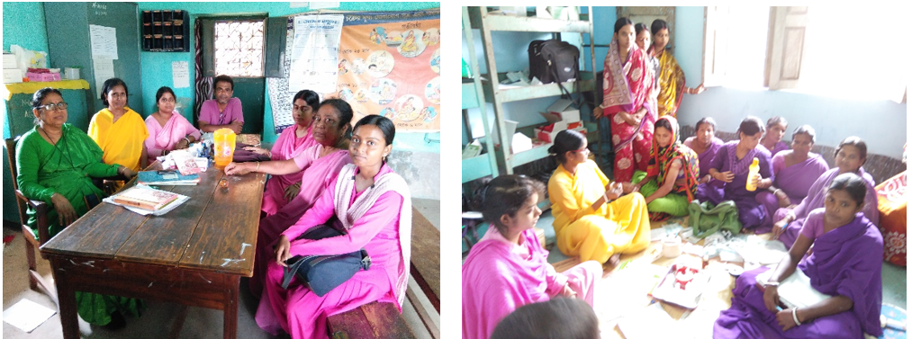
Figure 1.6 ANMs and ASHAs in Various Sub-centres of Khargram during Primary Survey
Source: (Author’s photo from Field Survey in Khargram Block)
6.7 Empowerment Level of ASHA in Khargram Block- 9 domains are used to calculate the empowerment level of ASHAs.
6.7.1 Production Domain: This domain highlights the ability of ASHAs to perform their duty. The more the duty is performed by ASHA the higher is their ability to function and higher will be their empowerment.
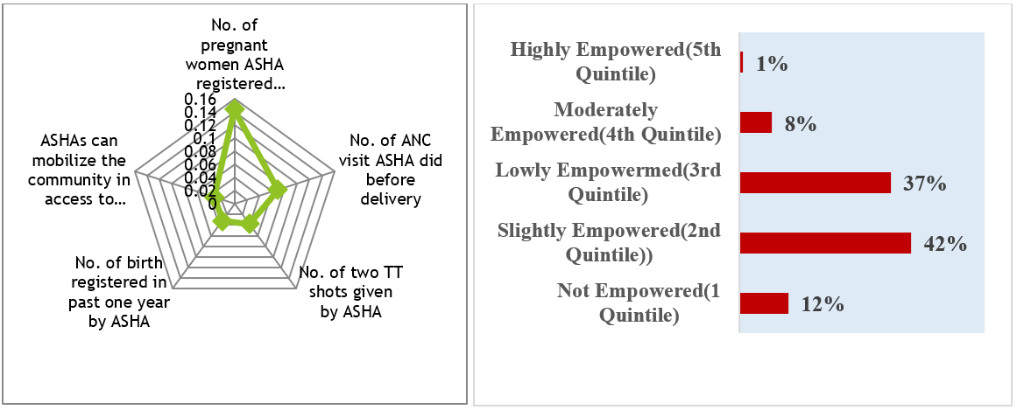
Fig 1.7a & 1.7b Level of Empowerment of ASHA in Production Domain of Khargram Block
The majority of ASHAs empowerment level in this domain is between 2nd and 3rd quintile as allocation of duties to ASHAs are not sufficient. The ASHAs of Khargram Block when categorized in five groups based on quintiles it is observed that 12 percent of ASHAs do not feel empowered, 42 percent feel slightly empowered, 37 percent feel lowly empowered, 8 percent feel moderately empowered and 1percent feel highly empowered (Fig 1.7 b). Thus, the empowerment level of ASHA is mainly concentrated in 2nd and 3rd quintile. Disaggregated data shows that ASHAs in Khargram perform best in registering pregnant women of the village (Fig 1.7a).
6.7.2 Autonomy Domain: This domain reflects ASHA’s authoritative aspects. If they enjoy autonomy, they are bound to feel empowered. Four indicators are selected in this domain. Fig 1.8a highlights that ASHAs have no autonomy in reaching higher officials by themselves in financial and incentive-based disputes, minimum autonomy in selecting referred institutional place of delivery and answering queries of patients.
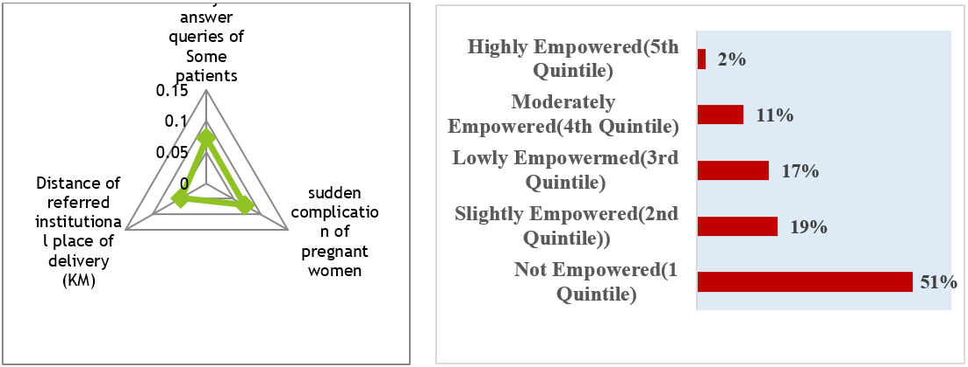
Fig 1.8a & 1.8 b Level Of Empowerment of ASHAs in Autonomy of Khargram Block
Hence in case of autonomy, 51 percent of ASHA in Khargram Block belongs to the 1st quintile i.e. no empowerment at all. (Fig 1.8b). Only 19 percent feels slight empowerment,17 percent feels low empowerment, 11 percent feel moderate empowerment and 2 percent feel high empowerment (Fig 1.8b).
6.7.3 Resource Domain:
This domain explains the ownership of ASHAs on health equipment. If ASHAs don’t have the ownership of their health equipment their ability to perform hampers. They become accountable and efficiently perform their duties if they have resources like drug kits, restocked drug kits, first aid medicine, reproductive and child health medicine.
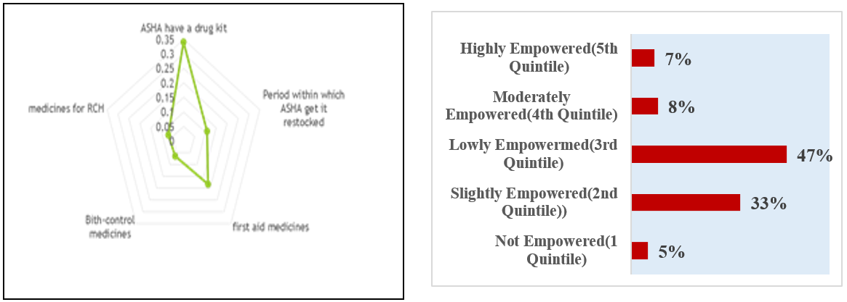
Figure 1.9 a & 1.9 b Level of Empowerment of ASHA in Resource Domain
Fig 1.9a reveal that the situation is very gloomy in case of resource domain. ASHAs have drug kits with them with almost meagre medicines and contraceptives. 5 percent of ASHAs in Khargram lacks ownership of health equipment completely, 33 percent feels slight empowerment, 47 percent feels low empowerment, 8 percent feels moderate empowerment and only 7 percent feels complete ownership on health equipment (Fig 1.9b).
6.7.4 Financial Autonomy:
This domain highlights the income or financial empowerment of ASHAs. The main source of income is from Janani Surkhya Yojana for ASHAs. However, the incentives from this scheme often remains pending. They also don’t get incentives for attending training and their demand for pay rise often goes neglected (Fig1.10a). In such scenario, 8 percent of ASHA feels highly empowered, 38 percent feels moderately empowered, 30 percent feels lowly empowered, 19 percent feel slightly empowered and 4 percent feel not empowered (Fig 1.10b).
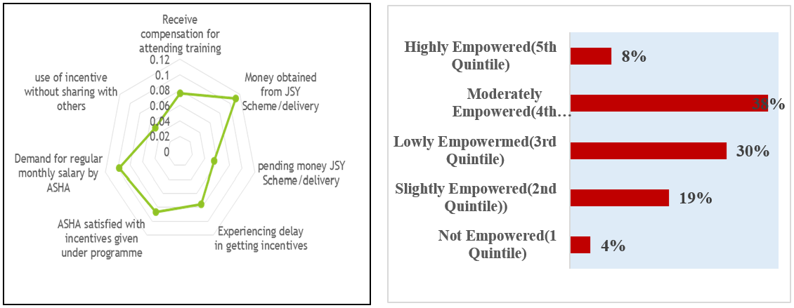
Fig 1.10a &1.10b Level of Empowerment of ASHAs by Financial Autonomy of Khargram Block
6.7.5 Leadership Domain:
This is a domain which shows better empowerment of ASHAs. ASHAs took part in Group discussions, motivated mothers for breastfeeding and birth preparedness and also addressed in Mother’s meet on child-care in subcenters (Fig 1.11a). The culmination of leadership qualities within ASHA, helps them evolve as community health representatives. In case of leadership domain in Khargram block 39 percent of ASHAs feel highly empowered, 28 percent feel moderately empowered, 21 percent feel lowly empowered, 7 percent feel slightly empowered 5 percent feel not empowered (Fig 1.11b).
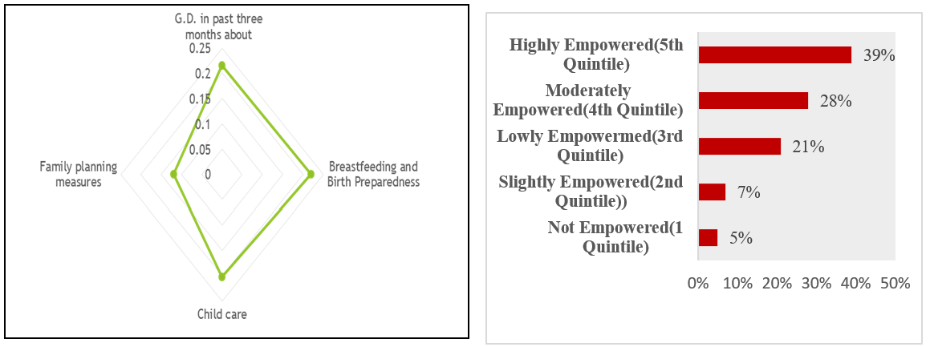
Fig 1.11a & 1.11b Level of Empowerment of ASHA in Addressing Community of Khargram Block
6.7.6 Social Prestige Domain:
Social prestige also enables the feeling of empowerment. The job as community-based health workers should enhance their opportunity, exposure and social prestige as ASHA “Didi”, security and feeling of contribution towards society. ASHAs feel this job gives them more exposure to contribute to their own villagers and also feel social prestige from villagers. However, they don’t get the social prestige as compared to ANMs who are considered permanent health staffs and they cannot do much in improvement of health facilities as their status are as volunteers (Fig 1.12a). Thus, social empowerment is explained by this domain. In Khargram Block 58 percent of ASHAs feel not empowered, 6 percent feel slightly empowered, 30 percent feel lowly empowered, 5 percent feel highly empowered (Fig 1.12b).
Fig 1.12a & 1.12b Level of Empowerment of ASHA in Gaining Social Prestige in Khargram Block
6.7.7 Group Membership Domain:
The recognition and representation of ASHA in committees like Panchayati Raj Institution, Village Health Sanitation Nutrition Committee improve their group recognition. Peer pressure also allows ASHA to perform better.
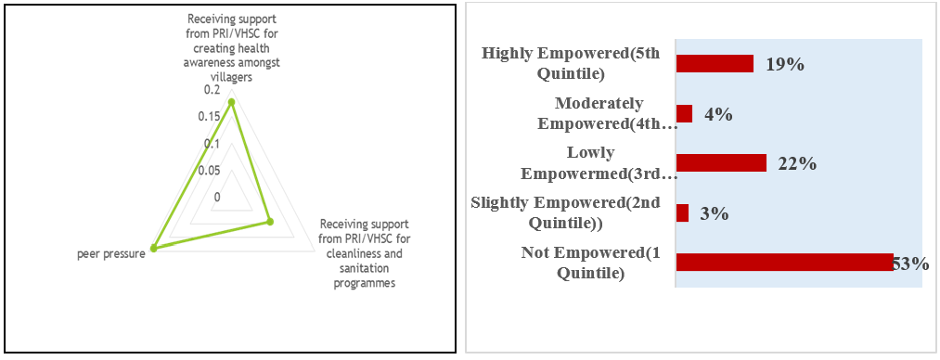
Fig 1.13a & 1.13b Level of Empowerment of ASHAs in Group Membership of Khargram Block
In Khargram the ASHAs face peer pressure and competition at work. Although the ASHAs are well represented in Village Health Sanitation Nutrition Committee but they are not included in various cleanliness and awareness drive organized by Panchayat (Fig1.13a). In Khargram Block 53 percent of ASHA lacks empowerment in group membership, 3 percent is slightly empowered, 22 percent is lowly empowered, 4 percent moderately empowered and 19 percent feels highly empowered (Fig 1.13b).
6.7.8 Work Load Domain:
ASHAs in entire Khargram Block is serving population size much higher than the IPHC standards. In Sadal Gram Panchayat subcenter has only single ASHA. However, ASHAs only serve her own village (Fig 1.14a). In this domain 8 percent ASHA in Khargram Block feel highly empowered, 22 percent feel moderately empowered, 17 percent feel lowly empowered, 37 percent feel slightly empowered and 16 percent feel not empowered (Fig 1.14b). In Khargram Block the ASHAs are well distributed in all the quintiles.
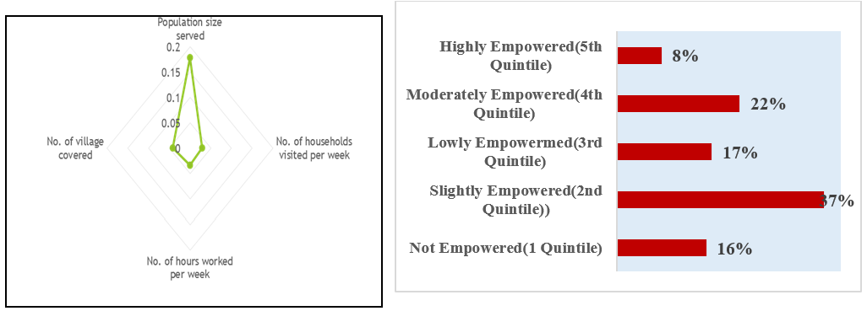
Fig 1.14a & 1.14b Level of Empowerment of ASHAs in Workload of Khargram Block
6.7.9 Knowledge Domain:
This domain is very crucial because for gaining empowerment acquiring professional knowledge is very crucial. In Fig 1.15a all ASHAs have the minimum school years to become ASHA. However, ASHAs completely lack knowledge of emergency medicine and the year of experience for ASHAs is also same for all. ASHAs responded they have attended training and refresher training. Hence on the basis of the data collected in Khargram Block 18 percent of ASHAs feel highly empowered, 27 percent feel moderately empowered, 23 percent feel lowly empowered, 7 percent feel slightly empowered and 25 percent feel not empowered (Fig 1.15b).
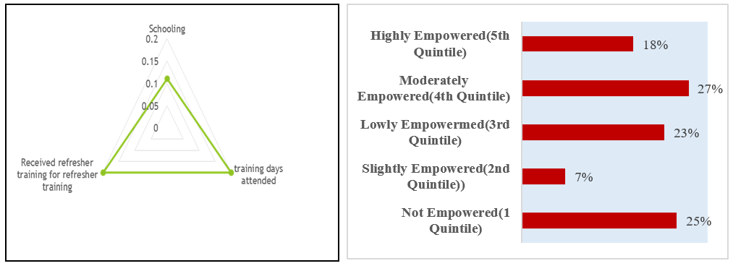
Fig 1.15a & 1.15b Level of Empowerment of ASHA in Gaining Knowledge of Khargram Block

Thus, the overall empowerment of ASHAs in Khargram highlights 4 percent of ASHA belongs to 5Th quintile, 13 percent to 4th Quintile, 26 percent to 3rd Quintile, 34 percent to 2nd Quintile and 29 percent to 1st Quintile.
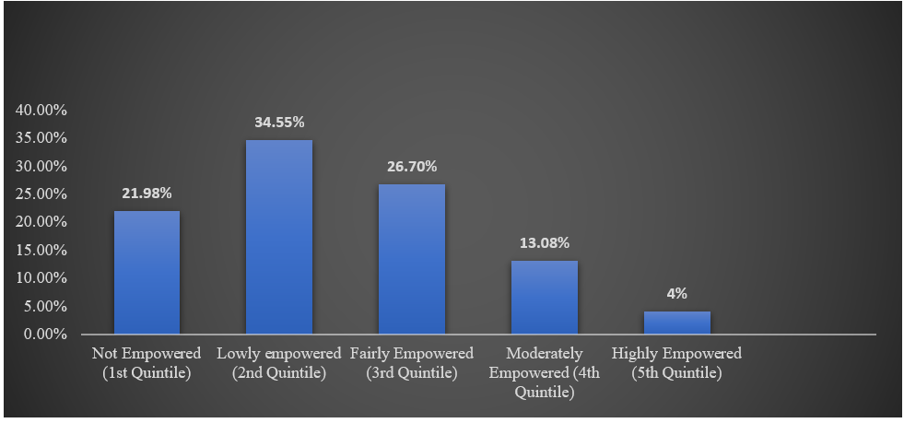
Fig 1.16 Overall Empowerment Rate of ASHAs in Khargram Block
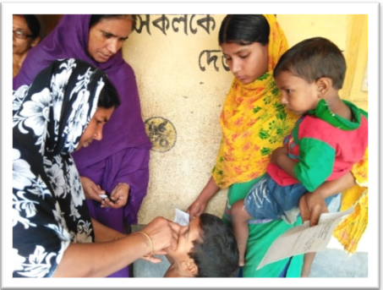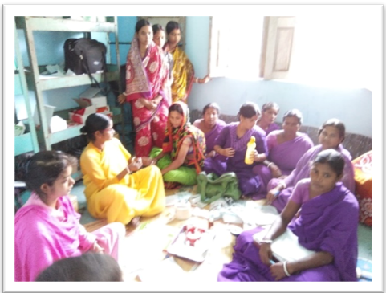
Fig 1.17a ASHAs Engaged in Polio Vaccination Fig 1.17b ASHAs Participation in Group Discussion
Source: (Author’s photo from Field Survey in Khargram Block)
9. Results and Discussion of Community Satisfaction Towards ASHA in Khargram Block by Logistic Regression
For logistic regression with Odd Ratios, 591 respondents from the community were selected who received healthcare from ASHA’s in last three months. For the present study fifteen explanatory variables are considered to explain satisfaction of community towards ASHA workers. The goodness of fitness of the model is adequate (R² =0.72) (Table 1.7). The results of the analysis of the determinants of community satisfaction are presented. First three columns show that all variable significantly influence the satisfaction of community except ASHA’s role in new born care. Instead of reporting coefficient the Odd Ratio and the corresponding marginal effect of each explanatory variable of community satisfaction is shown. In the present study odds of satisfaction of community increases in ASHA's role in informing about health services, creating awareness on health and hygiene, providing antenatal services, providing mother's immunization, sanitation, care for illness and fever, birth preparedness, guidance towards breastfeeding, child immunization, guidance on contraceptives, family planning, personal hygiene and sanitation, accompanying pregnant women to health facility, informing about birth and death in the village. Only in case of newborn care the severity of odd is less than 1.
Table 1.7 Logistic Regression Showing Community’s Satisfaction Towards ASHAs in Khargram
Iteration Completed 6, N=591, LR chi2(17) =581.76***, PseudoR2=0.726
Variables | Odds Ratio | Z-value | P>|z| | Marginal Effect
ASHA provide information about health services | 13.47 | 4.95 | 0.000*** | 0.36***
ASHA create awareness on health, hygiene and nutrition | 18.6 | 5.56 | 0.000*** | 0.27***
ASHA provides ANC Services | 9.01 | 3.26 | 0.000*** | 0.25***
Asha provides PNC Services | 15.02 | 4.18 | 0.000*** | 0.35***
ASHA does Immunization | 9.87 | 4.92 | 0.000*** | 0.37***
ASHA aware community about Sanitation | 11.65 | 4.94 | 0.000*** | 0.38***
ASHA cures Illness and fever | 13.32 | 5.09 | 0.000*** | 0.42***
ASHA help in birth preparedness & safe delivery | 22.45 | 4.17 | 0.000*** | 0.24***
ASHA does newborn care | 0.999 | -0.03 | 0.977 | -0.001
ASHA guides about Breast feeding & complimentary feeding | 5.02 | 3.9 | 0.000*** | 0.25***
ASHA does Immunization of infants | 43.82 | 6.12 | 0.000*** | 0.73***
ASHA guides about use of contraceptives | 6.83 | 4.15 | 0.000*** | 0.28***
ASHA discuss about family planning measures | 6.46 | 3.17 | 0.002*** | 0.37***
ASHA guides about personal hygiene & sanitation for mother and child | 15.95 | 4.21 | 0.000*** | 0.58***
ASHA accompanying pregnant women or sick children to health facility | 23.87 | 11.1 | 0.000*** | 0.43***
ASHA Inform health facility about birth and death in village | 17.35 | 4.71 | 0.000*** | 0.58***
ASHA Inform about outbreak of health problem and diseases | 2.13 | 1.62 | 0.105 | 0.13
*P<0.10, **P<0.05, ***P<0.01

Thus, in Khargram the odd of satisfaction within the community towards ASHA performance is very high. Since the newborn care is mainly the role of doctors and nurses in medical institutions therefore the role of ASHA in newborn care does not significantly influence community satisfaction. Those who experience home delivery depends on elderly women of the family or 'Dai-maas’ for new born care. Hence even though the odd ratio is less than 1 the variable is not significant. The marginal effects for respective explanatory variables are significant except for newborn care and information about outbreak of health problems and diseases. The absolute effect of each explanatory variable on the community satisfaction is high.
The marginal effect of ASHA's providing information on health services is positive and the probability of increase in community satisfaction is 36 percent. The probability of increase in community satisfaction is 27 percent if ASHAs perform better on awareness on health services, 25 percent for antenatal care services, 35 percent for postnatal care services, 37 percent for mothers immunization, 38 percent for awareness on sanitation, 42 for percent birth preparedness and safe delivery, 25 percent for breastfeeding, 73 percent for child immunization, 20 percent on use of contraceptives, 37 percent for guidance on family planning, 58 percent on personal hygiene, 43 percent for accompanying mothers, 58 percent for informing about birth and death and 13 percent for informing on outbreak in the villages. Marginal effects show that the community satisfaction towards ASHA will increase to great extent if ASHAs are more empowered particularly in reproductive and child health in Khargram (Table 1.7).
12. Conclusion and Policy Implication-The present study analyses three aspects. The role of Primary Healthcare System in extending provisions and training provided to the ASHAs. It also analyses how far the ASHA’s could gain empowerment with the initiative of Primary Healthcare System under the guidelines of NRHM (2005). After gaining empowerment, whether community is satisfied with ASHAs performance. In Khargram Block candidates with previous experience of community-based work is needed as these candidates have already gained some amount of confidence and closeness with the community. Primary Healthcare System need to organize training which is practical and field based to prepare ASHA’s for medical emergency. Proper definition and demarcation of role of ANM and ASHA is needed in written form by the Primary Healthcare System to minimize work overlap. Monitoring is needed from District level in all the Blocks in West Bengal. The ASHA facilitators in each district should be more involved in the monitoring process of Primary Healthcare System regarding the capacity building of ASHAs. The identified backward regions in terms of ASHAs empowerment needs extra attention towards ASHA in terms of selection and training. ASHAs need to focus more on reproductive and child healthcare. Strict regulation is needed on the part of Primary Healthcare System for ASHA’s to accompany mothers for institutional deliveries particularly at night. Policies need to be framed to extend transportation support to the ASHAs at night. Through all these interventions ASHA’s can be truly empowered to make a difference to their own life and the community where they serve. Since empowerment is a feeling of gaining power continuous motivation through dialogue, workshops, trainings and recognition by Primary Healthcare System jointly with Panchayat is needed.
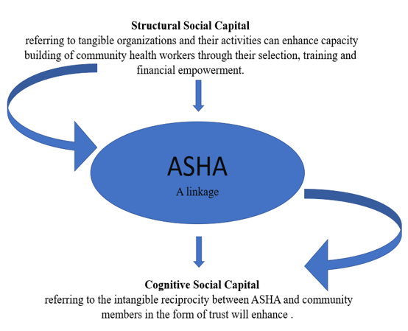
Fig 1.18 Authors Conceptualization of Linkage between Healthcare System, ASHA and Community

AI Discloser: No AI tool is used for preparation of this manuscript.
Reference:
1. Alkire, S., Dich-Meinzen, R., Peterman, A., Quisumberg, R., Seymour, G., Vaz, A. (2013): “The Women Empowerment in Agriculture Index”, OPHI Working Paper No. 58. https://doi.org/10.1016/j.worlddev.2013.06.007
2. Arole, M. and Arole, R. (1975): “A Comprehensive Rural Health Project in Jamkhed (India)” in Knneth Newell (ed.), Health by the People (Geneva: World Health Organisation). https://wellcomecollection.org/works/b1040000x
3. Bajpai, N. and Dholakia, R. H. (2011): “Improving the Performance of Accredited Social Health Activists in India. Working Paper Series: Working Paper No. 1. https://doi.org/10.7916/D8988G63
4. Bhattacharya, H., Lnwang, N., Sarkar, M., Chakraborty, T. and Baidya, S. (2015): “Utilization of ASHA services by the pregnant woman of rural Tripura, India”, International Journal of Research in Medical Sciences, Vol 3(9), pp 2223-2227.
5. Charu, K., Kishore, J., Sharma, S. and Nayak, H. (2015): “Knowledge and Practice of Accredited Social Health Activists for maternal healthcare delivery in Delhi”, Journal of Family Medicine and Primary Care, Vol 4(3), pp 359-363. https://doi.org/10.4103/2249-4863.161317
6. Desai, P.B (2016): “Role of Accredited Social Health Activist”, in the improvement of Health Status of Villagers under NRHM in Kolhapur District, Maharashtra”, Journal of Community Medicine and Health education, Vol 6(2), https://doi.org/10.4172/2161-0711.1000416
7. Dinesh, P., Gopalakrishnan, S., and Singh, P. (2013): “Functioning of Accredited Social -Health Activists (ASHAs) in ICDS: An Evaluation”, Journal of Health and Population-Perspectives and Issues, Vol 36 (384), pp 78-89. http://medind.nic.in/hab/t13/i3/habt13i3p78.pdf
8. Dyalchand, A. and Soni, I. (1983): “Evaluation in Primary Health Care: A Case Study from India”, in David Morely, Jon Rohd and Glen Williams (ed.), Practising Health for All (London: Oxford University Press), pp 87-100.
9. Fathima, F. N., Raju, M., Varadharajan, K. S., Krishnamurthy, A., Ananth Kumar, S. R. and Mony, K. P. (2015): “Assessment of ‘Accredited Social Health Activists’- A National Community Health Volunteer Scheme in Karnataka State, India”, Journal of Health, Population and Nutrition, Vol 33(1), pp 137-145. https://doi.org/10.1186/s40728-015-0019-z
10. George, M. and Joshi, R. S. (2012): “Healthcare Through Community Participation”, Economic and Political Weekly, Vol 18(10), pp 70-6. https://www.epw.in/journal/2012/10/notes/healthcare-through-community-participation.html
11. Garg, P. K., Bhardwaj, J. A., Singh, A. and Ahluwalia, S. K. (2013): “An Evaluation of ASHA Worker’s Awareness and Practice of Their Responsibilities in Rural Haryana”, National Journal of Community Medicine, Vol 4(1), pp 76-80. https://njcmindia.com/index.php/file/article/view/1463
12. Karir, S., Haider, S., Kashyap, V., Sagar, V., and Singh, B. S. (2015): “Assessment of Sahiyya (Accredited Social Health Activist) in relation to antenatal services: Ormanjhi, Ranchi, Jharkhand”, International Journal of Community Medicine and Public Health, Vol 2(21), pp 130-136. https://doi.org/10.5455/2394-6040.ijcmph20150513
13. Kochukuttan, S., Sundari Ravindran, T. K. and Krishnan, S. (2013): “Evaluating Birth Preparedness and Pregnancy Complications Readiness Knowledge and Skills of Accredited Social Health Activists in India”, International Journal of MCH and AIDS, Vol 2(1), pp 121-8. https://doi.org/10.21106/ijma.17
14. Kumar, S., Kaushik, A. and Kaushal, F. (2012): “Factors influencing the work performance of ASHA under NRHM: a cross-sectional study from Eastern Uttar Pradesh”, Indian Journal of Community Health, Vol 24(4), pp 325-31 https://www.iapsmupuk.org/journal/index.php/IJCH/article/view/273 .
15. Markides, K.S. and McFarland, C. (1982), “A note on recent trends in the infant mortality-socio-economic status relationship”, Social Forces, Vol 61(1), pp 268-276. https://doi.org/10.1093/sf/61.1.268
16. Maru, M. R. (1983): “The Community Health Volunteer Scheme in India: An Evaluation”, Social Science and Medicine, Vol 17 (19), pp 1477-83. https://doi.org/10.1016/0277-9536(83)90046-1
17. Mondal, N. and Murhekar, V. M. (2018): “Factors associated with low performance of Accredited Social Health Activists (ASHA) regarding maternal care in Howrah district, West Bengal, 2015-15: An unmatched case control study”, Clinical Epidemiology and Global Health, Vol 6(1), pp 21-28.
18. Mishra, A. (2010): “The role of Accredited Social Health Activists in effective healthcare delivery: evidence from a study in South Orissa”, BMC Proceedings 6(Suppl 1): P1.
19. Nagaraj, N., Achappa, S., Bettapa, P. and Prakash, B. (2017): “Performance Evaluation of Accredited Social Health Activist under National Rural Health Mission in Mysore District: A Cross-Sectional Study”, National Journal of Community Medicine, Vol 8(6) , pp 324-328. https://njcmindia.com/index.php/file/article/view/940
20. PHRN, 2007: Community Participation and Community Health Workers: With Special Reference to ASHA, Book 4 Raipur: Public Health Resource Network Publication.
21. Padda, P., Devgun, S., Gupta, V., Chaudhari, S. and Singh, G, (2013): “Role of ASHA in Improvement of Maternal Health Status in Northern India: An Urban Rural Comparison”, Indian Journal of Community Health, Vol 25(4), pp 465-77. https://www.iapsmupuk.org/journal/index.php/IJCH/article/view/357
22. Rifkin, S. B. (2008): “Community Health Workers”, International Encyclopedia of Public Health, Vol 1, pp 773-82. https://doi.org/10.1016/B978-012373960-5.00534-7
23. Shashank, K. J. and Mahabaleshwar, M. A. (2015): “A study to evaluate the knowledge of ASHA workers on antenatal and postnatal care in Bijapur District”, International Journal of Research in Medical Sciences, Vol 3(9), pp 2299-2302. https://doi.org/10.18203/2320-6012.ijrms20150620
24. Sprii, L., Richards, E., Kokhe, P. and Theobald, S. (2015): “Community health workers in rural India: Analyzing the opportunities and challenges, Accredited Social Health Activists (ASHAs) face in realising their multiple roles”, Human Resource for Health Vol 13, pp 95. https://doi.org/10.1186/s12960-015-0094-3
25. Srivastava, D. K., Prakash, S., Adhish, V., Nair, K. S., Gupta, S. and Nandan, D. (2009): “A Study of Interface of ASHA with the Community and the Service Providers in Eastern Uttar Pradesh”, Indian Journal of Public Health, Vol 53(3), pp 133-6. https://pubmed.ncbi.nlm.nih.gov/20108875/
26. Sharma, P., Semwal, J. and Kishore, S. A. (2011): “Comparative Study of Janani Suraksha Yojana (Maternity Benefit Scheme) in Rural Areas and Urban Slums”, Indian Journal of Community Health, Vol 22(2), pp 11-4.
27. Saxena, V., Kakkar, R. and Semual, V. D. (2012): “A study on ASHA- a change agent of society”, Indian Journal of Community Health, Vol 24(1), pp 15-18.
28. Sagar, S. M., Bogam, M. M., Murarkar, S. K., Patil, U. P. and Ghate, M. M. (2012): “Knowledge, attitude and practices of ASHAs regarding tuberculosis and DOTS”, Indian Journal of Science and Technology, Vol 5(3), pp 2401-2404. https://doi.org/10.17485/ijst/2012/v5i3.31
29. Shevky, E. and Bell, W (1955). Social Area Analysis. Stanford. Stanford University Press.
30. Tripathy, P., Nair, N., Mahapatra, R. (2011): “Community Mobilization with Women’s groups facilitated by Accredited Social Health Activists (ASHAs) to improve maternal and new born health in underserved areas of Jharkhand and Orissa: Study protocol for a cluster-randomised controlled trial. Trials, 12:182. https://doi.org/10.1186/1745-6215-12-182
31. Walt, Gill. (1988): “CHWs: Are National Programmes in Crisis?” Health Policy and Planning, Vol 3(1), pp 1-21. https://doi.org/10.1093/heapol/3.1.1

